Version

# Table of Contents

Table of contents

# Namespace Index

## Packages

Here are the packages with brief descriptions (if available):

**Assets**

**Assets.MyScripts**

**Assets.MyScripts.SInt**

**Assets.MyScripts.SInt.Common**

**Assets.MyScripts.SInt.Common.Calculation**

**Complete**

**Examples**

**Examples.Command (Utility script that creates a random color for us and returns it )**

**UnityEditor**

**UnityEditor.PostProcessing**

**UnityEngine**

**UnityEngine.InputSystem**

**UnityEngine.InputSystem.Samples**

**UnityEngine.InputSystem.Samples.InGameHints**

**UnityEngine.InputSystem.Samples.RebindUI**

**UnityEngine.InputSystem.UI**

**UnityEngine.PostProcessing**

# Hierarchical Index

## Class Hierarchy

This inheritance list is sorted roughly, but not completely, alphabetically:

AINavAgentCommon

Attribute

UnityEditor.PostProcessing.PostProcessingModelEditorAttribute

AudioFade

UnityEngine.PostProcessing.ColorGradingModel.BasicSettings

UnityEngine.PostProcessing.BloomModel.BloomSettings

ChainCommandData

ChainCommandDataOld

UnityEngine.PostProcessing.ColorGradingModel.ChannelMixerSettings

Examples.Command.ColorCreator

UnityEngine.PostProcessing.ColorGradingCurve

UnityEngine.PostProcessing.ColorGradingModel.ColorWheelsSettings

CommandHandler

CommandQueue

CommandAccessorRefsBase.CommandSlotUnityEvents

CommandStack

ConstraintCommon

CommandBase.CooldownInfo

UnityEngine.PostProcessing.ColorGradingModel.CurvesSettings

UnityEngine.PostProcessing.BuiltinDebugViewsModel.DepthSettings

DialogueSystem.DIALOGUE_ELEMENTS

DoxygenConfig

DoxyRunner

DoxyThreadSafeOutput

Editor

EventEditor

EditorWindow

DoxygenWindow

EventArgs

PlayerSkills.OnSkillUnlockedEventArgs

InputCommand.ExecExtraInfo

CommandBase.ExecutionInfo

Extensions

FileReadWrite

UnityEngine.PostProcessing.MotionBlurComponent.FrameBlendingFilter

UnityEngine.PostProcessing.AntialiasingModel.FxaaConsoleSettings

UnityEngine.PostProcessing.AntialiasingModel.FxaaQualitySettings

UnityEngine.PostProcessing.AntialiasingModel.FxaaSettings

UnityEngine.InputSystem.Samples.RebindUI.GamepadIconsExample.GamepadIcons

UnityEngine.InputSystem.Samples.RebindUI.RebindIconsHelper.GamepadIcons

SimpleControls.GameplayActions

UnityEngine.InputSystem.Samples.InGameHints.InGameHintsActions.GameplayActions

RebindUISampleActionsModified.GameplaySampleUnusedActions

UnityEngine.PostProcessing.GraphicsUtils

IBeginDragHandler

itemSlots

ICommand

CommandBase

BinCommandWithCooldown

InputCommand

AbilityCommand

EnableDisableGameObjectCommand

SetMaterialColorCommand

Examples.Command.LightActiveToggle

Examples.Command.LightColorChange

Examples.Command.LightDecreaseIntensity

Examples.Command.LightIncreaseIntensity

ICommandOWS

Move

IDictionary

GenericDictionary< TKey, TValue >

IDisposable

RebindUISampleActionsModified

SimpleControls

TanksInputActions

UnityEngine.InputSystem.Samples.InGameHints.InGameHintsActions

UnityEngine.PostProcessing.MaterialFactory

UnityEngine.PostProcessing.RenderTextureFactory

IDragHandler

itemSlots

IDropHandler

itemSlots

IEndDragHandler

itemSlots

SimpleControls.IGameplayActions

UnityEngine.InputSystem.Samples.InGameHints.InGameHintsActions.IGameplayActions

RebindUISampleActionsModified.IGameplaySampleUnusedActions

IInputActionCollection2

RebindUISampleActionsModified

SimpleControls

TanksInputActions

UnityEngine.InputSystem.Samples.InGameHints.InGameHintsActions

IInputStateTypeInfo

CustomDeviceState

IInputUpdateCallbackReceiver

CustomDevice

CommandBase.Info

InitCustomDeviceUsages

InputBindingComposite

CustomComposite

InputDevice

CustomDevice

InstalledUpgradeSaveData

CommandBase.InstanceInfoRuntime

UnityEngine.PostProcessing.ScreenSpaceReflectionModel.IntensitySettings

TanksInputActions.IPlayerActions

RebindUISampleActionsModified.IPlayerMainActions

IPointerClickHandler

itemSlots

itemSlotsNew

IPointerEnterHandler

itemSlots

IPointerExitHandler

itemSlots

ISerializationCallbackReceiver

GenericDictionary< TKey, TValue >

IStateBehavior

ItemContainerSaveData

ItemSaveIO

ItemSlotSaveData

TanksInputActions.IUIActions

RebindUISampleActionsModified.IUIMainActions

RebindUISampleActionsModified.IVector2AxisActions

UnityEngine.InputSystem.Samples.RebindUI.RebindIconsHelper.KeyMouseIcons

UnityEngine.PostProcessing.BloomModel.LensDirtSettings

UnityEngine.PostProcessing.ColorGradingModel.LinearWheelsSettings

UnityEngine.PostProcessing.ColorGradingModel.LogWheelsSettings

MapLocation

MathCommon

MonoBehaviour

AStarPathFinder

AnimationEventHelper

AreaOfEffect

Assets.MyScripts.SInt.Common.Calculation.PhysicsCastCommon

AudioManager

AutoFlipSpriteByDir

BadScript

BinCommandAccessorRefsBase

ButtonRemapScreenController

ButtonTrigger

CameraControl

CameraSightPerceptionSensor2D

ChainCommandInvoker

ChainCommandInvokerOldTypeA

Character

CharacterMove

CharacterMoveClean

CharacterMoveTurnBased

CharacterMoveUndo

CollisionByTagEvent

CommandAccessorRefsBase

CommandCoolDownComp

CommandManagerOld

CommandQueueHelper

CommandSlotHolder

CommandSlotsHolderManager

Complete.UIDirectionControl

ConfirmPopup

ControlRebindingUI

CustomDeviceUsages

DayCounter

DestroyBySeconds

DialogueSystem

DontDestroyOnLoad

EnemyAttack

EnemyFinder

EnemyHealth

EnemyMovement

Examples.Command.LightController

FSMSystemBase

NPCAISystemTypeA

FlockAI

GameEventListener

CommandEventListener

GameManager

GameObjActivePauseSync

GameObjSpawnHelper

GameplayManager

HealthBar

IgnoreChildCollision

InputHandlerOld_NewInputSystem

InputManager

InputManagerTurnBased

IntroChoice

Introduction

ItemContainer

storage

ItemSaveManager

ItemToolTip

Key_CtrlG_SnapToGround

LastInHeirarchy

LineRendererDrawer

LookAtCameraMain

Maze

MeterTank

Movement

NavAgentTestAutoSetMouseDestination

NavAgentTestAutoSetRandomDestination

NavAgentTestAutoSetWASDMovement

NavMeshCustomMove

NextStageBarrier

OnAllUnityEventCall

OnEnableEventCallTimer

OnEnablePlayBGM

OnEnablePlaySFX

OutpostChoices

PathDraw

PauseMenu

PauseMenuScripts

PlayTestSpeedUp

Player

PlayerAttack

PlayerHealth

PlayerMovement

PlayerBullet

BreakableWallBullet

HomingBullet

PlayerPrefTextSync

PolyColToMesh

PressureStageChecker

QuickOpenInventory

QuickPauseFix

RandomEnemy

RandomSpawner

RebindResetAllBindings

RebindSaveLoad

RequirementChecker

Resource

FishMaterial

RawMaterial

RigidBody2DAutoAddRelativeForceUp

SaveHandler

SceneAsyncManager

SceneBetweenStages

SceneHandler

SceneTransitioning

PreviousPosition

SceneTransitionsToOutpost

ScenearioScreenHandler

ShellExplosion

SimpleController_UsingActionAsset

SimpleController_UsingActions

SimpleController_UsingPlayerInput

SimpleController_UsingState

SimpleMultiplayerPlayer

SingleTonOnClickHelper

Singleton< T >

SpawnFlockManager

SyncTextWithTextMeshPro

TankHealth

TankMovement

TankShooting

TestDialogue

Testing

TextAnimation

Transform2DAutoLookAtObj2D

TransformAutoFakeParent

TransformAutoRelative

TransformAutoRotate

TransformPosShake

TutoManager

TutoOutpostDialogue

Tutorial

ButtonTuto

CloseButtonTuto

ContinueNextTuto

HoldKeyInputTuto

KeyInputTuto

TriggerTransitionTuto

UICommandList

UIHPSliderColor

UIShowHideToggle

UIToggleSaveToPlayerPrefs

UIVolumeSlider

UI_SkillTree

UnityEngine.InputSystem.InputRecorder

UnityEngine.InputSystem.Samples.InGameHints.InGameHintsExample

UnityEngine.InputSystem.Samples.InputVisualizer

UnityEngine.InputSystem.Samples.InputActionVisualizer

UnityEngine.InputSystem.Samples.InputControlVisualizer

UnityEngine.InputSystem.Samples.RebindUI.GamepadIconsExample

UnityEngine.InputSystem.Samples.RebindUI.RebindActionUI

UnityEngine.InputSystem.Samples.RebindUI.RebindIconsHelper

UnityEngine.InputSystem.UI.VirtualMouseInput

UnityEngine.PostProcessing.PostProcessingBehaviour

UpgradeChecker

UpgradeHolder

UpgradeSaveManager

WaypointPath

WaypointPathMaker

breakableWall

inventoryNew

itemSlots

itemSlotsNew

turbineUnique

UnityEngine.PostProcessing.BuiltinDebugViewsModel.MotionVectorsSettings

PathMarker

TanksInputActions.PlayerActions

PlayerBulletProperties

PlayerData

RebindUISampleActionsModified.PlayerMainActions

PlayerSkills

UnityEngine.PostProcessing.PostProcessingComponentBase

UnityEngine.PostProcessing.PostProcessingComponent< T >

UnityEngine.PostProcessing.PostProcessingComponentCommandBuffer< T >

UnityEngine.PostProcessing.PostProcessingComponentRenderTexture< T >

UnityEngine.PostProcessing.PostProcessingComponentCommandBuffer< AmbientOcclusionModel >

UnityEngine.PostProcessing.AmbientOcclusionComponent

UnityEngine.PostProcessing.PostProcessingComponentCommandBuffer< BuiltinDebugViewsModel >

UnityEngine.PostProcessing.BuiltinDebugViewsComponent

UnityEngine.PostProcessing.PostProcessingComponentCommandBuffer< FogModel >

UnityEngine.PostProcessing.FogComponent

UnityEngine.PostProcessing.PostProcessingComponentCommandBuffer< MotionBlurModel >

UnityEngine.PostProcessing.MotionBlurComponent

UnityEngine.PostProcessing.PostProcessingComponentCommandBuffer< ScreenSpaceReflectionModel >

UnityEngine.PostProcessing.ScreenSpaceReflectionComponent

UnityEngine.PostProcessing.PostProcessingComponentRenderTexture< AntialiasingModel >

UnityEngine.PostProcessing.FxaaComponent

UnityEngine.PostProcessing.TaaComponent

UnityEngine.PostProcessing.PostProcessingComponentRenderTexture< BloomModel >

UnityEngine.PostProcessing.BloomComponent

UnityEngine.PostProcessing.PostProcessingComponentRenderTexture< ChromaticAberrationModel >

UnityEngine.PostProcessing.ChromaticAberrationComponent

UnityEngine.PostProcessing.PostProcessingComponentRenderTexture< ColorGradingModel >

UnityEngine.PostProcessing.ColorGradingComponent

UnityEngine.PostProcessing.PostProcessingComponentRenderTexture< DepthOfFieldModel >

UnityEngine.PostProcessing.DepthOfFieldComponent

UnityEngine.PostProcessing.PostProcessingComponentRenderTexture< DitheringModel >

UnityEngine.PostProcessing.DitheringComponent

UnityEngine.PostProcessing.PostProcessingComponentRenderTexture< EyeAdaptationModel >

UnityEngine.PostProcessing.EyeAdaptationComponent

UnityEngine.PostProcessing.PostProcessingComponentRenderTexture< GrainModel >

UnityEngine.PostProcessing.GrainComponent

UnityEngine.PostProcessing.PostProcessingComponentRenderTexture< UserLutModel >

UnityEngine.PostProcessing.UserLutComponent

UnityEngine.PostProcessing.PostProcessingComponentRenderTexture< VignetteModel >

UnityEngine.PostProcessing.VignetteComponent

UnityEngine.PostProcessing.PostProcessingContext

UnityEngine.PostProcessing.PostProcessingModel

UnityEngine.PostProcessing.AmbientOcclusionModel

UnityEngine.PostProcessing.AntialiasingModel

UnityEngine.PostProcessing.BloomModel

UnityEngine.PostProcessing.BuiltinDebugViewsModel

UnityEngine.PostProcessing.ChromaticAberrationModel

UnityEngine.PostProcessing.ColorGradingModel

UnityEngine.PostProcessing.DepthOfFieldModel

UnityEngine.PostProcessing.DitheringModel

UnityEngine.PostProcessing.EyeAdaptationModel

UnityEngine.PostProcessing.FogModel

UnityEngine.PostProcessing.GrainModel

UnityEngine.PostProcessing.MotionBlurModel

UnityEngine.PostProcessing.ScreenSpaceReflectionModel

UnityEngine.PostProcessing.UserLutModel

UnityEngine.PostProcessing.VignetteModel

PropertyAttribute

UnityEngine.PostProcessing.GetSetAttribute

UnityEngine.PostProcessing.MinAttribute

UnityEngine.PostProcessing.TrackballAttribute

UnityEngine.PostProcessing.TrackballGroupAttribute

PropertyDrawer

ExtendedScriptableObjectDrawer

GenericDictionaryPropertyDrawer

UnityEngine.PostProcessing.MotionBlurComponent.ReconstructionFilter

UnityEngine.PostProcessing.ScreenSpaceReflectionModel.ReflectionSettings

UnityEditor.PostProcessing.ReflectionUtils

UnityEngine.InputSystem.Samples.VisualizationHelpers.RingBuffer< TValue >

SaveSystem

UnityEngine.PostProcessing.ScreenSpaceReflectionModel.ScreenEdgeMask

ScriptableObject

CommandBase

FSMBaseState

Alert

Chase

DefaultState

Flee

PatrolByRandomPos

PatrolByWaypoints

GameEvent

CommandEvent

ItemDatabase

PlayerUpgrades

Hull

Inventory

OxygenTank

SelfRepair

Turbine

Weapon

UnityEngine.PostProcessing.PostProcessingProfile

UpgradeDatabase

item

itemNew

ScrollRectCommon

SerializableQueueList< T >

SetParamStateData

UnityEngine.PostProcessing.AmbientOcclusionModel.Settings

UnityEngine.PostProcessing.AntialiasingModel.Settings

UnityEngine.PostProcessing.BloomModel.Settings

UnityEngine.PostProcessing.BuiltinDebugViewsModel.Settings

UnityEngine.PostProcessing.ChromaticAberrationModel.Settings

UnityEngine.PostProcessing.ColorGradingModel.Settings

UnityEngine.PostProcessing.DepthOfFieldModel.Settings

UnityEngine.PostProcessing.DitheringModel.Settings

UnityEngine.PostProcessing.EyeAdaptationModel.Settings

UnityEngine.PostProcessing.FogModel.Settings

UnityEngine.PostProcessing.GrainModel.Settings

UnityEngine.PostProcessing.MotionBlurModel.Settings

UnityEngine.PostProcessing.ScreenSpaceReflectionModel.Settings

UnityEngine.PostProcessing.UserLutModel.Settings

UnityEngine.PostProcessing.VignetteModel.Settings

Sound

Stat

StateMachineBehaviour

ParamStateBehavior

TimedParamStateBehavior

StdioCommon

UnityEngine.PostProcessing.AntialiasingModel.TaaSettings

TankManager

UnityEngine.PostProcessing.ColorGradingModel.TonemappingSettings

TransformCommon

TanksInputActions.UIActions

RebindUISampleActionsModified.UIMainActions

UnityEvent

UnityEngine.InputSystem.InputRecorder.ChangeEvent

UnityEngine.InputSystem.Samples.RebindUI.RebindActionUI.InteractiveRebindEvent

UnityEngine.InputSystem.Samples.RebindUI.RebindActionUI.UpdateBindingUIEvent

UpgradeSaveData

UpgradeSaveIO

UnityEngine.InputSystem.Samples.VisualizationHelpers.ValueVisualizer< Vector2 >

UnityEngine.InputSystem.Samples.VisualizationHelpers.Vector2Visualizer

RebindUISampleActionsModified.Vector2AxisActions

Vector2Common

Vector3Common

UnityEngine.InputSystem.Samples.VisualizationHelpers.Visualizer

UnityEngine.InputSystem.Samples.VisualizationHelpers.TimelineVisualizer

UnityEngine.InputSystem.Samples.VisualizationHelpers.ValueVisualizer< TValue >

UnityEngine.InputSystem.Samples.VisualizationHelpers.ScalarVisualizer< TValue >

# Class Index

## Class List

Here are the classes, structs, unions and interfaces with brief descriptions:

**AbilityCommand**

**AINavAgentCommon**

**Alert**

**UnityEngine.PostProcessing.AmbientOcclusionComponent**

**UnityEngine.PostProcessing.AmbientOcclusionModel**

**AnimationEventHelper**

**UnityEngine.PostProcessing.AntialiasingModel**

**AreaOfEffect**

**AStarPathFinder**

**AudioFade**

**AudioManager**

**AutoFlipSpriteByDir**

**BadScript**

**UnityEngine.PostProcessing.ColorGradingModel.BasicSettings**

**BinCommandAccessorRefsBase**

**BinCommandWithCooldown**

**UnityEngine.PostProcessing.BloomComponent**

**UnityEngine.PostProcessing.BloomModel**

**UnityEngine.PostProcessing.BloomModel.BloomSettings**

**breakableWall**

**BreakableWallBullet**

**UnityEngine.PostProcessing.BuiltinDebugViewsComponent**

**UnityEngine.PostProcessing.BuiltinDebugViewsModel**

**ButtonRemapScreenController**

**ButtonTrigger**

**ButtonTuto**

**CameraControl**

**CameraSightPerceptionSensor2D**

**ChainCommandData**

**ChainCommandDataOld**

**ChainCommandInvoker**

**ChainCommandInvokerOldTypeA**

**UnityEngine.InputSystem.InputRecorder.ChangeEvent**

**UnityEngine.PostProcessing.ColorGradingModel.ChannelMixerSettings**

**Character**

**CharacterMove**

**CharacterMoveClean**

**CharacterMoveTurnBased**

**CharacterMoveUndo**

**Chase**

**UnityEngine.PostProcessing.ChromaticAberrationComponent**

**UnityEngine.PostProcessing.ChromaticAberrationModel**

**CloseButtonTuto**

**CollisionByTagEvent**

**Examples.Command.ColorCreator**

**UnityEngine.PostProcessing.ColorGradingComponent**

**UnityEngine.PostProcessing.ColorGradingCurve**

**UnityEngine.PostProcessing.ColorGradingModel**

**UnityEngine.PostProcessing.ColorGradingModel.ColorWheelsSettings**

**CommandAccessorRefsBase**

**CommandBase**

**CommandCoolDownComp**

**CommandEvent**

**CommandEventListener**

**CommandHandler**

**CommandManagerOld**

**CommandQueue**

**CommandQueueHelper**

**CommandSlotHolder**

**CommandSlotsHolderManager**

**CommandAccessorRefsBase.CommandSlotUnityEvents**

**CommandStack**

**ConfirmPopup**

**ConstraintCommon**

**ContinueNextTuto**

**ControlRebindingUI**

**CommandBase.CooldownInfo**

**UnityEngine.PostProcessing.ColorGradingModel.CurvesSettings**

**CustomComposite**

**CustomDevice**

**CustomDeviceState**

**CustomDeviceUsages**

**DayCounter**

**DefaultState**

**UnityEngine.PostProcessing.DepthOfFieldComponent**

**UnityEngine.PostProcessing.DepthOfFieldModel**

**UnityEngine.PostProcessing.BuiltinDebugViewsModel.DepthSettings**

**DestroyBySeconds**

**DialogueSystem.DIALOGUE_ELEMENTS**

**DialogueSystem**

**UnityEngine.PostProcessing.DitheringComponent**

**UnityEngine.PostProcessing.DitheringModel**

**DontDestroyOnLoad**

**DoxygenConfig ()**

**DoxygenWindow ()**

**DoxyRunner (This class spawns and runs Doxygen in a separate thread, and could serve as an example of how to create plugins for unity that call a command line application and then get the data back into Unity safely )**

**DoxyThreadSafeOutput (This class encapsulates the data output by Doxygen so it can be shared with Unity in a thread share way )**

**EnableDisableGameObjectCommand**

**EnemyAttack**

**EnemyFinder**

**EnemyHealth**

**EnemyMovement**

**EventEditor**

**InputCommand.ExecExtraInfo**

**CommandBase.ExecutionInfo**

**ExtendedScriptableObjectDrawer (Extends how ScriptableObject object references are displayed in the inspector Shows you all values under the object reference Also provides a button to create a new ScriptableObject if property is null )**

**Extensions**

**UnityEngine.PostProcessing.EyeAdaptationComponent**

**UnityEngine.PostProcessing.EyeAdaptationModel**

**FileReadWrite**

**FishMaterial**

**Flee**

**FlockAI**

**UnityEngine.PostProcessing.FogComponent**

**UnityEngine.PostProcessing.FogModel**

**UnityEngine.PostProcessing.MotionBlurComponent.FrameBlendingFilter**

**FSMBaseState**

**FSMSystemBase**

**UnityEngine.PostProcessing.FxaaComponent**

**UnityEngine.PostProcessing.AntialiasingModel.FxaaConsoleSettings**

**UnityEngine.PostProcessing.AntialiasingModel.FxaaQualitySettings**

**UnityEngine.PostProcessing.AntialiasingModel.FxaaSettings**

**GameEvent**

**GameEventListener**

**GameManager**

**GameObjActivePauseSync**

**GameObjSpawnHelper**

**UnityEngine.InputSystem.Samples.RebindUI.GamepadIconsExample.GamepadIcons**

**UnityEngine.InputSystem.Samples.RebindUI.RebindIconsHelper.GamepadIcons**

**UnityEngine.InputSystem.Samples.RebindUI.GamepadIconsExample (This is an example for how to override the default display behavior of bindings )**

**SimpleControls.GameplayActions**

**UnityEngine.InputSystem.Samples.InGameHints.InGameHintsActions.GameplayActions**

**GameplayManager**

**RebindUISampleActionsModified.GameplaySampleUnusedActions**

**GenericDictionary< TKey, TValue > (Generic Serializable Dictionary for Unity 2020.1 )**

**GenericDictionaryPropertyDrawer (Draws the generic dictionary a bit nicer than Unity would natively (not as many expand-arrows and better spacing between KeyValue pairs) )**

**UnityEngine.PostProcessing.GetSetAttribute**

**UnityEngine.PostProcessing.GrainComponent**

**UnityEngine.PostProcessing.GrainModel**

**UnityEngine.PostProcessing.GraphicsUtils**

**HealthBar**

**HoldKeyInputTuto**

**HomingBullet**

**Hull**

**ICommand**

**ICommandOWS**

**SimpleControls.IGameplayActions**

**UnityEngine.InputSystem.Samples.InGameHints.InGameHintsActions.IGameplayActions**

**RebindUISampleActionsModified.IGameplaySampleUnusedActions**

**IgnoreChildCollision**

**CommandBase.Info**

**UnityEngine.InputSystem.Samples.InGameHints.InGameHintsActions**

**UnityEngine.InputSystem.Samples.InGameHints.InGameHintsExample**

**InitCustomDeviceUsages**

**UnityEngine.InputSystem.Samples.InputActionVisualizer (A component for debugging purposes that adds an on-screen display which shows activity on an input action over time (InputActionVisualizer.Visualization.Interaction) or an action's current value (InputActionVisualizer.Visualization.Value) )**

**InputCommand**

**UnityEngine.InputSystem.Samples.InputControlVisualizer (A component for debugging purposes that adds an on-screen display which shows activity on an input control over time )**

**InputHandlerOld_NewInputSystem**

**InputManager**

**InputManagerTurnBased**

**UnityEngine.InputSystem.InputRecorder (A wrapper component around InputEventTrace that provides an easy interface for recording input from a GameObject )**

**UnityEngine.InputSystem.Samples.InputVisualizer (Base class for InputActionVisualizer and InputControlVisualizer )**

**InstalledUpgradeSaveData**

**CommandBase.InstanceInfoRuntime**

**UnityEngine.PostProcessing.ScreenSpaceReflectionModel.IntensitySettings**

**UnityEngine.InputSystem.Samples.RebindUI.RebindActionUI.InteractiveRebindEvent**

**IntroChoice**

**Introduction**

**Inventory**

**inventoryNew**

**TanksInputActions.IPlayerActions**

**RebindUISampleActionsModified.IPlayerMainActions**

**IStateBehavior**

**item**

**ItemContainer**

**ItemContainerSaveData**

**ItemDatabase**

**itemNew**

**ItemSaveIO**

**ItemSaveManager**

**itemSlots**

**ItemSlotSaveData**

**itemSlotsNew**

**ItemToolTip**

**TanksInputActions.IUIActions**

**RebindUISampleActionsModified.IUIMainActions**

**RebindUISampleActionsModified.IVector2AxisActions**

**Key_CtrlG_SnapToGround**

**KeyInputTuto**

**UnityEngine.InputSystem.Samples.RebindUI.RebindIconsHelper.KeyMouseIcons**

**LastInHeirarchy**

**UnityEngine.PostProcessing.BloomModel.LensDirtSettings**

**Examples.Command.LightActiveToggle**

**Examples.Command.LightColorChange**

**Examples.Command.LightController**

**Examples.Command.LightDecreaseIntensity**

**Examples.Command.LightIncreaseIntensity**

**UnityEngine.PostProcessing.ColorGradingModel.LinearWheelsSettings**

**LineRendererDrawer (This class gets a line renderer in this object, and then set its end points based on its target )**

**UnityEngine.PostProcessing.ColorGradingModel.LogWheelsSettings**

**LookAtCameraMain**

**MapLocation**

**UnityEngine.PostProcessing.MaterialFactory**

**MathCommon**

**Maze**

**MeterTank**

**UnityEngine.PostProcessing.MinAttribute**

**UnityEngine.PostProcessing.MotionBlurComponent**

**UnityEngine.PostProcessing.MotionBlurModel**

**UnityEngine.PostProcessing.BuiltinDebugViewsModel.MotionVectorsSettings**

**Move**

**Movement**

**NavAgentTestAutoSetMouseDestination**

**NavAgentTestAutoSetRandomDestination**

**NavAgentTestAutoSetWASDMovement**

**NavMeshCustomMove**

**NextStageBarrier**

**NPCAISystemTypeA**

**OnAllUnityEventCall**

**OnEnableEventCallTimer**

**OnEnablePlayBGM**

**OnEnablePlaySFX**

**PlayerSkills.OnSkillUnlockedEventArgs**

**OutpostChoices**

**OxygenTank**

**ParamStateBehavior**

**PathDraw**

**PathMarker**

**PatrolByRandomPos**

**PatrolByWaypoints**

**PauseMenu**

**PauseMenuScripts**

**Assets.MyScripts.SInt.Common.Calculation.PhysicsCastCommon**

**Player**

**TanksInputActions.PlayerActions**

**PlayerAttack**

**PlayerBullet**

**PlayerBulletProperties**

**PlayerData**

**PlayerHealth**

**RebindUISampleActionsModified.PlayerMainActions**

**PlayerMovement**

**PlayerPrefTextSync**

**PlayerSkills**

**PlayerUpgrades**

**PlayTestSpeedUp**

**PolyColToMesh**

**UnityEngine.PostProcessing.PostProcessingBehaviour**

**UnityEngine.PostProcessing.PostProcessingComponent< T >**

**UnityEngine.PostProcessing.PostProcessingComponentBase**

**UnityEngine.PostProcessing.PostProcessingComponentCommandBuffer< T >**

**UnityEngine.PostProcessing.PostProcessingComponentRenderTexture< T >**

**UnityEngine.PostProcessing.PostProcessingContext**

**UnityEngine.PostProcessing.PostProcessingModel**

**UnityEditor.PostProcessing.PostProcessingModelEditorAttribute**

**UnityEngine.PostProcessing.PostProcessingProfile**

**PressureStageChecker**

**PreviousPosition**

**QuickOpenInventory**

**QuickPauseFix**

**RandomEnemy**

**RandomSpawner**

**RawMaterial**

**UnityEngine.InputSystem.Samples.RebindUI.RebindActionUI (A reusable component with a self-contained UI for rebinding a single action )**

**UnityEngine.InputSystem.Samples.RebindUI.RebindIconsHelper (This is an example for how to override the default display behavior of bindings )**

**RebindResetAllBindings**

**RebindSaveLoad**

**RebindUISampleActionsModified**

**UnityEngine.PostProcessing.MotionBlurComponent.ReconstructionFilter**

**UnityEngine.PostProcessing.ScreenSpaceReflectionModel.ReflectionSettings**

**UnityEditor.PostProcessing.ReflectionUtils**

**UnityEngine.PostProcessing.RenderTextureFactory**

**RequirementChecker**

**Resource**

**RigidBody2DAutoAddRelativeForceUp**

**UnityEngine.InputSystem.Samples.VisualizationHelpers.RingBuffer< TValue >**

**SaveHandler**

**SaveSystem**

**UnityEngine.InputSystem.Samples.VisualizationHelpers.ScalarVisualizer< TValue >**

**ScenearioScreenHandler**

**SceneAsyncManager**

**SceneBetweenStages**

**SceneHandler**

**SceneTransitioning**

**SceneTransitionsToOutpost**

**UnityEngine.PostProcessing.ScreenSpaceReflectionModel.ScreenEdgeMask**

**UnityEngine.PostProcessing.ScreenSpaceReflectionComponent**

**UnityEngine.PostProcessing.ScreenSpaceReflectionModel**

**ScrollRectCommon**

**SelfRepair**

**SerializableQueueList< T >**

**SetMaterialColorCommand**

**SetParamStateData**

**UnityEngine.PostProcessing.AmbientOcclusionModel.Settings**

**UnityEngine.PostProcessing.AntialiasingModel.Settings**

**UnityEngine.PostProcessing.BloomModel.Settings**

**UnityEngine.PostProcessing.BuiltinDebugViewsModel.Settings**

**UnityEngine.PostProcessing.ChromaticAberrationModel.Settings**

**UnityEngine.PostProcessing.ColorGradingModel.Settings**

**UnityEngine.PostProcessing.DepthOfFieldModel.Settings**

**UnityEngine.PostProcessing.DitheringModel.Settings**

**UnityEngine.PostProcessing.EyeAdaptationModel.Settings**

**UnityEngine.PostProcessing.FogModel.Settings**

**UnityEngine.PostProcessing.GrainModel.Settings**

**UnityEngine.PostProcessing.MotionBlurModel.Settings**

**UnityEngine.PostProcessing.ScreenSpaceReflectionModel.Settings**

**UnityEngine.PostProcessing.UserLutModel.Settings**

**UnityEngine.PostProcessing.VignetteModel.Settings**

**ShellExplosion**

**SimpleController_UsingActionAsset**

**SimpleController_UsingActions**

**SimpleController_UsingPlayerInput**

**SimpleController_UsingState**

**SimpleControls**

**SimpleMultiplayerPlayer**

**Singleton< T >**

**SingleTonOnClickHelper**

**Sound**

**SpawnFlockManager**

**Stat**

**StdioCommon**

**storage**

**SyncTextWithTextMeshPro**

**UnityEngine.PostProcessing.TaaComponent**

**UnityEngine.PostProcessing.AntialiasingModel.TaaSettings**

**TankHealth**

**TankManager**

**TankMovement**

**TankShooting**

**TanksInputActions**

**TestDialogue**

**Testing**

**TextAnimation**

**TimedParamStateBehavior**

**UnityEngine.InputSystem.Samples.VisualizationHelpers.TimelineVisualizer**

**UnityEngine.PostProcessing.ColorGradingModel.TonemappingSettings**

**UnityEngine.PostProcessing.TrackballAttribute**

**UnityEngine.PostProcessing.TrackballGroupAttribute**

**Transform2DAutoLookAtObj2D**

**TransformAutoFakeParent**

**TransformAutoRelative**

**TransformAutoRotate**

**TransformCommon**

**TransformPosShake**

**TriggerTransitionTuto**

**Turbine**

**turbineUnique**

**TutoManager**

**TutoOutpostDialogue**

**Tutorial**

**UI_SkillTree**

**TanksInputActions.UIActions**

**UICommandList**

**Complete.UIDirectionControl**

**UIHPSliderColor**

**RebindUISampleActionsModified.UIMainActions**

**UIShowHideToggle**

**UIToggleSaveToPlayerPrefs**

**UIVolumeSlider**

**UnityEngine.InputSystem.Samples.RebindUI.RebindActionUI.UpdateBindingUIEvent**

**UpgradeChecker**

**UpgradeDatabase**

**UpgradeHolder**

**UpgradeSaveData**

**UpgradeSaveIO**

**UpgradeSaveManager**

**UnityEngine.PostProcessing.UserLutComponent**

**UnityEngine.PostProcessing.UserLutModel**

**UnityEngine.InputSystem.Samples.VisualizationHelpers.ValueVisualizer< TValue >**

**RebindUISampleActionsModified.Vector2AxisActions**

**Vector2Common**

**UnityEngine.InputSystem.Samples.VisualizationHelpers.Vector2Visualizer**

**Vector3Common**

**UnityEngine.PostProcessing.VignetteComponent**

**UnityEngine.PostProcessing.VignetteModel**

**UnityEngine.InputSystem.UI.VirtualMouseInput (A component that creates a virtual Mouse device and drives its input from gamepad-style inputs )**

**UnityEngine.InputSystem.Samples.VisualizationHelpers.Visualizer**

**WaypointPath**

**WaypointPathMaker**

**Weapon**

# File Index

## File List

Here is a list of all files with brief descriptions:

**C:/_SSDSPEEDUP/2021/clone/gps1_manadesigner/GPS1-Manadesigner/Assets/AreaOfEffect.cs**

**C:/_SSDSPEEDUP/2021/clone/gps1_manadesigner/GPS1-Manadesigner/Assets/Character.cs**

**C:/_SSDSPEEDUP/2021/clone/gps1_manadesigner/GPS1-Manadesigner/Assets/EnemyAttack.cs**

**C:/_SSDSPEEDUP/2021/clone/gps1_manadesigner/GPS1-Manadesigner/Assets/EnemyFinder.cs**

**C:/_SSDSPEEDUP/2021/clone/gps1_manadesigner/GPS1-Manadesigner/Assets/EnemyHealth.cs**

**C:/_SSDSPEEDUP/2021/clone/gps1_manadesigner/GPS1-Manadesigner/Assets/EnemyMovement.cs**

**C:/_SSDSPEEDUP/2021/clone/gps1_manadesigner/GPS1-Manadesigner/Assets/IgnoreChildCollision.cs**

**C:/_SSDSPEEDUP/2021/clone/gps1_manadesigner/GPS1-Manadesigner/Assets/Movement.cs**

**C:/_SSDSPEEDUP/2021/clone/gps1_manadesigner/GPS1-Manadesigner/Assets/NextStageBarrier.cs**

**C:/_SSDSPEEDUP/2021/clone/gps1_manadesigner/GPS1-Manadesigner/Assets/PolyColToMesh.cs**

**C:/_SSDSPEEDUP/2021/clone/gps1_manadesigner/GPS1-Manadesigner/Assets/PressureStageChecker.cs**

**C:/_SSDSPEEDUP/2021/clone/gps1_manadesigner/GPS1-Manadesigner/Assets/QuickOpenInventory.cs**

**C:/_SSDSPEEDUP/2021/clone/gps1_manadesigner/GPS1-Manadesigner/Assets/QuickPauseFix.cs**

**C:/_SSDSPEEDUP/2021/clone/gps1_manadesigner/GPS1-Manadesigner/Assets/RequirementChecker.cs**

**C:/_SSDSPEEDUP/2021/clone/gps1_manadesigner/GPS1-Manadesigner/Assets/ScenearioScreenHandler.cs**

**C:/_SSDSPEEDUP/2021/clone/gps1_manadesigner/GPS1-Manadesigner/Assets/SceneHandler.cs**

**C:/_SSDSPEEDUP/2021/clone/gps1_manadesigner/GPS1-Manadesigner/Assets/UIToggleSaveToPlayerPrefs.cs**

**C:/_SSDSPEEDUP/2021/clone/gps1_manadesigner/GPS1-Manadesigner/Assets/UpgradeChecker.cs**

**C:/_SSDSPEEDUP/2021/clone/gps1_manadesigner/GPS1-Manadesigner/Assets/_UtilsV0.4/_ProjectSpecific/Ocean/MyScripts/Passive Components/AutoFlipSpriteByDir.cs**

**C:/_SSDSPEEDUP/2021/clone/gps1_manadesigner/GPS1-Manadesigner/Assets/_UtilsV0.4/Extend/BadScript.cs**

**C:/_SSDSPEEDUP/2021/clone/gps1_manadesigner/GPS1-Manadesigner/Assets/_UtilsV0.4/Extend/CollisionByTagEvent.cs**

**C:/_SSDSPEEDUP/2021/clone/gps1_manadesigner/GPS1-Manadesigner/Assets/_UtilsV0.4/MyScripts/_Utils/__Experimental/Stat.cs**

**C:/_SSDSPEEDUP/2021/clone/gps1_manadesigner/GPS1-Manadesigner/Assets/_UtilsV0.4/MyScripts/_Utils/__Experimental/AIApproach/General/WaypointPath.cs**

**C:/_SSDSPEEDUP/2021/clone/gps1_manadesigner/GPS1-Manadesigner/Assets/_UtilsV0.4/MyScripts/_Utils/__Experimental/AIApproach/General/Unique/FlockAI.cs**

**C:/_SSDSPEEDUP/2021/clone/gps1_manadesigner/GPS1-Manadesigner/Assets/_UtilsV0.4/MyScripts/_Utils/__Experimental/AIApproach/General/Unique/SpawnFlockManager.cs**

**C:/_SSDSPEEDUP/2021/clone/gps1_manadesigner/GPS1-Manadesigner/Assets/_UtilsV0.4/MyScripts/_Utils/__Experimental/AIApproach/StatePattern/CameraSightPerceptionSensor2D.cs**

**C:/_SSDSPEEDUP/2021/clone/gps1_manadesigner/GPS1-Manadesigner/Assets/_UtilsV0.4/MyScripts/_Utils/__Experimental/AIApproach/StatePattern/FSMBaseState.cs**

**C:/_SSDSPEEDUP/2021/clone/gps1_manadesigner/GPS1-Manadesigner/Assets/_UtilsV0.4/MyScripts/_Utils/__Experimental/AIApproach/StatePattern/FSMSystemBase.cs**

**C:/_SSDSPEEDUP/2021/clone/gps1_manadesigner/GPS1-Manadesigner/Assets/_UtilsV0.4/MyScripts/_Utils/__Experimental/AIApproach/StatePattern/NPCAIStatesTypeA.cs**

**C:/_SSDSPEEDUP/2021/clone/gps1_manadesigner/GPS1-Manadesigner/Assets/_UtilsV0.4/MyScripts/_Utils/__Experimental/AIApproach/StatePattern/NPCAISystemTypeA.cs**

**C:/_SSDSPEEDUP/2021/clone/gps1_manadesigner/GPS1-Manadesigner/Assets/_UtilsV0.4/MyScripts/_Utils/__Experimental/AIApproach/StatePattern/_bin/BinPatrol.cs**

**C:/_SSDSPEEDUP/2021/clone/gps1_manadesigner/GPS1-Manadesigner/Assets/_UtilsV0.4/MyScripts/_Utils/__Experimental/AIApproach/StatePattern/Misc/TestState1.cs**

**C:/_SSDSPEEDUP/2021/clone/gps1_manadesigner/GPS1-Manadesigner/Assets/_UtilsV0.4/MyScripts/_Utils/_CommonV0.2/Animator/ParamStateBehavior.cs**

**C:/_SSDSPEEDUP/2021/clone/gps1_manadesigner/GPS1-Manadesigner/Assets/_UtilsV0.4/MyScripts/_Utils/_CommonV0.2/Animator/TimedParamStateBehavior.cs**

**C:/_SSDSPEEDUP/2021/clone/gps1_manadesigner/GPS1-Manadesigner/Assets/_UtilsV0.4/MyScripts/_Utils/_CommonV0.2/Animator/_Bin/IStateBehavior.cs**

**C:/_SSDSPEEDUP/2021/clone/gps1_manadesigner/GPS1-Manadesigner/Assets/_UtilsV0.4/MyScripts/_Utils/_CommonV0.2/Animator/_Bin/MotionTypeStateBehavior.cs**

**C:/_SSDSPEEDUP/2021/clone/gps1_manadesigner/GPS1-Manadesigner/Assets/_UtilsV0.4/MyScripts/_Utils/_CommonV0.2/Calculation/MathCommon.cs**

**C:/_SSDSPEEDUP/2021/clone/gps1_manadesigner/GPS1-Manadesigner/Assets/_UtilsV0.4/MyScripts/_Utils/_CommonV0.2/Calculation/PhysicsCastCommon.cs**

**C:/_SSDSPEEDUP/2021/clone/gps1_manadesigner/GPS1-Manadesigner/Assets/_UtilsV0.4/MyScripts/_Utils/_CommonV0.2/Calculation/StdioCommon.cs**

**C:/_SSDSPEEDUP/2021/clone/gps1_manadesigner/GPS1-Manadesigner/Assets/_UtilsV0.4/MyScripts/_Utils/_CommonV0.2/Calculation/TransformCommon.cs**

**C:/_SSDSPEEDUP/2021/clone/gps1_manadesigner/GPS1-Manadesigner/Assets/_UtilsV0.4/MyScripts/_Utils/_CommonV0.2/Calculation/Vector3Common.cs**

**C:/_SSDSPEEDUP/2021/clone/gps1_manadesigner/GPS1-Manadesigner/Assets/_UtilsV0.4/MyScripts/_Utils/_CommonV0.2/Calculation/Components/ConstraintCommon.cs**

**C:/_SSDSPEEDUP/2021/clone/gps1_manadesigner/GPS1-Manadesigner/Assets/_UtilsV0.4/MyScripts/_Utils/_CommonV0.2/CommonExtend/TransformPosShake.cs**

**C:/_SSDSPEEDUP/2021/clone/gps1_manadesigner/GPS1-Manadesigner/Assets/_UtilsV0.4/MyScripts/_Utils/_CommonV0.2/CommonExtend/2D/RigidBody2DAutoAddRelativeForceUp.cs**

**C:/_SSDSPEEDUP/2021/clone/gps1_manadesigner/GPS1-Manadesigner/Assets/_UtilsV0.4/MyScripts/_Utils/_CommonV0.2/CommonExtend/2D/Transform2DAutoLookAtObj2D.cs**

**C:/_SSDSPEEDUP/2021/clone/gps1_manadesigner/GPS1-Manadesigner/Assets/_UtilsV0.4/MyScripts/_Utils/_CommonV0.2/CommonExtend/2D/Vector2Common.cs**

**C:/_SSDSPEEDUP/2021/clone/gps1_manadesigner/GPS1-Manadesigner/Assets/_UtilsV0.4/MyScripts/_Utils/_CommonV0.2/CommonExtend/AINav/AINavAgentCommon.cs**

**C:/_SSDSPEEDUP/2021/clone/gps1_manadesigner/GPS1-Manadesigner/Assets/_UtilsV0.4/MyScripts/_Utils/_CommonV0.2/CommonExtend/AINav/NavAgentTestAutoSetMouseDestination.cs**

**C:/_SSDSPEEDUP/2021/clone/gps1_manadesigner/GPS1-Manadesigner/Assets/_UtilsV0.4/MyScripts/_Utils/_CommonV0.2/CommonExtend/AINav/NavAgentTestAutoSetRandomDestination.cs**

**C:/_SSDSPEEDUP/2021/clone/gps1_manadesigner/GPS1-Manadesigner/Assets/_UtilsV0.4/MyScripts/_Utils/_CommonV0.2/CommonExtend/AINav/NavAgentTestAutoSetWASDMovement.cs**

**C:/_SSDSPEEDUP/2021/clone/gps1_manadesigner/GPS1-Manadesigner/Assets/_UtilsV0.4/MyScripts/_Utils/_CommonV0.2/CommonExtend/AINav/NavMeshCustomMove.cs**

**C:/_SSDSPEEDUP/2021/clone/gps1_manadesigner/GPS1-Manadesigner/Assets/_UtilsV0.4/MyScripts/_Utils/_CommonV0.2/CommonExtend/CommonEdit/GameObjSpawnHelper.cs**

**C:/_SSDSPEEDUP/2021/clone/gps1_manadesigner/GPS1-Manadesigner/Assets/_UtilsV0.4/MyScripts/_Utils/_CommonV0.2/EngineOverride/Debug.cs**

**C:/_SSDSPEEDUP/2021/clone/gps1_manadesigner/GPS1-Manadesigner/Assets/_UtilsV0.4/MyScripts/_Utils/_CommonV0.2/Event/AnimationEventHelper.cs**

**C:/_SSDSPEEDUP/2021/clone/gps1_manadesigner/GPS1-Manadesigner/Assets/_UtilsV0.4/MyScripts/_Utils/_CommonV0.2/Event/OnAllUnityEventCall.cs**

**C:/_SSDSPEEDUP/2021/clone/gps1_manadesigner/GPS1-Manadesigner/Assets/_UtilsV0.4/MyScripts/_Utils/_CommonV0.2/Event/OnEnableEventCallTimer.cs**

**C:/_SSDSPEEDUP/2021/clone/gps1_manadesigner/GPS1-Manadesigner/Assets/_UtilsV0.4/MyScripts/_Utils/_CommonV0.2/Event/OnEnablePlayBGM.cs**

**C:/_SSDSPEEDUP/2021/clone/gps1_manadesigner/GPS1-Manadesigner/Assets/_UtilsV0.4/MyScripts/_Utils/_CommonV0.2/Event/OnEnablePlaySFX.cs**

**C:/_SSDSPEEDUP/2021/clone/gps1_manadesigner/GPS1-Manadesigner/Assets/_UtilsV0.4/MyScripts/_Utils/_CommonV0.2/Helper/LineRendererDrawer.cs**

**C:/_SSDSPEEDUP/2021/clone/gps1_manadesigner/GPS1-Manadesigner/Assets/_UtilsV0.4/MyScripts/_Utils/_CommonV0.2/Helper/LookAtCameraMain.cs**

**C:/_SSDSPEEDUP/2021/clone/gps1_manadesigner/GPS1-Manadesigner/Assets/_UtilsV0.4/MyScripts/_Utils/_CommonV0.2/Helper/PlayTestSpeedUp.cs**

**C:/_SSDSPEEDUP/2021/clone/gps1_manadesigner/GPS1-Manadesigner/Assets/_UtilsV0.4/MyScripts/_Utils/_CommonV0.2/Monobehavior/DestroyBySeconds.cs**

**C:/_SSDSPEEDUP/2021/clone/gps1_manadesigner/GPS1-Manadesigner/Assets/_UtilsV0.4/MyScripts/_Utils/_CommonV0.2/Monobehavior/DontDestroyOnLoad.cs**

**C:/_SSDSPEEDUP/2021/clone/gps1_manadesigner/GPS1-Manadesigner/Assets/_UtilsV0.4/MyScripts/_Utils/_CommonV0.2/Monobehavior/BaseClass/Singleton.cs**

**C:/_SSDSPEEDUP/2021/clone/gps1_manadesigner/GPS1-Manadesigner/Assets/_UtilsV0.4/MyScripts/_Utils/_CommonV0.2/Redundant/TransformAutoFakeParent.cs**

**C:/_SSDSPEEDUP/2021/clone/gps1_manadesigner/GPS1-Manadesigner/Assets/_UtilsV0.4/MyScripts/_Utils/_CommonV0.2/Redundant/TransformAutoRelative.cs**

**C:/_SSDSPEEDUP/2021/clone/gps1_manadesigner/GPS1-Manadesigner/Assets/_UtilsV0.4/MyScripts/_Utils/_CommonV0.2/Redundant/WaypointPathMaker.cs**

**C:/_SSDSPEEDUP/2021/clone/gps1_manadesigner/GPS1-Manadesigner/Assets/_UtilsV0.4/MyScripts/_Utils/_CommonV0.2/Singletons/AudioManager.cs**

**C:/_SSDSPEEDUP/2021/clone/gps1_manadesigner/GPS1-Manadesigner/Assets/_UtilsV0.4/MyScripts/_Utils/_CommonV0.2/Singletons/GameplayManager.cs**

**C:/_SSDSPEEDUP/2021/clone/gps1_manadesigner/GPS1-Manadesigner/Assets/_UtilsV0.4/MyScripts/_Utils/_CommonV0.2/Singletons/SceneAsyncManager.cs**

**C:/_SSDSPEEDUP/2021/clone/gps1_manadesigner/GPS1-Manadesigner/Assets/_UtilsV0.4/MyScripts/_Utils/_CommonV0.2/Singletons/Sound.cs**

**C:/_SSDSPEEDUP/2021/clone/gps1_manadesigner/GPS1-Manadesigner/Assets/_UtilsV0.4/MyScripts/_Utils/_CommonV0.2/TransformOffsetORCustomTwine/TransformAutoRotate.cs**

**C:/_SSDSPEEDUP/2021/clone/gps1_manadesigner/GPS1-Manadesigner/Assets/_UtilsV0.4/MyScripts/_Utils/_CommonV0.2/UICanvas/GameObjActivePauseSync.cs**

**C:/_SSDSPEEDUP/2021/clone/gps1_manadesigner/GPS1-Manadesigner/Assets/_UtilsV0.4/MyScripts/_Utils/_CommonV0.2/UICanvas/PlayerPrefTextSync.cs**

**C:/_SSDSPEEDUP/2021/clone/gps1_manadesigner/GPS1-Manadesigner/Assets/_UtilsV0.4/MyScripts/_Utils/_CommonV0.2/UICanvas/ScrollRectCommon.cs**

**C:/_SSDSPEEDUP/2021/clone/gps1_manadesigner/GPS1-Manadesigner/Assets/_UtilsV0.4/MyScripts/_Utils/_CommonV0.2/UICanvas/SyncTextWithTextMeshPro.cs**

**C:/_SSDSPEEDUP/2021/clone/gps1_manadesigner/GPS1-Manadesigner/Assets/_UtilsV0.4/MyScripts/_Utils/_CommonV0.2/UICanvas/UIHPSliderColor.cs**

**C:/_SSDSPEEDUP/2021/clone/gps1_manadesigner/GPS1-Manadesigner/Assets/_UtilsV0.4/MyScripts/_Utils/_CommonV0.2/UICanvas/UIShowHideToggle.cs**

**C:/_SSDSPEEDUP/2021/clone/gps1_manadesigner/GPS1-Manadesigner/Assets/_UtilsV0.4/MyScripts/_Utils/_CommonV0.2/UICanvas/UIVolumeSlider.cs**

**C:/_SSDSPEEDUP/2021/clone/gps1_manadesigner/GPS1-Manadesigner/Assets/_UtilsV0.4/MyScripts/_Utils/_CommonV0.2/UICanvas/Helper/SingleTonOnClickHelper.cs**

**C:/_SSDSPEEDUP/2021/clone/gps1_manadesigner/GPS1-Manadesigner/Assets/_UtilsV0.4/MyScripts/_Utils/CommandPattern/_Bin/OWS/CommandHandler.cs**

**C:/_SSDSPEEDUP/2021/clone/gps1_manadesigner/GPS1-Manadesigner/Assets/_UtilsV0.4/MyScripts/_Utils/CommandPattern/_Bin/OWS/_Samples/Script/CharacterMove.cs**

**C:/_SSDSPEEDUP/2021/clone/gps1_manadesigner/GPS1-Manadesigner/Assets/_UtilsV0.4/MyScripts/_Utils/CommandPattern/_Bin/OWS/_Samples/Script/CharacterMoveClean.cs**

**C:/_SSDSPEEDUP/2021/clone/gps1_manadesigner/GPS1-Manadesigner/Assets/_UtilsV0.4/MyScripts/_Utils/CommandPattern/_Bin/OWS/_Samples/Script/CharacterMoveTurnBased.cs**

**C:/_SSDSPEEDUP/2021/clone/gps1_manadesigner/GPS1-Manadesigner/Assets/_UtilsV0.4/MyScripts/_Utils/CommandPattern/_Bin/OWS/_Samples/Script/CharacterMoveUndo.cs**

**C:/_SSDSPEEDUP/2021/clone/gps1_manadesigner/GPS1-Manadesigner/Assets/_UtilsV0.4/MyScripts/_Utils/CommandPattern/_Bin/OWS/_Samples/Script/InputManager.cs**

**C:/_SSDSPEEDUP/2021/clone/gps1_manadesigner/GPS1-Manadesigner/Assets/_UtilsV0.4/MyScripts/_Utils/CommandPattern/_Bin/OWS/_Samples/Script/InputManagerTurnBased.cs**

**C:/_SSDSPEEDUP/2021/clone/gps1_manadesigner/GPS1-Manadesigner/Assets/_UtilsV0.4/MyScripts/_Utils/CommandPattern/_Bin/OWS/_Samples/Script/Move.cs**

**C:/_SSDSPEEDUP/2021/clone/gps1_manadesigner/GPS1-Manadesigner/Assets/_UtilsV0.4/MyScripts/_Utils/CommandPattern/_Bin/OWS/_Samples/Script/PathDraw.cs**

**C:/_SSDSPEEDUP/2021/clone/gps1_manadesigner/GPS1-Manadesigner/Assets/_UtilsV0.4/MyScripts/_Utils/CommandPattern/_Bin/OWS/_Samples/Script/UICommandList.cs**

**C:/_SSDSPEEDUP/2021/clone/gps1_manadesigner/GPS1-Manadesigner/Assets/_UtilsV0.4/MyScripts/_Utils/CommandPattern/_Bin/OWS/Interfaces/ICommandOWS.cs**

**C:/_SSDSPEEDUP/2021/clone/gps1_manadesigner/GPS1-Manadesigner/Assets/_UtilsV0.4/MyScripts/_Utils/CommandPattern/Command/_Bin/BinCommandHolder.cs**

**C:/_SSDSPEEDUP/2021/clone/gps1_manadesigner/GPS1-Manadesigner/Assets/_UtilsV0.4/MyScripts/_Utils/CommandPattern/Command/_Bin/CommandHolder.cs**

**C:/_SSDSPEEDUP/2021/clone/gps1_manadesigner/GPS1-Manadesigner/Assets/_UtilsV0.4/MyScripts/_Utils/CommandPattern/Command/_Bin/CommandManagerOld.cs**

**C:/_SSDSPEEDUP/2021/clone/gps1_manadesigner/GPS1-Manadesigner/Assets/_UtilsV0.4/MyScripts/_Utils/CommandPattern/Command/_Bin/ECommandEnums.cs**

**C:/_SSDSPEEDUP/2021/clone/gps1_manadesigner/GPS1-Manadesigner/Assets/_UtilsV0.4/MyScripts/_Utils/CommandPattern/Command/_Bin/Custom/BinCommandAccessorRefsBase.cs**

**C:/_SSDSPEEDUP/2021/clone/gps1_manadesigner/GPS1-Manadesigner/Assets/_UtilsV0.4/MyScripts/_Utils/CommandPattern/Command/_Bin/Custom/CommandCoolDownComp.cs**

**C:/_SSDSPEEDUP/2021/clone/gps1_manadesigner/GPS1-Manadesigner/Assets/_UtilsV0.4/MyScripts/_Utils/CommandPattern/Command/_Bin/CustomScriptableObjectBase/BinCommandWithCooldown.cs**

**C:/_SSDSPEEDUP/2021/clone/gps1_manadesigner/GPS1-Manadesigner/Assets/_UtilsV0.4/MyScripts/_Utils/CommandPattern/Command/_Bin/MyScene/Sample/Example/Scripts/ColorCreator.cs**

**C:/_SSDSPEEDUP/2021/clone/gps1_manadesigner/GPS1-Manadesigner/Assets/_UtilsV0.4/MyScripts/_Utils/CommandPattern/Command/_Bin/MyScene/Sample/Example/Scripts/LightController.cs**

**C:/_SSDSPEEDUP/2021/clone/gps1_manadesigner/GPS1-Manadesigner/Assets/_UtilsV0.4/MyScripts/_Utils/CommandPattern/Command/_Bin/MyScene/Sample/Example/Scripts/Commands/LightActiveToggle.cs**

**C:/_SSDSPEEDUP/2021/clone/gps1_manadesigner/GPS1-Manadesigner/Assets/_UtilsV0.4/MyScripts/_Utils/CommandPattern/Command/_Bin/MyScene/Sample/Example/Scripts/Commands/LightColorChange.cs**

**C:/_SSDSPEEDUP/2021/clone/gps1_manadesigner/GPS1-Manadesigner/Assets/_UtilsV0.4/MyScripts/_Utils/CommandPattern/Command/_Bin/MyScene/Sample/Example/Scripts/Commands/LightDecreaseIntensity.cs**

**C:/_SSDSPEEDUP/2021/clone/gps1_manadesigner/GPS1-Manadesigner/Assets/_UtilsV0.4/MyScripts/_Utils/CommandPattern/Command/_Bin/MyScene/Sample/Example/Scripts/Commands/LightIncreaseIntensity.cs**

**C:/_SSDSPEEDUP/2021/clone/gps1_manadesigner/GPS1-Manadesigner/Assets/_UtilsV0.4/MyScripts/_Utils/CommandPattern/Command/MyScripts/ChainCommandData.cs**

**C:/_SSDSPEEDUP/2021/clone/gps1_manadesigner/GPS1-Manadesigner/Assets/_UtilsV0.4/MyScripts/_Utils/CommandPattern/Command/MyScripts/ChainCommandInvoker.cs**

**C:/_SSDSPEEDUP/2021/clone/gps1_manadesigner/GPS1-Manadesigner/Assets/_UtilsV0.4/MyScripts/_Utils/CommandPattern/Command/MyScripts/CommandAccessorRefsBase.cs**

**C:/_SSDSPEEDUP/2021/clone/gps1_manadesigner/GPS1-Manadesigner/Assets/_UtilsV0.4/MyScripts/_Utils/CommandPattern/Command/MyScripts/CommandQueue.cs**

**C:/_SSDSPEEDUP/2021/clone/gps1_manadesigner/GPS1-Manadesigner/Assets/_UtilsV0.4/MyScripts/_Utils/CommandPattern/Command/MyScripts/CommandQueueHelper.cs**

**C:/_SSDSPEEDUP/2021/clone/gps1_manadesigner/GPS1-Manadesigner/Assets/_UtilsV0.4/MyScripts/_Utils/CommandPattern/Command/MyScripts/Reusable/ICommand.cs**

**C:/_SSDSPEEDUP/2021/clone/gps1_manadesigner/GPS1-Manadesigner/Assets/_UtilsV0.4/MyScripts/_Utils/CommandPattern/Command/MyScripts/Reusable/_Bin/CommandStack.cs**

**C:/_SSDSPEEDUP/2021/clone/gps1_manadesigner/GPS1-Manadesigner/Assets/_UtilsV0.4/MyScripts/_Utils/CommandPattern/Command/MyScripts/TypeA_RefsToAllAvailableCommandInSingleScript/ChainCommandInvokerOldTypeA.cs**

**C:/_SSDSPEEDUP/2021/clone/gps1_manadesigner/GPS1-Manadesigner/Assets/_UtilsV0.4/MyScripts/_Utils/CommandPattern/Command/MyScripts/TypeA_RefsToAllAvailableCommandInSingleScript/InputHandlerOld_NewInputSystem.cs**

**C:/_SSDSPEEDUP/2021/clone/gps1_manadesigner/GPS1-Manadesigner/Assets/_UtilsV0.4/MyScripts/_Utils/CommandPattern/Command/MyScripts/TypeB_CommandHolder/CommandSlotHolder.cs**

**C:/_SSDSPEEDUP/2021/clone/gps1_manadesigner/GPS1-Manadesigner/Assets/_UtilsV0.4/MyScripts/_Utils/CommandPattern/Command/MyScripts/TypeB_CommandHolder/CommandSlotsHolderManager.cs**

**C:/_SSDSPEEDUP/2021/clone/gps1_manadesigner/GPS1-Manadesigner/Assets/_UtilsV0.4/MyScripts/_Utils/CommandPattern/Command/SOAssets/InputSystemPackage/RebindUISampleActionsModified.cs**

**C:/_SSDSPEEDUP/2021/clone/gps1_manadesigner/GPS1-Manadesigner/Assets/_UtilsV0.4/MyScripts/_Utils/CommandPattern/Command/SOScripts/AbilityCommand.cs**

**C:/_SSDSPEEDUP/2021/clone/gps1_manadesigner/GPS1-Manadesigner/Assets/_UtilsV0.4/MyScripts/_Utils/CommandPattern/Command/SOScripts/CommandBase.cs**

**C:/_SSDSPEEDUP/2021/clone/gps1_manadesigner/GPS1-Manadesigner/Assets/_UtilsV0.4/MyScripts/_Utils/CommandPattern/Command/SOScripts/InputCommand.cs**

**C:/_SSDSPEEDUP/2021/clone/gps1_manadesigner/GPS1-Manadesigner/Assets/_UtilsV0.4/MyScripts/_Utils/CommandPattern/Command/SOScripts/_Bin/CommandTemplateCooldown.cs**

**C:/_SSDSPEEDUP/2021/clone/gps1_manadesigner/GPS1-Manadesigner/Assets/_UtilsV0.4/MyScripts/_Utils/CommandPattern/Command/SOScripts/Misc/EnableDisableGameObjectCommand.cs**

**C:/_SSDSPEEDUP/2021/clone/gps1_manadesigner/GPS1-Manadesigner/Assets/_UtilsV0.4/MyScripts/_Utils/CommandPattern/Command/SOScripts/Misc/SetMaterialColorCommand.cs**

**C:/_SSDSPEEDUP/2021/clone/gps1_manadesigner/GPS1-Manadesigner/Assets/_UtilsV0.4/MyScripts/_Utils/CommandPattern/Events/CommandEvent.cs**

**C:/_SSDSPEEDUP/2021/clone/gps1_manadesigner/GPS1-Manadesigner/Assets/_UtilsV0.4/MyScripts/_Utils/CommandPattern/Events/CommandEventListener.cs**

**C:/_SSDSPEEDUP/2021/clone/gps1_manadesigner/GPS1-Manadesigner/Assets/_UtilsV0.4/MyScripts/_Utils/CommandPattern/Events/GameEvent.cs**

**C:/_SSDSPEEDUP/2021/clone/gps1_manadesigner/GPS1-Manadesigner/Assets/_UtilsV0.4/MyScripts/_Utils/CommandPattern/Events/GameEventListener.cs**

**C:/_SSDSPEEDUP/2021/clone/gps1_manadesigner/GPS1-Manadesigner/Assets/_UtilsV0.4/MyScripts/_Utils/CommandPattern/Events/Editor/EventEditor.cs**

**C:/_SSDSPEEDUP/2021/clone/gps1_manadesigner/GPS1-Manadesigner/Assets/_UtilsV0.4/MyScripts/_Utils/SerializableDataStructures/GenericDictionary.cs**

**C:/_SSDSPEEDUP/2021/clone/gps1_manadesigner/GPS1-Manadesigner/Assets/_UtilsV0.4/MyScripts/_Utils/SerializableDataStructures/SerializableQueueList.cs**

**C:/_SSDSPEEDUP/2021/clone/gps1_manadesigner/GPS1-Manadesigner/Assets/_UtilsV0.4/MyScripts/_Utils/UnityRegistryIntegration/InputSystem/Rebinding UI/GamepadIconsExample.cs**

**C:/_SSDSPEEDUP/2021/clone/gps1_manadesigner/GPS1-Manadesigner/Assets/_UtilsV0.4/MyScripts/_Utils/UnityRegistryIntegration/InputSystem/Rebinding UI/RebindActionUIEditor.cs**

**C:/_SSDSPEEDUP/2021/clone/gps1_manadesigner/GPS1-Manadesigner/Assets/_UtilsV0.4/MyScripts/_Utils/UnityRegistryIntegration/InputSystem/Rebinding UI/_Modified/RebindActionUI.cs**

**C:/_SSDSPEEDUP/2021/clone/gps1_manadesigner/GPS1-Manadesigner/Assets/_UtilsV0.4/MyScripts/_Utils/UnityRegistryIntegration/InputSystem/Rebinding UI/_Modified/RebindIconsHelper.cs**

**C:/_SSDSPEEDUP/2021/clone/gps1_manadesigner/GPS1-Manadesigner/Assets/_UtilsV0.4/MyScripts/_Utils/UnityRegistryIntegration/InputSystem/Rebinding UI/_Modified/RebindResetAllBindings.cs**

**C:/_SSDSPEEDUP/2021/clone/gps1_manadesigner/GPS1-Manadesigner/Assets/_UtilsV0.4/MyScripts/_Utils/UnityRegistryIntegration/InputSystem/Rebinding UI/_Modified/RebindSaveLoad.cs**

**C:/_SSDSPEEDUP/2021/clone/gps1_manadesigner/GPS1-Manadesigner/Assets/Editor/Doxygen/DoxygenWindow.cs**

**C:/_SSDSPEEDUP/2021/clone/gps1_manadesigner/GPS1-Manadesigner/Assets/PlayerBullet/BreakableWallBullet.cs**

**C:/_SSDSPEEDUP/2021/clone/gps1_manadesigner/GPS1-Manadesigner/Assets/PlayerBullet/HomingBullet.cs**

**C:/_SSDSPEEDUP/2021/clone/gps1_manadesigner/GPS1-Manadesigner/Assets/PlayerBullet/PlayerBullet.cs**

**C:/_SSDSPEEDUP/2021/clone/gps1_manadesigner/GPS1-Manadesigner/Assets/Samples/Input System/1.0.2/Custom Binding Composite/CustomComposite.cs**

**C:/_SSDSPEEDUP/2021/clone/gps1_manadesigner/GPS1-Manadesigner/Assets/Samples/Input System/1.0.2/Custom Device Usages/CustomDeviceUsages.cs**

**C:/_SSDSPEEDUP/2021/clone/gps1_manadesigner/GPS1-Manadesigner/Assets/Samples/Input System/1.0.2/Custom Device/CustomDevice.cs**

**C:/_SSDSPEEDUP/2021/clone/gps1_manadesigner/GPS1-Manadesigner/Assets/Samples/Input System/1.0.2/Gamepad Mouse Cursor/VirtualMouseInput.cs**

**C:/_SSDSPEEDUP/2021/clone/gps1_manadesigner/GPS1-Manadesigner/Assets/Samples/Input System/1.0.2/In-Game Hints/InGameHintsActions.cs**

**C:/_SSDSPEEDUP/2021/clone/gps1_manadesigner/GPS1-Manadesigner/Assets/Samples/Input System/1.0.2/In-Game Hints/InGameHintsExample.cs**

**C:/_SSDSPEEDUP/2021/clone/gps1_manadesigner/GPS1-Manadesigner/Assets/Samples/Input System/1.0.2/Input Recorder/InputRecorder.cs**

**C:/_SSDSPEEDUP/2021/clone/gps1_manadesigner/GPS1-Manadesigner/Assets/Samples/Input System/1.0.2/Input Recorder/InputRecorderInspector.cs**

**C:/_SSDSPEEDUP/2021/clone/gps1_manadesigner/GPS1-Manadesigner/Assets/Samples/Input System/1.0.2/Simple Demo/SimpleController_UsingActionAsset.cs**

**C:/_SSDSPEEDUP/2021/clone/gps1_manadesigner/GPS1-Manadesigner/Assets/Samples/Input System/1.0.2/Simple Demo/SimpleController_UsingActions.cs**

**C:/_SSDSPEEDUP/2021/clone/gps1_manadesigner/GPS1-Manadesigner/Assets/Samples/Input System/1.0.2/Simple Demo/SimpleController_UsingPlayerInput.cs**

**C:/_SSDSPEEDUP/2021/clone/gps1_manadesigner/GPS1-Manadesigner/Assets/Samples/Input System/1.0.2/Simple Demo/SimpleController_UsingState.cs**

**C:/_SSDSPEEDUP/2021/clone/gps1_manadesigner/GPS1-Manadesigner/Assets/Samples/Input System/1.0.2/Simple Demo/SimpleControls.cs**

**C:/_SSDSPEEDUP/2021/clone/gps1_manadesigner/GPS1-Manadesigner/Assets/Samples/Input System/1.0.2/Simple Multiplayer/SimpleMultiplayerPlayer.cs**

**C:/_SSDSPEEDUP/2021/clone/gps1_manadesigner/GPS1-Manadesigner/Assets/Samples/Input System/1.0.2/Tanks Demo/TanksDemo/TanksInputActions.cs**

**C:/_SSDSPEEDUP/2021/clone/gps1_manadesigner/GPS1-Manadesigner/Assets/Samples/Input System/1.0.2/Tanks Demo/TanksDemo/Editor/MoveSceneViewCamera.cs**

**C:/_SSDSPEEDUP/2021/clone/gps1_manadesigner/GPS1-Manadesigner/Assets/Samples/Input System/1.0.2/Tanks Demo/TanksDemo/PostProcessing/Editor/PostProcessingBehaviourEditor.cs**

**C:/_SSDSPEEDUP/2021/clone/gps1_manadesigner/GPS1-Manadesigner/Assets/Samples/Input System/1.0.2/Tanks Demo/TanksDemo/PostProcessing/Editor/PostProcessingFactory.cs**

**C:/_SSDSPEEDUP/2021/clone/gps1_manadesigner/GPS1-Manadesigner/Assets/Samples/Input System/1.0.2/Tanks Demo/TanksDemo/PostProcessing/Editor/PostProcessingInspector.cs**

**C:/_SSDSPEEDUP/2021/clone/gps1_manadesigner/GPS1-Manadesigner/Assets/Samples/Input System/1.0.2/Tanks Demo/TanksDemo/PostProcessing/Editor/PostProcessingModelEditor.cs**

**C:/_SSDSPEEDUP/2021/clone/gps1_manadesigner/GPS1-Manadesigner/Assets/Samples/Input System/1.0.2/Tanks Demo/TanksDemo/PostProcessing/Editor/PostProcessingMonitor.cs**

**C:/_SSDSPEEDUP/2021/clone/gps1_manadesigner/GPS1-Manadesigner/Assets/Samples/Input System/1.0.2/Tanks Demo/TanksDemo/PostProcessing/Editor/Attributes/PostProcessingModelEditorAttribute.cs**

**C:/_SSDSPEEDUP/2021/clone/gps1_manadesigner/GPS1-Manadesigner/Assets/Samples/Input System/1.0.2/Tanks Demo/TanksDemo/PostProcessing/Editor/Models/AmbientOcclusionModelEditor.cs**

**C:/_SSDSPEEDUP/2021/clone/gps1_manadesigner/GPS1-Manadesigner/Assets/Samples/Input System/1.0.2/Tanks Demo/TanksDemo/PostProcessing/Editor/Models/AntialiasingModelEditor.cs**

**C:/_SSDSPEEDUP/2021/clone/gps1_manadesigner/GPS1-Manadesigner/Assets/Samples/Input System/1.0.2/Tanks Demo/TanksDemo/PostProcessing/Editor/Models/BloomModelEditor.cs**

**C:/_SSDSPEEDUP/2021/clone/gps1_manadesigner/GPS1-Manadesigner/Assets/Samples/Input System/1.0.2/Tanks Demo/TanksDemo/PostProcessing/Editor/Models/BuiltinDebugViewsEditor.cs**

**C:/_SSDSPEEDUP/2021/clone/gps1_manadesigner/GPS1-Manadesigner/Assets/Samples/Input System/1.0.2/Tanks Demo/TanksDemo/PostProcessing/Editor/Models/ChromaticAberrationEditor.cs**

**C:/_SSDSPEEDUP/2021/clone/gps1_manadesigner/GPS1-Manadesigner/Assets/Samples/Input System/1.0.2/Tanks Demo/TanksDemo/PostProcessing/Editor/Models/ColorGradingModelEditor.cs**

**C:/_SSDSPEEDUP/2021/clone/gps1_manadesigner/GPS1-Manadesigner/Assets/Samples/Input System/1.0.2/Tanks Demo/TanksDemo/PostProcessing/Editor/Models/DefaultPostFxModelEditor.cs**

**C:/_SSDSPEEDUP/2021/clone/gps1_manadesigner/GPS1-Manadesigner/Assets/Samples/Input System/1.0.2/Tanks Demo/TanksDemo/PostProcessing/Editor/Models/DepthOfFieldModelEditor.cs**

**C:/_SSDSPEEDUP/2021/clone/gps1_manadesigner/GPS1-Manadesigner/Assets/Samples/Input System/1.0.2/Tanks Demo/TanksDemo/PostProcessing/Editor/Models/DitheringModelEditor.cs**

**C:/_SSDSPEEDUP/2021/clone/gps1_manadesigner/GPS1-Manadesigner/Assets/Samples/Input System/1.0.2/Tanks Demo/TanksDemo/PostProcessing/Editor/Models/EyeAdaptationModelEditor.cs**

**C:/_SSDSPEEDUP/2021/clone/gps1_manadesigner/GPS1-Manadesigner/Assets/Samples/Input System/1.0.2/Tanks Demo/TanksDemo/PostProcessing/Editor/Models/FogModelEditor.cs**

**C:/_SSDSPEEDUP/2021/clone/gps1_manadesigner/GPS1-Manadesigner/Assets/Samples/Input System/1.0.2/Tanks Demo/TanksDemo/PostProcessing/Editor/Models/GrainModelEditor.cs**

**C:/_SSDSPEEDUP/2021/clone/gps1_manadesigner/GPS1-Manadesigner/Assets/Samples/Input System/1.0.2/Tanks Demo/TanksDemo/PostProcessing/Editor/Models/MotionBlurModelEditor.cs**

**C:/_SSDSPEEDUP/2021/clone/gps1_manadesigner/GPS1-Manadesigner/Assets/Samples/Input System/1.0.2/Tanks Demo/TanksDemo/PostProcessing/Editor/Models/ScreenSpaceReflectionModelEditor.cs**

**C:/_SSDSPEEDUP/2021/clone/gps1_manadesigner/GPS1-Manadesigner/Assets/Samples/Input System/1.0.2/Tanks Demo/TanksDemo/PostProcessing/Editor/Models/UserLutModelEditor.cs**

**C:/_SSDSPEEDUP/2021/clone/gps1_manadesigner/GPS1-Manadesigner/Assets/Samples/Input System/1.0.2/Tanks Demo/TanksDemo/PostProcessing/Editor/Models/VignetteModelEditor.cs**

**C:/_SSDSPEEDUP/2021/clone/gps1_manadesigner/GPS1-Manadesigner/Assets/Samples/Input System/1.0.2/Tanks Demo/TanksDemo/PostProcessing/Editor/Monitors/HistogramMonitor.cs**

**C:/_SSDSPEEDUP/2021/clone/gps1_manadesigner/GPS1-Manadesigner/Assets/Samples/Input System/1.0.2/Tanks Demo/TanksDemo/PostProcessing/Editor/Monitors/ParadeMonitor.cs**

**C:/_SSDSPEEDUP/2021/clone/gps1_manadesigner/GPS1-Manadesigner/Assets/Samples/Input System/1.0.2/Tanks Demo/TanksDemo/PostProcessing/Editor/Monitors/VectorscopeMonitor.cs**

**C:/_SSDSPEEDUP/2021/clone/gps1_manadesigner/GPS1-Manadesigner/Assets/Samples/Input System/1.0.2/Tanks Demo/TanksDemo/PostProcessing/Editor/Monitors/WaveformMonitor.cs**

**C:/_SSDSPEEDUP/2021/clone/gps1_manadesigner/GPS1-Manadesigner/Assets/Samples/Input System/1.0.2/Tanks Demo/TanksDemo/PostProcessing/Editor/PropertyDrawers/GetSetDrawer.cs**

**C:/_SSDSPEEDUP/2021/clone/gps1_manadesigner/GPS1-Manadesigner/Assets/Samples/Input System/1.0.2/Tanks Demo/TanksDemo/PostProcessing/Editor/PropertyDrawers/MinDrawer.cs**

**C:/_SSDSPEEDUP/2021/clone/gps1_manadesigner/GPS1-Manadesigner/Assets/Samples/Input System/1.0.2/Tanks Demo/TanksDemo/PostProcessing/Editor/PropertyDrawers/TrackballGroupDrawer.cs**

**C:/_SSDSPEEDUP/2021/clone/gps1_manadesigner/GPS1-Manadesigner/Assets/Samples/Input System/1.0.2/Tanks Demo/TanksDemo/PostProcessing/Editor/Utils/CurveEditor.cs**

**C:/_SSDSPEEDUP/2021/clone/gps1_manadesigner/GPS1-Manadesigner/Assets/Samples/Input System/1.0.2/Tanks Demo/TanksDemo/PostProcessing/Editor/Utils/EditorGUIHelper.cs**

**C:/_SSDSPEEDUP/2021/clone/gps1_manadesigner/GPS1-Manadesigner/Assets/Samples/Input System/1.0.2/Tanks Demo/TanksDemo/PostProcessing/Editor/Utils/EditorResources.cs**

**C:/_SSDSPEEDUP/2021/clone/gps1_manadesigner/GPS1-Manadesigner/Assets/Samples/Input System/1.0.2/Tanks Demo/TanksDemo/PostProcessing/Editor/Utils/FxStyles.cs**

**C:/_SSDSPEEDUP/2021/clone/gps1_manadesigner/GPS1-Manadesigner/Assets/Samples/Input System/1.0.2/Tanks Demo/TanksDemo/PostProcessing/Editor/Utils/ReflectionUtils.cs**

**C:/_SSDSPEEDUP/2021/clone/gps1_manadesigner/GPS1-Manadesigner/Assets/Samples/Input System/1.0.2/Tanks Demo/TanksDemo/PostProcessing/Runtime/PostProcessingBehaviour.cs**

**C:/_SSDSPEEDUP/2021/clone/gps1_manadesigner/GPS1-Manadesigner/Assets/Samples/Input System/1.0.2/Tanks Demo/TanksDemo/PostProcessing/Runtime/PostProcessingComponent.cs**

**C:/_SSDSPEEDUP/2021/clone/gps1_manadesigner/GPS1-Manadesigner/Assets/Samples/Input System/1.0.2/Tanks Demo/TanksDemo/PostProcessing/Runtime/PostProcessingContext.cs**

**C:/_SSDSPEEDUP/2021/clone/gps1_manadesigner/GPS1-Manadesigner/Assets/Samples/Input System/1.0.2/Tanks Demo/TanksDemo/PostProcessing/Runtime/PostProcessingModel.cs**

**C:/_SSDSPEEDUP/2021/clone/gps1_manadesigner/GPS1-Manadesigner/Assets/Samples/Input System/1.0.2/Tanks Demo/TanksDemo/PostProcessing/Runtime/PostProcessingProfile.cs**

**C:/_SSDSPEEDUP/2021/clone/gps1_manadesigner/GPS1-Manadesigner/Assets/Samples/Input System/1.0.2/Tanks Demo/TanksDemo/PostProcessing/Runtime/Attributes/GetSetAttribute.cs**

**C:/_SSDSPEEDUP/2021/clone/gps1_manadesigner/GPS1-Manadesigner/Assets/Samples/Input System/1.0.2/Tanks Demo/TanksDemo/PostProcessing/Runtime/Attributes/MinAttribute.cs**

**C:/_SSDSPEEDUP/2021/clone/gps1_manadesigner/GPS1-Manadesigner/Assets/Samples/Input System/1.0.2/Tanks Demo/TanksDemo/PostProcessing/Runtime/Attributes/TrackballAttribute.cs**

**C:/_SSDSPEEDUP/2021/clone/gps1_manadesigner/GPS1-Manadesigner/Assets/Samples/Input System/1.0.2/Tanks Demo/TanksDemo/PostProcessing/Runtime/Attributes/TrackballGroupAttribute.cs**

**C:/_SSDSPEEDUP/2021/clone/gps1_manadesigner/GPS1-Manadesigner/Assets/Samples/Input System/1.0.2/Tanks Demo/TanksDemo/PostProcessing/Runtime/Components/AmbientOcclusionComponent.cs**

**C:/_SSDSPEEDUP/2021/clone/gps1_manadesigner/GPS1-Manadesigner/Assets/Samples/Input System/1.0.2/Tanks Demo/TanksDemo/PostProcessing/Runtime/Components/BloomComponent.cs**

**C:/_SSDSPEEDUP/2021/clone/gps1_manadesigner/GPS1-Manadesigner/Assets/Samples/Input System/1.0.2/Tanks Demo/TanksDemo/PostProcessing/Runtime/Components/BuiltinDebugViewsComponent.cs**

**C:/_SSDSPEEDUP/2021/clone/gps1_manadesigner/GPS1-Manadesigner/Assets/Samples/Input System/1.0.2/Tanks Demo/TanksDemo/PostProcessing/Runtime/Components/ChromaticAberrationComponent.cs**

**C:/_SSDSPEEDUP/2021/clone/gps1_manadesigner/GPS1-Manadesigner/Assets/Samples/Input System/1.0.2/Tanks Demo/TanksDemo/PostProcessing/Runtime/Components/ColorGradingComponent.cs**

**C:/_SSDSPEEDUP/2021/clone/gps1_manadesigner/GPS1-Manadesigner/Assets/Samples/Input System/1.0.2/Tanks Demo/TanksDemo/PostProcessing/Runtime/Components/DepthOfFieldComponent.cs**

**C:/_SSDSPEEDUP/2021/clone/gps1_manadesigner/GPS1-Manadesigner/Assets/Samples/Input System/1.0.2/Tanks Demo/TanksDemo/PostProcessing/Runtime/Components/DitheringComponent.cs**

**C:/_SSDSPEEDUP/2021/clone/gps1_manadesigner/GPS1-Manadesigner/Assets/Samples/Input System/1.0.2/Tanks Demo/TanksDemo/PostProcessing/Runtime/Components/EyeAdaptationComponent.cs**

**C:/_SSDSPEEDUP/2021/clone/gps1_manadesigner/GPS1-Manadesigner/Assets/Samples/Input System/1.0.2/Tanks Demo/TanksDemo/PostProcessing/Runtime/Components/FogComponent.cs**

**C:/_SSDSPEEDUP/2021/clone/gps1_manadesigner/GPS1-Manadesigner/Assets/Samples/Input System/1.0.2/Tanks Demo/TanksDemo/PostProcessing/Runtime/Components/FxaaComponent.cs**

**C:/_SSDSPEEDUP/2021/clone/gps1_manadesigner/GPS1-Manadesigner/Assets/Samples/Input System/1.0.2/Tanks Demo/TanksDemo/PostProcessing/Runtime/Components/GrainComponent.cs**

**C:/_SSDSPEEDUP/2021/clone/gps1_manadesigner/GPS1-Manadesigner/Assets/Samples/Input System/1.0.2/Tanks Demo/TanksDemo/PostProcessing/Runtime/Components/MotionBlurComponent.cs**

**C:/_SSDSPEEDUP/2021/clone/gps1_manadesigner/GPS1-Manadesigner/Assets/Samples/Input System/1.0.2/Tanks Demo/TanksDemo/PostProcessing/Runtime/Components/ScreenSpaceReflectionComponent.cs**

**C:/_SSDSPEEDUP/2021/clone/gps1_manadesigner/GPS1-Manadesigner/Assets/Samples/Input System/1.0.2/Tanks Demo/TanksDemo/PostProcessing/Runtime/Components/TaaComponent.cs**

**C:/_SSDSPEEDUP/2021/clone/gps1_manadesigner/GPS1-Manadesigner/Assets/Samples/Input System/1.0.2/Tanks Demo/TanksDemo/PostProcessing/Runtime/Components/UserLutComponent.cs**

**C:/_SSDSPEEDUP/2021/clone/gps1_manadesigner/GPS1-Manadesigner/Assets/Samples/Input System/1.0.2/Tanks Demo/TanksDemo/PostProcessing/Runtime/Components/VignetteComponent.cs**

**C:/_SSDSPEEDUP/2021/clone/gps1_manadesigner/GPS1-Manadesigner/Assets/Samples/Input System/1.0.2/Tanks Demo/TanksDemo/PostProcessing/Runtime/Models/AmbientOcclusionModel.cs**

**C:/_SSDSPEEDUP/2021/clone/gps1_manadesigner/GPS1-Manadesigner/Assets/Samples/Input System/1.0.2/Tanks Demo/TanksDemo/PostProcessing/Runtime/Models/AntialiasingModel.cs**

**C:/_SSDSPEEDUP/2021/clone/gps1_manadesigner/GPS1-Manadesigner/Assets/Samples/Input System/1.0.2/Tanks Demo/TanksDemo/PostProcessing/Runtime/Models/BloomModel.cs**

**C:/_SSDSPEEDUP/2021/clone/gps1_manadesigner/GPS1-Manadesigner/Assets/Samples/Input System/1.0.2/Tanks Demo/TanksDemo/PostProcessing/Runtime/Models/BuiltinDebugViewsModel.cs**

**C:/_SSDSPEEDUP/2021/clone/gps1_manadesigner/GPS1-Manadesigner/Assets/Samples/Input System/1.0.2/Tanks Demo/TanksDemo/PostProcessing/Runtime/Models/ChromaticAberrationModel.cs**

**C:/_SSDSPEEDUP/2021/clone/gps1_manadesigner/GPS1-Manadesigner/Assets/Samples/Input System/1.0.2/Tanks Demo/TanksDemo/PostProcessing/Runtime/Models/ColorGradingModel.cs**

**C:/_SSDSPEEDUP/2021/clone/gps1_manadesigner/GPS1-Manadesigner/Assets/Samples/Input System/1.0.2/Tanks Demo/TanksDemo/PostProcessing/Runtime/Models/DepthOfFieldModel.cs**

**C:/_SSDSPEEDUP/2021/clone/gps1_manadesigner/GPS1-Manadesigner/Assets/Samples/Input System/1.0.2/Tanks Demo/TanksDemo/PostProcessing/Runtime/Models/DitheringModel.cs**

**C:/_SSDSPEEDUP/2021/clone/gps1_manadesigner/GPS1-Manadesigner/Assets/Samples/Input System/1.0.2/Tanks Demo/TanksDemo/PostProcessing/Runtime/Models/EyeAdaptationModel.cs**

**C:/_SSDSPEEDUP/2021/clone/gps1_manadesigner/GPS1-Manadesigner/Assets/Samples/Input System/1.0.2/Tanks Demo/TanksDemo/PostProcessing/Runtime/Models/FogModel.cs**

**C:/_SSDSPEEDUP/2021/clone/gps1_manadesigner/GPS1-Manadesigner/Assets/Samples/Input System/1.0.2/Tanks Demo/TanksDemo/PostProcessing/Runtime/Models/GrainModel.cs**

**C:/_SSDSPEEDUP/2021/clone/gps1_manadesigner/GPS1-Manadesigner/Assets/Samples/Input System/1.0.2/Tanks Demo/TanksDemo/PostProcessing/Runtime/Models/MotionBlurModel.cs**

**C:/_SSDSPEEDUP/2021/clone/gps1_manadesigner/GPS1-Manadesigner/Assets/Samples/Input System/1.0.2/Tanks Demo/TanksDemo/PostProcessing/Runtime/Models/ScreenSpaceReflectionModel.cs**

**C:/_SSDSPEEDUP/2021/clone/gps1_manadesigner/GPS1-Manadesigner/Assets/Samples/Input System/1.0.2/Tanks Demo/TanksDemo/PostProcessing/Runtime/Models/UserLutModel.cs**

**C:/_SSDSPEEDUP/2021/clone/gps1_manadesigner/GPS1-Manadesigner/Assets/Samples/Input System/1.0.2/Tanks Demo/TanksDemo/PostProcessing/Runtime/Models/VignetteModel.cs**

**C:/_SSDSPEEDUP/2021/clone/gps1_manadesigner/GPS1-Manadesigner/Assets/Samples/Input System/1.0.2/Tanks Demo/TanksDemo/PostProcessing/Runtime/Utils/ColorGradingCurve.cs**

**C:/_SSDSPEEDUP/2021/clone/gps1_manadesigner/GPS1-Manadesigner/Assets/Samples/Input System/1.0.2/Tanks Demo/TanksDemo/PostProcessing/Runtime/Utils/GraphicsUtils.cs**

**C:/_SSDSPEEDUP/2021/clone/gps1_manadesigner/GPS1-Manadesigner/Assets/Samples/Input System/1.0.2/Tanks Demo/TanksDemo/PostProcessing/Runtime/Utils/MaterialFactory.cs**

**C:/_SSDSPEEDUP/2021/clone/gps1_manadesigner/GPS1-Manadesigner/Assets/Samples/Input System/1.0.2/Tanks Demo/TanksDemo/PostProcessing/Runtime/Utils/RenderTextureFactory.cs**

**C:/_SSDSPEEDUP/2021/clone/gps1_manadesigner/GPS1-Manadesigner/Assets/Samples/Input System/1.0.2/Tanks Demo/TanksDemo/Scripts/Camera/CameraControl.cs**

**C:/_SSDSPEEDUP/2021/clone/gps1_manadesigner/GPS1-Manadesigner/Assets/Samples/Input System/1.0.2/Tanks Demo/TanksDemo/Scripts/Managers/GameManager.cs**

**C:/_SSDSPEEDUP/2021/clone/gps1_manadesigner/GPS1-Manadesigner/Assets/Samples/Input System/1.0.2/Tanks Demo/TanksDemo/Scripts/Managers/TankManager.cs**

**C:/_SSDSPEEDUP/2021/clone/gps1_manadesigner/GPS1-Manadesigner/Assets/Samples/Input System/1.0.2/Tanks Demo/TanksDemo/Scripts/Shell/ShellExplosion.cs**

**C:/_SSDSPEEDUP/2021/clone/gps1_manadesigner/GPS1-Manadesigner/Assets/Samples/Input System/1.0.2/Tanks Demo/TanksDemo/Scripts/Tank/TankHealth.cs**

**C:/_SSDSPEEDUP/2021/clone/gps1_manadesigner/GPS1-Manadesigner/Assets/Samples/Input System/1.0.2/Tanks Demo/TanksDemo/Scripts/Tank/TankMovement.cs**

**C:/_SSDSPEEDUP/2021/clone/gps1_manadesigner/GPS1-Manadesigner/Assets/Samples/Input System/1.0.2/Tanks Demo/TanksDemo/Scripts/Tank/TankShooting.cs**

**C:/_SSDSPEEDUP/2021/clone/gps1_manadesigner/GPS1-Manadesigner/Assets/Samples/Input System/1.0.2/Tanks Demo/TanksDemo/Scripts/UI/ButtonRemapScreenController.cs**

**C:/_SSDSPEEDUP/2021/clone/gps1_manadesigner/GPS1-Manadesigner/Assets/Samples/Input System/1.0.2/Tanks Demo/TanksDemo/Scripts/UI/ControlRebindingUI.cs**

**C:/_SSDSPEEDUP/2021/clone/gps1_manadesigner/GPS1-Manadesigner/Assets/Samples/Input System/1.0.2/Tanks Demo/TanksDemo/Scripts/UI/UIDirectionControl.cs**

**C:/_SSDSPEEDUP/2021/clone/gps1_manadesigner/GPS1-Manadesigner/Assets/Samples/Input System/1.0.2/Visualizers/InputActionVisualizer.cs**

**C:/_SSDSPEEDUP/2021/clone/gps1_manadesigner/GPS1-Manadesigner/Assets/Samples/Input System/1.0.2/Visualizers/InputControlVisualizer.cs**

**C:/_SSDSPEEDUP/2021/clone/gps1_manadesigner/GPS1-Manadesigner/Assets/Samples/Input System/1.0.2/Visualizers/InputVisualizer.cs**

**C:/_SSDSPEEDUP/2021/clone/gps1_manadesigner/GPS1-Manadesigner/Assets/Samples/Input System/1.0.2/Visualizers/VisualizationHelpers.cs**

**C:/_SSDSPEEDUP/2021/clone/gps1_manadesigner/GPS1-Manadesigner/Assets/Scripts/PlayerAttack.cs**

**C:/_SSDSPEEDUP/2021/clone/gps1_manadesigner/GPS1-Manadesigner/Assets/Scripts/PlayerHealth.cs**

**C:/_SSDSPEEDUP/2021/clone/gps1_manadesigner/GPS1-Manadesigner/Assets/Scripts/PlayerMovement.cs**

**C:/_SSDSPEEDUP/2021/clone/gps1_manadesigner/GPS1-Manadesigner/Assets/Scripts/UpgradeHolder.cs**

**C:/_SSDSPEEDUP/2021/clone/gps1_manadesigner/GPS1-Manadesigner/Assets/Scripts/Arif's Test Scripts/AStarPathFinder.cs**

**C:/_SSDSPEEDUP/2021/clone/gps1_manadesigner/GPS1-Manadesigner/Assets/Scripts/Arif's Test Scripts/Extensions.cs**

**C:/_SSDSPEEDUP/2021/clone/gps1_manadesigner/GPS1-Manadesigner/Assets/Scripts/Arif's Test Scripts/ItemContainer.cs**

**C:/_SSDSPEEDUP/2021/clone/gps1_manadesigner/GPS1-Manadesigner/Assets/Scripts/Arif's Test Scripts/ItemToolTip.cs**

**C:/_SSDSPEEDUP/2021/clone/gps1_manadesigner/GPS1-Manadesigner/Assets/Scripts/Arif's Test Scripts/Maze.cs**

**C:/_SSDSPEEDUP/2021/clone/gps1_manadesigner/GPS1-Manadesigner/Assets/Scripts/Arif's Test Scripts/PauseMenu.cs**

**C:/_SSDSPEEDUP/2021/clone/gps1_manadesigner/GPS1-Manadesigner/Assets/Scripts/Arif's Test Scripts/Inventory/InventoryTest.cs**

**C:/_SSDSPEEDUP/2021/clone/gps1_manadesigner/GPS1-Manadesigner/Assets/Scripts/Arif's Test Scripts/Resource/FishMaterial.cs**

**C:/_SSDSPEEDUP/2021/clone/gps1_manadesigner/GPS1-Manadesigner/Assets/Scripts/Arif's Test Scripts/Resource/RawMaterial.cs**

**C:/_SSDSPEEDUP/2021/clone/gps1_manadesigner/GPS1-Manadesigner/Assets/Scripts/Arif's Test Scripts/Resource/Resource.cs**

**C:/_SSDSPEEDUP/2021/clone/gps1_manadesigner/GPS1-Manadesigner/Assets/Scripts/Arif's Test Scripts/Save State/FileReadWrite.cs**

**C:/_SSDSPEEDUP/2021/clone/gps1_manadesigner/GPS1-Manadesigner/Assets/Scripts/Arif's Test Scripts/Save State/ItemDatabase.cs**

**C:/_SSDSPEEDUP/2021/clone/gps1_manadesigner/GPS1-Manadesigner/Assets/Scripts/Arif's Test Scripts/Save State/ItemSaveData.cs**

**C:/_SSDSPEEDUP/2021/clone/gps1_manadesigner/GPS1-Manadesigner/Assets/Scripts/Arif's Test Scripts/Save State/ItemSaveIO.cs**

**C:/_SSDSPEEDUP/2021/clone/gps1_manadesigner/GPS1-Manadesigner/Assets/Scripts/Arif's Test Scripts/Save State/ItemSaveManager.cs**

**C:/_SSDSPEEDUP/2021/clone/gps1_manadesigner/GPS1-Manadesigner/Assets/Scripts/Arif's Test Scripts/Save State/UpgradeDatabase.cs**

**C:/_SSDSPEEDUP/2021/clone/gps1_manadesigner/GPS1-Manadesigner/Assets/Scripts/Arif's Test Scripts/Save State/UpgradeSaveData.cs**

**C:/_SSDSPEEDUP/2021/clone/gps1_manadesigner/GPS1-Manadesigner/Assets/Scripts/Arif's Test Scripts/Save State/UpgradeSaveIO.cs**

**C:/_SSDSPEEDUP/2021/clone/gps1_manadesigner/GPS1-Manadesigner/Assets/Scripts/Arif's Test Scripts/Save State/UpgradeSaveManager.cs**

**C:/_SSDSPEEDUP/2021/clone/gps1_manadesigner/GPS1-Manadesigner/Assets/Scripts/Arif's Test Scripts/Save State/Old/SaveHandler.cs**

**C:/_SSDSPEEDUP/2021/clone/gps1_manadesigner/GPS1-Manadesigner/Assets/Scripts/Arif's Test Scripts/Save State/Unused/PlayerData.cs**

**C:/_SSDSPEEDUP/2021/clone/gps1_manadesigner/GPS1-Manadesigner/Assets/Scripts/Arif's Test Scripts/Save State/Unused/SaveSystem.cs**

**C:/_SSDSPEEDUP/2021/clone/gps1_manadesigner/GPS1-Manadesigner/Assets/Scripts/Arif's Test Scripts/Skill Tree/PlayerSkills.cs**

**C:/_SSDSPEEDUP/2021/clone/gps1_manadesigner/GPS1-Manadesigner/Assets/Scripts/Arif's Test Scripts/Skill Tree/Testing.cs**

**C:/_SSDSPEEDUP/2021/clone/gps1_manadesigner/GPS1-Manadesigner/Assets/Scripts/Arif's Test Scripts/Skill Tree/UI_SkillTree.cs**

**C:/_SSDSPEEDUP/2021/clone/gps1_manadesigner/GPS1-Manadesigner/Assets/Scripts/Arif's Test Scripts/Upgrades/PlayerUpgrades.cs**

**C:/_SSDSPEEDUP/2021/clone/gps1_manadesigner/GPS1-Manadesigner/Assets/Scripts/Arif's Test Scripts/Upgrades/Hull/Hull.cs**

**C:/_SSDSPEEDUP/2021/clone/gps1_manadesigner/GPS1-Manadesigner/Assets/Scripts/Arif's Test Scripts/Upgrades/Inventory/Inventory.cs**

**C:/_SSDSPEEDUP/2021/clone/gps1_manadesigner/GPS1-Manadesigner/Assets/Scripts/Arif's Test Scripts/Upgrades/Oxygen Tank/OxygenTank.cs**

**C:/_SSDSPEEDUP/2021/clone/gps1_manadesigner/GPS1-Manadesigner/Assets/Scripts/Arif's Test Scripts/Upgrades/Self Repair/SelfRepair.cs**

**C:/_SSDSPEEDUP/2021/clone/gps1_manadesigner/GPS1-Manadesigner/Assets/Scripts/Arif's Test Scripts/Upgrades/Turbine/Turbine.cs**

**C:/_SSDSPEEDUP/2021/clone/gps1_manadesigner/GPS1-Manadesigner/Assets/Scripts/Arif's Test Scripts/Upgrades/Weapon/Weapon.cs**

**C:/_SSDSPEEDUP/2021/clone/gps1_manadesigner/GPS1-Manadesigner/Assets/Scripts/Editor/_Utils/KeyShortcuts/Key_CtrlG_SnapToGround.cs**

**C:/_SSDSPEEDUP/2021/clone/gps1_manadesigner/GPS1-Manadesigner/Assets/Scripts/Editor/_Utils/SerializableDataStructures/ExtendedScriptableObjectDrawer.cs**

**C:/_SSDSPEEDUP/2021/clone/gps1_manadesigner/GPS1-Manadesigner/Assets/Scripts/Editor/_Utils/SerializableDataStructures/GenericDictionaryPropertyDrawer.cs**

**C:/_SSDSPEEDUP/2021/clone/gps1_manadesigner/GPS1-Manadesigner/Assets/Scripts/InventoryScripts/item.cs**

**C:/_SSDSPEEDUP/2021/clone/gps1_manadesigner/GPS1-Manadesigner/Assets/Scripts/InventoryScripts/itemSlots.cs**

**C:/_SSDSPEEDUP/2021/clone/gps1_manadesigner/GPS1-Manadesigner/Assets/Scripts/InventoryScripts/storage.cs**

**C:/_SSDSPEEDUP/2021/clone/gps1_manadesigner/GPS1-Manadesigner/Assets/Scripts/Player Script/Player.cs**

**C:/_SSDSPEEDUP/2021/clone/gps1_manadesigner/GPS1-Manadesigner/Assets/Scripts/Stage Scripts/Game Over/LastInHeirarchy.cs**

**C:/_SSDSPEEDUP/2021/clone/gps1_manadesigner/GPS1-Manadesigner/Assets/Scripts/Stage Scripts/Main Menu/ButtonTrigger.cs**

**C:/_SSDSPEEDUP/2021/clone/gps1_manadesigner/GPS1-Manadesigner/Assets/Scripts/Stage Scripts/Outpost/DayCounter.cs**

**C:/_SSDSPEEDUP/2021/clone/gps1_manadesigner/GPS1-Manadesigner/Assets/Scripts/Stage Scripts/Outpost/Dialogues/DialogueSystem.cs**

**C:/_SSDSPEEDUP/2021/clone/gps1_manadesigner/GPS1-Manadesigner/Assets/Scripts/Stage Scripts/Outpost/Dialogues/OutpostChoices.cs**

**C:/_SSDSPEEDUP/2021/clone/gps1_manadesigner/GPS1-Manadesigner/Assets/Scripts/Stage Scripts/Outpost/Dialogues/TestDialogue.cs**

**C:/_SSDSPEEDUP/2021/clone/gps1_manadesigner/GPS1-Manadesigner/Assets/Scripts/Stage Scripts/Outpost/Dialogues/TextAnimation.cs**

**C:/_SSDSPEEDUP/2021/clone/gps1_manadesigner/GPS1-Manadesigner/Assets/Scripts/Stage Scripts/Pause Menu/PauseMenuScripts.cs**

**C:/_SSDSPEEDUP/2021/clone/gps1_manadesigner/GPS1-Manadesigner/Assets/Scripts/Stage Scripts/Resource Spawn/RandomEnemy.cs**

**C:/_SSDSPEEDUP/2021/clone/gps1_manadesigner/GPS1-Manadesigner/Assets/Scripts/Stage Scripts/Resource Spawn/RandomSpawner.cs**

**C:/_SSDSPEEDUP/2021/clone/gps1_manadesigner/GPS1-Manadesigner/Assets/Scripts/Stage Scripts/Scene Transitions/PreviousPosition.cs**

**C:/_SSDSPEEDUP/2021/clone/gps1_manadesigner/GPS1-Manadesigner/Assets/Scripts/Stage Scripts/Scene Transitions/SceneBetweenStages.cs**

**C:/_SSDSPEEDUP/2021/clone/gps1_manadesigner/GPS1-Manadesigner/Assets/Scripts/Stage Scripts/Scene Transitions/SceneTransitioning.cs**

**C:/_SSDSPEEDUP/2021/clone/gps1_manadesigner/GPS1-Manadesigner/Assets/Scripts/Stage Scripts/Scene Transitions/To Outpost/ConfirmPopup.cs**

**C:/_SSDSPEEDUP/2021/clone/gps1_manadesigner/GPS1-Manadesigner/Assets/Scripts/Stage Scripts/Scene Transitions/To Outpost/SceneTransitionsToOutpost.cs**

**C:/_SSDSPEEDUP/2021/clone/gps1_manadesigner/GPS1-Manadesigner/Assets/Scripts/Thrish/breakableWall.cs**

**C:/_SSDSPEEDUP/2021/clone/gps1_manadesigner/GPS1-Manadesigner/Assets/Scripts/Thrish/inventoryNew.cs**

**C:/_SSDSPEEDUP/2021/clone/gps1_manadesigner/GPS1-Manadesigner/Assets/Scripts/Thrish/itemSlotsNew.cs**

**C:/_SSDSPEEDUP/2021/clone/gps1_manadesigner/GPS1-Manadesigner/Assets/Scripts/Thrish/itemsNew.cs**

**C:/_SSDSPEEDUP/2021/clone/gps1_manadesigner/GPS1-Manadesigner/Assets/Scripts/Thrish/turbineUnique.cs**

**C:/_SSDSPEEDUP/2021/clone/gps1_manadesigner/GPS1-Manadesigner/Assets/Scripts/Tutorial Scripts/ButtonTuto.cs**

**C:/_SSDSPEEDUP/2021/clone/gps1_manadesigner/GPS1-Manadesigner/Assets/Scripts/Tutorial Scripts/CloseButtonTuto.cs**

**C:/_SSDSPEEDUP/2021/clone/gps1_manadesigner/GPS1-Manadesigner/Assets/Scripts/Tutorial Scripts/ContinueNextTuto.cs**

**C:/_SSDSPEEDUP/2021/clone/gps1_manadesigner/GPS1-Manadesigner/Assets/Scripts/Tutorial Scripts/HoldKeyInputTuto.cs**

**C:/_SSDSPEEDUP/2021/clone/gps1_manadesigner/GPS1-Manadesigner/Assets/Scripts/Tutorial Scripts/IntroChoice.cs**

**C:/_SSDSPEEDUP/2021/clone/gps1_manadesigner/GPS1-Manadesigner/Assets/Scripts/Tutorial Scripts/Introduction.cs**

**C:/_SSDSPEEDUP/2021/clone/gps1_manadesigner/GPS1-Manadesigner/Assets/Scripts/Tutorial Scripts/KeyInputTuto.cs**

**C:/_SSDSPEEDUP/2021/clone/gps1_manadesigner/GPS1-Manadesigner/Assets/Scripts/Tutorial Scripts/TriggerTransitionTuto.cs**

**C:/_SSDSPEEDUP/2021/clone/gps1_manadesigner/GPS1-Manadesigner/Assets/Scripts/Tutorial Scripts/TutoManager.cs**

**C:/_SSDSPEEDUP/2021/clone/gps1_manadesigner/GPS1-Manadesigner/Assets/Scripts/Tutorial Scripts/TutoOutpostDialogue.cs**

**C:/_SSDSPEEDUP/2021/clone/gps1_manadesigner/GPS1-Manadesigner/Assets/Scripts/Tutorial Scripts/Tutorial.cs**

**C:/_SSDSPEEDUP/2021/clone/gps1_manadesigner/GPS1-Manadesigner/Assets/Scripts/UI Test Scripts/HealthBar.cs**

**C:/_SSDSPEEDUP/2021/clone/gps1_manadesigner/GPS1-Manadesigner/Assets/Scripts/UI Test Scripts/MeterTank.cs**

# Namespace Documentation

## Assets Namespace Reference

### Namespaces

namespace **MyScripts**

## Assets.MyScripts Namespace Reference

### Namespaces

namespace **SInt**

## Assets.MyScripts.SInt Namespace Reference

### Namespaces

namespace **Common**

## Assets.MyScripts.SInt.Common Namespace Reference

### Namespaces

namespace **Calculation**

## Assets.MyScripts.SInt.Common.Calculation Namespace Reference

### Classes

class **PhysicsCastCommon**

## Complete Namespace Reference

### Classes

class **UIDirectionControl**

## Examples Namespace Reference

### Namespaces

namespace **Command**

*Utility script that creates a random color for us and returns it.*

## Examples.Command Namespace Reference

Utility script that creates a random color for us and returns it.

### Classes

class **ColorCreator**

class **LightActiveToggle**

class **LightColorChange**

class **LightController**

class **LightDecreaseIntensity**

class **LightIncreaseIntensity**

### Detailed Description

Utility script that creates a random color for us and returns it.

This class is used to test our **Command** Stack functionality.

Example of a **Command** for our Light.

Example of a **Command** for the light.

Example of a command for the light.

An example **Command** for our light that turns on and off the light component.

We assign a new color to the light, and change it back when we're done.

We decrease its intensity, and undo our decrease on undo

We increase the intensity, and on Undo, we revert our increase.

You can use key inputs to execute commands through the **Command** Stack **Command** Stack tracks history, so Undo button will undo our last command

## UnityEditor Namespace Reference

### Namespaces

namespace **PostProcessing**

## UnityEditor.PostProcessing Namespace Reference

### Classes

class **PostProcessingModelEditorAttribute**

class **ReflectionUtils**

## UnityEngine Namespace Reference

### Namespaces

namespace **InputSystem**

namespace **PostProcessing**

## UnityEngine.InputSystem Namespace Reference

### Namespaces

namespace **Samples**

namespace **UI**

### Classes

class **InputRecorder**

*A wrapper component around InputEventTrace that provides an easy interface for recording input from a GameObject.*

## UnityEngine.InputSystem.Samples Namespace Reference

### Namespaces

namespace **InGameHints**

namespace **RebindUI**

### Classes

class **InputActionVisualizer**

*A component for debugging purposes that adds an on-screen display which shows activity on an input action over time (****InputActionVisualizer.Visualization.Interaction****) or an action's current value (****InputActionVisualizer.Visualization.Value****).*

class **InputControlVisualizer**

*A component for debugging purposes that adds an on-screen display which shows activity on an input control over time.*

class **InputVisualizer**

*Base class for* ***InputActionVisualizer*** *and* ***InputControlVisualizer****.*

class **VisualizationHelpers**

## UnityEngine.InputSystem.Samples.InGameHints Namespace Reference

### Classes

class **InGameHintsActions**

class **InGameHintsExample**

## UnityEngine.InputSystem.Samples.RebindUI Namespace Reference

### Classes

class **GamepadIconsExample**

*This is an example for how to override the default display behavior of bindings.*

class **RebindActionUI**

*A reusable component with a self-contained* ***UI*** *for rebinding a single action.*

class **RebindIconsHelper**

*This is an example for how to override the default display behavior of bindings.*

## UnityEngine.InputSystem.UI Namespace Reference

### Classes

class **VirtualMouseInput**

*A component that creates a virtual Mouse device and drives its input from gamepad-style inputs.*

## UnityEngine.PostProcessing Namespace Reference

### Classes

class **AmbientOcclusionComponent**

class **AmbientOcclusionModel**

class **AntialiasingModel**

class **BloomComponent**

class **BloomModel**

class **BuiltinDebugViewsComponent**

class **BuiltinDebugViewsModel**

class **ChromaticAberrationComponent**

class **ChromaticAberrationModel**

class **ColorGradingComponent**

class **ColorGradingCurve**

class **ColorGradingModel**

class **DepthOfFieldComponent**

class **DepthOfFieldModel**

class **DitheringComponent**

class **DitheringModel**

class **EyeAdaptationComponent**

class **EyeAdaptationModel**

class **FogComponent**

class **FogModel**

class **FxaaComponent**

class **GetSetAttribute**

class **GrainComponent**

class **GrainModel**

class **GraphicsUtils**

class **MaterialFactory**

class **MinAttribute**

class **MotionBlurComponent**

class **MotionBlurModel**

class **PostProcessingBehaviour**

class **PostProcessingComponent**

class **PostProcessingComponentBase**

class **PostProcessingComponentCommandBuffer**

class **PostProcessingComponentRenderTexture**

class **PostProcessingContext**

class **PostProcessingModel**

class **PostProcessingProfile**

class **RenderTextureFactory**

class **ScreenSpaceReflectionComponent**

class **ScreenSpaceReflectionModel**

class **TaaComponent**

class **TrackballAttribute**

class **TrackballGroupAttribute**

class **UserLutComponent**

class **UserLutModel**

class **VignetteComponent**

class **VignetteModel**

### Typedefs

using **DebugMode** = **BuiltinDebugViewsModel.Mode**

using **Mode** = **BuiltinDebugViewsModel.Mode**

using **Settings** = **MotionBlurModel.Settings**

using **SSRResolution** = **ScreenSpaceReflectionModel.SSRResolution**

using **SSRReflectionBlendType** = **ScreenSpaceReflectionModel.SSRReflectionBlendType**

using **UnityObject** = **Object**

### Typedef Documentation

#### typedef BuiltinDebugViewsModel Mode UnityEngine.PostProcessing.DebugMode

#### using UnityEngine.PostProcessing.Mode = typedef BuiltinDebugViewsModel.Mode

#### using UnityEngine.PostProcessing.Settings = typedef MotionBlurModel.Settings

#### using UnityEngine.PostProcessing.SSRReflectionBlendType = typedef ScreenSpaceReflectionModel.SSRReflectionBlendType

#### using UnityEngine.PostProcessing.SSRResolution = typedef ScreenSpaceReflectionModel.SSRResolution

#### typedef Object UnityEngine.PostProcessing.UnityObject

# Class Documentation

## AbilityCommand Class Reference

Inheritance diagram for AbilityCommand:

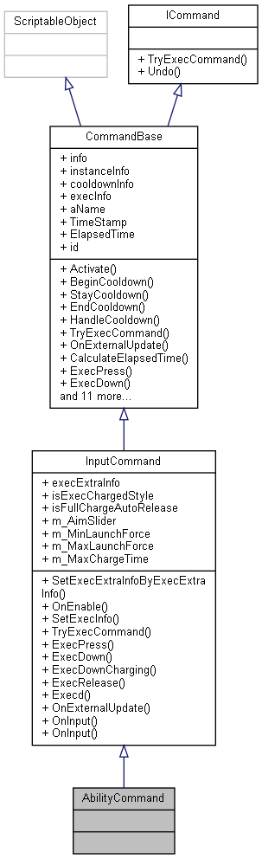

Collaboration diagram for AbilityCommand:

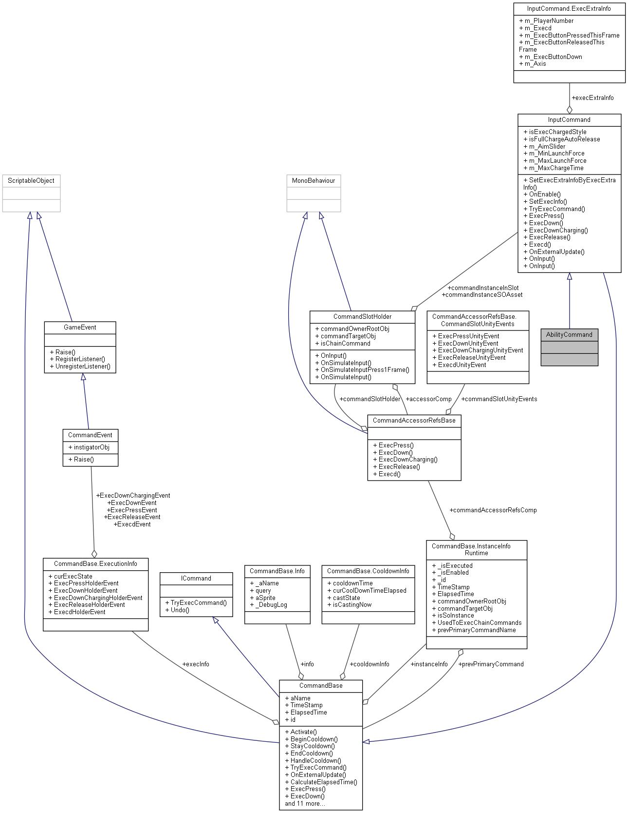

### Additional Inherited Members

The documentation for this class was generated from the following file:

C:/_SSDSPEEDUP/2021/clone/gps1_manadesigner/GPS1-Manadesigner/Assets/_UtilsV0.4/MyScripts/_Utils/CommandPattern/Command/SOScripts/**AbilityCommand.cs**

## AINavAgentCommon Class Reference

Collaboration diagram for AINavAgentCommon:

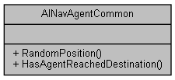

### Static Public Member Functions

static Vector3 **RandomPosition** (Vector3 origin, float radius)

static bool **HasAgentReachedDestination** (NavMeshAgent mNavMeshAgent)

### Member Function Documentation

#### static bool AINavAgentCommon.HasAgentReachedDestination (NavMeshAgent *mNavMeshAgent*)[static]

Here is the caller graph for this function:

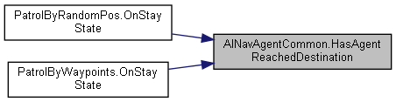

#### static Vector3 AINavAgentCommon.RandomPosition (Vector3 *origin*, float *radius*)[static]

Here is the caller graph for this function:

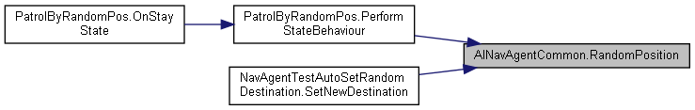

#### The documentation for this class was generated from the following file:

C:/_SSDSPEEDUP/2021/clone/gps1_manadesigner/GPS1-Manadesigner/Assets/_UtilsV0.4/MyScripts/_Utils/_CommonV0.2/CommonExtend/AINav/**AINavAgentCommon.cs**

## Alert Class Reference

Inheritance diagram for Alert:

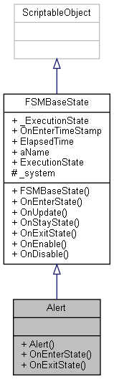

Collaboration diagram for Alert:

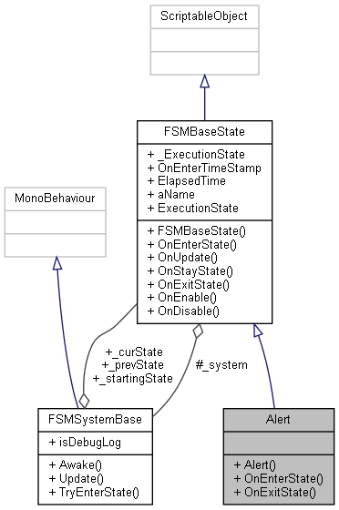

### Public Member Functions

**Alert** (**FSMSystemBase** system)

override bool **OnEnterState** ()

override bool **OnExitState** ()

### Additional Inherited Members

### Constructor & Destructor Documentation

#### Alert.Alert (FSMSystemBase *system*)

### Member Function Documentation

#### override bool Alert.OnEnterState ()[virtual]

Reimplemented from **FSMBaseState** (*p.279*).

#### override bool Alert.OnExitState ()[virtual]

Reimplemented from **FSMBaseState** (*p.279*).

#### The documentation for this class was generated from the following file:

C:/_SSDSPEEDUP/2021/clone/gps1_manadesigner/GPS1-Manadesigner/Assets/_UtilsV0.4/MyScripts/_Utils/__Experimental/AIApproach/StatePattern/**NPCAIStatesTypeA.cs**

## UnityEngine.PostProcessing.AmbientOcclusionComponent Class Reference

Inheritance diagram for UnityEngine.PostProcessing.AmbientOcclusionComponent:

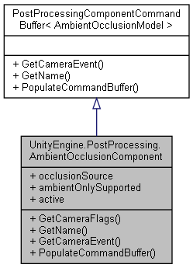

Collaboration diagram for UnityEngine.PostProcessing.AmbientOcclusionComponent:



### Public Member Functions

override DepthTextureMode **GetCameraFlags** ()

override string **GetName** ()

override CameraEvent **GetCameraEvent** ()

override void **PopulateCommandBuffer** (CommandBuffer cb)

### Properties

override bool **active** [get]

### Member Function Documentation

#### override CameraEvent UnityEngine.PostProcessing.AmbientOcclusionComponent.GetCameraEvent ()[virtual]

Implements **UnityEngine.PostProcessing.PostProcessingComponentCommandBuffer< AmbientOcclusionModel >** (*p.592*).

#### override DepthTextureMode UnityEngine.PostProcessing.AmbientOcclusionComponent.GetCameraFlags ()

#### override string UnityEngine.PostProcessing.AmbientOcclusionComponent.GetName ()[virtual]

Implements **UnityEngine.PostProcessing.PostProcessingComponentCommandBuffer< AmbientOcclusionModel >** (*p.592*).

#### override void UnityEngine.PostProcessing.AmbientOcclusionComponent.PopulateCommandBuffer (CommandBuffer *cb*)[virtual]

Implements **UnityEngine.PostProcessing.PostProcessingComponentCommandBuffer< AmbientOcclusionModel >** (*p.592*).

### Property Documentation

#### override bool UnityEngine.PostProcessing.AmbientOcclusionComponent.active[get]

#### The documentation for this class was generated from the following file:

C:/_SSDSPEEDUP/2021/clone/gps1_manadesigner/GPS1-Manadesigner/Assets/Samples/Input System/1.0.2/Tanks Demo/TanksDemo/PostProcessing/Runtime/Components/**AmbientOcclusionComponent.cs**

## UnityEngine.PostProcessing.AmbientOcclusionModel Class Reference

Inheritance diagram for UnityEngine.PostProcessing.AmbientOcclusionModel:

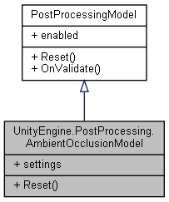

Collaboration diagram for UnityEngine.PostProcessing.AmbientOcclusionModel:



### Classes

struct **Settings**

### Public Types

enum **SampleCount** { **Lowest** = 3, **Low** = 6, **Medium** = 10, **High** = 16 }

### Public Member Functions

override void **Reset** ()

### Properties

**Settings** **settings** [getset]

### Member Enumeration Documentation

#### enum UnityEngine.PostProcessing.AmbientOcclusionModel.SampleCount

##### Enumerator:

|  |  |
| --- | --- |
| Lowest |  |
| Low |  |
| Medium |  |
| High |  |

### Member Function Documentation

#### override void UnityEngine.PostProcessing.AmbientOcclusionModel.Reset ()[virtual]

Implements **UnityEngine.PostProcessing.PostProcessingModel** (*p.597*).

### Property Documentation

#### Settings UnityEngine.PostProcessing.AmbientOcclusionModel.settings[get], [set]

#### The documentation for this class was generated from the following file:

C:/_SSDSPEEDUP/2021/clone/gps1_manadesigner/GPS1-Manadesigner/Assets/Samples/Input System/1.0.2/Tanks Demo/TanksDemo/PostProcessing/Runtime/Models/**AmbientOcclusionModel.cs**

## AnimationEventHelper Class Reference

Inheritance diagram for AnimationEventHelper:

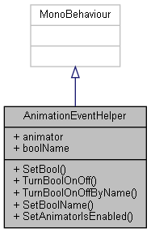

Collaboration diagram for AnimationEventHelper:



### Public Member Functions

void **SetBool** (bool value)

void **TurnBoolOnOff** ()

void **TurnBoolOnOffByName** (string name)

void **SetBoolName** (string newBoolname)

void **SetAnimatorIsEnabled** (bool isEnabled)

### Public Attributes

Animator **animator**

string **boolName**

### Member Function Documentation

#### void AnimationEventHelper.SetAnimatorIsEnabled (bool *isEnabled*)

#### void AnimationEventHelper.SetBool (bool *value*)

#### void AnimationEventHelper.SetBoolName (string *newBoolname*)

#### void AnimationEventHelper.TurnBoolOnOff ()

#### void AnimationEventHelper.TurnBoolOnOffByName (string *name*)

### Member Data Documentation

#### Animator AnimationEventHelper.animator

#### string AnimationEventHelper.boolName

#### The documentation for this class was generated from the following file:

C:/_SSDSPEEDUP/2021/clone/gps1_manadesigner/GPS1-Manadesigner/Assets/_UtilsV0.4/MyScripts/_Utils/_CommonV0.2/Event/**AnimationEventHelper.cs**

## UnityEngine.PostProcessing.AntialiasingModel Class Reference

Inheritance diagram for UnityEngine.PostProcessing.AntialiasingModel:

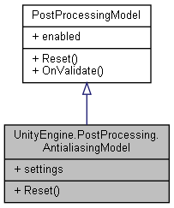

Collaboration diagram for UnityEngine.PostProcessing.AntialiasingModel:



### Classes

struct **FxaaConsoleSettings**

struct **FxaaQualitySettings**

struct **FxaaSettings**

struct **Settings**

struct **TaaSettings**

### Public Types

enum **Method** { **Fxaa**, **Taa** }

enum **FxaaPreset** { **ExtremePerformance**, **Performance**, **Default**, **Quality**, **ExtremeQuality** }

### Public Member Functions

override void **Reset** ()

### Properties

**Settings** **settings** [getset]

### Member Enumeration Documentation

#### enum UnityEngine.PostProcessing.AntialiasingModel.FxaaPreset

##### Enumerator:

|  |  |
| --- | --- |
| ExtremePerformance |  |
| Performance |  |
| Default |  |
| Quality |  |
| ExtremeQuality |  |

#### enum UnityEngine.PostProcessing.AntialiasingModel.Method

##### Enumerator:

|  |  |
| --- | --- |
| Fxaa |  |
| Taa |  |

### Member Function Documentation

#### override void UnityEngine.PostProcessing.AntialiasingModel.Reset ()[virtual]

Implements **UnityEngine.PostProcessing.PostProcessingModel** (*p.597*).

### Property Documentation

#### Settings UnityEngine.PostProcessing.AntialiasingModel.settings[get], [set]

#### The documentation for this class was generated from the following file:

C:/_SSDSPEEDUP/2021/clone/gps1_manadesigner/GPS1-Manadesigner/Assets/Samples/Input System/1.0.2/Tanks Demo/TanksDemo/PostProcessing/Runtime/Models/**AntialiasingModel.cs**

## AreaOfEffect Class Reference

Inheritance diagram for AreaOfEffect:

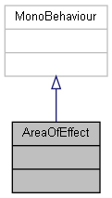

Collaboration diagram for AreaOfEffect:



The documentation for this class was generated from the following file:

C:/_SSDSPEEDUP/2021/clone/gps1_manadesigner/GPS1-Manadesigner/Assets/**AreaOfEffect.cs**

## AStarPathFinder Class Reference

Inheritance diagram for AStarPathFinder:

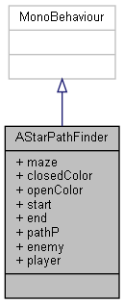

Collaboration diagram for AStarPathFinder:

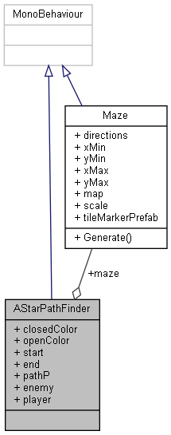

### Public Attributes

**Maze** **maze**

Color **closedColor**

Color **openColor**

GameObject **start**

GameObject **end**

GameObject **pathP**

GameObject **enemy**

GameObject **player**

### Member Data Documentation

#### Color AStarPathFinder.closedColor

#### GameObject AStarPathFinder.end

#### GameObject AStarPathFinder.enemy

#### Maze AStarPathFinder.maze

#### Color AStarPathFinder.openColor

#### GameObject AStarPathFinder.pathP

#### GameObject AStarPathFinder.player

#### GameObject AStarPathFinder.start

#### The documentation for this class was generated from the following file:

C:/_SSDSPEEDUP/2021/clone/gps1_manadesigner/GPS1-Manadesigner/Assets/Scripts/Arif's Test Scripts/**AStarPathFinder.cs**

## AudioFade Class Reference

Collaboration diagram for AudioFade:

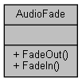

### Static Public Member Functions

static IEnumerator **FadeOut** (**Sound** sound, float fadingTime, Func< float, float, float, float > Interpolate)

static IEnumerator **FadeIn** (**Sound** sound, float fadingTime, Func< float, float, float, float > Interpolate)

### Member Function Documentation

#### static IEnumerator AudioFade.FadeIn (Sound *sound*, float *fadingTime*, Func< float, float, float, float > *Interpolate*)[static]

Here is the caller graph for this function:

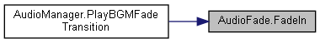

#### static IEnumerator AudioFade.FadeOut (Sound *sound*, float *fadingTime*, Func< float, float, float, float > *Interpolate*)[static]

Here is the caller graph for this function:



#### The documentation for this class was generated from the following file:

C:/_SSDSPEEDUP/2021/clone/gps1_manadesigner/GPS1-Manadesigner/Assets/_UtilsV0.4/MyScripts/_Utils/_CommonV0.2/Singletons/**AudioManager.cs**

## AudioManager Class Reference

Inheritance diagram for AudioManager:

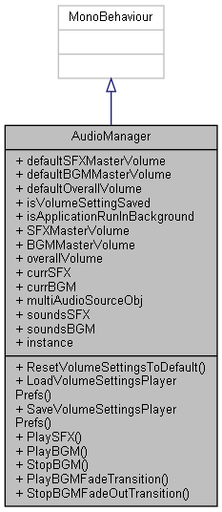

Collaboration diagram for AudioManager:

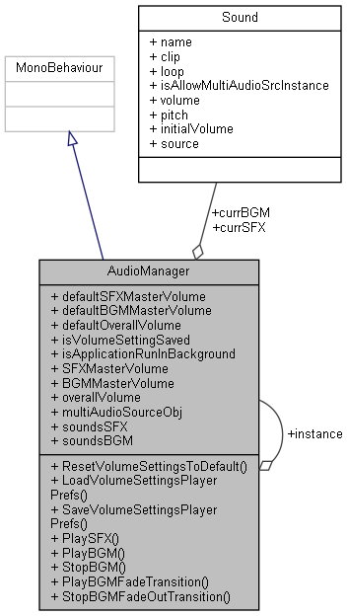

### Public Member Functions

void **ResetVolumeSettingsToDefault** ()

void **LoadVolumeSettingsPlayerPrefs** ()

void **SaveVolumeSettingsPlayerPrefs** ()

void **PlaySFX** (string sfxName)

void **PlayBGM** (string bgmName)

void **StopBGM** (string name)

void **PlayBGMFadeTransition** (string name)

void **StopBGMFadeOutTransition** (string name)

### Public Attributes

float **defaultSFXMasterVolume** = 0.75f

float **defaultBGMMasterVolume** = 0.8f

float **defaultOverallVolume** = 0.3f

bool **isVolumeSettingSaved**

bool **isApplicationRunInBackground** = true

float **SFXMasterVolume** = 1f

float **BGMMasterVolume** = 1f

float **overallVolume** = 1f

**Sound** **currSFX**

**Sound** **currBGM**

GameObject **multiAudioSourceObj**

List< **Sound** > **soundsSFX**

List< **Sound** > **soundsBGM**

### Static Public Attributes

static **AudioManager** **instance**

### Member Function Documentation

#### void AudioManager.LoadVolumeSettingsPlayerPrefs ()

#### void AudioManager.PlayBGM (string *bgmName*)

Here is the caller graph for this function:

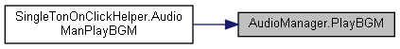

#### void AudioManager.PlayBGMFadeTransition (string *name*)

Here is the call graph for this function:

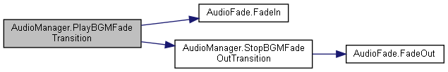

#### void AudioManager.PlaySFX (string *sfxName*)

Here is the caller graph for this function:

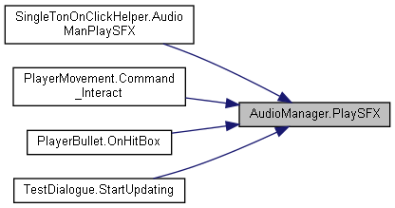

#### void AudioManager.ResetVolumeSettingsToDefault ()

Here is the caller graph for this function:

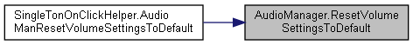

#### void AudioManager.SaveVolumeSettingsPlayerPrefs ()

Here is the caller graph for this function:

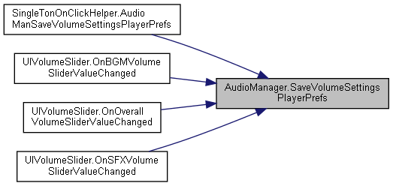

#### void AudioManager.StopBGM (string *name*)

#### void AudioManager.StopBGMFadeOutTransition (string *name*)

Here is the call graph for this function:

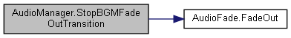

Here is the caller graph for this function:

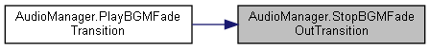

### Member Data Documentation

#### float AudioManager.BGMMasterVolume = 1f

#### Sound AudioManager.currBGM

#### Sound AudioManager.currSFX

#### float AudioManager.defaultBGMMasterVolume = 0.8f

#### float AudioManager.defaultOverallVolume = 0.3f

#### float AudioManager.defaultSFXMasterVolume = 0.75f

#### AudioManager AudioManager.instance[static]

#### bool AudioManager.isApplicationRunInBackground = true

#### bool AudioManager.isVolumeSettingSaved

#### GameObject AudioManager.multiAudioSourceObj

#### float AudioManager.overallVolume = 1f

#### float AudioManager.SFXMasterVolume = 1f

#### List<Sound> AudioManager.soundsBGM

#### List<Sound> AudioManager.soundsSFX

#### The documentation for this class was generated from the following file:

C:/_SSDSPEEDUP/2021/clone/gps1_manadesigner/GPS1-Manadesigner/Assets/_UtilsV0.4/MyScripts/_Utils/_CommonV0.2/Singletons/**AudioManager.cs**

## AutoFlipSpriteByDir Class Reference

Inheritance diagram for AutoFlipSpriteByDir:

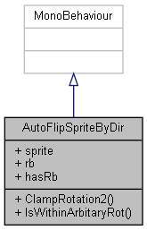

Collaboration diagram for AutoFlipSpriteByDir:



### Public Member Functions

float **ClampRotation2** (float angle, float min, float max)

bool **IsWithinArbitaryRot** (float angle, float min, float max)

### Public Attributes

SpriteRenderer **sprite**

Rigidbody2D **rb**

bool **hasRb**

### Member Function Documentation

#### float AutoFlipSpriteByDir.ClampRotation2 (float *angle*, float *min*, float *max*)

Here is the caller graph for this function:

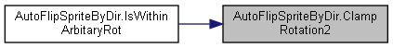

#### bool AutoFlipSpriteByDir.IsWithinArbitaryRot (float *angle*, float *min*, float *max*)

Here is the call graph for this function:

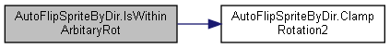

### Member Data Documentation

#### bool AutoFlipSpriteByDir.hasRb

#### Rigidbody2D AutoFlipSpriteByDir.rb

#### SpriteRenderer AutoFlipSpriteByDir.sprite

#### The documentation for this class was generated from the following file:

C:/_SSDSPEEDUP/2021/clone/gps1_manadesigner/GPS1-Manadesigner/Assets/_UtilsV0.4/_ProjectSpecific/Ocean/MyScripts/Passive Components/**AutoFlipSpriteByDir.cs**

## BadScript Class Reference

Inheritance diagram for BadScript:

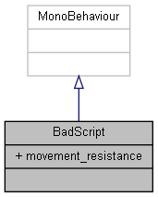

Collaboration diagram for BadScript:



### Public Attributes

float **movement_resistance** = 1f

### Member Data Documentation

#### float BadScript.movement_resistance = 1f

#### The documentation for this class was generated from the following file:

C:/_SSDSPEEDUP/2021/clone/gps1_manadesigner/GPS1-Manadesigner/Assets/_UtilsV0.4/Extend/**BadScript.cs**

## UnityEngine.PostProcessing.ColorGradingModel.BasicSettings Struct Reference

Collaboration diagram for UnityEngine.PostProcessing.ColorGradingModel.BasicSettings:

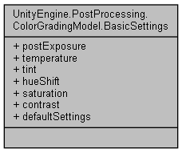

### Public Attributes

float **postExposure**

float **temperature**

float **tint**

float **hueShift**

float **saturation**

float **contrast**

### Properties

static **BasicSettings** **defaultSettings** [get]

### Member Data Documentation

#### float UnityEngine.PostProcessing.ColorGradingModel.BasicSettings.contrast

#### float UnityEngine.PostProcessing.ColorGradingModel.BasicSettings.hueShift

#### float UnityEngine.PostProcessing.ColorGradingModel.BasicSettings.postExposure

#### float UnityEngine.PostProcessing.ColorGradingModel.BasicSettings.saturation

#### float UnityEngine.PostProcessing.ColorGradingModel.BasicSettings.temperature

#### float UnityEngine.PostProcessing.ColorGradingModel.BasicSettings.tint

### Property Documentation

#### BasicSettings UnityEngine.PostProcessing.ColorGradingModel.BasicSettings.defaultSettings[static], [get]

#### The documentation for this struct was generated from the following file:

C:/_SSDSPEEDUP/2021/clone/gps1_manadesigner/GPS1-Manadesigner/Assets/Samples/Input System/1.0.2/Tanks Demo/TanksDemo/PostProcessing/Runtime/Models/**ColorGradingModel.cs**

## BinCommandAccessorRefsBase Class Reference

Inheritance diagram for BinCommandAccessorRefsBase:

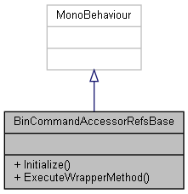

Collaboration diagram for BinCommandAccessorRefsBase:



### Public Member Functions

void **Initialize** ()

void **ExecuteWrapperMethod** ()

### Member Function Documentation

#### void BinCommandAccessorRefsBase.ExecuteWrapperMethod ()

#### void BinCommandAccessorRefsBase.Initialize ()

#### The documentation for this class was generated from the following file:

C:/_SSDSPEEDUP/2021/clone/gps1_manadesigner/GPS1-Manadesigner/Assets/_UtilsV0.4/MyScripts/_Utils/CommandPattern/Command/_Bin/Custom/**BinCommandAccessorRefsBase.cs**

## BinCommandWithCooldown Class Reference

Inheritance diagram for BinCommandWithCooldown:

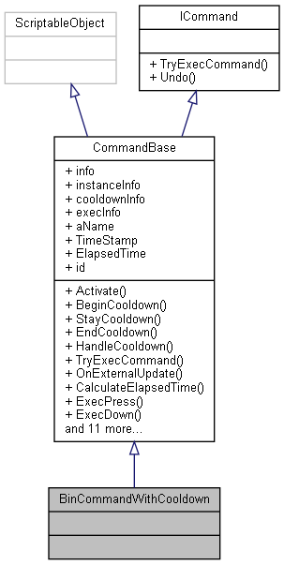

Collaboration diagram for BinCommandWithCooldown:

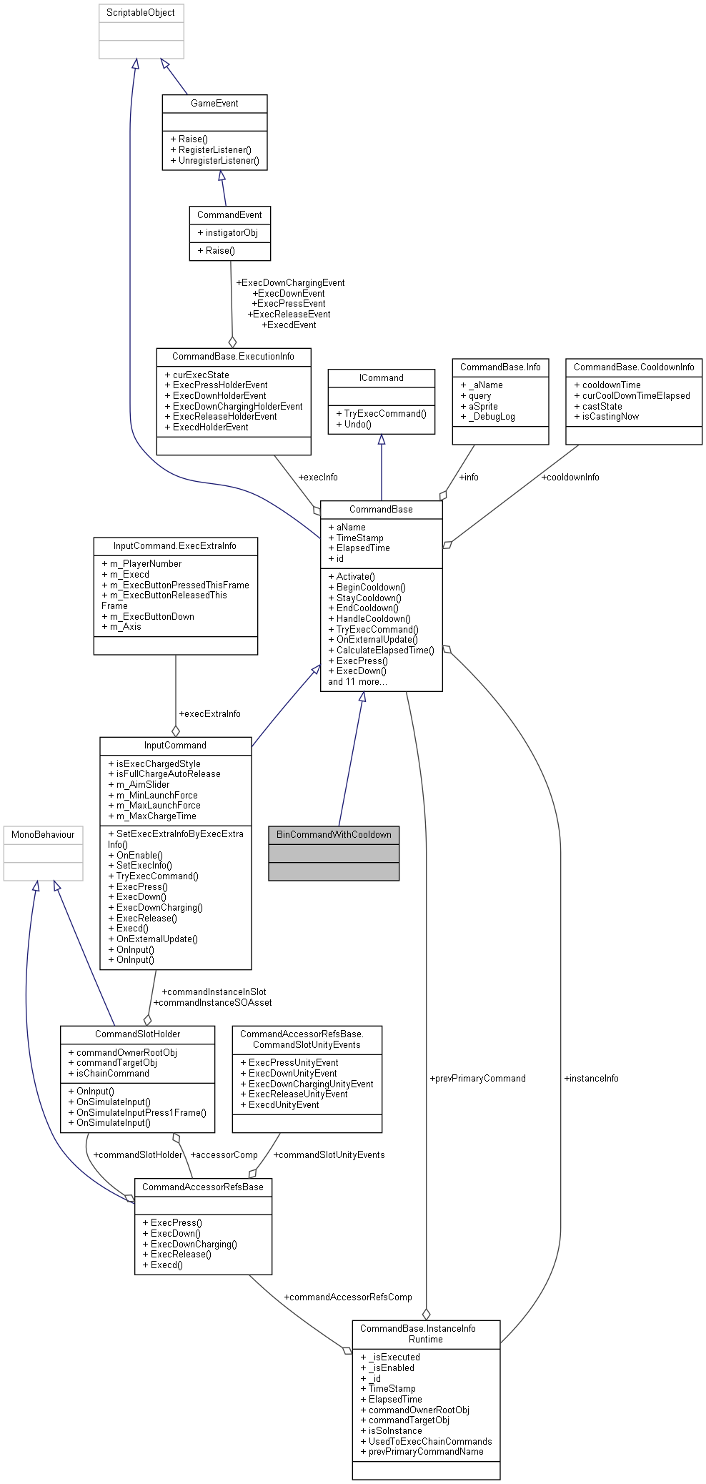

### Additional Inherited Members

The documentation for this class was generated from the following file:

C:/_SSDSPEEDUP/2021/clone/gps1_manadesigner/GPS1-Manadesigner/Assets/_UtilsV0.4/MyScripts/_Utils/CommandPattern/Command/_Bin/CustomScriptableObjectBase/**BinCommandWithCooldown.cs**

## UnityEngine.PostProcessing.BloomComponent Class Reference

Inheritance diagram for UnityEngine.PostProcessing.BloomComponent:

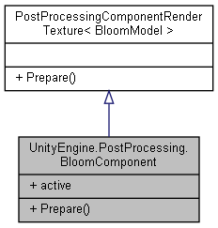

Collaboration diagram for UnityEngine.PostProcessing.BloomComponent:



### Public Member Functions

void **Prepare** (RenderTexture source, Material uberMaterial, Texture autoExposure)

### Properties

override bool **active** [get]

### Member Function Documentation

#### void UnityEngine.PostProcessing.BloomComponent.Prepare (RenderTexture *source*, Material *uberMaterial*, Texture *autoExposure*)

### Property Documentation

#### override bool UnityEngine.PostProcessing.BloomComponent.active[get]

#### The documentation for this class was generated from the following file:

C:/_SSDSPEEDUP/2021/clone/gps1_manadesigner/GPS1-Manadesigner/Assets/Samples/Input System/1.0.2/Tanks Demo/TanksDemo/PostProcessing/Runtime/Components/**BloomComponent.cs**

## UnityEngine.PostProcessing.BloomModel Class Reference

Inheritance diagram for UnityEngine.PostProcessing.BloomModel:

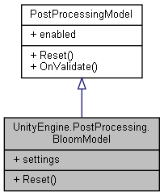

Collaboration diagram for UnityEngine.PostProcessing.BloomModel:



### Classes

struct **BloomSettings**

struct **LensDirtSettings**

struct **Settings**

### Public Member Functions

override void **Reset** ()

### Properties

**Settings** **settings** [getset]

### Member Function Documentation

#### override void UnityEngine.PostProcessing.BloomModel.Reset ()[virtual]

Implements **UnityEngine.PostProcessing.PostProcessingModel** (*p.597*).

### Property Documentation

#### Settings UnityEngine.PostProcessing.BloomModel.settings[get], [set]

#### The documentation for this class was generated from the following file:

C:/_SSDSPEEDUP/2021/clone/gps1_manadesigner/GPS1-Manadesigner/Assets/Samples/Input System/1.0.2/Tanks Demo/TanksDemo/PostProcessing/Runtime/Models/**BloomModel.cs**

## UnityEngine.PostProcessing.BloomModel.BloomSettings Struct Reference

Collaboration diagram for UnityEngine.PostProcessing.BloomModel.BloomSettings:

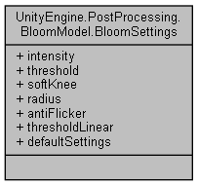

### Public Attributes

float **intensity**

float **threshold**

float **softKnee**

float **radius**

bool **antiFlicker**

### Properties

float **thresholdLinear** [getset]

static **BloomSettings** **defaultSettings** [get]

### Member Data Documentation

#### bool UnityEngine.PostProcessing.BloomModel.BloomSettings.antiFlicker

#### float UnityEngine.PostProcessing.BloomModel.BloomSettings.intensity

#### float UnityEngine.PostProcessing.BloomModel.BloomSettings.radius

#### float UnityEngine.PostProcessing.BloomModel.BloomSettings.softKnee

#### float UnityEngine.PostProcessing.BloomModel.BloomSettings.threshold

### Property Documentation

#### BloomSettings UnityEngine.PostProcessing.BloomModel.BloomSettings.defaultSettings[static], [get]

#### float UnityEngine.PostProcessing.BloomModel.BloomSettings.thresholdLinear[get], [set]

#### The documentation for this struct was generated from the following file:

C:/_SSDSPEEDUP/2021/clone/gps1_manadesigner/GPS1-Manadesigner/Assets/Samples/Input System/1.0.2/Tanks Demo/TanksDemo/PostProcessing/Runtime/Models/**BloomModel.cs**

## breakableWall Class Reference

Inheritance diagram for breakableWall:

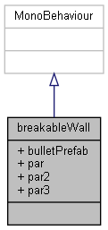

Collaboration diagram for breakableWall:



### Public Attributes

GameObject **bulletPrefab**

ParticleSystem **par**

ParticleSystem **par2**

ParticleSystem **par3**

### Member Data Documentation

#### GameObject breakableWall.bulletPrefab

#### ParticleSystem breakableWall.par

#### ParticleSystem breakableWall.par2

#### ParticleSystem breakableWall.par3

#### The documentation for this class was generated from the following file:

C:/_SSDSPEEDUP/2021/clone/gps1_manadesigner/GPS1-Manadesigner/Assets/Scripts/Thrish/**breakableWall.cs**

## BreakableWallBullet Class Reference

Inheritance diagram for BreakableWallBullet:

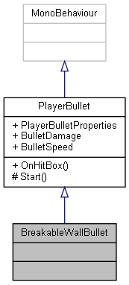

Collaboration diagram for BreakableWallBullet:

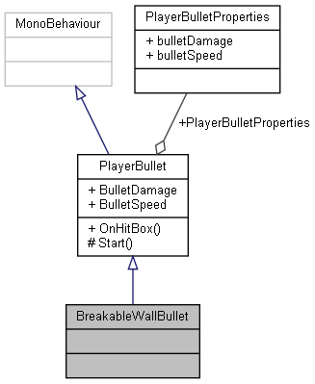

### Additional Inherited Members

The documentation for this class was generated from the following file:

C:/_SSDSPEEDUP/2021/clone/gps1_manadesigner/GPS1-Manadesigner/Assets/PlayerBullet/**BreakableWallBullet.cs**

## UnityEngine.PostProcessing.BuiltinDebugViewsComponent Class Reference

Inheritance diagram for UnityEngine.PostProcessing.BuiltinDebugViewsComponent:

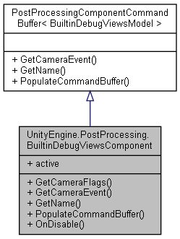

Collaboration diagram for UnityEngine.PostProcessing.BuiltinDebugViewsComponent:



### Public Member Functions

override DepthTextureMode **GetCameraFlags** ()

override CameraEvent **GetCameraEvent** ()

override string **GetName** ()

override void **PopulateCommandBuffer** (CommandBuffer cb)

override void **OnDisable** ()

### Properties

override bool **active** [get]

### Member Function Documentation

#### override CameraEvent UnityEngine.PostProcessing.BuiltinDebugViewsComponent.GetCameraEvent ()[virtual]

Implements **UnityEngine.PostProcessing.PostProcessingComponentCommandBuffer< BuiltinDebugViewsModel >** (*p.592*).

#### override DepthTextureMode UnityEngine.PostProcessing.BuiltinDebugViewsComponent.GetCameraFlags ()

#### override string UnityEngine.PostProcessing.BuiltinDebugViewsComponent.GetName ()[virtual]

Implements **UnityEngine.PostProcessing.PostProcessingComponentCommandBuffer< BuiltinDebugViewsModel >** (*p.592*).

#### override void UnityEngine.PostProcessing.BuiltinDebugViewsComponent.OnDisable ()

#### override void UnityEngine.PostProcessing.BuiltinDebugViewsComponent.PopulateCommandBuffer (CommandBuffer *cb*)[virtual]

Implements **UnityEngine.PostProcessing.PostProcessingComponentCommandBuffer< BuiltinDebugViewsModel >** (*p.592*).

### Property Documentation

#### override bool UnityEngine.PostProcessing.BuiltinDebugViewsComponent.active[get]

#### The documentation for this class was generated from the following file:

C:/_SSDSPEEDUP/2021/clone/gps1_manadesigner/GPS1-Manadesigner/Assets/Samples/Input System/1.0.2/Tanks Demo/TanksDemo/PostProcessing/Runtime/Components/**BuiltinDebugViewsComponent.cs**

## UnityEngine.PostProcessing.BuiltinDebugViewsModel Class Reference

Inheritance diagram for UnityEngine.PostProcessing.BuiltinDebugViewsModel:

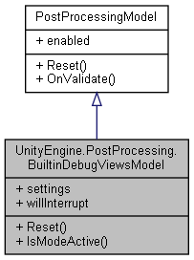

Collaboration diagram for UnityEngine.PostProcessing.BuiltinDebugViewsModel:



### Classes

struct **DepthSettings**

struct **MotionVectorsSettings**

struct **Settings**

### Public Types

enum **Mode** { **None**, **Depth**, **Normals**, **MotionVectors**, **AmbientOcclusion**, **EyeAdaptation**, **FocusPlane**, **PreGradingLog**, **LogLut**, **UserLut** }

### Public Member Functions

override void **Reset** ()

bool **IsModeActive** (**Mode** mode)

### Properties

**Settings** **settings** [getset]

bool **willInterrupt** [get]

### Member Enumeration Documentation

#### enum UnityEngine.PostProcessing.BuiltinDebugViewsModel.Mode

##### Enumerator:

|  |  |
| --- | --- |
| None |  |
| Depth |  |
| Normals |  |
| MotionVectors |  |
| AmbientOcclusion |  |
| EyeAdaptation |  |
| FocusPlane |  |
| PreGradingLog |  |
| LogLut |  |
| UserLut |  |

### Member Function Documentation

#### bool UnityEngine.PostProcessing.BuiltinDebugViewsModel.IsModeActive (Mode *mode*)

#### override void UnityEngine.PostProcessing.BuiltinDebugViewsModel.Reset ()[virtual]

Implements **UnityEngine.PostProcessing.PostProcessingModel** (*p.597*).

### Property Documentation

#### Settings UnityEngine.PostProcessing.BuiltinDebugViewsModel.settings[get], [set]

#### bool UnityEngine.PostProcessing.BuiltinDebugViewsModel.willInterrupt[get]

#### The documentation for this class was generated from the following file:

C:/_SSDSPEEDUP/2021/clone/gps1_manadesigner/GPS1-Manadesigner/Assets/Samples/Input System/1.0.2/Tanks Demo/TanksDemo/PostProcessing/Runtime/Models/**BuiltinDebugViewsModel.cs**

## ButtonRemapScreenController Class Reference

Inheritance diagram for ButtonRemapScreenController:

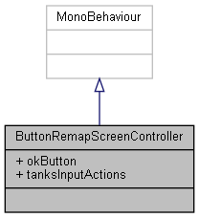

Collaboration diagram for ButtonRemapScreenController:



### Public Attributes

Button **okButton**

InputActionAsset **tanksInputActions**

### Member Data Documentation

#### Button ButtonRemapScreenController.okButton

#### InputActionAsset ButtonRemapScreenController.tanksInputActions

#### The documentation for this class was generated from the following file:

C:/_SSDSPEEDUP/2021/clone/gps1_manadesigner/GPS1-Manadesigner/Assets/Samples/Input System/1.0.2/Tanks Demo/TanksDemo/Scripts/UI/**ButtonRemapScreenController.cs**

## ButtonTrigger Class Reference

Inheritance diagram for ButtonTrigger:

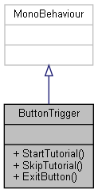

Collaboration diagram for ButtonTrigger:



### Public Member Functions

void **StartTutorial** ()

void **SkipTutorial** ()

void **ExitButton** ()

### Member Function Documentation

#### void ButtonTrigger.ExitButton ()

#### void ButtonTrigger.SkipTutorial ()

#### void ButtonTrigger.StartTutorial ()

#### The documentation for this class was generated from the following file:

C:/_SSDSPEEDUP/2021/clone/gps1_manadesigner/GPS1-Manadesigner/Assets/Scripts/Stage Scripts/Main Menu/**ButtonTrigger.cs**

## ButtonTuto Class Reference

Inheritance diagram for ButtonTuto:

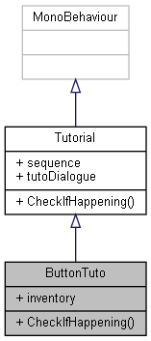

Collaboration diagram for ButtonTuto:



### Public Member Functions

override void **CheckIfHappening** ()

### Public Attributes

GameObject **inventory**

### Member Function Documentation

#### override void ButtonTuto.CheckIfHappening ()[virtual]

Reimplemented from **Tutorial** (*p.787*).

Here is the call graph for this function:

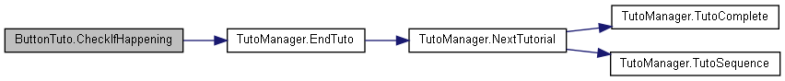

### Member Data Documentation

#### GameObject ButtonTuto.inventory

#### The documentation for this class was generated from the following file:

C:/_SSDSPEEDUP/2021/clone/gps1_manadesigner/GPS1-Manadesigner/Assets/Scripts/Tutorial Scripts/**ButtonTuto.cs**

## CameraControl Class Reference

Inheritance diagram for CameraControl:

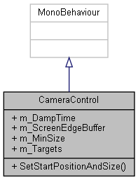

Collaboration diagram for CameraControl:



### Public Member Functions

void **SetStartPositionAndSize** ()

### Public Attributes

float **m_DampTime** = 0.2f

float **m_ScreenEdgeBuffer** = 4f

float **m_MinSize** = 6.5f

Transform[] **m_Targets**

### Member Function Documentation

#### void CameraControl.SetStartPositionAndSize ()

### Member Data Documentation

#### float CameraControl.m_DampTime = 0.2f

#### float CameraControl.m_MinSize = 6.5f

#### float CameraControl.m_ScreenEdgeBuffer = 4f

#### Transform [] CameraControl.m_Targets

#### The documentation for this class was generated from the following file:

C:/_SSDSPEEDUP/2021/clone/gps1_manadesigner/GPS1-Manadesigner/Assets/Samples/Input System/1.0.2/Tanks Demo/TanksDemo/Scripts/Camera/**CameraControl.cs**

## CameraSightPerceptionSensor2D Class Reference

Inheritance diagram for CameraSightPerceptionSensor2D:

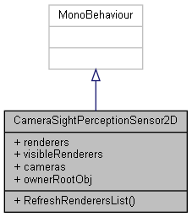

Collaboration diagram for CameraSightPerceptionSensor2D:



### Public Member Functions

void **RefreshRenderersList** ()

### Public Attributes

List< SpriteRenderer > **renderers**

List< Transform > **visibleRenderers**

List< Camera > **cameras**

GameObject **ownerRootObj**

### Member Function Documentation

#### void CameraSightPerceptionSensor2D.RefreshRenderersList ()

### Member Data Documentation

#### List<Camera> CameraSightPerceptionSensor2D.cameras

#### GameObject CameraSightPerceptionSensor2D.ownerRootObj

#### List<SpriteRenderer> CameraSightPerceptionSensor2D.renderers

#### List<Transform> CameraSightPerceptionSensor2D.visibleRenderers

#### The documentation for this class was generated from the following file:

C:/_SSDSPEEDUP/2021/clone/gps1_manadesigner/GPS1-Manadesigner/Assets/_UtilsV0.4/MyScripts/_Utils/__Experimental/AIApproach/StatePattern/**CameraSightPerceptionSensor2D.cs**

## ChainCommandData Class Reference

Collaboration diagram for ChainCommandData:

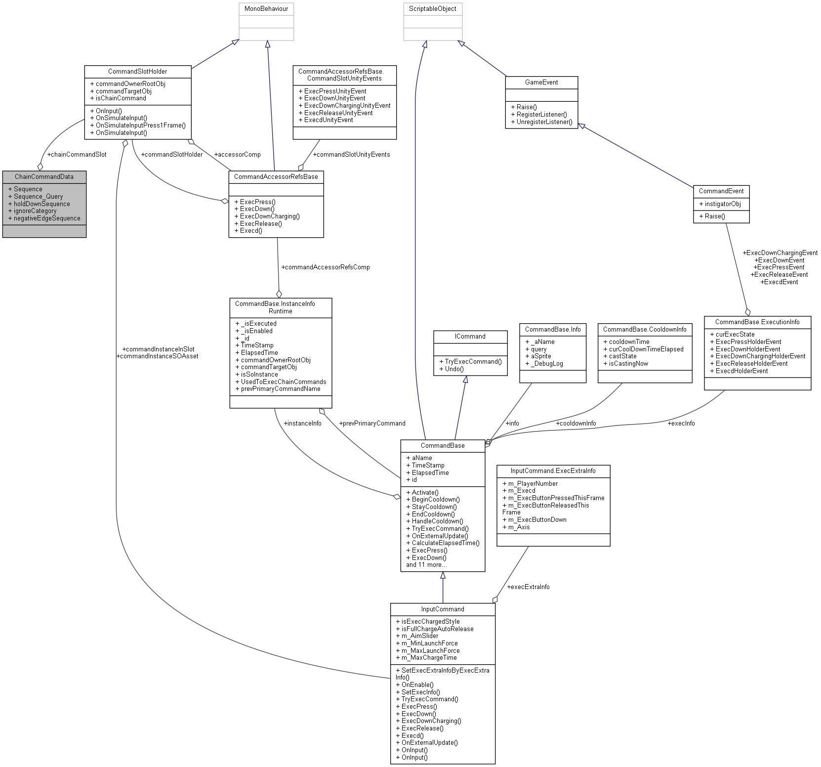

### Public Attributes

**CommandSlotHolder** **chainCommandSlot**

string[] **Sequence**

string[] **Sequence_Query**

string[] **holdDownSequence**

string[] **ignoreCategory**

string[] **negativeEdgeSequence**

### Member Data Documentation

#### CommandSlotHolder ChainCommandData.chainCommandSlot

#### string [] ChainCommandData.holdDownSequence

#### string [] ChainCommandData.ignoreCategory

#### string [] ChainCommandData.negativeEdgeSequence

#### string [] ChainCommandData.Sequence

#### string [] ChainCommandData.Sequence_Query

#### The documentation for this class was generated from the following file:

C:/_SSDSPEEDUP/2021/clone/gps1_manadesigner/GPS1-Manadesigner/Assets/_UtilsV0.4/MyScripts/_Utils/CommandPattern/Command/MyScripts/**ChainCommandData.cs**

## ChainCommandDataOld Class Reference

Collaboration diagram for ChainCommandDataOld:

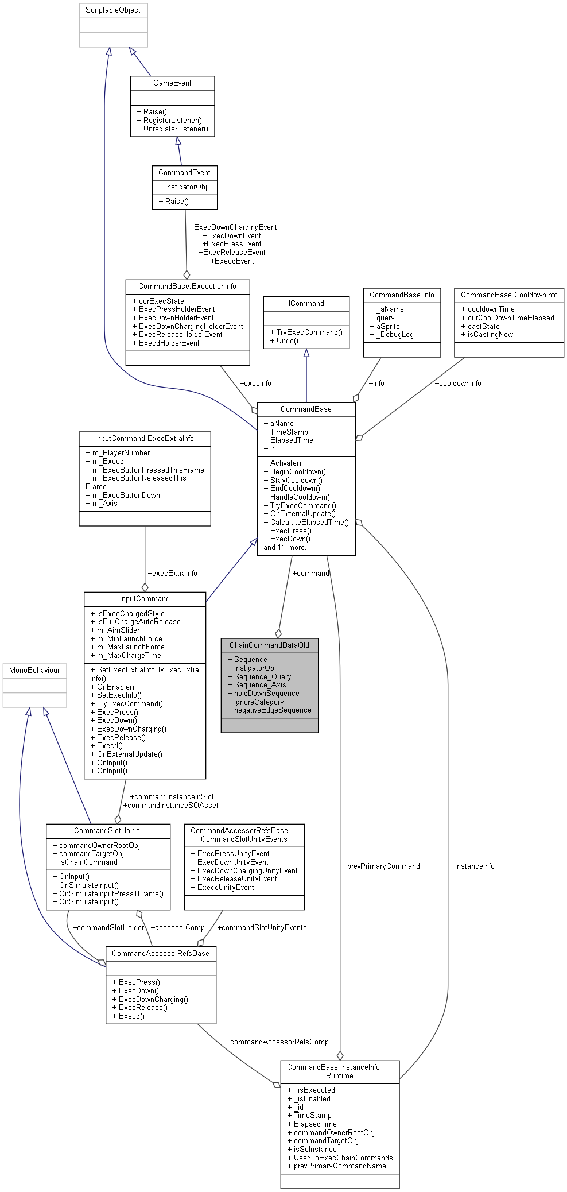

### Public Attributes

**CommandBase** **command**

string[] **Sequence**

GameObject **instigatorObj**

string[] **Sequence_Query**

int[] **Sequence_Axis**

string[] **holdDownSequence**

string **ignoreCategory**

string[] **negativeEdgeSequence**

### Member Data Documentation

#### CommandBase ChainCommandDataOld.command

#### string [] ChainCommandDataOld.holdDownSequence

#### string ChainCommandDataOld.ignoreCategory

#### GameObject ChainCommandDataOld.instigatorObj

#### string [] ChainCommandDataOld.negativeEdgeSequence

#### string [] ChainCommandDataOld.Sequence

#### int [] ChainCommandDataOld.Sequence_Axis

#### string [] ChainCommandDataOld.Sequence_Query

#### The documentation for this class was generated from the following file:

C:/_SSDSPEEDUP/2021/clone/gps1_manadesigner/GPS1-Manadesigner/Assets/_UtilsV0.4/MyScripts/_Utils/CommandPattern/Command/MyScripts/TypeA_RefsToAllAvailableCommandInSingleScript/**ChainCommandInvokerOldTypeA.cs**

## ChainCommandInvoker Class Reference

Inheritance diagram for ChainCommandInvoker:

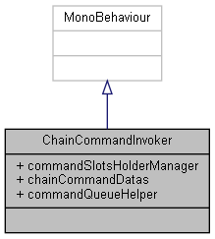

Collaboration diagram for ChainCommandInvoker:

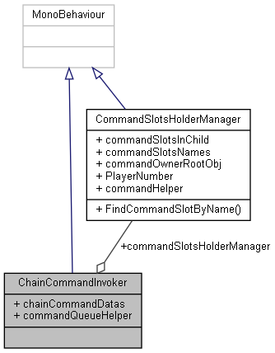

### Public Attributes

**CommandSlotsHolderManager** **commandSlotsHolderManager**

List< **ChainCommandData** > **chainCommandDatas**

### Properties

virtual **CommandQueueHelper** **commandQueueHelper** [getset]

### Member Data Documentation

#### List<ChainCommandData> ChainCommandInvoker.chainCommandDatas

#### CommandSlotsHolderManager ChainCommandInvoker.commandSlotsHolderManager

### Property Documentation

#### virtual CommandQueueHelper ChainCommandInvoker.commandQueueHelper[get], [set]

#### The documentation for this class was generated from the following file:

C:/_SSDSPEEDUP/2021/clone/gps1_manadesigner/GPS1-Manadesigner/Assets/_UtilsV0.4/MyScripts/_Utils/CommandPattern/Command/MyScripts/**ChainCommandInvoker.cs**

## ChainCommandInvokerOldTypeA Class Reference

Inheritance diagram for ChainCommandInvokerOldTypeA:

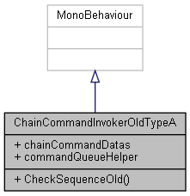

Collaboration diagram for ChainCommandInvokerOldTypeA:



### Public Member Functions

bool **CheckSequenceOld** (string entryQueueName, **ChainCommandDataOld** c)

### Public Attributes

List< **ChainCommandDataOld** > **chainCommandDatas**

### Properties

virtual **CommandQueueHelper** **commandQueueHelper** [getset]

### Member Function Documentation

#### bool ChainCommandInvokerOldTypeA.CheckSequenceOld (string *entryQueueName*, ChainCommandDataOld *c*)

Here is the call graph for this function:

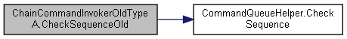

### Member Data Documentation

#### List<ChainCommandDataOld> ChainCommandInvokerOldTypeA.chainCommandDatas

### Property Documentation

#### virtual CommandQueueHelper ChainCommandInvokerOldTypeA.commandQueueHelper[get], [set]

#### The documentation for this class was generated from the following file:

C:/_SSDSPEEDUP/2021/clone/gps1_manadesigner/GPS1-Manadesigner/Assets/_UtilsV0.4/MyScripts/_Utils/CommandPattern/Command/MyScripts/TypeA_RefsToAllAvailableCommandInSingleScript/**ChainCommandInvokerOldTypeA.cs**

## UnityEngine.InputSystem.InputRecorder.ChangeEvent Class Reference

Inheritance diagram for UnityEngine.InputSystem.InputRecorder.ChangeEvent:

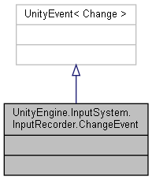

Collaboration diagram for UnityEngine.InputSystem.InputRecorder.ChangeEvent:



The documentation for this class was generated from the following file:

C:/_SSDSPEEDUP/2021/clone/gps1_manadesigner/GPS1-Manadesigner/Assets/Samples/Input System/1.0.2/Input Recorder/**InputRecorder.cs**

## UnityEngine.PostProcessing.ColorGradingModel.ChannelMixerSettings Struct Reference

Collaboration diagram for UnityEngine.PostProcessing.ColorGradingModel.ChannelMixerSettings:

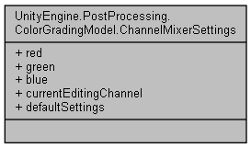

### Public Attributes

Vector3 **red**

Vector3 **green**

Vector3 **blue**

int **currentEditingChannel**

### Properties

static **ChannelMixerSettings** **defaultSettings** [get]

### Member Data Documentation

#### Vector3 UnityEngine.PostProcessing.ColorGradingModel.ChannelMixerSettings.blue

#### int UnityEngine.PostProcessing.ColorGradingModel.ChannelMixerSettings.currentEditingChannel

#### Vector3 UnityEngine.PostProcessing.ColorGradingModel.ChannelMixerSettings.green

#### Vector3 UnityEngine.PostProcessing.ColorGradingModel.ChannelMixerSettings.red

### Property Documentation

#### ChannelMixerSettings UnityEngine.PostProcessing.ColorGradingModel.ChannelMixerSettings.defaultSettings[static], [get]

#### The documentation for this struct was generated from the following file:

C:/_SSDSPEEDUP/2021/clone/gps1_manadesigner/GPS1-Manadesigner/Assets/Samples/Input System/1.0.2/Tanks Demo/TanksDemo/PostProcessing/Runtime/Models/**ColorGradingModel.cs**

## Character Class Reference

Inheritance diagram for Character:

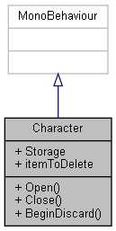

Collaboration diagram for Character:

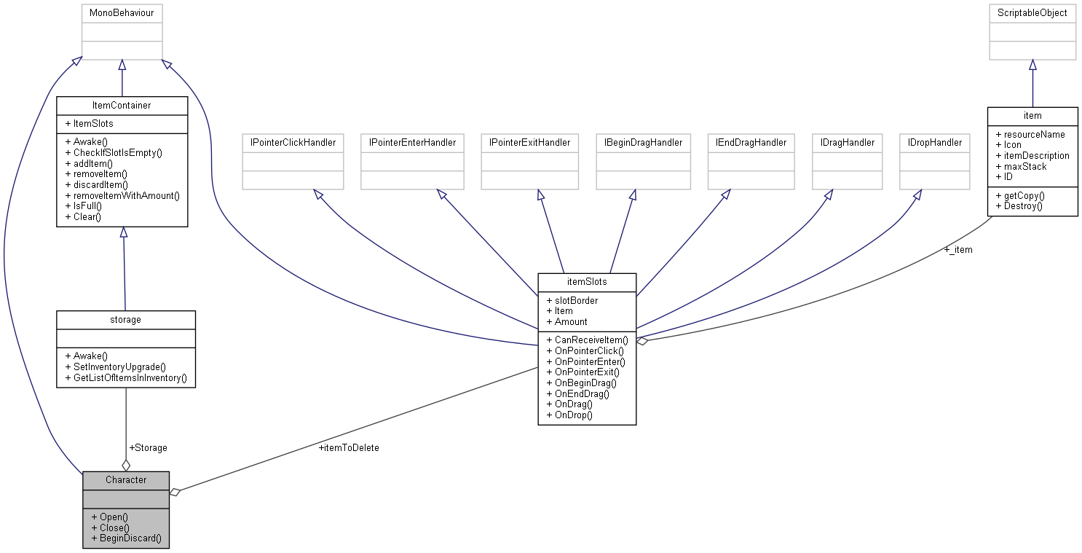

### Public Member Functions

void **Open** ()

void **Close** ()

void **BeginDiscard** ()

### Public Attributes

**storage** **Storage**

**itemSlots** **itemToDelete**

### Member Function Documentation

#### void Character.BeginDiscard ()

Here is the call graph for this function:



#### void Character.Close ()

#### void Character.Open ()

### Member Data Documentation

#### itemSlots Character.itemToDelete

#### storage Character.Storage

#### The documentation for this class was generated from the following file:

C:/_SSDSPEEDUP/2021/clone/gps1_manadesigner/GPS1-Manadesigner/Assets/**Character.cs**

## CharacterMove Class Reference

Inheritance diagram for CharacterMove:

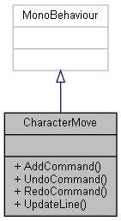

Collaboration diagram for CharacterMove:



### Public Member Functions

void **AddCommand** (**Move** command)

void **UndoCommand** ()

void **RedoCommand** ()

void **UpdateLine** ()

### Member Function Documentation

#### void CharacterMove.AddCommand (Move *command*)

Here is the call graph for this function:

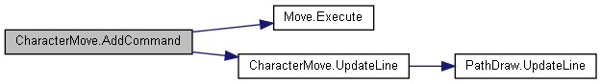

#### void CharacterMove.RedoCommand ()

Here is the call graph for this function:



#### void CharacterMove.UndoCommand ()

Here is the call graph for this function:



#### void CharacterMove.UpdateLine ()

Here is the call graph for this function:



Here is the caller graph for this function:

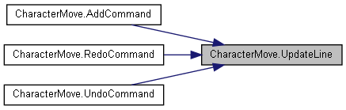

#### The documentation for this class was generated from the following file:

C:/_SSDSPEEDUP/2021/clone/gps1_manadesigner/GPS1-Manadesigner/Assets/_UtilsV0.4/MyScripts/_Utils/CommandPattern/_Bin/OWS/_Samples/Script/**CharacterMove.cs**

## CharacterMoveClean Class Reference

Inheritance diagram for CharacterMoveClean:

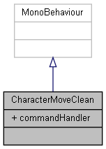

Collaboration diagram for CharacterMoveClean:

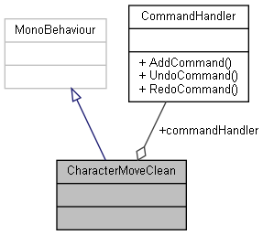

### Public Attributes

**CommandHandler** **commandHandler** = new **CommandHandler**()

### Member Data Documentation

#### CommandHandler CharacterMoveClean.commandHandler = new CommandHandler()

#### The documentation for this class was generated from the following file:

C:/_SSDSPEEDUP/2021/clone/gps1_manadesigner/GPS1-Manadesigner/Assets/_UtilsV0.4/MyScripts/_Utils/CommandPattern/_Bin/OWS/_Samples/Script/**CharacterMoveClean.cs**

## CharacterMoveTurnBased Class Reference

Inheritance diagram for CharacterMoveTurnBased:

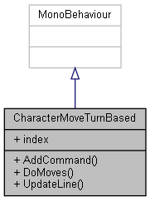

Collaboration diagram for CharacterMoveTurnBased:



### Public Member Functions

void **AddCommand** (**ICommandOWS** command)

void **DoMoves** ()

void **UpdateLine** ()

### Public Attributes

int **index** = 0

### Member Function Documentation

#### void CharacterMoveTurnBased.AddCommand (ICommandOWS *command*)

#### void CharacterMoveTurnBased.DoMoves ()

#### void CharacterMoveTurnBased.UpdateLine ()

Here is the call graph for this function:



### Member Data Documentation

#### int CharacterMoveTurnBased.index = 0

#### The documentation for this class was generated from the following file:

C:/_SSDSPEEDUP/2021/clone/gps1_manadesigner/GPS1-Manadesigner/Assets/_UtilsV0.4/MyScripts/_Utils/CommandPattern/_Bin/OWS/_Samples/Script/**CharacterMoveTurnBased.cs**

## CharacterMoveUndo Class Reference

Inheritance diagram for CharacterMoveUndo:

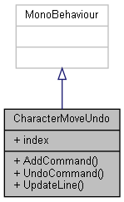

Collaboration diagram for CharacterMoveUndo:



### Public Member Functions

void **AddCommand** (**ICommandOWS** command)

void **UndoCommand** ()

void **UpdateLine** ()

### Public Attributes

int **index** = 0

### Member Function Documentation

#### void CharacterMoveUndo.AddCommand (ICommandOWS *command*)

Here is the call graph for this function:

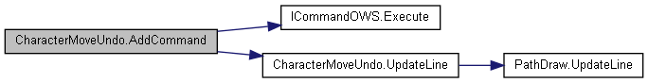

#### void CharacterMoveUndo.UndoCommand ()

Here is the call graph for this function:



#### void CharacterMoveUndo.UpdateLine ()

Here is the call graph for this function:



Here is the caller graph for this function:

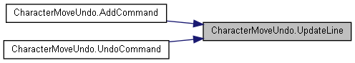

### Member Data Documentation

#### int CharacterMoveUndo.index = 0

#### The documentation for this class was generated from the following file:

C:/_SSDSPEEDUP/2021/clone/gps1_manadesigner/GPS1-Manadesigner/Assets/_UtilsV0.4/MyScripts/_Utils/CommandPattern/_Bin/OWS/_Samples/Script/**CharacterMoveUndo.cs**

## Chase Class Reference

Inheritance diagram for Chase:

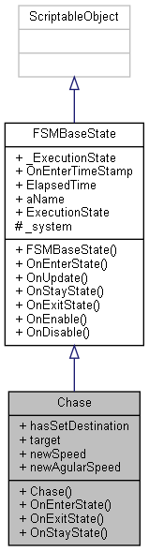

Collaboration diagram for Chase:

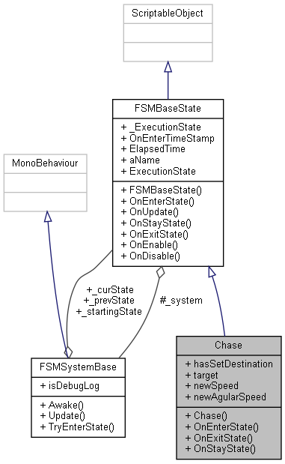

### Public Member Functions

**Chase** (**FSMSystemBase** system)

override bool **OnEnterState** ()

override bool **OnExitState** ()

override void **OnStayState** ()

### Public Attributes

bool **hasSetDestination**

Transform **target**

float **newSpeed** = 30f

float **newAgularSpeed** = 500f

### Additional Inherited Members

### Constructor & Destructor Documentation

#### Chase.Chase (FSMSystemBase *system*)

### Member Function Documentation

#### override bool Chase.OnEnterState ()[virtual]

Reimplemented from **FSMBaseState** (*p.279*).

#### override bool Chase.OnExitState ()[virtual]

Reimplemented from **FSMBaseState** (*p.279*).

#### override void Chase.OnStayState ()[virtual]

Reimplemented from **FSMBaseState** (*p.279*).

### Member Data Documentation

#### bool Chase.hasSetDestination

#### float Chase.newAgularSpeed = 500f

#### float Chase.newSpeed = 30f

#### Transform Chase.target

#### The documentation for this class was generated from the following file:

C:/_SSDSPEEDUP/2021/clone/gps1_manadesigner/GPS1-Manadesigner/Assets/_UtilsV0.4/MyScripts/_Utils/__Experimental/AIApproach/StatePattern/**NPCAIStatesTypeA.cs**

## UnityEngine.PostProcessing.ChromaticAberrationComponent Class Reference

Inheritance diagram for UnityEngine.PostProcessing.ChromaticAberrationComponent:

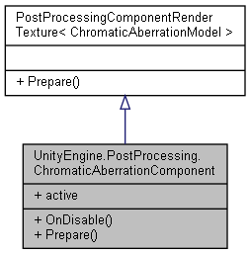

Collaboration diagram for UnityEngine.PostProcessing.ChromaticAberrationComponent:



### Public Member Functions

override void **OnDisable** ()

override void **Prepare** (Material uberMaterial)

### Properties

override bool **active** [get]

### Member Function Documentation

#### override void UnityEngine.PostProcessing.ChromaticAberrationComponent.OnDisable ()

Here is the call graph for this function:

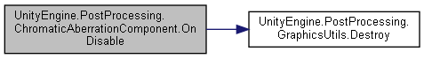

#### override void UnityEngine.PostProcessing.ChromaticAberrationComponent.Prepare (Material *uberMaterial*)[virtual]

Reimplemented from **UnityEngine.PostProcessing.PostProcessingComponentRenderTexture< ChromaticAberrationModel >** (*p.594*).

### Property Documentation

#### override bool UnityEngine.PostProcessing.ChromaticAberrationComponent.active[get]

#### The documentation for this class was generated from the following file:

C:/_SSDSPEEDUP/2021/clone/gps1_manadesigner/GPS1-Manadesigner/Assets/Samples/Input System/1.0.2/Tanks Demo/TanksDemo/PostProcessing/Runtime/Components/**ChromaticAberrationComponent.cs**

## UnityEngine.PostProcessing.ChromaticAberrationModel Class Reference

Inheritance diagram for UnityEngine.PostProcessing.ChromaticAberrationModel:

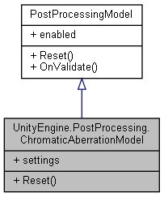

Collaboration diagram for UnityEngine.PostProcessing.ChromaticAberrationModel:



### Classes

struct **Settings**

### Public Member Functions

override void **Reset** ()

### Properties

**Settings** **settings** [getset]

### Member Function Documentation

#### override void UnityEngine.PostProcessing.ChromaticAberrationModel.Reset ()[virtual]

Implements **UnityEngine.PostProcessing.PostProcessingModel** (*p.597*).

### Property Documentation

#### Settings UnityEngine.PostProcessing.ChromaticAberrationModel.settings[get], [set]

#### The documentation for this class was generated from the following file:

C:/_SSDSPEEDUP/2021/clone/gps1_manadesigner/GPS1-Manadesigner/Assets/Samples/Input System/1.0.2/Tanks Demo/TanksDemo/PostProcessing/Runtime/Models/**ChromaticAberrationModel.cs**

## CloseButtonTuto Class Reference

Inheritance diagram for CloseButtonTuto:

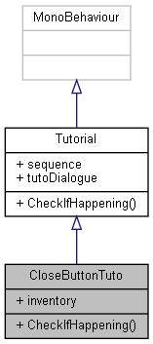

Collaboration diagram for CloseButtonTuto:



### Public Member Functions

override void **CheckIfHappening** ()

### Public Attributes

GameObject **inventory**

### Member Function Documentation

#### override void CloseButtonTuto.CheckIfHappening ()[virtual]

Reimplemented from **Tutorial** (*p.787*).

Here is the call graph for this function:



### Member Data Documentation

#### GameObject CloseButtonTuto.inventory

#### The documentation for this class was generated from the following file:

C:/_SSDSPEEDUP/2021/clone/gps1_manadesigner/GPS1-Manadesigner/Assets/Scripts/Tutorial Scripts/**CloseButtonTuto.cs**

## CollisionByTagEvent Class Reference

Inheritance diagram for CollisionByTagEvent:

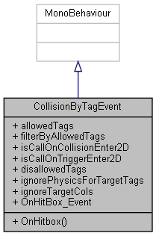

Collaboration diagram for CollisionByTagEvent:



### Public Member Functions

void **OnHitbox** (GameObject other)

### Public Attributes

List< string > **allowedTags**

bool **filterByAllowedTags** = true

bool **isCallOnCollisionEnter2D**

bool **isCallOnTriggerEnter2D**

List< string > **disallowedTags**

List< string > **ignorePhysicsForTargetTags**

List< Collider2D > **ignoreTargetCols** = new List<Collider2D>()

UnityEvent **OnHitBox_Event**

### Member Function Documentation

#### void CollisionByTagEvent.OnHitbox (GameObject *other*)

### Member Data Documentation

#### List<string> CollisionByTagEvent.allowedTags

#### List<string> CollisionByTagEvent.disallowedTags

#### bool CollisionByTagEvent.filterByAllowedTags = true

#### List<string> CollisionByTagEvent.ignorePhysicsForTargetTags

#### List<Collider2D> CollisionByTagEvent.ignoreTargetCols = new List<Collider2D>()

#### bool CollisionByTagEvent.isCallOnCollisionEnter2D

#### bool CollisionByTagEvent.isCallOnTriggerEnter2D

#### UnityEvent CollisionByTagEvent.OnHitBox_Event

#### The documentation for this class was generated from the following file:

C:/_SSDSPEEDUP/2021/clone/gps1_manadesigner/GPS1-Manadesigner/Assets/_UtilsV0.4/Extend/**CollisionByTagEvent.cs**

## Examples.Command.ColorCreator Class Reference

Collaboration diagram for Examples.Command.ColorCreator:

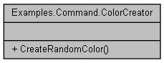

### Static Public Member Functions

static Color **CreateRandomColor** ()

### Member Function Documentation

#### static Color Examples.Command.ColorCreator.CreateRandomColor ()[static]

#### The documentation for this class was generated from the following file:

C:/_SSDSPEEDUP/2021/clone/gps1_manadesigner/GPS1-Manadesigner/Assets/_UtilsV0.4/MyScripts/_Utils/CommandPattern/Command/_Bin/MyScene/Sample/Example/Scripts/**ColorCreator.cs**

## UnityEngine.PostProcessing.ColorGradingComponent Class Reference

Inheritance diagram for UnityEngine.PostProcessing.ColorGradingComponent:

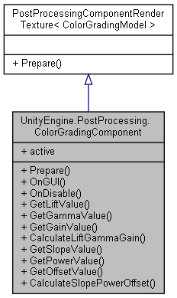

Collaboration diagram for UnityEngine.PostProcessing.ColorGradingComponent:



### Public Member Functions

override void **Prepare** (Material uberMaterial)

void **OnGUI** ()

override void **OnDisable** ()

### Static Public Member Functions

static Vector3 **GetLiftValue** (Color lift)

static Vector3 **GetGammaValue** (Color gamma)

static Vector3 **GetGainValue** (Color gain)

static void **CalculateLiftGammaGain** (Color lift, Color gamma, Color gain, out Vector3 outLift, out Vector3 outGamma, out Vector3 outGain)

static Vector3 **GetSlopeValue** (Color slope)

static Vector3 **GetPowerValue** (Color power)

static Vector3 **GetOffsetValue** (Color offset)

static void **CalculateSlopePowerOffset** (Color slope, Color power, Color offset, out Vector3 outSlope, out Vector3 outPower, out Vector3 outOffset)

### Properties

override bool **active** [get]

### Member Function Documentation

#### static void UnityEngine.PostProcessing.ColorGradingComponent.CalculateLiftGammaGain (Color *lift*, Color *gamma*, Color *gain*, out Vector3 *outLift*, out Vector3 *outGamma*, out Vector3 *outGain*)[static]

Here is the call graph for this function:

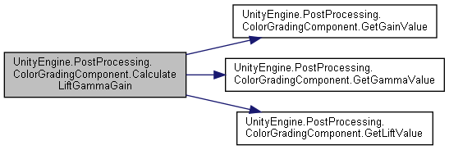

#### static void UnityEngine.PostProcessing.ColorGradingComponent.CalculateSlopePowerOffset (Color *slope*, Color *power*, Color *offset*, out Vector3 *outSlope*, out Vector3 *outPower*, out Vector3 *outOffset*)[static]

Here is the call graph for this function:

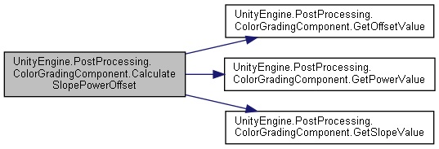

#### static Vector3 UnityEngine.PostProcessing.ColorGradingComponent.GetGainValue (Color *gain*)[static]

Here is the caller graph for this function:

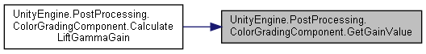

#### static Vector3 UnityEngine.PostProcessing.ColorGradingComponent.GetGammaValue (Color *gamma*)[static]

Here is the caller graph for this function:

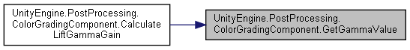

#### static Vector3 UnityEngine.PostProcessing.ColorGradingComponent.GetLiftValue (Color *lift*)[static]

Here is the caller graph for this function:

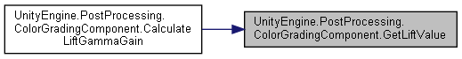

#### static Vector3 UnityEngine.PostProcessing.ColorGradingComponent.GetOffsetValue (Color *offset*)[static]

Here is the caller graph for this function:

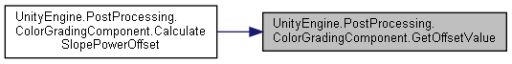

#### static Vector3 UnityEngine.PostProcessing.ColorGradingComponent.GetPowerValue (Color *power*)[static]

Here is the caller graph for this function:

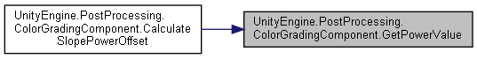

#### static Vector3 UnityEngine.PostProcessing.ColorGradingComponent.GetSlopeValue (Color *slope*)[static]

Here is the caller graph for this function:

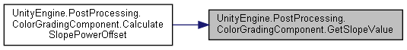

#### override void UnityEngine.PostProcessing.ColorGradingComponent.OnDisable ()

Here is the call graph for this function:

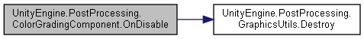

#### void UnityEngine.PostProcessing.ColorGradingComponent.OnGUI ()

#### override void UnityEngine.PostProcessing.ColorGradingComponent.Prepare (Material *uberMaterial*)[virtual]

Reimplemented from **UnityEngine.PostProcessing.PostProcessingComponentRenderTexture< ColorGradingModel >** (*p.594*).

### Property Documentation

#### override bool UnityEngine.PostProcessing.ColorGradingComponent.active[get]

#### The documentation for this class was generated from the following file:

C:/_SSDSPEEDUP/2021/clone/gps1_manadesigner/GPS1-Manadesigner/Assets/Samples/Input System/1.0.2/Tanks Demo/TanksDemo/PostProcessing/Runtime/Components/**ColorGradingComponent.cs**

## UnityEngine.PostProcessing.ColorGradingCurve Class Reference

Collaboration diagram for UnityEngine.PostProcessing.ColorGradingCurve:

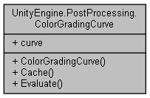

### Public Member Functions

**ColorGradingCurve** (AnimationCurve **curve**, float zeroValue, bool loop, Vector2 bounds)

void **Cache** ()

float **Evaluate** (float t)

### Public Attributes

AnimationCurve **curve**

### Constructor & Destructor Documentation

#### UnityEngine.PostProcessing.ColorGradingCurve.ColorGradingCurve (AnimationCurve *curve*, float *zeroValue*, bool *loop*, Vector2 *bounds*)

### Member Function Documentation

#### void UnityEngine.PostProcessing.ColorGradingCurve.Cache ()

#### float UnityEngine.PostProcessing.ColorGradingCurve.Evaluate (float *t*)

### Member Data Documentation

#### AnimationCurve UnityEngine.PostProcessing.ColorGradingCurve.curve

#### The documentation for this class was generated from the following file:

C:/_SSDSPEEDUP/2021/clone/gps1_manadesigner/GPS1-Manadesigner/Assets/Samples/Input System/1.0.2/Tanks Demo/TanksDemo/PostProcessing/Runtime/Utils/**ColorGradingCurve.cs**

## UnityEngine.PostProcessing.ColorGradingModel Class Reference

Inheritance diagram for UnityEngine.PostProcessing.ColorGradingModel:

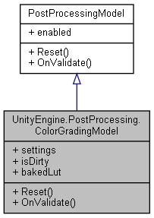

Collaboration diagram for UnityEngine.PostProcessing.ColorGradingModel:



### Classes

struct **BasicSettings**

struct **ChannelMixerSettings**

struct **ColorWheelsSettings**

struct **CurvesSettings**

struct **LinearWheelsSettings**

struct **LogWheelsSettings**

struct **Settings**

struct **TonemappingSettings**

### Public Types

enum **Tonemapper** { **None**, **ACES**, **Neutral** }

enum **ColorWheelMode** { **Linear**, **Log** }

### Public Member Functions

override void **Reset** ()

override void **OnValidate** ()

### Properties

**Settings** **settings** [getset]

bool **isDirty** [getset]

RenderTexture **bakedLut** [getset]

### Member Enumeration Documentation

#### enum UnityEngine.PostProcessing.ColorGradingModel.ColorWheelMode

##### Enumerator:

|  |  |
| --- | --- |
| Linear |  |
| Log |  |

#### enum UnityEngine.PostProcessing.ColorGradingModel.Tonemapper

##### Enumerator:

|  |  |
| --- | --- |
| None |  |
| ACES | ACES Filmic reference tonemapper. |
| Neutral | Neutral tonemapper (based off John Hable's & Jim Hejl's work). |

### Member Function Documentation

#### override void UnityEngine.PostProcessing.ColorGradingModel.OnValidate ()[virtual]

Reimplemented from **UnityEngine.PostProcessing.PostProcessingModel** (*p.597*).

Here is the caller graph for this function:

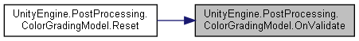

#### override void UnityEngine.PostProcessing.ColorGradingModel.Reset ()[virtual]

Implements **UnityEngine.PostProcessing.PostProcessingModel** (*p.597*).

Here is the call graph for this function:

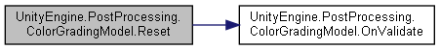

### Property Documentation

#### RenderTexture UnityEngine.PostProcessing.ColorGradingModel.bakedLut[get], [set]

#### bool UnityEngine.PostProcessing.ColorGradingModel.isDirty[get], [set]

#### Settings UnityEngine.PostProcessing.ColorGradingModel.settings[get], [set]

#### The documentation for this class was generated from the following file:

C:/_SSDSPEEDUP/2021/clone/gps1_manadesigner/GPS1-Manadesigner/Assets/Samples/Input System/1.0.2/Tanks Demo/TanksDemo/PostProcessing/Runtime/Models/**ColorGradingModel.cs**

## UnityEngine.PostProcessing.ColorGradingModel.ColorWheelsSettings Struct Reference

Collaboration diagram for UnityEngine.PostProcessing.ColorGradingModel.ColorWheelsSettings:

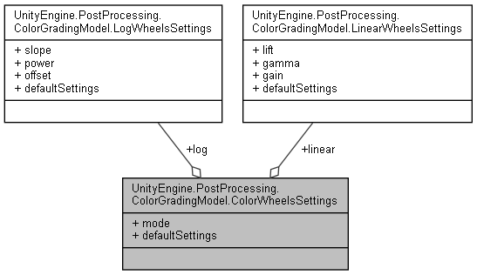

### Public Attributes

**ColorWheelMode** **mode**

**LogWheelsSettings** **log**

**LinearWheelsSettings** **linear**

### Properties

static **ColorWheelsSettings** **defaultSettings** [get]

### Member Data Documentation

#### LinearWheelsSettings UnityEngine.PostProcessing.ColorGradingModel.ColorWheelsSettings.linear

#### LogWheelsSettings UnityEngine.PostProcessing.ColorGradingModel.ColorWheelsSettings.log

#### ColorWheelMode UnityEngine.PostProcessing.ColorGradingModel.ColorWheelsSettings.mode

### Property Documentation

#### ColorWheelsSettings UnityEngine.PostProcessing.ColorGradingModel.ColorWheelsSettings.defaultSettings[static], [get]

#### The documentation for this struct was generated from the following file:

C:/_SSDSPEEDUP/2021/clone/gps1_manadesigner/GPS1-Manadesigner/Assets/Samples/Input System/1.0.2/Tanks Demo/TanksDemo/PostProcessing/Runtime/Models/**ColorGradingModel.cs**

## CommandAccessorRefsBase Class Reference

Inheritance diagram for CommandAccessorRefsBase:

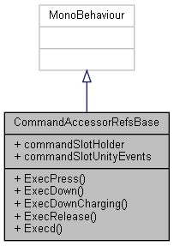

Collaboration diagram for CommandAccessorRefsBase:

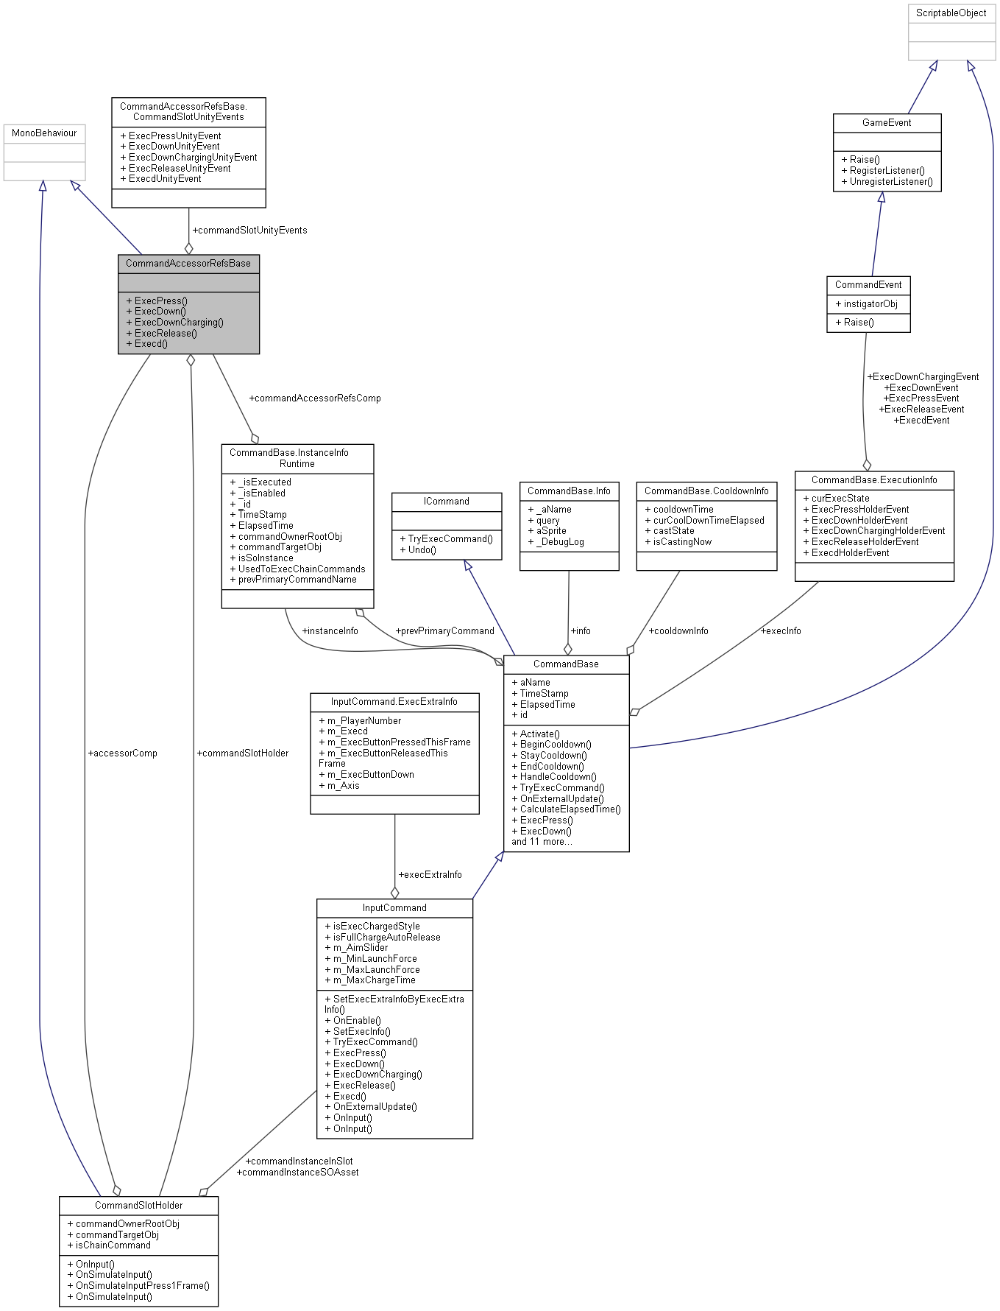

### Classes

struct **CommandSlotUnityEvents**

### Public Member Functions

virtual void **ExecPress** ()

virtual void **ExecDown** ()

virtual void **ExecDownCharging** ()

virtual void **ExecRelease** ()

virtual void **Execd** ()

### Public Attributes

**CommandSlotHolder** **commandSlotHolder**

**CommandSlotUnityEvents** **commandSlotUnityEvents**

### Member Function Documentation

#### virtual void CommandAccessorRefsBase.Execd ()[virtual]

#### virtual void CommandAccessorRefsBase.ExecDown ()[virtual]

#### virtual void CommandAccessorRefsBase.ExecDownCharging ()[virtual]

#### virtual void CommandAccessorRefsBase.ExecPress ()[virtual]

#### virtual void CommandAccessorRefsBase.ExecRelease ()[virtual]

### Member Data Documentation

#### CommandSlotHolder CommandAccessorRefsBase.commandSlotHolder

#### CommandSlotUnityEvents CommandAccessorRefsBase.commandSlotUnityEvents

#### The documentation for this class was generated from the following file:

C:/_SSDSPEEDUP/2021/clone/gps1_manadesigner/GPS1-Manadesigner/Assets/_UtilsV0.4/MyScripts/_Utils/CommandPattern/Command/MyScripts/**CommandAccessorRefsBase.cs**

## CommandBase Class Reference

Inheritance diagram for CommandBase:

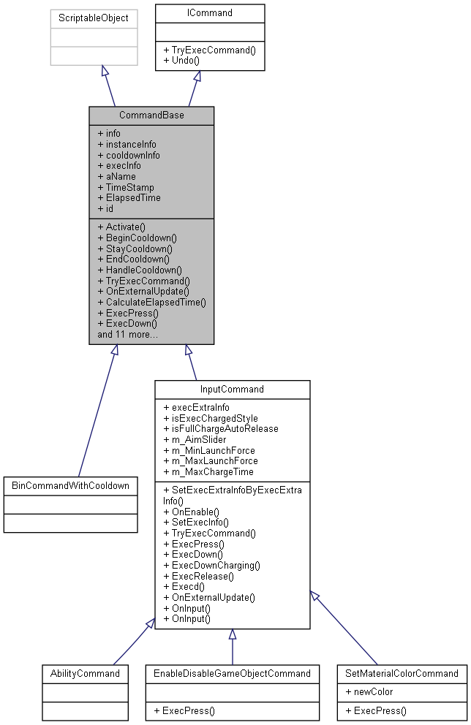

Collaboration diagram for CommandBase:

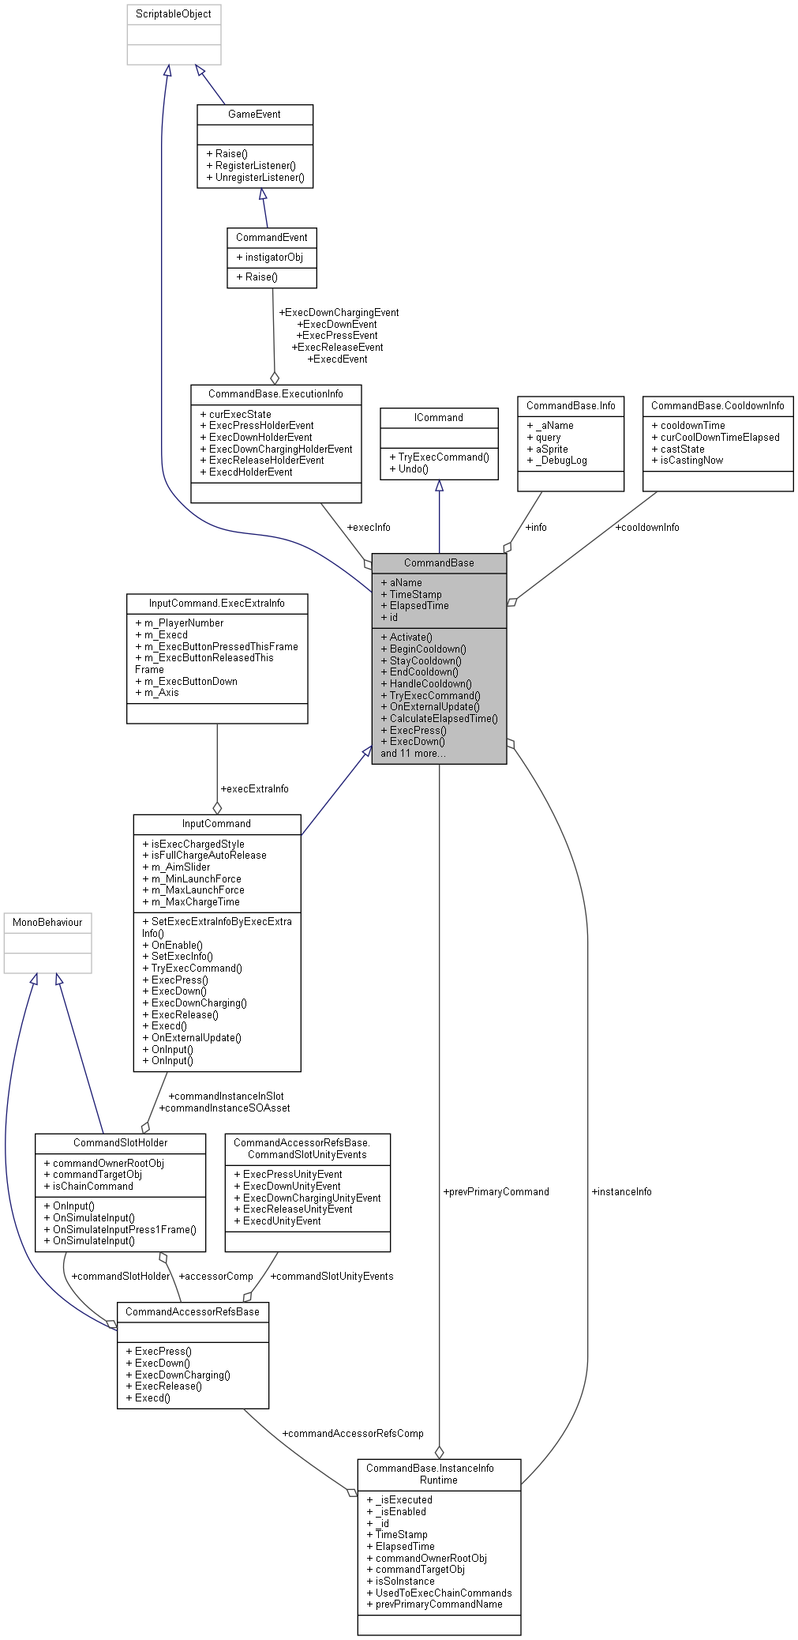

### Classes

struct **CooldownInfo**

class **ExecutionInfo**

struct **Info**

struct **InstanceInfoRuntime**

### Public Types

enum **CastState** { **ready**, **active**, **cooldown** }

### Public Member Functions

virtual void **Activate** (GameObject ownerRootParentObj=null)

virtual void **BeginCooldown** (GameObject ownerRootParentObj=null)

virtual void **StayCooldown** (GameObject ownerRootParentObj=null)

virtual void **EndCooldown** (GameObject ownerRootParentObj=null)

void **HandleCooldown** (GameObject ownerRootParentObj)

virtual void **TryExecCommand** ()

virtual void **OnExternalUpdate** ()

virtual void **CalculateElapsedTime** ()

virtual void **ExecPress** ()

virtual void **ExecDown** ()

virtual void **ExecDownCharging** ()

virtual void **ExecRelease** ()

virtual void **Execd** ()

virtual void **InitGameObj** (GameObject ownerRootParentObj)

virtual void **Init** ()

virtual **CommandBase** **CreateNewInstanceOfSelf** (GameObject newInstigatorObjRef=null)

virtual void **Awake** ()

virtual void **OnEnable** ()

virtual void **OnDisable** ()

virtual void **OnDestroy** ()

virtual void **Undo** ()

### Public Attributes

**Info** **info**

**InstanceInfoRuntime** **instanceInfo**

**CooldownInfo** **cooldownInfo**

**ExecutionInfo** **execInfo**

### Properties

virtual string **aName** [getset]

virtual float **TimeStamp** [getset]

virtual float **ElapsedTime** [getset]

virtual int **id** [getset]

### Member Enumeration Documentation

#### enum CommandBase.CastState

##### Enumerator:

|  |  |
| --- | --- |
| ready |  |
| active |  |
| cooldown |  |

### Member Function Documentation

#### virtual void CommandBase.Activate (GameObject *ownerRootParentObj* = null)[virtual]

Here is the caller graph for this function:



#### virtual void CommandBase.Awake ()[virtual]

#### virtual void CommandBase.BeginCooldown (GameObject *ownerRootParentObj* = null)[virtual]

Here is the caller graph for this function:



#### virtual void CommandBase.CalculateElapsedTime ()[virtual]

Here is the caller graph for this function:



#### virtual CommandBase CommandBase.CreateNewInstanceOfSelf (GameObject *newInstigatorObjRef* = null)[virtual]

Here is the caller graph for this function:



#### virtual void CommandBase.EndCooldown (GameObject *ownerRootParentObj* = null)[virtual]

Here is the caller graph for this function:



#### virtual void CommandBase.Execd ()[virtual]

Reimplemented in **InputCommand** (*p.370*).

Here is the call graph for this function:



#### virtual void CommandBase.ExecDown ()[virtual]

Reimplemented in **InputCommand** (*p.370*).

Here is the call graph for this function:



#### virtual void CommandBase.ExecDownCharging ()[virtual]

Reimplemented in **InputCommand** (*p.370*).

Here is the call graph for this function:



#### virtual void CommandBase.ExecPress ()[virtual]

Reimplemented in **InputCommand** (*p.370*), **EnableDisableGameObjectCommand** (*p.244*), and **SetMaterialColorCommand** (*p.680*).

Here is the call graph for this function:



#### virtual void CommandBase.ExecRelease ()[virtual]

Reimplemented in **InputCommand** (*p.371*).

Here is the call graph for this function:



#### void CommandBase.HandleCooldown (GameObject *ownerRootParentObj*)

Here is the call graph for this function:

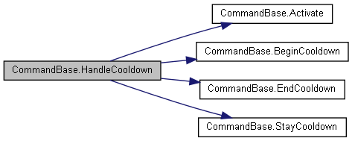

Here is the caller graph for this function:



#### virtual void CommandBase.Init ()[virtual]

Here is the caller graph for this function:

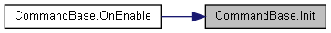

#### virtual void CommandBase.InitGameObj (GameObject *ownerRootParentObj*)[virtual]

#### virtual void CommandBase.OnDestroy ()[virtual]

#### virtual void CommandBase.OnDisable ()[virtual]

#### virtual void CommandBase.OnEnable ()[virtual]

Reimplemented in **InputCommand** (*p.371*).

Here is the call graph for this function:

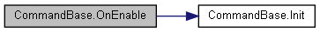

#### virtual void CommandBase.OnExternalUpdate ()[virtual]

Reimplemented in **InputCommand** (*p.371*).

Here is the call graph for this function:

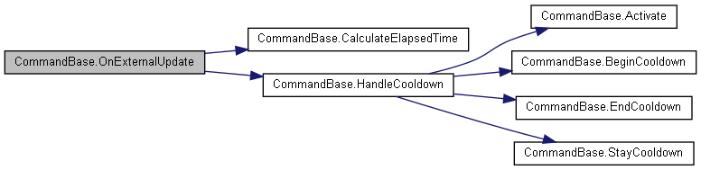

#### virtual void CommandBase.StayCooldown (GameObject *ownerRootParentObj* = null)[virtual]

Here is the caller graph for this function:



#### virtual void CommandBase.TryExecCommand ()[virtual]

Implements **ICommand** (*p.346*).

Reimplemented in **InputCommand** (*p.373*).

#### virtual void CommandBase.Undo ()[virtual]

Implements **ICommand** (*p.347*).

Here is the caller graph for this function:



### Member Data Documentation

#### CooldownInfo CommandBase.cooldownInfo

#### ExecutionInfo CommandBase.execInfo

#### Info CommandBase.info

#### InstanceInfoRuntime CommandBase.instanceInfo

### Property Documentation

#### virtual string CommandBase.aName[get], [set]

#### virtual float CommandBase.ElapsedTime[get], [set]

#### virtual int CommandBase.id[get], [set]

#### virtual float CommandBase.TimeStamp[get], [set]

#### The documentation for this class was generated from the following file:

C:/_SSDSPEEDUP/2021/clone/gps1_manadesigner/GPS1-Manadesigner/Assets/_UtilsV0.4/MyScripts/_Utils/CommandPattern/Command/SOScripts/**CommandBase.cs**

## CommandCoolDownComp Class Reference

Inheritance diagram for CommandCoolDownComp:

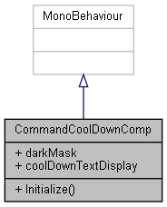

Collaboration diagram for CommandCoolDownComp:

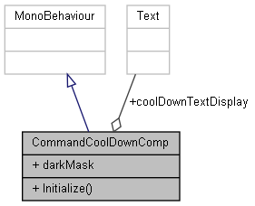

### Public Member Functions

void **Initialize** (**CommandBase** selectedAbility, GameObject weaponHolder)

### Public Attributes

Image **darkMask**

Text **coolDownTextDisplay**

### Member Function Documentation

#### void CommandCoolDownComp.Initialize (CommandBase *selectedAbility*, GameObject *weaponHolder*)

### Member Data Documentation

#### Text CommandCoolDownComp.coolDownTextDisplay

#### Image CommandCoolDownComp.darkMask

#### The documentation for this class was generated from the following file:

C:/_SSDSPEEDUP/2021/clone/gps1_manadesigner/GPS1-Manadesigner/Assets/_UtilsV0.4/MyScripts/_Utils/CommandPattern/Command/_Bin/Custom/**CommandCoolDownComp.cs**

## CommandEvent Class Reference

Inheritance diagram for CommandEvent:

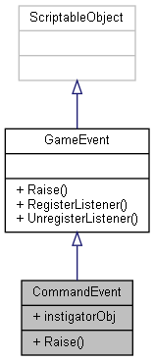

Collaboration diagram for CommandEvent:



### Public Member Functions

virtual void **Raise** (GameObject instigatorObjRef)

### Public Attributes

GameObject **instigatorObj**

### Member Function Documentation

#### virtual void CommandEvent.Raise (GameObject *instigatorObjRef*)[virtual]

Here is the call graph for this function:

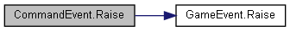

Here is the caller graph for this function:

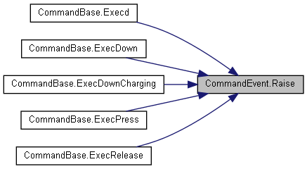

### Member Data Documentation

#### GameObject CommandEvent.instigatorObj

#### The documentation for this class was generated from the following file:

C:/_SSDSPEEDUP/2021/clone/gps1_manadesigner/GPS1-Manadesigner/Assets/_UtilsV0.4/MyScripts/_Utils/CommandPattern/Events/**CommandEvent.cs**

## CommandEventListener Class Reference

Inheritance diagram for CommandEventListener:

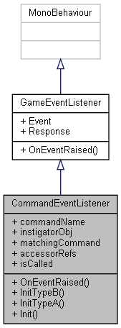

Collaboration diagram for CommandEventListener:

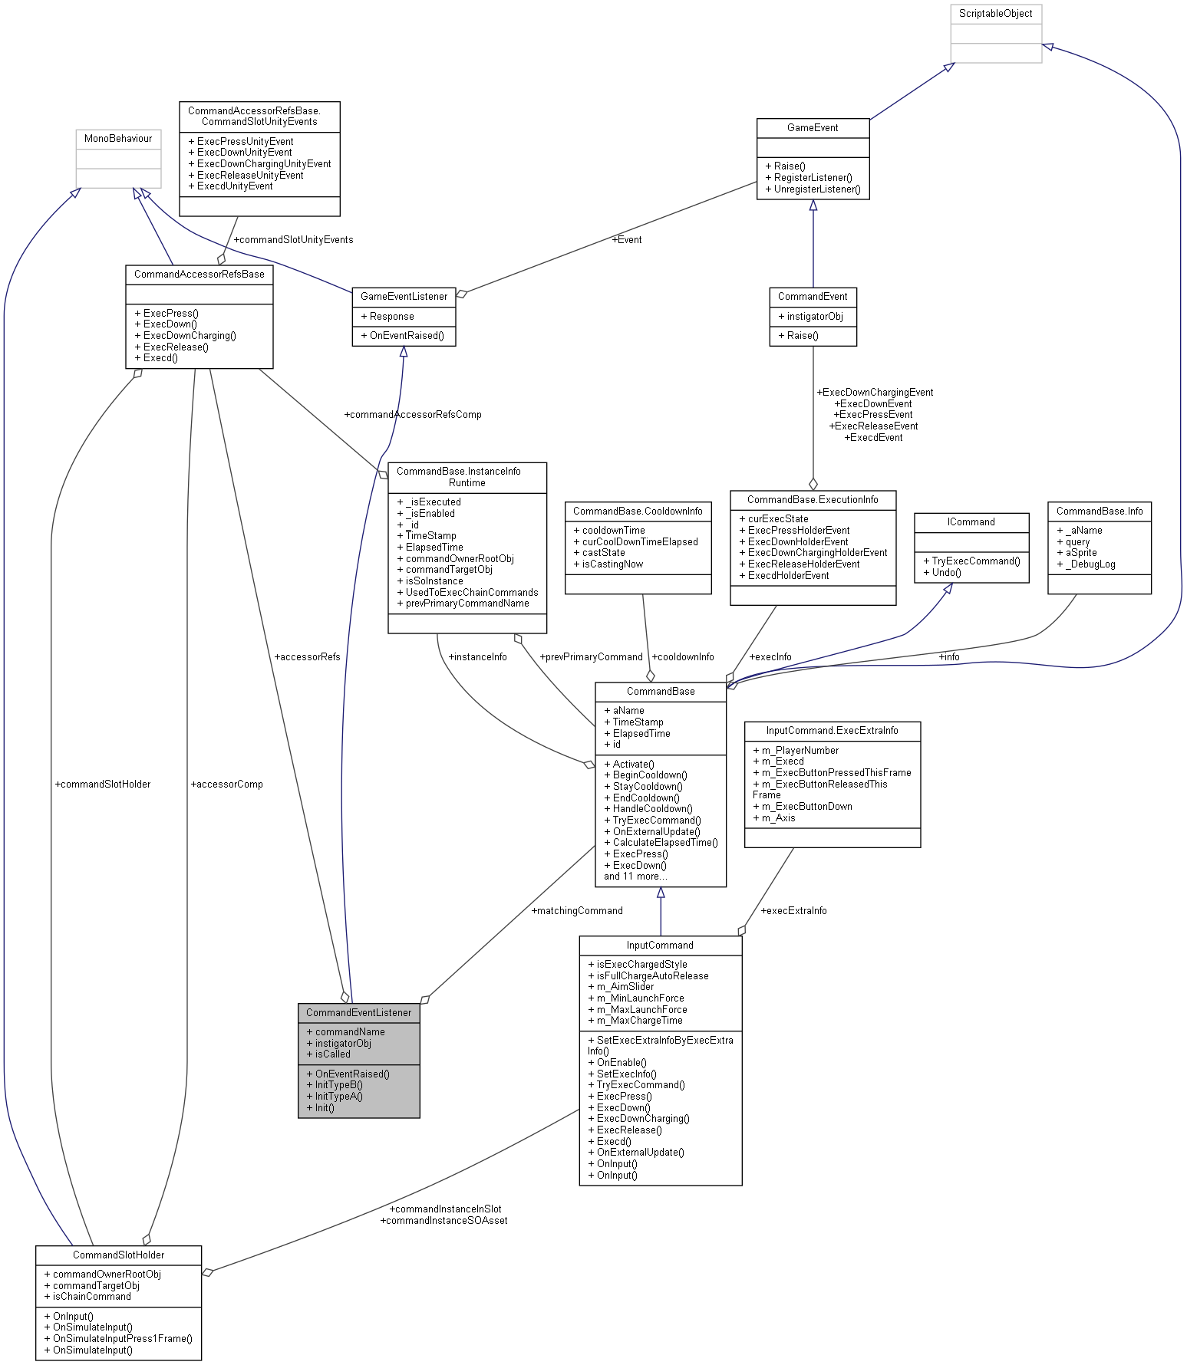

### Public Member Functions

override void **OnEventRaised** ()

void **InitTypeB** ()

void **InitTypeA** ()

void **Init** ()

### Public Attributes

string **commandName**

GameObject **instigatorObj**

**CommandBase** **matchingCommand**

**CommandAccessorRefsBase** **accessorRefs**

bool **isCalled**

### Member Function Documentation

#### void CommandEventListener.Init ()

Here is the caller graph for this function:

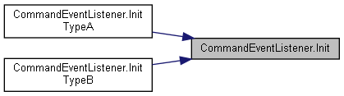

#### void CommandEventListener.InitTypeA ()

Here is the call graph for this function:

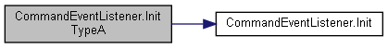

#### void CommandEventListener.InitTypeB ()

Here is the call graph for this function:

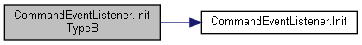

#### override void CommandEventListener.OnEventRaised ()[virtual]

Reimplemented from **GameEventListener** (*p.294*).

### Member Data Documentation

#### CommandAccessorRefsBase CommandEventListener.accessorRefs

#### string CommandEventListener.commandName

#### GameObject CommandEventListener.instigatorObj

#### bool CommandEventListener.isCalled

#### CommandBase CommandEventListener.matchingCommand

#### The documentation for this class was generated from the following file:

C:/_SSDSPEEDUP/2021/clone/gps1_manadesigner/GPS1-Manadesigner/Assets/_UtilsV0.4/MyScripts/_Utils/CommandPattern/Events/**CommandEventListener.cs**

## CommandHandler Class Reference

Collaboration diagram for CommandHandler:

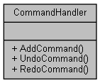

### Public Member Functions

void **AddCommand** (**ICommandOWS** command)

void **UndoCommand** ()

void **RedoCommand** ()

### Member Function Documentation

#### void CommandHandler.AddCommand (ICommandOWS *command*)

Here is the call graph for this function:



#### void CommandHandler.RedoCommand ()

#### void CommandHandler.UndoCommand ()

#### The documentation for this class was generated from the following file:

C:/_SSDSPEEDUP/2021/clone/gps1_manadesigner/GPS1-Manadesigner/Assets/_UtilsV0.4/MyScripts/_Utils/CommandPattern/_Bin/OWS/**CommandHandler.cs**

## CommandManagerOld Class Reference

Inheritance diagram for CommandManagerOld:

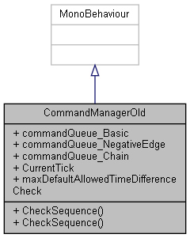

Collaboration diagram for CommandManagerOld:

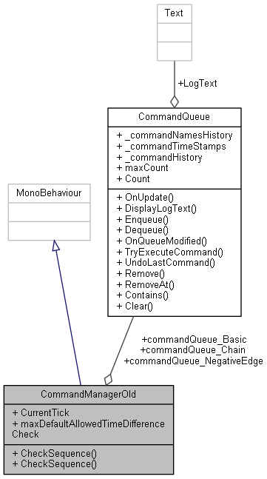

### Public Member Functions

bool **CheckSequence** (string[] sequence, int maxDuration, **CommandBase** chainCommand)

bool **CheckSequence** (string[] sequence, **CommandBase** chainCommand)

### Public Attributes

**CommandQueue** **commandQueue_Basic** = new **CommandQueue**()

**CommandQueue** **commandQueue_NegativeEdge** = new **CommandQueue**()

**CommandQueue** **commandQueue_Chain** = new **CommandQueue**()

int **CurrentTick** = 0

float **maxDefaultAllowedTimeDifferenceCheck** = 2f

### Member Function Documentation

#### bool CommandManagerOld.CheckSequence (string[] *sequence*, CommandBase *chainCommand*)

Here is the call graph for this function:



#### bool CommandManagerOld.CheckSequence (string[] *sequence*, int *maxDuration*, CommandBase *chainCommand*)

Here is the caller graph for this function:



### Member Data Documentation

#### CommandQueue CommandManagerOld.commandQueue_Basic = new CommandQueue()

#### CommandQueue CommandManagerOld.commandQueue_Chain = new CommandQueue()

#### CommandQueue CommandManagerOld.commandQueue_NegativeEdge = new CommandQueue()

#### int CommandManagerOld.CurrentTick = 0

#### float CommandManagerOld.maxDefaultAllowedTimeDifferenceCheck = 2f

#### The documentation for this class was generated from the following file:

C:/_SSDSPEEDUP/2021/clone/gps1_manadesigner/GPS1-Manadesigner/Assets/_UtilsV0.4/MyScripts/_Utils/CommandPattern/Command/_Bin/**CommandManagerOld.cs**

## CommandQueue Class Reference

Collaboration diagram for CommandQueue:

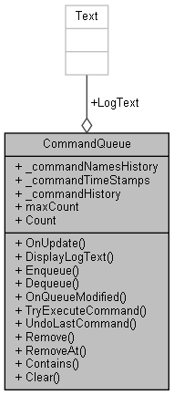

### Public Member Functions

void **OnUpdate** ()

void **DisplayLogText** ()

void **Enqueue** (**CommandBase** command)

**CommandBase** **Dequeue** ()

void **OnQueueModified** ()

**CommandBase** **TryExecuteCommand** (**CommandBase** command, bool willInstanteACloneSO=false)

virtual void **UndoLastCommand** ()

void **Remove** (**CommandBase** c)

void **RemoveAt** (int index)

bool **Contains** (string commandName)

void **Clear** ()

### Public Attributes

**SerializableQueueList**< string > **_commandNamesHistory** = new **SerializableQueueList**<string>()

**SerializableQueueList**< float > **_commandTimeStamps** = new **SerializableQueueList**<float>()

**SerializableQueueList**< **CommandBase** > **_commandHistory** = new **SerializableQueueList**<**CommandBase**>()

int **maxCount** = 30

Text **LogText**

### Properties

int **Count** [get]

### Member Function Documentation

#### void CommandQueue.Clear ()

Here is the call graph for this function:



#### bool CommandQueue.Contains (string *commandName*)

#### CommandBase CommandQueue.Dequeue ()

Here is the call graph for this function:



Here is the caller graph for this function:

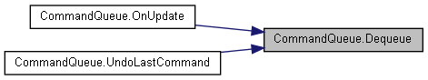

#### void CommandQueue.DisplayLogText ()

Here is the caller graph for this function:



#### void CommandQueue.Enqueue (CommandBase *command*)

Here is the call graph for this function:



Here is the caller graph for this function:



#### void CommandQueue.OnQueueModified ()

Here is the caller graph for this function:

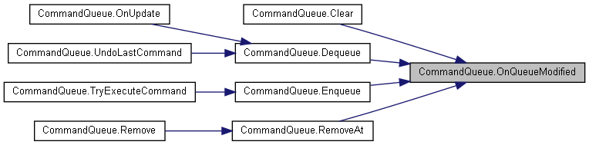

#### void CommandQueue.OnUpdate ()

Here is the call graph for this function:

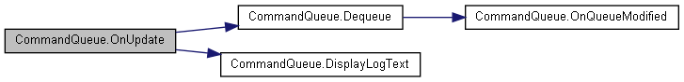

#### void CommandQueue.Remove (CommandBase *c*)

Here is the call graph for this function:



#### void CommandQueue.RemoveAt (int *index*)

Here is the call graph for this function:



Here is the caller graph for this function:



#### CommandBase CommandQueue.TryExecuteCommand (CommandBase *command*, bool *willInstanteACloneSO* = false)

Here is the call graph for this function:

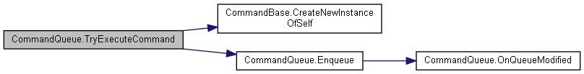

#### virtual void CommandQueue.UndoLastCommand ()[virtual]

Here is the call graph for this function:

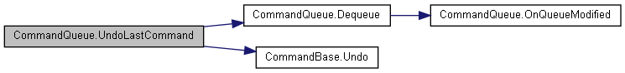

### Member Data Documentation

#### SerializableQueueList<CommandBase> CommandQueue._commandHistory = new SerializableQueueList<CommandBase>()

#### SerializableQueueList<string> CommandQueue._commandNamesHistory = new SerializableQueueList<string>()

#### SerializableQueueList<float> CommandQueue._commandTimeStamps = new SerializableQueueList<float>()

#### Text CommandQueue.LogText

#### int CommandQueue.maxCount = 30

### Property Documentation

#### int CommandQueue.Count[get]

#### The documentation for this class was generated from the following file:

C:/_SSDSPEEDUP/2021/clone/gps1_manadesigner/GPS1-Manadesigner/Assets/_UtilsV0.4/MyScripts/_Utils/CommandPattern/Command/MyScripts/**CommandQueue.cs**

## CommandQueueHelper Class Reference

Inheritance diagram for CommandQueueHelper:

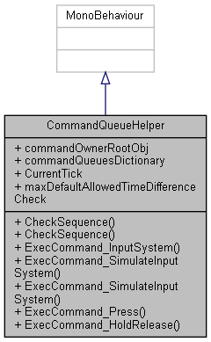

Collaboration diagram for CommandQueueHelper:



### Public Member Functions

bool **CheckSequence** (string entryQueueName, string[] sequence, string[] Sequence_Query, string[] ignoreCategory, int maxDuration, **CommandBase** chainCommand)

bool **CheckSequence** (string entryQueueName, **ChainCommandData** c)

void **ExecCommand_InputSystem** (InputAction.CallbackContext context, **InputCommand** curCommand, string queueDictionaryElementName="Primary")

void **ExecCommand_SimulateInputSystem** (bool IsPressedThisFrame, float axis, **InputCommand** curCommand, string queueDictionaryElementName="Primary")

void **ExecCommand_SimulateInputSystem** (bool IsPressedThisFrame, **InputCommand** curCommand, string queueDictionaryElementName="Primary")

void **ExecCommand_Press** (**InputCommand** curCommand, string queueDictionaryElementName="Primary")

void **ExecCommand_HoldRelease** (**InputCommand** curCommand)

### Public Attributes

GameObject **commandOwnerRootObj**

**GenericDictionary**< string, **CommandQueue** > **commandQueuesDictionary**

int **CurrentTick** = 0

float **maxDefaultAllowedTimeDifferenceCheck** = 2f

### Member Function Documentation

#### bool CommandQueueHelper.CheckSequence (string *entryQueueName*, ChainCommandData *c*)

Here is the call graph for this function:

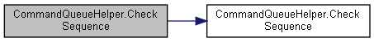

#### bool CommandQueueHelper.CheckSequence (string *entryQueueName*, string[] *sequence*, string[] *Sequence_Query*, string[] *ignoreCategory*, int *maxDuration*, CommandBase *chainCommand*)

Here is the caller graph for this function:

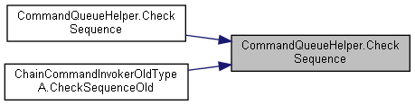

#### void CommandQueueHelper.ExecCommand_HoldRelease (InputCommand *curCommand*)

#### void CommandQueueHelper.ExecCommand_InputSystem (InputAction.CallbackContext *context*, InputCommand *curCommand*, string *queueDictionaryElementName* = "Primary")

Here is the call graph for this function:

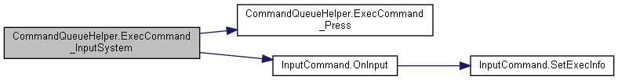

Here is the caller graph for this function:

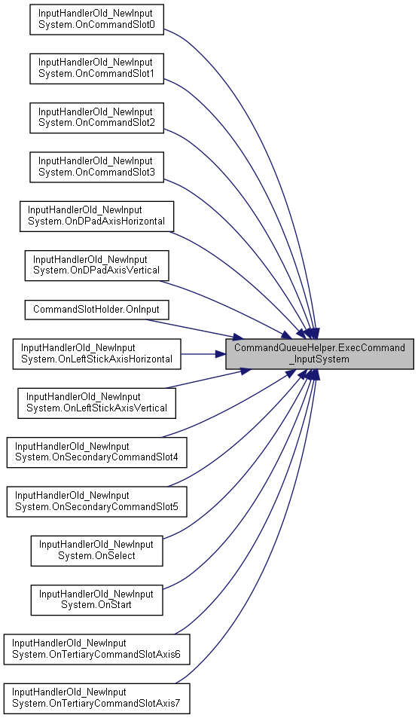

#### void CommandQueueHelper.ExecCommand_Press (InputCommand *curCommand*, string *queueDictionaryElementName* = "Primary")

Here is the caller graph for this function:

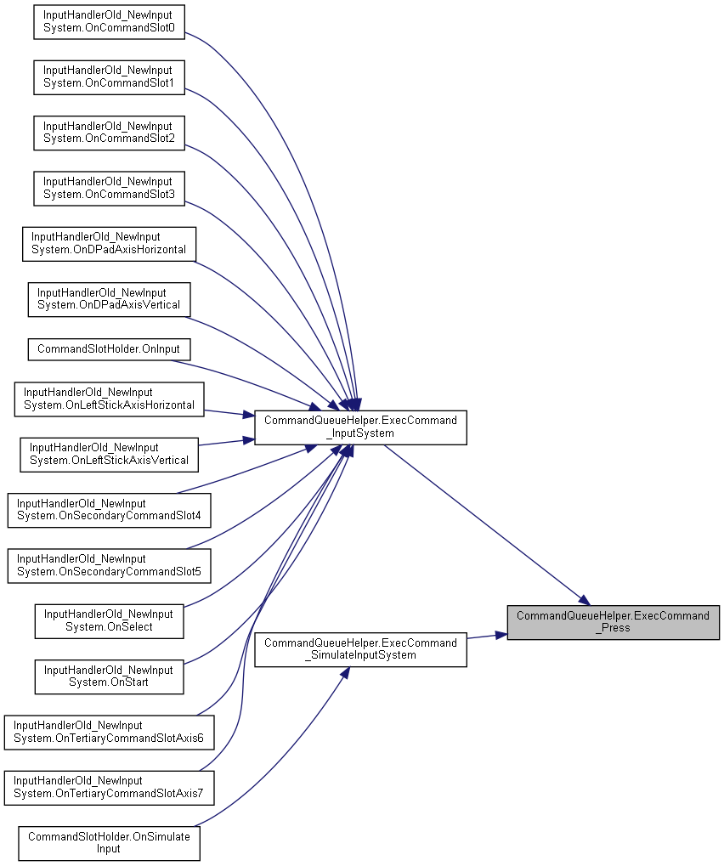

#### void CommandQueueHelper.ExecCommand_SimulateInputSystem (bool *IsPressedThisFrame*, float *axis*, InputCommand *curCommand*, string *queueDictionaryElementName* = "Primary")

Here is the call graph for this function:

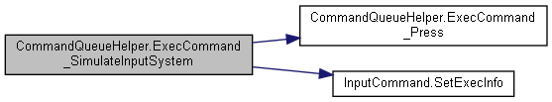

Here is the caller graph for this function:



#### void CommandQueueHelper.ExecCommand_SimulateInputSystem (bool *IsPressedThisFrame*, InputCommand *curCommand*, string *queueDictionaryElementName* = "Primary")

Here is the call graph for this function:



### Member Data Documentation

#### GameObject CommandQueueHelper.commandOwnerRootObj

#### GenericDictionary<string, CommandQueue> CommandQueueHelper.commandQueuesDictionary

**Initial value:**= new GenericDictionary<string, CommandQueue>()

{

{ "Primary", new CommandQueue()},

{ "Secondary", new CommandQueue()} ,

{ "Tertiary", new CommandQueue()},

{ "Axis", new CommandQueue()},

{ "HoldDown", new CommandQueue()},

{ "NegativeEdge", new CommandQueue()},

{ "Chain", new CommandQueue()},

}

#### int CommandQueueHelper.CurrentTick = 0

#### float CommandQueueHelper.maxDefaultAllowedTimeDifferenceCheck = 2f

#### The documentation for this class was generated from the following file:

C:/_SSDSPEEDUP/2021/clone/gps1_manadesigner/GPS1-Manadesigner/Assets/_UtilsV0.4/MyScripts/_Utils/CommandPattern/Command/MyScripts/**CommandQueueHelper.cs**

## CommandSlotHolder Class Reference

Inheritance diagram for CommandSlotHolder:

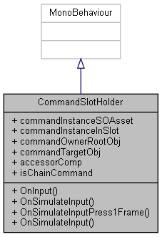

Collaboration diagram for CommandSlotHolder:

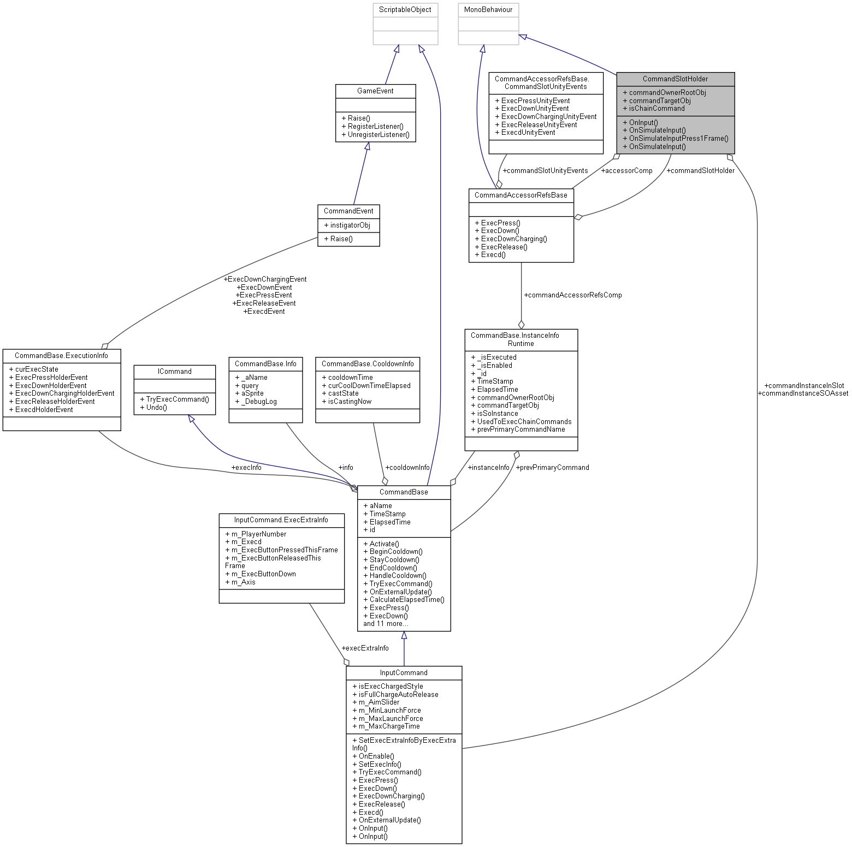

### Public Member Functions

void **OnInput** (InputAction.CallbackContext context)

void **OnSimulateInput** (bool IsPressedThisFrame, float axis)

void **OnSimulateInputPress1Frame** ()

void **OnSimulateInput** (bool IsPressedThisFrame)

### Public Attributes

**InputCommand** **commandInstanceSOAsset**

**InputCommand** **commandInstanceInSlot**

GameObject **commandOwnerRootObj**

GameObject **commandTargetObj**

**CommandAccessorRefsBase** **accessorComp**

bool **isChainCommand**

### Member Function Documentation

#### void CommandSlotHolder.OnInput (InputAction.CallbackContext *context*)

Here is the call graph for this function:

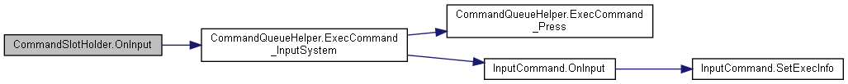

#### void CommandSlotHolder.OnSimulateInput (bool *IsPressedThisFrame*)

Here is the call graph for this function:

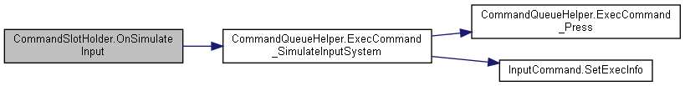

#### void CommandSlotHolder.OnSimulateInput (bool *IsPressedThisFrame*, float *axis*)

Here is the call graph for this function:



#### void CommandSlotHolder.OnSimulateInputPress1Frame ()

### Member Data Documentation

#### CommandAccessorRefsBase CommandSlotHolder.accessorComp

#### InputCommand CommandSlotHolder.commandInstanceInSlot

#### InputCommand CommandSlotHolder.commandInstanceSOAsset

#### GameObject CommandSlotHolder.commandOwnerRootObj

#### GameObject CommandSlotHolder.commandTargetObj

#### bool CommandSlotHolder.isChainCommand

#### The documentation for this class was generated from the following file:

C:/_SSDSPEEDUP/2021/clone/gps1_manadesigner/GPS1-Manadesigner/Assets/_UtilsV0.4/MyScripts/_Utils/CommandPattern/Command/MyScripts/TypeB_CommandHolder/**CommandSlotHolder.cs**

## CommandSlotsHolderManager Class Reference

Inheritance diagram for CommandSlotsHolderManager:

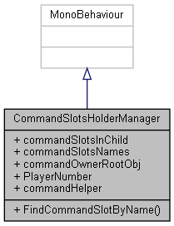

Collaboration diagram for CommandSlotsHolderManager:



### Public Member Functions

**CommandSlotHolder** **FindCommandSlotByName** (string commandName)

### Public Attributes

List< **CommandSlotHolder** > **commandSlotsInChild**

List< string > **commandSlotsNames** = new List<string>()

GameObject **commandOwnerRootObj**

int **PlayerNumber**

### Properties

virtual **CommandQueueHelper** **commandHelper** [getset]

### Member Function Documentation

#### CommandSlotHolder CommandSlotsHolderManager.FindCommandSlotByName (string *commandName*)

### Member Data Documentation

#### GameObject CommandSlotsHolderManager.commandOwnerRootObj

#### List<CommandSlotHolder> CommandSlotsHolderManager.commandSlotsInChild

#### List<string> CommandSlotsHolderManager.commandSlotsNames = new List<string>()

#### int CommandSlotsHolderManager.PlayerNumber

### Property Documentation

#### virtual CommandQueueHelper CommandSlotsHolderManager.commandHelper[get], [set]

#### The documentation for this class was generated from the following file:

C:/_SSDSPEEDUP/2021/clone/gps1_manadesigner/GPS1-Manadesigner/Assets/_UtilsV0.4/MyScripts/_Utils/CommandPattern/Command/MyScripts/TypeB_CommandHolder/**CommandSlotsHolderManager.cs**

## CommandAccessorRefsBase.CommandSlotUnityEvents Struct Reference

Collaboration diagram for CommandAccessorRefsBase.CommandSlotUnityEvents:

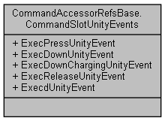

### Public Attributes

UnityEvent **ExecPressUnityEvent**

UnityEvent **ExecDownUnityEvent**

UnityEvent **ExecDownChargingUnityEvent**

UnityEvent **ExecReleaseUnityEvent**

UnityEvent **ExecdUnityEvent**

### Member Data Documentation

#### UnityEvent CommandAccessorRefsBase.CommandSlotUnityEvents.ExecDownChargingUnityEvent

#### UnityEvent CommandAccessorRefsBase.CommandSlotUnityEvents.ExecDownUnityEvent

#### UnityEvent CommandAccessorRefsBase.CommandSlotUnityEvents.ExecdUnityEvent

#### UnityEvent CommandAccessorRefsBase.CommandSlotUnityEvents.ExecPressUnityEvent

#### UnityEvent CommandAccessorRefsBase.CommandSlotUnityEvents.ExecReleaseUnityEvent

#### The documentation for this struct was generated from the following file:

C:/_SSDSPEEDUP/2021/clone/gps1_manadesigner/GPS1-Manadesigner/Assets/_UtilsV0.4/MyScripts/_Utils/CommandPattern/Command/MyScripts/**CommandAccessorRefsBase.cs**

## CommandStack Class Reference

Collaboration diagram for CommandStack:

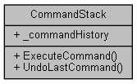

### Public Member Functions

virtual void **ExecuteCommand** (**ICommand** command)

virtual void **UndoLastCommand** ()

### Public Attributes

Stack< **ICommand** > **_commandHistory** = new Stack<**ICommand**>()

### Member Function Documentation

#### virtual void CommandStack.ExecuteCommand (ICommand *command*)[virtual]

Here is the call graph for this function:



#### virtual void CommandStack.UndoLastCommand ()[virtual]

### Member Data Documentation

#### Stack<ICommand> CommandStack._commandHistory = new Stack<ICommand>()

#### The documentation for this class was generated from the following file:

C:/_SSDSPEEDUP/2021/clone/gps1_manadesigner/GPS1-Manadesigner/Assets/_UtilsV0.4/MyScripts/_Utils/CommandPattern/Command/MyScripts/Reusable/_Bin/**CommandStack.cs**

## ConfirmPopup Class Reference

Inheritance diagram for ConfirmPopup:

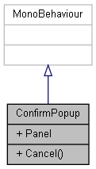

Collaboration diagram for ConfirmPopup:



### Public Member Functions

void **Cancel** ()

### Public Attributes

GameObject **Panel**

### Member Function Documentation

#### void ConfirmPopup.Cancel ()

### Member Data Documentation

#### GameObject ConfirmPopup.Panel

#### The documentation for this class was generated from the following file:

C:/_SSDSPEEDUP/2021/clone/gps1_manadesigner/GPS1-Manadesigner/Assets/Scripts/Stage Scripts/Scene Transitions/To Outpost/**ConfirmPopup.cs**

## ConstraintCommon Class Reference

Collaboration diagram for ConstraintCommon:

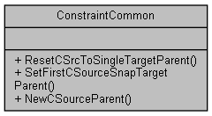

### Static Public Member Functions

static void **ResetCSrcToSingleTargetParent** (ParentConstraint parentConstraint, Transform targetTrans)

static void **SetFirstCSourceSnapTargetParent** (ParentConstraint parentConstraint, Transform targetTrans)

static ConstraintSource **NewCSourceParent** (Transform srcTransform, float weight)

### Member Function Documentation

#### static ConstraintSource ConstraintCommon.NewCSourceParent (Transform *srcTransform*, float *weight*)[static]

#### static void ConstraintCommon.ResetCSrcToSingleTargetParent (ParentConstraint *parentConstraint*, Transform *targetTrans*)[static]

#### static void ConstraintCommon.SetFirstCSourceSnapTargetParent (ParentConstraint *parentConstraint*, Transform *targetTrans*)[static]

#### The documentation for this class was generated from the following file:

C:/_SSDSPEEDUP/2021/clone/gps1_manadesigner/GPS1-Manadesigner/Assets/_UtilsV0.4/MyScripts/_Utils/_CommonV0.2/Calculation/Components/**ConstraintCommon.cs**

## ContinueNextTuto Class Reference

Inheritance diagram for ContinueNextTuto:

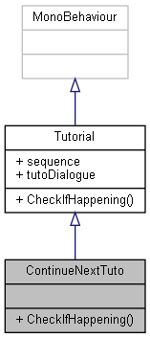

Collaboration diagram for ContinueNextTuto:



### Public Member Functions

override void **CheckIfHappening** ()

### Additional Inherited Members

### Member Function Documentation

#### override void ContinueNextTuto.CheckIfHappening ()[virtual]

Reimplemented from **Tutorial** (*p.787*).

Here is the call graph for this function:

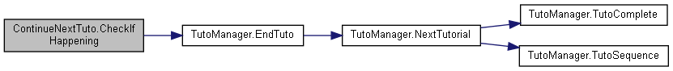

#### The documentation for this class was generated from the following file:

C:/_SSDSPEEDUP/2021/clone/gps1_manadesigner/GPS1-Manadesigner/Assets/Scripts/Tutorial Scripts/**ContinueNextTuto.cs**

## ControlRebindingUI Class Reference

Inheritance diagram for ControlRebindingUI:

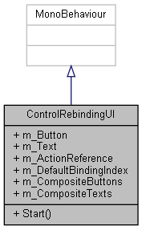

Collaboration diagram for ControlRebindingUI:

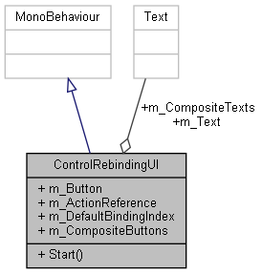

### Public Member Functions

void **Start** ()

### Public Attributes

Button **m_Button**

Text **m_Text**

InputActionReference **m_ActionReference**

int **m_DefaultBindingIndex**

Button[] **m_CompositeButtons**

Text[] **m_CompositeTexts**

### Member Function Documentation

#### void ControlRebindingUI.Start ()

### Member Data Documentation

#### InputActionReference ControlRebindingUI.m_ActionReference

#### Button ControlRebindingUI.m_Button

#### Button [] ControlRebindingUI.m_CompositeButtons

#### Text [] ControlRebindingUI.m_CompositeTexts

#### int ControlRebindingUI.m_DefaultBindingIndex

#### Text ControlRebindingUI.m_Text

#### The documentation for this class was generated from the following file:

C:/_SSDSPEEDUP/2021/clone/gps1_manadesigner/GPS1-Manadesigner/Assets/Samples/Input System/1.0.2/Tanks Demo/TanksDemo/Scripts/UI/**ControlRebindingUI.cs**

## CommandBase.CooldownInfo Struct Reference

Collaboration diagram for CommandBase.CooldownInfo:

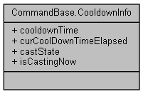

### Public Attributes

float **cooldownTime**

float **curCoolDownTimeElapsed**

**CastState** **castState**

bool **isCastingNow**

### Member Data Documentation

#### CastState CommandBase.CooldownInfo.castState

#### float CommandBase.CooldownInfo.cooldownTime

#### float CommandBase.CooldownInfo.curCoolDownTimeElapsed

#### bool CommandBase.CooldownInfo.isCastingNow

#### The documentation for this struct was generated from the following file:

C:/_SSDSPEEDUP/2021/clone/gps1_manadesigner/GPS1-Manadesigner/Assets/_UtilsV0.4/MyScripts/_Utils/CommandPattern/Command/SOScripts/**CommandBase.cs**

## UnityEngine.PostProcessing.ColorGradingModel.CurvesSettings Struct Reference

Collaboration diagram for UnityEngine.PostProcessing.ColorGradingModel.CurvesSettings:

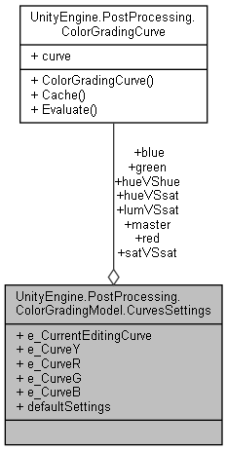

### Public Attributes

**ColorGradingCurve** **master**

**ColorGradingCurve** **red**

**ColorGradingCurve** **green**

**ColorGradingCurve** **blue**

**ColorGradingCurve** **hueVShue**

**ColorGradingCurve** **hueVSsat**

**ColorGradingCurve** **satVSsat**

**ColorGradingCurve** **lumVSsat**

int **e_CurrentEditingCurve**

bool **e_CurveY**

bool **e_CurveR**

bool **e_CurveG**

bool **e_CurveB**

### Properties

static **CurvesSettings** **defaultSettings** [get]

### Member Data Documentation

#### ColorGradingCurve UnityEngine.PostProcessing.ColorGradingModel.CurvesSettings.blue

#### int UnityEngine.PostProcessing.ColorGradingModel.CurvesSettings.e_CurrentEditingCurve

#### bool UnityEngine.PostProcessing.ColorGradingModel.CurvesSettings.e_CurveB

#### bool UnityEngine.PostProcessing.ColorGradingModel.CurvesSettings.e_CurveG

#### bool UnityEngine.PostProcessing.ColorGradingModel.CurvesSettings.e_CurveR

#### bool UnityEngine.PostProcessing.ColorGradingModel.CurvesSettings.e_CurveY

#### ColorGradingCurve UnityEngine.PostProcessing.ColorGradingModel.CurvesSettings.green

#### ColorGradingCurve UnityEngine.PostProcessing.ColorGradingModel.CurvesSettings.hueVShue

#### ColorGradingCurve UnityEngine.PostProcessing.ColorGradingModel.CurvesSettings.hueVSsat

#### ColorGradingCurve UnityEngine.PostProcessing.ColorGradingModel.CurvesSettings.lumVSsat

#### ColorGradingCurve UnityEngine.PostProcessing.ColorGradingModel.CurvesSettings.master

#### ColorGradingCurve UnityEngine.PostProcessing.ColorGradingModel.CurvesSettings.red

#### ColorGradingCurve UnityEngine.PostProcessing.ColorGradingModel.CurvesSettings.satVSsat

### Property Documentation

#### CurvesSettings UnityEngine.PostProcessing.ColorGradingModel.CurvesSettings.defaultSettings[static], [get]

#### The documentation for this struct was generated from the following file:

C:/_SSDSPEEDUP/2021/clone/gps1_manadesigner/GPS1-Manadesigner/Assets/Samples/Input System/1.0.2/Tanks Demo/TanksDemo/PostProcessing/Runtime/Models/**ColorGradingModel.cs**

## CustomComposite Class Reference

Inheritance diagram for CustomComposite:

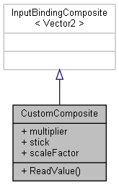

Collaboration diagram for CustomComposite:



### Public Member Functions

override Vector2 **ReadValue** (ref InputBindingCompositeContext context)

### Public Attributes

int **multiplier**

int **stick**

float **scaleFactor** = 1

### Member Function Documentation

#### override Vector2 CustomComposite.ReadValue (ref InputBindingCompositeContext *context*)

### Member Data Documentation

#### int CustomComposite.multiplier

#### float CustomComposite.scaleFactor = 1

#### int CustomComposite.stick

#### The documentation for this class was generated from the following file:

C:/_SSDSPEEDUP/2021/clone/gps1_manadesigner/GPS1-Manadesigner/Assets/Samples/Input System/1.0.2/Custom Binding Composite/**CustomComposite.cs**

## CustomDevice Class Reference

Inheritance diagram for CustomDevice:

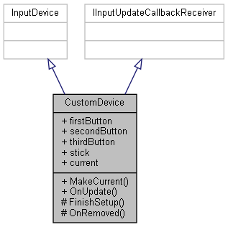

Collaboration diagram for CustomDevice:



### Public Member Functions

override void **MakeCurrent** ()

void **OnUpdate** ()

### Protected Member Functions

override void **FinishSetup** ()

override void **OnRemoved** ()

### Properties

ButtonControl **firstButton** [get]

ButtonControl **secondButton** [get]

ButtonControl **thirdButton** [get]

StickControl **stick** [get]

static **CustomDevice** **current** [get]

### Member Function Documentation

#### override void CustomDevice.FinishSetup ()[protected]

#### override void CustomDevice.MakeCurrent ()

#### override void CustomDevice.OnRemoved ()[protected]

#### void CustomDevice.OnUpdate ()

### Property Documentation

#### CustomDevice CustomDevice.current[static], [get]

#### ButtonControl CustomDevice.firstButton[get]

#### ButtonControl CustomDevice.secondButton[get]

#### StickControl CustomDevice.stick[get]

#### ButtonControl CustomDevice.thirdButton[get]

#### The documentation for this class was generated from the following file:

C:/_SSDSPEEDUP/2021/clone/gps1_manadesigner/GPS1-Manadesigner/Assets/Samples/Input System/1.0.2/Custom Device/**CustomDevice.cs**

## CustomDeviceState Struct Reference

Inheritance diagram for CustomDeviceState:

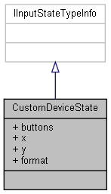

Collaboration diagram for CustomDeviceState:



### Public Attributes

ushort **buttons**

byte **x**

byte **y**

### Properties

FourCC **format** [get]

### Member Data Documentation

#### ushort CustomDeviceState.buttons

#### byte CustomDeviceState.x

#### byte CustomDeviceState.y

### Property Documentation

#### FourCC CustomDeviceState.format[get]

#### The documentation for this struct was generated from the following file:

C:/_SSDSPEEDUP/2021/clone/gps1_manadesigner/GPS1-Manadesigner/Assets/Samples/Input System/1.0.2/Custom Device/**CustomDevice.cs**

## CustomDeviceUsages Class Reference

Inheritance diagram for CustomDeviceUsages:

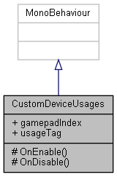

Collaboration diagram for CustomDeviceUsages:



### Public Attributes

int **gamepadIndex**

string **usageTag**

### Protected Member Functions

void **OnEnable** ()

void **OnDisable** ()

### Member Function Documentation

#### void CustomDeviceUsages.OnDisable ()[protected]

#### void CustomDeviceUsages.OnEnable ()[protected]

### Member Data Documentation

#### int CustomDeviceUsages.gamepadIndex

#### string CustomDeviceUsages.usageTag

#### The documentation for this class was generated from the following file:

C:/_SSDSPEEDUP/2021/clone/gps1_manadesigner/GPS1-Manadesigner/Assets/Samples/Input System/1.0.2/Custom Device Usages/**CustomDeviceUsages.cs**

## DayCounter Class Reference

Inheritance diagram for DayCounter:

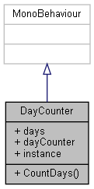

Collaboration diagram for DayCounter:

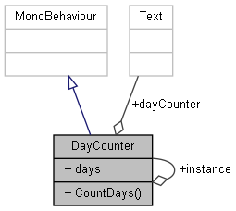

### Public Member Functions

void **CountDays** ()

### Public Attributes

int **days** = 0

Text **dayCounter**

### Static Public Attributes

static **DayCounter** **instance**

### Member Function Documentation

#### void DayCounter.CountDays ()

### Member Data Documentation

#### Text DayCounter.dayCounter

#### int DayCounter.days = 0

#### DayCounter DayCounter.instance[static]

#### The documentation for this class was generated from the following file:

C:/_SSDSPEEDUP/2021/clone/gps1_manadesigner/GPS1-Manadesigner/Assets/Scripts/Stage Scripts/Outpost/**DayCounter.cs**

## DefaultState Class Reference

Inheritance diagram for DefaultState:

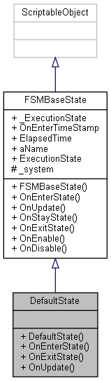

Collaboration diagram for DefaultState:

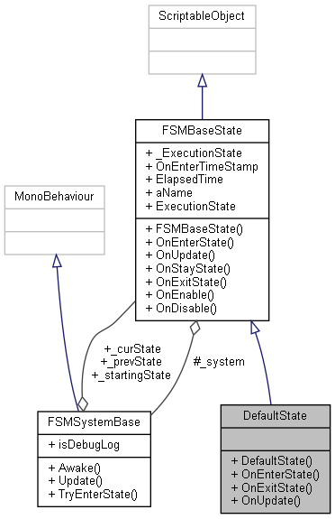

### Public Member Functions

**DefaultState** (**FSMSystemBase** system)

override bool **OnEnterState** ()

override bool **OnExitState** ()

override void **OnUpdate** ()

### Additional Inherited Members

### Constructor & Destructor Documentation

#### DefaultState.DefaultState (FSMSystemBase *system*)

### Member Function Documentation

#### override bool DefaultState.OnEnterState ()[virtual]

Reimplemented from **FSMBaseState** (*p.279*).

#### override bool DefaultState.OnExitState ()[virtual]

Reimplemented from **FSMBaseState** (*p.279*).

#### override void DefaultState.OnUpdate ()[virtual]

Reimplemented from **FSMBaseState** (*p.279*).

#### The documentation for this class was generated from the following file:

C:/_SSDSPEEDUP/2021/clone/gps1_manadesigner/GPS1-Manadesigner/Assets/_UtilsV0.4/MyScripts/_Utils/__Experimental/AIApproach/StatePattern/**NPCAIStatesTypeA.cs**

## UnityEngine.PostProcessing.DepthOfFieldComponent Class Reference

Inheritance diagram for UnityEngine.PostProcessing.DepthOfFieldComponent:

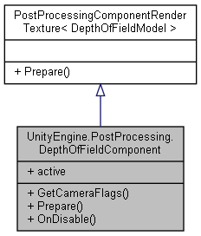

Collaboration diagram for UnityEngine.PostProcessing.DepthOfFieldComponent:



### Public Member Functions

override DepthTextureMode **GetCameraFlags** ()

void **Prepare** (RenderTexture source, Material uberMaterial, bool antialiasCoC)

override void **OnDisable** ()

### Properties

override bool **active** [get]

### Member Function Documentation

#### override DepthTextureMode UnityEngine.PostProcessing.DepthOfFieldComponent.GetCameraFlags ()

#### override void UnityEngine.PostProcessing.DepthOfFieldComponent.OnDisable ()

#### void UnityEngine.PostProcessing.DepthOfFieldComponent.Prepare (RenderTexture *source*, Material *uberMaterial*, bool *antialiasCoC*)

Here is the call graph for this function:

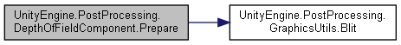

### Property Documentation

#### override bool UnityEngine.PostProcessing.DepthOfFieldComponent.active[get]

#### The documentation for this class was generated from the following file:

C:/_SSDSPEEDUP/2021/clone/gps1_manadesigner/GPS1-Manadesigner/Assets/Samples/Input System/1.0.2/Tanks Demo/TanksDemo/PostProcessing/Runtime/Components/**DepthOfFieldComponent.cs**

## UnityEngine.PostProcessing.DepthOfFieldModel Class Reference

Inheritance diagram for UnityEngine.PostProcessing.DepthOfFieldModel:

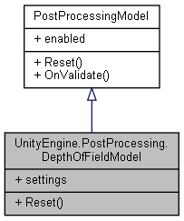

Collaboration diagram for UnityEngine.PostProcessing.DepthOfFieldModel:



### Classes

struct **Settings**

### Public Types

enum **KernelSize** { **Small**, **Medium**, **Large**, **VeryLarge** }

### Public Member Functions

override void **Reset** ()

### Properties

**Settings** **settings** [getset]

### Member Enumeration Documentation

#### enum UnityEngine.PostProcessing.DepthOfFieldModel.KernelSize

##### Enumerator:

|  |  |
| --- | --- |
| Small |  |
| Medium |  |
| Large |  |
| VeryLarge |  |

### Member Function Documentation

#### override void UnityEngine.PostProcessing.DepthOfFieldModel.Reset ()[virtual]

Implements **UnityEngine.PostProcessing.PostProcessingModel** (*p.597*).

### Property Documentation

#### Settings UnityEngine.PostProcessing.DepthOfFieldModel.settings[get], [set]

#### The documentation for this class was generated from the following file:

C:/_SSDSPEEDUP/2021/clone/gps1_manadesigner/GPS1-Manadesigner/Assets/Samples/Input System/1.0.2/Tanks Demo/TanksDemo/PostProcessing/Runtime/Models/**DepthOfFieldModel.cs**

## UnityEngine.PostProcessing.BuiltinDebugViewsModel.DepthSettings Struct Reference

Collaboration diagram for UnityEngine.PostProcessing.BuiltinDebugViewsModel.DepthSettings:

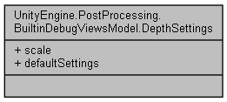

### Public Attributes

float **scale**

### Properties

static **DepthSettings** **defaultSettings** [get]

### Member Data Documentation

#### float UnityEngine.PostProcessing.BuiltinDebugViewsModel.DepthSettings.scale

### Property Documentation

#### DepthSettings UnityEngine.PostProcessing.BuiltinDebugViewsModel.DepthSettings.defaultSettings[static], [get]

#### The documentation for this struct was generated from the following file:

C:/_SSDSPEEDUP/2021/clone/gps1_manadesigner/GPS1-Manadesigner/Assets/Samples/Input System/1.0.2/Tanks Demo/TanksDemo/PostProcessing/Runtime/Models/**BuiltinDebugViewsModel.cs**

## DestroyBySeconds Class Reference

Inheritance diagram for DestroyBySeconds:

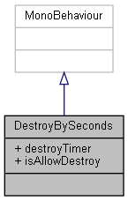

Collaboration diagram for DestroyBySeconds:



### Public Attributes

float **destroyTimer** = 3f

bool **isAllowDestroy** = true

### Member Data Documentation

#### float DestroyBySeconds.destroyTimer = 3f

#### bool DestroyBySeconds.isAllowDestroy = true

#### The documentation for this class was generated from the following file:

C:/_SSDSPEEDUP/2021/clone/gps1_manadesigner/GPS1-Manadesigner/Assets/_UtilsV0.4/MyScripts/_Utils/_CommonV0.2/Monobehavior/**DestroyBySeconds.cs**

## DialogueSystem.DIALOGUE_ELEMENTS Class Reference

Collaboration diagram for DialogueSystem.DIALOGUE_ELEMENTS:

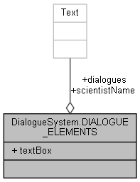

### Public Attributes

GameObject **textBox**

Text **scientistName**

Text **dialogues**

### Member Data Documentation

#### Text DialogueSystem.DIALOGUE_ELEMENTS.dialogues

#### Text DialogueSystem.DIALOGUE_ELEMENTS.scientistName

#### GameObject DialogueSystem.DIALOGUE_ELEMENTS.textBox

#### The documentation for this class was generated from the following file:

C:/_SSDSPEEDUP/2021/clone/gps1_manadesigner/GPS1-Manadesigner/Assets/Scripts/Stage Scripts/Outpost/Dialogues/**DialogueSystem.cs**

## DialogueSystem Class Reference

Inheritance diagram for DialogueSystem:

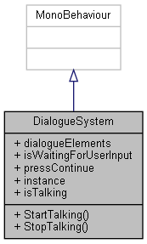

Collaboration diagram for DialogueSystem:

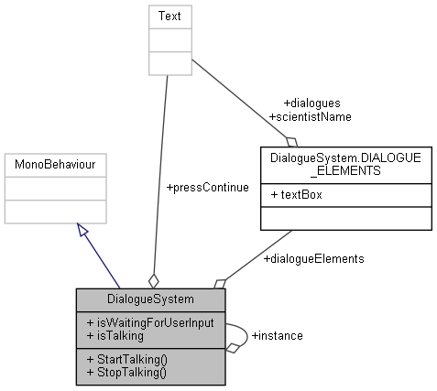

### Classes

class **DIALOGUE_ELEMENTS**

### Public Member Functions

void **StartTalking** (string speech, string speaker="")

void **StopTalking** ()

### Public Attributes

**DIALOGUE_ELEMENTS** **dialogueElements**

bool **isWaitingForUserInput** = false

Text **pressContinue**

### Static Public Attributes

static **DialogueSystem** **instance**

### Properties

bool **isTalking** [get]

### Member Function Documentation

#### void DialogueSystem.StartTalking (string *speech*, string *speaker* = "")

Here is the call graph for this function:



#### void DialogueSystem.StopTalking ()

Here is the caller graph for this function:



### Member Data Documentation

#### DIALOGUE_ELEMENTS DialogueSystem.dialogueElements

#### DialogueSystem DialogueSystem.instance[static]

#### bool DialogueSystem.isWaitingForUserInput = false

#### Text DialogueSystem.pressContinue

### Property Documentation

#### bool DialogueSystem.isTalking[get]

#### The documentation for this class was generated from the following file:

C:/_SSDSPEEDUP/2021/clone/gps1_manadesigner/GPS1-Manadesigner/Assets/Scripts/Stage Scripts/Outpost/Dialogues/**DialogueSystem.cs**

## UnityEngine.PostProcessing.DitheringComponent Class Reference

Inheritance diagram for UnityEngine.PostProcessing.DitheringComponent:

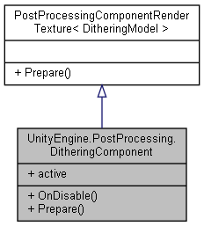

Collaboration diagram for UnityEngine.PostProcessing.DitheringComponent:



### Public Member Functions

override void **OnDisable** ()

override void **Prepare** (Material uberMaterial)

### Properties

override bool **active** [get]

### Member Function Documentation

#### override void UnityEngine.PostProcessing.DitheringComponent.OnDisable ()

#### override void UnityEngine.PostProcessing.DitheringComponent.Prepare (Material *uberMaterial*)[virtual]

Reimplemented from **UnityEngine.PostProcessing.PostProcessingComponentRenderTexture< DitheringModel >** (*p.594*).

### Property Documentation

#### override bool UnityEngine.PostProcessing.DitheringComponent.active[get]

#### The documentation for this class was generated from the following file:

C:/_SSDSPEEDUP/2021/clone/gps1_manadesigner/GPS1-Manadesigner/Assets/Samples/Input System/1.0.2/Tanks Demo/TanksDemo/PostProcessing/Runtime/Components/**DitheringComponent.cs**

## UnityEngine.PostProcessing.DitheringModel Class Reference

Inheritance diagram for UnityEngine.PostProcessing.DitheringModel:

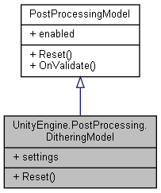

Collaboration diagram for UnityEngine.PostProcessing.DitheringModel:



### Classes

struct **Settings**

### Public Member Functions

override void **Reset** ()

### Properties

**Settings** **settings** [getset]

### Member Function Documentation

#### override void UnityEngine.PostProcessing.DitheringModel.Reset ()[virtual]

Implements **UnityEngine.PostProcessing.PostProcessingModel** (*p.597*).

### Property Documentation

#### Settings UnityEngine.PostProcessing.DitheringModel.settings[get], [set]

#### The documentation for this class was generated from the following file:

C:/_SSDSPEEDUP/2021/clone/gps1_manadesigner/GPS1-Manadesigner/Assets/Samples/Input System/1.0.2/Tanks Demo/TanksDemo/PostProcessing/Runtime/Models/**DitheringModel.cs**

## DontDestroyOnLoad Class Reference

Inheritance diagram for DontDestroyOnLoad:

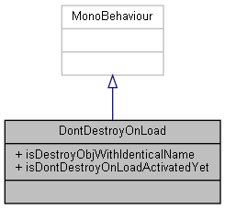

Collaboration diagram for DontDestroyOnLoad:



### Public Attributes

bool **isDestroyObjWithIdenticalName** = true

bool **isDontDestroyOnLoadActivatedYet**

### Member Data Documentation

#### bool DontDestroyOnLoad.isDestroyObjWithIdenticalName = true

#### bool DontDestroyOnLoad.isDontDestroyOnLoadActivatedYet

#### The documentation for this class was generated from the following file:

C:/_SSDSPEEDUP/2021/clone/gps1_manadesigner/GPS1-Manadesigner/Assets/_UtilsV0.4/MyScripts/_Utils/_CommonV0.2/Monobehavior/**DontDestroyOnLoad.cs**

## DoxygenConfig Class Reference

Collaboration diagram for DoxygenConfig:

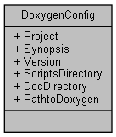

### Public Attributes

string **Project** = PlayerSettings.productName

string **Synopsis** = ""

string **Version** = ""

string **ScriptsDirectory** = Application.dataPath

string **DocDirectory** = Application.dataPath.Replace("Assets", "Docs")

string **PathtoDoxygen** = ""

### Detailed Description

A small data structure class hold values for making Doxygen config files

### Member Data Documentation

#### string DoxygenConfig.DocDirectory = Application.dataPath.Replace("Assets", "Docs")

#### string DoxygenConfig.PathtoDoxygen = ""

#### string DoxygenConfig.Project = PlayerSettings.productName

#### string DoxygenConfig.ScriptsDirectory = Application.dataPath

#### string DoxygenConfig.Synopsis = ""

#### string DoxygenConfig.Version = ""

#### The documentation for this class was generated from the following file:

C:/_SSDSPEEDUP/2021/clone/gps1_manadesigner/GPS1-Manadesigner/Assets/Editor/Doxygen/**DoxygenWindow.cs**

## DoxygenWindow Class Reference

Inheritance diagram for DoxygenWindow:

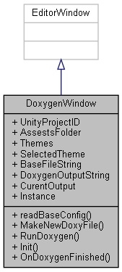

Collaboration diagram for DoxygenWindow:

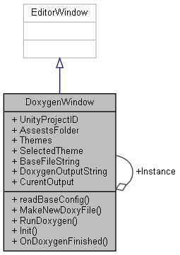

### Public Types

enum **WindowModes** { **Generate**, **Configuration**, **About** }

### Public Member Functions

void **readBaseConfig** ()

void **MakeNewDoxyFile** (**DoxygenConfig** config)

void **RunDoxygen** ()

### Static Public Member Functions

static void **Init** ()

static void **OnDoxygenFinished** (int code)

### Public Attributes

string **UnityProjectID** = PlayerSettings.productName+":"

string **AssestsFolder** = Application.dataPath

string[] **Themes** = new string[3] {"Default", "Dark and Colorful", "Light and Clean"}

int **SelectedTheme** = 1

string **BaseFileString** = null

string **DoxygenOutputString** = null

string **CurentOutput** = null

### Static Public Attributes

static **DoxygenWindow** **Instance**

### Detailed Description

A Editor Plugin for automatic doc generation through Doxygen

Author: Jacob Pennock (http://Jacobpennock.com)

Version: 1.0

### Member Enumeration Documentation

#### enum DoxygenWindow.WindowModes

##### Enumerator:

|  |  |
| --- | --- |
| Generate |  |
| Configuration |  |
| About |  |

### Member Function Documentation

#### static void DoxygenWindow.Init ()[static]

#### void DoxygenWindow.MakeNewDoxyFile (DoxygenConfig *config*)

#### static void DoxygenWindow.OnDoxygenFinished (int *code*)[static]

Here is the caller graph for this function:



#### void DoxygenWindow.readBaseConfig ()

#### void DoxygenWindow.RunDoxygen ()

Here is the call graph for this function:

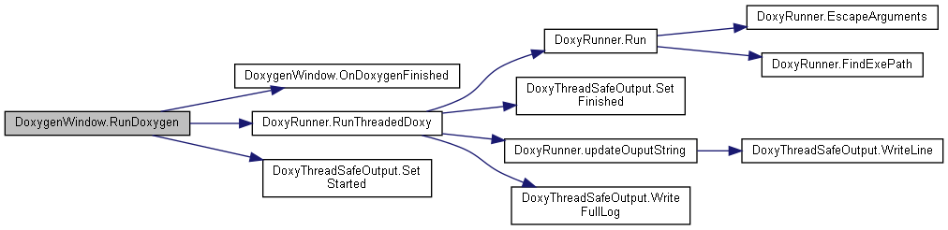

### Member Data Documentation

#### string DoxygenWindow.AssestsFolder = Application.dataPath

#### string DoxygenWindow.BaseFileString = null

#### string DoxygenWindow.CurentOutput = null

#### string DoxygenWindow.DoxygenOutputString = null

#### DoxygenWindow DoxygenWindow.Instance[static]

#### int DoxygenWindow.SelectedTheme = 1

#### string [] DoxygenWindow.Themes = new string[3] {"Default", "Dark and Colorful", "Light and Clean"}

#### string DoxygenWindow.UnityProjectID = PlayerSettings.productName+":"

#### The documentation for this class was generated from the following file:

C:/_SSDSPEEDUP/2021/clone/gps1_manadesigner/GPS1-Manadesigner/Assets/Editor/Doxygen/**DoxygenWindow.cs**

## DoxyRunner Class Reference

This class spawns and runs Doxygen in a separate thread, and could serve as an example of how to create plugins for unity that call a command line application and then get the data back into Unity safely.

Collaboration diagram for DoxyRunner:

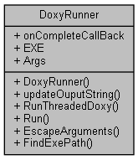

### Public Member Functions

**DoxyRunner** (string exepath, string[] args, **DoxyThreadSafeOutput** safeoutput, Action< int > callback)

void **updateOuputString** (string output)

void **RunThreadedDoxy** ()

### Static Public Member Functions

static int **Run** (Action< string > output, TextReader input, string exe, params string[] args)

*Runs the specified executable with the provided arguments and returns the process' exit code.*

static string **EscapeArguments** (params string[] args)

*Quotes all arguments that contain whitespace, or begin with a quote and returns a single argument string for use with Process.Start().*

static string **FindExePath** (string exe)

*Expands environment variables and, if unqualified, locates the exe in the working directory or the evironment's path.*

### Public Attributes

Action< int > **onCompleteCallBack**

string **EXE** = null

string[] **Args**

### Detailed Description

This class spawns and runs Doxygen in a separate thread, and could serve as an example of how to create plugins for unity that call a command line application and then get the data back into Unity safely.

### Constructor & Destructor Documentation

#### DoxyRunner.DoxyRunner (string *exepath*, string[] *args*, DoxyThreadSafeOutput *safeoutput*, Action< int > *callback*)

### Member Function Documentation

#### static string DoxyRunner.EscapeArguments (params string[] *args*)[static]

Quotes all arguments that contain whitespace, or begin with a quote and returns a single argument string for use with Process.Start().

##### Parameters

|  |  |
| --- | --- |
| *args* | A list of strings for arguments, may not contain null, '\0', '\r', or '  ' |

##### Returns

The combined list of escaped/quoted strings

##### Exceptions

|  |  |
| --- | --- |
| *System.ArgumentNullException* | Raised when one of the arguments is null |
| *System.ArgumentOutOfRangeException* | Raised if an argument contains '\0', '\r', or '  ' |

Here is the caller graph for this function:



#### static string DoxyRunner.FindExePath (string *exe*)[static]

Expands environment variables and, if unqualified, locates the exe in the working directory or the evironment's path.

##### Parameters

|  |  |
| --- | --- |
| *exe* | The name of the executable file |

##### Returns

The fully-qualified path to the file

##### Exceptions

|  |  |
| --- | --- |
| *System.IO.FileNotFoundException* | Raised when the exe was not found |

Here is the caller graph for this function:



#### static int DoxyRunner.Run (Action< string > *output*, TextReader *input*, string *exe*, params string[] *args*)[static]

Runs the specified executable with the provided arguments and returns the process' exit code.

##### Parameters

|  |  |
| --- | --- |
| *output* | Recieves the output of either std/err or std/out |
| *input* | Provides the line-by-line input that will be written to std/in, null for empty |
| *exe* | The executable to run, may be unqualified or contain environment variables |
| *args* | The list of unescaped arguments to provide to the executable |

##### Returns

Returns process' exit code after the program exits

##### Exceptions

|  |  |
| --- | --- |
| *System.IO.FileNotFoundException* | Raised when the exe was not found |
| *System.ArgumentNullException* | Raised when one of the arguments is null |
| *System.ArgumentOutOfRangeException* | Raised if an argument contains '\0', '\r', or '  ' |

Here is the call graph for this function:

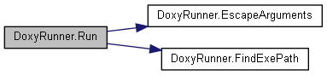

Here is the caller graph for this function:



#### void DoxyRunner.RunThreadedDoxy ()

Here is the call graph for this function:

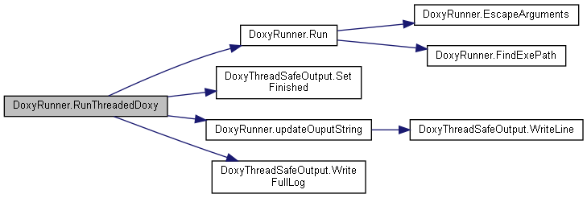

Here is the caller graph for this function:



#### void DoxyRunner.updateOuputString (string *output*)

Here is the call graph for this function:



Here is the caller graph for this function:



### Member Data Documentation

#### string [] DoxyRunner.Args

#### string DoxyRunner.EXE = null

#### Action<int> DoxyRunner.onCompleteCallBack

#### The documentation for this class was generated from the following file:

C:/_SSDSPEEDUP/2021/clone/gps1_manadesigner/GPS1-Manadesigner/Assets/Editor/Doxygen/**DoxygenWindow.cs**

## DoxyThreadSafeOutput Class Reference

This class encapsulates the data output by Doxygen so it can be shared with Unity in a thread share way.

Collaboration diagram for DoxyThreadSafeOutput:

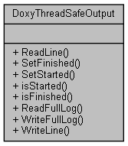

### Public Member Functions

string **ReadLine** ()

void **SetFinished** ()

void **SetStarted** ()

bool **isStarted** ()

bool **isFinished** ()

List< string > **ReadFullLog** ()

void **WriteFullLog** (List< string > newLog)

void **WriteLine** (string newOutput)

### Detailed Description

This class encapsulates the data output by Doxygen so it can be shared with Unity in a thread share way.

### Member Function Documentation

#### bool DoxyThreadSafeOutput.isFinished ()

#### bool DoxyThreadSafeOutput.isStarted ()

#### List< string > DoxyThreadSafeOutput.ReadFullLog ()

#### string DoxyThreadSafeOutput.ReadLine ()

#### void DoxyThreadSafeOutput.SetFinished ()

Here is the caller graph for this function:



#### void DoxyThreadSafeOutput.SetStarted ()

Here is the caller graph for this function:

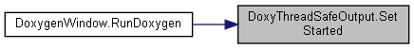

#### void DoxyThreadSafeOutput.WriteFullLog (List< string > *newLog*)

Here is the caller graph for this function:



#### void DoxyThreadSafeOutput.WriteLine (string *newOutput*)

Here is the caller graph for this function:



#### The documentation for this class was generated from the following file:

C:/_SSDSPEEDUP/2021/clone/gps1_manadesigner/GPS1-Manadesigner/Assets/Editor/Doxygen/**DoxygenWindow.cs**

## EnableDisableGameObjectCommand Class Reference

Inheritance diagram for EnableDisableGameObjectCommand:

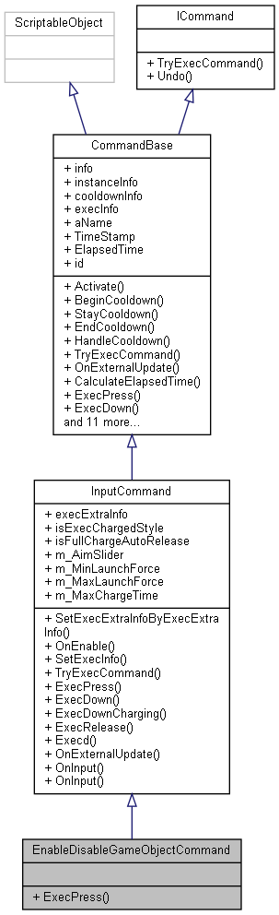

Collaboration diagram for EnableDisableGameObjectCommand:

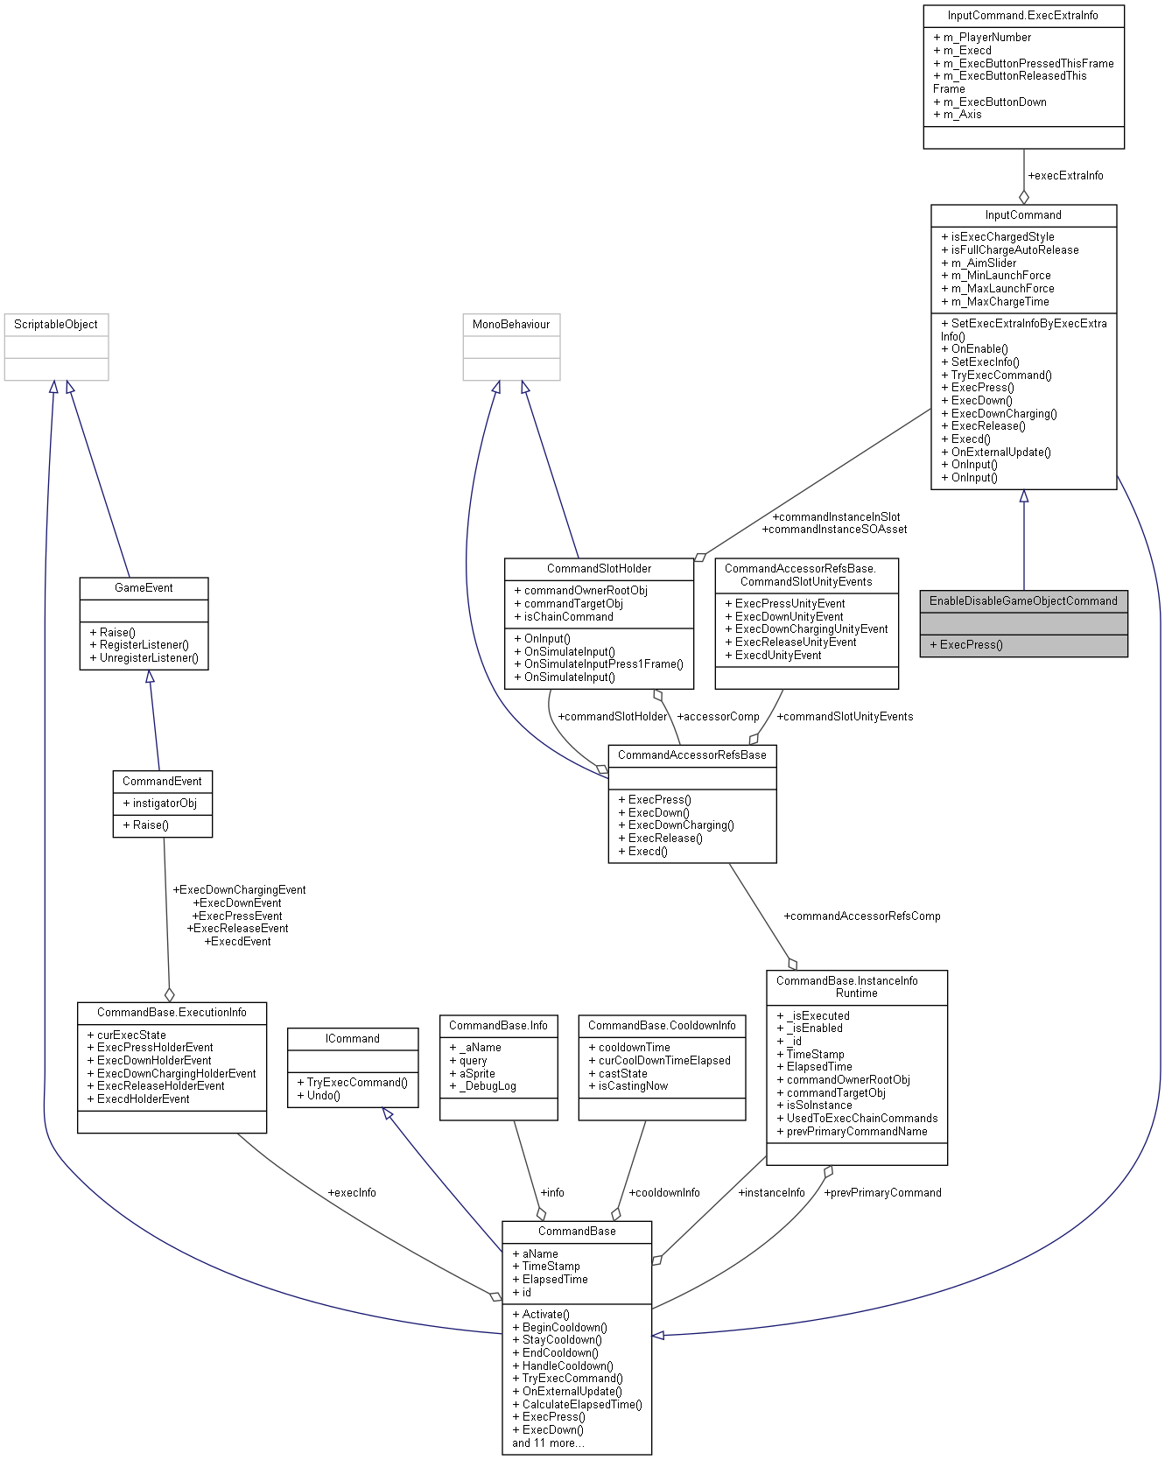

### Public Member Functions

override void **ExecPress** ()

### Additional Inherited Members

### Member Function Documentation

#### override void EnableDisableGameObjectCommand.ExecPress ()[virtual]

Reimplemented from **InputCommand** (*p.370*).

#### The documentation for this class was generated from the following file:

C:/_SSDSPEEDUP/2021/clone/gps1_manadesigner/GPS1-Manadesigner/Assets/_UtilsV0.4/MyScripts/_Utils/CommandPattern/Command/SOScripts/Misc/**EnableDisableGameObjectCommand.cs**

## EnemyAttack Class Reference

Inheritance diagram for EnemyAttack:

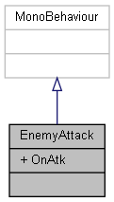

Collaboration diagram for EnemyAttack:



### Public Attributes

UnityEvent **OnAtk**

### Member Data Documentation

#### UnityEvent EnemyAttack.OnAtk

#### The documentation for this class was generated from the following file:

C:/_SSDSPEEDUP/2021/clone/gps1_manadesigner/GPS1-Manadesigner/Assets/**EnemyAttack.cs**

## EnemyFinder Class Reference

Inheritance diagram for EnemyFinder:

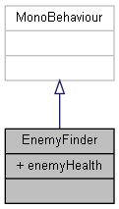

Collaboration diagram for EnemyFinder:

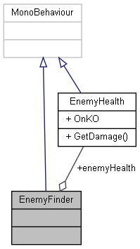

### Public Attributes

**EnemyHealth** **enemyHealth**

### Member Data Documentation

#### EnemyHealth EnemyFinder.enemyHealth

#### The documentation for this class was generated from the following file:

C:/_SSDSPEEDUP/2021/clone/gps1_manadesigner/GPS1-Manadesigner/Assets/**EnemyFinder.cs**

## EnemyHealth Class Reference

Inheritance diagram for EnemyHealth:

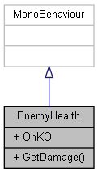

Collaboration diagram for EnemyHealth:



### Public Member Functions

void **GetDamage** (float damage)

### Public Attributes

UnityEvent **OnKO**

### Member Function Documentation

#### void EnemyHealth.GetDamage (float *damage*)

Here is the caller graph for this function:



### Member Data Documentation

#### UnityEvent EnemyHealth.OnKO

#### The documentation for this class was generated from the following file:

C:/_SSDSPEEDUP/2021/clone/gps1_manadesigner/GPS1-Manadesigner/Assets/**EnemyHealth.cs**

## EnemyMovement Class Reference

Inheritance diagram for EnemyMovement:

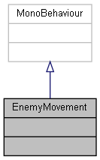

Collaboration diagram for EnemyMovement:



The documentation for this class was generated from the following file:

C:/_SSDSPEEDUP/2021/clone/gps1_manadesigner/GPS1-Manadesigner/Assets/**EnemyMovement.cs**

## EventEditor Class Reference

Inheritance diagram for EventEditor:

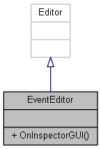

Collaboration diagram for EventEditor:



### Public Member Functions

override void **OnInspectorGUI** ()

### Member Function Documentation

#### override void EventEditor.OnInspectorGUI ()

Here is the call graph for this function:

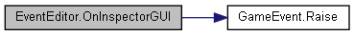

#### The documentation for this class was generated from the following file:

C:/_SSDSPEEDUP/2021/clone/gps1_manadesigner/GPS1-Manadesigner/Assets/_UtilsV0.4/MyScripts/_Utils/CommandPattern/Events/Editor/**EventEditor.cs**

## InputCommand.ExecExtraInfo Struct Reference

Collaboration diagram for InputCommand.ExecExtraInfo:

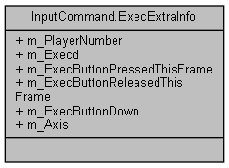

### Public Attributes

int **m_PlayerNumber**

bool **m_Execd**

bool **m_ExecButtonPressedThisFrame**

bool **m_ExecButtonReleasedThisFrame**

bool **m_ExecButtonDown**

float **m_Axis**

### Member Data Documentation

#### float InputCommand.ExecExtraInfo.m_Axis

#### bool InputCommand.ExecExtraInfo.m_ExecButtonDown

#### bool InputCommand.ExecExtraInfo.m_ExecButtonPressedThisFrame

#### bool InputCommand.ExecExtraInfo.m_ExecButtonReleasedThisFrame

#### bool InputCommand.ExecExtraInfo.m_Execd

#### int InputCommand.ExecExtraInfo.m_PlayerNumber

#### The documentation for this struct was generated from the following file:

C:/_SSDSPEEDUP/2021/clone/gps1_manadesigner/GPS1-Manadesigner/Assets/_UtilsV0.4/MyScripts/_Utils/CommandPattern/Command/SOScripts/**InputCommand.cs**

## CommandBase.ExecutionInfo Class Reference

Collaboration diagram for CommandBase.ExecutionInfo:

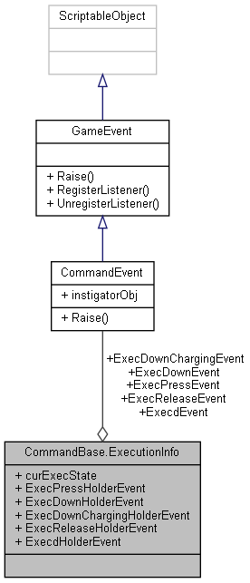

### Public Attributes

**ExecStatus** **curExecState**

UnityAction **ExecPressHolderEvent**

UnityAction **ExecDownHolderEvent**

UnityAction **ExecDownChargingHolderEvent**

UnityAction **ExecReleaseHolderEvent**

UnityAction **ExecdHolderEvent**

**CommandEvent** **ExecPressEvent**

**CommandEvent** **ExecDownEvent**

**CommandEvent** **ExecDownChargingEvent**

**CommandEvent** **ExecReleaseEvent**

**CommandEvent** **ExecdEvent**

### Member Data Documentation

#### ExecStatus CommandBase.ExecutionInfo.curExecState

#### CommandEvent CommandBase.ExecutionInfo.ExecdEvent

#### UnityAction CommandBase.ExecutionInfo.ExecdHolderEvent

#### CommandEvent CommandBase.ExecutionInfo.ExecDownChargingEvent

#### UnityAction CommandBase.ExecutionInfo.ExecDownChargingHolderEvent

#### CommandEvent CommandBase.ExecutionInfo.ExecDownEvent

#### UnityAction CommandBase.ExecutionInfo.ExecDownHolderEvent

#### CommandEvent CommandBase.ExecutionInfo.ExecPressEvent

#### UnityAction CommandBase.ExecutionInfo.ExecPressHolderEvent

#### CommandEvent CommandBase.ExecutionInfo.ExecReleaseEvent

#### UnityAction CommandBase.ExecutionInfo.ExecReleaseHolderEvent

#### The documentation for this class was generated from the following file:

C:/_SSDSPEEDUP/2021/clone/gps1_manadesigner/GPS1-Manadesigner/Assets/_UtilsV0.4/MyScripts/_Utils/CommandPattern/Command/SOScripts/**CommandBase.cs**

## ExtendedScriptableObjectDrawer Class Reference

Extends how ScriptableObject object references are displayed in the inspector Shows you all values under the object reference Also provides a button to create a new ScriptableObject if property is null.

Inheritance diagram for ExtendedScriptableObjectDrawer:

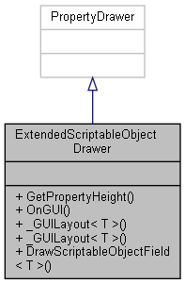

Collaboration diagram for ExtendedScriptableObjectDrawer:



### Public Member Functions

override float **GetPropertyHeight** (SerializedProperty property, GUIContent label)

override void **OnGUI** (Rect position, SerializedProperty property, GUIContent label)

### Static Public Member Functions

static T **_GUILayout< T >** (string label, T objectReferenceValue, ref bool isExpanded)

static T **_GUILayout< T >** (GUIContent label, T objectReferenceValue, ref bool isExpanded)

static T **DrawScriptableObjectField< T >** (GUIContent label, T objectReferenceValue, ref bool isExpanded)

### Detailed Description

Extends how ScriptableObject object references are displayed in the inspector Shows you all values under the object reference Also provides a button to create a new ScriptableObject if property is null.

### Member Function Documentation

#### static T ExtendedScriptableObjectDrawer._GUILayout< T > (GUIContent *label*, T *objectReferenceValue*, ref bool *isExpanded*)[static]

**Type Constraints**

*T* : *ScriptableObject*

#### static T ExtendedScriptableObjectDrawer._GUILayout< T > (string *label*, T *objectReferenceValue*, ref bool *isExpanded*)[static]

**Type Constraints**

*T* : *ScriptableObject*

Here is the call graph for this function:

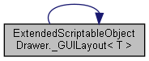

Here is the caller graph for this function:

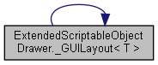

#### static T ExtendedScriptableObjectDrawer.DrawScriptableObjectField< T > (GUIContent *label*, T *objectReferenceValue*, ref bool *isExpanded*)[static]

**Type Constraints**

*T* : *ScriptableObject*

#### override float ExtendedScriptableObjectDrawer.GetPropertyHeight (SerializedProperty *property*, GUIContent *label*)

#### override void ExtendedScriptableObjectDrawer.OnGUI (Rect *position*, SerializedProperty *property*, GUIContent *label*)

#### The documentation for this class was generated from the following file:

C:/_SSDSPEEDUP/2021/clone/gps1_manadesigner/GPS1-Manadesigner/Assets/Scripts/Editor/_Utils/SerializableDataStructures/**ExtendedScriptableObjectDrawer.cs**

## Extensions Class Reference

Collaboration diagram for Extensions:

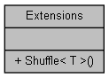

### Static Public Member Functions

static void **Shuffle< T >** (this IList< T > list)

### Member Function Documentation

#### static void Extensions.Shuffle< T > (this IList< T > *list*)[static]

#### The documentation for this class was generated from the following file:

C:/_SSDSPEEDUP/2021/clone/gps1_manadesigner/GPS1-Manadesigner/Assets/Scripts/Arif's Test Scripts/**Extensions.cs**

## UnityEngine.PostProcessing.EyeAdaptationComponent Class Reference

Inheritance diagram for UnityEngine.PostProcessing.EyeAdaptationComponent:

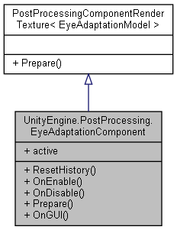

Collaboration diagram for UnityEngine.PostProcessing.EyeAdaptationComponent:



### Public Member Functions

void **ResetHistory** ()

override void **OnEnable** ()

override void **OnDisable** ()

Texture **Prepare** (RenderTexture source, Material uberMaterial)

void **OnGUI** ()

### Properties

override bool **active** [get]

### Member Function Documentation

#### override void UnityEngine.PostProcessing.EyeAdaptationComponent.OnDisable ()

Here is the call graph for this function:

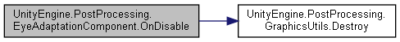

#### override void UnityEngine.PostProcessing.EyeAdaptationComponent.OnEnable ()

#### void UnityEngine.PostProcessing.EyeAdaptationComponent.OnGUI ()

#### Texture UnityEngine.PostProcessing.EyeAdaptationComponent.Prepare (RenderTexture *source*, Material *uberMaterial*)

#### void UnityEngine.PostProcessing.EyeAdaptationComponent.ResetHistory ()

Here is the caller graph for this function:

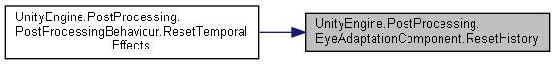

### Property Documentation

#### override bool UnityEngine.PostProcessing.EyeAdaptationComponent.active[get]

#### The documentation for this class was generated from the following file:

C:/_SSDSPEEDUP/2021/clone/gps1_manadesigner/GPS1-Manadesigner/Assets/Samples/Input System/1.0.2/Tanks Demo/TanksDemo/PostProcessing/Runtime/Components/**EyeAdaptationComponent.cs**

## UnityEngine.PostProcessing.EyeAdaptationModel Class Reference

Inheritance diagram for UnityEngine.PostProcessing.EyeAdaptationModel:

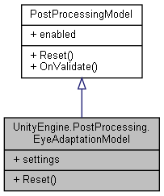

Collaboration diagram for UnityEngine.PostProcessing.EyeAdaptationModel:



### Classes

struct **Settings**

### Public Types

enum **EyeAdaptationType** { **Progressive**, **Fixed** }

### Public Member Functions

override void **Reset** ()

### Properties

**Settings** **settings** [getset]

### Member Enumeration Documentation

#### enum UnityEngine.PostProcessing.EyeAdaptationModel.EyeAdaptationType

##### Enumerator:

|  |  |
| --- | --- |
| Progressive |  |
| Fixed |  |

### Member Function Documentation

#### override void UnityEngine.PostProcessing.EyeAdaptationModel.Reset ()[virtual]

Implements **UnityEngine.PostProcessing.PostProcessingModel** (*p.597*).

### Property Documentation

#### Settings UnityEngine.PostProcessing.EyeAdaptationModel.settings[get], [set]

#### The documentation for this class was generated from the following file:

C:/_SSDSPEEDUP/2021/clone/gps1_manadesigner/GPS1-Manadesigner/Assets/Samples/Input System/1.0.2/Tanks Demo/TanksDemo/PostProcessing/Runtime/Models/**EyeAdaptationModel.cs**

## FileReadWrite Class Reference

Collaboration diagram for FileReadWrite:

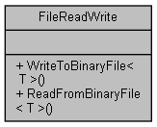

### Static Public Member Functions

static void **WriteToBinaryFile< T >** (string filePath, T objectToWrite)

static T **ReadFromBinaryFile< T >** (string filePath)

### Member Function Documentation

#### static T FileReadWrite.ReadFromBinaryFile< T > (string *filePath*)[static]

#### static void FileReadWrite.WriteToBinaryFile< T > (string *filePath*, T *objectToWrite*)[static]

#### The documentation for this class was generated from the following file:

C:/_SSDSPEEDUP/2021/clone/gps1_manadesigner/GPS1-Manadesigner/Assets/Scripts/Arif's Test Scripts/Save State/**FileReadWrite.cs**

## FishMaterial Class Reference

Inheritance diagram for FishMaterial:

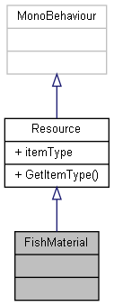

Collaboration diagram for FishMaterial:

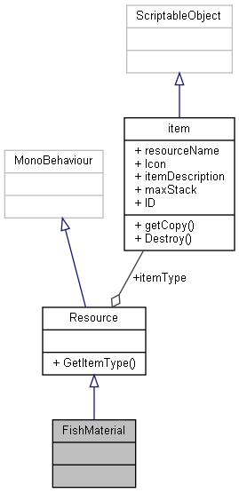

### Additional Inherited Members

The documentation for this class was generated from the following file:

C:/_SSDSPEEDUP/2021/clone/gps1_manadesigner/GPS1-Manadesigner/Assets/Scripts/Arif's Test Scripts/Resource/**FishMaterial.cs**

## Flee Class Reference

Inheritance diagram for Flee:

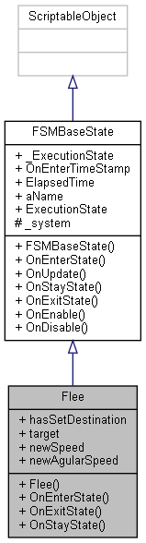

Collaboration diagram for Flee:

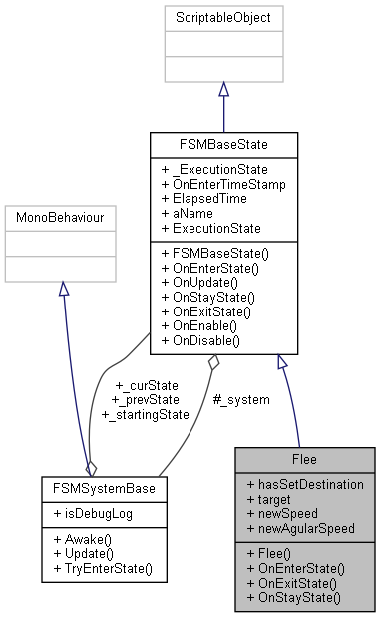

### Public Member Functions

**Flee** (**FSMSystemBase** system)

override bool **OnEnterState** ()

override bool **OnExitState** ()

override void **OnStayState** ()

### Public Attributes

bool **hasSetDestination**

Transform **target**

float **newSpeed** = 30f

float **newAgularSpeed** = 500f

### Additional Inherited Members

### Constructor & Destructor Documentation

#### Flee.Flee (FSMSystemBase *system*)

### Member Function Documentation

#### override bool Flee.OnEnterState ()[virtual]

Reimplemented from **FSMBaseState** (*p.279*).

#### override bool Flee.OnExitState ()[virtual]

Reimplemented from **FSMBaseState** (*p.279*).

#### override void Flee.OnStayState ()[virtual]

Reimplemented from **FSMBaseState** (*p.279*).

### Member Data Documentation

#### bool Flee.hasSetDestination

#### float Flee.newAgularSpeed = 500f

#### float Flee.newSpeed = 30f

#### Transform Flee.target

#### The documentation for this class was generated from the following file:

C:/_SSDSPEEDUP/2021/clone/gps1_manadesigner/GPS1-Manadesigner/Assets/_UtilsV0.4/MyScripts/_Utils/__Experimental/AIApproach/StatePattern/**NPCAIStatesTypeA.cs**

## FlockAI Class Reference

Inheritance diagram for FlockAI:

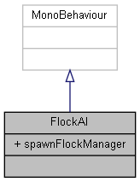

Collaboration diagram for FlockAI:

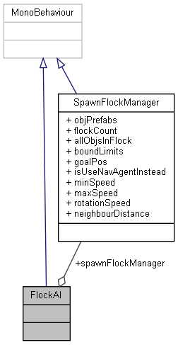

### Public Attributes

**SpawnFlockManager** **spawnFlockManager**

### Member Data Documentation

#### SpawnFlockManager FlockAI.spawnFlockManager

#### The documentation for this class was generated from the following file:

C:/_SSDSPEEDUP/2021/clone/gps1_manadesigner/GPS1-Manadesigner/Assets/_UtilsV0.4/MyScripts/_Utils/__Experimental/AIApproach/General/Unique/**FlockAI.cs**

## UnityEngine.PostProcessing.FogComponent Class Reference

Inheritance diagram for UnityEngine.PostProcessing.FogComponent:

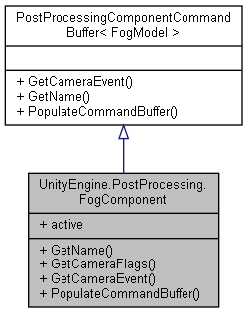

Collaboration diagram for UnityEngine.PostProcessing.FogComponent:



### Public Member Functions

override string **GetName** ()

override DepthTextureMode **GetCameraFlags** ()

override CameraEvent **GetCameraEvent** ()

override void **PopulateCommandBuffer** (CommandBuffer cb)

### Properties

override bool **active** [get]

### Member Function Documentation

#### override CameraEvent UnityEngine.PostProcessing.FogComponent.GetCameraEvent ()[virtual]

Implements **UnityEngine.PostProcessing.PostProcessingComponentCommandBuffer< FogModel >** (*p.592*).

#### override DepthTextureMode UnityEngine.PostProcessing.FogComponent.GetCameraFlags ()

#### override string UnityEngine.PostProcessing.FogComponent.GetName ()[virtual]

Implements **UnityEngine.PostProcessing.PostProcessingComponentCommandBuffer< FogModel >** (*p.592*).

#### override void UnityEngine.PostProcessing.FogComponent.PopulateCommandBuffer (CommandBuffer *cb*)[virtual]

Implements **UnityEngine.PostProcessing.PostProcessingComponentCommandBuffer< FogModel >** (*p.592*).

### Property Documentation

#### override bool UnityEngine.PostProcessing.FogComponent.active[get]

#### The documentation for this class was generated from the following file:

C:/_SSDSPEEDUP/2021/clone/gps1_manadesigner/GPS1-Manadesigner/Assets/Samples/Input System/1.0.2/Tanks Demo/TanksDemo/PostProcessing/Runtime/Components/**FogComponent.cs**

## UnityEngine.PostProcessing.FogModel Class Reference

Inheritance diagram for UnityEngine.PostProcessing.FogModel:

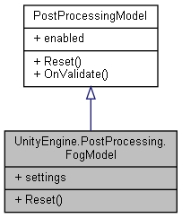

Collaboration diagram for UnityEngine.PostProcessing.FogModel:



### Classes

struct **Settings**

### Public Member Functions

override void **Reset** ()

### Properties

**Settings** **settings** [getset]

### Member Function Documentation

#### override void UnityEngine.PostProcessing.FogModel.Reset ()[virtual]

Implements **UnityEngine.PostProcessing.PostProcessingModel** (*p.597*).

### Property Documentation

#### Settings UnityEngine.PostProcessing.FogModel.settings[get], [set]

#### The documentation for this class was generated from the following file:

C:/_SSDSPEEDUP/2021/clone/gps1_manadesigner/GPS1-Manadesigner/Assets/Samples/Input System/1.0.2/Tanks Demo/TanksDemo/PostProcessing/Runtime/Models/**FogModel.cs**

## UnityEngine.PostProcessing.MotionBlurComponent.FrameBlendingFilter Class Reference

Collaboration diagram for UnityEngine.PostProcessing.MotionBlurComponent.FrameBlendingFilter:

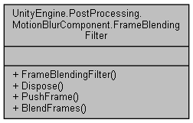

### Public Member Functions

**FrameBlendingFilter** ()

void **Dispose** ()

void **PushFrame** (CommandBuffer cb, RenderTargetIdentifier source, int width, int height, Material material)

void **BlendFrames** (CommandBuffer cb, float strength, RenderTargetIdentifier source, RenderTargetIdentifier destination, Material material)

### Constructor & Destructor Documentation

#### UnityEngine.PostProcessing.MotionBlurComponent.FrameBlendingFilter.FrameBlendingFilter ()

### Member Function Documentation

#### void UnityEngine.PostProcessing.MotionBlurComponent.FrameBlendingFilter.BlendFrames (CommandBuffer *cb*, float *strength*, RenderTargetIdentifier *source*, RenderTargetIdentifier *destination*, Material *material*)

Here is the caller graph for this function:

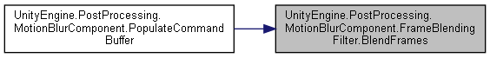

#### void UnityEngine.PostProcessing.MotionBlurComponent.FrameBlendingFilter.Dispose ()

#### void UnityEngine.PostProcessing.MotionBlurComponent.FrameBlendingFilter.PushFrame (CommandBuffer *cb*, RenderTargetIdentifier *source*, int *width*, int *height*, Material *material*)

Here is the caller graph for this function:

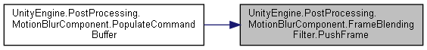

#### The documentation for this class was generated from the following file:

C:/_SSDSPEEDUP/2021/clone/gps1_manadesigner/GPS1-Manadesigner/Assets/Samples/Input System/1.0.2/Tanks Demo/TanksDemo/PostProcessing/Runtime/Components/**MotionBlurComponent.cs**

## FSMBaseState Class Reference

Inheritance diagram for FSMBaseState:

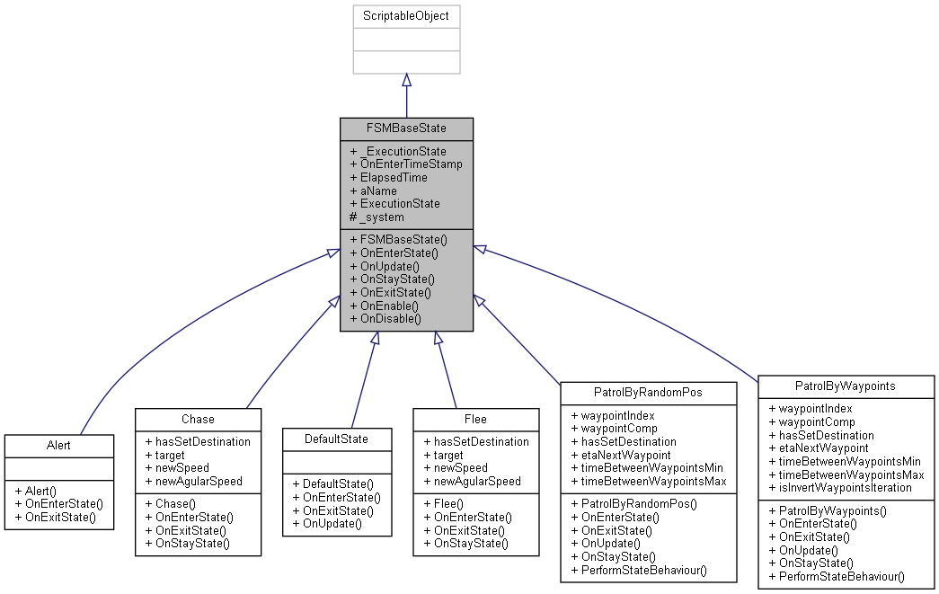

Collaboration diagram for FSMBaseState:

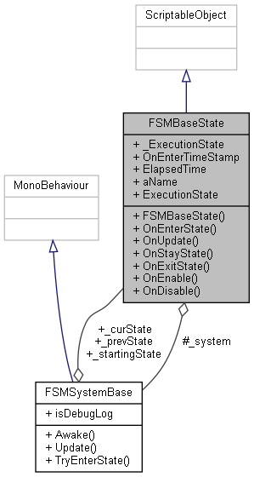

### Public Member Functions

**FSMBaseState** (**FSMSystemBase** system)

virtual bool **OnEnterState** ()

virtual void **OnUpdate** ()

virtual void **OnStayState** ()

virtual bool **OnExitState** ()

void **OnEnable** ()

void **OnDisable** ()

### Public Attributes

**FSMExecutionState** **_ExecutionState**

float **OnEnterTimeStamp**

float **ElapsedTime**

### Protected Attributes

readonly **FSMSystemBase** **_system**

### Properties

virtual string **aName** [getset]

virtual **FSMExecutionState** **ExecutionState** [getset]

### Constructor & Destructor Documentation

#### FSMBaseState.FSMBaseState (FSMSystemBase *system*)

### Member Function Documentation

#### void FSMBaseState.OnDisable ()

#### void FSMBaseState.OnEnable ()

#### virtual bool FSMBaseState.OnEnterState ()[virtual]

Reimplemented in **DefaultState** (*p.216*), **Alert** (*p.61*), **Chase** (*p.135*), **Flee** (*p.268*), **PatrolByRandomPos** (*p.537*), and **PatrolByWaypoints** (*p.541*).

Here is the caller graph for this function:

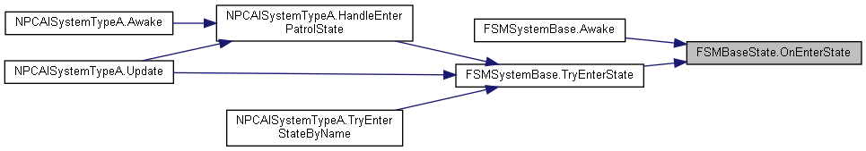

#### virtual bool FSMBaseState.OnExitState ()[virtual]

Reimplemented in **DefaultState** (*p.216*), **Alert** (*p.62*), **Chase** (*p.135*), **Flee** (*p.268*), **PatrolByRandomPos** (*p.537*), and **PatrolByWaypoints** (*p.541*).

Here is the caller graph for this function:

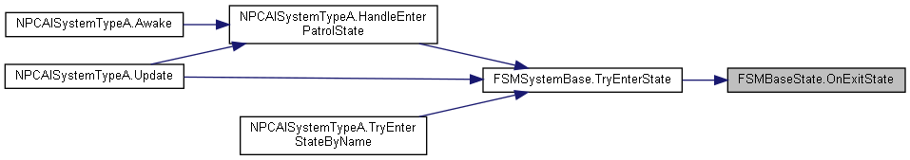

#### virtual void FSMBaseState.OnStayState ()[virtual]

Reimplemented in **Chase** (*p.135*), **Flee** (*p.268*), **PatrolByRandomPos** (*p.537*), and **PatrolByWaypoints** (*p.541*).

Here is the caller graph for this function:



#### virtual void FSMBaseState.OnUpdate ()[virtual]

Reimplemented in **DefaultState** (*p.216*), **PatrolByRandomPos** (*p.537*), and **PatrolByWaypoints** (*p.541*).

Here is the call graph for this function:



Here is the caller graph for this function:



### Member Data Documentation

#### FSMExecutionState FSMBaseState._ExecutionState

#### readonly FSMSystemBase FSMBaseState._system[protected]

#### float FSMBaseState.ElapsedTime

#### float FSMBaseState.OnEnterTimeStamp

### Property Documentation

#### virtual string FSMBaseState.aName[get], [set]

#### virtual FSMExecutionState FSMBaseState.ExecutionState[get], [set]

#### The documentation for this class was generated from the following file:

C:/_SSDSPEEDUP/2021/clone/gps1_manadesigner/GPS1-Manadesigner/Assets/_UtilsV0.4/MyScripts/_Utils/__Experimental/AIApproach/StatePattern/**FSMBaseState.cs**

## FSMSystemBase Class Reference

Inheritance diagram for FSMSystemBase:

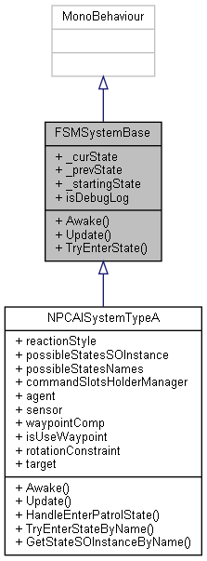

Collaboration diagram for FSMSystemBase:

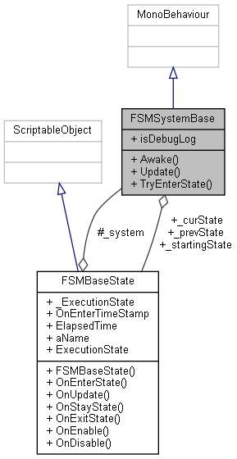

### Public Member Functions

virtual void **Awake** ()

virtual void **Update** ()

virtual void **TryEnterState** (**FSMBaseState** nextState)

### Public Attributes

**FSMBaseState** **_curState**

**FSMBaseState** **_prevState**

**FSMBaseState** **_startingState**

bool **isDebugLog** = false

### Member Function Documentation

#### virtual void FSMSystemBase.Awake ()[virtual]

Reimplemented in **NPCAISystemTypeA** (*p.511*).

Here is the call graph for this function:



#### virtual void FSMSystemBase.TryEnterState (FSMBaseState *nextState*)[virtual]

Here is the call graph for this function:

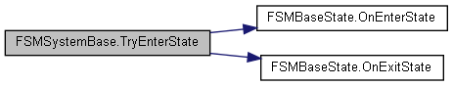

Here is the caller graph for this function:

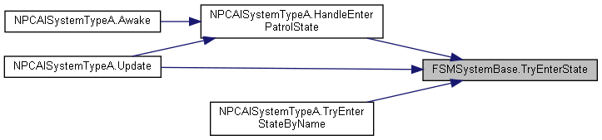

#### virtual void FSMSystemBase.Update ()[virtual]

Reimplemented in **NPCAISystemTypeA** (*p.512*).

Here is the call graph for this function:



### Member Data Documentation

#### FSMBaseState FSMSystemBase._curState

#### FSMBaseState FSMSystemBase._prevState

#### FSMBaseState FSMSystemBase._startingState

#### bool FSMSystemBase.isDebugLog = false

#### The documentation for this class was generated from the following file:

C:/_SSDSPEEDUP/2021/clone/gps1_manadesigner/GPS1-Manadesigner/Assets/_UtilsV0.4/MyScripts/_Utils/__Experimental/AIApproach/StatePattern/**FSMSystemBase.cs**

## UnityEngine.PostProcessing.FxaaComponent Class Reference

Inheritance diagram for UnityEngine.PostProcessing.FxaaComponent:

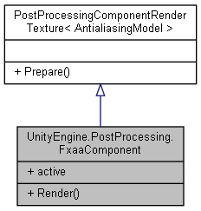

Collaboration diagram for UnityEngine.PostProcessing.FxaaComponent:



### Public Member Functions

void **Render** (RenderTexture source, RenderTexture destination)

### Properties

override bool **active** [get]

### Member Function Documentation

#### void UnityEngine.PostProcessing.FxaaComponent.Render (RenderTexture *source*, RenderTexture *destination*)

### Property Documentation

#### override bool UnityEngine.PostProcessing.FxaaComponent.active[get]

#### The documentation for this class was generated from the following file:

C:/_SSDSPEEDUP/2021/clone/gps1_manadesigner/GPS1-Manadesigner/Assets/Samples/Input System/1.0.2/Tanks Demo/TanksDemo/PostProcessing/Runtime/Components/**FxaaComponent.cs**

## UnityEngine.PostProcessing.AntialiasingModel.FxaaConsoleSettings Struct Reference

Collaboration diagram for UnityEngine.PostProcessing.AntialiasingModel.FxaaConsoleSettings:

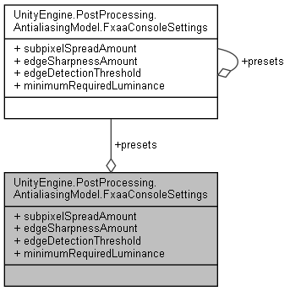

### Public Attributes

float **subpixelSpreadAmount**

float **edgeSharpnessAmount**

float **edgeDetectionThreshold**

float **minimumRequiredLuminance**

### Static Public Attributes

static **FxaaConsoleSettings**[] **presets**

### Member Data Documentation

#### float UnityEngine.PostProcessing.AntialiasingModel.FxaaConsoleSettings.edgeDetectionThreshold

#### float UnityEngine.PostProcessing.AntialiasingModel.FxaaConsoleSettings.edgeSharpnessAmount

#### float UnityEngine.PostProcessing.AntialiasingModel.FxaaConsoleSettings.minimumRequiredLuminance

#### FxaaConsoleSettings [] UnityEngine.PostProcessing.AntialiasingModel.FxaaConsoleSettings.presets[static]

#### float UnityEngine.PostProcessing.AntialiasingModel.FxaaConsoleSettings.subpixelSpreadAmount

#### The documentation for this struct was generated from the following file:

C:/_SSDSPEEDUP/2021/clone/gps1_manadesigner/GPS1-Manadesigner/Assets/Samples/Input System/1.0.2/Tanks Demo/TanksDemo/PostProcessing/Runtime/Models/**AntialiasingModel.cs**

## UnityEngine.PostProcessing.AntialiasingModel.FxaaQualitySettings Struct Reference

Collaboration diagram for UnityEngine.PostProcessing.AntialiasingModel.FxaaQualitySettings:

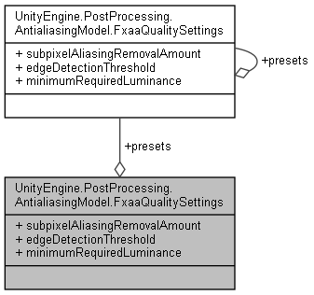

### Public Attributes

float **subpixelAliasingRemovalAmount**

float **edgeDetectionThreshold**

float **minimumRequiredLuminance**

### Static Public Attributes

static **FxaaQualitySettings**[] **presets**

### Member Data Documentation

#### float UnityEngine.PostProcessing.AntialiasingModel.FxaaQualitySettings.edgeDetectionThreshold

#### float UnityEngine.PostProcessing.AntialiasingModel.FxaaQualitySettings.minimumRequiredLuminance

#### FxaaQualitySettings [] UnityEngine.PostProcessing.AntialiasingModel.FxaaQualitySettings.presets[static]

#### float UnityEngine.PostProcessing.AntialiasingModel.FxaaQualitySettings.subpixelAliasingRemovalAmount

#### The documentation for this struct was generated from the following file:

C:/_SSDSPEEDUP/2021/clone/gps1_manadesigner/GPS1-Manadesigner/Assets/Samples/Input System/1.0.2/Tanks Demo/TanksDemo/PostProcessing/Runtime/Models/**AntialiasingModel.cs**

## UnityEngine.PostProcessing.AntialiasingModel.FxaaSettings Struct Reference

Collaboration diagram for UnityEngine.PostProcessing.AntialiasingModel.FxaaSettings:

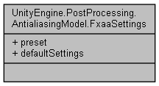

### Public Attributes

**FxaaPreset** **preset**

### Properties

static **FxaaSettings** **defaultSettings** [get]

### Member Data Documentation

#### FxaaPreset UnityEngine.PostProcessing.AntialiasingModel.FxaaSettings.preset

### Property Documentation

#### FxaaSettings UnityEngine.PostProcessing.AntialiasingModel.FxaaSettings.defaultSettings[static], [get]

#### The documentation for this struct was generated from the following file:

C:/_SSDSPEEDUP/2021/clone/gps1_manadesigner/GPS1-Manadesigner/Assets/Samples/Input System/1.0.2/Tanks Demo/TanksDemo/PostProcessing/Runtime/Models/**AntialiasingModel.cs**

## GameEvent Class Reference

Inheritance diagram for GameEvent:

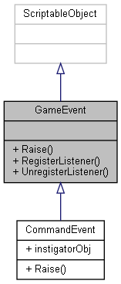

Collaboration diagram for GameEvent:

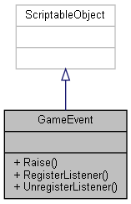

### Public Member Functions

virtual void **Raise** ()

virtual void **RegisterListener** (**GameEventListener** listener)

virtual void **UnregisterListener** (**GameEventListener** listener)

### Member Function Documentation

#### virtual void GameEvent.Raise ()[virtual]

Here is the caller graph for this function:

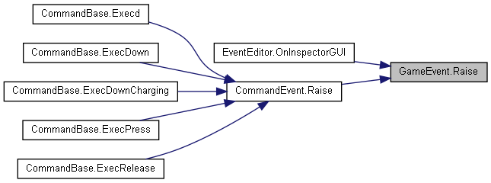

#### virtual void GameEvent.RegisterListener (GameEventListener *listener*)[virtual]

#### virtual void GameEvent.UnregisterListener (GameEventListener *listener*)[virtual]

#### The documentation for this class was generated from the following file:

C:/_SSDSPEEDUP/2021/clone/gps1_manadesigner/GPS1-Manadesigner/Assets/_UtilsV0.4/MyScripts/_Utils/CommandPattern/Events/**GameEvent.cs**

## GameEventListener Class Reference

Inheritance diagram for GameEventListener:

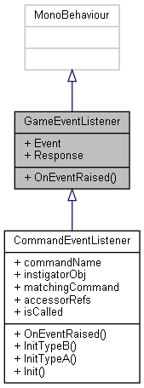

Collaboration diagram for GameEventListener:

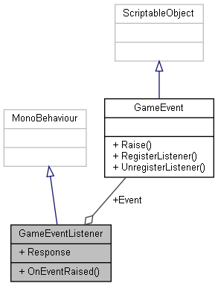

### Public Member Functions

virtual void **OnEventRaised** ()

### Public Attributes

**GameEvent** **Event**

UnityEvent **Response**

### Member Function Documentation

#### virtual void GameEventListener.OnEventRaised ()[virtual]

Reimplemented in **CommandEventListener** (*p.173*).

### Member Data Documentation

#### GameEvent GameEventListener.Event

#### UnityEvent GameEventListener.Response

#### The documentation for this class was generated from the following file:

C:/_SSDSPEEDUP/2021/clone/gps1_manadesigner/GPS1-Manadesigner/Assets/_UtilsV0.4/MyScripts/_Utils/CommandPattern/Events/**GameEventListener.cs**

## GameManager Class Reference

Inheritance diagram for GameManager:

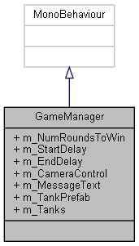

Collaboration diagram for GameManager:

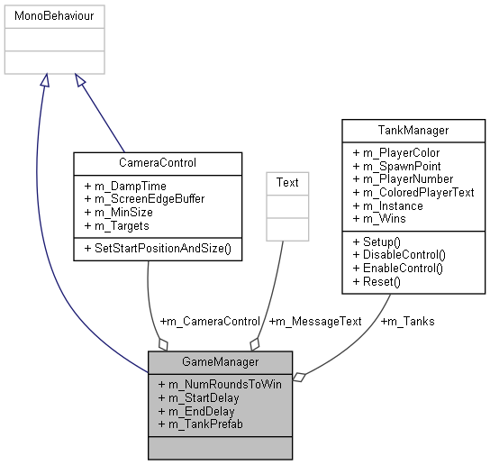

### Public Attributes

int **m_NumRoundsToWin** = 5

float **m_StartDelay** = 3f

float **m_EndDelay** = 3f

**CameraControl** **m_CameraControl**

Text **m_MessageText**

GameObject **m_TankPrefab**

**TankManager**[] **m_Tanks**

### Member Data Documentation

#### CameraControl GameManager.m_CameraControl

#### float GameManager.m_EndDelay = 3f

#### Text GameManager.m_MessageText

#### int GameManager.m_NumRoundsToWin = 5

#### float GameManager.m_StartDelay = 3f

#### GameObject GameManager.m_TankPrefab

#### TankManager [] GameManager.m_Tanks

#### The documentation for this class was generated from the following file:

C:/_SSDSPEEDUP/2021/clone/gps1_manadesigner/GPS1-Manadesigner/Assets/Samples/Input System/1.0.2/Tanks Demo/TanksDemo/Scripts/Managers/**GameManager.cs**

## GameObjActivePauseSync Class Reference

Inheritance diagram for GameObjActivePauseSync:

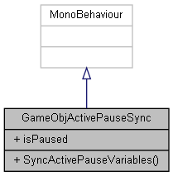

Collaboration diagram for GameObjActivePauseSync:



### Public Member Functions

void **SyncActivePauseVariables** ()

### Public Attributes

bool **isPaused**

### Member Function Documentation

#### void GameObjActivePauseSync.SyncActivePauseVariables ()

### Member Data Documentation

#### bool GameObjActivePauseSync.isPaused

#### The documentation for this class was generated from the following file:

C:/_SSDSPEEDUP/2021/clone/gps1_manadesigner/GPS1-Manadesigner/Assets/_UtilsV0.4/MyScripts/_Utils/_CommonV0.2/UICanvas/**GameObjActivePauseSync.cs**

## GameObjSpawnHelper Class Reference

Inheritance diagram for GameObjSpawnHelper:

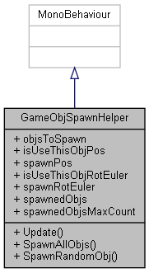

Collaboration diagram for GameObjSpawnHelper:



### Public Member Functions

void **Update** ()

void **SpawnAllObjs** ()

void **SpawnRandomObj** ()

### Public Attributes

List< GameObject > **objsToSpawn**

bool **isUseThisObjPos** = true

Vector3 **spawnPos**

bool **isUseThisObjRotEuler** = true

Vector3 **spawnRotEuler**

List< GameObject > **spawnedObjs**

int **spawnedObjsMaxCount** = 3

### Member Function Documentation

#### void GameObjSpawnHelper.SpawnAllObjs ()

#### void GameObjSpawnHelper.SpawnRandomObj ()

#### void GameObjSpawnHelper.Update ()

### Member Data Documentation

#### bool GameObjSpawnHelper.isUseThisObjPos = true

#### bool GameObjSpawnHelper.isUseThisObjRotEuler = true

#### List<GameObject> GameObjSpawnHelper.objsToSpawn

#### List<GameObject> GameObjSpawnHelper.spawnedObjs

#### int GameObjSpawnHelper.spawnedObjsMaxCount = 3

#### Vector3 GameObjSpawnHelper.spawnPos

#### Vector3 GameObjSpawnHelper.spawnRotEuler

#### The documentation for this class was generated from the following file:

C:/_SSDSPEEDUP/2021/clone/gps1_manadesigner/GPS1-Manadesigner/Assets/_UtilsV0.4/MyScripts/_Utils/_CommonV0.2/CommonExtend/CommonEdit/**GameObjSpawnHelper.cs**

## UnityEngine.InputSystem.Samples.RebindUI.GamepadIconsExample.GamepadIcons Struct Reference

Collaboration diagram for UnityEngine.InputSystem.Samples.RebindUI.GamepadIconsExample.GamepadIcons:

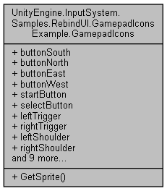

### Public Member Functions

Sprite **GetSprite** (string controlPath)

### Public Attributes

Sprite **buttonSouth**

Sprite **buttonNorth**

Sprite **buttonEast**

Sprite **buttonWest**

Sprite **startButton**

Sprite **selectButton**

Sprite **leftTrigger**

Sprite **rightTrigger**

Sprite **leftShoulder**

Sprite **rightShoulder**

Sprite **dpad**

Sprite **dpadUp**

Sprite **dpadDown**

Sprite **dpadLeft**

Sprite **dpadRight**

Sprite **leftStick**

Sprite **rightStick**

Sprite **leftStickPress**

Sprite **rightStickPress**

### Member Function Documentation

#### Sprite UnityEngine.InputSystem.Samples.RebindUI.GamepadIconsExample.GamepadIcons.GetSprite (string *controlPath*)

Here is the caller graph for this function:



### Member Data Documentation

#### Sprite UnityEngine.InputSystem.Samples.RebindUI.GamepadIconsExample.GamepadIcons.buttonEast

#### Sprite UnityEngine.InputSystem.Samples.RebindUI.GamepadIconsExample.GamepadIcons.buttonNorth

#### Sprite UnityEngine.InputSystem.Samples.RebindUI.GamepadIconsExample.GamepadIcons.buttonSouth

#### Sprite UnityEngine.InputSystem.Samples.RebindUI.GamepadIconsExample.GamepadIcons.buttonWest

#### Sprite UnityEngine.InputSystem.Samples.RebindUI.GamepadIconsExample.GamepadIcons.dpad

#### Sprite UnityEngine.InputSystem.Samples.RebindUI.GamepadIconsExample.GamepadIcons.dpadDown

#### Sprite UnityEngine.InputSystem.Samples.RebindUI.GamepadIconsExample.GamepadIcons.dpadLeft

#### Sprite UnityEngine.InputSystem.Samples.RebindUI.GamepadIconsExample.GamepadIcons.dpadRight

#### Sprite UnityEngine.InputSystem.Samples.RebindUI.GamepadIconsExample.GamepadIcons.dpadUp

#### Sprite UnityEngine.InputSystem.Samples.RebindUI.GamepadIconsExample.GamepadIcons.leftShoulder

#### Sprite UnityEngine.InputSystem.Samples.RebindUI.GamepadIconsExample.GamepadIcons.leftStick

#### Sprite UnityEngine.InputSystem.Samples.RebindUI.GamepadIconsExample.GamepadIcons.leftStickPress

#### Sprite UnityEngine.InputSystem.Samples.RebindUI.GamepadIconsExample.GamepadIcons.leftTrigger

#### Sprite UnityEngine.InputSystem.Samples.RebindUI.GamepadIconsExample.GamepadIcons.rightShoulder

#### Sprite UnityEngine.InputSystem.Samples.RebindUI.GamepadIconsExample.GamepadIcons.rightStick

#### Sprite UnityEngine.InputSystem.Samples.RebindUI.GamepadIconsExample.GamepadIcons.rightStickPress

#### Sprite UnityEngine.InputSystem.Samples.RebindUI.GamepadIconsExample.GamepadIcons.rightTrigger

#### Sprite UnityEngine.InputSystem.Samples.RebindUI.GamepadIconsExample.GamepadIcons.selectButton

#### Sprite UnityEngine.InputSystem.Samples.RebindUI.GamepadIconsExample.GamepadIcons.startButton

#### The documentation for this struct was generated from the following file:

C:/_SSDSPEEDUP/2021/clone/gps1_manadesigner/GPS1-Manadesigner/Assets/_UtilsV0.4/MyScripts/_Utils/UnityRegistryIntegration/InputSystem/Rebinding UI/**GamepadIconsExample.cs**

## UnityEngine.InputSystem.Samples.RebindUI.RebindIconsHelper.GamepadIcons Struct Reference

Collaboration diagram for UnityEngine.InputSystem.Samples.RebindUI.RebindIconsHelper.GamepadIcons:

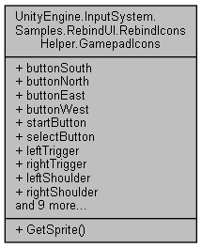

### Public Member Functions

Sprite **GetSprite** (string controlPath)

### Public Attributes

Sprite **buttonSouth**

Sprite **buttonNorth**

Sprite **buttonEast**

Sprite **buttonWest**

Sprite **startButton**

Sprite **selectButton**

Sprite **leftTrigger**

Sprite **rightTrigger**

Sprite **leftShoulder**

Sprite **rightShoulder**

Sprite **dpad**

Sprite **dpadUp**

Sprite **dpadDown**

Sprite **dpadLeft**

Sprite **dpadRight**

Sprite **leftStick**

Sprite **rightStick**

Sprite **leftStickPress**

Sprite **rightStickPress**

### Member Function Documentation

#### Sprite UnityEngine.InputSystem.Samples.RebindUI.RebindIconsHelper.GamepadIcons.GetSprite (string *controlPath*)

Here is the caller graph for this function:



### Member Data Documentation

#### Sprite UnityEngine.InputSystem.Samples.RebindUI.RebindIconsHelper.GamepadIcons.buttonEast

#### Sprite UnityEngine.InputSystem.Samples.RebindUI.RebindIconsHelper.GamepadIcons.buttonNorth

#### Sprite UnityEngine.InputSystem.Samples.RebindUI.RebindIconsHelper.GamepadIcons.buttonSouth

#### Sprite UnityEngine.InputSystem.Samples.RebindUI.RebindIconsHelper.GamepadIcons.buttonWest

#### Sprite UnityEngine.InputSystem.Samples.RebindUI.RebindIconsHelper.GamepadIcons.dpad

#### Sprite UnityEngine.InputSystem.Samples.RebindUI.RebindIconsHelper.GamepadIcons.dpadDown

#### Sprite UnityEngine.InputSystem.Samples.RebindUI.RebindIconsHelper.GamepadIcons.dpadLeft

#### Sprite UnityEngine.InputSystem.Samples.RebindUI.RebindIconsHelper.GamepadIcons.dpadRight

#### Sprite UnityEngine.InputSystem.Samples.RebindUI.RebindIconsHelper.GamepadIcons.dpadUp

#### Sprite UnityEngine.InputSystem.Samples.RebindUI.RebindIconsHelper.GamepadIcons.leftShoulder

#### Sprite UnityEngine.InputSystem.Samples.RebindUI.RebindIconsHelper.GamepadIcons.leftStick

#### Sprite UnityEngine.InputSystem.Samples.RebindUI.RebindIconsHelper.GamepadIcons.leftStickPress

#### Sprite UnityEngine.InputSystem.Samples.RebindUI.RebindIconsHelper.GamepadIcons.leftTrigger

#### Sprite UnityEngine.InputSystem.Samples.RebindUI.RebindIconsHelper.GamepadIcons.rightShoulder

#### Sprite UnityEngine.InputSystem.Samples.RebindUI.RebindIconsHelper.GamepadIcons.rightStick

#### Sprite UnityEngine.InputSystem.Samples.RebindUI.RebindIconsHelper.GamepadIcons.rightStickPress

#### Sprite UnityEngine.InputSystem.Samples.RebindUI.RebindIconsHelper.GamepadIcons.rightTrigger

#### Sprite UnityEngine.InputSystem.Samples.RebindUI.RebindIconsHelper.GamepadIcons.selectButton

#### Sprite UnityEngine.InputSystem.Samples.RebindUI.RebindIconsHelper.GamepadIcons.startButton

#### The documentation for this struct was generated from the following file:

C:/_SSDSPEEDUP/2021/clone/gps1_manadesigner/GPS1-Manadesigner/Assets/_UtilsV0.4/MyScripts/_Utils/UnityRegistryIntegration/InputSystem/Rebinding UI/_Modified/**RebindIconsHelper.cs**

## UnityEngine.InputSystem.Samples.RebindUI.GamepadIconsExample Class Reference

This is an example for how to override the default display behavior of bindings.

Inheritance diagram for UnityEngine.InputSystem.Samples.RebindUI.GamepadIconsExample:

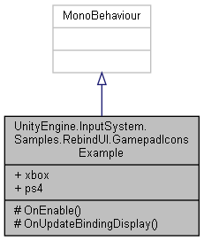

Collaboration diagram for UnityEngine.InputSystem.Samples.RebindUI.GamepadIconsExample:

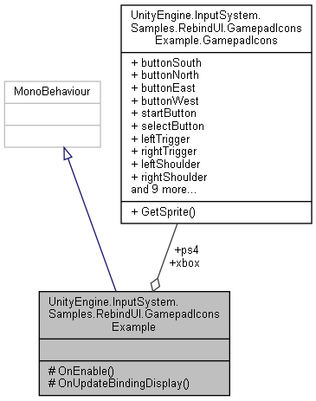

### Classes

struct **GamepadIcons**

### Public Attributes

**GamepadIcons** **xbox**

**GamepadIcons** **ps4**

### Protected Member Functions

void **OnEnable** ()

void **OnUpdateBindingDisplay** (**RebindActionUI** component, string bindingDisplayString, string deviceLayoutName, string controlPath)

### Detailed Description

This is an example for how to override the default display behavior of bindings.

The component hooks into **RebindActionUI.updateBindingUIEvent** which is triggered when **UI** display of a binding should be refreshed. It then checks whether we have an icon for the current binding and if so, replaces the default text display with an icon.

### Member Function Documentation

#### void UnityEngine.InputSystem.Samples.RebindUI.GamepadIconsExample.OnEnable ()[protected]

Here is the call graph for this function:



#### void UnityEngine.InputSystem.Samples.RebindUI.GamepadIconsExample.OnUpdateBindingDisplay (RebindActionUI *component*, string *bindingDisplayString*, string *deviceLayoutName*, string *controlPath*)[protected]

Here is the call graph for this function:

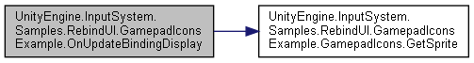

Here is the caller graph for this function:

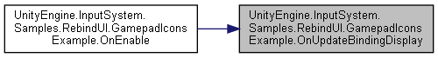

### Member Data Documentation

#### GamepadIcons UnityEngine.InputSystem.Samples.RebindUI.GamepadIconsExample.ps4

#### GamepadIcons UnityEngine.InputSystem.Samples.RebindUI.GamepadIconsExample.xbox

#### The documentation for this class was generated from the following file:

C:/_SSDSPEEDUP/2021/clone/gps1_manadesigner/GPS1-Manadesigner/Assets/_UtilsV0.4/MyScripts/_Utils/UnityRegistryIntegration/InputSystem/Rebinding UI/**GamepadIconsExample.cs**

## SimpleControls.GameplayActions Struct Reference

Collaboration diagram for SimpleControls.GameplayActions:

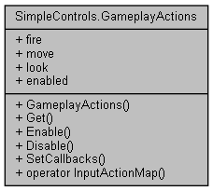

### Public Member Functions

**GameplayActions** (@**SimpleControls** wrapper)

InputActionMap **Get** ()

void **Enable** ()

void **Disable** ()

void **SetCallbacks** (**IGameplayActions** instance)

### Static Public Member Functions

static implicit **operator InputActionMap** (**GameplayActions** set)

### Properties

InputAction **fire** [get]

InputAction **move** [get]

InputAction **look** [get]

bool **enabled** [get]

### Constructor & Destructor Documentation

#### SimpleControls.GameplayActions.GameplayActions (@SimpleControls *wrapper*)

### Member Function Documentation

#### void SimpleControls.GameplayActions.Disable ()

Here is the call graph for this function:



#### void SimpleControls.GameplayActions.Enable ()

Here is the call graph for this function:



#### InputActionMap SimpleControls.GameplayActions.Get ()

Here is the caller graph for this function:

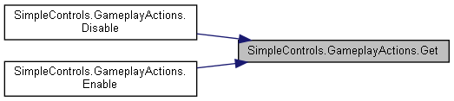

#### static implicit SimpleControls.GameplayActions.operator InputActionMap (GameplayActions *set*)[static]

#### void SimpleControls.GameplayActions.SetCallbacks (IGameplayActions *instance*)

Here is the call graph for this function:

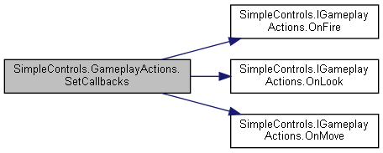

### Property Documentation

#### bool SimpleControls.GameplayActions.enabled[get]

#### InputAction SimpleControls.GameplayActions.fire[get]

#### InputAction SimpleControls.GameplayActions.look[get]

#### InputAction SimpleControls.GameplayActions.move[get]

#### The documentation for this struct was generated from the following file:

C:/_SSDSPEEDUP/2021/clone/gps1_manadesigner/GPS1-Manadesigner/Assets/Samples/Input System/1.0.2/Simple Demo/**SimpleControls.cs**

## UnityEngine.InputSystem.Samples.InGameHints.InGameHintsActions.GameplayActions Struct Reference

Collaboration diagram for UnityEngine.InputSystem.Samples.InGameHints.InGameHintsActions.GameplayActions:

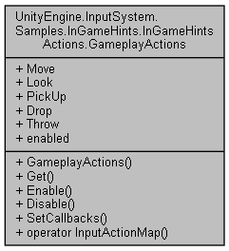

### Public Member Functions

**GameplayActions** (@**InGameHintsActions** wrapper)

InputActionMap **Get** ()

void **Enable** ()

void **Disable** ()

void **SetCallbacks** (**IGameplayActions** instance)

### Static Public Member Functions

static implicit **operator InputActionMap** (**GameplayActions** set)

### Properties

InputAction **Move** [get]

InputAction **Look** [get]

InputAction **PickUp** [get]

InputAction **Drop** [get]

InputAction **Throw** [get]

bool **enabled** [get]

### Constructor & Destructor Documentation

#### UnityEngine.InputSystem.Samples.InGameHints.InGameHintsActions.GameplayActions.GameplayActions (@InGameHintsActions *wrapper*)

### Member Function Documentation

#### void UnityEngine.InputSystem.Samples.InGameHints.InGameHintsActions.GameplayActions.Disable ()

Here is the call graph for this function:

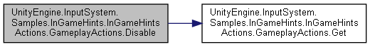

#### void UnityEngine.InputSystem.Samples.InGameHints.InGameHintsActions.GameplayActions.Enable ()

Here is the call graph for this function:

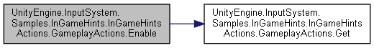

#### InputActionMap UnityEngine.InputSystem.Samples.InGameHints.InGameHintsActions.GameplayActions.Get ()

Here is the caller graph for this function:

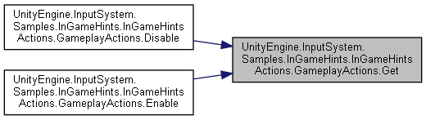

#### static implicit UnityEngine.InputSystem.Samples.InGameHints.InGameHintsActions.GameplayActions.operator InputActionMap (GameplayActions *set*)[static]

#### void UnityEngine.InputSystem.Samples.InGameHints.InGameHintsActions.GameplayActions.SetCallbacks (IGameplayActions *instance*)

Here is the call graph for this function:

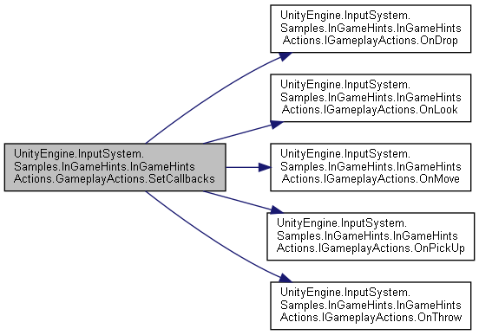

### Property Documentation

#### InputAction UnityEngine.InputSystem.Samples.InGameHints.InGameHintsActions.GameplayActions.Drop[get]

#### bool UnityEngine.InputSystem.Samples.InGameHints.InGameHintsActions.GameplayActions.enabled[get]

#### InputAction UnityEngine.InputSystem.Samples.InGameHints.InGameHintsActions.GameplayActions.Look[get]

#### InputAction UnityEngine.InputSystem.Samples.InGameHints.InGameHintsActions.GameplayActions.Move[get]

#### InputAction UnityEngine.InputSystem.Samples.InGameHints.InGameHintsActions.GameplayActions.PickUp[get]

#### InputAction UnityEngine.InputSystem.Samples.InGameHints.InGameHintsActions.GameplayActions.Throw[get]

#### The documentation for this struct was generated from the following file:

C:/_SSDSPEEDUP/2021/clone/gps1_manadesigner/GPS1-Manadesigner/Assets/Samples/Input System/1.0.2/In-Game Hints/**InGameHintsActions.cs**

## GameplayManager Class Reference

Inheritance diagram for GameplayManager:

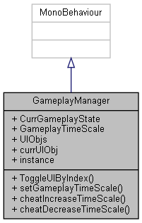

Collaboration diagram for GameplayManager:

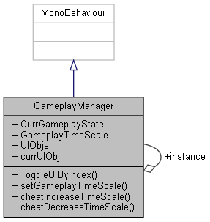

### Public Types

enum **GameplayState** { **GAME_RUNNING**, **GAME_PAUSE**, **GAME_GAMEOVER**, **GAME_GAMEWIN**, **GAME_ENDCLOSE** }

### Public Member Functions

void **ToggleUIByIndex** (int index)

void **setGameplayTimeScale** (float timeScaleVal)

void **cheatIncreaseTimeScale** ()

void **cheatDecreaseTimeScale** ()

### Public Attributes

**GameplayState** **CurrGameplayState**

float **GameplayTimeScale** = 1

List< GameObject > **UIObjs**

GameObject **currUIObj**

### Static Public Attributes

static **GameplayManager** **instance**

### Member Enumeration Documentation

#### enum GameplayManager.GameplayState

##### Enumerator:

|  |  |
| --- | --- |
| GAME_RUNNING |  |
| GAME_PAUSE |  |
| GAME_GAMEOVER |  |
| GAME_GAMEWIN |  |
| GAME_ENDCLOSE |  |

### Member Function Documentation

#### void GameplayManager.cheatDecreaseTimeScale ()

#### void GameplayManager.cheatIncreaseTimeScale ()

#### void GameplayManager.setGameplayTimeScale (float *timeScaleVal*)

#### void GameplayManager.ToggleUIByIndex (int *index*)

### Member Data Documentation

#### GameplayState GameplayManager.CurrGameplayState

#### GameObject GameplayManager.currUIObj

#### float GameplayManager.GameplayTimeScale = 1

#### GameplayManager GameplayManager.instance[static]

#### List<GameObject> GameplayManager.UIObjs

#### The documentation for this class was generated from the following file:

C:/_SSDSPEEDUP/2021/clone/gps1_manadesigner/GPS1-Manadesigner/Assets/_UtilsV0.4/MyScripts/_Utils/_CommonV0.2/Singletons/**GameplayManager.cs**

## RebindUISampleActionsModified.GameplaySampleUnusedActions Struct Reference

Collaboration diagram for RebindUISampleActionsModified.GameplaySampleUnusedActions:

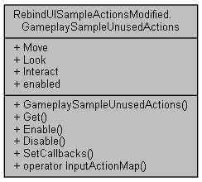

### Public Member Functions

**GameplaySampleUnusedActions** (@**RebindUISampleActionsModified** wrapper)

InputActionMap **Get** ()

void **Enable** ()

void **Disable** ()

void **SetCallbacks** (**IGameplaySampleUnusedActions** instance)

### Static Public Member Functions

static implicit **operator InputActionMap** (**GameplaySampleUnusedActions** set)

### Properties

InputAction **Move** [get]

InputAction **Look** [get]

InputAction **Interact** [get]

bool **enabled** [get]

### Constructor & Destructor Documentation

#### RebindUISampleActionsModified.GameplaySampleUnusedActions.GameplaySampleUnusedActions (@RebindUISampleActionsModified *wrapper*)

### Member Function Documentation

#### void RebindUISampleActionsModified.GameplaySampleUnusedActions.Disable ()

Here is the call graph for this function:



#### void RebindUISampleActionsModified.GameplaySampleUnusedActions.Enable ()

Here is the call graph for this function:



#### InputActionMap RebindUISampleActionsModified.GameplaySampleUnusedActions.Get ()

Here is the caller graph for this function:

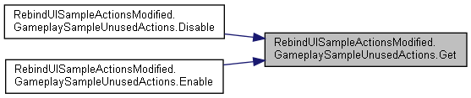

#### static implicit RebindUISampleActionsModified.GameplaySampleUnusedActions.operator InputActionMap (GameplaySampleUnusedActions *set*)[static]

#### void RebindUISampleActionsModified.GameplaySampleUnusedActions.SetCallbacks (IGameplaySampleUnusedActions *instance*)

Here is the call graph for this function:

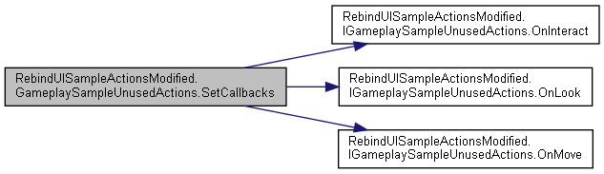

### Property Documentation

#### bool RebindUISampleActionsModified.GameplaySampleUnusedActions.enabled[get]

#### InputAction RebindUISampleActionsModified.GameplaySampleUnusedActions.Interact[get]

#### InputAction RebindUISampleActionsModified.GameplaySampleUnusedActions.Look[get]

#### InputAction RebindUISampleActionsModified.GameplaySampleUnusedActions.Move[get]

#### The documentation for this struct was generated from the following file:

C:/_SSDSPEEDUP/2021/clone/gps1_manadesigner/GPS1-Manadesigner/Assets/_UtilsV0.4/MyScripts/_Utils/CommandPattern/Command/SOAssets/InputSystemPackage/**RebindUISampleActionsModified.cs**

## GenericDictionary< TKey, TValue > Class Template Reference

Generic Serializable Dictionary for Unity 2020.1.

Inheritance diagram for GenericDictionary< TKey, TValue >:

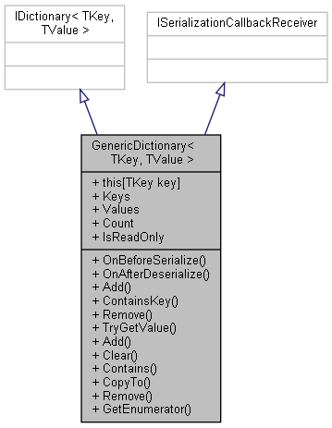

Collaboration diagram for GenericDictionary< TKey, TValue >:



### Public Member Functions

void **OnBeforeSerialize** ()

void **OnAfterDeserialize** ()

void **Add** (TKey key, TValue value)

bool **ContainsKey** (TKey key)

bool **Remove** (TKey key)

bool **TryGetValue** (TKey key, out TValue value)

void **Add** (KeyValuePair< TKey, TValue > pair)

void **Clear** ()

bool **Contains** (KeyValuePair< TKey, TValue > pair)

void **CopyTo** (KeyValuePair< TKey, TValue >[] array, int arrayIndex)

bool **Remove** (KeyValuePair< TKey, TValue > pair)

IEnumerator< KeyValuePair< TKey, TValue > > **GetEnumerator** ()

### Properties

TValue **this[TKey key]** [getset]

ICollection< TKey > **Keys** [get]

ICollection< TValue > **Values** [get]

int **Count** [get]

bool **IsReadOnly** [getset]

### Detailed Description

Generic Serializable Dictionary for Unity 2020.1.

Simply declare your key/value types and you're good to go - zero boilerplate.

### Member Function Documentation

#### void GenericDictionary< TKey, TValue >.Add (KeyValuePair< TKey, TValue > *pair*)

Here is the call graph for this function:

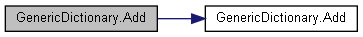

#### void GenericDictionary< TKey, TValue >.Add (TKey *key*, TValue *value*)

Here is the caller graph for this function:

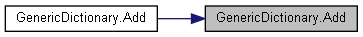

#### void GenericDictionary< TKey, TValue >.Clear ()

#### bool GenericDictionary< TKey, TValue >.Contains (KeyValuePair< TKey, TValue > *pair*)

#### bool GenericDictionary< TKey, TValue >.ContainsKey (TKey *key*)

Here is the caller graph for this function:

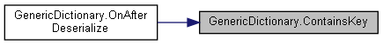

#### void GenericDictionary< TKey, TValue >.CopyTo (KeyValuePair< TKey, TValue >[] *array*, int *arrayIndex*)

#### IEnumerator< KeyValuePair< TKey, TValue > > GenericDictionary< TKey, TValue >.GetEnumerator ()

#### void GenericDictionary< TKey, TValue >.OnAfterDeserialize ()

Here is the call graph for this function:

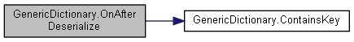

#### void GenericDictionary< TKey, TValue >.OnBeforeSerialize ()

#### bool GenericDictionary< TKey, TValue >.Remove (KeyValuePair< TKey, TValue > *pair*)

Here is the call graph for this function:



#### bool GenericDictionary< TKey, TValue >.Remove (TKey *key*)

Here is the caller graph for this function:



#### bool GenericDictionary< TKey, TValue >.TryGetValue (TKey *key*, out TValue *value*)

### Property Documentation

#### int GenericDictionary< TKey, TValue >.Count[get]

#### bool GenericDictionary< TKey, TValue >.IsReadOnly[get], [set]

#### ICollection<TKey> GenericDictionary< TKey, TValue >.Keys[get]

#### TValue GenericDictionary< TKey, TValue >.this[TKey key][get], [set]

#### ICollection<TValue> GenericDictionary< TKey, TValue >.Values[get]

#### The documentation for this class was generated from the following file:

C:/_SSDSPEEDUP/2021/clone/gps1_manadesigner/GPS1-Manadesigner/Assets/_UtilsV0.4/MyScripts/_Utils/SerializableDataStructures/**GenericDictionary.cs**

## GenericDictionaryPropertyDrawer Class Reference

Draws the generic dictionary a bit nicer than Unity would natively (not as many expand-arrows and better spacing between KeyValue pairs).

Inheritance diagram for GenericDictionaryPropertyDrawer:

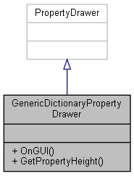

Collaboration diagram for GenericDictionaryPropertyDrawer:



### Public Member Functions

override void **OnGUI** (Rect pos, SerializedProperty property, GUIContent label)

override float **GetPropertyHeight** (SerializedProperty property, GUIContent label)

### Detailed Description

Draws the generic dictionary a bit nicer than Unity would natively (not as many expand-arrows and better spacing between KeyValue pairs).

Also renders a warning-box if there are duplicate keys in the dictionary.

### Member Function Documentation

#### override float GenericDictionaryPropertyDrawer.GetPropertyHeight (SerializedProperty *property*, GUIContent *label*)

#### override void GenericDictionaryPropertyDrawer.OnGUI (Rect *pos*, SerializedProperty *property*, GUIContent *label*)

#### The documentation for this class was generated from the following file:

C:/_SSDSPEEDUP/2021/clone/gps1_manadesigner/GPS1-Manadesigner/Assets/Scripts/Editor/_Utils/SerializableDataStructures/**GenericDictionaryPropertyDrawer.cs**

## UnityEngine.PostProcessing.GetSetAttribute Class Reference

Inheritance diagram for UnityEngine.PostProcessing.GetSetAttribute:

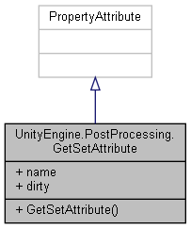

Collaboration diagram for UnityEngine.PostProcessing.GetSetAttribute:



### Public Member Functions

**GetSetAttribute** (string **name**)

### Public Attributes

readonly string **name**

bool **dirty**

### Constructor & Destructor Documentation

#### UnityEngine.PostProcessing.GetSetAttribute.GetSetAttribute (string *name*)

### Member Data Documentation

#### bool UnityEngine.PostProcessing.GetSetAttribute.dirty

#### readonly string UnityEngine.PostProcessing.GetSetAttribute.name

#### The documentation for this class was generated from the following file:

C:/_SSDSPEEDUP/2021/clone/gps1_manadesigner/GPS1-Manadesigner/Assets/Samples/Input System/1.0.2/Tanks Demo/TanksDemo/PostProcessing/Runtime/Attributes/**GetSetAttribute.cs**

## UnityEngine.PostProcessing.GrainComponent Class Reference

Inheritance diagram for UnityEngine.PostProcessing.GrainComponent:

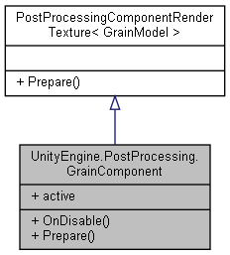

Collaboration diagram for UnityEngine.PostProcessing.GrainComponent:



### Public Member Functions

override void **OnDisable** ()

override void **Prepare** (Material uberMaterial)

### Properties

override bool **active** [get]

### Member Function Documentation

#### override void UnityEngine.PostProcessing.GrainComponent.OnDisable ()

Here is the call graph for this function:

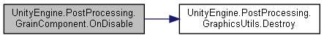

#### override void UnityEngine.PostProcessing.GrainComponent.Prepare (Material *uberMaterial*)[virtual]

Reimplemented from **UnityEngine.PostProcessing.PostProcessingComponentRenderTexture< GrainModel >** (*p.594*).

Here is the call graph for this function:

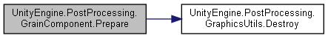

### Property Documentation

#### override bool UnityEngine.PostProcessing.GrainComponent.active[get]

#### The documentation for this class was generated from the following file:

C:/_SSDSPEEDUP/2021/clone/gps1_manadesigner/GPS1-Manadesigner/Assets/Samples/Input System/1.0.2/Tanks Demo/TanksDemo/PostProcessing/Runtime/Components/**GrainComponent.cs**

## UnityEngine.PostProcessing.GrainModel Class Reference

Inheritance diagram for UnityEngine.PostProcessing.GrainModel:

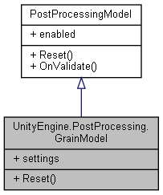

Collaboration diagram for UnityEngine.PostProcessing.GrainModel:



### Classes

struct **Settings**

### Public Member Functions

override void **Reset** ()

### Properties

**Settings** **settings** [getset]

### Member Function Documentation

#### override void UnityEngine.PostProcessing.GrainModel.Reset ()[virtual]

Implements **UnityEngine.PostProcessing.PostProcessingModel** (*p.597*).

### Property Documentation

#### Settings UnityEngine.PostProcessing.GrainModel.settings[get], [set]

#### The documentation for this class was generated from the following file:

C:/_SSDSPEEDUP/2021/clone/gps1_manadesigner/GPS1-Manadesigner/Assets/Samples/Input System/1.0.2/Tanks Demo/TanksDemo/PostProcessing/Runtime/Models/**GrainModel.cs**

## UnityEngine.PostProcessing.GraphicsUtils Class Reference

Collaboration diagram for UnityEngine.PostProcessing.GraphicsUtils:

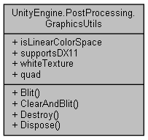

### Static Public Member Functions

static void **Blit** (Material material, int pass)

static void **ClearAndBlit** (Texture source, RenderTexture destination, Material material, int pass, bool clearColor=true, bool clearDepth=false)

static void **Destroy** (**UnityObject** obj)

static void **Dispose** ()

### Properties

static bool **isLinearColorSpace** [get]

static bool **supportsDX11** [get]

static Texture2D **whiteTexture** [get]

static Mesh **quad** [get]

### Member Function Documentation

#### static void UnityEngine.PostProcessing.GraphicsUtils.Blit (Material *material*, int *pass*)[static]

Here is the caller graph for this function:

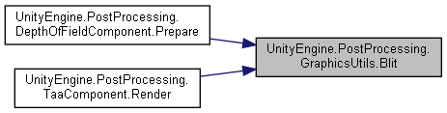

#### static void UnityEngine.PostProcessing.GraphicsUtils.ClearAndBlit (Texture *source*, RenderTexture *destination*, Material *material*, int *pass*, bool *clearColor* = true, bool *clearDepth* = false)[static]

#### static void UnityEngine.PostProcessing.GraphicsUtils.Destroy (UnityObject *obj*)[static]

Here is the caller graph for this function:

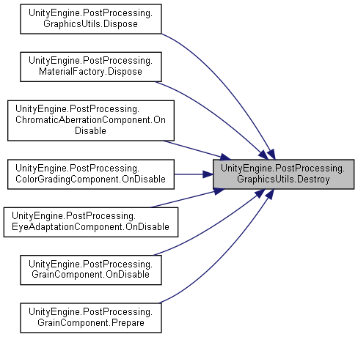

#### static void UnityEngine.PostProcessing.GraphicsUtils.Dispose ()[static]

Here is the call graph for this function:

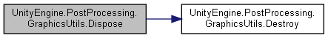

### Property Documentation

#### bool UnityEngine.PostProcessing.GraphicsUtils.isLinearColorSpace[static], [get]

#### Mesh UnityEngine.PostProcessing.GraphicsUtils.quad[static], [get]

#### bool UnityEngine.PostProcessing.GraphicsUtils.supportsDX11[static], [get]

#### Texture2D UnityEngine.PostProcessing.GraphicsUtils.whiteTexture[static], [get]

#### The documentation for this class was generated from the following file:

C:/_SSDSPEEDUP/2021/clone/gps1_manadesigner/GPS1-Manadesigner/Assets/Samples/Input System/1.0.2/Tanks Demo/TanksDemo/PostProcessing/Runtime/Utils/**GraphicsUtils.cs**

## HealthBar Class Reference

Inheritance diagram for HealthBar:

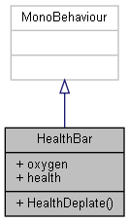

Collaboration diagram for HealthBar:

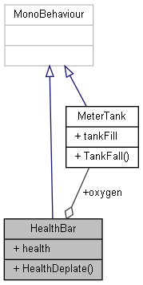

### Public Member Functions

void **HealthDeplate** ()

### Public Attributes

**MeterTank** **oxygen**

Slider **health**

### Member Function Documentation

#### void HealthBar.HealthDeplate ()

### Member Data Documentation

#### Slider HealthBar.health

#### MeterTank HealthBar.oxygen

#### The documentation for this class was generated from the following file:

C:/_SSDSPEEDUP/2021/clone/gps1_manadesigner/GPS1-Manadesigner/Assets/Scripts/UI Test Scripts/**HealthBar.cs**

## HoldKeyInputTuto Class Reference

Inheritance diagram for HoldKeyInputTuto:

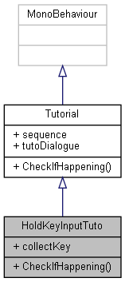

Collaboration diagram for HoldKeyInputTuto:



### Public Member Functions

override void **CheckIfHappening** ()

### Public Attributes

KeyCode **collectKey**

### Member Function Documentation

#### override void HoldKeyInputTuto.CheckIfHappening ()[virtual]

Reimplemented from **Tutorial** (*p.787*).

Here is the call graph for this function:

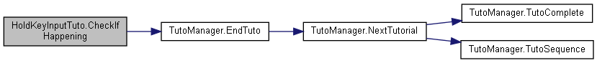

### Member Data Documentation

#### KeyCode HoldKeyInputTuto.collectKey

#### The documentation for this class was generated from the following file:

C:/_SSDSPEEDUP/2021/clone/gps1_manadesigner/GPS1-Manadesigner/Assets/Scripts/Tutorial Scripts/**HoldKeyInputTuto.cs**

## HomingBullet Class Reference

Inheritance diagram for HomingBullet:

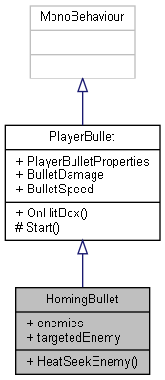

Collaboration diagram for HomingBullet:

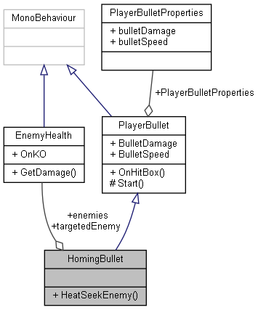

### Public Member Functions

void **HeatSeekEnemy** ()

### Public Attributes

**EnemyHealth**[] **enemies**

**EnemyHealth** **targetedEnemy**

### Additional Inherited Members

### Member Function Documentation

#### void HomingBullet.HeatSeekEnemy ()

### Member Data Documentation

#### EnemyHealth [] HomingBullet.enemies

#### EnemyHealth HomingBullet.targetedEnemy

#### The documentation for this class was generated from the following file:

C:/_SSDSPEEDUP/2021/clone/gps1_manadesigner/GPS1-Manadesigner/Assets/PlayerBullet/**HomingBullet.cs**

## Hull Class Reference

Inheritance diagram for Hull:

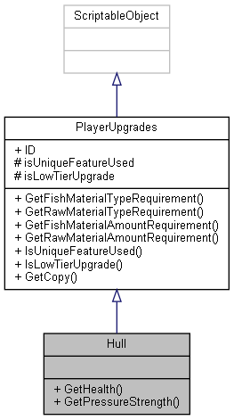

Collaboration diagram for Hull:



### Public Member Functions

float **GetHealth** ()

float **GetPressureStrength** ()

### Additional Inherited Members

### Member Function Documentation

#### float Hull.GetHealth ()

#### float Hull.GetPressureStrength ()

#### The documentation for this class was generated from the following file:

C:/_SSDSPEEDUP/2021/clone/gps1_manadesigner/GPS1-Manadesigner/Assets/Scripts/Arif's Test Scripts/Upgrades/Hull/**Hull.cs**

## ICommand Interface Reference

Inheritance diagram for ICommand:

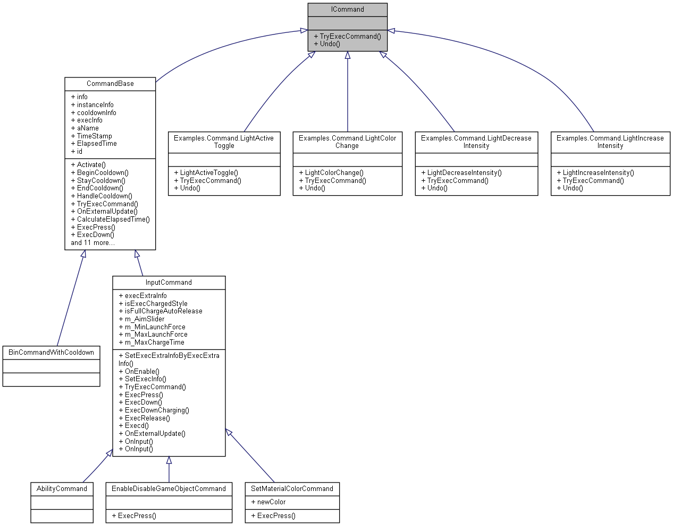

Collaboration diagram for ICommand:

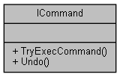

### Public Member Functions

void **TryExecCommand** ()

void **Undo** ()

### Member Function Documentation

#### void ICommand.TryExecCommand ()

Implemented in **Examples.Command.LightActiveToggle** (*p.468*), **Examples.Command.LightColorChange** (*p.470*), **Examples.Command.LightDecreaseIntensity** (*p.473*), **Examples.Command.LightIncreaseIntensity** (*p.475*), **CommandBase** (*p.165*), and **InputCommand** (*p.373*).

Here is the caller graph for this function:



#### void ICommand.Undo ()

Implemented in **Examples.Command.LightActiveToggle** (*p.468*), **Examples.Command.LightColorChange** (*p.470*), **Examples.Command.LightDecreaseIntensity** (*p.473*), **Examples.Command.LightIncreaseIntensity** (*p.475*), and **CommandBase** (*p.165*).

#### The documentation for this interface was generated from the following file:

C:/_SSDSPEEDUP/2021/clone/gps1_manadesigner/GPS1-Manadesigner/Assets/_UtilsV0.4/MyScripts/_Utils/CommandPattern/Command/MyScripts/Reusable/**ICommand.cs**

## ICommandOWS Interface Reference

Inheritance diagram for ICommandOWS:

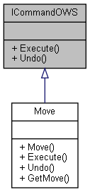

Collaboration diagram for ICommandOWS:

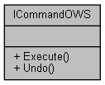

### Public Member Functions

void **Execute** ()

void **Undo** ()

### Member Function Documentation

#### void ICommandOWS.Execute ()

Implemented in **Move** (*p.501*).

Here is the caller graph for this function:

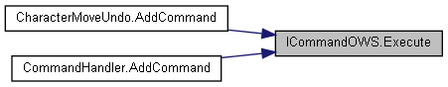

#### void ICommandOWS.Undo ()

Implemented in **Move** (*p.501*).

#### The documentation for this interface was generated from the following file:

C:/_SSDSPEEDUP/2021/clone/gps1_manadesigner/GPS1-Manadesigner/Assets/_UtilsV0.4/MyScripts/_Utils/CommandPattern/_Bin/OWS/Interfaces/**ICommandOWS.cs**

## SimpleControls.IGameplayActions Interface Reference

Collaboration diagram for SimpleControls.IGameplayActions:

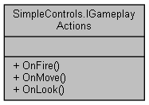

### Public Member Functions

void **OnFire** (InputAction.CallbackContext context)

void **OnMove** (InputAction.CallbackContext context)

void **OnLook** (InputAction.CallbackContext context)

### Member Function Documentation

#### void SimpleControls.IGameplayActions.OnFire (InputAction.CallbackContext *context*)

Here is the caller graph for this function:

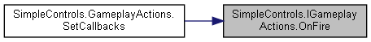

#### void SimpleControls.IGameplayActions.OnLook (InputAction.CallbackContext *context*)

Here is the caller graph for this function:

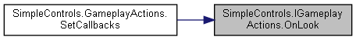

#### void SimpleControls.IGameplayActions.OnMove (InputAction.CallbackContext *context*)

Here is the caller graph for this function:

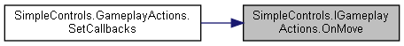

#### The documentation for this interface was generated from the following file:

C:/_SSDSPEEDUP/2021/clone/gps1_manadesigner/GPS1-Manadesigner/Assets/Samples/Input System/1.0.2/Simple Demo/**SimpleControls.cs**

## UnityEngine.InputSystem.Samples.InGameHints.InGameHintsActions.IGameplayActions Interface Reference

Collaboration diagram for UnityEngine.InputSystem.Samples.InGameHints.InGameHintsActions.IGameplayActions:

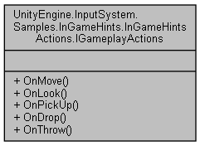

### Public Member Functions

void **OnMove** (InputAction.CallbackContext context)

void **OnLook** (InputAction.CallbackContext context)

void **OnPickUp** (InputAction.CallbackContext context)

void **OnDrop** (InputAction.CallbackContext context)

void **OnThrow** (InputAction.CallbackContext context)

### Member Function Documentation

#### void UnityEngine.InputSystem.Samples.InGameHints.InGameHintsActions.IGameplayActions.OnDrop (InputAction.CallbackContext *context*)

Here is the caller graph for this function:

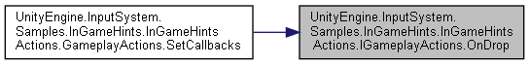

#### void UnityEngine.InputSystem.Samples.InGameHints.InGameHintsActions.IGameplayActions.OnLook (InputAction.CallbackContext *context*)

Here is the caller graph for this function:

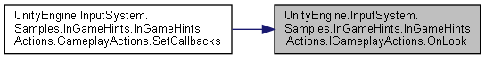

#### void UnityEngine.InputSystem.Samples.InGameHints.InGameHintsActions.IGameplayActions.OnMove (InputAction.CallbackContext *context*)

Here is the caller graph for this function:

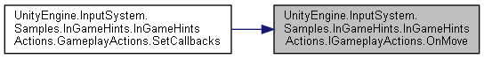

#### void UnityEngine.InputSystem.Samples.InGameHints.InGameHintsActions.IGameplayActions.OnPickUp (InputAction.CallbackContext *context*)

Here is the caller graph for this function:

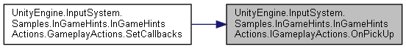

#### void UnityEngine.InputSystem.Samples.InGameHints.InGameHintsActions.IGameplayActions.OnThrow (InputAction.CallbackContext *context*)

Here is the caller graph for this function:

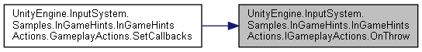

#### The documentation for this interface was generated from the following file:

C:/_SSDSPEEDUP/2021/clone/gps1_manadesigner/GPS1-Manadesigner/Assets/Samples/Input System/1.0.2/In-Game Hints/**InGameHintsActions.cs**

## RebindUISampleActionsModified.IGameplaySampleUnusedActions Interface Reference

Collaboration diagram for RebindUISampleActionsModified.IGameplaySampleUnusedActions:

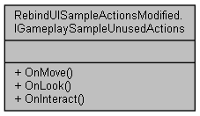

### Public Member Functions

void **OnMove** (InputAction.CallbackContext context)

void **OnLook** (InputAction.CallbackContext context)

void **OnInteract** (InputAction.CallbackContext context)

### Member Function Documentation

#### void RebindUISampleActionsModified.IGameplaySampleUnusedActions.OnInteract (InputAction.CallbackContext *context*)

Here is the caller graph for this function:



#### void RebindUISampleActionsModified.IGameplaySampleUnusedActions.OnLook (InputAction.CallbackContext *context*)

Here is the caller graph for this function:



#### void RebindUISampleActionsModified.IGameplaySampleUnusedActions.OnMove (InputAction.CallbackContext *context*)

Here is the caller graph for this function:



#### The documentation for this interface was generated from the following file:

C:/_SSDSPEEDUP/2021/clone/gps1_manadesigner/GPS1-Manadesigner/Assets/_UtilsV0.4/MyScripts/_Utils/CommandPattern/Command/SOAssets/InputSystemPackage/**RebindUISampleActionsModified.cs**

## IgnoreChildCollision Class Reference

Inheritance diagram for IgnoreChildCollision:

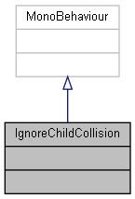

Collaboration diagram for IgnoreChildCollision:



The documentation for this class was generated from the following file:

C:/_SSDSPEEDUP/2021/clone/gps1_manadesigner/GPS1-Manadesigner/Assets/**IgnoreChildCollision.cs**

## CommandBase.Info Struct Reference

Collaboration diagram for CommandBase.Info:

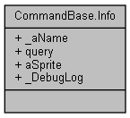

### Public Attributes

string **_aName**

string **query**

Sprite **aSprite**

bool **_DebugLog**

### Member Data Documentation

#### string CommandBase.Info._aName

#### bool CommandBase.Info._DebugLog

#### Sprite CommandBase.Info.aSprite

#### string CommandBase.Info.query

#### The documentation for this struct was generated from the following file:

C:/_SSDSPEEDUP/2021/clone/gps1_manadesigner/GPS1-Manadesigner/Assets/_UtilsV0.4/MyScripts/_Utils/CommandPattern/Command/SOScripts/**CommandBase.cs**

## UnityEngine.InputSystem.Samples.InGameHints.InGameHintsActions Class Reference

Inheritance diagram for UnityEngine.InputSystem.Samples.InGameHints.InGameHintsActions:

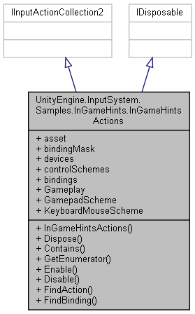

Collaboration diagram for UnityEngine.InputSystem.Samples.InGameHints.InGameHintsActions:



### Classes

struct **GameplayActions**

interface **IGameplayActions**

### Public Member Functions

**InGameHintsActions** ()

void **Dispose** ()

bool **Contains** (InputAction action)

IEnumerator< InputAction > **GetEnumerator** ()

void **Enable** ()

void **Disable** ()

InputAction **FindAction** (string actionNameOrId, bool throwIfNotFound=false)

int **FindBinding** (InputBinding **bindingMask**, out InputAction action)

### Properties

InputActionAsset **asset** [get]

InputBinding? **bindingMask** [getset]

ReadOnlyArray< InputDevice >? **devices** [getset]

ReadOnlyArray< InputControlScheme > **controlSchemes** [get]

IEnumerable< InputBinding > **bindings** [get]

**GameplayActions** **Gameplay** [get]

InputControlScheme **GamepadScheme** [get]

InputControlScheme **KeyboardMouseScheme** [get]

### Constructor & Destructor Documentation

#### UnityEngine.InputSystem.Samples.InGameHints.InGameHintsActions.InGameHintsActions ()

### Member Function Documentation

#### bool UnityEngine.InputSystem.Samples.InGameHints.InGameHintsActions.Contains (InputAction *action*)

#### void UnityEngine.InputSystem.Samples.InGameHints.InGameHintsActions.Disable ()

#### void UnityEngine.InputSystem.Samples.InGameHints.InGameHintsActions.Dispose ()

#### void UnityEngine.InputSystem.Samples.InGameHints.InGameHintsActions.Enable ()

#### InputAction UnityEngine.InputSystem.Samples.InGameHints.InGameHintsActions.FindAction (string *actionNameOrId*, bool *throwIfNotFound* = false)

#### int UnityEngine.InputSystem.Samples.InGameHints.InGameHintsActions.FindBinding (InputBinding *bindingMask*, out InputAction *action*)

#### IEnumerator< InputAction > UnityEngine.InputSystem.Samples.InGameHints.InGameHintsActions.GetEnumerator ()

### Property Documentation

#### InputActionAsset UnityEngine.InputSystem.Samples.InGameHints.InGameHintsActions.asset[get]

#### InputBinding? UnityEngine.InputSystem.Samples.InGameHints.InGameHintsActions.bindingMask[get], [set]

#### IEnumerable<InputBinding> UnityEngine.InputSystem.Samples.InGameHints.InGameHintsActions.bindings[get]

#### ReadOnlyArray<InputControlScheme> UnityEngine.InputSystem.Samples.InGameHints.InGameHintsActions.controlSchemes[get]

#### ReadOnlyArray<InputDevice>? UnityEngine.InputSystem.Samples.InGameHints.InGameHintsActions.devices[get], [set]

#### InputControlScheme UnityEngine.InputSystem.Samples.InGameHints.InGameHintsActions.GamepadScheme[get]

#### GameplayActions UnityEngine.InputSystem.Samples.InGameHints.InGameHintsActions.Gameplay[get]

#### InputControlScheme UnityEngine.InputSystem.Samples.InGameHints.InGameHintsActions.KeyboardMouseScheme[get]

#### The documentation for this class was generated from the following file:

C:/_SSDSPEEDUP/2021/clone/gps1_manadesigner/GPS1-Manadesigner/Assets/Samples/Input System/1.0.2/In-Game Hints/**InGameHintsActions.cs**

## UnityEngine.InputSystem.Samples.InGameHints.InGameHintsExample Class Reference

Inheritance diagram for UnityEngine.InputSystem.Samples.InGameHints.InGameHintsExample:

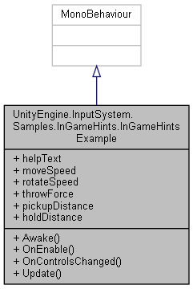

Collaboration diagram for UnityEngine.InputSystem.Samples.InGameHints.InGameHintsExample:

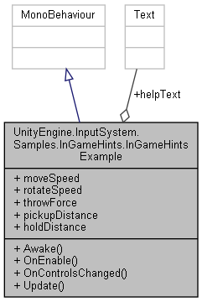

### Public Member Functions

void **Awake** ()

void **OnEnable** ()

void **OnControlsChanged** ()

void **Update** ()

### Public Attributes

Text **helpText**

float **moveSpeed**

float **rotateSpeed**

float **throwForce**

float **pickupDistance**

float **holdDistance**

### Member Function Documentation

#### void UnityEngine.InputSystem.Samples.InGameHints.InGameHintsExample.Awake ()

#### void UnityEngine.InputSystem.Samples.InGameHints.InGameHintsExample.OnControlsChanged ()

#### void UnityEngine.InputSystem.Samples.InGameHints.InGameHintsExample.OnEnable ()

#### void UnityEngine.InputSystem.Samples.InGameHints.InGameHintsExample.Update ()

### Member Data Documentation

#### Text UnityEngine.InputSystem.Samples.InGameHints.InGameHintsExample.helpText

#### float UnityEngine.InputSystem.Samples.InGameHints.InGameHintsExample.holdDistance

#### float UnityEngine.InputSystem.Samples.InGameHints.InGameHintsExample.moveSpeed

#### float UnityEngine.InputSystem.Samples.InGameHints.InGameHintsExample.pickupDistance

#### float UnityEngine.InputSystem.Samples.InGameHints.InGameHintsExample.rotateSpeed

#### float UnityEngine.InputSystem.Samples.InGameHints.InGameHintsExample.throwForce

#### The documentation for this class was generated from the following file:

C:/_SSDSPEEDUP/2021/clone/gps1_manadesigner/GPS1-Manadesigner/Assets/Samples/Input System/1.0.2/In-Game Hints/**InGameHintsExample.cs**

## InitCustomDeviceUsages Class Reference

Collaboration diagram for InitCustomDeviceUsages:

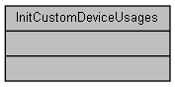

The documentation for this class was generated from the following file:

C:/_SSDSPEEDUP/2021/clone/gps1_manadesigner/GPS1-Manadesigner/Assets/Samples/Input System/1.0.2/Custom Device Usages/**CustomDeviceUsages.cs**

## UnityEngine.InputSystem.Samples.InputActionVisualizer Class Reference

A component for debugging purposes that adds an on-screen display which shows activity on an input action over time (**InputActionVisualizer.Visualization.Interaction**) or an action's current value (**InputActionVisualizer.Visualization.Value**).

Inheritance diagram for UnityEngine.InputSystem.Samples.InputActionVisualizer:

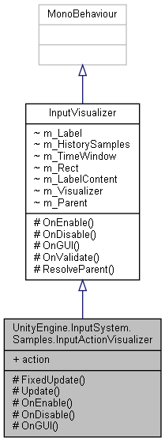

Collaboration diagram for UnityEngine.InputSystem.Samples.InputActionVisualizer:

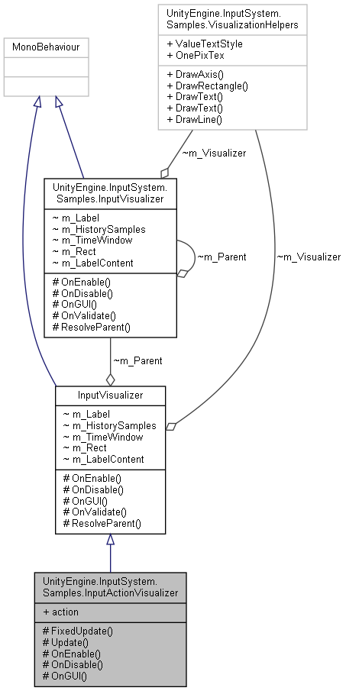

### Public Types

enum **Visualization** { **None**, **Value**, **Interaction** }

### Protected Member Functions

void **FixedUpdate** ()

void **Update** ()

new void **OnEnable** ()

new void **OnDisable** ()

new void **OnGUI** ()

### Properties

InputAction **action** [get]

*The action that is being visualized.*

### Detailed Description

A component for debugging purposes that adds an on-screen display which shows activity on an input action over time (**InputActionVisualizer.Visualization.Interaction**) or an action's current value (**InputActionVisualizer.Visualization.Value**).

##### See also

**InputControlVisualizer**

### Member Enumeration Documentation

#### enum UnityEngine.InputSystem.Samples.InputActionVisualizer.Visualization

##### Enumerator:

|  |  |
| --- | --- |
| None |  |
| Value |  |
| Interaction |  |

### Member Function Documentation

#### void UnityEngine.InputSystem.Samples.InputActionVisualizer.FixedUpdate ()[protected]

#### new void UnityEngine.InputSystem.Samples.InputActionVisualizer.OnDisable ()[protected]

#### new void UnityEngine.InputSystem.Samples.InputActionVisualizer.OnEnable ()[protected]

#### new void UnityEngine.InputSystem.Samples.InputActionVisualizer.OnGUI ()[protected]

#### void UnityEngine.InputSystem.Samples.InputActionVisualizer.Update ()[protected]

### Property Documentation

#### InputAction UnityEngine.InputSystem.Samples.InputActionVisualizer.action[get]

The action that is being visualized.

May be null.

#### The documentation for this class was generated from the following file:

C:/_SSDSPEEDUP/2021/clone/gps1_manadesigner/GPS1-Manadesigner/Assets/Samples/Input System/1.0.2/Visualizers/**InputActionVisualizer.cs**

## InputCommand Class Reference

Inheritance diagram for InputCommand:

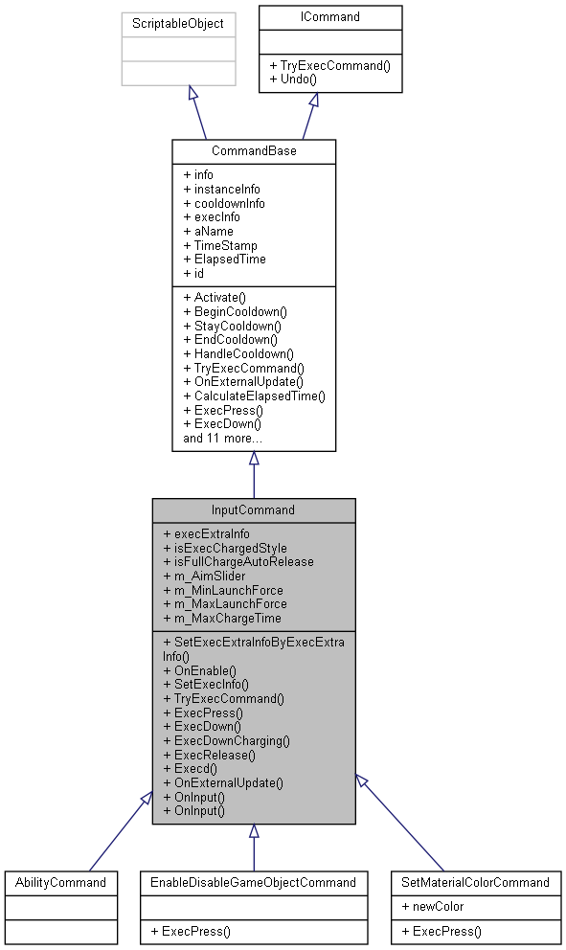

Collaboration diagram for InputCommand:

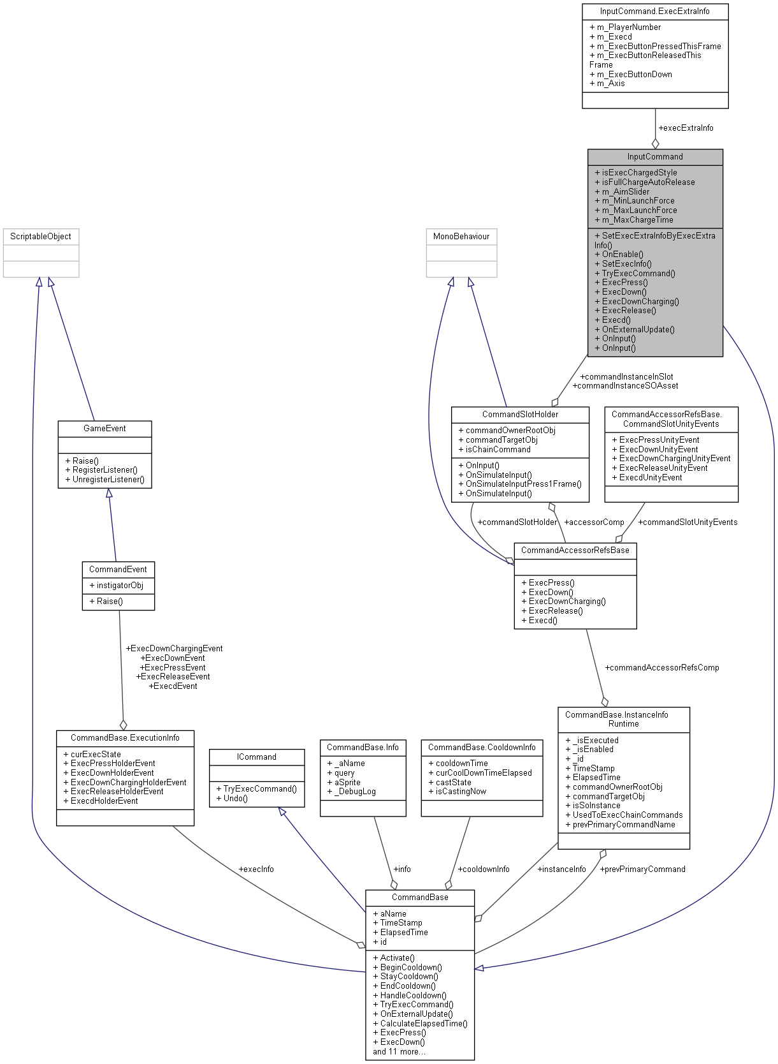

### Classes

struct **ExecExtraInfo**

### Public Member Functions

void **SetExecExtraInfoByExecExtraInfo** (**ExecExtraInfo** ex2)

override void **OnEnable** ()

void **SetExecInfo** (bool IsPress)

override void **TryExecCommand** ()

override void **ExecPress** ()

override void **ExecDown** ()

override void **ExecDownCharging** ()

override void **ExecRelease** ()

override void **Execd** ()

override void **OnExternalUpdate** ()

void **OnInput** (InputAction.CallbackContext context)

void **OnInput** (InputValue value)

### Public Attributes

**ExecExtraInfo** **execExtraInfo**

bool **isExecChargedStyle**

bool **isFullChargeAutoRelease**

Slider **m_AimSlider**

float **m_MinLaunchForce** = 15f

float **m_MaxLaunchForce** = 30f

float **m_MaxChargeTime** = 0.75f

### Additional Inherited Members

### Member Function Documentation

#### override void InputCommand.Execd ()[virtual]

Reimplemented from **CommandBase** (*p.163*).

#### override void InputCommand.ExecDown ()[virtual]

Reimplemented from **CommandBase** (*p.163*).

Here is the call graph for this function:



#### override void InputCommand.ExecDownCharging ()[virtual]

Reimplemented from **CommandBase** (*p.164*).

Here is the caller graph for this function:



#### override void InputCommand.ExecPress ()[virtual]

Reimplemented from **CommandBase** (*p.164*).

Reimplemented in **EnableDisableGameObjectCommand** (*p.244*), and **SetMaterialColorCommand** (*p.680*).

#### override void InputCommand.ExecRelease ()[virtual]

Reimplemented from **CommandBase** (*p.164*).

#### override void InputCommand.OnEnable ()[virtual]

Reimplemented from **CommandBase** (*p.165*).

#### override void InputCommand.OnExternalUpdate ()[virtual]

Reimplemented from **CommandBase** (*p.165*).

#### void InputCommand.OnInput (InputAction.CallbackContext *context*)

Here is the call graph for this function:



Here is the caller graph for this function:

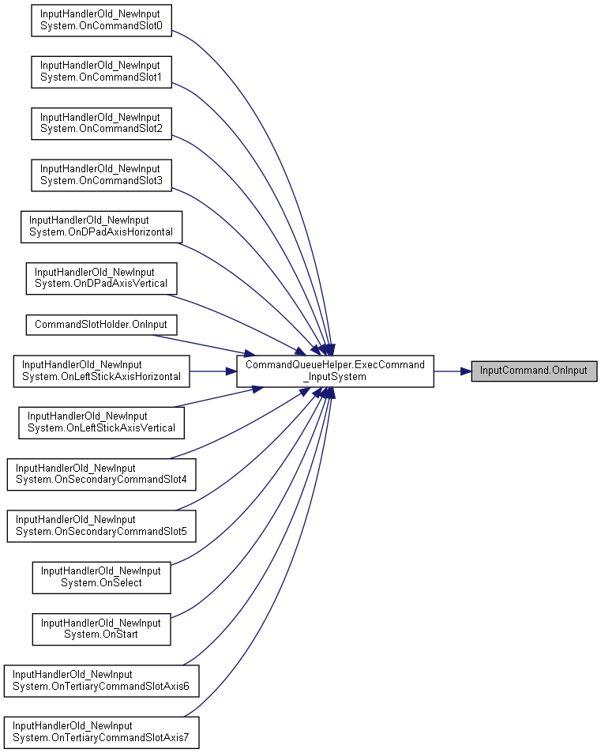

#### void InputCommand.OnInput (InputValue *value*)

Here is the call graph for this function:



#### void InputCommand.SetExecExtraInfoByExecExtraInfo (ExecExtraInfo *ex2*)

Here is the call graph for this function:

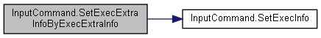

#### void InputCommand.SetExecInfo (bool *IsPress*)

Here is the caller graph for this function:

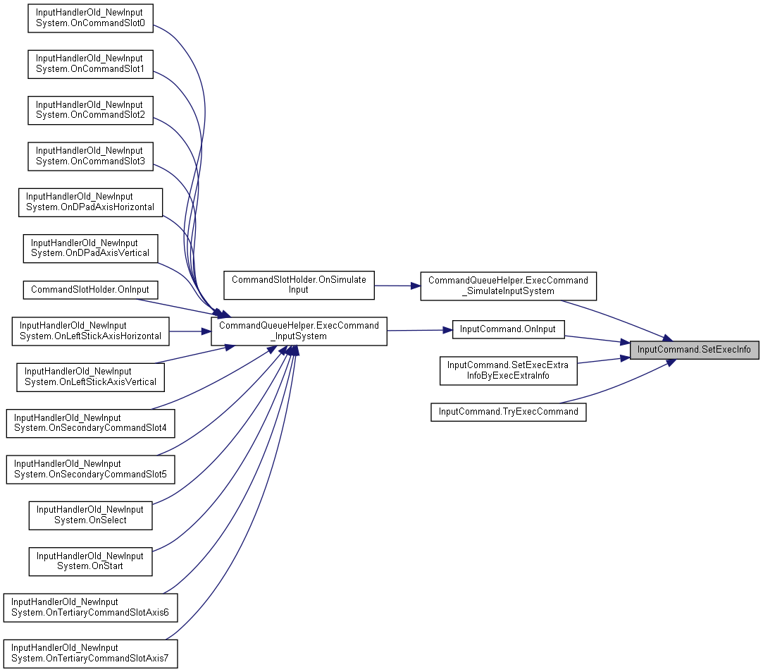

#### override void InputCommand.TryExecCommand ()[virtual]

Reimplemented from **CommandBase** (*p.165*).

Here is the call graph for this function:



### Member Data Documentation

#### ExecExtraInfo InputCommand.execExtraInfo

#### bool InputCommand.isExecChargedStyle

#### bool InputCommand.isFullChargeAutoRelease

#### Slider InputCommand.m_AimSlider

#### float InputCommand.m_MaxChargeTime = 0.75f

#### float InputCommand.m_MaxLaunchForce = 30f

#### float InputCommand.m_MinLaunchForce = 15f

#### The documentation for this class was generated from the following file:

C:/_SSDSPEEDUP/2021/clone/gps1_manadesigner/GPS1-Manadesigner/Assets/_UtilsV0.4/MyScripts/_Utils/CommandPattern/Command/SOScripts/**InputCommand.cs**

## UnityEngine.InputSystem.Samples.InputControlVisualizer Class Reference

A component for debugging purposes that adds an on-screen display which shows activity on an input control over time.

Inheritance diagram for UnityEngine.InputSystem.Samples.InputControlVisualizer:

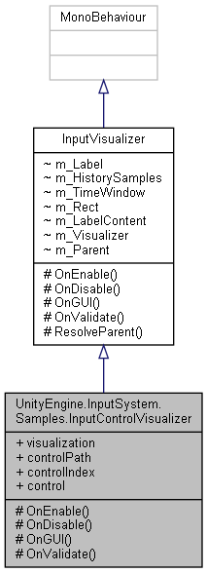

Collaboration diagram for UnityEngine.InputSystem.Samples.InputControlVisualizer:

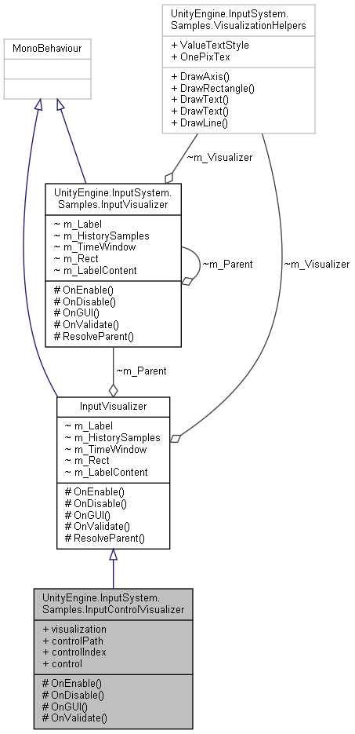

### Public Types

enum **Mode** { **None** = 0, **Value** = 1, **Events** = 4, **MaximumLag** = 6, **Bytes** = 7 }

*Determines which aspect of the control should be visualized.*

### Protected Member Functions

new void **OnEnable** ()

new void **OnDisable** ()

new void **OnGUI** ()

new void **OnValidate** ()

### Properties

**Mode** **visualization** [getset]

*What kind of visualization to show.*

string **controlPath** [getset]

*Path of the control that is to be visualized.*

int **controlIndex** [getset]

*If, at runtime, multiple controls are matching* ***controlPath****, this property determines the index of the control that is retrieved from the possible options.*

InputControl **control** [get]

*The control resolved from* ***controlPath*** *at runtime.*

### Detailed Description

A component for debugging purposes that adds an on-screen display which shows activity on an input control over time.

This component is most useful for debugging input directly on the source device.

##### See also

**InputActionVisualizer**

### Member Enumeration Documentation

#### enum UnityEngine.InputSystem.Samples.InputControlVisualizer.Mode

Determines which aspect of the control should be visualized.

##### Enumerator:

|  |  |
| --- | --- |
| None |  |
| Value |  |
| Events |  |
| MaximumLag |  |
| Bytes |  |

### Member Function Documentation

#### new void UnityEngine.InputSystem.Samples.InputControlVisualizer.OnDisable ()[protected]

#### new void UnityEngine.InputSystem.Samples.InputControlVisualizer.OnEnable ()[protected]

#### new void UnityEngine.InputSystem.Samples.InputControlVisualizer.OnGUI ()[protected]

#### new void UnityEngine.InputSystem.Samples.InputControlVisualizer.OnValidate ()[protected]

### Property Documentation

#### InputControl UnityEngine.InputSystem.Samples.InputControlVisualizer.control[get]

The control resolved from **controlPath** at runtime.

May be null.

#### int UnityEngine.InputSystem.Samples.InputControlVisualizer.controlIndex[get], [set]

If, at runtime, multiple controls are matching **controlPath**, this property determines the index of the control that is retrieved from the possible options.

#### string UnityEngine.InputSystem.Samples.InputControlVisualizer.controlPath[get], [set]

Path of the control that is to be visualized.

##### See also

InputControlPath, InputControl.path

#### Mode UnityEngine.InputSystem.Samples.InputControlVisualizer.visualization[get], [set]

What kind of visualization to show.

#### The documentation for this class was generated from the following file:

C:/_SSDSPEEDUP/2021/clone/gps1_manadesigner/GPS1-Manadesigner/Assets/Samples/Input System/1.0.2/Visualizers/**InputControlVisualizer.cs**

## InputHandlerOld_NewInputSystem Class Reference

Inheritance diagram for InputHandlerOld_NewInputSystem:

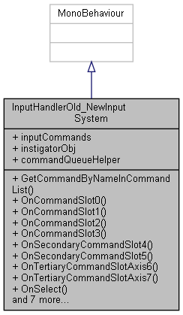

Collaboration diagram for InputHandlerOld_NewInputSystem:



### Public Member Functions

**CommandBase** **GetCommandByNameInCommandList** (string commandName)

void **OnCommandSlot0** (InputAction.CallbackContext context)

void **OnCommandSlot1** (InputAction.CallbackContext context)

void **OnCommandSlot2** (InputAction.CallbackContext context)

void **OnCommandSlot3** (InputAction.CallbackContext context)

void **OnSecondaryCommandSlot4** (InputAction.CallbackContext context)

void **OnSecondaryCommandSlot5** (InputAction.CallbackContext context)

void **OnTertiaryCommandSlotAxis6** (InputAction.CallbackContext context)

void **OnTertiaryCommandSlotAxis7** (InputAction.CallbackContext context)

void **OnSelect** (InputAction.CallbackContext context)

void **OnStart** (InputAction.CallbackContext context)

void **OnDPadAxisHorizontal** (InputAction.CallbackContext context)

void **OnDPadAxisVertical** (InputAction.CallbackContext context)

void **OnLeftStickAxisHorizontal** (InputAction.CallbackContext context)

void **OnLeftStickAxisVertical** (InputAction.CallbackContext context)

void **OnRightStickAxisHorizontal** (InputAction.CallbackContext context)

void **OnRightStickAxisVertical** (InputAction.CallbackContext context)

### Public Attributes

List< **CommandBase** > **inputCommands**

GameObject **instigatorObj**

### Properties

virtual **CommandQueueHelper** **commandQueueHelper** [getset]

### Member Function Documentation

#### CommandBase InputHandlerOld_NewInputSystem.GetCommandByNameInCommandList (string *commandName*)

Here is the caller graph for this function:

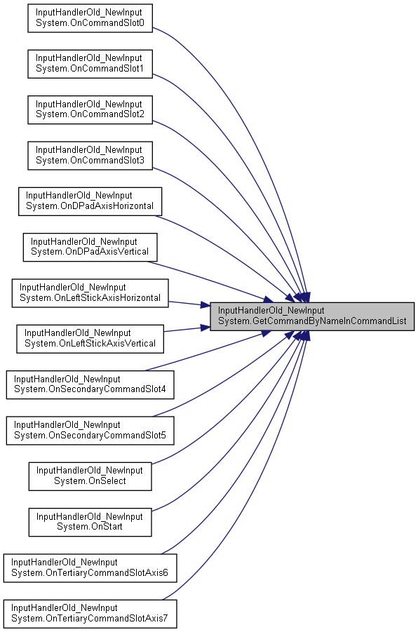

#### void InputHandlerOld_NewInputSystem.OnCommandSlot0 (InputAction.CallbackContext *context*)

Here is the call graph for this function:

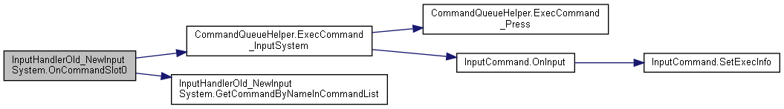

#### void InputHandlerOld_NewInputSystem.OnCommandSlot1 (InputAction.CallbackContext *context*)

Here is the call graph for this function:

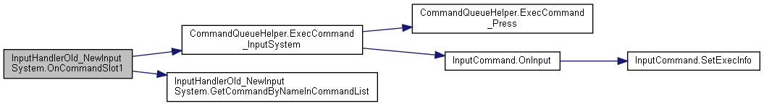

#### void InputHandlerOld_NewInputSystem.OnCommandSlot2 (InputAction.CallbackContext *context*)

Here is the call graph for this function:

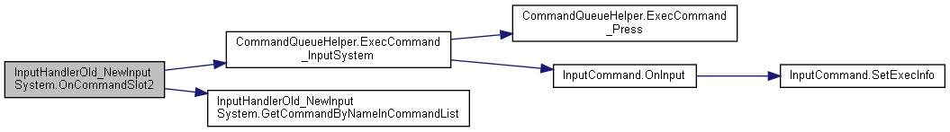

#### void InputHandlerOld_NewInputSystem.OnCommandSlot3 (InputAction.CallbackContext *context*)

Here is the call graph for this function:

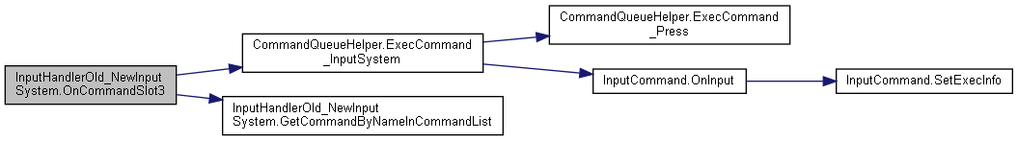

#### void InputHandlerOld_NewInputSystem.OnDPadAxisHorizontal (InputAction.CallbackContext *context*)

Here is the call graph for this function:

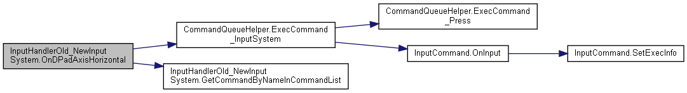

#### void InputHandlerOld_NewInputSystem.OnDPadAxisVertical (InputAction.CallbackContext *context*)

Here is the call graph for this function:

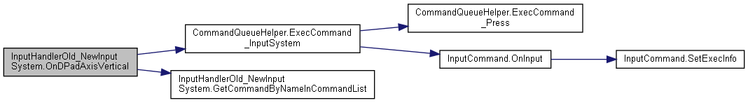

#### void InputHandlerOld_NewInputSystem.OnLeftStickAxisHorizontal (InputAction.CallbackContext *context*)

Here is the call graph for this function:

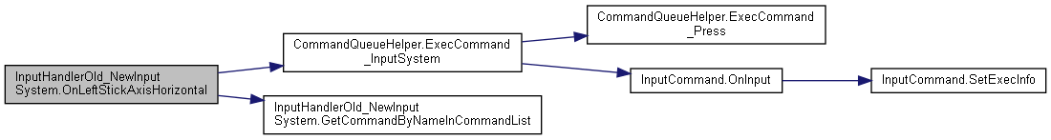

#### void InputHandlerOld_NewInputSystem.OnLeftStickAxisVertical (InputAction.CallbackContext *context*)

Here is the call graph for this function:

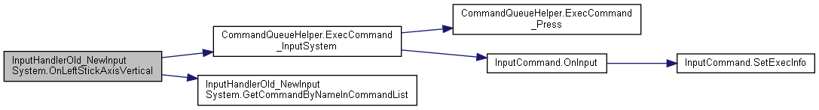

#### void InputHandlerOld_NewInputSystem.OnRightStickAxisHorizontal (InputAction.CallbackContext *context*)

#### void InputHandlerOld_NewInputSystem.OnRightStickAxisVertical (InputAction.CallbackContext *context*)

#### void InputHandlerOld_NewInputSystem.OnSecondaryCommandSlot4 (InputAction.CallbackContext *context*)

Here is the call graph for this function:

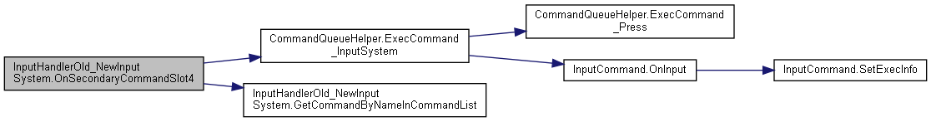

#### void InputHandlerOld_NewInputSystem.OnSecondaryCommandSlot5 (InputAction.CallbackContext *context*)

Here is the call graph for this function:

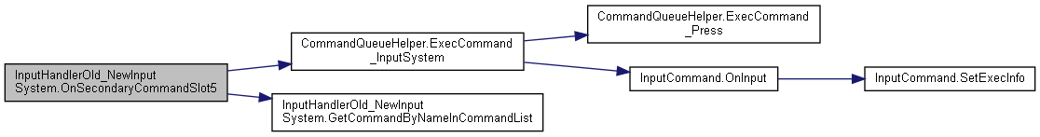

#### void InputHandlerOld_NewInputSystem.OnSelect (InputAction.CallbackContext *context*)

Here is the call graph for this function:

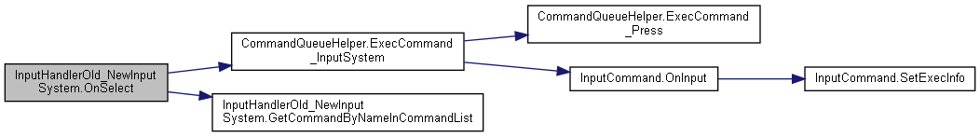

#### void InputHandlerOld_NewInputSystem.OnStart (InputAction.CallbackContext *context*)

Here is the call graph for this function:

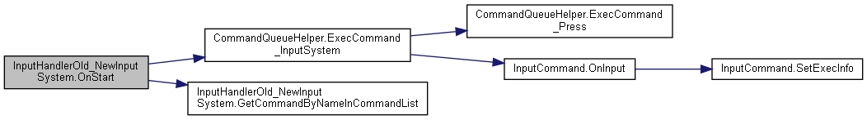

#### void InputHandlerOld_NewInputSystem.OnTertiaryCommandSlotAxis6 (InputAction.CallbackContext *context*)

Here is the call graph for this function:

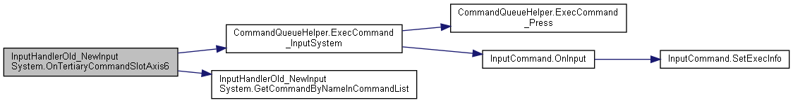

#### void InputHandlerOld_NewInputSystem.OnTertiaryCommandSlotAxis7 (InputAction.CallbackContext *context*)

Here is the call graph for this function:

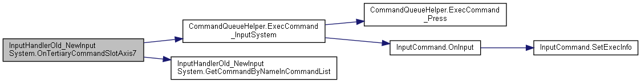

### Member Data Documentation

#### List<CommandBase> InputHandlerOld_NewInputSystem.inputCommands

#### GameObject InputHandlerOld_NewInputSystem.instigatorObj

### Property Documentation

#### virtual CommandQueueHelper InputHandlerOld_NewInputSystem.commandQueueHelper[get], [set]

#### The documentation for this class was generated from the following file:

C:/_SSDSPEEDUP/2021/clone/gps1_manadesigner/GPS1-Manadesigner/Assets/_UtilsV0.4/MyScripts/_Utils/CommandPattern/Command/MyScripts/TypeA_RefsToAllAvailableCommandInSingleScript/**InputHandlerOld_NewInputSystem.cs**

## InputManager Class Reference

Inheritance diagram for InputManager:

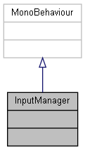

Collaboration diagram for InputManager:



The documentation for this class was generated from the following file:

C:/_SSDSPEEDUP/2021/clone/gps1_manadesigner/GPS1-Manadesigner/Assets/_UtilsV0.4/MyScripts/_Utils/CommandPattern/_Bin/OWS/_Samples/Script/**InputManager.cs**

## InputManagerTurnBased Class Reference

Inheritance diagram for InputManagerTurnBased:

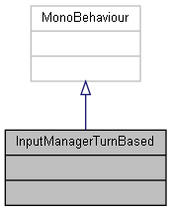

Collaboration diagram for InputManagerTurnBased:



The documentation for this class was generated from the following file:

C:/_SSDSPEEDUP/2021/clone/gps1_manadesigner/GPS1-Manadesigner/Assets/_UtilsV0.4/MyScripts/_Utils/CommandPattern/_Bin/OWS/_Samples/Script/**InputManagerTurnBased.cs**

## UnityEngine.InputSystem.InputRecorder Class Reference

A wrapper component around InputEventTrace that provides an easy interface for recording input from a GameObject.

Inheritance diagram for UnityEngine.InputSystem.InputRecorder:

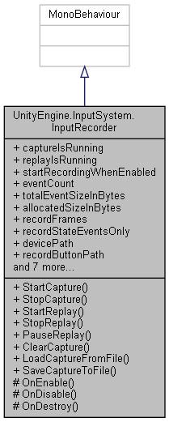

Collaboration diagram for UnityEngine.InputSystem.InputRecorder:



### Classes

class **ChangeEvent**

### Public Types

enum **Change** { **None**, **EventCaptured**, **EventPlayed**, **CaptureStarted**, **CaptureStopped**, **ReplayStarted**, **ReplayStopped** }

### Public Member Functions

void **StartCapture** ()

void **StopCapture** ()

void **StartReplay** ()

void **StopReplay** ()

void **PauseReplay** ()

void **ClearCapture** ()

void **LoadCaptureFromFile** (string fileName)

void **SaveCaptureToFile** (string fileName)

### Protected Member Functions

void **OnEnable** ()

void **OnDisable** ()

void **OnDestroy** ()

### Properties

bool **captureIsRunning** [get]

*Whether a capture is currently in progress.*

bool **replayIsRunning** [get]

*Whether a replay is currently being run by the component.*

bool **startRecordingWhenEnabled** [getset]

*If true, input recording is started immediately when the component is enabled.*

long **eventCount** [get]

*Total number of events captured.*

long **totalEventSizeInBytes** [get]

*Total size of captured events.*

long **allocatedSizeInBytes** [get]

*Total size of capture memory currently allocated.*

bool **recordFrames** [getset]

*Whether to record frame marker events when capturing input.*

bool **recordStateEventsOnly** [getset]

*Whether to record only StateEvents and DeltaStateEvents.*

string **devicePath** [getset]

*Path that constrains the devices to record from.*

string **recordButtonPath** [getset]

string **playButtonPath** [getset]

InputEventTrace **capture** [get]

*The underlying event trace that contains the captured input events.*

InputEventTrace.ReplayController **replay** [get]

*The replay controller for when a replay is running.*

int **replayPosition** [get]

bool **replayOnNewDevices** [getset]

*Whether a replay should create new devices or replay recorded events as is.*

bool **simulateOriginalTimingOnReplay** [getset]

*Whether to attempt to re-create the original event timing when replaying events.*

**ChangeEvent** **changeEvent** [get]

### Detailed Description

A wrapper component around InputEventTrace that provides an easy interface for recording input from a GameObject.

This component comes with a custom inspector that provides an easy recording and playback interface and also gives feedback about what has been recorded in the trace. The interface also allows saving and loading event traces.

Capturing can either be constrained by a **devicePath** or capture all input occuring in the system.

Replay by default will happen frame by frame (see InputEventTrace.ReplayController.PlayAllFramesOneByOne). If frame markers are disabled (see **recordFrames**), all events are queued right away in the first frame and replay completes immediately.

Other than frame-by-frame, replay can be made to happen in a way that tries to simulate the original input timing. To do so, enable **simulateOriginalTimingOnReplay**. This will make use of InputEventTrace.ReplayController.PlayAllEventsAccordingToTimestamps

### Member Enumeration Documentation

#### enum UnityEngine.InputSystem.InputRecorder.Change

##### Enumerator:

|  |  |
| --- | --- |
| None |  |
| EventCaptured |  |
| EventPlayed |  |
| CaptureStarted |  |
| CaptureStopped |  |
| ReplayStarted |  |
| ReplayStopped |  |

### Member Function Documentation

#### void UnityEngine.InputSystem.InputRecorder.ClearCapture ()

#### void UnityEngine.InputSystem.InputRecorder.LoadCaptureFromFile (string *fileName*)

#### void UnityEngine.InputSystem.InputRecorder.OnDestroy ()[protected]

#### void UnityEngine.InputSystem.InputRecorder.OnDisable ()[protected]

Here is the call graph for this function:

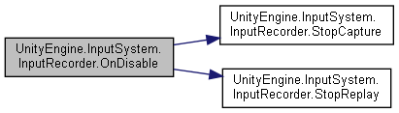

#### void UnityEngine.InputSystem.InputRecorder.OnEnable ()[protected]

Here is the call graph for this function:

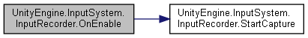

#### void UnityEngine.InputSystem.InputRecorder.PauseReplay ()

#### void UnityEngine.InputSystem.InputRecorder.SaveCaptureToFile (string *fileName*)

#### void UnityEngine.InputSystem.InputRecorder.StartCapture ()

Here is the caller graph for this function:

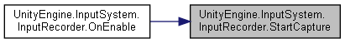

#### void UnityEngine.InputSystem.InputRecorder.StartReplay ()

Here is the call graph for this function:

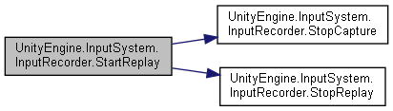

#### void UnityEngine.InputSystem.InputRecorder.StopCapture ()

Here is the caller graph for this function:

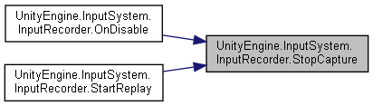

#### void UnityEngine.InputSystem.InputRecorder.StopReplay ()

Here is the caller graph for this function:

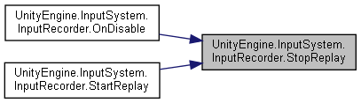

### Property Documentation

#### long UnityEngine.InputSystem.InputRecorder.allocatedSizeInBytes[get]

Total size of capture memory currently allocated.

Size of memory allocated for capture.

#### InputEventTrace UnityEngine.InputSystem.InputRecorder.capture[get]

The underlying event trace that contains the captured input events.

Underlying event trace.

This will be null if no capture is currently associated with the recorder.

#### bool UnityEngine.InputSystem.InputRecorder.captureIsRunning[get]

Whether a capture is currently in progress.

True if a capture is in progress.

#### ChangeEvent UnityEngine.InputSystem.InputRecorder.changeEvent[get]

#### string UnityEngine.InputSystem.InputRecorder.devicePath[get], [set]

Path that constrains the devices to record from.

Input control path to match devices or null/empty.

By default, this is not set. Meaning that input will be recorded from all devices. By setting this property to a path, only events for devices that match the given path (as dictated by InputControlPath.Matches) will be recorded from.

By setting this property to the exact path of a device at runtime, recording can be restricted to just that device.

##### See also

InputControlPath, InputControlPath.Matches

#### long UnityEngine.InputSystem.InputRecorder.eventCount[get]

Total number of events captured.

Number of captured events.

#### string UnityEngine.InputSystem.InputRecorder.playButtonPath[get], [set]

#### string UnityEngine.InputSystem.InputRecorder.recordButtonPath[get], [set]

#### bool UnityEngine.InputSystem.InputRecorder.recordFrames[get], [set]

Whether to record frame marker events when capturing input.

Enabled by default.

True if frame marker events will be recorded.

##### See also

InputEventTrace.recordFrameMarkers

#### bool UnityEngine.InputSystem.InputRecorder.recordStateEventsOnly[get], [set]

Whether to record only StateEvents and DeltaStateEvents.

Disabled by default.

True if anything but state events should be ignored.

#### InputEventTrace.ReplayController UnityEngine.InputSystem.InputRecorder.replay[get]

The replay controller for when a replay is running.

Replay controller for the event trace while replay is running.

##### See also

**replayIsRunning**, **StartReplay**

#### bool UnityEngine.InputSystem.InputRecorder.replayIsRunning[get]

Whether a replay is currently being run by the component.

True if replay is running.

##### See also

**replay**, **StartReplay**, **StopReplay**

#### bool UnityEngine.InputSystem.InputRecorder.replayOnNewDevices[get], [set]

Whether a replay should create new devices or replay recorded events as is.

Disabled by default.

True if replay should temporary create new devices.

##### See also

InputEventTrace.ReplayController.WithAllDevicesMappedToNewInstances

#### int UnityEngine.InputSystem.InputRecorder.replayPosition[get]

#### bool UnityEngine.InputSystem.InputRecorder.simulateOriginalTimingOnReplay[get], [set]

Whether to attempt to re-create the original event timing when replaying events.

Disabled by default.

If true, events are queued based on their timestamp rather than based on their recorded frames (if any).

##### See also

InputEventTrace.ReplayController.PlayAllEventsAccordingToTimestamps

#### bool UnityEngine.InputSystem.InputRecorder.startRecordingWhenEnabled[get], [set]

If true, input recording is started immediately when the component is enabled.

Disabled by default. Call **StartCapture** to manually start capturing.

True if component will start recording automatically in **OnEnable**.

##### See also

**StartCapture**

#### long UnityEngine.InputSystem.InputRecorder.totalEventSizeInBytes[get]

Total size of captured events.

Size of captured events in bytes.

#### The documentation for this class was generated from the following file:

C:/_SSDSPEEDUP/2021/clone/gps1_manadesigner/GPS1-Manadesigner/Assets/Samples/Input System/1.0.2/Input Recorder/**InputRecorder.cs**

## UnityEngine.InputSystem.Samples.InputVisualizer Class Reference

Base class for **InputActionVisualizer** and **InputControlVisualizer**.

Inheritance diagram for UnityEngine.InputSystem.Samples.InputVisualizer:

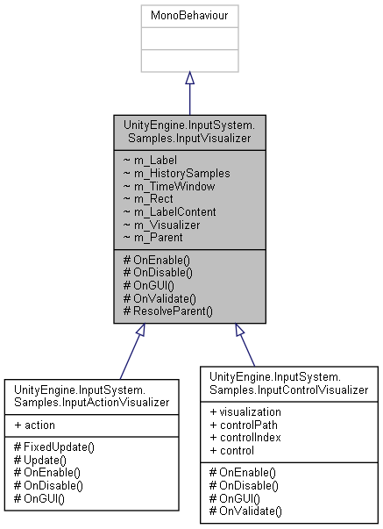

Collaboration diagram for UnityEngine.InputSystem.Samples.InputVisualizer:

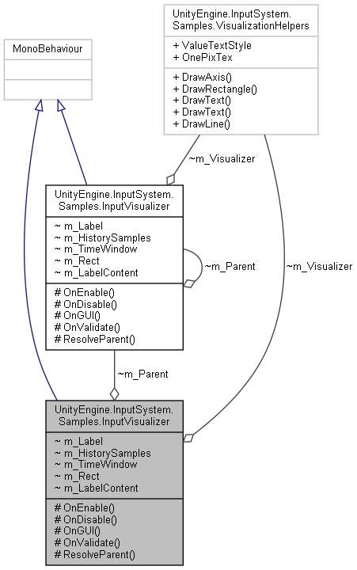

### Protected Member Functions

void **OnEnable** ()

void **OnDisable** ()

void **OnGUI** ()

void **OnValidate** ()

void **ResolveParent** ()

### Detailed Description

Base class for **InputActionVisualizer** and **InputControlVisualizer**.

Not meant to be extended outside of input system.

### Member Function Documentation

#### void UnityEngine.InputSystem.Samples.InputVisualizer.OnDisable ()[protected]

#### void UnityEngine.InputSystem.Samples.InputVisualizer.OnEnable ()[protected]

Here is the call graph for this function:

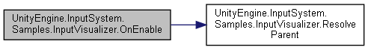

#### void UnityEngine.InputSystem.Samples.InputVisualizer.OnGUI ()[protected]

#### void UnityEngine.InputSystem.Samples.InputVisualizer.OnValidate ()[protected]

Here is the call graph for this function:

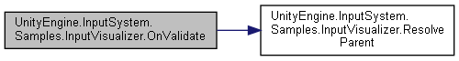

#### void UnityEngine.InputSystem.Samples.InputVisualizer.ResolveParent ()[protected]

Here is the caller graph for this function:

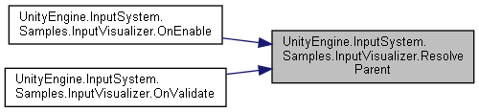

#### The documentation for this class was generated from the following file:

C:/_SSDSPEEDUP/2021/clone/gps1_manadesigner/GPS1-Manadesigner/Assets/Samples/Input System/1.0.2/Visualizers/**InputVisualizer.cs**

## InstalledUpgradeSaveData Class Reference

Collaboration diagram for InstalledUpgradeSaveData:

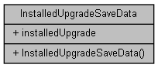

### Public Member Functions

**InstalledUpgradeSaveData** ()

### Public Attributes

List< **UpgradeSaveData** > **installedUpgrade**

### Constructor & Destructor Documentation

#### InstalledUpgradeSaveData.InstalledUpgradeSaveData ()

### Member Data Documentation

#### List<UpgradeSaveData> InstalledUpgradeSaveData.installedUpgrade

#### The documentation for this class was generated from the following file:

C:/_SSDSPEEDUP/2021/clone/gps1_manadesigner/GPS1-Manadesigner/Assets/Scripts/Arif's Test Scripts/Save State/**UpgradeSaveData.cs**

## CommandBase.InstanceInfoRuntime Struct Reference

Collaboration diagram for CommandBase.InstanceInfoRuntime:

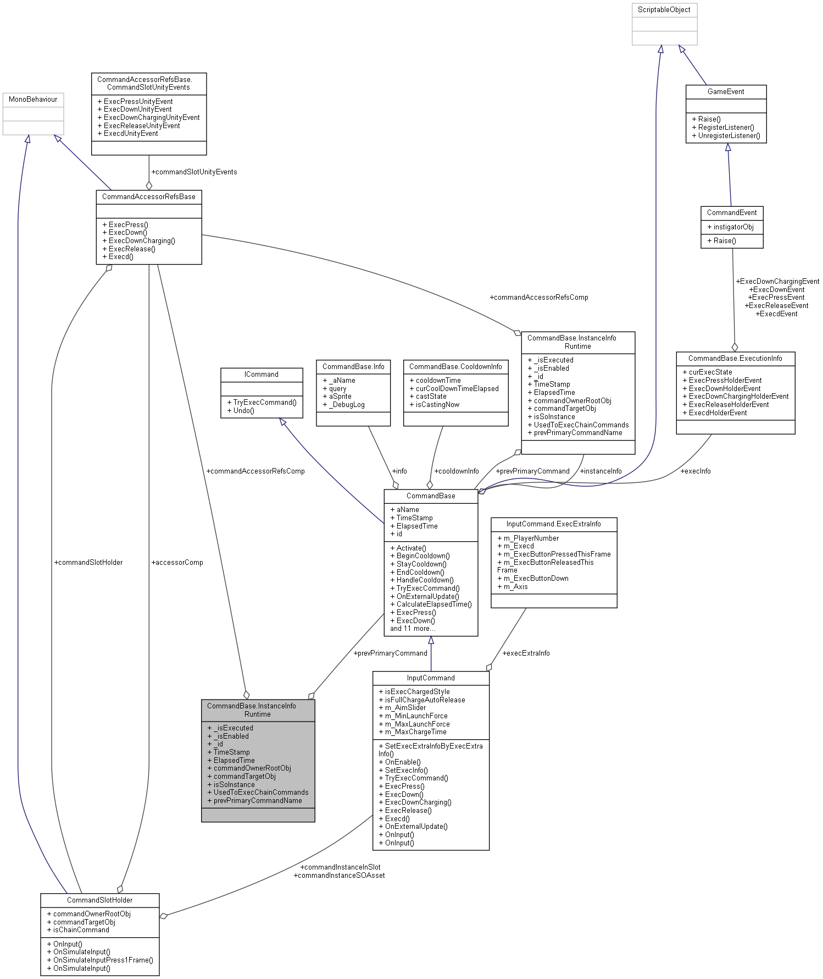

### Public Attributes

bool **_isExecuted**

bool **_isEnabled**

int **_id**

float **TimeStamp**

float **ElapsedTime**

GameObject **commandOwnerRootObj**

GameObject **commandTargetObj**

**CommandAccessorRefsBase** **commandAccessorRefsComp**

bool **isSoInstance**

List< string > **UsedToExecChainCommands**

string **prevPrimaryCommandName**

**CommandBase** **prevPrimaryCommand**

### Member Data Documentation

#### int CommandBase.InstanceInfoRuntime._id

#### bool CommandBase.InstanceInfoRuntime._isEnabled

#### bool CommandBase.InstanceInfoRuntime._isExecuted

#### CommandAccessorRefsBase CommandBase.InstanceInfoRuntime.commandAccessorRefsComp

#### GameObject CommandBase.InstanceInfoRuntime.commandOwnerRootObj

#### GameObject CommandBase.InstanceInfoRuntime.commandTargetObj

#### float CommandBase.InstanceInfoRuntime.ElapsedTime

#### bool CommandBase.InstanceInfoRuntime.isSoInstance

#### CommandBase CommandBase.InstanceInfoRuntime.prevPrimaryCommand

#### string CommandBase.InstanceInfoRuntime.prevPrimaryCommandName

#### float CommandBase.InstanceInfoRuntime.TimeStamp

#### List<string> CommandBase.InstanceInfoRuntime.UsedToExecChainCommands

#### The documentation for this struct was generated from the following file:

C:/_SSDSPEEDUP/2021/clone/gps1_manadesigner/GPS1-Manadesigner/Assets/_UtilsV0.4/MyScripts/_Utils/CommandPattern/Command/SOScripts/**CommandBase.cs**

## UnityEngine.PostProcessing.ScreenSpaceReflectionModel.IntensitySettings Struct Reference

Collaboration diagram for UnityEngine.PostProcessing.ScreenSpaceReflectionModel.IntensitySettings:

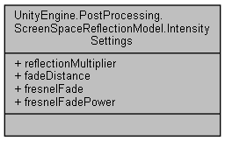

### Public Attributes

float **reflectionMultiplier**

float **fadeDistance**

float **fresnelFade**

float **fresnelFadePower**

### Member Data Documentation

#### float UnityEngine.PostProcessing.ScreenSpaceReflectionModel.IntensitySettings.fadeDistance

#### float UnityEngine.PostProcessing.ScreenSpaceReflectionModel.IntensitySettings.fresnelFade

#### float UnityEngine.PostProcessing.ScreenSpaceReflectionModel.IntensitySettings.fresnelFadePower

#### float UnityEngine.PostProcessing.ScreenSpaceReflectionModel.IntensitySettings.reflectionMultiplier

#### The documentation for this struct was generated from the following file:

C:/_SSDSPEEDUP/2021/clone/gps1_manadesigner/GPS1-Manadesigner/Assets/Samples/Input System/1.0.2/Tanks Demo/TanksDemo/PostProcessing/Runtime/Models/**ScreenSpaceReflectionModel.cs**

## UnityEngine.InputSystem.Samples.RebindUI.RebindActionUI.InteractiveRebindEvent Class Reference

Inheritance diagram for UnityEngine.InputSystem.Samples.RebindUI.RebindActionUI.InteractiveRebindEvent:

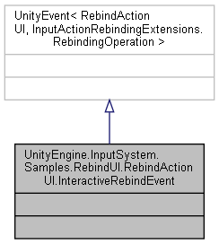

Collaboration diagram for UnityEngine.InputSystem.Samples.RebindUI.RebindActionUI.InteractiveRebindEvent:



The documentation for this class was generated from the following file:

C:/_SSDSPEEDUP/2021/clone/gps1_manadesigner/GPS1-Manadesigner/Assets/_UtilsV0.4/MyScripts/_Utils/UnityRegistryIntegration/InputSystem/Rebinding UI/_Modified/**RebindActionUI.cs**

## IntroChoice Class Reference

Inheritance diagram for IntroChoice:

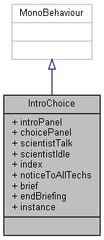

Collaboration diagram for IntroChoice:

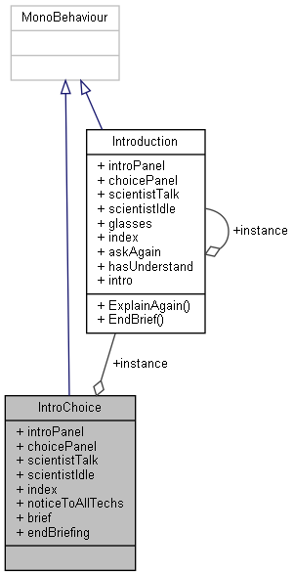

### Public Attributes

GameObject **introPanel**

GameObject **choicePanel**

GameObject **scientistTalk**

GameObject **scientistIdle**

int **index** = 0

string **noticeToAllTechs** = "Leave the last element in every dialogue boxes empty or there'll be an **index** boundary error."

string[] **brief**

string[] **endBriefing**

### Static Public Attributes

static **Introduction** **instance**

### Member Data Documentation

#### string [] IntroChoice.brief

**Initial value:**= new string[]

{

"The way Liam’s eyes squint at you is almost imperceptible, but you catch it regardless. It makes you flinch a little. :You",

"Alright, fine. Pay attention this time. :Liam",

"As you know, the USSR has been making rapid advancements on their nautical travel technology. ",

"Word has it that they’re close to reaching the bottom.",

"His lips form into a thin line. You can hear the disdain behind his words. :You",

"Naturally, that means the Cold War is drawing to a close very soon, with the USSR coming out as the victors. :Liam",

"Which is, well, not very ideal for us, no.",

"That’s where you come in.",

"Liam inclines his head at you. :You",

"You’ll be helping us gather live specimens for our research, hopefully efficiently enough, to let us better equip the submarine for deeper diving. :Liam",

"His hand gestures towards the door that leads to the submarine docking station. :You",

"And also do the diving to the bottom of the ocean, preferably before the USSR does. :Liam",

"He finishes, and folds his arms together. :You",

"We don’t know how long we have left, exactly, but we know it’s soon. :Liam",

"Liam takes out a clipboard from his coat and writes something down. :You",

"We’ll have to act quickly, especially when we can’t know when it’ll happen. :Liam",

"Let’s get you acquainted with the submarine, first. It’s a little… different from the conventional military models.",

"You trail behind Liam as he leads you to the submarine, visibly vibrating in excitement. :You",

" "

}

#### GameObject IntroChoice.choicePanel

#### string [] IntroChoice.endBriefing

**Initial value:**= new string[]

{

"Good, good. :Liam",

"Satisfied, he nods. :You",

"We don’t know how long we have left, exactly, but we know it’s soon. :Liam",

"Liam takes out a clipboard from his coat and writes something down. :You",

"We’ll have to act quickly, especially when we can’t know when it’ll happen. :Liam",

"Let’s get you acquainted with the submarine, first. It’s a little… different from the conventional military models.",

"You trail behind Liam as he leads you to the submarine, visibly vibrating in excitement. :You",

" "

}

#### int IntroChoice.index = 0

#### Introduction IntroChoice.instance[static]

#### GameObject IntroChoice.introPanel

#### string IntroChoice.noticeToAllTechs = "Leave the last element in every dialogue boxes empty or there'll be an index boundary error."

#### GameObject IntroChoice.scientistIdle

#### GameObject IntroChoice.scientistTalk

#### The documentation for this class was generated from the following file:

C:/_SSDSPEEDUP/2021/clone/gps1_manadesigner/GPS1-Manadesigner/Assets/Scripts/Tutorial Scripts/**IntroChoice.cs**

## Introduction Class Reference

Inheritance diagram for Introduction:

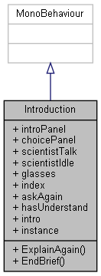

Collaboration diagram for Introduction:

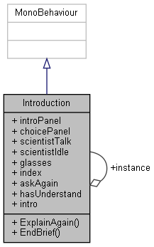

### Public Member Functions

void **ExplainAgain** ()

void **EndBrief** ()

### Public Attributes

GameObject **introPanel**

GameObject **choicePanel**

GameObject **scientistTalk**

GameObject **scientistIdle**

GameObject **glasses**

int **index** = 0

bool **askAgain** = false

bool **hasUnderstand** = false

string[] **intro**

### Static Public Attributes

static **Introduction** **instance**

### Member Function Documentation

#### void Introduction.EndBrief ()

#### void Introduction.ExplainAgain ()

### Member Data Documentation

#### bool Introduction.askAgain = false

#### GameObject Introduction.choicePanel

#### GameObject Introduction.glasses

#### bool Introduction.hasUnderstand = false

#### int Introduction.index = 0

#### Introduction Introduction.instance[static]

#### string [] Introduction.intro

#### GameObject Introduction.introPanel

#### GameObject Introduction.scientistIdle

#### GameObject Introduction.scientistTalk

#### The documentation for this class was generated from the following file:

C:/_SSDSPEEDUP/2021/clone/gps1_manadesigner/GPS1-Manadesigner/Assets/Scripts/Tutorial Scripts/**Introduction.cs**

## Inventory Class Reference

Inheritance diagram for Inventory:

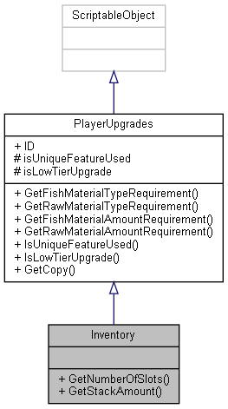

Collaboration diagram for Inventory:



### Public Member Functions

int **GetNumberOfSlots** ()

int **GetStackAmount** ()

### Additional Inherited Members

### Member Function Documentation

#### int Inventory.GetNumberOfSlots ()

Here is the caller graph for this function:

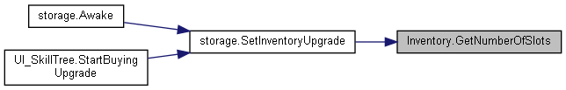

#### int Inventory.GetStackAmount ()

#### The documentation for this class was generated from the following file:

C:/_SSDSPEEDUP/2021/clone/gps1_manadesigner/GPS1-Manadesigner/Assets/Scripts/Arif's Test Scripts/Upgrades/Inventory/**Inventory.cs**

## inventoryNew Class Reference

Inheritance diagram for inventoryNew:

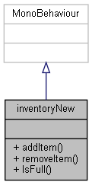

Collaboration diagram for inventoryNew:



### Public Member Functions

bool **addItem** (**itemNew** **item**)

bool **removeItem** (**item** **item**)

bool **IsFull** ()

### Events

System.Action< **itemNew** > **OnItemRightClickEvent**

### Member Function Documentation

#### bool inventoryNew.addItem (itemNew *item*)

Here is the call graph for this function:

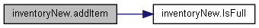

#### bool inventoryNew.IsFull ()

Here is the caller graph for this function:

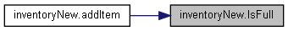

#### bool inventoryNew.removeItem (item *item*)

### Event Documentation

#### System.Action<itemNew> inventoryNew.OnItemRightClickEvent

#### The documentation for this class was generated from the following file:

C:/_SSDSPEEDUP/2021/clone/gps1_manadesigner/GPS1-Manadesigner/Assets/Scripts/Thrish/**inventoryNew.cs**

## TanksInputActions.IPlayerActions Interface Reference

Collaboration diagram for TanksInputActions.IPlayerActions:

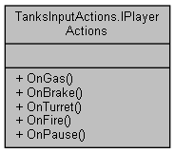

### Public Member Functions

void **OnGas** (InputAction.CallbackContext context)

void **OnBrake** (InputAction.CallbackContext context)

void **OnTurret** (InputAction.CallbackContext context)

void **OnFire** (InputAction.CallbackContext context)

void **OnPause** (InputAction.CallbackContext context)

### Member Function Documentation

#### void TanksInputActions.IPlayerActions.OnBrake (InputAction.CallbackContext *context*)

Here is the caller graph for this function:

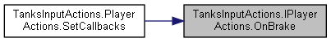

#### void TanksInputActions.IPlayerActions.OnFire (InputAction.CallbackContext *context*)

Here is the caller graph for this function:

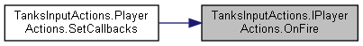

#### void TanksInputActions.IPlayerActions.OnGas (InputAction.CallbackContext *context*)

Here is the caller graph for this function:

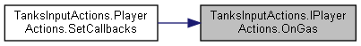

#### void TanksInputActions.IPlayerActions.OnPause (InputAction.CallbackContext *context*)

Here is the caller graph for this function:

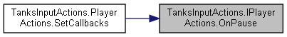

#### void TanksInputActions.IPlayerActions.OnTurret (InputAction.CallbackContext *context*)

Here is the caller graph for this function:

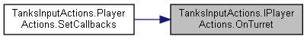

#### The documentation for this interface was generated from the following file:

C:/_SSDSPEEDUP/2021/clone/gps1_manadesigner/GPS1-Manadesigner/Assets/Samples/Input System/1.0.2/Tanks Demo/TanksDemo/**TanksInputActions.cs**

## RebindUISampleActionsModified.IPlayerMainActions Interface Reference

Collaboration diagram for RebindUISampleActionsModified.IPlayerMainActions:

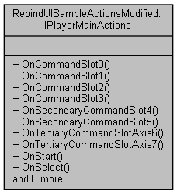

### Public Member Functions

void **OnCommandSlot0** (InputAction.CallbackContext context)

void **OnCommandSlot1** (InputAction.CallbackContext context)

void **OnCommandSlot2** (InputAction.CallbackContext context)

void **OnCommandSlot3** (InputAction.CallbackContext context)

void **OnSecondaryCommandSlot4** (InputAction.CallbackContext context)

void **OnSecondaryCommandSlot5** (InputAction.CallbackContext context)

void **OnTertiaryCommandSlotAxis6** (InputAction.CallbackContext context)

void **OnTertiaryCommandSlotAxis7** (InputAction.CallbackContext context)

void **OnStart** (InputAction.CallbackContext context)

void **OnSelect** (InputAction.CallbackContext context)

void **OnDPadAxisHorizontal** (InputAction.CallbackContext context)

void **OnDPadAxisVertical** (InputAction.CallbackContext context)

void **OnLeftStickAxisHorizontal** (InputAction.CallbackContext context)

void **OnLeftStickAxisVertical** (InputAction.CallbackContext context)

void **OnRightStickAxisHorizontal** (InputAction.CallbackContext context)

void **OnRightStickAxisVertical** (InputAction.CallbackContext context)

### Member Function Documentation

#### void RebindUISampleActionsModified.IPlayerMainActions.OnCommandSlot0 (InputAction.CallbackContext *context*)

Here is the caller graph for this function:

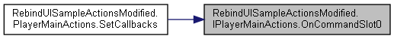

#### void RebindUISampleActionsModified.IPlayerMainActions.OnCommandSlot1 (InputAction.CallbackContext *context*)

Here is the caller graph for this function:

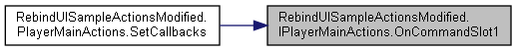

#### void RebindUISampleActionsModified.IPlayerMainActions.OnCommandSlot2 (InputAction.CallbackContext *context*)

Here is the caller graph for this function:

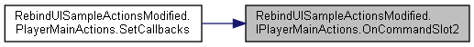

#### void RebindUISampleActionsModified.IPlayerMainActions.OnCommandSlot3 (InputAction.CallbackContext *context*)

Here is the caller graph for this function:

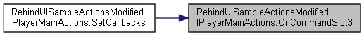

#### void RebindUISampleActionsModified.IPlayerMainActions.OnDPadAxisHorizontal (InputAction.CallbackContext *context*)

Here is the caller graph for this function:



#### void RebindUISampleActionsModified.IPlayerMainActions.OnDPadAxisVertical (InputAction.CallbackContext *context*)

Here is the caller graph for this function:



#### void RebindUISampleActionsModified.IPlayerMainActions.OnLeftStickAxisHorizontal (InputAction.CallbackContext *context*)

Here is the caller graph for this function:

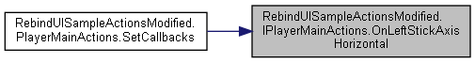

#### void RebindUISampleActionsModified.IPlayerMainActions.OnLeftStickAxisVertical (InputAction.CallbackContext *context*)

Here is the caller graph for this function:

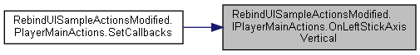

#### void RebindUISampleActionsModified.IPlayerMainActions.OnRightStickAxisHorizontal (InputAction.CallbackContext *context*)

Here is the caller graph for this function:

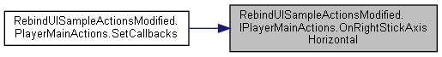

#### void RebindUISampleActionsModified.IPlayerMainActions.OnRightStickAxisVertical (InputAction.CallbackContext *context*)

Here is the caller graph for this function:

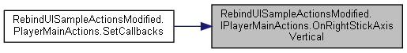

#### void RebindUISampleActionsModified.IPlayerMainActions.OnSecondaryCommandSlot4 (InputAction.CallbackContext *context*)

Here is the caller graph for this function:



#### void RebindUISampleActionsModified.IPlayerMainActions.OnSecondaryCommandSlot5 (InputAction.CallbackContext *context*)

Here is the caller graph for this function:



#### void RebindUISampleActionsModified.IPlayerMainActions.OnSelect (InputAction.CallbackContext *context*)

Here is the caller graph for this function:

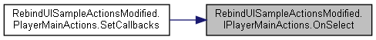

#### void RebindUISampleActionsModified.IPlayerMainActions.OnStart (InputAction.CallbackContext *context*)

Here is the caller graph for this function:

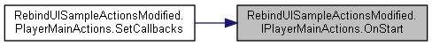

#### void RebindUISampleActionsModified.IPlayerMainActions.OnTertiaryCommandSlotAxis6 (InputAction.CallbackContext *context*)

Here is the caller graph for this function:

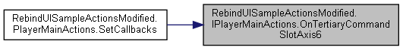

#### void RebindUISampleActionsModified.IPlayerMainActions.OnTertiaryCommandSlotAxis7 (InputAction.CallbackContext *context*)

Here is the caller graph for this function:

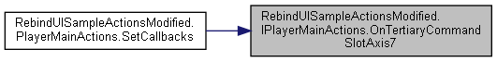

#### The documentation for this interface was generated from the following file:

C:/_SSDSPEEDUP/2021/clone/gps1_manadesigner/GPS1-Manadesigner/Assets/_UtilsV0.4/MyScripts/_Utils/CommandPattern/Command/SOAssets/InputSystemPackage/**RebindUISampleActionsModified.cs**

## IStateBehavior Interface Reference

Collaboration diagram for IStateBehavior:

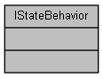

The documentation for this interface was generated from the following file:

C:/_SSDSPEEDUP/2021/clone/gps1_manadesigner/GPS1-Manadesigner/Assets/_UtilsV0.4/MyScripts/_Utils/_CommonV0.2/Animator/_Bin/**IStateBehavior.cs**

## item Class Reference

Inheritance diagram for item:

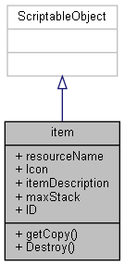

Collaboration diagram for item:



### Public Member Functions

virtual **item** **getCopy** ()

virtual void **Destroy** ()

### Public Attributes

string **resourceName**

Sprite **Icon**

string **itemDescription**

int **maxStack** = 2

### Properties

string **ID** [get]

### Member Function Documentation

#### virtual void item.Destroy ()[virtual]

#### virtual item item.getCopy ()[virtual]

Here is the caller graph for this function:



### Member Data Documentation

#### Sprite item.Icon

#### string item.itemDescription

#### int item.maxStack = 2

#### string item.resourceName

### Property Documentation

#### string item.ID[get]

#### The documentation for this class was generated from the following file:

C:/_SSDSPEEDUP/2021/clone/gps1_manadesigner/GPS1-Manadesigner/Assets/Scripts/InventoryScripts/**item.cs**

## ItemContainer Class Reference

Inheritance diagram for ItemContainer:

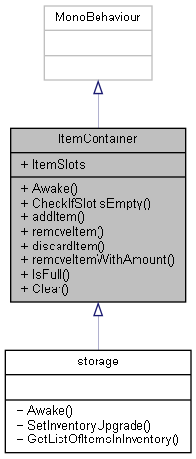

Collaboration diagram for ItemContainer:

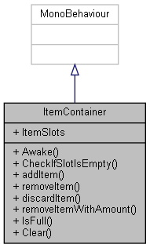

### Public Member Functions

virtual void **Awake** ()

bool **CheckIfSlotIsEmpty** (**item** **item**)

bool **addItem** (**item** **item**)

bool **removeItem** (**item** **item**)

bool **discardItem** (**itemSlots** **item**)

bool **removeItemWithAmount** (**item** **item**, int amount)

bool **IsFull** ()

void **Clear** ()

### Public Attributes

List< **itemSlots** > **ItemSlots**

### Events

Action< **itemSlots** > **OnPointerEnterEvent**

Action< **itemSlots** > **OnPointerExitEvent**

Action< **itemSlots** > **OnLeftClickEvent**

Action< **itemSlots** > **OnBeginDragEvent**

Action< **itemSlots** > **OnEndDragEvent**

Action< **itemSlots** > **OnDragEvent**

Action< **itemSlots** > **OnDropEvent**

### Member Function Documentation

#### bool ItemContainer.addItem (item *item*)

Here is the caller graph for this function:

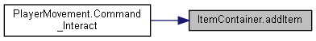

#### virtual void ItemContainer.Awake ()[virtual]

Reimplemented in **storage** (*p.730*).

#### bool ItemContainer.CheckIfSlotIsEmpty (item *item*)

Here is the caller graph for this function:

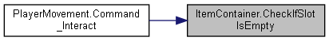

#### void ItemContainer.Clear ()

Here is the caller graph for this function:



#### bool ItemContainer.discardItem (itemSlots *item*)

Here is the caller graph for this function:



#### bool ItemContainer.IsFull ()

#### bool ItemContainer.removeItem (item *item*)

#### bool ItemContainer.removeItemWithAmount (item *item*, int *amount*)

Here is the caller graph for this function:



### Member Data Documentation

#### List<itemSlots> ItemContainer.ItemSlots

### Event Documentation

#### Action<itemSlots> ItemContainer.OnBeginDragEvent

#### Action<itemSlots> ItemContainer.OnDragEvent

#### Action<itemSlots> ItemContainer.OnDropEvent

#### Action<itemSlots> ItemContainer.OnEndDragEvent

#### Action<itemSlots> ItemContainer.OnLeftClickEvent

#### Action<itemSlots> ItemContainer.OnPointerEnterEvent

#### Action<itemSlots> ItemContainer.OnPointerExitEvent

#### The documentation for this class was generated from the following file:

C:/_SSDSPEEDUP/2021/clone/gps1_manadesigner/GPS1-Manadesigner/Assets/Scripts/Arif's Test Scripts/**ItemContainer.cs**

## ItemContainerSaveData Class Reference

Collaboration diagram for ItemContainerSaveData:

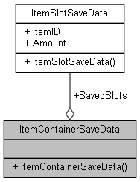

### Public Member Functions

**ItemContainerSaveData** (int numItems)

### Public Attributes

**ItemSlotSaveData**[] **SavedSlots**

### Constructor & Destructor Documentation

#### ItemContainerSaveData.ItemContainerSaveData (int *numItems*)

### Member Data Documentation

#### ItemSlotSaveData [] ItemContainerSaveData.SavedSlots

#### The documentation for this class was generated from the following file:

C:/_SSDSPEEDUP/2021/clone/gps1_manadesigner/GPS1-Manadesigner/Assets/Scripts/Arif's Test Scripts/Save State/**ItemSaveData.cs**

## ItemDatabase Class Reference

Inheritance diagram for ItemDatabase:

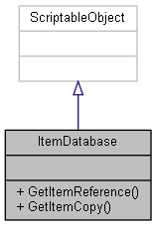

Collaboration diagram for ItemDatabase:



### Public Member Functions

**item** **GetItemReference** (string itemID)

**item** **GetItemCopy** (string itemID)

### Member Function Documentation

#### item ItemDatabase.GetItemCopy (string *itemID*)

Here is the call graph for this function:

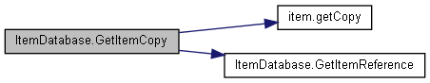

Here is the caller graph for this function:



#### item ItemDatabase.GetItemReference (string *itemID*)

Here is the caller graph for this function:



#### The documentation for this class was generated from the following file:

C:/_SSDSPEEDUP/2021/clone/gps1_manadesigner/GPS1-Manadesigner/Assets/Scripts/Arif's Test Scripts/Save State/**ItemDatabase.cs**

## itemNew Class Reference

Inheritance diagram for itemNew:

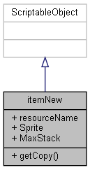

Collaboration diagram for itemNew:



### Public Member Functions

virtual **itemNew** **getCopy** ()

### Public Attributes

string **resourceName**

Sprite **Sprite**

int **MaxStack** = 10

### Member Function Documentation

#### virtual itemNew itemNew.getCopy ()[virtual]

### Member Data Documentation

#### int itemNew.MaxStack = 10

#### string itemNew.resourceName

#### Sprite itemNew.Sprite

#### The documentation for this class was generated from the following file:

C:/_SSDSPEEDUP/2021/clone/gps1_manadesigner/GPS1-Manadesigner/Assets/Scripts/Thrish/**itemsNew.cs**

## ItemSaveIO Class Reference

Collaboration diagram for ItemSaveIO:

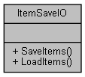

### Static Public Member Functions

static void **SaveItems** (**ItemContainerSaveData** items, string fileName)

static **ItemContainerSaveData** **LoadItems** (string fileName)

### Member Function Documentation

#### static ItemContainerSaveData ItemSaveIO.LoadItems (string *fileName*)[static]

Here is the caller graph for this function:



#### static void ItemSaveIO.SaveItems (ItemContainerSaveData *items*, string *fileName*)[static]

#### The documentation for this class was generated from the following file:

C:/_SSDSPEEDUP/2021/clone/gps1_manadesigner/GPS1-Manadesigner/Assets/Scripts/Arif's Test Scripts/Save State/**ItemSaveIO.cs**

## ItemSaveManager Class Reference

Inheritance diagram for ItemSaveManager:

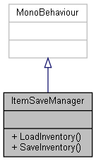

Collaboration diagram for ItemSaveManager:



### Public Member Functions

void **LoadInventory** (**Character** character)

void **SaveInventory** (**Character** character)

### Member Function Documentation

#### void ItemSaveManager.LoadInventory (Character *character*)

Here is the call graph for this function:

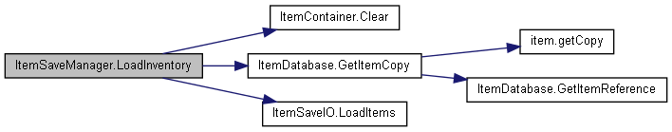

#### void ItemSaveManager.SaveInventory (Character *character*)

Here is the caller graph for this function:

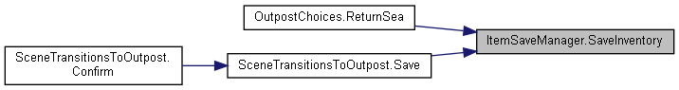

#### The documentation for this class was generated from the following file:

C:/_SSDSPEEDUP/2021/clone/gps1_manadesigner/GPS1-Manadesigner/Assets/Scripts/Arif's Test Scripts/Save State/**ItemSaveManager.cs**

## itemSlots Class Reference

Inheritance diagram for itemSlots:

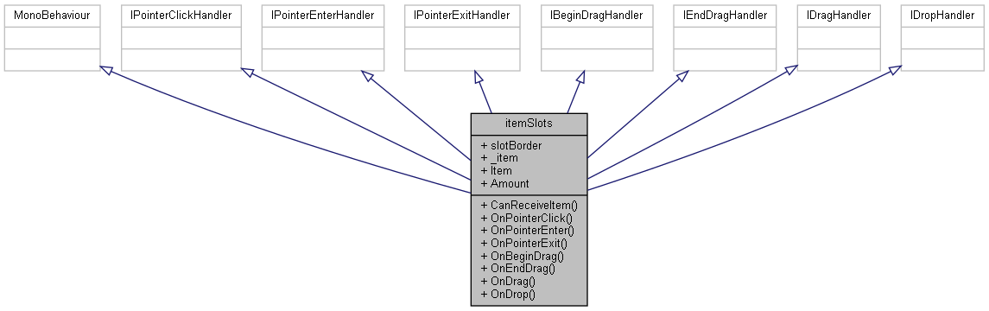

Collaboration diagram for itemSlots:

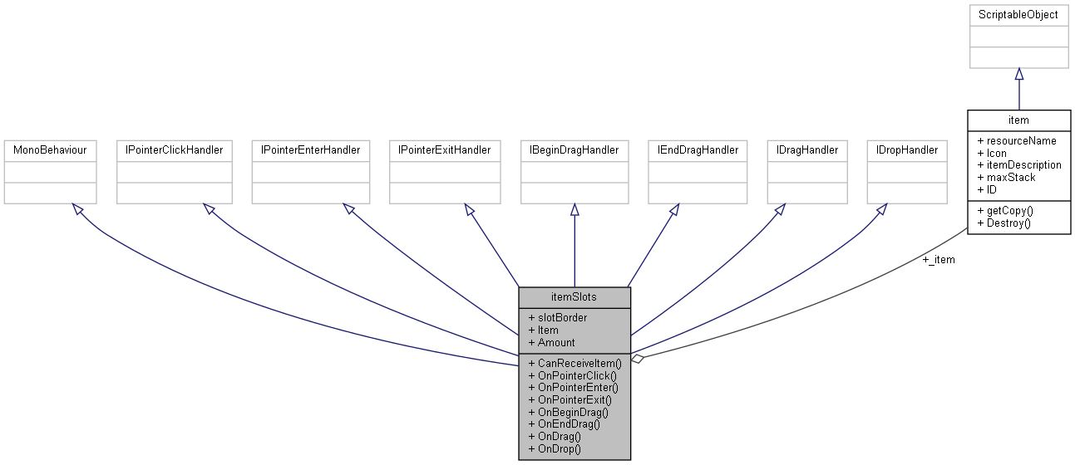

### Public Member Functions

virtual bool **CanReceiveItem** (**item** **item**)

void **OnPointerClick** (PointerEventData eventData)

void **OnPointerEnter** (PointerEventData eventData)

void **OnPointerExit** (PointerEventData eventData)

void **OnBeginDrag** (PointerEventData eventData)

void **OnEndDrag** (PointerEventData eventData)

void **OnDrag** (PointerEventData eventData)

void **OnDrop** (PointerEventData eventData)

### Public Attributes

Image **slotBorder**

**item** **_item**

### Properties

**item** **Item** [getset]

int **Amount** [getset]

### Events

Action< **itemSlots** > **OnPointerEnterEvent**

Action< **itemSlots** > **OnPointerExitEvent**

Action< **itemSlots** > **OnLeftClickEvent**

Action< **itemSlots** > **OnBeginDragEvent**

Action< **itemSlots** > **OnEndDragEvent**

Action< **itemSlots** > **OnDragEvent**

Action< **itemSlots** > **OnDropEvent**

### Member Function Documentation

#### virtual bool itemSlots.CanReceiveItem (item *item*)[virtual]

#### void itemSlots.OnBeginDrag (PointerEventData *eventData*)

#### void itemSlots.OnDrag (PointerEventData *eventData*)

#### void itemSlots.OnDrop (PointerEventData *eventData*)

#### void itemSlots.OnEndDrag (PointerEventData *eventData*)

#### void itemSlots.OnPointerClick (PointerEventData *eventData*)

#### void itemSlots.OnPointerEnter (PointerEventData *eventData*)

#### void itemSlots.OnPointerExit (PointerEventData *eventData*)

### Member Data Documentation

#### item itemSlots._item

#### Image itemSlots.slotBorder

### Property Documentation

#### int itemSlots.Amount[get], [set]

#### item itemSlots.Item[get], [set]

### Event Documentation

#### Action<itemSlots> itemSlots.OnBeginDragEvent

#### Action<itemSlots> itemSlots.OnDragEvent

#### Action<itemSlots> itemSlots.OnDropEvent

#### Action<itemSlots> itemSlots.OnEndDragEvent

#### Action<itemSlots> itemSlots.OnLeftClickEvent

#### Action<itemSlots> itemSlots.OnPointerEnterEvent

#### Action<itemSlots> itemSlots.OnPointerExitEvent

#### The documentation for this class was generated from the following file:

C:/_SSDSPEEDUP/2021/clone/gps1_manadesigner/GPS1-Manadesigner/Assets/Scripts/InventoryScripts/**itemSlots.cs**

## ItemSlotSaveData Class Reference

Collaboration diagram for ItemSlotSaveData:

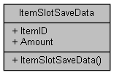

### Public Member Functions

**ItemSlotSaveData** (string id, int amount)

### Public Attributes

string **ItemID**

int **Amount**

### Constructor & Destructor Documentation

#### ItemSlotSaveData.ItemSlotSaveData (string *id*, int *amount*)

### Member Data Documentation

#### int ItemSlotSaveData.Amount

#### string ItemSlotSaveData.ItemID

#### The documentation for this class was generated from the following file:

C:/_SSDSPEEDUP/2021/clone/gps1_manadesigner/GPS1-Manadesigner/Assets/Scripts/Arif's Test Scripts/Save State/**ItemSaveData.cs**

## itemSlotsNew Class Reference

Inheritance diagram for itemSlotsNew:

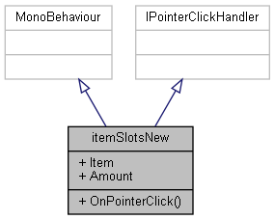

Collaboration diagram for itemSlotsNew:



### Public Member Functions

void **OnPointerClick** (PointerEventData eventData)

### Properties

**itemNew** **Item** [getset]

int **Amount** [getset]

### Events

System.Action< **itemNew** > **OnRightClickEvent**

### Member Function Documentation

#### void itemSlotsNew.OnPointerClick (PointerEventData *eventData*)

### Property Documentation

#### int itemSlotsNew.Amount[get], [set]

#### itemNew itemSlotsNew.Item[get], [set]

### Event Documentation

#### System.Action<itemNew> itemSlotsNew.OnRightClickEvent

#### The documentation for this class was generated from the following file:

C:/_SSDSPEEDUP/2021/clone/gps1_manadesigner/GPS1-Manadesigner/Assets/Scripts/Thrish/**itemSlotsNew.cs**

## ItemToolTip Class Reference

Inheritance diagram for ItemToolTip:

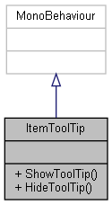

Collaboration diagram for ItemToolTip:



### Public Member Functions

void **ShowToolTip** (**item** itemInInventory)

void **HideToolTip** ()

### Member Function Documentation

#### void ItemToolTip.HideToolTip ()

#### void ItemToolTip.ShowToolTip (item *itemInInventory*)

#### The documentation for this class was generated from the following file:

C:/_SSDSPEEDUP/2021/clone/gps1_manadesigner/GPS1-Manadesigner/Assets/Scripts/Arif's Test Scripts/**ItemToolTip.cs**

## TanksInputActions.IUIActions Interface Reference

Collaboration diagram for TanksInputActions.IUIActions:

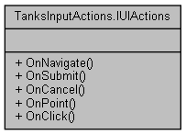

### Public Member Functions

void **OnNavigate** (InputAction.CallbackContext context)

void **OnSubmit** (InputAction.CallbackContext context)

void **OnCancel** (InputAction.CallbackContext context)

void **OnPoint** (InputAction.CallbackContext context)

void **OnClick** (InputAction.CallbackContext context)

### Member Function Documentation

#### void TanksInputActions.IUIActions.OnCancel (InputAction.CallbackContext *context*)

Here is the caller graph for this function:

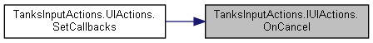

#### void TanksInputActions.IUIActions.OnClick (InputAction.CallbackContext *context*)

Here is the caller graph for this function:

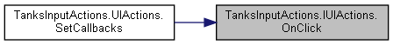

#### void TanksInputActions.IUIActions.OnNavigate (InputAction.CallbackContext *context*)

Here is the caller graph for this function:

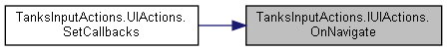

#### void TanksInputActions.IUIActions.OnPoint (InputAction.CallbackContext *context*)

Here is the caller graph for this function:

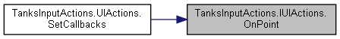

#### void TanksInputActions.IUIActions.OnSubmit (InputAction.CallbackContext *context*)

Here is the caller graph for this function:

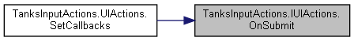

#### The documentation for this interface was generated from the following file:

C:/_SSDSPEEDUP/2021/clone/gps1_manadesigner/GPS1-Manadesigner/Assets/Samples/Input System/1.0.2/Tanks Demo/TanksDemo/**TanksInputActions.cs**

## RebindUISampleActionsModified.IUIMainActions Interface Reference

Collaboration diagram for RebindUISampleActionsModified.IUIMainActions:

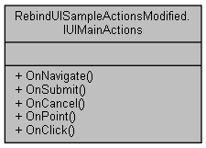

### Public Member Functions

void **OnNavigate** (InputAction.CallbackContext context)

void **OnSubmit** (InputAction.CallbackContext context)

void **OnCancel** (InputAction.CallbackContext context)

void **OnPoint** (InputAction.CallbackContext context)

void **OnClick** (InputAction.CallbackContext context)

### Member Function Documentation

#### void RebindUISampleActionsModified.IUIMainActions.OnCancel (InputAction.CallbackContext *context*)

Here is the caller graph for this function:

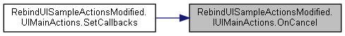

#### void RebindUISampleActionsModified.IUIMainActions.OnClick (InputAction.CallbackContext *context*)

Here is the caller graph for this function:

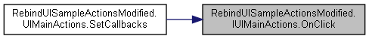

#### void RebindUISampleActionsModified.IUIMainActions.OnNavigate (InputAction.CallbackContext *context*)

Here is the caller graph for this function:

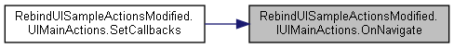

#### void RebindUISampleActionsModified.IUIMainActions.OnPoint (InputAction.CallbackContext *context*)

Here is the caller graph for this function:

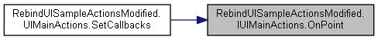

#### void RebindUISampleActionsModified.IUIMainActions.OnSubmit (InputAction.CallbackContext *context*)

Here is the caller graph for this function:

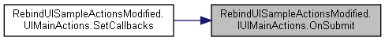

#### The documentation for this interface was generated from the following file:

C:/_SSDSPEEDUP/2021/clone/gps1_manadesigner/GPS1-Manadesigner/Assets/_UtilsV0.4/MyScripts/_Utils/CommandPattern/Command/SOAssets/InputSystemPackage/**RebindUISampleActionsModified.cs**

## RebindUISampleActionsModified.IVector2AxisActions Interface Reference

Collaboration diagram for RebindUISampleActionsModified.IVector2AxisActions:

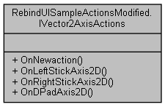

### Public Member Functions

void **OnNewaction** (InputAction.CallbackContext context)

void **OnLeftStickAxis2D** (InputAction.CallbackContext context)

void **OnRightStickAxis2D** (InputAction.CallbackContext context)

void **OnDPadAxis2D** (InputAction.CallbackContext context)

### Member Function Documentation

#### void RebindUISampleActionsModified.IVector2AxisActions.OnDPadAxis2D (InputAction.CallbackContext *context*)

Here is the caller graph for this function:

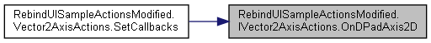

#### void RebindUISampleActionsModified.IVector2AxisActions.OnLeftStickAxis2D (InputAction.CallbackContext *context*)

Here is the caller graph for this function:



#### void RebindUISampleActionsModified.IVector2AxisActions.OnNewaction (InputAction.CallbackContext *context*)

Here is the caller graph for this function:

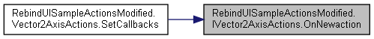

#### void RebindUISampleActionsModified.IVector2AxisActions.OnRightStickAxis2D (InputAction.CallbackContext *context*)

Here is the caller graph for this function:

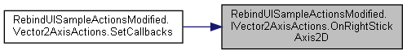

#### The documentation for this interface was generated from the following file:

C:/_SSDSPEEDUP/2021/clone/gps1_manadesigner/GPS1-Manadesigner/Assets/_UtilsV0.4/MyScripts/_Utils/CommandPattern/Command/SOAssets/InputSystemPackage/**RebindUISampleActionsModified.cs**

## Key_CtrlG_SnapToGround Class Reference

Inheritance diagram for Key_CtrlG_SnapToGround:

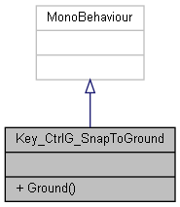

Collaboration diagram for Key_CtrlG_SnapToGround:



### Static Public Member Functions

static void **Ground** ()

### Member Function Documentation

#### static void Key_CtrlG_SnapToGround.Ground ()[static]

#### The documentation for this class was generated from the following file:

C:/_SSDSPEEDUP/2021/clone/gps1_manadesigner/GPS1-Manadesigner/Assets/Scripts/Editor/_Utils/KeyShortcuts/**Key_CtrlG_SnapToGround.cs**

## KeyInputTuto Class Reference

Inheritance diagram for KeyInputTuto:

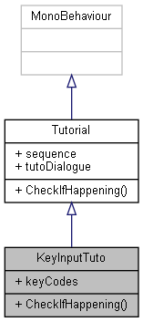

Collaboration diagram for KeyInputTuto:



### Public Member Functions

override void **CheckIfHappening** ()

### Public Attributes

List< KeyCode > **keyCodes** = new List<KeyCode>()

### Member Function Documentation

#### override void KeyInputTuto.CheckIfHappening ()[virtual]

Reimplemented from **Tutorial** (*p.787*).

Here is the call graph for this function:

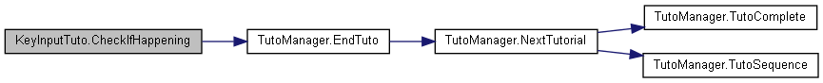

### Member Data Documentation

#### List<KeyCode> KeyInputTuto.keyCodes = new List<KeyCode>()

#### The documentation for this class was generated from the following file:

C:/_SSDSPEEDUP/2021/clone/gps1_manadesigner/GPS1-Manadesigner/Assets/Scripts/Tutorial Scripts/**KeyInputTuto.cs**

## UnityEngine.InputSystem.Samples.RebindUI.RebindIconsHelper.KeyMouseIcons Struct Reference

Collaboration diagram for UnityEngine.InputSystem.Samples.RebindUI.RebindIconsHelper.KeyMouseIcons:

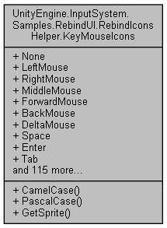

### Public Member Functions

string **CamelCase** (string s)

string **PascalCase** (string s)

Sprite **GetSprite** (string controlPath)

### Public Attributes

Sprite **None**

Sprite **LeftMouse**

Sprite **RightMouse**

Sprite **MiddleMouse**

Sprite **ForwardMouse**

Sprite **BackMouse**

Sprite **DeltaMouse**

Sprite **Space**

Sprite **Enter**

Sprite **Tab**

Sprite **Backquote**

Sprite **Quote**

Sprite **Semicolon**

Sprite **Comma**

Sprite **Period**

Sprite **Slash**

Sprite **Backslash**

Sprite **LeftBracket**

Sprite **RightBracket**

Sprite **Minus**

Sprite **Equals**

Sprite **A**

Sprite **B**

Sprite **C**

Sprite **D**

Sprite **E**

Sprite **F**

Sprite **G**

Sprite **H**

Sprite **I**

Sprite **J**

Sprite **K**

Sprite **L**

Sprite **M**

Sprite **N**

Sprite **O**

Sprite **P**

Sprite **Q**

Sprite **R**

Sprite **S**

Sprite **T**

Sprite **U**

Sprite **V**

Sprite **W**

Sprite **X**

Sprite **Y**

Sprite **Z**

Sprite **Digit1**

Sprite **Digit2**

Sprite **Digit3**

Sprite **Digit4**

Sprite **Digit5**

Sprite **Digit6**

Sprite **Digit7**

Sprite **Digit8**

Sprite **Digit9**

Sprite **Digit0**

Sprite **LeftShift**

Sprite **RightShift**

Sprite **LeftAlt**

Sprite **RightAlt**

Sprite **AltGr**

Sprite **LeftCtrl**

Sprite **RightCtrl**

Sprite **LeftMeta**

Sprite **RightMeta**

Sprite **LeftWindows**

Sprite **RightWindows**

Sprite **LeftApple**

Sprite **RightApple**

Sprite **LeftCommand**

Sprite **RightCommand**

Sprite **ContextMenu**

Sprite **Escape**

Sprite **LeftArrow**

Sprite **RightArrow**

Sprite **UpArrow**

Sprite **DownArrow**

Sprite **Backspace**

Sprite **PageDown**

Sprite **PageUp**

Sprite **Home**

Sprite **End**

Sprite **Insert**

Sprite **Delete**

Sprite **CapsLock**

Sprite **NumLock**

Sprite **PrintScreen**

Sprite **ScrollLock**

Sprite **Pause**

Sprite **NumpadEnter**

Sprite **NumpadDivide**

Sprite **NumpadMultiply**

Sprite **NumpadPlus**

Sprite **NumpadMinus**

Sprite **NumpadPeriod**

Sprite **NumpadEquals**

Sprite **Numpad0**

Sprite **Numpad1**

Sprite **Numpad2**

Sprite **Numpad3**

Sprite **Numpad4**

Sprite **Numpad5**

Sprite **Numpad6**

Sprite **Numpad7**

Sprite **Numpad8**

Sprite **Numpad9**

Sprite **F1**

Sprite **F2**

Sprite **F3**

Sprite **F4**

Sprite **F5**

Sprite **F6**

Sprite **F7**

Sprite **F8**

Sprite **F9**

Sprite **F10**

Sprite **F11**

Sprite **F12**

Sprite **OEM1**

Sprite **OEM2**

Sprite **OEM3**

Sprite **OEM4**

Sprite **OEM5**

Sprite **IMESelected**

### Member Function Documentation

#### string UnityEngine.InputSystem.Samples.RebindUI.RebindIconsHelper.KeyMouseIcons.CamelCase (string *s*)

Here is the caller graph for this function:



#### Sprite UnityEngine.InputSystem.Samples.RebindUI.RebindIconsHelper.KeyMouseIcons.GetSprite (string *controlPath*)

Here is the call graph for this function:



Here is the caller graph for this function:



#### string UnityEngine.InputSystem.Samples.RebindUI.RebindIconsHelper.KeyMouseIcons.PascalCase (string *s*)

Here is the call graph for this function:

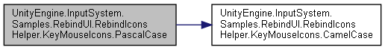

Here is the caller graph for this function:



### Member Data Documentation

#### Sprite UnityEngine.InputSystem.Samples.RebindUI.RebindIconsHelper.KeyMouseIcons.A

#### Sprite UnityEngine.InputSystem.Samples.RebindUI.RebindIconsHelper.KeyMouseIcons.AltGr

#### Sprite UnityEngine.InputSystem.Samples.RebindUI.RebindIconsHelper.KeyMouseIcons.B

#### Sprite UnityEngine.InputSystem.Samples.RebindUI.RebindIconsHelper.KeyMouseIcons.BackMouse

#### Sprite UnityEngine.InputSystem.Samples.RebindUI.RebindIconsHelper.KeyMouseIcons.Backquote

#### Sprite UnityEngine.InputSystem.Samples.RebindUI.RebindIconsHelper.KeyMouseIcons.Backslash

#### Sprite UnityEngine.InputSystem.Samples.RebindUI.RebindIconsHelper.KeyMouseIcons.Backspace

#### Sprite UnityEngine.InputSystem.Samples.RebindUI.RebindIconsHelper.KeyMouseIcons.C

#### Sprite UnityEngine.InputSystem.Samples.RebindUI.RebindIconsHelper.KeyMouseIcons.CapsLock

#### Sprite UnityEngine.InputSystem.Samples.RebindUI.RebindIconsHelper.KeyMouseIcons.Comma

#### Sprite UnityEngine.InputSystem.Samples.RebindUI.RebindIconsHelper.KeyMouseIcons.ContextMenu

#### Sprite UnityEngine.InputSystem.Samples.RebindUI.RebindIconsHelper.KeyMouseIcons.D

#### Sprite UnityEngine.InputSystem.Samples.RebindUI.RebindIconsHelper.KeyMouseIcons.Delete

#### Sprite UnityEngine.InputSystem.Samples.RebindUI.RebindIconsHelper.KeyMouseIcons.DeltaMouse

#### Sprite UnityEngine.InputSystem.Samples.RebindUI.RebindIconsHelper.KeyMouseIcons.Digit0

#### Sprite UnityEngine.InputSystem.Samples.RebindUI.RebindIconsHelper.KeyMouseIcons.Digit1

#### Sprite UnityEngine.InputSystem.Samples.RebindUI.RebindIconsHelper.KeyMouseIcons.Digit2

#### Sprite UnityEngine.InputSystem.Samples.RebindUI.RebindIconsHelper.KeyMouseIcons.Digit3

#### Sprite UnityEngine.InputSystem.Samples.RebindUI.RebindIconsHelper.KeyMouseIcons.Digit4

#### Sprite UnityEngine.InputSystem.Samples.RebindUI.RebindIconsHelper.KeyMouseIcons.Digit5

#### Sprite UnityEngine.InputSystem.Samples.RebindUI.RebindIconsHelper.KeyMouseIcons.Digit6

#### Sprite UnityEngine.InputSystem.Samples.RebindUI.RebindIconsHelper.KeyMouseIcons.Digit7

#### Sprite UnityEngine.InputSystem.Samples.RebindUI.RebindIconsHelper.KeyMouseIcons.Digit8

#### Sprite UnityEngine.InputSystem.Samples.RebindUI.RebindIconsHelper.KeyMouseIcons.Digit9

#### Sprite UnityEngine.InputSystem.Samples.RebindUI.RebindIconsHelper.KeyMouseIcons.DownArrow

#### Sprite UnityEngine.InputSystem.Samples.RebindUI.RebindIconsHelper.KeyMouseIcons.E

#### Sprite UnityEngine.InputSystem.Samples.RebindUI.RebindIconsHelper.KeyMouseIcons.End

#### Sprite UnityEngine.InputSystem.Samples.RebindUI.RebindIconsHelper.KeyMouseIcons.Enter

#### Sprite UnityEngine.InputSystem.Samples.RebindUI.RebindIconsHelper.KeyMouseIcons.Equals

#### Sprite UnityEngine.InputSystem.Samples.RebindUI.RebindIconsHelper.KeyMouseIcons.Escape

#### Sprite UnityEngine.InputSystem.Samples.RebindUI.RebindIconsHelper.KeyMouseIcons.F

#### Sprite UnityEngine.InputSystem.Samples.RebindUI.RebindIconsHelper.KeyMouseIcons.F1

#### Sprite UnityEngine.InputSystem.Samples.RebindUI.RebindIconsHelper.KeyMouseIcons.F10

#### Sprite UnityEngine.InputSystem.Samples.RebindUI.RebindIconsHelper.KeyMouseIcons.F11

#### Sprite UnityEngine.InputSystem.Samples.RebindUI.RebindIconsHelper.KeyMouseIcons.F12

#### Sprite UnityEngine.InputSystem.Samples.RebindUI.RebindIconsHelper.KeyMouseIcons.F2

#### Sprite UnityEngine.InputSystem.Samples.RebindUI.RebindIconsHelper.KeyMouseIcons.F3

#### Sprite UnityEngine.InputSystem.Samples.RebindUI.RebindIconsHelper.KeyMouseIcons.F4

#### Sprite UnityEngine.InputSystem.Samples.RebindUI.RebindIconsHelper.KeyMouseIcons.F5

#### Sprite UnityEngine.InputSystem.Samples.RebindUI.RebindIconsHelper.KeyMouseIcons.F6

#### Sprite UnityEngine.InputSystem.Samples.RebindUI.RebindIconsHelper.KeyMouseIcons.F7

#### Sprite UnityEngine.InputSystem.Samples.RebindUI.RebindIconsHelper.KeyMouseIcons.F8

#### Sprite UnityEngine.InputSystem.Samples.RebindUI.RebindIconsHelper.KeyMouseIcons.F9

#### Sprite UnityEngine.InputSystem.Samples.RebindUI.RebindIconsHelper.KeyMouseIcons.ForwardMouse

#### Sprite UnityEngine.InputSystem.Samples.RebindUI.RebindIconsHelper.KeyMouseIcons.G

#### Sprite UnityEngine.InputSystem.Samples.RebindUI.RebindIconsHelper.KeyMouseIcons.H

#### Sprite UnityEngine.InputSystem.Samples.RebindUI.RebindIconsHelper.KeyMouseIcons.Home

#### Sprite UnityEngine.InputSystem.Samples.RebindUI.RebindIconsHelper.KeyMouseIcons.I

#### Sprite UnityEngine.InputSystem.Samples.RebindUI.RebindIconsHelper.KeyMouseIcons.IMESelected

#### Sprite UnityEngine.InputSystem.Samples.RebindUI.RebindIconsHelper.KeyMouseIcons.Insert

#### Sprite UnityEngine.InputSystem.Samples.RebindUI.RebindIconsHelper.KeyMouseIcons.J

#### Sprite UnityEngine.InputSystem.Samples.RebindUI.RebindIconsHelper.KeyMouseIcons.K

#### Sprite UnityEngine.InputSystem.Samples.RebindUI.RebindIconsHelper.KeyMouseIcons.L

#### Sprite UnityEngine.InputSystem.Samples.RebindUI.RebindIconsHelper.KeyMouseIcons.LeftAlt

#### Sprite UnityEngine.InputSystem.Samples.RebindUI.RebindIconsHelper.KeyMouseIcons.LeftApple

#### Sprite UnityEngine.InputSystem.Samples.RebindUI.RebindIconsHelper.KeyMouseIcons.LeftArrow

#### Sprite UnityEngine.InputSystem.Samples.RebindUI.RebindIconsHelper.KeyMouseIcons.LeftBracket

#### Sprite UnityEngine.InputSystem.Samples.RebindUI.RebindIconsHelper.KeyMouseIcons.LeftCommand

#### Sprite UnityEngine.InputSystem.Samples.RebindUI.RebindIconsHelper.KeyMouseIcons.LeftCtrl

#### Sprite UnityEngine.InputSystem.Samples.RebindUI.RebindIconsHelper.KeyMouseIcons.LeftMeta

#### Sprite UnityEngine.InputSystem.Samples.RebindUI.RebindIconsHelper.KeyMouseIcons.LeftMouse

#### Sprite UnityEngine.InputSystem.Samples.RebindUI.RebindIconsHelper.KeyMouseIcons.LeftShift

#### Sprite UnityEngine.InputSystem.Samples.RebindUI.RebindIconsHelper.KeyMouseIcons.LeftWindows

#### Sprite UnityEngine.InputSystem.Samples.RebindUI.RebindIconsHelper.KeyMouseIcons.M

#### Sprite UnityEngine.InputSystem.Samples.RebindUI.RebindIconsHelper.KeyMouseIcons.MiddleMouse

#### Sprite UnityEngine.InputSystem.Samples.RebindUI.RebindIconsHelper.KeyMouseIcons.Minus

#### Sprite UnityEngine.InputSystem.Samples.RebindUI.RebindIconsHelper.KeyMouseIcons.N

#### Sprite UnityEngine.InputSystem.Samples.RebindUI.RebindIconsHelper.KeyMouseIcons.None

#### Sprite UnityEngine.InputSystem.Samples.RebindUI.RebindIconsHelper.KeyMouseIcons.NumLock

#### Sprite UnityEngine.InputSystem.Samples.RebindUI.RebindIconsHelper.KeyMouseIcons.Numpad0

#### Sprite UnityEngine.InputSystem.Samples.RebindUI.RebindIconsHelper.KeyMouseIcons.Numpad1

#### Sprite UnityEngine.InputSystem.Samples.RebindUI.RebindIconsHelper.KeyMouseIcons.Numpad2

#### Sprite UnityEngine.InputSystem.Samples.RebindUI.RebindIconsHelper.KeyMouseIcons.Numpad3

#### Sprite UnityEngine.InputSystem.Samples.RebindUI.RebindIconsHelper.KeyMouseIcons.Numpad4

#### Sprite UnityEngine.InputSystem.Samples.RebindUI.RebindIconsHelper.KeyMouseIcons.Numpad5

#### Sprite UnityEngine.InputSystem.Samples.RebindUI.RebindIconsHelper.KeyMouseIcons.Numpad6

#### Sprite UnityEngine.InputSystem.Samples.RebindUI.RebindIconsHelper.KeyMouseIcons.Numpad7

#### Sprite UnityEngine.InputSystem.Samples.RebindUI.RebindIconsHelper.KeyMouseIcons.Numpad8

#### Sprite UnityEngine.InputSystem.Samples.RebindUI.RebindIconsHelper.KeyMouseIcons.Numpad9

#### Sprite UnityEngine.InputSystem.Samples.RebindUI.RebindIconsHelper.KeyMouseIcons.NumpadDivide

#### Sprite UnityEngine.InputSystem.Samples.RebindUI.RebindIconsHelper.KeyMouseIcons.NumpadEnter

#### Sprite UnityEngine.InputSystem.Samples.RebindUI.RebindIconsHelper.KeyMouseIcons.NumpadEquals

#### Sprite UnityEngine.InputSystem.Samples.RebindUI.RebindIconsHelper.KeyMouseIcons.NumpadMinus

#### Sprite UnityEngine.InputSystem.Samples.RebindUI.RebindIconsHelper.KeyMouseIcons.NumpadMultiply

#### Sprite UnityEngine.InputSystem.Samples.RebindUI.RebindIconsHelper.KeyMouseIcons.NumpadPeriod

#### Sprite UnityEngine.InputSystem.Samples.RebindUI.RebindIconsHelper.KeyMouseIcons.NumpadPlus

#### Sprite UnityEngine.InputSystem.Samples.RebindUI.RebindIconsHelper.KeyMouseIcons.O

#### Sprite UnityEngine.InputSystem.Samples.RebindUI.RebindIconsHelper.KeyMouseIcons.OEM1

#### Sprite UnityEngine.InputSystem.Samples.RebindUI.RebindIconsHelper.KeyMouseIcons.OEM2

#### Sprite UnityEngine.InputSystem.Samples.RebindUI.RebindIconsHelper.KeyMouseIcons.OEM3

#### Sprite UnityEngine.InputSystem.Samples.RebindUI.RebindIconsHelper.KeyMouseIcons.OEM4

#### Sprite UnityEngine.InputSystem.Samples.RebindUI.RebindIconsHelper.KeyMouseIcons.OEM5

#### Sprite UnityEngine.InputSystem.Samples.RebindUI.RebindIconsHelper.KeyMouseIcons.P

#### Sprite UnityEngine.InputSystem.Samples.RebindUI.RebindIconsHelper.KeyMouseIcons.PageDown

#### Sprite UnityEngine.InputSystem.Samples.RebindUI.RebindIconsHelper.KeyMouseIcons.PageUp

#### Sprite UnityEngine.InputSystem.Samples.RebindUI.RebindIconsHelper.KeyMouseIcons.Pause

#### Sprite UnityEngine.InputSystem.Samples.RebindUI.RebindIconsHelper.KeyMouseIcons.Period

#### Sprite UnityEngine.InputSystem.Samples.RebindUI.RebindIconsHelper.KeyMouseIcons.PrintScreen

#### Sprite UnityEngine.InputSystem.Samples.RebindUI.RebindIconsHelper.KeyMouseIcons.Q

#### Sprite UnityEngine.InputSystem.Samples.RebindUI.RebindIconsHelper.KeyMouseIcons.Quote

#### Sprite UnityEngine.InputSystem.Samples.RebindUI.RebindIconsHelper.KeyMouseIcons.R

#### Sprite UnityEngine.InputSystem.Samples.RebindUI.RebindIconsHelper.KeyMouseIcons.RightAlt

#### Sprite UnityEngine.InputSystem.Samples.RebindUI.RebindIconsHelper.KeyMouseIcons.RightApple

#### Sprite UnityEngine.InputSystem.Samples.RebindUI.RebindIconsHelper.KeyMouseIcons.RightArrow

#### Sprite UnityEngine.InputSystem.Samples.RebindUI.RebindIconsHelper.KeyMouseIcons.RightBracket

#### Sprite UnityEngine.InputSystem.Samples.RebindUI.RebindIconsHelper.KeyMouseIcons.RightCommand

#### Sprite UnityEngine.InputSystem.Samples.RebindUI.RebindIconsHelper.KeyMouseIcons.RightCtrl

#### Sprite UnityEngine.InputSystem.Samples.RebindUI.RebindIconsHelper.KeyMouseIcons.RightMeta

#### Sprite UnityEngine.InputSystem.Samples.RebindUI.RebindIconsHelper.KeyMouseIcons.RightMouse

#### Sprite UnityEngine.InputSystem.Samples.RebindUI.RebindIconsHelper.KeyMouseIcons.RightShift

#### Sprite UnityEngine.InputSystem.Samples.RebindUI.RebindIconsHelper.KeyMouseIcons.RightWindows

#### Sprite UnityEngine.InputSystem.Samples.RebindUI.RebindIconsHelper.KeyMouseIcons.S

#### Sprite UnityEngine.InputSystem.Samples.RebindUI.RebindIconsHelper.KeyMouseIcons.ScrollLock

#### Sprite UnityEngine.InputSystem.Samples.RebindUI.RebindIconsHelper.KeyMouseIcons.Semicolon

#### Sprite UnityEngine.InputSystem.Samples.RebindUI.RebindIconsHelper.KeyMouseIcons.Slash

#### Sprite UnityEngine.InputSystem.Samples.RebindUI.RebindIconsHelper.KeyMouseIcons.Space

#### Sprite UnityEngine.InputSystem.Samples.RebindUI.RebindIconsHelper.KeyMouseIcons.T

#### Sprite UnityEngine.InputSystem.Samples.RebindUI.RebindIconsHelper.KeyMouseIcons.Tab

#### Sprite UnityEngine.InputSystem.Samples.RebindUI.RebindIconsHelper.KeyMouseIcons.U

#### Sprite UnityEngine.InputSystem.Samples.RebindUI.RebindIconsHelper.KeyMouseIcons.UpArrow

#### Sprite UnityEngine.InputSystem.Samples.RebindUI.RebindIconsHelper.KeyMouseIcons.V

#### Sprite UnityEngine.InputSystem.Samples.RebindUI.RebindIconsHelper.KeyMouseIcons.W

#### Sprite UnityEngine.InputSystem.Samples.RebindUI.RebindIconsHelper.KeyMouseIcons.X

#### Sprite UnityEngine.InputSystem.Samples.RebindUI.RebindIconsHelper.KeyMouseIcons.Y

#### Sprite UnityEngine.InputSystem.Samples.RebindUI.RebindIconsHelper.KeyMouseIcons.Z

#### The documentation for this struct was generated from the following file:

C:/_SSDSPEEDUP/2021/clone/gps1_manadesigner/GPS1-Manadesigner/Assets/_UtilsV0.4/MyScripts/_Utils/UnityRegistryIntegration/InputSystem/Rebinding UI/_Modified/**RebindIconsHelper.cs**

## LastInHeirarchy Class Reference

Inheritance diagram for LastInHeirarchy:

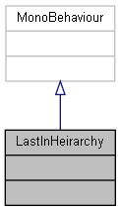

Collaboration diagram for LastInHeirarchy:



The documentation for this class was generated from the following file:

C:/_SSDSPEEDUP/2021/clone/gps1_manadesigner/GPS1-Manadesigner/Assets/Scripts/Stage Scripts/Game Over/**LastInHeirarchy.cs**

## UnityEngine.PostProcessing.BloomModel.LensDirtSettings Struct Reference

Collaboration diagram for UnityEngine.PostProcessing.BloomModel.LensDirtSettings:

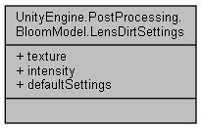

### Public Attributes

Texture **texture**

float **intensity**

### Properties

static **LensDirtSettings** **defaultSettings** [get]

### Member Data Documentation

#### float UnityEngine.PostProcessing.BloomModel.LensDirtSettings.intensity

#### Texture UnityEngine.PostProcessing.BloomModel.LensDirtSettings.texture

### Property Documentation

#### LensDirtSettings UnityEngine.PostProcessing.BloomModel.LensDirtSettings.defaultSettings[static], [get]

#### The documentation for this struct was generated from the following file:

C:/_SSDSPEEDUP/2021/clone/gps1_manadesigner/GPS1-Manadesigner/Assets/Samples/Input System/1.0.2/Tanks Demo/TanksDemo/PostProcessing/Runtime/Models/**BloomModel.cs**

## Examples.Command.LightActiveToggle Class Reference

Inheritance diagram for Examples.Command.LightActiveToggle:

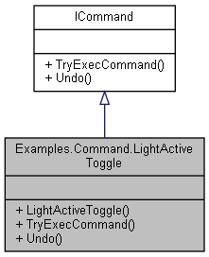

Collaboration diagram for Examples.Command.LightActiveToggle:



### Public Member Functions

**LightActiveToggle** (Light light)

void **TryExecCommand** ()

void **Undo** ()

### Constructor & Destructor Documentation

#### Examples.Command.LightActiveToggle.LightActiveToggle (Light *light*)

### Member Function Documentation

#### void Examples.Command.LightActiveToggle.TryExecCommand ()

Implements **ICommand** (*p.346*).

#### void Examples.Command.LightActiveToggle.Undo ()

Implements **ICommand** (*p.347*).

#### The documentation for this class was generated from the following file:

C:/_SSDSPEEDUP/2021/clone/gps1_manadesigner/GPS1-Manadesigner/Assets/_UtilsV0.4/MyScripts/_Utils/CommandPattern/Command/_Bin/MyScene/Sample/Example/Scripts/Commands/**LightActiveToggle.cs**

## Examples.Command.LightColorChange Class Reference

Inheritance diagram for Examples.Command.LightColorChange:

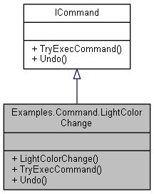

Collaboration diagram for Examples.Command.LightColorChange:



### Public Member Functions

**LightColorChange** (Light light, Color newColor)

void **TryExecCommand** ()

void **Undo** ()

### Constructor & Destructor Documentation

#### Examples.Command.LightColorChange.LightColorChange (Light *light*, Color *newColor*)

### Member Function Documentation

#### void Examples.Command.LightColorChange.TryExecCommand ()

Implements **ICommand** (*p.346*).

#### void Examples.Command.LightColorChange.Undo ()

Implements **ICommand** (*p.347*).

#### The documentation for this class was generated from the following file:

C:/_SSDSPEEDUP/2021/clone/gps1_manadesigner/GPS1-Manadesigner/Assets/_UtilsV0.4/MyScripts/_Utils/CommandPattern/Command/_Bin/MyScene/Sample/Example/Scripts/Commands/**LightColorChange.cs**

## Examples.Command.LightController Class Reference

Inheritance diagram for Examples.Command.LightController:

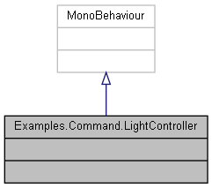

Collaboration diagram for Examples.Command.LightController:



The documentation for this class was generated from the following file:

C:/_SSDSPEEDUP/2021/clone/gps1_manadesigner/GPS1-Manadesigner/Assets/_UtilsV0.4/MyScripts/_Utils/CommandPattern/Command/_Bin/MyScene/Sample/Example/Scripts/**LightController.cs**

## Examples.Command.LightDecreaseIntensity Class Reference

Inheritance diagram for Examples.Command.LightDecreaseIntensity:

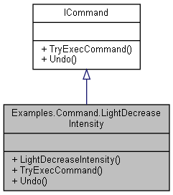

Collaboration diagram for Examples.Command.LightDecreaseIntensity:



### Public Member Functions

**LightDecreaseIntensity** (Light light)

void **TryExecCommand** ()

void **Undo** ()

### Constructor & Destructor Documentation

#### Examples.Command.LightDecreaseIntensity.LightDecreaseIntensity (Light *light*)

### Member Function Documentation

#### void Examples.Command.LightDecreaseIntensity.TryExecCommand ()

Implements **ICommand** (*p.346*).

#### void Examples.Command.LightDecreaseIntensity.Undo ()

Implements **ICommand** (*p.347*).

#### The documentation for this class was generated from the following file:

C:/_SSDSPEEDUP/2021/clone/gps1_manadesigner/GPS1-Manadesigner/Assets/_UtilsV0.4/MyScripts/_Utils/CommandPattern/Command/_Bin/MyScene/Sample/Example/Scripts/Commands/**LightDecreaseIntensity.cs**

## Examples.Command.LightIncreaseIntensity Class Reference

Inheritance diagram for Examples.Command.LightIncreaseIntensity:

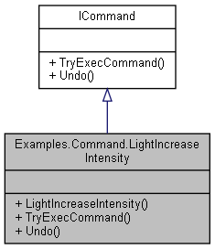

Collaboration diagram for Examples.Command.LightIncreaseIntensity:



### Public Member Functions

**LightIncreaseIntensity** (Light light)

void **TryExecCommand** ()

void **Undo** ()

### Constructor & Destructor Documentation

#### Examples.Command.LightIncreaseIntensity.LightIncreaseIntensity (Light *light*)

### Member Function Documentation

#### void Examples.Command.LightIncreaseIntensity.TryExecCommand ()

Implements **ICommand** (*p.346*).

#### void Examples.Command.LightIncreaseIntensity.Undo ()

Implements **ICommand** (*p.347*).

#### The documentation for this class was generated from the following file:

C:/_SSDSPEEDUP/2021/clone/gps1_manadesigner/GPS1-Manadesigner/Assets/_UtilsV0.4/MyScripts/_Utils/CommandPattern/Command/_Bin/MyScene/Sample/Example/Scripts/Commands/**LightIncreaseIntensity.cs**

## UnityEngine.PostProcessing.ColorGradingModel.LinearWheelsSettings Struct Reference

Collaboration diagram for UnityEngine.PostProcessing.ColorGradingModel.LinearWheelsSettings:

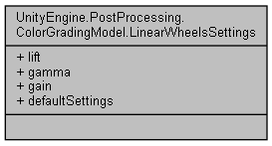

### Public Attributes

Color **lift**

Color **gamma**

Color **gain**

### Properties

static **LinearWheelsSettings** **defaultSettings** [get]

### Member Data Documentation

#### Color UnityEngine.PostProcessing.ColorGradingModel.LinearWheelsSettings.gain

#### Color UnityEngine.PostProcessing.ColorGradingModel.LinearWheelsSettings.gamma

#### Color UnityEngine.PostProcessing.ColorGradingModel.LinearWheelsSettings.lift

### Property Documentation

#### LinearWheelsSettings UnityEngine.PostProcessing.ColorGradingModel.LinearWheelsSettings.defaultSettings[static], [get]

#### The documentation for this struct was generated from the following file:

C:/_SSDSPEEDUP/2021/clone/gps1_manadesigner/GPS1-Manadesigner/Assets/Samples/Input System/1.0.2/Tanks Demo/TanksDemo/PostProcessing/Runtime/Models/**ColorGradingModel.cs**

## LineRendererDrawer Class Reference

This class gets a line renderer in this object, and then set its end points based on its target.

Inheritance diagram for LineRendererDrawer:

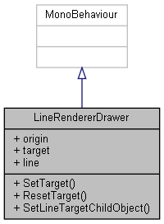

Collaboration diagram for LineRendererDrawer:



### Public Member Functions

void **SetTarget** (Transform newTarget)

void **ResetTarget** ()

void **SetLineTargetChildObject** ()

*This function will attach line Renderer to any child objects of this object Explanation:*

### Public Attributes

Transform **origin**

Transform **target**

LineRenderer **line**

### Detailed Description

This class gets a line renderer in this object, and then set its end points based on its target.

Explanation:

Usage: Integration:

Attach this class script to an Obj with LineRenderer attached to it.

Line Renderer will automatically set its endPoint as the target that is passed in this script

You can swap the target endPoint by calling the setTarget function

You can reset the target to the initial default target by calling the ResetTarget function

You can make the LineRenderer target any child obj under this Obj by calling the SetLineTargetChildObject function Implement Later:

### Member Function Documentation

#### void LineRendererDrawer.ResetTarget ()

Here is the caller graph for this function:

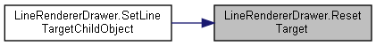

#### void LineRendererDrawer.SetLineTargetChildObject ()

This function will attach line Renderer to any child objects of this object Explanation:

Whenever there is more than 0 child attached to this object

Set first child object as endpoint Usage:

Integration:

Call this function to make line renderer set its endpoint as targetChildObject

Here is the call graph for this function:

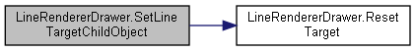

#### void LineRendererDrawer.SetTarget (Transform *newTarget*)

### Member Data Documentation

#### LineRenderer LineRendererDrawer.line

#### Transform LineRendererDrawer.origin

#### Transform LineRendererDrawer.target

#### The documentation for this class was generated from the following file:

C:/_SSDSPEEDUP/2021/clone/gps1_manadesigner/GPS1-Manadesigner/Assets/_UtilsV0.4/MyScripts/_Utils/_CommonV0.2/Helper/**LineRendererDrawer.cs**

## UnityEngine.PostProcessing.ColorGradingModel.LogWheelsSettings Struct Reference

Collaboration diagram for UnityEngine.PostProcessing.ColorGradingModel.LogWheelsSettings:

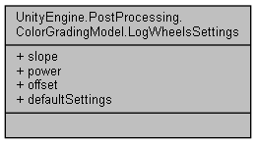

### Public Attributes

Color **slope**

Color **power**

Color **offset**

### Properties

static **LogWheelsSettings** **defaultSettings** [get]

### Member Data Documentation

#### Color UnityEngine.PostProcessing.ColorGradingModel.LogWheelsSettings.offset

#### Color UnityEngine.PostProcessing.ColorGradingModel.LogWheelsSettings.power

#### Color UnityEngine.PostProcessing.ColorGradingModel.LogWheelsSettings.slope

### Property Documentation

#### LogWheelsSettings UnityEngine.PostProcessing.ColorGradingModel.LogWheelsSettings.defaultSettings[static], [get]

#### The documentation for this struct was generated from the following file:

C:/_SSDSPEEDUP/2021/clone/gps1_manadesigner/GPS1-Manadesigner/Assets/Samples/Input System/1.0.2/Tanks Demo/TanksDemo/PostProcessing/Runtime/Models/**ColorGradingModel.cs**

## LookAtCameraMain Class Reference

Inheritance diagram for LookAtCameraMain:

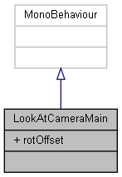

Collaboration diagram for LookAtCameraMain:



### Public Attributes

Vector3 **rotOffset**

### Member Data Documentation

#### Vector3 LookAtCameraMain.rotOffset

#### The documentation for this class was generated from the following file:

C:/_SSDSPEEDUP/2021/clone/gps1_manadesigner/GPS1-Manadesigner/Assets/_UtilsV0.4/MyScripts/_Utils/_CommonV0.2/Helper/**LookAtCameraMain.cs**

## MapLocation Class Reference

Collaboration diagram for MapLocation:

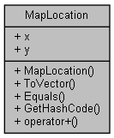

### Public Member Functions

**MapLocation** (int _x, int _y)

Vector2 **ToVector** ()

override bool **Equals** (object obj)

override int **GetHashCode** ()

### Static Public Member Functions

static **MapLocation** **operator+** (**MapLocation** a, **MapLocation** b)

### Public Attributes

int **x**

int **y**

### Constructor & Destructor Documentation

#### MapLocation.MapLocation (int *_x*, int *_y*)

Here is the caller graph for this function:

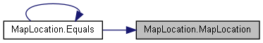

### Member Function Documentation

#### override bool MapLocation.Equals (object *obj*)

Here is the call graph for this function:

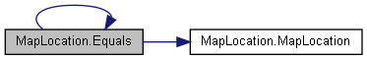

Here is the caller graph for this function:

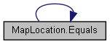

#### override int MapLocation.GetHashCode ()

#### static MapLocation MapLocation.operator+ (MapLocation *a*, MapLocation *b*)[static]

#### Vector2 MapLocation.ToVector ()

### Member Data Documentation

#### int MapLocation.x

#### int MapLocation.y

#### The documentation for this class was generated from the following file:

C:/_SSDSPEEDUP/2021/clone/gps1_manadesigner/GPS1-Manadesigner/Assets/Scripts/Arif's Test Scripts/**Maze.cs**

## UnityEngine.PostProcessing.MaterialFactory Class Reference

Inheritance diagram for UnityEngine.PostProcessing.MaterialFactory:

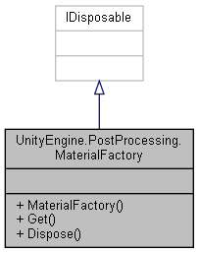

Collaboration diagram for UnityEngine.PostProcessing.MaterialFactory:



### Public Member Functions

**MaterialFactory** ()

Material **Get** (string shaderName)

void **Dispose** ()

### Constructor & Destructor Documentation

#### UnityEngine.PostProcessing.MaterialFactory.MaterialFactory ()

### Member Function Documentation

#### void UnityEngine.PostProcessing.MaterialFactory.Dispose ()

Here is the call graph for this function:

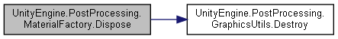

#### Material UnityEngine.PostProcessing.MaterialFactory.Get (string *shaderName*)

#### The documentation for this class was generated from the following file:

C:/_SSDSPEEDUP/2021/clone/gps1_manadesigner/GPS1-Manadesigner/Assets/Samples/Input System/1.0.2/Tanks Demo/TanksDemo/PostProcessing/Runtime/Utils/**MaterialFactory.cs**

## MathCommon Class Reference

Collaboration diagram for MathCommon:

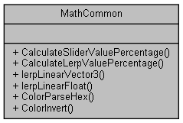

### Static Public Member Functions

static float **CalculateSliderValuePercentage** (Slider sliderUI, float currValue, float maxValue, float lerpTime)

static float **CalculateLerpValuePercentage** (float currValue, float maxValue, float lerpTime)

static Vector3 **lerpLinearVector3** (Vector3 start, Vector3 end, float timeStartedLerping, float lerpTime=1)

static float **lerpLinearFloat** (float startVal, float endVal, float timeStartedLerping, float lerpTime=1)

static Color **ColorParseHex** (string hexValue)

static Color **ColorInvert** (Color color)

### Member Function Documentation

#### static float MathCommon.CalculateLerpValuePercentage (float *currValue*, float *maxValue*, float *lerpTime*)[static]

#### static float MathCommon.CalculateSliderValuePercentage (Slider *sliderUI*, float *currValue*, float *maxValue*, float *lerpTime*)[static]

#### static Color MathCommon.ColorInvert (Color *color*)[static]

#### static Color MathCommon.ColorParseHex (string *hexValue*)[static]

#### static float MathCommon.lerpLinearFloat (float *startVal*, float *endVal*, float *timeStartedLerping*, float *lerpTime* = 1)[static]

#### static Vector3 MathCommon.lerpLinearVector3 (Vector3 *start*, Vector3 *end*, float *timeStartedLerping*, float *lerpTime* = 1)[static]

#### The documentation for this class was generated from the following file:

C:/_SSDSPEEDUP/2021/clone/gps1_manadesigner/GPS1-Manadesigner/Assets/_UtilsV0.4/MyScripts/_Utils/_CommonV0.2/Calculation/**MathCommon.cs**

## Maze Class Reference

Inheritance diagram for Maze:

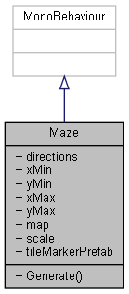

Collaboration diagram for Maze:



### Public Member Functions

virtual void **Generate** ()

### Public Attributes

List< **MapLocation** > **directions**

int **xMin**

int **yMin**

int **xMax**

int **yMax**

byte[,] **map**

int **scale** = 6

GameObject **tileMarkerPrefab**

### Member Function Documentation

#### virtual void Maze.Generate ()[virtual]

### Member Data Documentation

#### List<MapLocation> Maze.directions

**Initial value:**= new List<MapLocation>()

{

new MapLocation(1,0),

new MapLocation(0,1),

new MapLocation(-1,0),

new MapLocation(0,-1)

}

#### byte [,] Maze.map

#### int Maze.scale = 6

#### GameObject Maze.tileMarkerPrefab

#### int Maze.xMax

#### int Maze.xMin

#### int Maze.yMax

#### int Maze.yMin

#### The documentation for this class was generated from the following file:

C:/_SSDSPEEDUP/2021/clone/gps1_manadesigner/GPS1-Manadesigner/Assets/Scripts/Arif's Test Scripts/**Maze.cs**

## MeterTank Class Reference

Inheritance diagram for MeterTank:

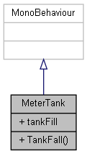

Collaboration diagram for MeterTank:



### Public Member Functions

void **TankFall** ()

### Public Attributes

Slider **tankFill**

### Member Function Documentation

#### void MeterTank.TankFall ()

### Member Data Documentation

#### Slider MeterTank.tankFill

#### The documentation for this class was generated from the following file:

C:/_SSDSPEEDUP/2021/clone/gps1_manadesigner/GPS1-Manadesigner/Assets/Scripts/UI Test Scripts/**MeterTank.cs**

## UnityEngine.PostProcessing.MinAttribute Class Reference

Inheritance diagram for UnityEngine.PostProcessing.MinAttribute:

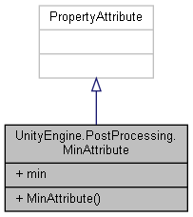

Collaboration diagram for UnityEngine.PostProcessing.MinAttribute:



### Public Member Functions

**MinAttribute** (float **min**)

### Public Attributes

readonly float **min**

### Constructor & Destructor Documentation

#### UnityEngine.PostProcessing.MinAttribute.MinAttribute (float *min*)

### Member Data Documentation

#### readonly float UnityEngine.PostProcessing.MinAttribute.min

#### The documentation for this class was generated from the following file:

C:/_SSDSPEEDUP/2021/clone/gps1_manadesigner/GPS1-Manadesigner/Assets/Samples/Input System/1.0.2/Tanks Demo/TanksDemo/PostProcessing/Runtime/Attributes/**MinAttribute.cs**

## UnityEngine.PostProcessing.MotionBlurComponent Class Reference

Inheritance diagram for UnityEngine.PostProcessing.MotionBlurComponent:

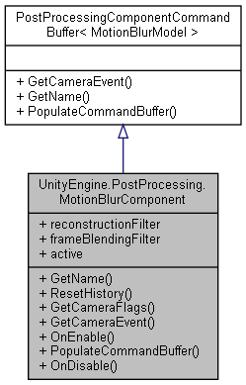

Collaboration diagram for UnityEngine.PostProcessing.MotionBlurComponent:



### Classes

class **FrameBlendingFilter**

class **ReconstructionFilter**

### Public Member Functions

override string **GetName** ()

void **ResetHistory** ()

override DepthTextureMode **GetCameraFlags** ()

override CameraEvent **GetCameraEvent** ()

override void **OnEnable** ()

override void **PopulateCommandBuffer** (CommandBuffer cb)

override void **OnDisable** ()

### Properties

**ReconstructionFilter** **reconstructionFilter** [get]

**FrameBlendingFilter** **frameBlendingFilter** [get]

override bool **active** [get]

### Member Function Documentation

#### override CameraEvent UnityEngine.PostProcessing.MotionBlurComponent.GetCameraEvent ()[virtual]

Implements **UnityEngine.PostProcessing.PostProcessingComponentCommandBuffer< MotionBlurModel >** (*p.592*).

#### override DepthTextureMode UnityEngine.PostProcessing.MotionBlurComponent.GetCameraFlags ()

#### override string UnityEngine.PostProcessing.MotionBlurComponent.GetName ()[virtual]

Implements **UnityEngine.PostProcessing.PostProcessingComponentCommandBuffer< MotionBlurModel >** (*p.592*).

#### override void UnityEngine.PostProcessing.MotionBlurComponent.OnDisable ()

#### override void UnityEngine.PostProcessing.MotionBlurComponent.OnEnable ()

#### override void UnityEngine.PostProcessing.MotionBlurComponent.PopulateCommandBuffer (CommandBuffer *cb*)[virtual]

Implements **UnityEngine.PostProcessing.PostProcessingComponentCommandBuffer< MotionBlurModel >** (*p.592*).

Here is the call graph for this function:

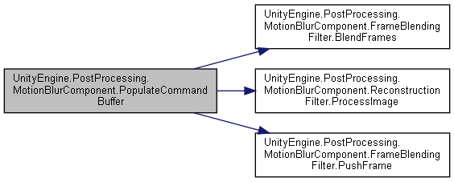

#### void UnityEngine.PostProcessing.MotionBlurComponent.ResetHistory ()

Here is the caller graph for this function:

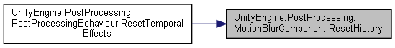

### Property Documentation

#### override bool UnityEngine.PostProcessing.MotionBlurComponent.active[get]

#### FrameBlendingFilter UnityEngine.PostProcessing.MotionBlurComponent.frameBlendingFilter[get]

#### ReconstructionFilter UnityEngine.PostProcessing.MotionBlurComponent.reconstructionFilter[get]

#### The documentation for this class was generated from the following file:

C:/_SSDSPEEDUP/2021/clone/gps1_manadesigner/GPS1-Manadesigner/Assets/Samples/Input System/1.0.2/Tanks Demo/TanksDemo/PostProcessing/Runtime/Components/**MotionBlurComponent.cs**

## UnityEngine.PostProcessing.MotionBlurModel Class Reference

Inheritance diagram for UnityEngine.PostProcessing.MotionBlurModel:

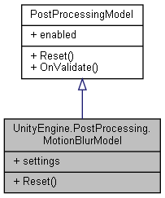

Collaboration diagram for UnityEngine.PostProcessing.MotionBlurModel:



### Classes

struct **Settings**

### Public Member Functions

override void **Reset** ()

### Properties

**Settings** **settings** [getset]

### Member Function Documentation

#### override void UnityEngine.PostProcessing.MotionBlurModel.Reset ()[virtual]

Implements **UnityEngine.PostProcessing.PostProcessingModel** (*p.597*).

### Property Documentation

#### Settings UnityEngine.PostProcessing.MotionBlurModel.settings[get], [set]

#### The documentation for this class was generated from the following file:

C:/_SSDSPEEDUP/2021/clone/gps1_manadesigner/GPS1-Manadesigner/Assets/Samples/Input System/1.0.2/Tanks Demo/TanksDemo/PostProcessing/Runtime/Models/**MotionBlurModel.cs**

## UnityEngine.PostProcessing.BuiltinDebugViewsModel.MotionVectorsSettings Struct Reference

Collaboration diagram for UnityEngine.PostProcessing.BuiltinDebugViewsModel.MotionVectorsSettings:

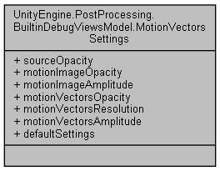

### Public Attributes

float **sourceOpacity**

float **motionImageOpacity**

float **motionImageAmplitude**

float **motionVectorsOpacity**

int **motionVectorsResolution**

float **motionVectorsAmplitude**

### Properties

static **MotionVectorsSettings** **defaultSettings** [get]

### Member Data Documentation

#### float UnityEngine.PostProcessing.BuiltinDebugViewsModel.MotionVectorsSettings.motionImageAmplitude

#### float UnityEngine.PostProcessing.BuiltinDebugViewsModel.MotionVectorsSettings.motionImageOpacity

#### float UnityEngine.PostProcessing.BuiltinDebugViewsModel.MotionVectorsSettings.motionVectorsAmplitude

#### float UnityEngine.PostProcessing.BuiltinDebugViewsModel.MotionVectorsSettings.motionVectorsOpacity

#### int UnityEngine.PostProcessing.BuiltinDebugViewsModel.MotionVectorsSettings.motionVectorsResolution

#### float UnityEngine.PostProcessing.BuiltinDebugViewsModel.MotionVectorsSettings.sourceOpacity

### Property Documentation

#### MotionVectorsSettings UnityEngine.PostProcessing.BuiltinDebugViewsModel.MotionVectorsSettings.defaultSettings[static], [get]

#### The documentation for this struct was generated from the following file:

C:/_SSDSPEEDUP/2021/clone/gps1_manadesigner/GPS1-Manadesigner/Assets/Samples/Input System/1.0.2/Tanks Demo/TanksDemo/PostProcessing/Runtime/Models/**BuiltinDebugViewsModel.cs**

## Move Class Reference

Inheritance diagram for Move:

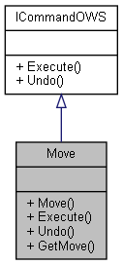

Collaboration diagram for Move:



### Public Member Functions

**Move** (Transform objectToMove, Vector3 direction, float distance=1f)

void **Execute** ()

void **Undo** ()

Vector3 **GetMove** ()

### Constructor & Destructor Documentation

#### Move.Move (Transform *objectToMove*, Vector3 *direction*, float *distance* = 1f)

### Member Function Documentation

#### void Move.Execute ()

Implements **ICommandOWS** (*p.348*).

Here is the caller graph for this function:

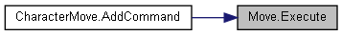

#### Vector3 Move.GetMove ()

#### void Move.Undo ()

Implements **ICommandOWS** (*p.348*).

#### The documentation for this class was generated from the following file:

C:/_SSDSPEEDUP/2021/clone/gps1_manadesigner/GPS1-Manadesigner/Assets/_UtilsV0.4/MyScripts/_Utils/CommandPattern/_Bin/OWS/_Samples/Script/**Move.cs**

## Movement Class Reference

Inheritance diagram for Movement:

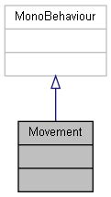

Collaboration diagram for Movement:



The documentation for this class was generated from the following file:

C:/_SSDSPEEDUP/2021/clone/gps1_manadesigner/GPS1-Manadesigner/Assets/**Movement.cs**

## NavAgentTestAutoSetMouseDestination Class Reference

Inheritance diagram for NavAgentTestAutoSetMouseDestination:

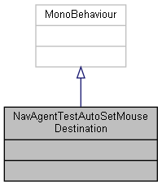

Collaboration diagram for NavAgentTestAutoSetMouseDestination:



The documentation for this class was generated from the following file:

C:/_SSDSPEEDUP/2021/clone/gps1_manadesigner/GPS1-Manadesigner/Assets/_UtilsV0.4/MyScripts/_Utils/_CommonV0.2/CommonExtend/AINav/**NavAgentTestAutoSetMouseDestination.cs**

## NavAgentTestAutoSetRandomDestination Class Reference

Inheritance diagram for NavAgentTestAutoSetRandomDestination:

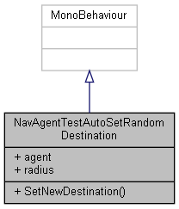

Collaboration diagram for NavAgentTestAutoSetRandomDestination:



### Public Member Functions

void **SetNewDestination** ()

### Public Attributes

NavMeshAgent **agent**

float **radius** = 25

### Member Function Documentation

#### void NavAgentTestAutoSetRandomDestination.SetNewDestination ()

Here is the call graph for this function:

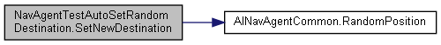

### Member Data Documentation

#### NavMeshAgent NavAgentTestAutoSetRandomDestination.agent

#### float NavAgentTestAutoSetRandomDestination.radius = 25

#### The documentation for this class was generated from the following file:

C:/_SSDSPEEDUP/2021/clone/gps1_manadesigner/GPS1-Manadesigner/Assets/_UtilsV0.4/MyScripts/_Utils/_CommonV0.2/CommonExtend/AINav/**NavAgentTestAutoSetRandomDestination.cs**

## NavAgentTestAutoSetWASDMovement Class Reference

Inheritance diagram for NavAgentTestAutoSetWASDMovement:

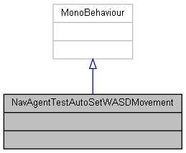

Collaboration diagram for NavAgentTestAutoSetWASDMovement:



The documentation for this class was generated from the following file:

C:/_SSDSPEEDUP/2021/clone/gps1_manadesigner/GPS1-Manadesigner/Assets/_UtilsV0.4/MyScripts/_Utils/_CommonV0.2/CommonExtend/AINav/**NavAgentTestAutoSetWASDMovement.cs**

## NavMeshCustomMove Class Reference

Inheritance diagram for NavMeshCustomMove:

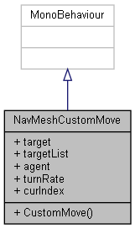

Collaboration diagram for NavMeshCustomMove:



### Public Member Functions

void **CustomMove** (Vector3 nextPos)

### Public Attributes

Transform **target**

Transform[] **targetList**

NavMeshAgent **agent**

float **turnRate** = 1f

int **curIndex**

### Member Function Documentation

#### void NavMeshCustomMove.CustomMove (Vector3 *nextPos*)

### Member Data Documentation

#### NavMeshAgent NavMeshCustomMove.agent

#### int NavMeshCustomMove.curIndex

#### Transform NavMeshCustomMove.target

#### Transform [] NavMeshCustomMove.targetList

#### float NavMeshCustomMove.turnRate = 1f

#### The documentation for this class was generated from the following file:

C:/_SSDSPEEDUP/2021/clone/gps1_manadesigner/GPS1-Manadesigner/Assets/_UtilsV0.4/MyScripts/_Utils/_CommonV0.2/CommonExtend/AINav/**NavMeshCustomMove.cs**

## NextStageBarrier Class Reference

Inheritance diagram for NextStageBarrier:

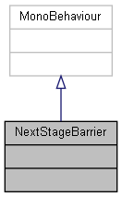

Collaboration diagram for NextStageBarrier:



The documentation for this class was generated from the following file:

C:/_SSDSPEEDUP/2021/clone/gps1_manadesigner/GPS1-Manadesigner/Assets/**NextStageBarrier.cs**

## NPCAISystemTypeA Class Reference

Inheritance diagram for NPCAISystemTypeA:

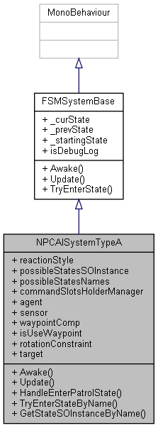

Collaboration diagram for NPCAISystemTypeA:

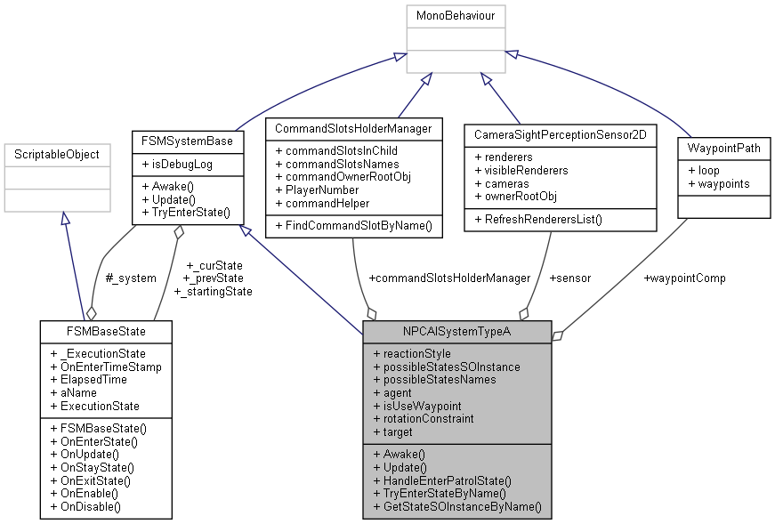

### Public Member Functions

override void **Awake** ()

override void **Update** ()

void **HandleEnterPatrolState** ()

void **TryEnterStateByName** (string nextStateName)

**FSMBaseState** **GetStateSOInstanceByName** (string stateName)

### Public Attributes

**NPCAITypeAReactinStyle** **reactionStyle** = **NPCAITypeAReactinStyle.Chase**

List< **FSMBaseState** > **possibleStatesSOInstance**

List< string > **possibleStatesNames**

**CommandSlotsHolderManager** **commandSlotsHolderManager**

NavMeshAgent **agent**

**CameraSightPerceptionSensor2D** **sensor**

**WaypointPath** **waypointComp**

bool **isUseWaypoint** = true

RotationConstraint **rotationConstraint**

Transform **target**

### Member Function Documentation

#### override void NPCAISystemTypeA.Awake ()[virtual]

Reimplemented from **FSMSystemBase** (*p.282*).

Here is the call graph for this function:

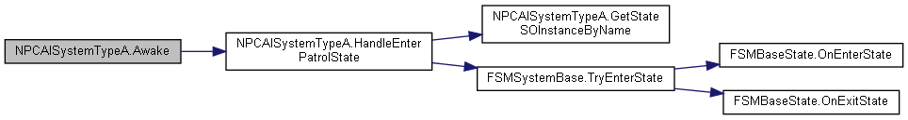

#### FSMBaseState NPCAISystemTypeA.GetStateSOInstanceByName (string *stateName*)

Here is the caller graph for this function:

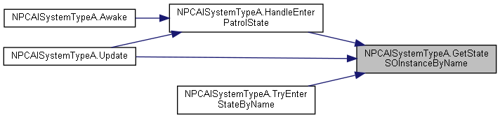

#### void NPCAISystemTypeA.HandleEnterPatrolState ()

Here is the call graph for this function:

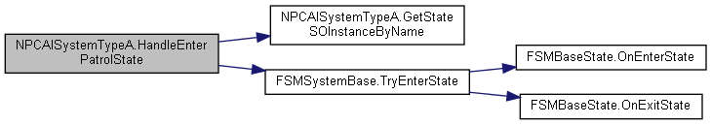

Here is the caller graph for this function:

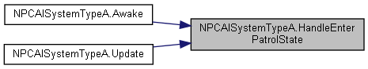

#### void NPCAISystemTypeA.TryEnterStateByName (string *nextStateName*)

Here is the call graph for this function:

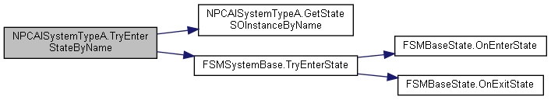

#### override void NPCAISystemTypeA.Update ()[virtual]

Reimplemented from **FSMSystemBase** (*p.283*).

Here is the call graph for this function:

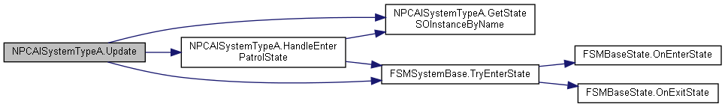

### Member Data Documentation

#### NavMeshAgent NPCAISystemTypeA.agent

#### CommandSlotsHolderManager NPCAISystemTypeA.commandSlotsHolderManager

#### bool NPCAISystemTypeA.isUseWaypoint = true

#### List<string> NPCAISystemTypeA.possibleStatesNames

#### List<FSMBaseState> NPCAISystemTypeA.possibleStatesSOInstance

#### NPCAITypeAReactinStyle NPCAISystemTypeA.reactionStyle = NPCAITypeAReactinStyle.Chase

#### RotationConstraint NPCAISystemTypeA.rotationConstraint

#### CameraSightPerceptionSensor2D NPCAISystemTypeA.sensor

#### Transform NPCAISystemTypeA.target

#### WaypointPath NPCAISystemTypeA.waypointComp

#### The documentation for this class was generated from the following file:

C:/_SSDSPEEDUP/2021/clone/gps1_manadesigner/GPS1-Manadesigner/Assets/_UtilsV0.4/MyScripts/_Utils/__Experimental/AIApproach/StatePattern/**NPCAISystemTypeA.cs**

## OnAllUnityEventCall Class Reference

Inheritance diagram for OnAllUnityEventCall:

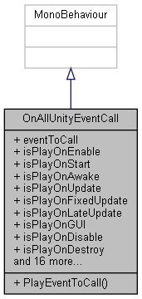

Collaboration diagram for OnAllUnityEventCall:



### Public Member Functions

void **PlayEventToCall** ()

### Public Attributes

UnityEvent **eventToCall**

bool **isPlayOnEnable** = true

bool **isPlayOnStart** = false

bool **isPlayOnAwake** = false

bool **isPlayOnUpdate** = false

bool **isPlayOnFixedUpdate** = false

bool **isPlayOnLateUpdate** = false

bool **isPlayOnGUI** = false

bool **isPlayOnDisable** = false

bool **isPlayOnDestroy** = false

bool **isPlayOnApplicationPause** = false

bool **isPlayOnTransformChildrenChanged** = false

bool **isPlayOnTransformParentChanged** = false

bool **isPlayOnBeforeTransformParentChanged** = false

bool **isPlayOnCollisionEnter** = false

bool **isPlayOnCollisionExit** = false

bool **isPlayOnCollisionStay** = false

bool **isPlayOnTriggerEnter** = false

bool **isPlayOnTriggerExit** = false

bool **isPlayOnTriggerStay** = false

bool **isPlayOnCollisionEnter2D** = false

bool **isPlayOnCollisionExit2D** = false

bool **isPlayOnCollisionStay2D** = false

bool **isPlayOnTriggerEnter2D** = false

bool **isPlayOnTriggerExit2D** = false

bool **isPlayOnTriggerStay2D** = false

### Member Function Documentation

#### void OnAllUnityEventCall.PlayEventToCall ()

### Member Data Documentation

#### UnityEvent OnAllUnityEventCall.eventToCall

#### bool OnAllUnityEventCall.isPlayOnApplicationPause = false

#### bool OnAllUnityEventCall.isPlayOnAwake = false

#### bool OnAllUnityEventCall.isPlayOnBeforeTransformParentChanged = false

#### bool OnAllUnityEventCall.isPlayOnCollisionEnter = false

#### bool OnAllUnityEventCall.isPlayOnCollisionEnter2D = false

#### bool OnAllUnityEventCall.isPlayOnCollisionExit = false

#### bool OnAllUnityEventCall.isPlayOnCollisionExit2D = false

#### bool OnAllUnityEventCall.isPlayOnCollisionStay = false

#### bool OnAllUnityEventCall.isPlayOnCollisionStay2D = false

#### bool OnAllUnityEventCall.isPlayOnDestroy = false

#### bool OnAllUnityEventCall.isPlayOnDisable = false

#### bool OnAllUnityEventCall.isPlayOnEnable = true

#### bool OnAllUnityEventCall.isPlayOnFixedUpdate = false

#### bool OnAllUnityEventCall.isPlayOnGUI = false

#### bool OnAllUnityEventCall.isPlayOnLateUpdate = false

#### bool OnAllUnityEventCall.isPlayOnStart = false

#### bool OnAllUnityEventCall.isPlayOnTransformChildrenChanged = false

#### bool OnAllUnityEventCall.isPlayOnTransformParentChanged = false

#### bool OnAllUnityEventCall.isPlayOnTriggerEnter = false

#### bool OnAllUnityEventCall.isPlayOnTriggerEnter2D = false

#### bool OnAllUnityEventCall.isPlayOnTriggerExit = false

#### bool OnAllUnityEventCall.isPlayOnTriggerExit2D = false

#### bool OnAllUnityEventCall.isPlayOnTriggerStay = false

#### bool OnAllUnityEventCall.isPlayOnTriggerStay2D = false

#### bool OnAllUnityEventCall.isPlayOnUpdate = false

#### The documentation for this class was generated from the following file:

C:/_SSDSPEEDUP/2021/clone/gps1_manadesigner/GPS1-Manadesigner/Assets/_UtilsV0.4/MyScripts/_Utils/_CommonV0.2/Event/**OnAllUnityEventCall.cs**

## OnEnableEventCallTimer Class Reference

Inheritance diagram for OnEnableEventCallTimer:

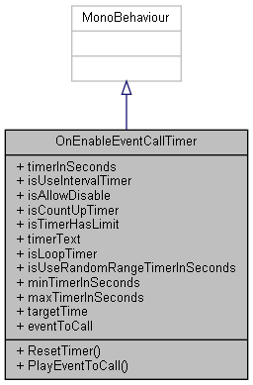

Collaboration diagram for OnEnableEventCallTimer:

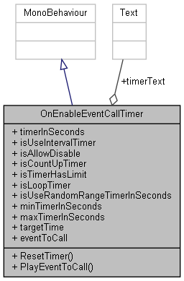

### Public Member Functions

void **ResetTimer** ()

void **PlayEventToCall** ()

### Public Attributes

float **timerInSeconds** = 3f

bool **isUseIntervalTimer**

bool **isAllowDisable** = false

bool **isCountUpTimer** = false

bool **isTimerHasLimit** = true

Text **timerText**

bool **isLoopTimer**

bool **isUseRandomRangeTimerInSeconds**

float **minTimerInSeconds**

float **maxTimerInSeconds**

float **targetTime**

UnityEvent **eventToCall**

### Member Function Documentation

#### void OnEnableEventCallTimer.PlayEventToCall ()

#### void OnEnableEventCallTimer.ResetTimer ()

### Member Data Documentation

#### UnityEvent OnEnableEventCallTimer.eventToCall

#### bool OnEnableEventCallTimer.isAllowDisable = false

#### bool OnEnableEventCallTimer.isCountUpTimer = false

#### bool OnEnableEventCallTimer.isLoopTimer

#### bool OnEnableEventCallTimer.isTimerHasLimit = true

#### bool OnEnableEventCallTimer.isUseIntervalTimer

#### bool OnEnableEventCallTimer.isUseRandomRangeTimerInSeconds

#### float OnEnableEventCallTimer.maxTimerInSeconds

#### float OnEnableEventCallTimer.minTimerInSeconds

#### float OnEnableEventCallTimer.targetTime

#### float OnEnableEventCallTimer.timerInSeconds = 3f

#### Text OnEnableEventCallTimer.timerText

#### The documentation for this class was generated from the following file:

C:/_SSDSPEEDUP/2021/clone/gps1_manadesigner/GPS1-Manadesigner/Assets/_UtilsV0.4/MyScripts/_Utils/_CommonV0.2/Event/**OnEnableEventCallTimer.cs**

## OnEnablePlayBGM Class Reference

Inheritance diagram for OnEnablePlayBGM:

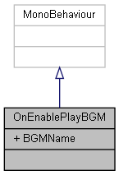

Collaboration diagram for OnEnablePlayBGM:



### Public Attributes

string **BGMName**

### Member Data Documentation

#### string OnEnablePlayBGM.BGMName

#### The documentation for this class was generated from the following file:

C:/_SSDSPEEDUP/2021/clone/gps1_manadesigner/GPS1-Manadesigner/Assets/_UtilsV0.4/MyScripts/_Utils/_CommonV0.2/Event/**OnEnablePlayBGM.cs**

## OnEnablePlaySFX Class Reference

Inheritance diagram for OnEnablePlaySFX:

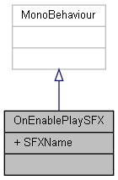

Collaboration diagram for OnEnablePlaySFX:



### Public Attributes

string **SFXName**

### Member Data Documentation

#### string OnEnablePlaySFX.SFXName

#### The documentation for this class was generated from the following file:

C:/_SSDSPEEDUP/2021/clone/gps1_manadesigner/GPS1-Manadesigner/Assets/_UtilsV0.4/MyScripts/_Utils/_CommonV0.2/Event/**OnEnablePlaySFX.cs**

## PlayerSkills.OnSkillUnlockedEventArgs Class Reference

Inheritance diagram for PlayerSkills.OnSkillUnlockedEventArgs:

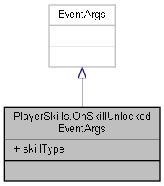

Collaboration diagram for PlayerSkills.OnSkillUnlockedEventArgs:



### Public Attributes

**SkillType** **skillType**

### Member Data Documentation

#### SkillType PlayerSkills.OnSkillUnlockedEventArgs.skillType

#### The documentation for this class was generated from the following file:

C:/_SSDSPEEDUP/2021/clone/gps1_manadesigner/GPS1-Manadesigner/Assets/Scripts/Arif's Test Scripts/Skill Tree/**PlayerSkills.cs**

## OutpostChoices Class Reference

Inheritance diagram for OutpostChoices:

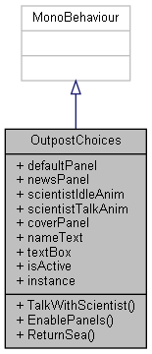

Collaboration diagram for OutpostChoices:

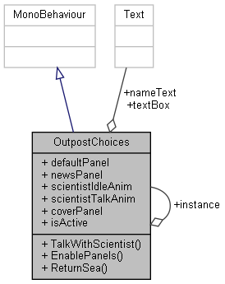

### Public Member Functions

void **TalkWithScientist** ()

void **EnablePanels** ()

void **ReturnSea** ()

### Public Attributes

GameObject **defaultPanel**

GameObject **newsPanel**

GameObject **scientistIdleAnim**

GameObject **scientistTalkAnim**

GameObject **coverPanel**

Text **nameText**

Text **textBox**

bool **isActive** = false

### Static Public Attributes

static **OutpostChoices** **instance**

### Member Function Documentation

#### void OutpostChoices.EnablePanels ()

Here is the caller graph for this function:



#### void OutpostChoices.ReturnSea ()

Here is the call graph for this function:

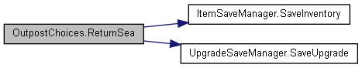

#### void OutpostChoices.TalkWithScientist ()

### Member Data Documentation

#### GameObject OutpostChoices.coverPanel

#### GameObject OutpostChoices.defaultPanel

#### OutpostChoices OutpostChoices.instance[static]

#### bool OutpostChoices.isActive = false

#### Text OutpostChoices.nameText

#### GameObject OutpostChoices.newsPanel

#### GameObject OutpostChoices.scientistIdleAnim

#### GameObject OutpostChoices.scientistTalkAnim

#### Text OutpostChoices.textBox

#### The documentation for this class was generated from the following file:

C:/_SSDSPEEDUP/2021/clone/gps1_manadesigner/GPS1-Manadesigner/Assets/Scripts/Stage Scripts/Outpost/Dialogues/**OutpostChoices.cs**

## OxygenTank Class Reference

Inheritance diagram for OxygenTank:

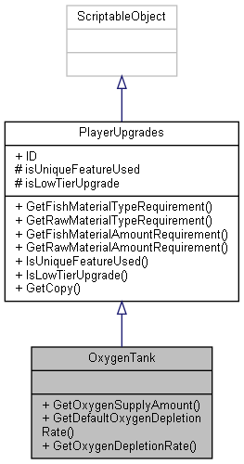

Collaboration diagram for OxygenTank:



### Public Member Functions

float **GetOxygenSupplyAmount** ()

float **GetDefaultOxygenDepletionRate** ()

float **GetOxygenDepletionRate** (int stage)

### Additional Inherited Members

### Member Function Documentation

#### float OxygenTank.GetDefaultOxygenDepletionRate ()

#### float OxygenTank.GetOxygenDepletionRate (int *stage*)

#### float OxygenTank.GetOxygenSupplyAmount ()

#### The documentation for this class was generated from the following file:

C:/_SSDSPEEDUP/2021/clone/gps1_manadesigner/GPS1-Manadesigner/Assets/Scripts/Arif's Test Scripts/Upgrades/Oxygen Tank/**OxygenTank.cs**

## ParamStateBehavior Class Reference

Inheritance diagram for ParamStateBehavior:

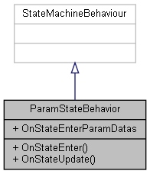

Collaboration diagram for ParamStateBehavior:

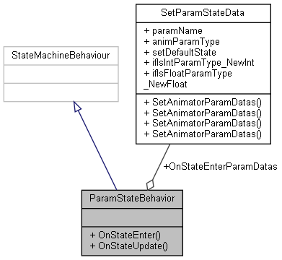

### Public Member Functions

override void **OnStateEnter** (Animator animator, AnimatorStateInfo stateInfo, int layerIndex)

override void **OnStateUpdate** (Animator animator, AnimatorStateInfo stateInfo, int layerIndex)

### Public Attributes

**SetParamStateData**[] **OnStateEnterParamDatas**

### Member Function Documentation

#### override void ParamStateBehavior.OnStateEnter (Animator *animator*, AnimatorStateInfo *stateInfo*, int *layerIndex*)

Here is the call graph for this function:

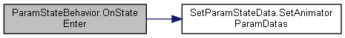

#### override void ParamStateBehavior.OnStateUpdate (Animator *animator*, AnimatorStateInfo *stateInfo*, int *layerIndex*)

### Member Data Documentation

#### SetParamStateData [] ParamStateBehavior.OnStateEnterParamDatas

#### The documentation for this class was generated from the following file:

C:/_SSDSPEEDUP/2021/clone/gps1_manadesigner/GPS1-Manadesigner/Assets/_UtilsV0.4/MyScripts/_Utils/_CommonV0.2/Animator/**ParamStateBehavior.cs**

## PathDraw Class Reference

Inheritance diagram for PathDraw:

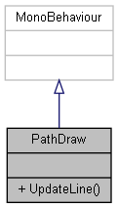

Collaboration diagram for PathDraw:



### Public Member Functions

void **UpdateLine** (List< Vector3 > points)

### Member Function Documentation

#### void PathDraw.UpdateLine (List< Vector3 > *points*)

Here is the caller graph for this function:

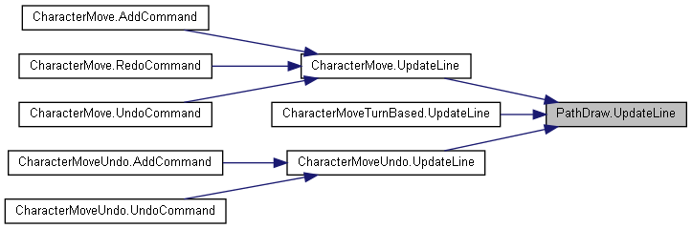

#### The documentation for this class was generated from the following file:

C:/_SSDSPEEDUP/2021/clone/gps1_manadesigner/GPS1-Manadesigner/Assets/_UtilsV0.4/MyScripts/_Utils/CommandPattern/_Bin/OWS/_Samples/Script/**PathDraw.cs**

## PathMarker Class Reference

Collaboration diagram for PathMarker:

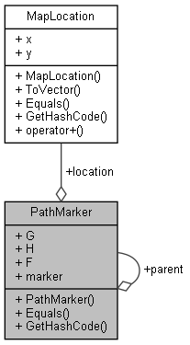

### Public Member Functions

**PathMarker** (**MapLocation** l, float g, float h, float f, GameObject **marker**, **PathMarker** p)

override bool **Equals** (object obj)

override int **GetHashCode** ()

### Public Attributes

**MapLocation** **location**

float **G**

float **H**

float **F**

GameObject **marker**

**PathMarker** **parent**

### Constructor & Destructor Documentation

#### PathMarker.PathMarker (MapLocation *l*, float *g*, float *h*, float *f*, GameObject *marker*, PathMarker *p*)

Here is the caller graph for this function:

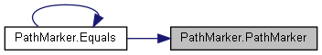

### Member Function Documentation

#### override bool PathMarker.Equals (object *obj*)

Here is the call graph for this function:

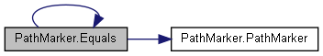

Here is the caller graph for this function:

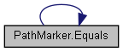

#### override int PathMarker.GetHashCode ()

### Member Data Documentation

#### float PathMarker.F

#### float PathMarker.G

#### float PathMarker.H

#### MapLocation PathMarker.location

#### GameObject PathMarker.marker

#### PathMarker PathMarker.parent

#### The documentation for this class was generated from the following file:

C:/_SSDSPEEDUP/2021/clone/gps1_manadesigner/GPS1-Manadesigner/Assets/Scripts/Arif's Test Scripts/**AStarPathFinder.cs**

## PatrolByRandomPos Class Reference

Inheritance diagram for PatrolByRandomPos:

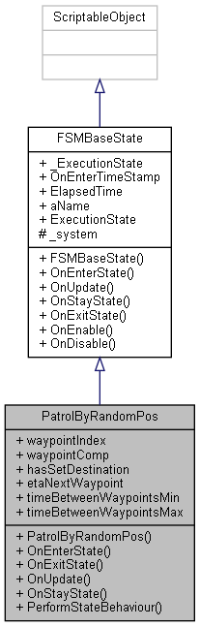

Collaboration diagram for PatrolByRandomPos:

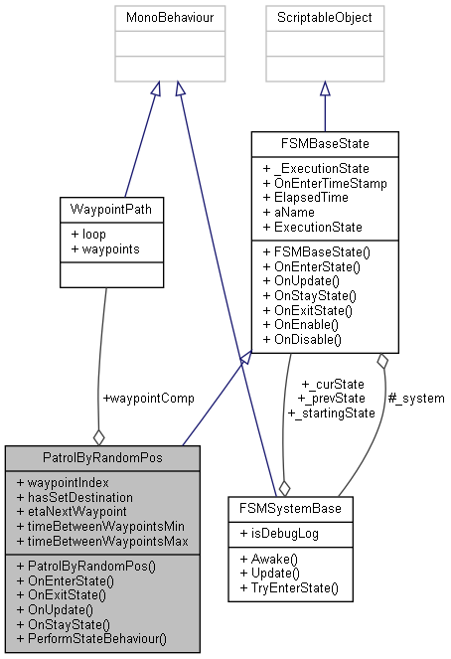

### Public Member Functions

**PatrolByRandomPos** (**FSMSystemBase** system)

override bool **OnEnterState** ()

override bool **OnExitState** ()

override void **OnUpdate** ()

override void **OnStayState** ()

void **PerformStateBehaviour** ()

### Public Attributes

int **waypointIndex** = 0

**WaypointPath** **waypointComp**

bool **hasSetDestination**

float **etaNextWaypoint**

float **timeBetweenWaypointsMin** = 5f

float **timeBetweenWaypointsMax** = 10f

### Additional Inherited Members

### Constructor & Destructor Documentation

#### PatrolByRandomPos.PatrolByRandomPos (FSMSystemBase *system*)

### Member Function Documentation

#### override bool PatrolByRandomPos.OnEnterState ()[virtual]

Reimplemented from **FSMBaseState** (*p.279*).

#### override bool PatrolByRandomPos.OnExitState ()[virtual]

Reimplemented from **FSMBaseState** (*p.279*).

#### override void PatrolByRandomPos.OnStayState ()[virtual]

Reimplemented from **FSMBaseState** (*p.279*).

Here is the call graph for this function:

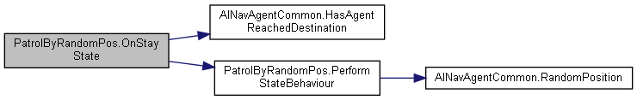

#### override void PatrolByRandomPos.OnUpdate ()[virtual]

Reimplemented from **FSMBaseState** (*p.279*).

#### void PatrolByRandomPos.PerformStateBehaviour ()

Here is the call graph for this function:

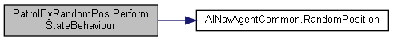

Here is the caller graph for this function:

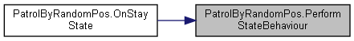

### Member Data Documentation

#### float PatrolByRandomPos.etaNextWaypoint

#### bool PatrolByRandomPos.hasSetDestination

#### float PatrolByRandomPos.timeBetweenWaypointsMax = 10f

#### float PatrolByRandomPos.timeBetweenWaypointsMin = 5f

#### WaypointPath PatrolByRandomPos.waypointComp

#### int PatrolByRandomPos.waypointIndex = 0

#### The documentation for this class was generated from the following file:

C:/_SSDSPEEDUP/2021/clone/gps1_manadesigner/GPS1-Manadesigner/Assets/_UtilsV0.4/MyScripts/_Utils/__Experimental/AIApproach/StatePattern/**NPCAIStatesTypeA.cs**

## PatrolByWaypoints Class Reference

Inheritance diagram for PatrolByWaypoints:

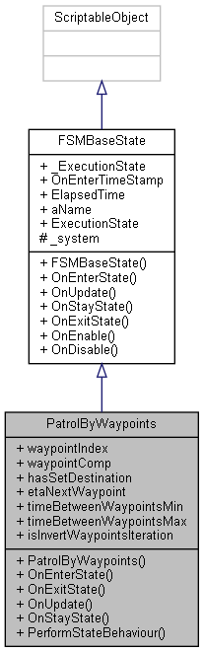

Collaboration diagram for PatrolByWaypoints:

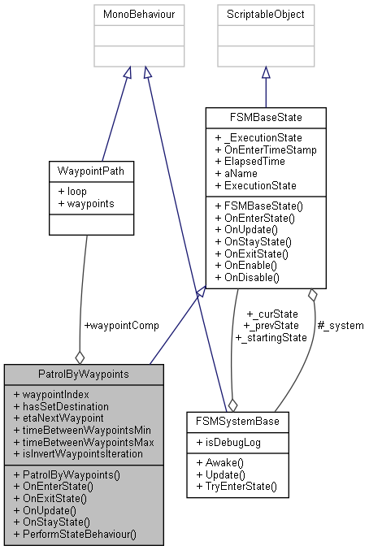

### Public Member Functions

**PatrolByWaypoints** (**FSMSystemBase** system)

override bool **OnEnterState** ()

override bool **OnExitState** ()

override void **OnUpdate** ()

override void **OnStayState** ()

void **PerformStateBehaviour** ()

### Public Attributes

int **waypointIndex** = 0

**WaypointPath** **waypointComp**

bool **hasSetDestination**

float **etaNextWaypoint**

float **timeBetweenWaypointsMin** = 5f

float **timeBetweenWaypointsMax** = 10f

bool **isInvertWaypointsIteration**

### Additional Inherited Members

### Constructor & Destructor Documentation

#### PatrolByWaypoints.PatrolByWaypoints (FSMSystemBase *system*)

### Member Function Documentation

#### override bool PatrolByWaypoints.OnEnterState ()[virtual]

Reimplemented from **FSMBaseState** (*p.279*).

#### override bool PatrolByWaypoints.OnExitState ()[virtual]

Reimplemented from **FSMBaseState** (*p.279*).

#### override void PatrolByWaypoints.OnStayState ()[virtual]

Reimplemented from **FSMBaseState** (*p.279*).

Here is the call graph for this function:

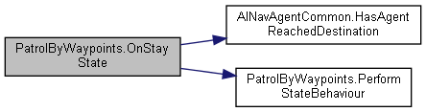

#### override void PatrolByWaypoints.OnUpdate ()[virtual]

Reimplemented from **FSMBaseState** (*p.279*).

#### void PatrolByWaypoints.PerformStateBehaviour ()

Here is the caller graph for this function:

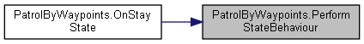

### Member Data Documentation

#### float PatrolByWaypoints.etaNextWaypoint

#### bool PatrolByWaypoints.hasSetDestination

#### bool PatrolByWaypoints.isInvertWaypointsIteration

#### float PatrolByWaypoints.timeBetweenWaypointsMax = 10f

#### float PatrolByWaypoints.timeBetweenWaypointsMin = 5f

#### WaypointPath PatrolByWaypoints.waypointComp

#### int PatrolByWaypoints.waypointIndex = 0

#### The documentation for this class was generated from the following file:

C:/_SSDSPEEDUP/2021/clone/gps1_manadesigner/GPS1-Manadesigner/Assets/_UtilsV0.4/MyScripts/_Utils/__Experimental/AIApproach/StatePattern/**NPCAIStatesTypeA.cs**

## PauseMenu Class Reference

Inheritance diagram for PauseMenu:

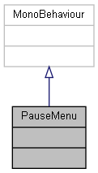

Collaboration diagram for PauseMenu:



The documentation for this class was generated from the following file:

C:/_SSDSPEEDUP/2021/clone/gps1_manadesigner/GPS1-Manadesigner/Assets/Scripts/Arif's Test Scripts/**PauseMenu.cs**

## PauseMenuScripts Class Reference

Inheritance diagram for PauseMenuScripts:

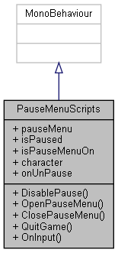

Collaboration diagram for PauseMenuScripts:

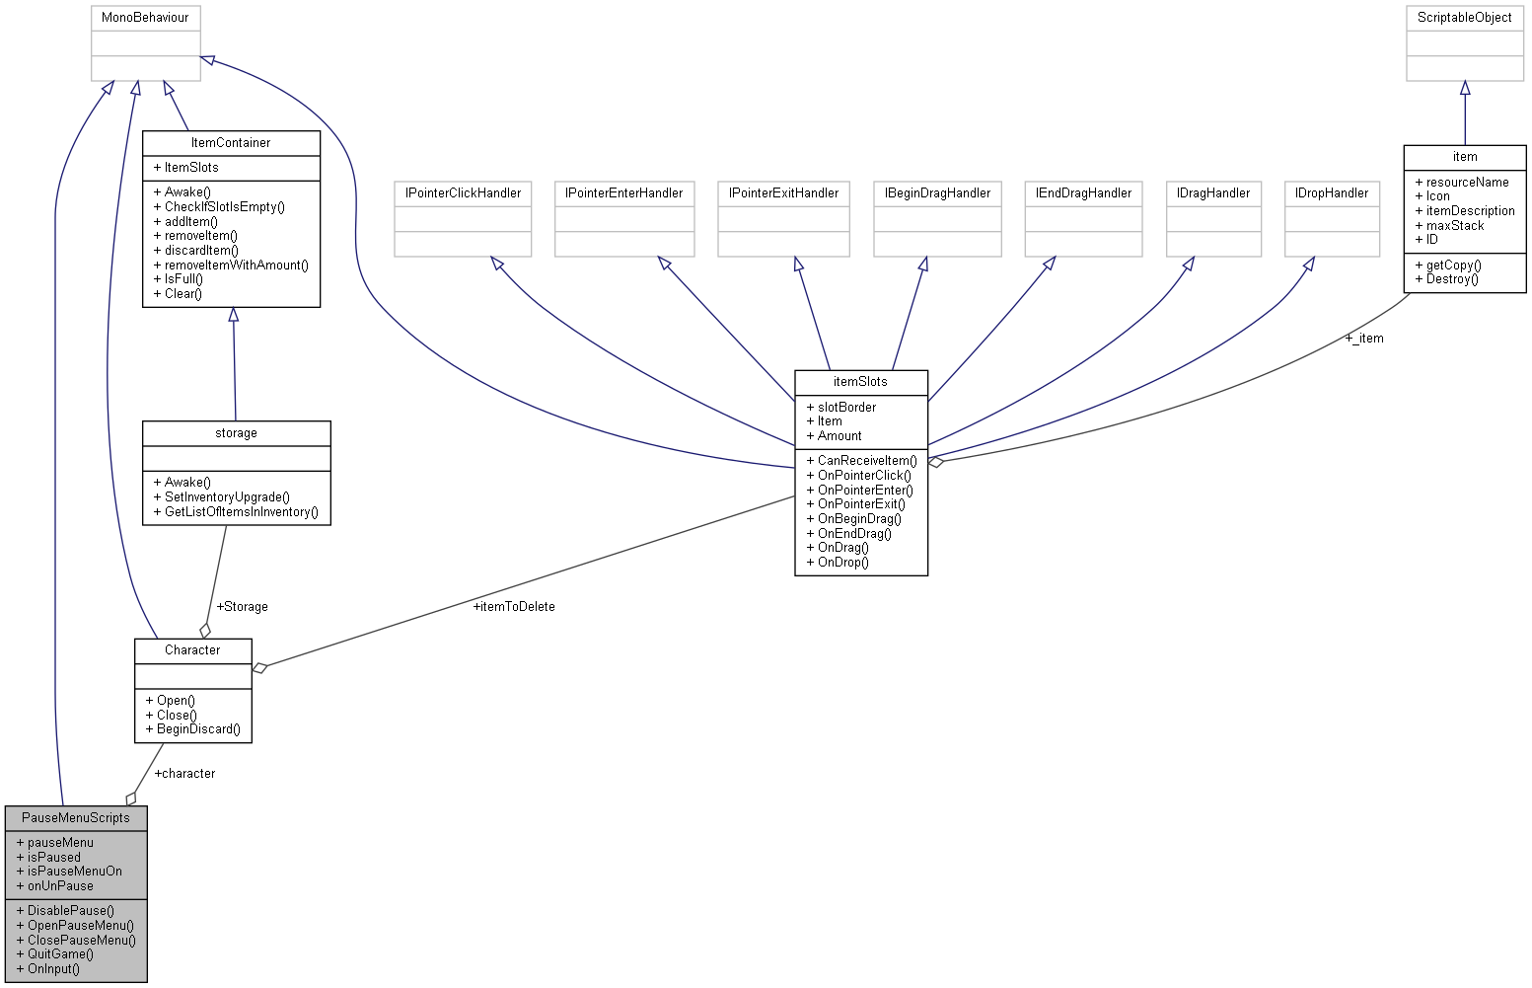

### Public Member Functions

void **DisablePause** ()

void **OpenPauseMenu** ()

void **ClosePauseMenu** ()

void **QuitGame** ()

void **OnInput** (InputAction.CallbackContext context)

### Public Attributes

GameObject **pauseMenu**

bool **isPaused**

bool **isPauseMenuOn**

**Character** **character**

UnityEvent **onUnPause**

### Member Function Documentation

#### void PauseMenuScripts.ClosePauseMenu ()

Here is the caller graph for this function:

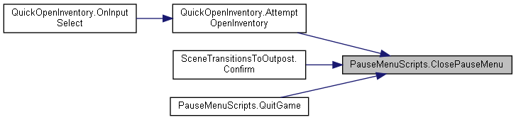

#### void PauseMenuScripts.DisablePause ()

#### void PauseMenuScripts.OnInput (InputAction.CallbackContext *context*)

#### void PauseMenuScripts.OpenPauseMenu ()

Here is the caller graph for this function:



#### void PauseMenuScripts.QuitGame ()

Here is the call graph for this function:



### Member Data Documentation

#### Character PauseMenuScripts.character

#### bool PauseMenuScripts.isPaused

#### bool PauseMenuScripts.isPauseMenuOn

#### UnityEvent PauseMenuScripts.onUnPause

#### GameObject PauseMenuScripts.pauseMenu

#### The documentation for this class was generated from the following file:

C:/_SSDSPEEDUP/2021/clone/gps1_manadesigner/GPS1-Manadesigner/Assets/Scripts/Stage Scripts/Pause Menu/**PauseMenuScripts.cs**

## Assets.MyScripts.SInt.Common.Calculation.PhysicsCastCommon Class Reference

Inheritance diagram for Assets.MyScripts.SInt.Common.Calculation.PhysicsCastCommon:

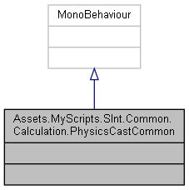

Collaboration diagram for Assets.MyScripts.SInt.Common.Calculation.PhysicsCastCommon:



The documentation for this class was generated from the following file:

C:/_SSDSPEEDUP/2021/clone/gps1_manadesigner/GPS1-Manadesigner/Assets/_UtilsV0.4/MyScripts/_Utils/_CommonV0.2/Calculation/**PhysicsCastCommon.cs**

## Player Class Reference

Inheritance diagram for Player:

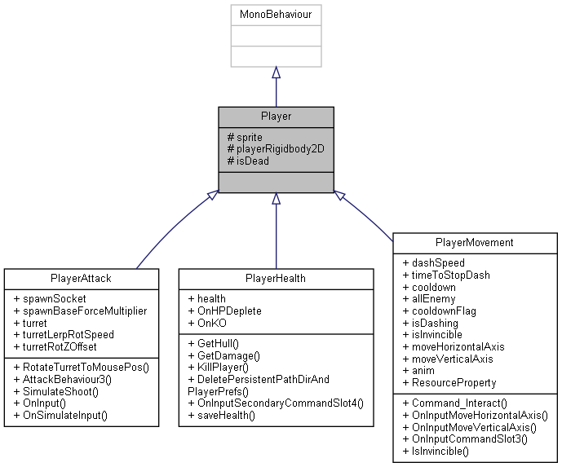

Collaboration diagram for Player:

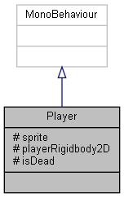

### Protected Attributes

SpriteRenderer **sprite**

Rigidbody2D **playerRigidbody2D**

bool **isDead** = false

### Member Data Documentation

#### bool Player.isDead = false[protected]

#### Rigidbody2D Player.playerRigidbody2D[protected]

#### SpriteRenderer Player.sprite[protected]

#### The documentation for this class was generated from the following file:

C:/_SSDSPEEDUP/2021/clone/gps1_manadesigner/GPS1-Manadesigner/Assets/Scripts/Player Script/**Player.cs**

## TanksInputActions.PlayerActions Struct Reference

Collaboration diagram for TanksInputActions.PlayerActions:

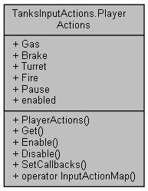

### Public Member Functions

**PlayerActions** (@**TanksInputActions** wrapper)

InputActionMap **Get** ()

void **Enable** ()

void **Disable** ()

void **SetCallbacks** (**IPlayerActions** instance)

### Static Public Member Functions

static implicit **operator InputActionMap** (**PlayerActions** set)

### Properties

InputAction **Gas** [get]

InputAction **Brake** [get]

InputAction **Turret** [get]

InputAction **Fire** [get]

InputAction **Pause** [get]

bool **enabled** [get]

### Constructor & Destructor Documentation

#### TanksInputActions.PlayerActions.PlayerActions (@TanksInputActions *wrapper*)

### Member Function Documentation

#### void TanksInputActions.PlayerActions.Disable ()

Here is the call graph for this function:

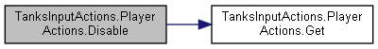

#### void TanksInputActions.PlayerActions.Enable ()

Here is the call graph for this function:

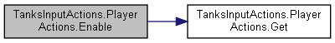

#### InputActionMap TanksInputActions.PlayerActions.Get ()

Here is the caller graph for this function:

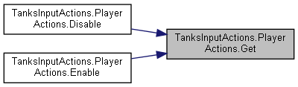

#### static implicit TanksInputActions.PlayerActions.operator InputActionMap (PlayerActions *set*)[static]

#### void TanksInputActions.PlayerActions.SetCallbacks (IPlayerActions *instance*)

Here is the call graph for this function:

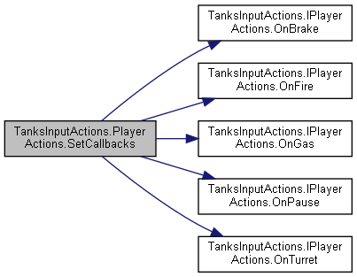

### Property Documentation

#### InputAction TanksInputActions.PlayerActions.Brake[get]

#### bool TanksInputActions.PlayerActions.enabled[get]

#### InputAction TanksInputActions.PlayerActions.Fire[get]

#### InputAction TanksInputActions.PlayerActions.Gas[get]

#### InputAction TanksInputActions.PlayerActions.Pause[get]

#### InputAction TanksInputActions.PlayerActions.Turret[get]

#### The documentation for this struct was generated from the following file:

C:/_SSDSPEEDUP/2021/clone/gps1_manadesigner/GPS1-Manadesigner/Assets/Samples/Input System/1.0.2/Tanks Demo/TanksDemo/**TanksInputActions.cs**

## PlayerAttack Class Reference

Inheritance diagram for PlayerAttack:

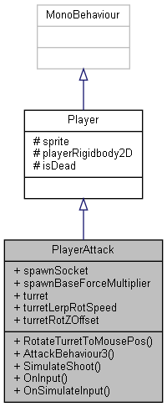

Collaboration diagram for PlayerAttack:



### Public Member Functions

void **RotateTurretToMousePos** ()

void **AttackBehaviour3** ()

void **SimulateShoot** ()

void **OnInput** (InputAction.CallbackContext context)

void **OnSimulateInput** (bool IsPressedThisFrame, float axis)

### Public Attributes

Transform **spawnSocket**

float **spawnBaseForceMultiplier** = 100f

Transform **turret**

float **turretLerpRotSpeed** = 5f

float **turretRotZOffset** = 90

### Additional Inherited Members

### Member Function Documentation

#### void PlayerAttack.AttackBehaviour3 ()

#### void PlayerAttack.OnInput (InputAction.CallbackContext *context*)

Here is the call graph for this function:

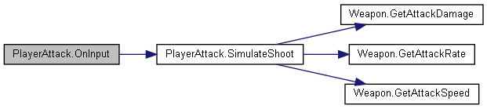

#### void PlayerAttack.OnSimulateInput (bool *IsPressedThisFrame*, float *axis*)

#### void PlayerAttack.RotateTurretToMousePos ()

#### void PlayerAttack.SimulateShoot ()

Here is the call graph for this function:

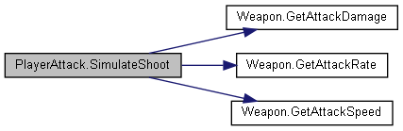

Here is the caller graph for this function:



### Member Data Documentation

#### float PlayerAttack.spawnBaseForceMultiplier = 100f

#### Transform PlayerAttack.spawnSocket

#### Transform PlayerAttack.turret

#### float PlayerAttack.turretLerpRotSpeed = 5f

#### float PlayerAttack.turretRotZOffset = 90

#### The documentation for this class was generated from the following file:

C:/_SSDSPEEDUP/2021/clone/gps1_manadesigner/GPS1-Manadesigner/Assets/Scripts/**PlayerAttack.cs**

## PlayerBullet Class Reference

Inheritance diagram for PlayerBullet:

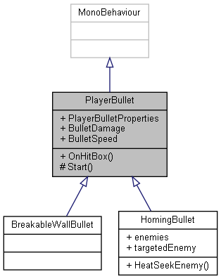

Collaboration diagram for PlayerBullet:

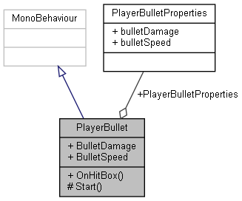

### Public Member Functions

void **OnHitBox** (GameObject other)

### Public Attributes

**PlayerBulletProperties** **PlayerBulletProperties**

### Protected Member Functions

void **Start** ()

### Properties

float **BulletDamage** [getset]

float **BulletSpeed** [getset]

### Member Function Documentation

#### void PlayerBullet.OnHitBox (GameObject *other*)

Here is the call graph for this function:

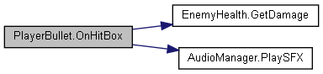

#### void PlayerBullet.Start ()[protected]

### Member Data Documentation

#### PlayerBulletProperties PlayerBullet.PlayerBulletProperties

### Property Documentation

#### float PlayerBullet.BulletDamage[get], [set]

#### float PlayerBullet.BulletSpeed[get], [set]

#### The documentation for this class was generated from the following file:

C:/_SSDSPEEDUP/2021/clone/gps1_manadesigner/GPS1-Manadesigner/Assets/PlayerBullet/**PlayerBullet.cs**

## PlayerBulletProperties Class Reference

Collaboration diagram for PlayerBulletProperties:

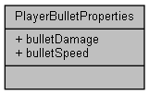

### Public Attributes

float **bulletDamage**

float **bulletSpeed**

### Member Data Documentation

#### float PlayerBulletProperties.bulletDamage

#### float PlayerBulletProperties.bulletSpeed

#### The documentation for this class was generated from the following file:

C:/_SSDSPEEDUP/2021/clone/gps1_manadesigner/GPS1-Manadesigner/Assets/PlayerBullet/**PlayerBullet.cs**

## PlayerData Class Reference

Collaboration diagram for PlayerData:

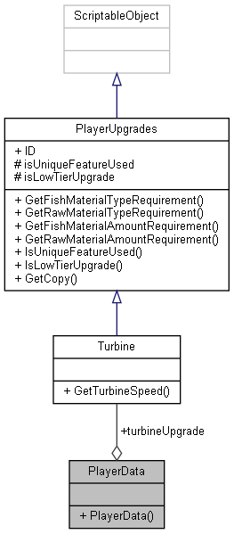

### Public Member Functions

**PlayerData** (**PlayerMovement** playerMovement)

### Public Attributes

**Turbine** **turbineUpgrade**

### Constructor & Destructor Documentation

#### PlayerData.PlayerData (PlayerMovement *playerMovement*)

### Member Data Documentation

#### Turbine PlayerData.turbineUpgrade

#### The documentation for this class was generated from the following file:

C:/_SSDSPEEDUP/2021/clone/gps1_manadesigner/GPS1-Manadesigner/Assets/Scripts/Arif's Test Scripts/Save State/Unused/**PlayerData.cs**

## PlayerHealth Class Reference

Inheritance diagram for PlayerHealth:

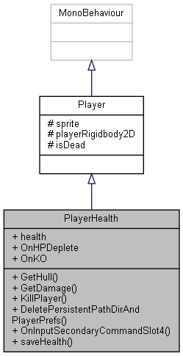

Collaboration diagram for PlayerHealth:



### Public Member Functions

**Hull** **GetHull** ()

void **GetDamage** (float damage)

void **KillPlayer** ()

void **DeletePersistentPathDirAndPlayerPrefs** ()

void **OnInputSecondaryCommandSlot4** (InputAction.CallbackContext context)

void **saveHealth** ()

### Public Attributes

float **health**

UnityEvent **OnHPDeplete**

UnityEvent **OnKO**

### Additional Inherited Members

### Member Function Documentation

#### void PlayerHealth.DeletePersistentPathDirAndPlayerPrefs ()

Here is the call graph for this function:

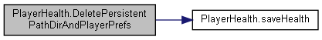

Here is the caller graph for this function:

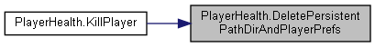

#### void PlayerHealth.GetDamage (float *damage*)

Here is the call graph for this function:

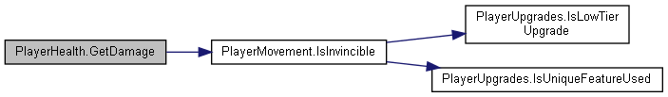

#### Hull PlayerHealth.GetHull ()

#### void PlayerHealth.KillPlayer ()

Here is the call graph for this function:



#### void PlayerHealth.OnInputSecondaryCommandSlot4 (InputAction.CallbackContext *context*)

#### void PlayerHealth.saveHealth ()

Here is the caller graph for this function:



### Member Data Documentation

#### float PlayerHealth.health

#### UnityEvent PlayerHealth.OnHPDeplete

#### UnityEvent PlayerHealth.OnKO

#### The documentation for this class was generated from the following file:

C:/_SSDSPEEDUP/2021/clone/gps1_manadesigner/GPS1-Manadesigner/Assets/Scripts/**PlayerHealth.cs**

## RebindUISampleActionsModified.PlayerMainActions Struct Reference

Collaboration diagram for RebindUISampleActionsModified.PlayerMainActions:

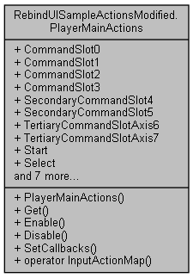

### Public Member Functions

**PlayerMainActions** (@**RebindUISampleActionsModified** wrapper)

InputActionMap **Get** ()

void **Enable** ()

void **Disable** ()

void **SetCallbacks** (**IPlayerMainActions** instance)

### Static Public Member Functions

static implicit **operator InputActionMap** (**PlayerMainActions** set)

### Properties

InputAction **CommandSlot0** [get]

InputAction **CommandSlot1** [get]

InputAction **CommandSlot2** [get]

InputAction **CommandSlot3** [get]

InputAction **SecondaryCommandSlot4** [get]

InputAction **SecondaryCommandSlot5** [get]

InputAction **TertiaryCommandSlotAxis6** [get]

InputAction **TertiaryCommandSlotAxis7** [get]

InputAction **Start** [get]

InputAction **Select** [get]

InputAction **DPadAxisHorizontal** [get]

InputAction **DPadAxisVertical** [get]

InputAction **LeftStickAxisHorizontal** [get]

InputAction **LeftStickAxisVertical** [get]

InputAction **RightStickAxisHorizontal** [get]

InputAction **RightStickAxisVertical** [get]

bool **enabled** [get]

### Constructor & Destructor Documentation

#### RebindUISampleActionsModified.PlayerMainActions.PlayerMainActions (@RebindUISampleActionsModified *wrapper*)

### Member Function Documentation

#### void RebindUISampleActionsModified.PlayerMainActions.Disable ()

Here is the call graph for this function:

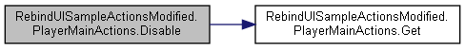

#### void RebindUISampleActionsModified.PlayerMainActions.Enable ()

Here is the call graph for this function:

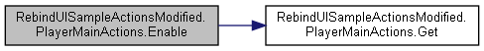

#### InputActionMap RebindUISampleActionsModified.PlayerMainActions.Get ()

Here is the caller graph for this function:

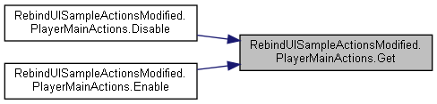

#### static implicit RebindUISampleActionsModified.PlayerMainActions.operator InputActionMap (PlayerMainActions *set*)[static]

#### void RebindUISampleActionsModified.PlayerMainActions.SetCallbacks (IPlayerMainActions *instance*)

Here is the call graph for this function:

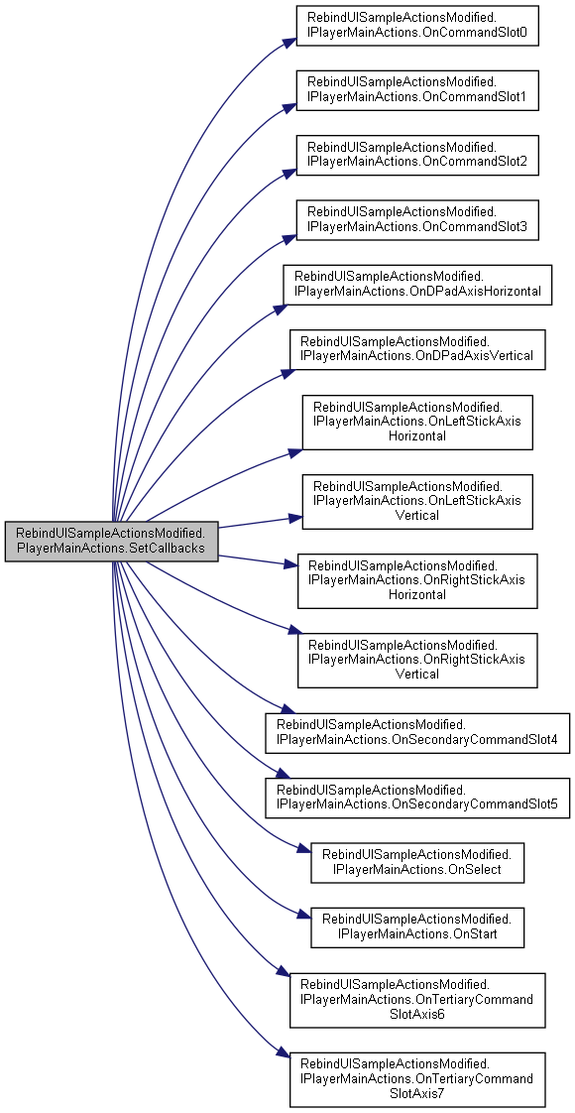

### Property Documentation

#### InputAction RebindUISampleActionsModified.PlayerMainActions.CommandSlot0[get]

#### InputAction RebindUISampleActionsModified.PlayerMainActions.CommandSlot1[get]

#### InputAction RebindUISampleActionsModified.PlayerMainActions.CommandSlot2[get]

#### InputAction RebindUISampleActionsModified.PlayerMainActions.CommandSlot3[get]

#### InputAction RebindUISampleActionsModified.PlayerMainActions.DPadAxisHorizontal[get]

#### InputAction RebindUISampleActionsModified.PlayerMainActions.DPadAxisVertical[get]

#### bool RebindUISampleActionsModified.PlayerMainActions.enabled[get]

#### InputAction RebindUISampleActionsModified.PlayerMainActions.LeftStickAxisHorizontal[get]

#### InputAction RebindUISampleActionsModified.PlayerMainActions.LeftStickAxisVertical[get]

#### InputAction RebindUISampleActionsModified.PlayerMainActions.RightStickAxisHorizontal[get]

#### InputAction RebindUISampleActionsModified.PlayerMainActions.RightStickAxisVertical[get]

#### InputAction RebindUISampleActionsModified.PlayerMainActions.SecondaryCommandSlot4[get]

#### InputAction RebindUISampleActionsModified.PlayerMainActions.SecondaryCommandSlot5[get]

#### InputAction RebindUISampleActionsModified.PlayerMainActions.Select[get]

#### InputAction RebindUISampleActionsModified.PlayerMainActions.Start[get]

#### InputAction RebindUISampleActionsModified.PlayerMainActions.TertiaryCommandSlotAxis6[get]

#### InputAction RebindUISampleActionsModified.PlayerMainActions.TertiaryCommandSlotAxis7[get]

#### The documentation for this struct was generated from the following file:

C:/_SSDSPEEDUP/2021/clone/gps1_manadesigner/GPS1-Manadesigner/Assets/_UtilsV0.4/MyScripts/_Utils/CommandPattern/Command/SOAssets/InputSystemPackage/**RebindUISampleActionsModified.cs**

## PlayerMovement Class Reference

Inheritance diagram for PlayerMovement:

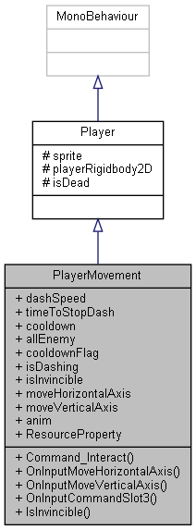

Collaboration diagram for PlayerMovement:



### Public Member Functions

void **Command_Interact** ()

void **OnInputMoveHorizontalAxis** (InputAction.CallbackContext context)

void **OnInputMoveVerticalAxis** (InputAction.CallbackContext context)

void **OnInputCommandSlot3** (InputAction.CallbackContext context)

bool **IsInvincible** ()

### Public Attributes

float **dashSpeed** = 100f

float **timeToStopDash** = 1f

float **cooldown** = 5f

GameObject[] **allEnemy**

bool **cooldownFlag**

bool **isDashing**

bool **isInvincible** = false

float **moveHorizontalAxis**

float **moveVerticalAxis**

Animator **anim**

### Additional Inherited Members

### Member Function Documentation

#### void PlayerMovement.Command_Interact ()

**storage.IsFull()** &&

Here is the call graph for this function:

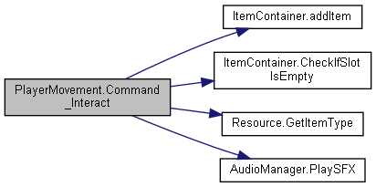

#### bool PlayerMovement.IsInvincible ()

Here is the call graph for this function:

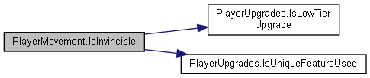

Here is the caller graph for this function:



#### void PlayerMovement.OnInputCommandSlot3 (InputAction.CallbackContext *context*)

#### void PlayerMovement.OnInputMoveHorizontalAxis (InputAction.CallbackContext *context*)

#### void PlayerMovement.OnInputMoveVerticalAxis (InputAction.CallbackContext *context*)

### Member Data Documentation

#### GameObject [] PlayerMovement.allEnemy

#### Animator PlayerMovement.anim

#### float PlayerMovement.cooldown = 5f

#### bool PlayerMovement.cooldownFlag

#### float PlayerMovement.dashSpeed = 100f

#### bool PlayerMovement.isDashing

#### bool PlayerMovement.isInvincible = false

#### float PlayerMovement.moveHorizontalAxis

#### float PlayerMovement.moveVerticalAxis

#### float PlayerMovement.timeToStopDash = 1f

#### The documentation for this class was generated from the following file:

C:/_SSDSPEEDUP/2021/clone/gps1_manadesigner/GPS1-Manadesigner/Assets/Scripts/**PlayerMovement.cs**

## PlayerPrefTextSync Class Reference

Inheritance diagram for PlayerPrefTextSync:

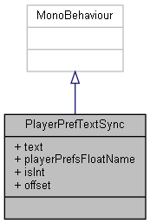

Collaboration diagram for PlayerPrefTextSync:



### Public Attributes

TextMeshProUGUI **text**

string **playerPrefsFloatName** = "Score"

bool **isInt**

float **offset**

### Member Data Documentation

#### bool PlayerPrefTextSync.isInt

#### float PlayerPrefTextSync.offset

#### string PlayerPrefTextSync.playerPrefsFloatName = "Score"

#### TextMeshProUGUI PlayerPrefTextSync.text

#### The documentation for this class was generated from the following file:

C:/_SSDSPEEDUP/2021/clone/gps1_manadesigner/GPS1-Manadesigner/Assets/_UtilsV0.4/MyScripts/_Utils/_CommonV0.2/UICanvas/**PlayerPrefTextSync.cs**

## PlayerSkills Class Reference

Collaboration diagram for PlayerSkills:

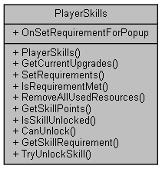

### Classes

class **OnSkillUnlockedEventArgs**

### Public Types

enum **SkillType** { **None**, **LowTierTurbineStage1**, **LowTierTurbineStage2**, **HighTierTurbineStage1**, **HighTierTurbineStage2**, **LowTierWeaponStage1**, **LowTierWeaponStage2**, **HighTierWeaponStage1**, **HighTierWeaponStage2**, **LowTierHullStage1**, **LowTierHullStage2**, **HighTierHullStage1**, **HighTierHullStage2**, **LowTierSelfRepairStage1**, **LowTierSelfRepairStage2**, **HighTierSelfRepairStage1**, **HighTierSelfRepairStage2**, **LowTierOxygenTankStage1**, **LowTierOxygenTankStage2**, **HighTierOxygenTankStage1**, **HighTierOxygenTankStage2**, **LowTierInventoryStage1**, **LowTierInventoryStage2**, **HighTierInventoryStage1**, **HighTierInventoryStage2** }

### Public Member Functions

**PlayerSkills** ()

void **GetCurrentUpgrades** (**UpgradeHolder** upgradeHolder)

void **SetRequirements** (**storage** inv, **PlayerUpgrades** upg)

bool **IsRequirementMet** ()

void **RemoveAllUsedResources** ()

int **GetSkillPoints** ()

bool **IsSkillUnlocked** (**SkillType** skillType)

bool **CanUnlock** (**SkillType** skillType)

**SkillType** **GetSkillRequirement** (**SkillType** skillType)

bool **TryUnlockSkill** (**SkillType** skillType)

### Static Public Attributes

static Action **OnSetRequirementForPopup**

### Events

EventHandler< **OnSkillUnlockedEventArgs** > **OnSkillUnlocked**

### Member Enumeration Documentation

#### enum PlayerSkills.SkillType

##### Enumerator:

|  |  |
| --- | --- |
| None |  |
| LowTierTurbineStage1 |  |
| LowTierTurbineStage2 |  |
| HighTierTurbineStage1 |  |
| HighTierTurbineStage2 |  |
| LowTierWeaponStage1 |  |
| LowTierWeaponStage2 |  |
| HighTierWeaponStage1 |  |
| HighTierWeaponStage2 |  |
| LowTierHullStage1 |  |
| LowTierHullStage2 |  |
| HighTierHullStage1 |  |
| HighTierHullStage2 |  |
| LowTierSelfRepairStage1 |  |
| LowTierSelfRepairStage2 |  |
| HighTierSelfRepairStage1 |  |
| HighTierSelfRepairStage2 |  |
| LowTierOxygenTankStage1 |  |
| LowTierOxygenTankStage2 |  |
| HighTierOxygenTankStage1 |  |
| HighTierOxygenTankStage2 |  |
| LowTierInventoryStage1 |  |
| LowTierInventoryStage2 |  |
| HighTierInventoryStage1 |  |
| HighTierInventoryStage2 |  |

### Constructor & Destructor Documentation

#### PlayerSkills.PlayerSkills ()

### Member Function Documentation

#### bool PlayerSkills.CanUnlock (SkillType *skillType*)

Here is the call graph for this function:

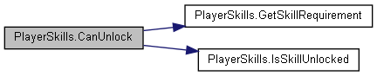

Here is the caller graph for this function:



#### void PlayerSkills.GetCurrentUpgrades (UpgradeHolder *upgradeHolder*)

Here is the call graph for this function:

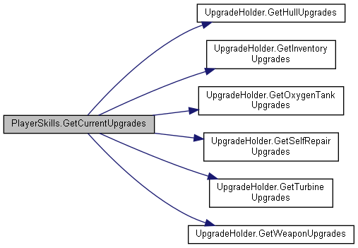

#### int PlayerSkills.GetSkillPoints ()

#### SkillType PlayerSkills.GetSkillRequirement (SkillType *skillType*)

Here is the caller graph for this function:



#### bool PlayerSkills.IsRequirementMet ()

Here is the call graph for this function:

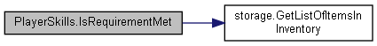

Here is the caller graph for this function:



#### bool PlayerSkills.IsSkillUnlocked (SkillType *skillType*)

Here is the caller graph for this function:



#### void PlayerSkills.RemoveAllUsedResources ()

Here is the call graph for this function:

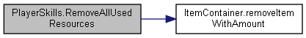

Here is the caller graph for this function:

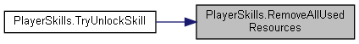

#### void PlayerSkills.SetRequirements (storage *inv*, PlayerUpgrades *upg*)

Here is the call graph for this function:

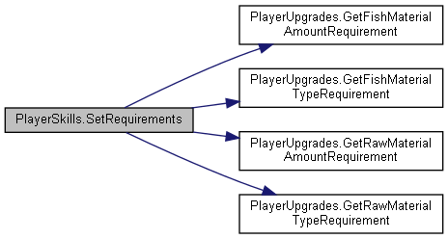

#### bool PlayerSkills.TryUnlockSkill (SkillType *skillType*)

Here is the call graph for this function:

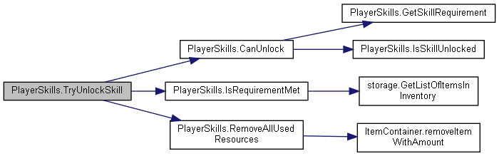

### Member Data Documentation

#### Action PlayerSkills.OnSetRequirementForPopup[static]

### Event Documentation

#### EventHandler<OnSkillUnlockedEventArgs> PlayerSkills.OnSkillUnlocked

#### The documentation for this class was generated from the following file:

C:/_SSDSPEEDUP/2021/clone/gps1_manadesigner/GPS1-Manadesigner/Assets/Scripts/Arif's Test Scripts/Skill Tree/**PlayerSkills.cs**

## PlayerUpgrades Class Reference

Inheritance diagram for PlayerUpgrades:

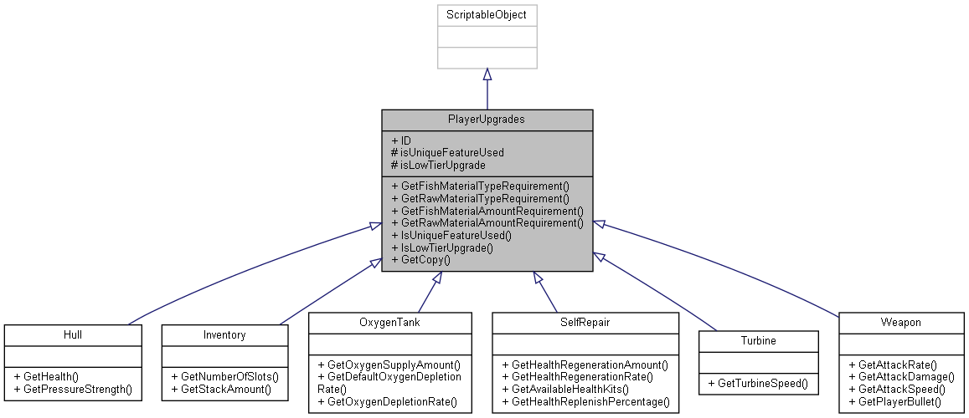

Collaboration diagram for PlayerUpgrades:

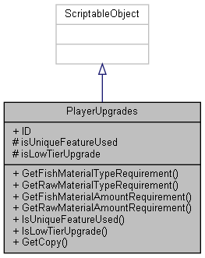

### Public Member Functions

**item**[] **GetFishMaterialTypeRequirement** ()

**item**[] **GetRawMaterialTypeRequirement** ()

int[] **GetFishMaterialAmountRequirement** ()

int[] **GetRawMaterialAmountRequirement** ()

bool **IsUniqueFeatureUsed** ()

bool **IsLowTierUpgrade** ()

virtual **PlayerUpgrades** **GetCopy** ()

### Public Attributes

string **ID**

### Protected Attributes

bool **isUniqueFeatureUsed**

bool **isLowTierUpgrade**

### Member Function Documentation

#### virtual PlayerUpgrades PlayerUpgrades.GetCopy ()[virtual]

Here is the caller graph for this function:



#### int[] PlayerUpgrades.GetFishMaterialAmountRequirement ()

Here is the caller graph for this function:

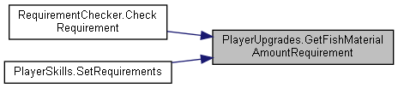

#### item[] PlayerUpgrades.GetFishMaterialTypeRequirement ()

Here is the caller graph for this function:

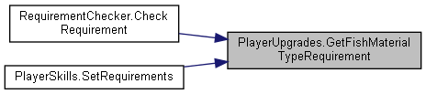

#### int[] PlayerUpgrades.GetRawMaterialAmountRequirement ()

Here is the caller graph for this function:

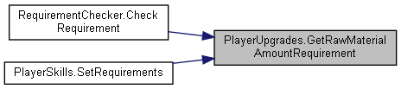

#### item[] PlayerUpgrades.GetRawMaterialTypeRequirement ()

Here is the caller graph for this function:

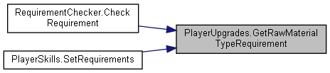

#### bool PlayerUpgrades.IsLowTierUpgrade ()

Here is the caller graph for this function:



#### bool PlayerUpgrades.IsUniqueFeatureUsed ()

Here is the caller graph for this function:



### Member Data Documentation

#### string PlayerUpgrades.ID

#### bool PlayerUpgrades.isLowTierUpgrade[protected]

#### bool PlayerUpgrades.isUniqueFeatureUsed[protected]

#### The documentation for this class was generated from the following file:

C:/_SSDSPEEDUP/2021/clone/gps1_manadesigner/GPS1-Manadesigner/Assets/Scripts/Arif's Test Scripts/Upgrades/**PlayerUpgrades.cs**

## PlayTestSpeedUp Class Reference

Inheritance diagram for PlayTestSpeedUp:

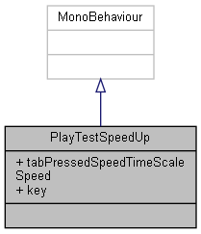

Collaboration diagram for PlayTestSpeedUp:



### Public Attributes

float **tabPressedSpeedTimeScaleSpeed** = 4.0f

KeyCode **key** = KeyCode.Tab

### Member Data Documentation

#### KeyCode PlayTestSpeedUp.key = KeyCode.Tab

#### float PlayTestSpeedUp.tabPressedSpeedTimeScaleSpeed = 4.0f

#### The documentation for this class was generated from the following file:

C:/_SSDSPEEDUP/2021/clone/gps1_manadesigner/GPS1-Manadesigner/Assets/_UtilsV0.4/MyScripts/_Utils/_CommonV0.2/Helper/**PlayTestSpeedUp.cs**

## PolyColToMesh Class Reference

Inheritance diagram for PolyColToMesh:

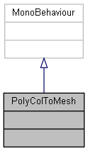

Collaboration diagram for PolyColToMesh:



The documentation for this class was generated from the following file:

C:/_SSDSPEEDUP/2021/clone/gps1_manadesigner/GPS1-Manadesigner/Assets/**PolyColToMesh.cs**

## UnityEngine.PostProcessing.PostProcessingBehaviour Class Reference

Inheritance diagram for UnityEngine.PostProcessing.PostProcessingBehaviour:

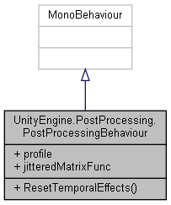

Collaboration diagram for UnityEngine.PostProcessing.PostProcessingBehaviour:

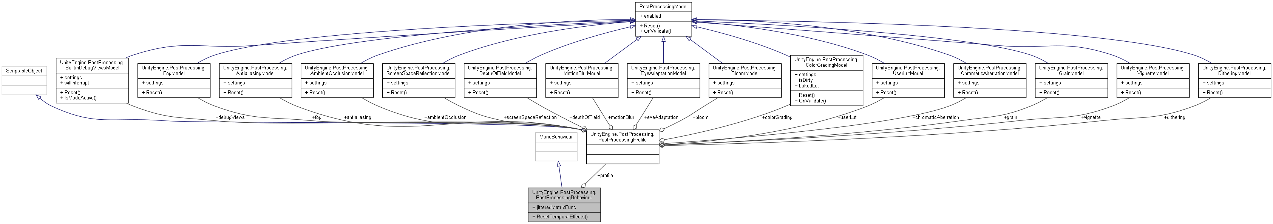

### Public Member Functions

void **ResetTemporalEffects** ()

### Public Attributes

**PostProcessingProfile** **profile**

Func< Vector2, Matrix4x4 > **jitteredMatrixFunc**

### Member Function Documentation

#### void UnityEngine.PostProcessing.PostProcessingBehaviour.ResetTemporalEffects ()

Here is the call graph for this function:

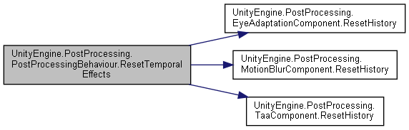

### Member Data Documentation

#### Func<Vector2, Matrix4x4> UnityEngine.PostProcessing.PostProcessingBehaviour.jitteredMatrixFunc

#### PostProcessingProfile UnityEngine.PostProcessing.PostProcessingBehaviour.profile

#### The documentation for this class was generated from the following file:

C:/_SSDSPEEDUP/2021/clone/gps1_manadesigner/GPS1-Manadesigner/Assets/Samples/Input System/1.0.2/Tanks Demo/TanksDemo/PostProcessing/Runtime/**PostProcessingBehaviour.cs**

## UnityEngine.PostProcessing.PostProcessingComponent< T > Class Template Reference

Inheritance diagram for UnityEngine.PostProcessing.PostProcessingComponent< T >:

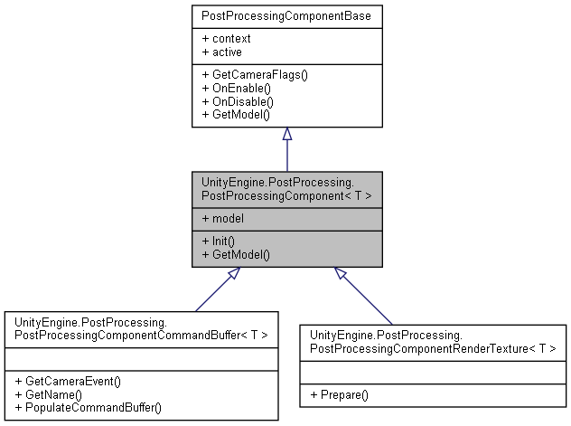

Collaboration diagram for UnityEngine.PostProcessing.PostProcessingComponent< T >:

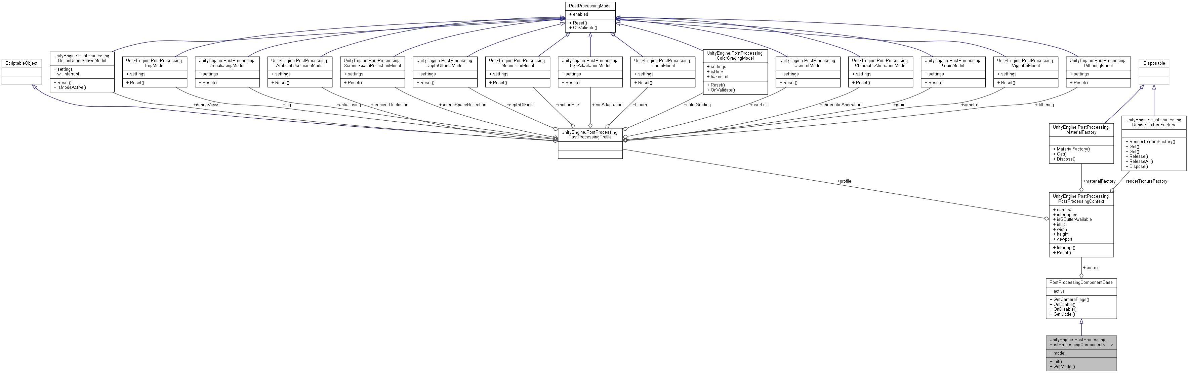

### Public Member Functions

virtual void **Init** (**PostProcessingContext** pcontext, T pmodel)

override **PostProcessingModel** **GetModel** ()

### Properties

T **model** [getset]

### Additional Inherited Members

### Member Function Documentation

#### override PostProcessingModel UnityEngine.PostProcessing.PostProcessingComponent< T >.GetModel ()[virtual]

Implements **UnityEngine.PostProcessing.PostProcessingComponentBase** (*p.590*).

#### virtual void UnityEngine.PostProcessing.PostProcessingComponent< T >.Init (PostProcessingContext *pcontext*, T *pmodel*)[virtual]

### Property Documentation

#### T UnityEngine.PostProcessing.PostProcessingComponent< T >.model[get], [set]

#### The documentation for this class was generated from the following file:

C:/_SSDSPEEDUP/2021/clone/gps1_manadesigner/GPS1-Manadesigner/Assets/Samples/Input System/1.0.2/Tanks Demo/TanksDemo/PostProcessing/Runtime/**PostProcessingComponent.cs**

## UnityEngine.PostProcessing.PostProcessingComponentBase Class Reference

Inheritance diagram for UnityEngine.PostProcessing.PostProcessingComponentBase:

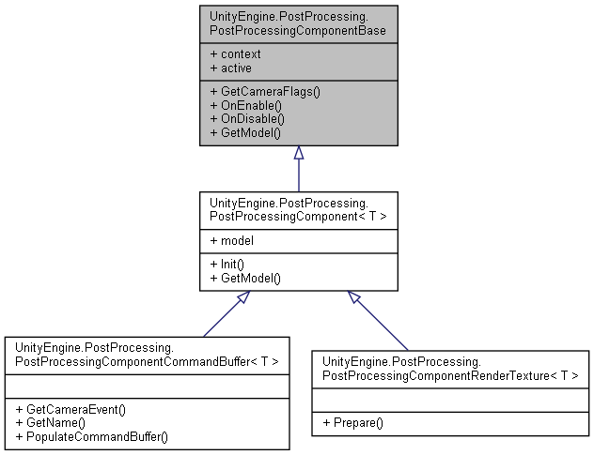

Collaboration diagram for UnityEngine.PostProcessing.PostProcessingComponentBase:

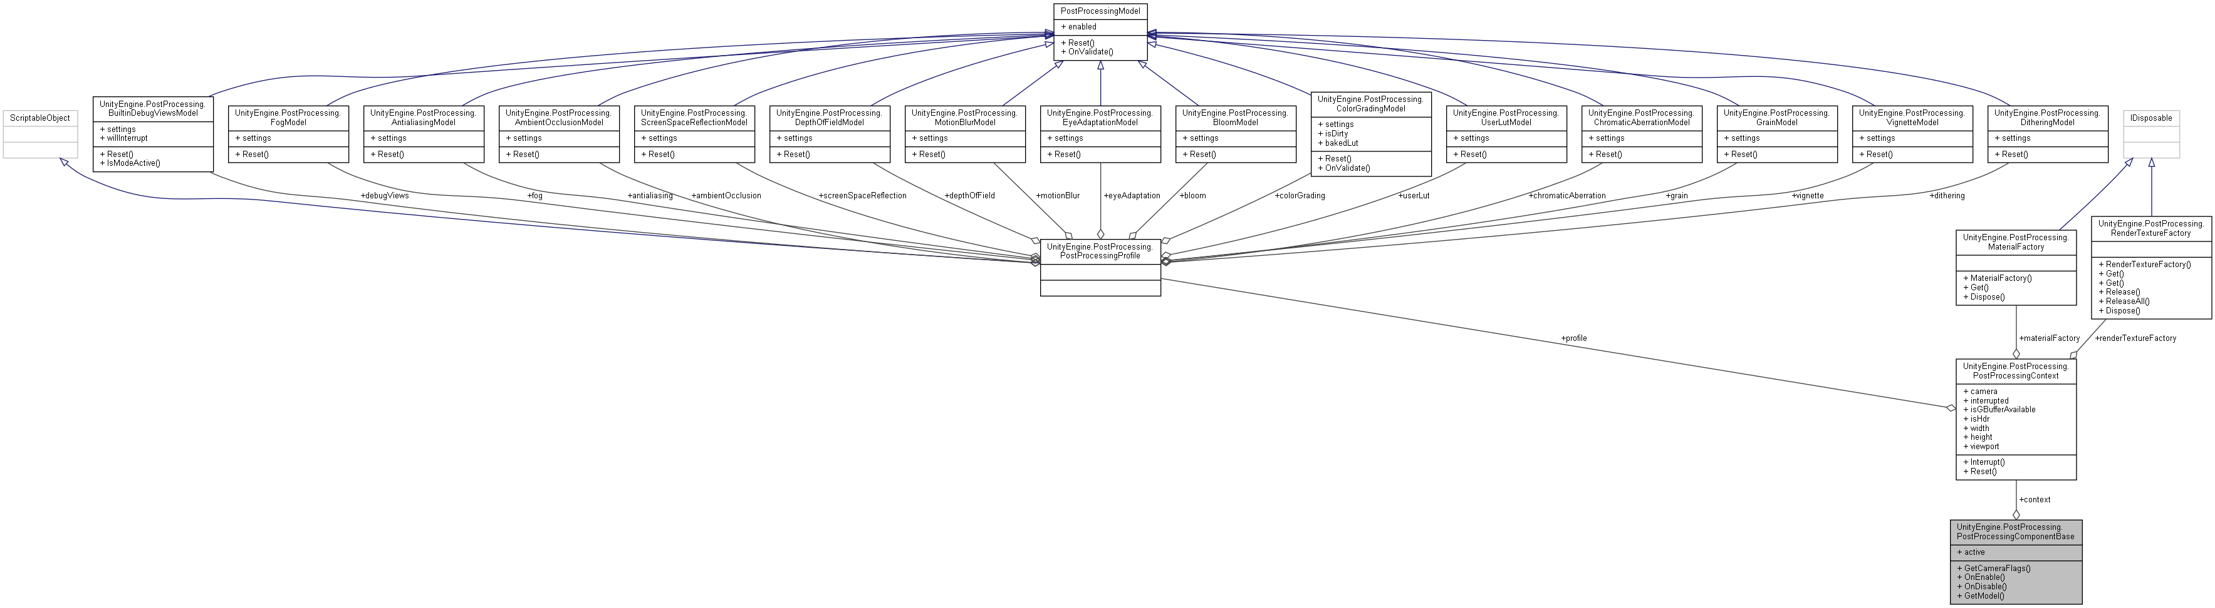

### Public Member Functions

virtual DepthTextureMode **GetCameraFlags** ()

virtual void **OnEnable** ()

virtual void **OnDisable** ()

abstract **PostProcessingModel** **GetModel** ()

### Public Attributes

**PostProcessingContext** **context**

### Properties

abstract bool **active** [get]

### Member Function Documentation

#### virtual DepthTextureMode UnityEngine.PostProcessing.PostProcessingComponentBase.GetCameraFlags ()[virtual]

#### abstract PostProcessingModel UnityEngine.PostProcessing.PostProcessingComponentBase.GetModel ()[pure virtual]

Implemented in **UnityEngine.PostProcessing.PostProcessingComponent< T >** (*p.588*).

#### virtual void UnityEngine.PostProcessing.PostProcessingComponentBase.OnDisable ()[virtual]

#### virtual void UnityEngine.PostProcessing.PostProcessingComponentBase.OnEnable ()[virtual]

### Member Data Documentation

#### PostProcessingContext UnityEngine.PostProcessing.PostProcessingComponentBase.context

### Property Documentation

#### abstract bool UnityEngine.PostProcessing.PostProcessingComponentBase.active[get]

#### The documentation for this class was generated from the following file:

C:/_SSDSPEEDUP/2021/clone/gps1_manadesigner/GPS1-Manadesigner/Assets/Samples/Input System/1.0.2/Tanks Demo/TanksDemo/PostProcessing/Runtime/**PostProcessingComponent.cs**

## UnityEngine.PostProcessing.PostProcessingComponentCommandBuffer< T > Class Template Reference

Inheritance diagram for UnityEngine.PostProcessing.PostProcessingComponentCommandBuffer< T >:

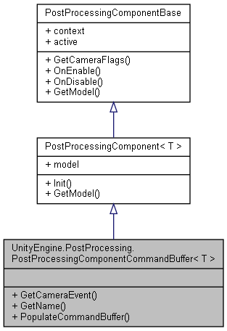

Collaboration diagram for UnityEngine.PostProcessing.PostProcessingComponentCommandBuffer< T >:

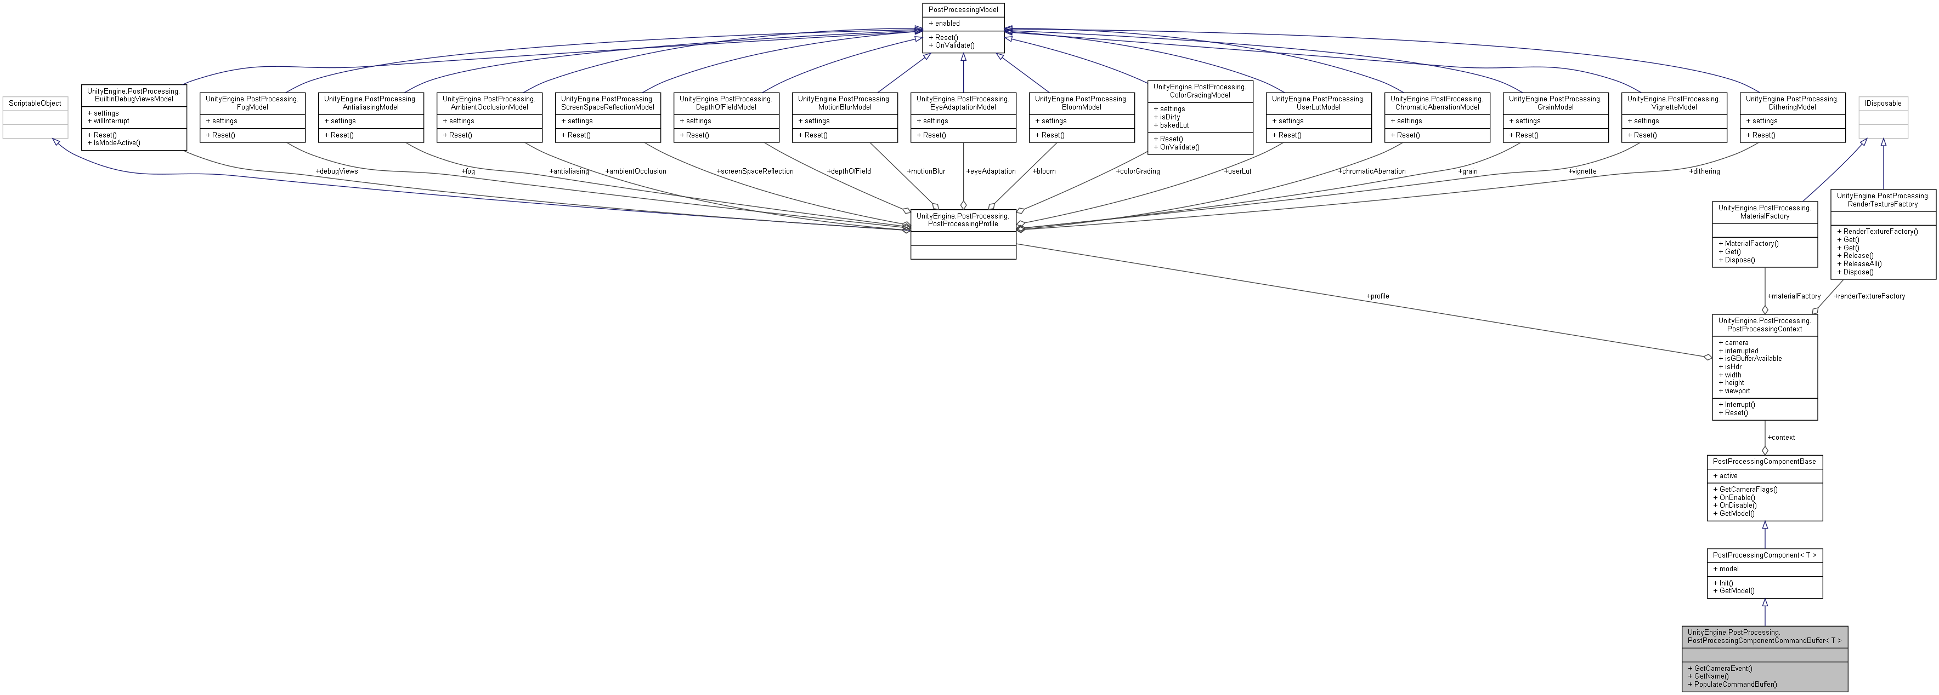

### Public Member Functions

abstract CameraEvent **GetCameraEvent** ()

abstract string **GetName** ()

abstract void **PopulateCommandBuffer** (CommandBuffer cb)

### Additional Inherited Members

### Member Function Documentation

#### abstract CameraEvent UnityEngine.PostProcessing.PostProcessingComponentCommandBuffer< T >.GetCameraEvent ()[pure virtual]

Implemented in **UnityEngine.PostProcessing.AmbientOcclusionComponent** (*p.64*), **UnityEngine.PostProcessing.BuiltinDebugViewsComponent** (*p.101*), **UnityEngine.PostProcessing.FogComponent** (*p.272*), **UnityEngine.PostProcessing.MotionBlurComponent** (*p.494*), and **UnityEngine.PostProcessing.ScreenSpaceReflectionComponent** (*p.667*).

#### abstract string UnityEngine.PostProcessing.PostProcessingComponentCommandBuffer< T >.GetName ()[pure virtual]

Implemented in **UnityEngine.PostProcessing.AmbientOcclusionComponent** (*p.64*), **UnityEngine.PostProcessing.BuiltinDebugViewsComponent** (*p.101*), **UnityEngine.PostProcessing.FogComponent** (*p.272*), **UnityEngine.PostProcessing.MotionBlurComponent** (*p.494*), and **UnityEngine.PostProcessing.ScreenSpaceReflectionComponent** (*p.667*).

#### abstract void UnityEngine.PostProcessing.PostProcessingComponentCommandBuffer< T >.PopulateCommandBuffer (CommandBuffer *cb*)[pure virtual]

Implemented in **UnityEngine.PostProcessing.AmbientOcclusionComponent** (*p.64*), **UnityEngine.PostProcessing.BuiltinDebugViewsComponent** (*p.101*), **UnityEngine.PostProcessing.FogComponent** (*p.272*), **UnityEngine.PostProcessing.MotionBlurComponent** (*p.494*), and **UnityEngine.PostProcessing.ScreenSpaceReflectionComponent** (*p.667*).

#### The documentation for this class was generated from the following file:

C:/_SSDSPEEDUP/2021/clone/gps1_manadesigner/GPS1-Manadesigner/Assets/Samples/Input System/1.0.2/Tanks Demo/TanksDemo/PostProcessing/Runtime/**PostProcessingComponent.cs**

## UnityEngine.PostProcessing.PostProcessingComponentRenderTexture< T > Class Template Reference

Inheritance diagram for UnityEngine.PostProcessing.PostProcessingComponentRenderTexture< T >:

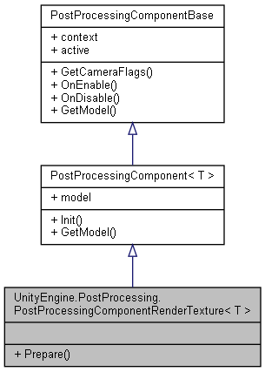

Collaboration diagram for UnityEngine.PostProcessing.PostProcessingComponentRenderTexture< T >:

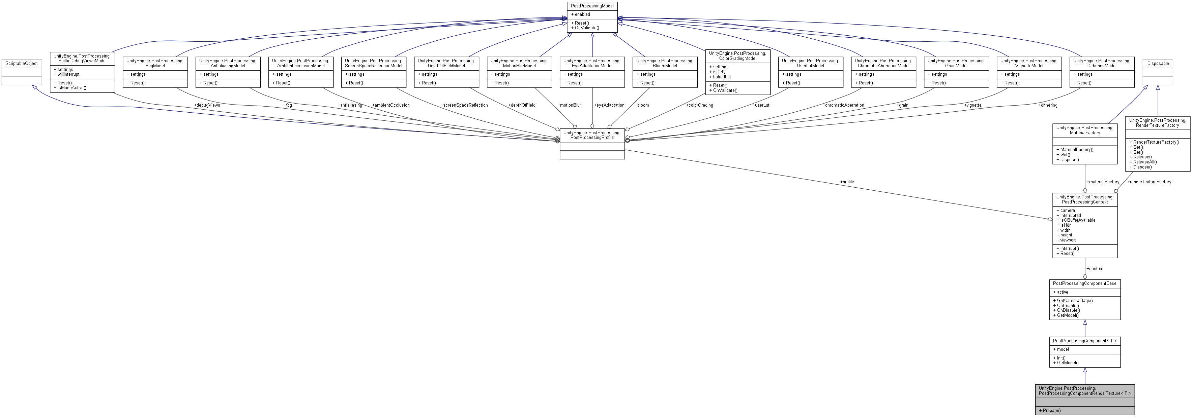

### Public Member Functions

virtual void **Prepare** (Material material)

### Additional Inherited Members

### Member Function Documentation

#### virtual void UnityEngine.PostProcessing.PostProcessingComponentRenderTexture< T >.Prepare (Material *material*)[virtual]

Reimplemented in **UnityEngine.PostProcessing.ChromaticAberrationComponent** (*p.137*), **UnityEngine.PostProcessing.ColorGradingComponent** (*p.148*), **UnityEngine.PostProcessing.DitheringComponent** (*p.227*), **UnityEngine.PostProcessing.GrainComponent** (*p.333*), **UnityEngine.PostProcessing.UserLutComponent** (*p.820*), and **UnityEngine.PostProcessing.VignetteComponent** (*p.835*).

#### The documentation for this class was generated from the following file:

C:/_SSDSPEEDUP/2021/clone/gps1_manadesigner/GPS1-Manadesigner/Assets/Samples/Input System/1.0.2/Tanks Demo/TanksDemo/PostProcessing/Runtime/**PostProcessingComponent.cs**

## UnityEngine.PostProcessing.PostProcessingContext Class Reference

Collaboration diagram for UnityEngine.PostProcessing.PostProcessingContext:

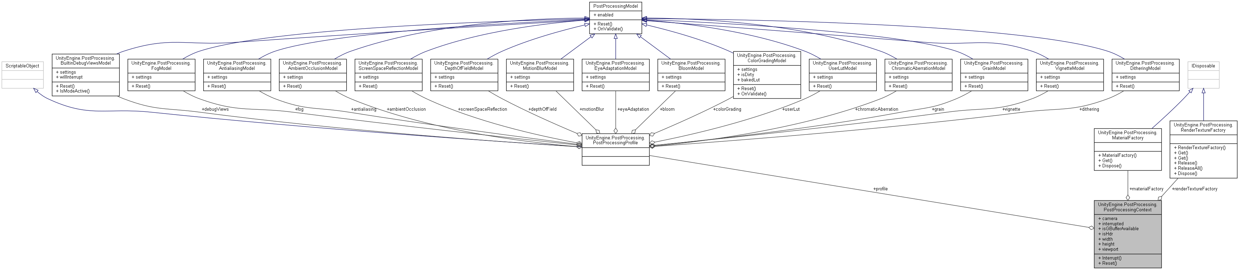

### Public Member Functions

void **Interrupt** ()

**PostProcessingContext** **Reset** ()

### Public Attributes

**PostProcessingProfile** **profile**

Camera **camera**

**MaterialFactory** **materialFactory**

**RenderTextureFactory** **renderTextureFactory**

### Properties

bool **interrupted** [get]

bool **isGBufferAvailable** [get]

bool **isHdr** [get]

int **width** [get]

int **height** [get]

Rect **viewport** [get]

### Member Function Documentation

#### void UnityEngine.PostProcessing.PostProcessingContext.Interrupt ()

#### PostProcessingContext UnityEngine.PostProcessing.PostProcessingContext.Reset ()

### Member Data Documentation

#### Camera UnityEngine.PostProcessing.PostProcessingContext.camera

#### MaterialFactory UnityEngine.PostProcessing.PostProcessingContext.materialFactory

#### PostProcessingProfile UnityEngine.PostProcessing.PostProcessingContext.profile

#### RenderTextureFactory UnityEngine.PostProcessing.PostProcessingContext.renderTextureFactory

### Property Documentation

#### int UnityEngine.PostProcessing.PostProcessingContext.height[get]

#### bool UnityEngine.PostProcessing.PostProcessingContext.interrupted[get]

#### bool UnityEngine.PostProcessing.PostProcessingContext.isGBufferAvailable[get]

#### bool UnityEngine.PostProcessing.PostProcessingContext.isHdr[get]

#### Rect UnityEngine.PostProcessing.PostProcessingContext.viewport[get]

#### int UnityEngine.PostProcessing.PostProcessingContext.width[get]

#### The documentation for this class was generated from the following file:

C:/_SSDSPEEDUP/2021/clone/gps1_manadesigner/GPS1-Manadesigner/Assets/Samples/Input System/1.0.2/Tanks Demo/TanksDemo/PostProcessing/Runtime/**PostProcessingContext.cs**

## UnityEngine.PostProcessing.PostProcessingModel Class Reference

Inheritance diagram for UnityEngine.PostProcessing.PostProcessingModel:



Collaboration diagram for UnityEngine.PostProcessing.PostProcessingModel:

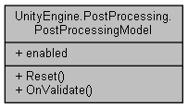

### Public Member Functions

abstract void **Reset** ()

virtual void **OnValidate** ()

### Properties

bool **enabled** [getset]

### Member Function Documentation

#### virtual void UnityEngine.PostProcessing.PostProcessingModel.OnValidate ()[virtual]

Reimplemented in **UnityEngine.PostProcessing.ColorGradingModel** (*p.151*).

#### abstract void UnityEngine.PostProcessing.PostProcessingModel.Reset ()[pure virtual]

Implemented in **UnityEngine.PostProcessing.AmbientOcclusionModel** (*p.66*), **UnityEngine.PostProcessing.AntialiasingModel** (*p.70*), **UnityEngine.PostProcessing.BloomModel** (*p.92*), **UnityEngine.PostProcessing.BuiltinDebugViewsModel** (*p.103*), **UnityEngine.PostProcessing.ChromaticAberrationModel** (*p.138*), **UnityEngine.PostProcessing.ColorGradingModel** (*p.151*), **UnityEngine.PostProcessing.DepthOfFieldModel** (*p.220*), **UnityEngine.PostProcessing.DitheringModel** (*p.228*), **UnityEngine.PostProcessing.EyeAdaptationModel** (*p.262*), **UnityEngine.PostProcessing.FogModel** (*p.273*), **UnityEngine.PostProcessing.GrainModel** (*p.334*), **UnityEngine.PostProcessing.MotionBlurModel** (*p.496*), **UnityEngine.PostProcessing.ScreenSpaceReflectionModel** (*p.669*), **UnityEngine.PostProcessing.UserLutModel** (*p.821*), and **UnityEngine.PostProcessing.VignetteModel** (*p.838*).

### Property Documentation

#### bool UnityEngine.PostProcessing.PostProcessingModel.enabled[get], [set]

#### The documentation for this class was generated from the following file:

C:/_SSDSPEEDUP/2021/clone/gps1_manadesigner/GPS1-Manadesigner/Assets/Samples/Input System/1.0.2/Tanks Demo/TanksDemo/PostProcessing/Runtime/**PostProcessingModel.cs**

## UnityEditor.PostProcessing.PostProcessingModelEditorAttribute Class Reference

Inheritance diagram for UnityEditor.PostProcessing.PostProcessingModelEditorAttribute:

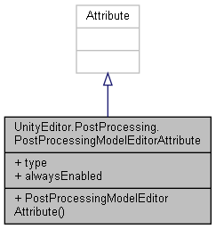

Collaboration diagram for UnityEditor.PostProcessing.PostProcessingModelEditorAttribute:



### Public Member Functions

**PostProcessingModelEditorAttribute** (Type **type**, bool **alwaysEnabled**=false)

### Public Attributes

readonly Type **type**

readonly bool **alwaysEnabled**

### Constructor & Destructor Documentation

#### UnityEditor.PostProcessing.PostProcessingModelEditorAttribute.PostProcessingModelEditorAttribute (Type *type*, bool *alwaysEnabled* = false)

### Member Data Documentation

#### readonly bool UnityEditor.PostProcessing.PostProcessingModelEditorAttribute.alwaysEnabled

#### readonly Type UnityEditor.PostProcessing.PostProcessingModelEditorAttribute.type

#### The documentation for this class was generated from the following file:

C:/_SSDSPEEDUP/2021/clone/gps1_manadesigner/GPS1-Manadesigner/Assets/Samples/Input System/1.0.2/Tanks Demo/TanksDemo/PostProcessing/Editor/Attributes/**PostProcessingModelEditorAttribute.cs**

## UnityEngine.PostProcessing.PostProcessingProfile Class Reference

Inheritance diagram for UnityEngine.PostProcessing.PostProcessingProfile:

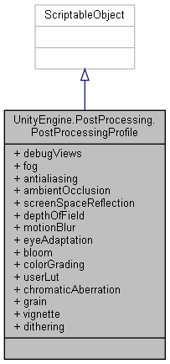

Collaboration diagram for UnityEngine.PostProcessing.PostProcessingProfile:

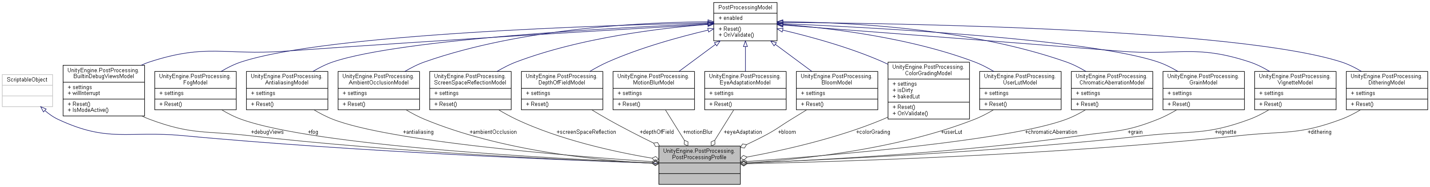

### Public Attributes

**BuiltinDebugViewsModel** **debugViews** = new **BuiltinDebugViewsModel**()

**FogModel** **fog** = new **FogModel**()

**AntialiasingModel** **antialiasing** = new **AntialiasingModel**()

**AmbientOcclusionModel** **ambientOcclusion** = new **AmbientOcclusionModel**()

**ScreenSpaceReflectionModel** **screenSpaceReflection** = new **ScreenSpaceReflectionModel**()

**DepthOfFieldModel** **depthOfField** = new **DepthOfFieldModel**()

**MotionBlurModel** **motionBlur** = new **MotionBlurModel**()

**EyeAdaptationModel** **eyeAdaptation** = new **EyeAdaptationModel**()

**BloomModel** **bloom** = new **BloomModel**()

**ColorGradingModel** **colorGrading** = new **ColorGradingModel**()

**UserLutModel** **userLut** = new **UserLutModel**()

**ChromaticAberrationModel** **chromaticAberration** = new **ChromaticAberrationModel**()

**GrainModel** **grain** = new **GrainModel**()

**VignetteModel** **vignette** = new **VignetteModel**()

**DitheringModel** **dithering** = new **DitheringModel**()

### Member Data Documentation

#### AmbientOcclusionModel UnityEngine.PostProcessing.PostProcessingProfile.ambientOcclusion = new AmbientOcclusionModel()

#### AntialiasingModel UnityEngine.PostProcessing.PostProcessingProfile.antialiasing = new AntialiasingModel()

#### BloomModel UnityEngine.PostProcessing.PostProcessingProfile.bloom = new BloomModel()

#### ChromaticAberrationModel UnityEngine.PostProcessing.PostProcessingProfile.chromaticAberration = new ChromaticAberrationModel()

#### ColorGradingModel UnityEngine.PostProcessing.PostProcessingProfile.colorGrading = new ColorGradingModel()

#### BuiltinDebugViewsModel UnityEngine.PostProcessing.PostProcessingProfile.debugViews = new BuiltinDebugViewsModel()

#### DepthOfFieldModel UnityEngine.PostProcessing.PostProcessingProfile.depthOfField = new DepthOfFieldModel()

#### DitheringModel UnityEngine.PostProcessing.PostProcessingProfile.dithering = new DitheringModel()

#### EyeAdaptationModel UnityEngine.PostProcessing.PostProcessingProfile.eyeAdaptation = new EyeAdaptationModel()

#### FogModel UnityEngine.PostProcessing.PostProcessingProfile.fog = new FogModel()

#### GrainModel UnityEngine.PostProcessing.PostProcessingProfile.grain = new GrainModel()

#### MotionBlurModel UnityEngine.PostProcessing.PostProcessingProfile.motionBlur = new MotionBlurModel()

#### ScreenSpaceReflectionModel UnityEngine.PostProcessing.PostProcessingProfile.screenSpaceReflection = new ScreenSpaceReflectionModel()

#### UserLutModel UnityEngine.PostProcessing.PostProcessingProfile.userLut = new UserLutModel()

#### VignetteModel UnityEngine.PostProcessing.PostProcessingProfile.vignette = new VignetteModel()

#### The documentation for this class was generated from the following file:

C:/_SSDSPEEDUP/2021/clone/gps1_manadesigner/GPS1-Manadesigner/Assets/Samples/Input System/1.0.2/Tanks Demo/TanksDemo/PostProcessing/Runtime/**PostProcessingProfile.cs**

## PressureStageChecker Class Reference

Inheritance diagram for PressureStageChecker:

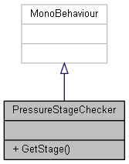

Collaboration diagram for PressureStageChecker:



### Public Member Functions

int **GetStage** ()

### Member Function Documentation

#### int PressureStageChecker.GetStage ()

#### The documentation for this class was generated from the following file:

C:/_SSDSPEEDUP/2021/clone/gps1_manadesigner/GPS1-Manadesigner/Assets/**PressureStageChecker.cs**

## PreviousPosition Class Reference

Inheritance diagram for PreviousPosition:

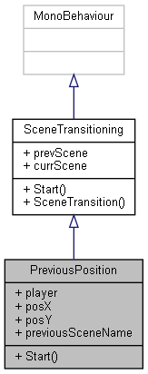

Collaboration diagram for PreviousPosition:



### Public Member Functions

override void **Start** ()

### Public Attributes

Transform **player**

float **posX**

float **posY**

string **previousSceneName**

### Additional Inherited Members

### Member Function Documentation

#### override void PreviousPosition.Start ()[virtual]

Reimplemented from **SceneTransitioning** (*p.662*).

### Member Data Documentation

#### Transform PreviousPosition.player

#### float PreviousPosition.posX

#### float PreviousPosition.posY

#### string PreviousPosition.previousSceneName

#### The documentation for this class was generated from the following file:

C:/_SSDSPEEDUP/2021/clone/gps1_manadesigner/GPS1-Manadesigner/Assets/Scripts/Stage Scripts/Scene Transitions/**PreviousPosition.cs**

## QuickOpenInventory Class Reference

Inheritance diagram for QuickOpenInventory:

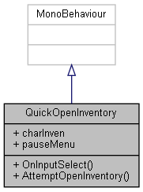

Collaboration diagram for QuickOpenInventory:

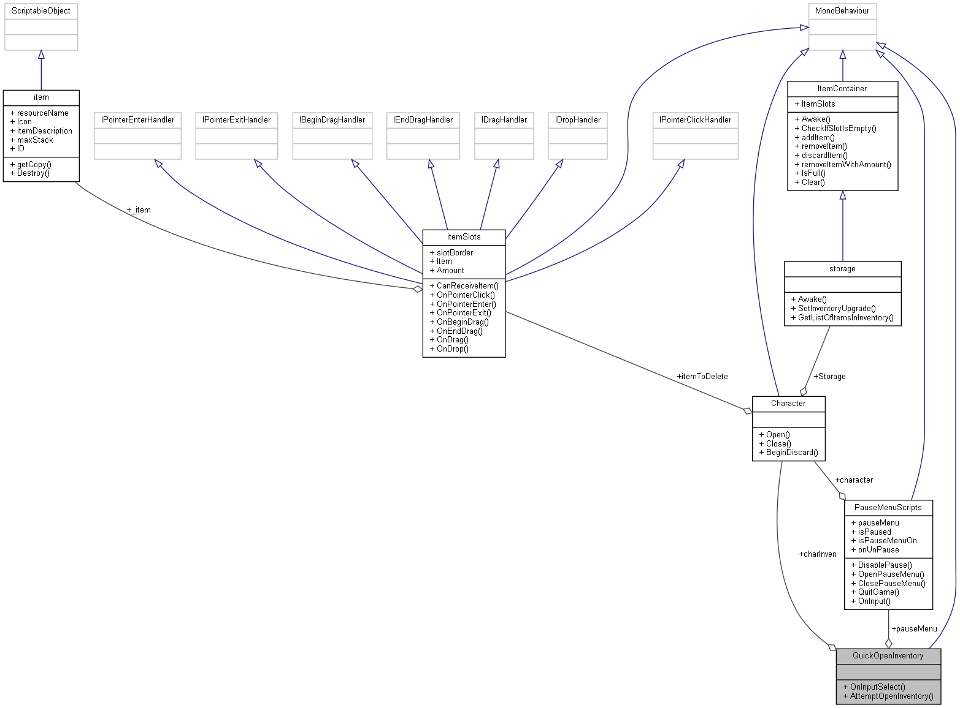

### Public Member Functions

void **OnInputSelect** (InputAction.CallbackContext context)

void **AttemptOpenInventory** ()

### Public Attributes

**Character** **charInven**

**PauseMenuScripts** **pauseMenu**

### Member Function Documentation

#### void QuickOpenInventory.AttemptOpenInventory ()

Here is the call graph for this function:

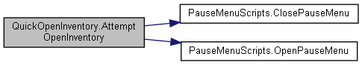

Here is the caller graph for this function:

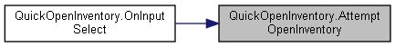

#### void QuickOpenInventory.OnInputSelect (InputAction.CallbackContext *context*)

Here is the call graph for this function:

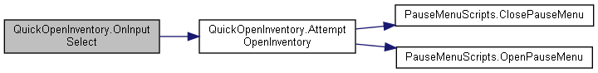

### Member Data Documentation

#### Character QuickOpenInventory.charInven

#### PauseMenuScripts QuickOpenInventory.pauseMenu

#### The documentation for this class was generated from the following file:

C:/_SSDSPEEDUP/2021/clone/gps1_manadesigner/GPS1-Manadesigner/Assets/**QuickOpenInventory.cs**

## QuickPauseFix Class Reference

Inheritance diagram for QuickPauseFix:

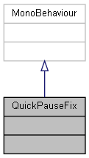

Collaboration diagram for QuickPauseFix:



The documentation for this class was generated from the following file:

C:/_SSDSPEEDUP/2021/clone/gps1_manadesigner/GPS1-Manadesigner/Assets/**QuickPauseFix.cs**

## RandomEnemy Class Reference

Inheritance diagram for RandomEnemy:

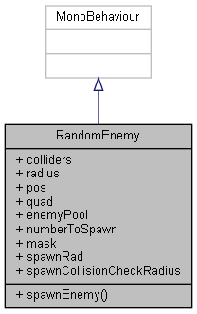

Collaboration diagram for RandomEnemy:



### Public Member Functions

void **spawnEnemy** ()

### Public Attributes

Collider2D[] **colliders**

float **radius**

Vector2 **pos** = new Vector2(0,0)

GameObject **quad**

List< GameObject > **enemyPool**

int **numberToSpawn**

LayerMask **mask**

float **spawnRad** = 5

float **spawnCollisionCheckRadius**

### Member Function Documentation

#### void RandomEnemy.spawnEnemy ()

### Member Data Documentation

#### Collider2D [] RandomEnemy.colliders

#### List<GameObject> RandomEnemy.enemyPool

#### LayerMask RandomEnemy.mask

#### int RandomEnemy.numberToSpawn

#### Vector2 RandomEnemy.pos = new Vector2(0,0)

#### GameObject RandomEnemy.quad

#### float RandomEnemy.radius

#### float RandomEnemy.spawnCollisionCheckRadius

#### float RandomEnemy.spawnRad = 5

#### The documentation for this class was generated from the following file:

C:/_SSDSPEEDUP/2021/clone/gps1_manadesigner/GPS1-Manadesigner/Assets/Scripts/Stage Scripts/Resource Spawn/**RandomEnemy.cs**

## RandomSpawner Class Reference

Inheritance diagram for RandomSpawner:

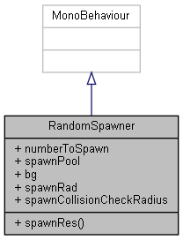

Collaboration diagram for RandomSpawner:



### Public Member Functions

void **spawnRes** ()

### Public Attributes

int **numberToSpawn**

List< GameObject > **spawnPool**

GameObject **bg**

float **spawnRad** = 5

float **spawnCollisionCheckRadius**

### Member Function Documentation

#### void RandomSpawner.spawnRes ()

### Member Data Documentation

#### GameObject RandomSpawner.bg

#### int RandomSpawner.numberToSpawn

#### float RandomSpawner.spawnCollisionCheckRadius

#### List<GameObject> RandomSpawner.spawnPool

#### float RandomSpawner.spawnRad = 5

#### The documentation for this class was generated from the following file:

C:/_SSDSPEEDUP/2021/clone/gps1_manadesigner/GPS1-Manadesigner/Assets/Scripts/Stage Scripts/Resource Spawn/**RandomSpawner.cs**

## RawMaterial Class Reference

Inheritance diagram for RawMaterial:

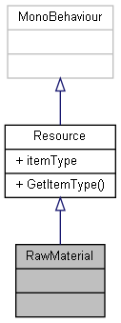

Collaboration diagram for RawMaterial:

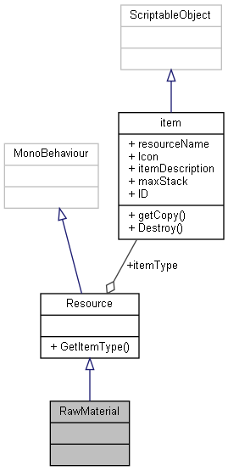

### Additional Inherited Members

The documentation for this class was generated from the following file:

C:/_SSDSPEEDUP/2021/clone/gps1_manadesigner/GPS1-Manadesigner/Assets/Scripts/Arif's Test Scripts/Resource/**RawMaterial.cs**

## UnityEngine.InputSystem.Samples.RebindUI.RebindActionUI Class Reference

A reusable component with a self-contained **UI** for rebinding a single action.

Inheritance diagram for UnityEngine.InputSystem.Samples.RebindUI.RebindActionUI:

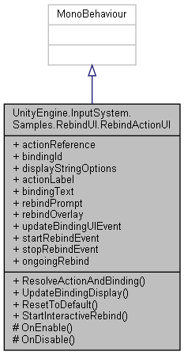

Collaboration diagram for UnityEngine.InputSystem.Samples.RebindUI.RebindActionUI:



### Classes

class **InteractiveRebindEvent**

class **UpdateBindingUIEvent**

### Public Member Functions

bool **ResolveActionAndBinding** (out InputAction action, out int bindingIndex)

*Return the action and binding index for the binding that is targeted by the component according to*

void **UpdateBindingDisplay** ()

*Trigger a refresh of the currently displayed binding.*

void **ResetToDefault** ()

*Remove currently applied binding overrides.*

void **StartInteractiveRebind** ()

*Initiate an interactive rebind that lets the player actuate a control to choose a new binding for the action.*

### Protected Member Functions

void **OnEnable** ()

void **OnDisable** ()

### Properties

InputActionReference **actionReference** [getset]

*Reference to the action that is to be rebound.*

string **bindingId** [getset]

*ID (in string form) of the binding that is to be rebound on the action.*

InputBinding.DisplayStringOptions **displayStringOptions** [getset]

Text **actionLabel** [getset]

*Text component that receives the name of the action.*

Text **bindingText** [getset]

*Text component that receives the display string of the binding.*

Text **rebindPrompt** [getset]

*Optional text component that receives a text prompt when waiting for a control to be actuated.*

GameObject **rebindOverlay** [getset]

*Optional* ***UI*** *that is activated when an interactive rebind is started and deactivated when the rebind is finished.*

**UpdateBindingUIEvent** **updateBindingUIEvent** [get]

*Event that is triggered every time the* ***UI*** *updates to reflect the current binding.*

**InteractiveRebindEvent** **startRebindEvent** [get]

*Event that is triggered when an interactive rebind is started on the action.*

**InteractiveRebindEvent** **stopRebindEvent** [get]

*Event that is triggered when an interactive rebind has been completed or canceled.*

InputActionRebindingExtensions.RebindingOperation **ongoingRebind** [get]

*When an interactive rebind is in progress, this is the rebind operation controller.*

### Detailed Description

A reusable component with a self-contained **UI** for rebinding a single action.

### Member Function Documentation

#### void UnityEngine.InputSystem.Samples.RebindUI.RebindActionUI.OnDisable ()[protected]

#### void UnityEngine.InputSystem.Samples.RebindUI.RebindActionUI.OnEnable ()[protected]

#### void UnityEngine.InputSystem.Samples.RebindUI.RebindActionUI.ResetToDefault ()

Remove currently applied binding overrides.

Here is the call graph for this function:

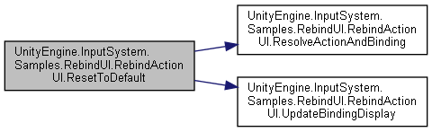

#### bool UnityEngine.InputSystem.Samples.RebindUI.RebindActionUI.ResolveActionAndBinding (out InputAction *action*, out int *bindingIndex*)

Return the action and binding index for the binding that is targeted by the component according to

##### Parameters

|  |  |
| --- | --- |
| *action* |  |
| *bindingIndex* |  |

##### Returns

Here is the caller graph for this function:

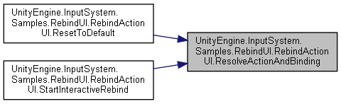

#### void UnityEngine.InputSystem.Samples.RebindUI.RebindActionUI.StartInteractiveRebind ()

Initiate an interactive rebind that lets the player actuate a control to choose a new binding for the action.

Here is the call graph for this function:

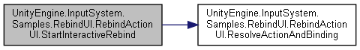

#### void UnityEngine.InputSystem.Samples.RebindUI.RebindActionUI.UpdateBindingDisplay ()

Trigger a refresh of the currently displayed binding.

Here is the caller graph for this function:

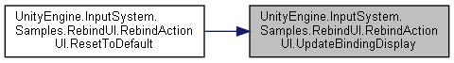

### Property Documentation

#### Text UnityEngine.InputSystem.Samples.RebindUI.RebindActionUI.actionLabel[get], [set]

Text component that receives the name of the action.

Optional.

#### InputActionReference UnityEngine.InputSystem.Samples.RebindUI.RebindActionUI.actionReference[get], [set]

Reference to the action that is to be rebound.

#### string UnityEngine.InputSystem.Samples.RebindUI.RebindActionUI.bindingId[get], [set]

ID (in string form) of the binding that is to be rebound on the action.

##### See also

InputBinding.id

#### Text UnityEngine.InputSystem.Samples.RebindUI.RebindActionUI.bindingText[get], [set]

Text component that receives the display string of the binding.

Can be null in which case the component entirely relies on **updateBindingUIEvent**.

#### InputBinding.DisplayStringOptions UnityEngine.InputSystem.Samples.RebindUI.RebindActionUI.displayStringOptions[get], [set]

#### InputActionRebindingExtensions.RebindingOperation UnityEngine.InputSystem.Samples.RebindUI.RebindActionUI.ongoingRebind[get]

When an interactive rebind is in progress, this is the rebind operation controller.

Otherwise, it is null .

#### GameObject UnityEngine.InputSystem.Samples.RebindUI.RebindActionUI.rebindOverlay[get], [set]

Optional **UI** that is activated when an interactive rebind is started and deactivated when the rebind is finished.

This is normally used to display an overlay over the current **UI** while the system is waiting for a control to be actuated.

If neither **rebindPrompt** nor rebindOverlay is set, the component will temporarily replaced the **bindingText** (if not null ) with "Waiting..." .

##### See also

**startRebindEvent**, **rebindPrompt**

#### Text UnityEngine.InputSystem.Samples.RebindUI.RebindActionUI.rebindPrompt[get], [set]

Optional text component that receives a text prompt when waiting for a control to be actuated.

##### See also

**startRebindEvent**, **rebindOverlay**

#### InteractiveRebindEvent UnityEngine.InputSystem.Samples.RebindUI.RebindActionUI.startRebindEvent[get]

Event that is triggered when an interactive rebind is started on the action.

#### InteractiveRebindEvent UnityEngine.InputSystem.Samples.RebindUI.RebindActionUI.stopRebindEvent[get]

Event that is triggered when an interactive rebind has been completed or canceled.

#### UpdateBindingUIEvent UnityEngine.InputSystem.Samples.RebindUI.RebindActionUI.updateBindingUIEvent[get]

Event that is triggered every time the **UI** updates to reflect the current binding.

This can be used to tie custom visualizations to bindings.

#### The documentation for this class was generated from the following file:

C:/_SSDSPEEDUP/2021/clone/gps1_manadesigner/GPS1-Manadesigner/Assets/_UtilsV0.4/MyScripts/_Utils/UnityRegistryIntegration/InputSystem/Rebinding UI/_Modified/**RebindActionUI.cs**

## UnityEngine.InputSystem.Samples.RebindUI.RebindIconsHelper Class Reference

This is an example for how to override the default display behavior of bindings.

Inheritance diagram for UnityEngine.InputSystem.Samples.RebindUI.RebindIconsHelper:

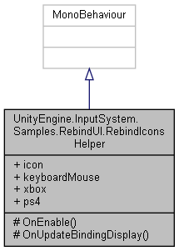

Collaboration diagram for UnityEngine.InputSystem.Samples.RebindUI.RebindIconsHelper:

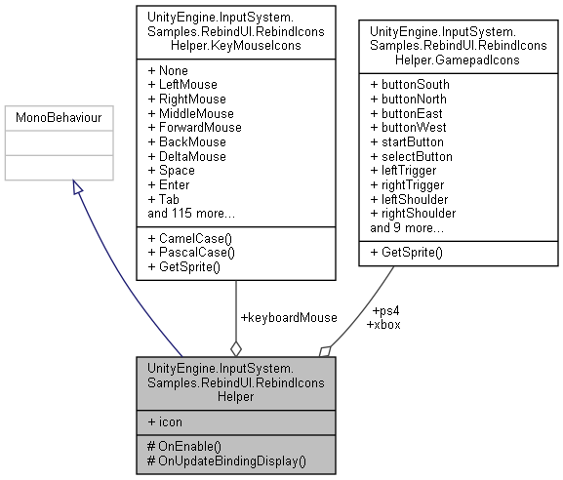

### Classes

struct **GamepadIcons**

struct **KeyMouseIcons**

### Public Attributes

Sprite **icon**

**KeyMouseIcons** **keyboardMouse**

**GamepadIcons** **xbox**

**GamepadIcons** **ps4**

### Protected Member Functions

void **OnEnable** ()

void **OnUpdateBindingDisplay** (**RebindActionUI** component, string bindingDisplayString, string deviceLayoutName, string controlPath)

### Detailed Description

This is an example for how to override the default display behavior of bindings.

The component hooks into **RebindActionUI.updateBindingUIEvent** which is triggered when **UI** display of a binding should be refreshed. It then checks whether we have an icon for the current binding and if so, replaces the default text display with an icon.

### Member Function Documentation

#### void UnityEngine.InputSystem.Samples.RebindUI.RebindIconsHelper.OnEnable ()[protected]

Here is the call graph for this function:

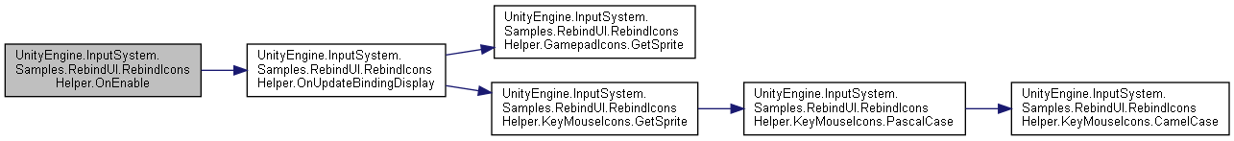

#### void UnityEngine.InputSystem.Samples.RebindUI.RebindIconsHelper.OnUpdateBindingDisplay (RebindActionUI *component*, string *bindingDisplayString*, string *deviceLayoutName*, string *controlPath*)[protected]

Here is the call graph for this function:

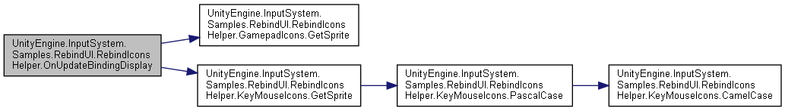

Here is the caller graph for this function:

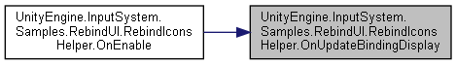

### Member Data Documentation

#### Sprite UnityEngine.InputSystem.Samples.RebindUI.RebindIconsHelper.icon

#### KeyMouseIcons UnityEngine.InputSystem.Samples.RebindUI.RebindIconsHelper.keyboardMouse

#### GamepadIcons UnityEngine.InputSystem.Samples.RebindUI.RebindIconsHelper.ps4

#### GamepadIcons UnityEngine.InputSystem.Samples.RebindUI.RebindIconsHelper.xbox

#### The documentation for this class was generated from the following file:

C:/_SSDSPEEDUP/2021/clone/gps1_manadesigner/GPS1-Manadesigner/Assets/_UtilsV0.4/MyScripts/_Utils/UnityRegistryIntegration/InputSystem/Rebinding UI/_Modified/**RebindIconsHelper.cs**

## RebindResetAllBindings Class Reference

Inheritance diagram for RebindResetAllBindings:

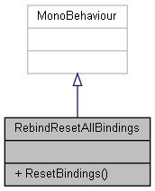

Collaboration diagram for RebindResetAllBindings:



### Public Member Functions

void **ResetBindings** ()

### Member Function Documentation

#### void RebindResetAllBindings.ResetBindings ()

#### The documentation for this class was generated from the following file:

C:/_SSDSPEEDUP/2021/clone/gps1_manadesigner/GPS1-Manadesigner/Assets/_UtilsV0.4/MyScripts/_Utils/UnityRegistryIntegration/InputSystem/Rebinding UI/_Modified/**RebindResetAllBindings.cs**

## RebindSaveLoad Class Reference

Inheritance diagram for RebindSaveLoad:

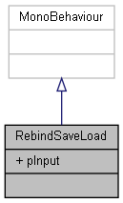

Collaboration diagram for RebindSaveLoad:



### Public Attributes

PlayerInput **pInput**

### Member Data Documentation

#### PlayerInput RebindSaveLoad.pInput

#### The documentation for this class was generated from the following file:

C:/_SSDSPEEDUP/2021/clone/gps1_manadesigner/GPS1-Manadesigner/Assets/_UtilsV0.4/MyScripts/_Utils/UnityRegistryIntegration/InputSystem/Rebinding UI/_Modified/**RebindSaveLoad.cs**

## RebindUISampleActionsModified Class Reference

Inheritance diagram for RebindUISampleActionsModified:

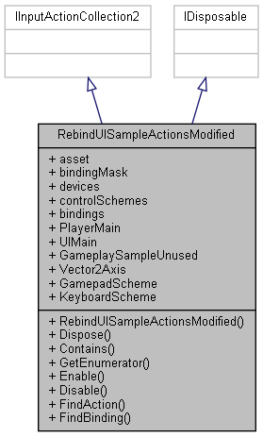

Collaboration diagram for RebindUISampleActionsModified:



### Classes

struct **GameplaySampleUnusedActions**

interface **IGameplaySampleUnusedActions**

interface **IPlayerMainActions**

interface **IUIMainActions**

interface **IVector2AxisActions**

struct **PlayerMainActions**

struct **UIMainActions**

struct **Vector2AxisActions**

### Public Member Functions

**RebindUISampleActionsModified** ()

void **Dispose** ()

bool **Contains** (InputAction action)

IEnumerator< InputAction > **GetEnumerator** ()

void **Enable** ()

void **Disable** ()

InputAction **FindAction** (string actionNameOrId, bool throwIfNotFound=false)

int **FindBinding** (InputBinding **bindingMask**, out InputAction action)

### Properties

InputActionAsset **asset** [get]

InputBinding? **bindingMask** [getset]

ReadOnlyArray< InputDevice >? **devices** [getset]

ReadOnlyArray< InputControlScheme > **controlSchemes** [get]

IEnumerable< InputBinding > **bindings** [get]

**PlayerMainActions** **PlayerMain** [get]

**UIMainActions** **UIMain** [get]

**GameplaySampleUnusedActions** **GameplaySampleUnused** [get]

**Vector2AxisActions** **Vector2Axis** [get]

InputControlScheme **GamepadScheme** [get]

InputControlScheme **KeyboardScheme** [get]

### Constructor & Destructor Documentation

#### RebindUISampleActionsModified.RebindUISampleActionsModified ()

### Member Function Documentation

#### bool RebindUISampleActionsModified.Contains (InputAction *action*)

#### void RebindUISampleActionsModified.Disable ()

#### void RebindUISampleActionsModified.Dispose ()

#### void RebindUISampleActionsModified.Enable ()

#### InputAction RebindUISampleActionsModified.FindAction (string *actionNameOrId*, bool *throwIfNotFound* = false)

#### int RebindUISampleActionsModified.FindBinding (InputBinding *bindingMask*, out InputAction *action*)

#### IEnumerator< InputAction > RebindUISampleActionsModified.GetEnumerator ()

### Property Documentation

#### InputActionAsset RebindUISampleActionsModified.asset[get]

#### InputBinding? RebindUISampleActionsModified.bindingMask[get], [set]

#### IEnumerable<InputBinding> RebindUISampleActionsModified.bindings[get]

#### ReadOnlyArray<InputControlScheme> RebindUISampleActionsModified.controlSchemes[get]

#### ReadOnlyArray<InputDevice>? RebindUISampleActionsModified.devices[get], [set]

#### InputControlScheme RebindUISampleActionsModified.GamepadScheme[get]

#### GameplaySampleUnusedActions RebindUISampleActionsModified.GameplaySampleUnused[get]

#### InputControlScheme RebindUISampleActionsModified.KeyboardScheme[get]

#### PlayerMainActions RebindUISampleActionsModified.PlayerMain[get]

#### UIMainActions RebindUISampleActionsModified.UIMain[get]

#### Vector2AxisActions RebindUISampleActionsModified.Vector2Axis[get]

#### The documentation for this class was generated from the following file:

C:/_SSDSPEEDUP/2021/clone/gps1_manadesigner/GPS1-Manadesigner/Assets/_UtilsV0.4/MyScripts/_Utils/CommandPattern/Command/SOAssets/InputSystemPackage/**RebindUISampleActionsModified.cs**

## UnityEngine.PostProcessing.MotionBlurComponent.ReconstructionFilter Class Reference

Collaboration diagram for UnityEngine.PostProcessing.MotionBlurComponent.ReconstructionFilter:

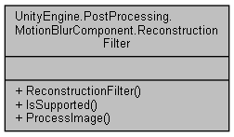

### Public Member Functions

**ReconstructionFilter** ()

bool **IsSupported** ()

void **ProcessImage** (**PostProcessingContext** context, CommandBuffer cb, ref **Settings** settings, RenderTargetIdentifier source, RenderTargetIdentifier destination, Material material)

### Constructor & Destructor Documentation

#### UnityEngine.PostProcessing.MotionBlurComponent.ReconstructionFilter.ReconstructionFilter ()

### Member Function Documentation

#### bool UnityEngine.PostProcessing.MotionBlurComponent.ReconstructionFilter.IsSupported ()

#### void UnityEngine.PostProcessing.MotionBlurComponent.ReconstructionFilter.ProcessImage (PostProcessingContext *context*, CommandBuffer *cb*, ref Settings *settings*, RenderTargetIdentifier *source*, RenderTargetIdentifier *destination*, Material *material*)

Here is the caller graph for this function:

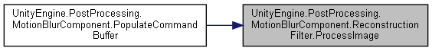

#### The documentation for this class was generated from the following file:

C:/_SSDSPEEDUP/2021/clone/gps1_manadesigner/GPS1-Manadesigner/Assets/Samples/Input System/1.0.2/Tanks Demo/TanksDemo/PostProcessing/Runtime/Components/**MotionBlurComponent.cs**

## UnityEngine.PostProcessing.ScreenSpaceReflectionModel.ReflectionSettings Struct Reference

Collaboration diagram for UnityEngine.PostProcessing.ScreenSpaceReflectionModel.ReflectionSettings:

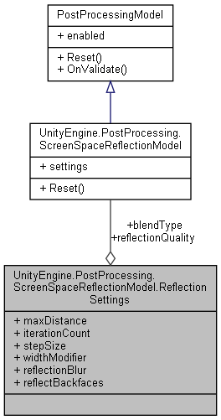

### Public Attributes

**SSRReflectionBlendType** **blendType**

**SSRResolution** **reflectionQuality**

float **maxDistance**

int **iterationCount**

*REFLECTIONS.*

int **stepSize**

float **widthModifier**

float **reflectionBlur**

bool **reflectBackfaces**

### Member Data Documentation

#### SSRReflectionBlendType UnityEngine.PostProcessing.ScreenSpaceReflectionModel.ReflectionSettings.blendType

#### int UnityEngine.PostProcessing.ScreenSpaceReflectionModel.ReflectionSettings.iterationCount

REFLECTIONS.

#### float UnityEngine.PostProcessing.ScreenSpaceReflectionModel.ReflectionSettings.maxDistance

#### bool UnityEngine.PostProcessing.ScreenSpaceReflectionModel.ReflectionSettings.reflectBackfaces

#### float UnityEngine.PostProcessing.ScreenSpaceReflectionModel.ReflectionSettings.reflectionBlur

#### SSRResolution UnityEngine.PostProcessing.ScreenSpaceReflectionModel.ReflectionSettings.reflectionQuality

#### int UnityEngine.PostProcessing.ScreenSpaceReflectionModel.ReflectionSettings.stepSize

#### float UnityEngine.PostProcessing.ScreenSpaceReflectionModel.ReflectionSettings.widthModifier

#### The documentation for this struct was generated from the following file:

C:/_SSDSPEEDUP/2021/clone/gps1_manadesigner/GPS1-Manadesigner/Assets/Samples/Input System/1.0.2/Tanks Demo/TanksDemo/PostProcessing/Runtime/Models/**ScreenSpaceReflectionModel.cs**

## UnityEditor.PostProcessing.ReflectionUtils Class Reference

Collaboration diagram for UnityEditor.PostProcessing.ReflectionUtils:

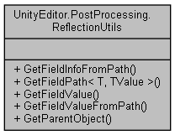

### Static Public Member Functions

static FieldInfo **GetFieldInfoFromPath** (object source, string path)

static string **GetFieldPath< T, TValue >** (Expression< Func< T, TValue > > expr)

static object **GetFieldValue** (object source, string name)

static object **GetFieldValueFromPath** (object source, ref Type baseType, string path)

static object **GetParentObject** (string path, object obj)

### Member Function Documentation

#### static FieldInfo UnityEditor.PostProcessing.ReflectionUtils.GetFieldInfoFromPath (object *source*, string *path*)[static]

#### static string UnityEditor.PostProcessing.ReflectionUtils.GetFieldPath< T, TValue > (Expression< Func< T, TValue > > *expr*)[static]

#### static object UnityEditor.PostProcessing.ReflectionUtils.GetFieldValue (object *source*, string *name*)[static]

Here is the caller graph for this function:

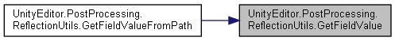

#### static object UnityEditor.PostProcessing.ReflectionUtils.GetFieldValueFromPath (object *source*, ref Type *baseType*, string *path*)[static]

Here is the call graph for this function:

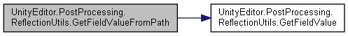

#### static object UnityEditor.PostProcessing.ReflectionUtils.GetParentObject (string *path*, object *obj*)[static]

Here is the call graph for this function:

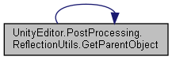

Here is the caller graph for this function:

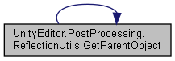

#### The documentation for this class was generated from the following file:

C:/_SSDSPEEDUP/2021/clone/gps1_manadesigner/GPS1-Manadesigner/Assets/Samples/Input System/1.0.2/Tanks Demo/TanksDemo/PostProcessing/Editor/Utils/**ReflectionUtils.cs**

## UnityEngine.PostProcessing.RenderTextureFactory Class Reference

Inheritance diagram for UnityEngine.PostProcessing.RenderTextureFactory:

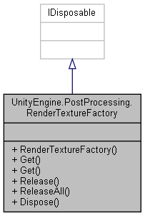

Collaboration diagram for UnityEngine.PostProcessing.RenderTextureFactory:



### Public Member Functions

**RenderTextureFactory** ()

RenderTexture **Get** (RenderTexture baseRenderTexture)

RenderTexture **Get** (int width, int height, int depthBuffer=0, RenderTextureFormat format=RenderTextureFormat.ARGBHalf, RenderTextureReadWrite rw=RenderTextureReadWrite.Default, FilterMode filterMode=FilterMode.Bilinear, TextureWrapMode wrapMode=TextureWrapMode.Clamp, string name="FactoryTempTexture")

void **Release** (RenderTexture rt)

void **ReleaseAll** ()

void **Dispose** ()

### Constructor & Destructor Documentation

#### UnityEngine.PostProcessing.RenderTextureFactory.RenderTextureFactory ()

### Member Function Documentation

#### void UnityEngine.PostProcessing.RenderTextureFactory.Dispose ()

Here is the call graph for this function:

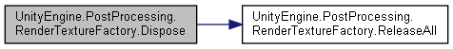

#### RenderTexture UnityEngine.PostProcessing.RenderTextureFactory.Get (int *width*, int *height*, int *depthBuffer* = 0, RenderTextureFormat *format* = RenderTextureFormat.ARGBHalf, RenderTextureReadWrite *rw* = RenderTextureReadWrite.Default, FilterMode *filterMode* = FilterMode.Bilinear, TextureWrapMode *wrapMode* = TextureWrapMode.Clamp, string *name* = "FactoryTempTexture")

#### RenderTexture UnityEngine.PostProcessing.RenderTextureFactory.Get (RenderTexture *baseRenderTexture*)

Here is the call graph for this function:

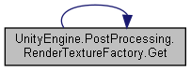

Here is the caller graph for this function:

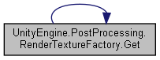

#### void UnityEngine.PostProcessing.RenderTextureFactory.Release (RenderTexture *rt*)

#### void UnityEngine.PostProcessing.RenderTextureFactory.ReleaseAll ()

Here is the caller graph for this function:

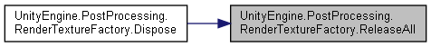

#### The documentation for this class was generated from the following file:

C:/_SSDSPEEDUP/2021/clone/gps1_manadesigner/GPS1-Manadesigner/Assets/Samples/Input System/1.0.2/Tanks Demo/TanksDemo/PostProcessing/Runtime/Utils/**RenderTextureFactory.cs**

## RequirementChecker Class Reference

Inheritance diagram for RequirementChecker:

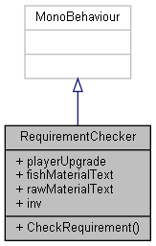

Collaboration diagram for RequirementChecker:

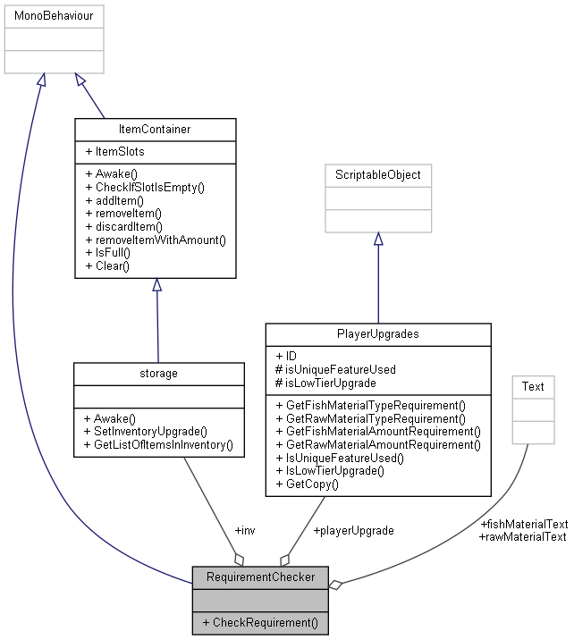

### Public Member Functions

void **CheckRequirement** ()

### Public Attributes

**PlayerUpgrades** **playerUpgrade**

Text[] **fishMaterialText**

Text[] **rawMaterialText**

**storage** **inv**

### Member Function Documentation

#### void RequirementChecker.CheckRequirement ()

Here is the call graph for this function:

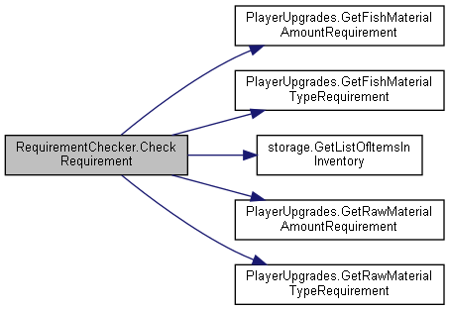

### Member Data Documentation

#### Text [] RequirementChecker.fishMaterialText

#### storage RequirementChecker.inv

#### PlayerUpgrades RequirementChecker.playerUpgrade

#### Text [] RequirementChecker.rawMaterialText

#### The documentation for this class was generated from the following file:

C:/_SSDSPEEDUP/2021/clone/gps1_manadesigner/GPS1-Manadesigner/Assets/**RequirementChecker.cs**

## Resource Class Reference

Inheritance diagram for Resource:

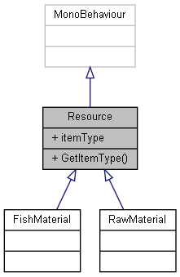

Collaboration diagram for Resource:

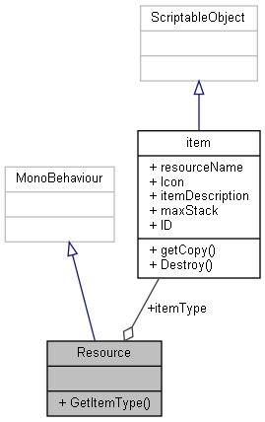

### Public Member Functions

**item** **GetItemType** ()

### Public Attributes

**item** **itemType**

### Member Function Documentation

#### item Resource.GetItemType ()

Here is the caller graph for this function:

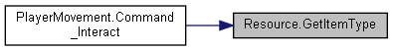

### Member Data Documentation

#### item Resource.itemType

#### The documentation for this class was generated from the following file:

C:/_SSDSPEEDUP/2021/clone/gps1_manadesigner/GPS1-Manadesigner/Assets/Scripts/Arif's Test Scripts/Resource/**Resource.cs**

## RigidBody2DAutoAddRelativeForceUp Class Reference

Inheritance diagram for RigidBody2DAutoAddRelativeForceUp:

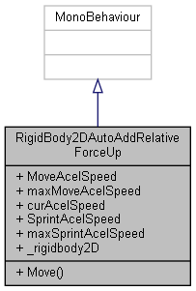

Collaboration diagram for RigidBody2DAutoAddRelativeForceUp:



### Public Member Functions

void **Move** ()

### Public Attributes

float **MoveAcelSpeed** = 2.0f

float **maxMoveAcelSpeed** = 10f

float **curAcelSpeed** = 0

float **SprintAcelSpeed** = 5.335f

float **maxSprintAcelSpeed** = 20f

Rigidbody2D **_rigidbody2D**

### Member Function Documentation

#### void RigidBody2DAutoAddRelativeForceUp.Move ()

### Member Data Documentation

#### Rigidbody2D RigidBody2DAutoAddRelativeForceUp._rigidbody2D

#### float RigidBody2DAutoAddRelativeForceUp.curAcelSpeed = 0

#### float RigidBody2DAutoAddRelativeForceUp.maxMoveAcelSpeed = 10f

#### float RigidBody2DAutoAddRelativeForceUp.maxSprintAcelSpeed = 20f

#### float RigidBody2DAutoAddRelativeForceUp.MoveAcelSpeed = 2.0f

#### float RigidBody2DAutoAddRelativeForceUp.SprintAcelSpeed = 5.335f

#### The documentation for this class was generated from the following file:

C:/_SSDSPEEDUP/2021/clone/gps1_manadesigner/GPS1-Manadesigner/Assets/_UtilsV0.4/MyScripts/_Utils/_CommonV0.2/CommonExtend/2D/**RigidBody2DAutoAddRelativeForceUp.cs**

## UnityEngine.InputSystem.Samples.VisualizationHelpers.RingBuffer< TValue > Struct Template Reference

Collaboration diagram for UnityEngine.InputSystem.Samples.VisualizationHelpers.RingBuffer< TValue >:

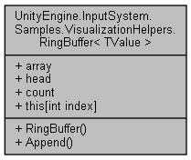

### Public Member Functions

**RingBuffer** (int size)

ref TValue **Append** (TValue value)

### Public Attributes

TValue[] **array**

int **head**

int **count**

### Properties

ref TValue **this[int index]** [get]

### Constructor & Destructor Documentation

#### UnityEngine.InputSystem.Samples.VisualizationHelpers.RingBuffer< TValue >.RingBuffer (int *size*)

### Member Function Documentation

#### ref TValue UnityEngine.InputSystem.Samples.VisualizationHelpers.RingBuffer< TValue >.Append (TValue *value*)

### Member Data Documentation

#### TValue [] UnityEngine.InputSystem.Samples.VisualizationHelpers.RingBuffer< TValue >.array

#### int UnityEngine.InputSystem.Samples.VisualizationHelpers.RingBuffer< TValue >.count

#### int UnityEngine.InputSystem.Samples.VisualizationHelpers.RingBuffer< TValue >.head

### Property Documentation

#### ref TValue UnityEngine.InputSystem.Samples.VisualizationHelpers.RingBuffer< TValue >.this[int index][get]

#### The documentation for this struct was generated from the following file:

C:/_SSDSPEEDUP/2021/clone/gps1_manadesigner/GPS1-Manadesigner/Assets/Samples/Input System/1.0.2/Visualizers/**VisualizationHelpers.cs**

## SaveHandler Class Reference

Inheritance diagram for SaveHandler:

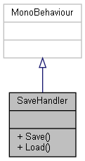

Collaboration diagram for SaveHandler:



### Public Member Functions

void **Save** ()

void **Load** ()

### Member Function Documentation

#### void SaveHandler.Load ()

#### void SaveHandler.Save ()

#### The documentation for this class was generated from the following file:

C:/_SSDSPEEDUP/2021/clone/gps1_manadesigner/GPS1-Manadesigner/Assets/Scripts/Arif's Test Scripts/Save State/Old/**SaveHandler.cs**

## SaveSystem Class Reference

Collaboration diagram for SaveSystem:

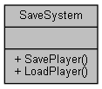

### Static Public Member Functions

static void **SavePlayer** (**PlayerMovement** playerMovement)

static **PlayerData** **LoadPlayer** ()

### Member Function Documentation

#### static PlayerData SaveSystem.LoadPlayer ()[static]

#### static void SaveSystem.SavePlayer (PlayerMovement *playerMovement*)[static]

#### The documentation for this class was generated from the following file:

C:/_SSDSPEEDUP/2021/clone/gps1_manadesigner/GPS1-Manadesigner/Assets/Scripts/Arif's Test Scripts/Save State/Unused/**SaveSystem.cs**

## UnityEngine.InputSystem.Samples.VisualizationHelpers.ScalarVisualizer< TValue > Class Template Reference

Inheritance diagram for UnityEngine.InputSystem.Samples.VisualizationHelpers.ScalarVisualizer< TValue >:

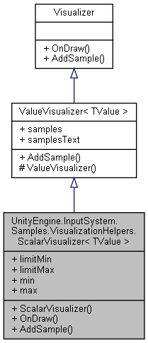

Collaboration diagram for UnityEngine.InputSystem.Samples.VisualizationHelpers.ScalarVisualizer< TValue >:



### Public Member Functions

**ScalarVisualizer** (int numSamples=10)

override void **OnDraw** (Rect rect)

override void **AddSample** (object value, double time)

### Public Attributes

TValue **limitMin**

TValue **limitMax**

TValue **min**

TValue **max**

### Additional Inherited Members

### Constructor & Destructor Documentation

#### UnityEngine.InputSystem.Samples.VisualizationHelpers.ScalarVisualizer< TValue >.ScalarVisualizer (int *numSamples* = 10)

### Member Function Documentation

#### override void UnityEngine.InputSystem.Samples.VisualizationHelpers.ScalarVisualizer< TValue >.AddSample (object *value*, double *time*)[virtual]

Reimplemented from **UnityEngine.InputSystem.Samples.VisualizationHelpers.ValueVisualizer< TValue >** (*p.824*).

#### override void UnityEngine.InputSystem.Samples.VisualizationHelpers.ScalarVisualizer< TValue >.OnDraw (Rect *rect*)[virtual]

Implements **UnityEngine.InputSystem.Samples.VisualizationHelpers.Visualizer** (*p.847*).

### Member Data Documentation

#### TValue UnityEngine.InputSystem.Samples.VisualizationHelpers.ScalarVisualizer< TValue >.limitMax

#### TValue UnityEngine.InputSystem.Samples.VisualizationHelpers.ScalarVisualizer< TValue >.limitMin

#### TValue UnityEngine.InputSystem.Samples.VisualizationHelpers.ScalarVisualizer< TValue >.max

#### TValue UnityEngine.InputSystem.Samples.VisualizationHelpers.ScalarVisualizer< TValue >.min

#### The documentation for this class was generated from the following file:

C:/_SSDSPEEDUP/2021/clone/gps1_manadesigner/GPS1-Manadesigner/Assets/Samples/Input System/1.0.2/Visualizers/**VisualizationHelpers.cs**

## ScenearioScreenHandler Class Reference

Inheritance diagram for ScenearioScreenHandler:

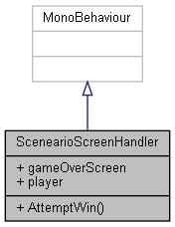

Collaboration diagram for ScenearioScreenHandler:



### Public Member Functions

void **AttemptWin** ()

### Public Attributes

GameObject **gameOverScreen**

GameObject **player**

### Member Function Documentation

#### void ScenearioScreenHandler.AttemptWin ()

### Member Data Documentation

#### GameObject ScenearioScreenHandler.gameOverScreen

#### GameObject ScenearioScreenHandler.player

#### The documentation for this class was generated from the following file:

C:/_SSDSPEEDUP/2021/clone/gps1_manadesigner/GPS1-Manadesigner/Assets/**ScenearioScreenHandler.cs**

## SceneAsyncManager Class Reference

Inheritance diagram for SceneAsyncManager:

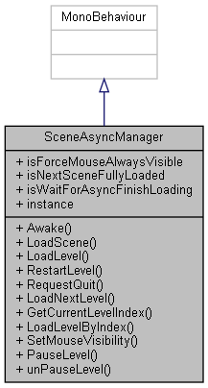

Collaboration diagram for SceneAsyncManager:

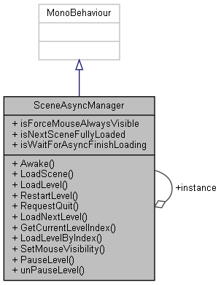

### Public Member Functions

void **Awake** ()

void **LoadScene** (string sceneName)

void **LoadLevel** (string Name)

void **RestartLevel** ()

void **RequestQuit** ()

void **LoadNextLevel** ()

int **GetCurrentLevelIndex** ()

void **LoadLevelByIndex** (int index)

void **SetMouseVisibility** (bool isVisible)

void **PauseLevel** ()

void **unPauseLevel** ()

### Public Attributes

bool **isForceMouseAlwaysVisible** = false

bool **isNextSceneFullyLoaded**

bool **isWaitForAsyncFinishLoading** = true

### Static Public Attributes

static **SceneAsyncManager** **instance**

### Member Function Documentation

#### void SceneAsyncManager.Awake ()

#### int SceneAsyncManager.GetCurrentLevelIndex ()

#### void SceneAsyncManager.LoadLevel (string *Name*)

Here is the call graph for this function:



#### void SceneAsyncManager.LoadLevelByIndex (int *index*)

Here is the call graph for this function:

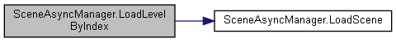

#### void SceneAsyncManager.LoadNextLevel ()

Here is the call graph for this function:

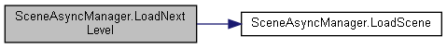

#### void SceneAsyncManager.LoadScene (string *sceneName*)

Here is the caller graph for this function:

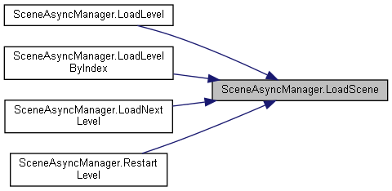

#### void SceneAsyncManager.PauseLevel ()

#### void SceneAsyncManager.RequestQuit ()

#### void SceneAsyncManager.RestartLevel ()

Here is the call graph for this function:

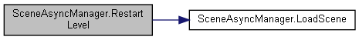

#### void SceneAsyncManager.SetMouseVisibility (bool *isVisible*)

#### void SceneAsyncManager.unPauseLevel ()

### Member Data Documentation

#### SceneAsyncManager SceneAsyncManager.instance[static]

#### bool SceneAsyncManager.isForceMouseAlwaysVisible = false

#### bool SceneAsyncManager.isNextSceneFullyLoaded

#### bool SceneAsyncManager.isWaitForAsyncFinishLoading = true

#### The documentation for this class was generated from the following file:

C:/_SSDSPEEDUP/2021/clone/gps1_manadesigner/GPS1-Manadesigner/Assets/_UtilsV0.4/MyScripts/_Utils/_CommonV0.2/Singletons/**SceneAsyncManager.cs**

## SceneBetweenStages Class Reference

Inheritance diagram for SceneBetweenStages:

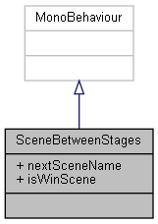

Collaboration diagram for SceneBetweenStages:



### Public Attributes

string **nextSceneName** = "Stage 2 Prototype"

bool **isWinScene** = true

### Member Data Documentation

#### bool SceneBetweenStages.isWinScene = true

#### string SceneBetweenStages.nextSceneName = "Stage 2 Prototype"

#### The documentation for this class was generated from the following file:

C:/_SSDSPEEDUP/2021/clone/gps1_manadesigner/GPS1-Manadesigner/Assets/Scripts/Stage Scripts/Scene Transitions/**SceneBetweenStages.cs**

## SceneHandler Class Reference

Inheritance diagram for SceneHandler:

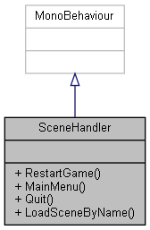

Collaboration diagram for SceneHandler:



### Public Member Functions

void **RestartGame** ()

void **MainMenu** ()

void **Quit** ()

void **LoadSceneByName** (string sceneName)

### Member Function Documentation

#### void SceneHandler.LoadSceneByName (string *sceneName*)

#### void SceneHandler.MainMenu ()

#### void SceneHandler.Quit ()

#### void SceneHandler.RestartGame ()

#### The documentation for this class was generated from the following file:

C:/_SSDSPEEDUP/2021/clone/gps1_manadesigner/GPS1-Manadesigner/Assets/**SceneHandler.cs**

## SceneTransitioning Class Reference

Inheritance diagram for SceneTransitioning:

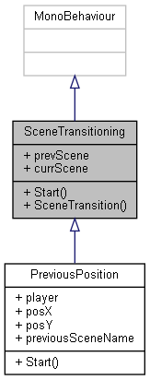

Collaboration diagram for SceneTransitioning:

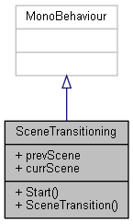

### Public Member Functions

virtual void **Start** ()

void **SceneTransition** (string name)

### Static Public Attributes

static string **prevScene**

static string **currScene**

### Member Function Documentation

#### void SceneTransitioning.SceneTransition (string *name*)

#### virtual void SceneTransitioning.Start ()[virtual]

Reimplemented in **PreviousPosition** (*p.606*).

### Member Data Documentation

#### string SceneTransitioning.currScene[static]

#### string SceneTransitioning.prevScene[static]

#### The documentation for this class was generated from the following file:

C:/_SSDSPEEDUP/2021/clone/gps1_manadesigner/GPS1-Manadesigner/Assets/Scripts/Stage Scripts/Scene Transitions/**SceneTransitioning.cs**

## SceneTransitionsToOutpost Class Reference

Inheritance diagram for SceneTransitionsToOutpost:

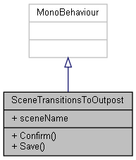

Collaboration diagram for SceneTransitionsToOutpost:



### Public Member Functions

void **Confirm** ()

void **Save** ()

### Public Attributes

string **sceneName**

### Member Function Documentation

#### void SceneTransitionsToOutpost.Confirm ()

Here is the call graph for this function:

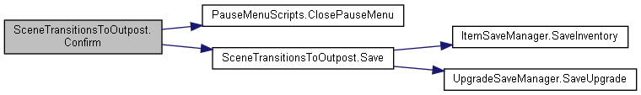

#### void SceneTransitionsToOutpost.Save ()

Here is the call graph for this function:

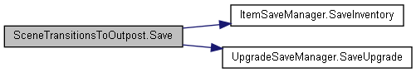

Here is the caller graph for this function:

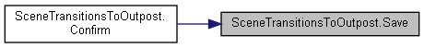

### Member Data Documentation

#### string SceneTransitionsToOutpost.sceneName

#### The documentation for this class was generated from the following file:

C:/_SSDSPEEDUP/2021/clone/gps1_manadesigner/GPS1-Manadesigner/Assets/Scripts/Stage Scripts/Scene Transitions/To Outpost/**SceneTransitionsToOutpost.cs**

## UnityEngine.PostProcessing.ScreenSpaceReflectionModel.ScreenEdgeMask Struct Reference

Collaboration diagram for UnityEngine.PostProcessing.ScreenSpaceReflectionModel.ScreenEdgeMask:

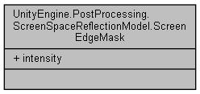

### Public Attributes

float **intensity**

### Member Data Documentation

#### float UnityEngine.PostProcessing.ScreenSpaceReflectionModel.ScreenEdgeMask.intensity

#### The documentation for this struct was generated from the following file:

C:/_SSDSPEEDUP/2021/clone/gps1_manadesigner/GPS1-Manadesigner/Assets/Samples/Input System/1.0.2/Tanks Demo/TanksDemo/PostProcessing/Runtime/Models/**ScreenSpaceReflectionModel.cs**

## UnityEngine.PostProcessing.ScreenSpaceReflectionComponent Class Reference

Inheritance diagram for UnityEngine.PostProcessing.ScreenSpaceReflectionComponent:

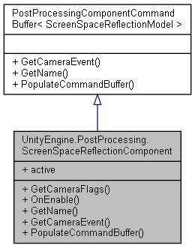

Collaboration diagram for UnityEngine.PostProcessing.ScreenSpaceReflectionComponent:



### Public Member Functions

override DepthTextureMode **GetCameraFlags** ()

override void **OnEnable** ()

override string **GetName** ()

override CameraEvent **GetCameraEvent** ()

override void **PopulateCommandBuffer** (CommandBuffer cb)

### Properties

override bool **active** [get]

### Member Function Documentation

#### override CameraEvent UnityEngine.PostProcessing.ScreenSpaceReflectionComponent.GetCameraEvent ()[virtual]

Implements **UnityEngine.PostProcessing.PostProcessingComponentCommandBuffer< ScreenSpaceReflectionModel >** (*p.592*).

#### override DepthTextureMode UnityEngine.PostProcessing.ScreenSpaceReflectionComponent.GetCameraFlags ()

#### override string UnityEngine.PostProcessing.ScreenSpaceReflectionComponent.GetName ()[virtual]

Implements **UnityEngine.PostProcessing.PostProcessingComponentCommandBuffer< ScreenSpaceReflectionModel >** (*p.592*).

#### override void UnityEngine.PostProcessing.ScreenSpaceReflectionComponent.OnEnable ()

#### override void UnityEngine.PostProcessing.ScreenSpaceReflectionComponent.PopulateCommandBuffer (CommandBuffer *cb*)[virtual]

Implements **UnityEngine.PostProcessing.PostProcessingComponentCommandBuffer< ScreenSpaceReflectionModel >** (*p.592*).

### Property Documentation

#### override bool UnityEngine.PostProcessing.ScreenSpaceReflectionComponent.active[get]

#### The documentation for this class was generated from the following file:

C:/_SSDSPEEDUP/2021/clone/gps1_manadesigner/GPS1-Manadesigner/Assets/Samples/Input System/1.0.2/Tanks Demo/TanksDemo/PostProcessing/Runtime/Components/**ScreenSpaceReflectionComponent.cs**

## UnityEngine.PostProcessing.ScreenSpaceReflectionModel Class Reference

Inheritance diagram for UnityEngine.PostProcessing.ScreenSpaceReflectionModel:

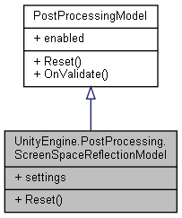

Collaboration diagram for UnityEngine.PostProcessing.ScreenSpaceReflectionModel:



### Classes

struct **IntensitySettings**

struct **ReflectionSettings**

struct **ScreenEdgeMask**

struct **Settings**

### Public Types

enum **SSRResolution** { **High** = 0, **Low** = 2 }

enum **SSRReflectionBlendType** { **PhysicallyBased**, **Additive** }

### Public Member Functions

override void **Reset** ()

### Properties

**Settings** **settings** [getset]

### Member Enumeration Documentation

#### enum UnityEngine.PostProcessing.ScreenSpaceReflectionModel.SSRReflectionBlendType

##### Enumerator:

|  |  |
| --- | --- |
| PhysicallyBased |  |
| Additive |  |

#### enum UnityEngine.PostProcessing.ScreenSpaceReflectionModel.SSRResolution

##### Enumerator:

|  |  |
| --- | --- |
| High |  |
| Low |  |

### Member Function Documentation

#### override void UnityEngine.PostProcessing.ScreenSpaceReflectionModel.Reset ()[virtual]

Implements **UnityEngine.PostProcessing.PostProcessingModel** (*p.597*).

### Property Documentation

#### Settings UnityEngine.PostProcessing.ScreenSpaceReflectionModel.settings[get], [set]

#### The documentation for this class was generated from the following file:

C:/_SSDSPEEDUP/2021/clone/gps1_manadesigner/GPS1-Manadesigner/Assets/Samples/Input System/1.0.2/Tanks Demo/TanksDemo/PostProcessing/Runtime/Models/**ScreenSpaceReflectionModel.cs**

## ScrollRectCommon Class Reference

Collaboration diagram for ScrollRectCommon:

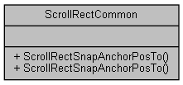

### Static Public Member Functions

static void **ScrollRectSnapAnchorPosTo** (ScrollRect scrollRect, RectTransform contentPanel, RectTransform target)

static void **ScrollRectSnapAnchorPosTo** (ScrollRect scrollRect, RectTransform contentPanel, RectTransform target, Vector2 offsetPos)

### Member Function Documentation

#### static void ScrollRectCommon.ScrollRectSnapAnchorPosTo (ScrollRect *scrollRect*, RectTransform *contentPanel*, RectTransform *target*)[static]

#### static void ScrollRectCommon.ScrollRectSnapAnchorPosTo (ScrollRect *scrollRect*, RectTransform *contentPanel*, RectTransform *target*, Vector2 *offsetPos*)[static]

#### The documentation for this class was generated from the following file:

C:/_SSDSPEEDUP/2021/clone/gps1_manadesigner/GPS1-Manadesigner/Assets/_UtilsV0.4/MyScripts/_Utils/_CommonV0.2/UICanvas/**ScrollRectCommon.cs**

## SelfRepair Class Reference

Inheritance diagram for SelfRepair:

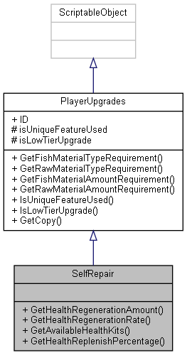

Collaboration diagram for SelfRepair:



### Public Member Functions

float **GetHealthRegenerationAmount** ()

float **GetHealthRegenerationRate** ()

int **GetAvailableHealthKits** ()

float **GetHealthReplenishPercentage** ()

### Additional Inherited Members

### Member Function Documentation

#### int SelfRepair.GetAvailableHealthKits ()

#### float SelfRepair.GetHealthRegenerationAmount ()

#### float SelfRepair.GetHealthRegenerationRate ()

#### float SelfRepair.GetHealthReplenishPercentage ()

#### The documentation for this class was generated from the following file:

C:/_SSDSPEEDUP/2021/clone/gps1_manadesigner/GPS1-Manadesigner/Assets/Scripts/Arif's Test Scripts/Upgrades/Self Repair/**SelfRepair.cs**

## SerializableQueueList< T > Class Template Reference

Collaboration diagram for SerializableQueueList< T >:

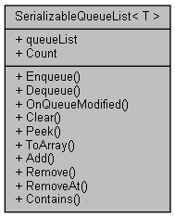

### Public Member Functions

void **Enqueue** (T t)

T **Dequeue** ()

void **OnQueueModified** ()

void **Clear** ()

T **Peek** ()

T[] **ToArray** ()

void **Add** (T t)

bool **Remove** (T t)

void **RemoveAt** (int i)

bool **Contains** (T t)

### Public Attributes

List< T > **queueList** = new List<T>()

### Properties

virtual int **Count** [get]

### Member Function Documentation

#### void SerializableQueueList< T >.Add (T *t*)

Here is the call graph for this function:

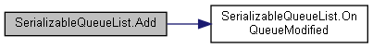

Here is the caller graph for this function:



#### void SerializableQueueList< T >.Clear ()

#### bool SerializableQueueList< T >.Contains (T *t*)

#### T SerializableQueueList< T >.Dequeue ()

Here is the call graph for this function:



#### void SerializableQueueList< T >.Enqueue (T *t*)

Here is the call graph for this function:



#### void SerializableQueueList< T >.OnQueueModified ()

Here is the caller graph for this function:

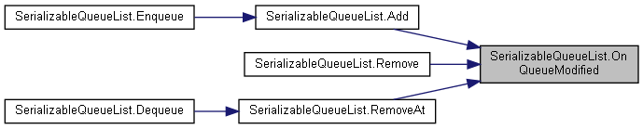

#### T SerializableQueueList< T >.Peek ()

#### bool SerializableQueueList< T >.Remove (T *t*)

Here is the call graph for this function:

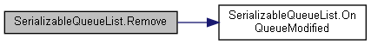

#### void SerializableQueueList< T >.RemoveAt (int *i*)

Here is the call graph for this function:

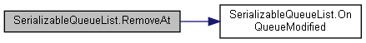

Here is the caller graph for this function:



#### T[] SerializableQueueList< T >.ToArray ()

### Member Data Documentation

#### List<T> SerializableQueueList< T >.queueList = new List<T>()

### Property Documentation

#### virtual int SerializableQueueList< T >.Count[get]

#### The documentation for this class was generated from the following file:

C:/_SSDSPEEDUP/2021/clone/gps1_manadesigner/GPS1-Manadesigner/Assets/_UtilsV0.4/MyScripts/_Utils/SerializableDataStructures/**SerializableQueueList.cs**

## SetMaterialColorCommand Class Reference

Inheritance diagram for SetMaterialColorCommand:

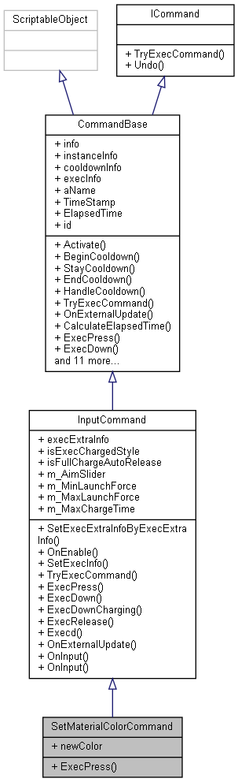

Collaboration diagram for SetMaterialColorCommand:

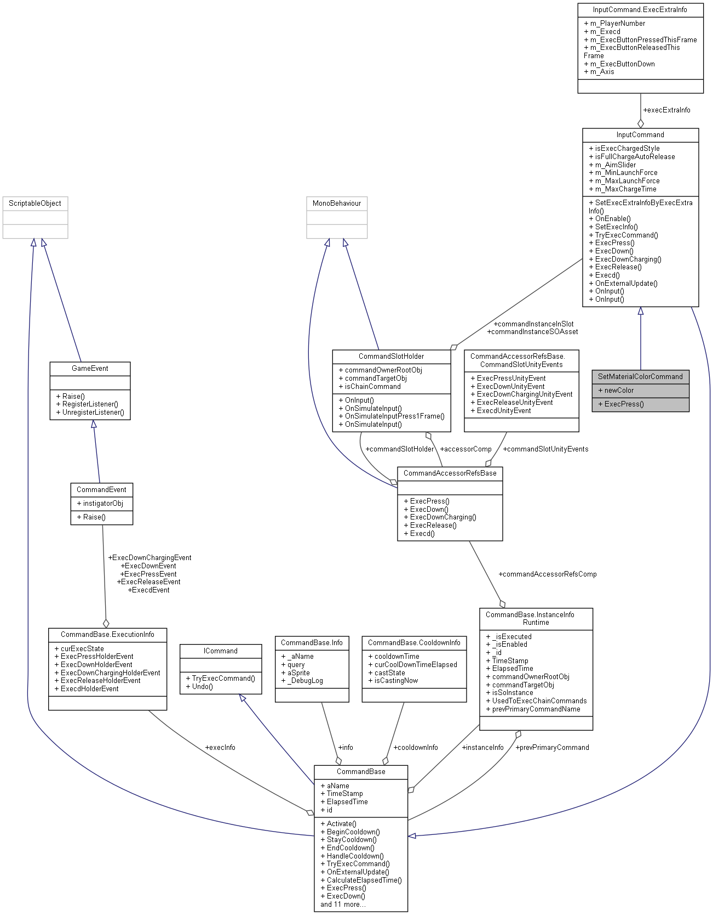

### Public Member Functions

override void **ExecPress** ()

### Public Attributes

Color **newColor** = Color.white

### Additional Inherited Members

### Member Function Documentation

#### override void SetMaterialColorCommand.ExecPress ()[virtual]

Reimplemented from **InputCommand** (*p.370*).

### Member Data Documentation

#### Color SetMaterialColorCommand.newColor = Color.white

#### The documentation for this class was generated from the following file:

C:/_SSDSPEEDUP/2021/clone/gps1_manadesigner/GPS1-Manadesigner/Assets/_UtilsV0.4/MyScripts/_Utils/CommandPattern/Command/SOScripts/Misc/**SetMaterialColorCommand.cs**

## SetParamStateData Class Reference

Collaboration diagram for SetParamStateData:

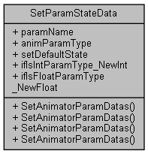

### Static Public Member Functions

static void **SetAnimatorParamDatas** (**SetParamStateData** data, Animator animator, AnimatorStateInfo stateInfo, int layerIndex)

static void **SetAnimatorParamDatas** (**SetParamStateData** data, Animator animator)

static void **SetAnimatorParamDatas** (**SetParamStateData** data, Animator animator, bool isInvertBOOL, AnimatorStateInfo stateInfo, int layerIndex)

static void **SetAnimatorParamDatas** (**SetParamStateData** data, Animator animator, bool isInvertBOOL)

### Public Attributes

string **paramName**

**EAnimParamType** **animParamType**

bool **setDefaultState**

int **ifIsIntParamType_NewInt**

float **ifIsFloatParamType_NewFloat**

### Member Function Documentation

#### static void SetParamStateData.SetAnimatorParamDatas (SetParamStateData *data*, Animator *animator*)[static]

#### static void SetParamStateData.SetAnimatorParamDatas (SetParamStateData *data*, Animator *animator*, AnimatorStateInfo *stateInfo*, int *layerIndex*)[static]

Here is the caller graph for this function:

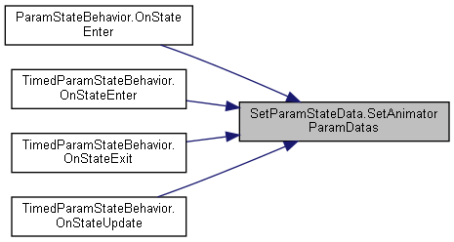

#### static void SetParamStateData.SetAnimatorParamDatas (SetParamStateData *data*, Animator *animator*, bool *isInvertBOOL*)[static]

#### static void SetParamStateData.SetAnimatorParamDatas (SetParamStateData *data*, Animator *animator*, bool *isInvertBOOL*, AnimatorStateInfo *stateInfo*, int *layerIndex*)[static]

### Member Data Documentation

#### EAnimParamType SetParamStateData.animParamType

#### float SetParamStateData.ifIsFloatParamType_NewFloat

#### int SetParamStateData.ifIsIntParamType_NewInt

#### string SetParamStateData.paramName

#### bool SetParamStateData.setDefaultState

#### The documentation for this class was generated from the following file:

C:/_SSDSPEEDUP/2021/clone/gps1_manadesigner/GPS1-Manadesigner/Assets/_UtilsV0.4/MyScripts/_Utils/_CommonV0.2/Animator/**ParamStateBehavior.cs**

## UnityEngine.PostProcessing.AmbientOcclusionModel.Settings Struct Reference

Collaboration diagram for UnityEngine.PostProcessing.AmbientOcclusionModel.Settings:

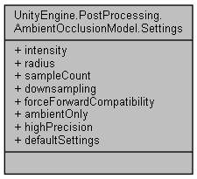

### Public Attributes

float **intensity**

float **radius**

**SampleCount** **sampleCount**

bool **downsampling**

bool **forceForwardCompatibility**

bool **ambientOnly**

bool **highPrecision**

### Properties

static **Settings** **defaultSettings** [get]

### Member Data Documentation

#### bool UnityEngine.PostProcessing.AmbientOcclusionModel.Settings.ambientOnly

#### bool UnityEngine.PostProcessing.AmbientOcclusionModel.Settings.downsampling

#### bool UnityEngine.PostProcessing.AmbientOcclusionModel.Settings.forceForwardCompatibility

#### bool UnityEngine.PostProcessing.AmbientOcclusionModel.Settings.highPrecision

#### float UnityEngine.PostProcessing.AmbientOcclusionModel.Settings.intensity

#### float UnityEngine.PostProcessing.AmbientOcclusionModel.Settings.radius

#### SampleCount UnityEngine.PostProcessing.AmbientOcclusionModel.Settings.sampleCount

### Property Documentation

#### Settings UnityEngine.PostProcessing.AmbientOcclusionModel.Settings.defaultSettings[static], [get]

#### The documentation for this struct was generated from the following file:

C:/_SSDSPEEDUP/2021/clone/gps1_manadesigner/GPS1-Manadesigner/Assets/Samples/Input System/1.0.2/Tanks Demo/TanksDemo/PostProcessing/Runtime/Models/**AmbientOcclusionModel.cs**

## UnityEngine.PostProcessing.AntialiasingModel.Settings Struct Reference

Collaboration diagram for UnityEngine.PostProcessing.AntialiasingModel.Settings:

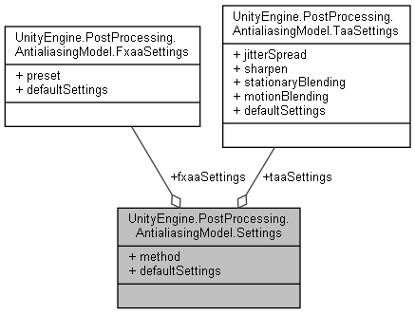

### Public Attributes

**Method** **method**

**FxaaSettings** **fxaaSettings**

**TaaSettings** **taaSettings**

### Properties

static **Settings** **defaultSettings** [get]

### Member Data Documentation

#### FxaaSettings UnityEngine.PostProcessing.AntialiasingModel.Settings.fxaaSettings

#### Method UnityEngine.PostProcessing.AntialiasingModel.Settings.method

#### TaaSettings UnityEngine.PostProcessing.AntialiasingModel.Settings.taaSettings

### Property Documentation

#### Settings UnityEngine.PostProcessing.AntialiasingModel.Settings.defaultSettings[static], [get]

#### The documentation for this struct was generated from the following file:

C:/_SSDSPEEDUP/2021/clone/gps1_manadesigner/GPS1-Manadesigner/Assets/Samples/Input System/1.0.2/Tanks Demo/TanksDemo/PostProcessing/Runtime/Models/**AntialiasingModel.cs**

## UnityEngine.PostProcessing.BloomModel.Settings Struct Reference

Collaboration diagram for UnityEngine.PostProcessing.BloomModel.Settings:

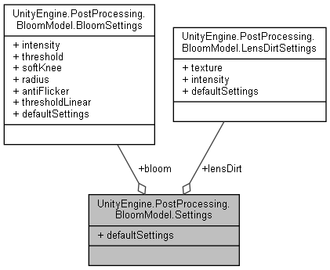

### Public Attributes

**BloomSettings** **bloom**

**LensDirtSettings** **lensDirt**

### Properties

static **Settings** **defaultSettings** [get]

### Member Data Documentation

#### BloomSettings UnityEngine.PostProcessing.BloomModel.Settings.bloom

#### LensDirtSettings UnityEngine.PostProcessing.BloomModel.Settings.lensDirt

### Property Documentation

#### Settings UnityEngine.PostProcessing.BloomModel.Settings.defaultSettings[static], [get]

#### The documentation for this struct was generated from the following file:

C:/_SSDSPEEDUP/2021/clone/gps1_manadesigner/GPS1-Manadesigner/Assets/Samples/Input System/1.0.2/Tanks Demo/TanksDemo/PostProcessing/Runtime/Models/**BloomModel.cs**

## UnityEngine.PostProcessing.BuiltinDebugViewsModel.Settings Struct Reference

Collaboration diagram for UnityEngine.PostProcessing.BuiltinDebugViewsModel.Settings:

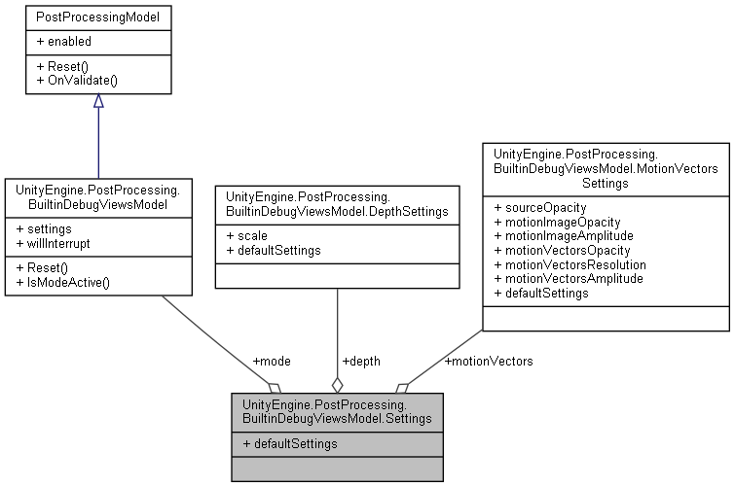

### Public Attributes

**Mode** **mode**

**DepthSettings** **depth**

**MotionVectorsSettings** **motionVectors**

### Properties

static **Settings** **defaultSettings** [get]

### Member Data Documentation

#### DepthSettings UnityEngine.PostProcessing.BuiltinDebugViewsModel.Settings.depth

#### Mode UnityEngine.PostProcessing.BuiltinDebugViewsModel.Settings.mode

#### MotionVectorsSettings UnityEngine.PostProcessing.BuiltinDebugViewsModel.Settings.motionVectors

### Property Documentation

#### Settings UnityEngine.PostProcessing.BuiltinDebugViewsModel.Settings.defaultSettings[static], [get]

#### The documentation for this struct was generated from the following file:

C:/_SSDSPEEDUP/2021/clone/gps1_manadesigner/GPS1-Manadesigner/Assets/Samples/Input System/1.0.2/Tanks Demo/TanksDemo/PostProcessing/Runtime/Models/**BuiltinDebugViewsModel.cs**

## UnityEngine.PostProcessing.ChromaticAberrationModel.Settings Struct Reference

Collaboration diagram for UnityEngine.PostProcessing.ChromaticAberrationModel.Settings:

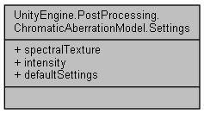

### Public Attributes

Texture2D **spectralTexture**

float **intensity**

### Properties

static **Settings** **defaultSettings** [get]

### Member Data Documentation

#### float UnityEngine.PostProcessing.ChromaticAberrationModel.Settings.intensity

#### Texture2D UnityEngine.PostProcessing.ChromaticAberrationModel.Settings.spectralTexture

### Property Documentation

#### Settings UnityEngine.PostProcessing.ChromaticAberrationModel.Settings.defaultSettings[static], [get]

#### The documentation for this struct was generated from the following file:

C:/_SSDSPEEDUP/2021/clone/gps1_manadesigner/GPS1-Manadesigner/Assets/Samples/Input System/1.0.2/Tanks Demo/TanksDemo/PostProcessing/Runtime/Models/**ChromaticAberrationModel.cs**

## UnityEngine.PostProcessing.ColorGradingModel.Settings Struct Reference

Collaboration diagram for UnityEngine.PostProcessing.ColorGradingModel.Settings:

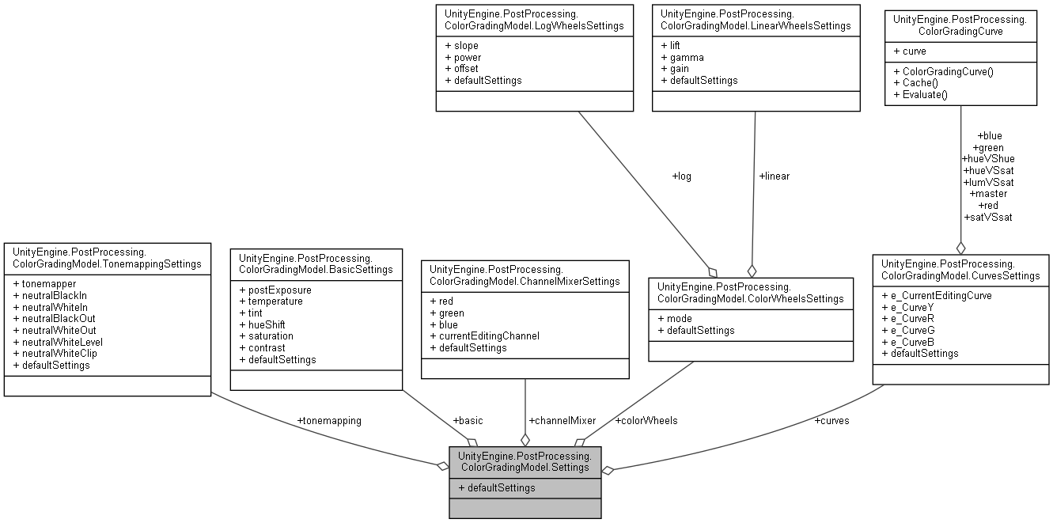

### Public Attributes

**TonemappingSettings** **tonemapping**

**BasicSettings** **basic**

**ChannelMixerSettings** **channelMixer**

**ColorWheelsSettings** **colorWheels**

**CurvesSettings** **curves**

### Properties

static **Settings** **defaultSettings** [get]

### Member Data Documentation

#### BasicSettings UnityEngine.PostProcessing.ColorGradingModel.Settings.basic

#### ChannelMixerSettings UnityEngine.PostProcessing.ColorGradingModel.Settings.channelMixer

#### ColorWheelsSettings UnityEngine.PostProcessing.ColorGradingModel.Settings.colorWheels

#### CurvesSettings UnityEngine.PostProcessing.ColorGradingModel.Settings.curves

#### TonemappingSettings UnityEngine.PostProcessing.ColorGradingModel.Settings.tonemapping

### Property Documentation

#### Settings UnityEngine.PostProcessing.ColorGradingModel.Settings.defaultSettings[static], [get]

#### The documentation for this struct was generated from the following file:

C:/_SSDSPEEDUP/2021/clone/gps1_manadesigner/GPS1-Manadesigner/Assets/Samples/Input System/1.0.2/Tanks Demo/TanksDemo/PostProcessing/Runtime/Models/**ColorGradingModel.cs**

## UnityEngine.PostProcessing.DepthOfFieldModel.Settings Struct Reference

Collaboration diagram for UnityEngine.PostProcessing.DepthOfFieldModel.Settings:

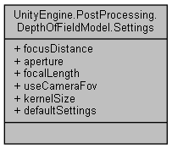

### Public Attributes

float **focusDistance**

float **aperture**

float **focalLength**

bool **useCameraFov**

**KernelSize** **kernelSize**

### Properties

static **Settings** **defaultSettings** [get]

### Member Data Documentation

#### float UnityEngine.PostProcessing.DepthOfFieldModel.Settings.aperture

#### float UnityEngine.PostProcessing.DepthOfFieldModel.Settings.focalLength

#### float UnityEngine.PostProcessing.DepthOfFieldModel.Settings.focusDistance

#### KernelSize UnityEngine.PostProcessing.DepthOfFieldModel.Settings.kernelSize

#### bool UnityEngine.PostProcessing.DepthOfFieldModel.Settings.useCameraFov

### Property Documentation

#### Settings UnityEngine.PostProcessing.DepthOfFieldModel.Settings.defaultSettings[static], [get]

#### The documentation for this struct was generated from the following file:

C:/_SSDSPEEDUP/2021/clone/gps1_manadesigner/GPS1-Manadesigner/Assets/Samples/Input System/1.0.2/Tanks Demo/TanksDemo/PostProcessing/Runtime/Models/**DepthOfFieldModel.cs**

## UnityEngine.PostProcessing.DitheringModel.Settings Struct Reference

Collaboration diagram for UnityEngine.PostProcessing.DitheringModel.Settings:

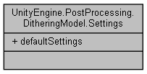

### Properties

static **Settings** **defaultSettings** [get]

### Property Documentation

#### Settings UnityEngine.PostProcessing.DitheringModel.Settings.defaultSettings[static], [get]

#### The documentation for this struct was generated from the following file:

C:/_SSDSPEEDUP/2021/clone/gps1_manadesigner/GPS1-Manadesigner/Assets/Samples/Input System/1.0.2/Tanks Demo/TanksDemo/PostProcessing/Runtime/Models/**DitheringModel.cs**

## UnityEngine.PostProcessing.EyeAdaptationModel.Settings Struct Reference

Collaboration diagram for UnityEngine.PostProcessing.EyeAdaptationModel.Settings:

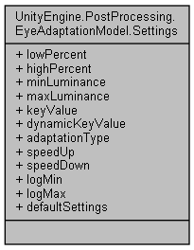

### Public Attributes

float **lowPercent**

float **highPercent**

float **minLuminance**

float **maxLuminance**

float **keyValue**

bool **dynamicKeyValue**

**EyeAdaptationType** **adaptationType**

float **speedUp**

float **speedDown**

int **logMin**

int **logMax**

### Properties

static **Settings** **defaultSettings** [get]

### Member Data Documentation

#### EyeAdaptationType UnityEngine.PostProcessing.EyeAdaptationModel.Settings.adaptationType

#### bool UnityEngine.PostProcessing.EyeAdaptationModel.Settings.dynamicKeyValue

#### float UnityEngine.PostProcessing.EyeAdaptationModel.Settings.highPercent

#### float UnityEngine.PostProcessing.EyeAdaptationModel.Settings.keyValue

#### int UnityEngine.PostProcessing.EyeAdaptationModel.Settings.logMax

#### int UnityEngine.PostProcessing.EyeAdaptationModel.Settings.logMin

#### float UnityEngine.PostProcessing.EyeAdaptationModel.Settings.lowPercent

#### float UnityEngine.PostProcessing.EyeAdaptationModel.Settings.maxLuminance

#### float UnityEngine.PostProcessing.EyeAdaptationModel.Settings.minLuminance

#### float UnityEngine.PostProcessing.EyeAdaptationModel.Settings.speedDown

#### float UnityEngine.PostProcessing.EyeAdaptationModel.Settings.speedUp

### Property Documentation

#### Settings UnityEngine.PostProcessing.EyeAdaptationModel.Settings.defaultSettings[static], [get]

#### The documentation for this struct was generated from the following file:

C:/_SSDSPEEDUP/2021/clone/gps1_manadesigner/GPS1-Manadesigner/Assets/Samples/Input System/1.0.2/Tanks Demo/TanksDemo/PostProcessing/Runtime/Models/**EyeAdaptationModel.cs**

## UnityEngine.PostProcessing.FogModel.Settings Struct Reference

Collaboration diagram for UnityEngine.PostProcessing.FogModel.Settings:

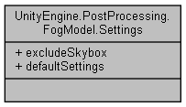

### Public Attributes

bool **excludeSkybox**

### Properties

static **Settings** **defaultSettings** [get]

### Member Data Documentation

#### bool UnityEngine.PostProcessing.FogModel.Settings.excludeSkybox

### Property Documentation

#### Settings UnityEngine.PostProcessing.FogModel.Settings.defaultSettings[static], [get]

#### The documentation for this struct was generated from the following file:

C:/_SSDSPEEDUP/2021/clone/gps1_manadesigner/GPS1-Manadesigner/Assets/Samples/Input System/1.0.2/Tanks Demo/TanksDemo/PostProcessing/Runtime/Models/**FogModel.cs**

## UnityEngine.PostProcessing.GrainModel.Settings Struct Reference

Collaboration diagram for UnityEngine.PostProcessing.GrainModel.Settings:

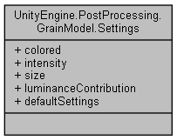

### Public Attributes

bool **colored**

float **intensity**

float **size**

float **luminanceContribution**

### Properties

static **Settings** **defaultSettings** [get]

### Member Data Documentation

#### bool UnityEngine.PostProcessing.GrainModel.Settings.colored

#### float UnityEngine.PostProcessing.GrainModel.Settings.intensity

#### float UnityEngine.PostProcessing.GrainModel.Settings.luminanceContribution

#### float UnityEngine.PostProcessing.GrainModel.Settings.size

### Property Documentation

#### Settings UnityEngine.PostProcessing.GrainModel.Settings.defaultSettings[static], [get]

#### The documentation for this struct was generated from the following file:

C:/_SSDSPEEDUP/2021/clone/gps1_manadesigner/GPS1-Manadesigner/Assets/Samples/Input System/1.0.2/Tanks Demo/TanksDemo/PostProcessing/Runtime/Models/**GrainModel.cs**

## UnityEngine.PostProcessing.MotionBlurModel.Settings Struct Reference

Collaboration diagram for UnityEngine.PostProcessing.MotionBlurModel.Settings:

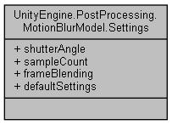

### Public Attributes

float **shutterAngle**

int **sampleCount**

float **frameBlending**

### Properties

static **Settings** **defaultSettings** [get]

### Member Data Documentation

#### float UnityEngine.PostProcessing.MotionBlurModel.Settings.frameBlending

#### int UnityEngine.PostProcessing.MotionBlurModel.Settings.sampleCount

#### float UnityEngine.PostProcessing.MotionBlurModel.Settings.shutterAngle

### Property Documentation

#### Settings UnityEngine.PostProcessing.MotionBlurModel.Settings.defaultSettings[static], [get]

#### The documentation for this struct was generated from the following file:

C:/_SSDSPEEDUP/2021/clone/gps1_manadesigner/GPS1-Manadesigner/Assets/Samples/Input System/1.0.2/Tanks Demo/TanksDemo/PostProcessing/Runtime/Models/**MotionBlurModel.cs**

## UnityEngine.PostProcessing.ScreenSpaceReflectionModel.Settings Struct Reference

Collaboration diagram for UnityEngine.PostProcessing.ScreenSpaceReflectionModel.Settings:

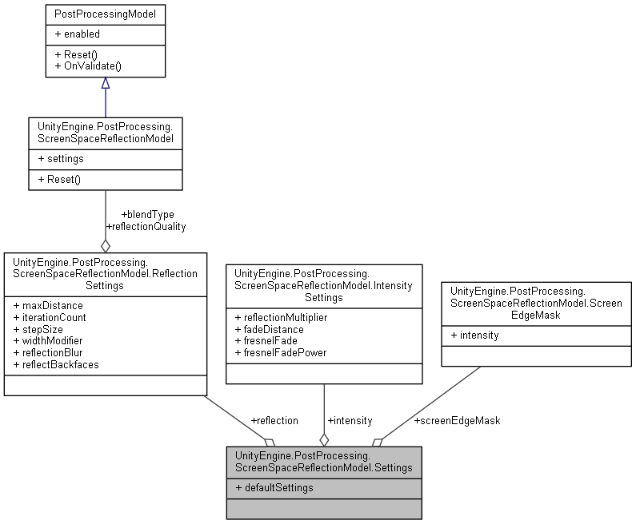

### Public Attributes

**ReflectionSettings** **reflection**

**IntensitySettings** **intensity**

**ScreenEdgeMask** **screenEdgeMask**

### Properties

static **Settings** **defaultSettings** [get]

### Member Data Documentation

#### IntensitySettings UnityEngine.PostProcessing.ScreenSpaceReflectionModel.Settings.intensity

#### ReflectionSettings UnityEngine.PostProcessing.ScreenSpaceReflectionModel.Settings.reflection

#### ScreenEdgeMask UnityEngine.PostProcessing.ScreenSpaceReflectionModel.Settings.screenEdgeMask

### Property Documentation

#### Settings UnityEngine.PostProcessing.ScreenSpaceReflectionModel.Settings.defaultSettings[static], [get]

#### The documentation for this struct was generated from the following file:

C:/_SSDSPEEDUP/2021/clone/gps1_manadesigner/GPS1-Manadesigner/Assets/Samples/Input System/1.0.2/Tanks Demo/TanksDemo/PostProcessing/Runtime/Models/**ScreenSpaceReflectionModel.cs**

## UnityEngine.PostProcessing.UserLutModel.Settings Struct Reference

Collaboration diagram for UnityEngine.PostProcessing.UserLutModel.Settings:

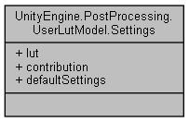

### Public Attributes

Texture2D **lut**

float **contribution**

### Properties

static **Settings** **defaultSettings** [get]

### Member Data Documentation

#### float UnityEngine.PostProcessing.UserLutModel.Settings.contribution

#### Texture2D UnityEngine.PostProcessing.UserLutModel.Settings.lut

### Property Documentation

#### Settings UnityEngine.PostProcessing.UserLutModel.Settings.defaultSettings[static], [get]

#### The documentation for this struct was generated from the following file:

C:/_SSDSPEEDUP/2021/clone/gps1_manadesigner/GPS1-Manadesigner/Assets/Samples/Input System/1.0.2/Tanks Demo/TanksDemo/PostProcessing/Runtime/Models/**UserLutModel.cs**

## UnityEngine.PostProcessing.VignetteModel.Settings Struct Reference

Collaboration diagram for UnityEngine.PostProcessing.VignetteModel.Settings:

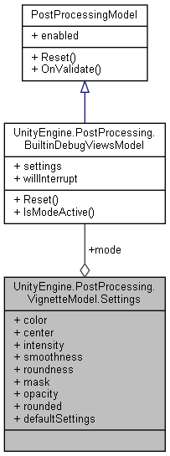

### Public Attributes

**Mode** **mode**

Color **color**

Vector2 **center**

float **intensity**

float **smoothness**

float **roundness**

Texture **mask**

float **opacity**

bool **rounded**

### Properties

static **Settings** **defaultSettings** [get]

### Member Data Documentation

#### Vector2 UnityEngine.PostProcessing.VignetteModel.Settings.center

#### Color UnityEngine.PostProcessing.VignetteModel.Settings.color

#### float UnityEngine.PostProcessing.VignetteModel.Settings.intensity

#### Texture UnityEngine.PostProcessing.VignetteModel.Settings.mask

#### Mode UnityEngine.PostProcessing.VignetteModel.Settings.mode

#### float UnityEngine.PostProcessing.VignetteModel.Settings.opacity

#### bool UnityEngine.PostProcessing.VignetteModel.Settings.rounded

#### float UnityEngine.PostProcessing.VignetteModel.Settings.roundness

#### float UnityEngine.PostProcessing.VignetteModel.Settings.smoothness

### Property Documentation

#### Settings UnityEngine.PostProcessing.VignetteModel.Settings.defaultSettings[static], [get]

#### The documentation for this struct was generated from the following file:

C:/_SSDSPEEDUP/2021/clone/gps1_manadesigner/GPS1-Manadesigner/Assets/Samples/Input System/1.0.2/Tanks Demo/TanksDemo/PostProcessing/Runtime/Models/**VignetteModel.cs**

## ShellExplosion Class Reference

Inheritance diagram for ShellExplosion:

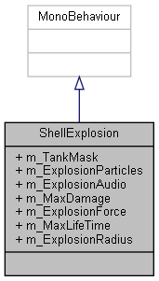

Collaboration diagram for ShellExplosion:



### Public Attributes

LayerMask **m_TankMask**

ParticleSystem **m_ExplosionParticles**

AudioSource **m_ExplosionAudio**

float **m_MaxDamage** = 100f

float **m_ExplosionForce** = 1000f

float **m_MaxLifeTime** = 2f

float **m_ExplosionRadius** = 5f

### Member Data Documentation

#### AudioSource ShellExplosion.m_ExplosionAudio

#### float ShellExplosion.m_ExplosionForce = 1000f

#### ParticleSystem ShellExplosion.m_ExplosionParticles

#### float ShellExplosion.m_ExplosionRadius = 5f

#### float ShellExplosion.m_MaxDamage = 100f

#### float ShellExplosion.m_MaxLifeTime = 2f

#### LayerMask ShellExplosion.m_TankMask

#### The documentation for this class was generated from the following file:

C:/_SSDSPEEDUP/2021/clone/gps1_manadesigner/GPS1-Manadesigner/Assets/Samples/Input System/1.0.2/Tanks Demo/TanksDemo/Scripts/Shell/**ShellExplosion.cs**

## SimpleController_UsingActionAsset Class Reference

Inheritance diagram for SimpleController_UsingActionAsset:

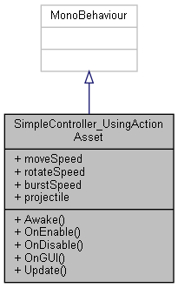

Collaboration diagram for SimpleController_UsingActionAsset:



### Public Member Functions

void **Awake** ()

void **OnEnable** ()

void **OnDisable** ()

void **OnGUI** ()

void **Update** ()

### Public Attributes

float **moveSpeed**

float **rotateSpeed**

float **burstSpeed**

GameObject **projectile**

### Member Function Documentation

#### void SimpleController_UsingActionAsset.Awake ()

#### void SimpleController_UsingActionAsset.OnDisable ()

Here is the call graph for this function:

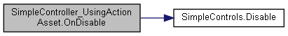

#### void SimpleController_UsingActionAsset.OnEnable ()

Here is the call graph for this function:

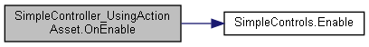

#### void SimpleController_UsingActionAsset.OnGUI ()

#### void SimpleController_UsingActionAsset.Update ()

### Member Data Documentation

#### float SimpleController_UsingActionAsset.burstSpeed

#### float SimpleController_UsingActionAsset.moveSpeed

#### GameObject SimpleController_UsingActionAsset.projectile

#### float SimpleController_UsingActionAsset.rotateSpeed

#### The documentation for this class was generated from the following file:

C:/_SSDSPEEDUP/2021/clone/gps1_manadesigner/GPS1-Manadesigner/Assets/Samples/Input System/1.0.2/Simple Demo/**SimpleController_UsingActionAsset.cs**

## SimpleController_UsingActions Class Reference

Inheritance diagram for SimpleController_UsingActions:

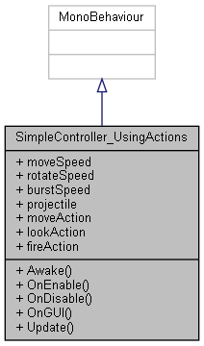

Collaboration diagram for SimpleController_UsingActions:



### Public Member Functions

void **Awake** ()

void **OnEnable** ()

void **OnDisable** ()

void **OnGUI** ()

void **Update** ()

### Public Attributes

float **moveSpeed**

float **rotateSpeed**

float **burstSpeed**

GameObject **projectile**

InputAction **moveAction**

InputAction **lookAction**

InputAction **fireAction**

### Member Function Documentation

#### void SimpleController_UsingActions.Awake ()

#### void SimpleController_UsingActions.OnDisable ()

#### void SimpleController_UsingActions.OnEnable ()

#### void SimpleController_UsingActions.OnGUI ()

#### void SimpleController_UsingActions.Update ()

### Member Data Documentation

#### float SimpleController_UsingActions.burstSpeed

#### InputAction SimpleController_UsingActions.fireAction

#### InputAction SimpleController_UsingActions.lookAction

#### InputAction SimpleController_UsingActions.moveAction

#### float SimpleController_UsingActions.moveSpeed

#### GameObject SimpleController_UsingActions.projectile

#### float SimpleController_UsingActions.rotateSpeed

#### The documentation for this class was generated from the following file:

C:/_SSDSPEEDUP/2021/clone/gps1_manadesigner/GPS1-Manadesigner/Assets/Samples/Input System/1.0.2/Simple Demo/**SimpleController_UsingActions.cs**

## SimpleController_UsingPlayerInput Class Reference

Inheritance diagram for SimpleController_UsingPlayerInput:

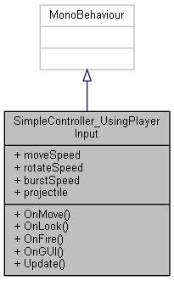

Collaboration diagram for SimpleController_UsingPlayerInput:



### Public Member Functions

void **OnMove** (InputAction.CallbackContext context)

void **OnLook** (InputAction.CallbackContext context)

void **OnFire** (InputAction.CallbackContext context)

void **OnGUI** ()

void **Update** ()

### Public Attributes

float **moveSpeed**

float **rotateSpeed**

float **burstSpeed**

GameObject **projectile**

### Member Function Documentation

#### void SimpleController_UsingPlayerInput.OnFire (InputAction.CallbackContext *context*)

#### void SimpleController_UsingPlayerInput.OnGUI ()

#### void SimpleController_UsingPlayerInput.OnLook (InputAction.CallbackContext *context*)

#### void SimpleController_UsingPlayerInput.OnMove (InputAction.CallbackContext *context*)

#### void SimpleController_UsingPlayerInput.Update ()

### Member Data Documentation

#### float SimpleController_UsingPlayerInput.burstSpeed

#### float SimpleController_UsingPlayerInput.moveSpeed

#### GameObject SimpleController_UsingPlayerInput.projectile

#### float SimpleController_UsingPlayerInput.rotateSpeed

#### The documentation for this class was generated from the following file:

C:/_SSDSPEEDUP/2021/clone/gps1_manadesigner/GPS1-Manadesigner/Assets/Samples/Input System/1.0.2/Simple Demo/**SimpleController_UsingPlayerInput.cs**

## SimpleController_UsingState Class Reference

Inheritance diagram for SimpleController_UsingState:

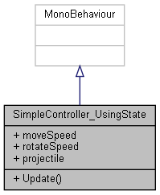

Collaboration diagram for SimpleController_UsingState:



### Public Member Functions

void **Update** ()

### Public Attributes

float **moveSpeed**

float **rotateSpeed**

GameObject **projectile**

### Member Function Documentation

#### void SimpleController_UsingState.Update ()

### Member Data Documentation

#### float SimpleController_UsingState.moveSpeed

#### GameObject SimpleController_UsingState.projectile

#### float SimpleController_UsingState.rotateSpeed

#### The documentation for this class was generated from the following file:

C:/_SSDSPEEDUP/2021/clone/gps1_manadesigner/GPS1-Manadesigner/Assets/Samples/Input System/1.0.2/Simple Demo/**SimpleController_UsingState.cs**

## SimpleControls Class Reference

Inheritance diagram for SimpleControls:

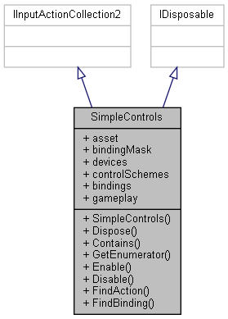

Collaboration diagram for SimpleControls:



### Classes

struct **GameplayActions**

interface **IGameplayActions**

### Public Member Functions

**SimpleControls** ()

void **Dispose** ()

bool **Contains** (InputAction action)

IEnumerator< InputAction > **GetEnumerator** ()

void **Enable** ()

void **Disable** ()

InputAction **FindAction** (string actionNameOrId, bool throwIfNotFound=false)

int **FindBinding** (InputBinding **bindingMask**, out InputAction action)

### Properties

InputActionAsset **asset** [get]

InputBinding? **bindingMask** [getset]

ReadOnlyArray< InputDevice >? **devices** [getset]

ReadOnlyArray< InputControlScheme > **controlSchemes** [get]

IEnumerable< InputBinding > **bindings** [get]

**GameplayActions** **gameplay** [get]

### Constructor & Destructor Documentation

#### SimpleControls.SimpleControls ()

### Member Function Documentation

#### bool SimpleControls.Contains (InputAction *action*)

#### void SimpleControls.Disable ()

Here is the caller graph for this function:

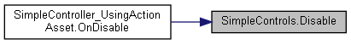

#### void SimpleControls.Dispose ()

#### void SimpleControls.Enable ()

Here is the caller graph for this function:

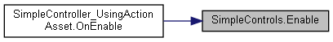

#### InputAction SimpleControls.FindAction (string *actionNameOrId*, bool *throwIfNotFound* = false)

#### int SimpleControls.FindBinding (InputBinding *bindingMask*, out InputAction *action*)

#### IEnumerator< InputAction > SimpleControls.GetEnumerator ()

### Property Documentation

#### InputActionAsset SimpleControls.asset[get]

#### InputBinding? SimpleControls.bindingMask[get], [set]

#### IEnumerable<InputBinding> SimpleControls.bindings[get]

#### ReadOnlyArray<InputControlScheme> SimpleControls.controlSchemes[get]

#### ReadOnlyArray<InputDevice>? SimpleControls.devices[get], [set]

#### GameplayActions SimpleControls.gameplay[get]

#### The documentation for this class was generated from the following file:

C:/_SSDSPEEDUP/2021/clone/gps1_manadesigner/GPS1-Manadesigner/Assets/Samples/Input System/1.0.2/Simple Demo/**SimpleControls.cs**

## SimpleMultiplayerPlayer Class Reference

Inheritance diagram for SimpleMultiplayerPlayer:

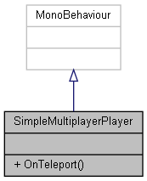

Collaboration diagram for SimpleMultiplayerPlayer:



### Public Member Functions

void **OnTeleport** ()

### Member Function Documentation

#### void SimpleMultiplayerPlayer.OnTeleport ()

#### The documentation for this class was generated from the following file:

C:/_SSDSPEEDUP/2021/clone/gps1_manadesigner/GPS1-Manadesigner/Assets/Samples/Input System/1.0.2/Simple Multiplayer/**SimpleMultiplayerPlayer.cs**

## Singleton< T > Class Template Reference

Inheritance diagram for Singleton< T >:

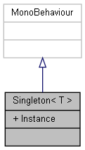

Collaboration diagram for Singleton< T >:



### Properties

static T **Instance** [get]

### Property Documentation

#### T Singleton< T >.Instance[static], [get]

#### The documentation for this class was generated from the following file:

C:/_SSDSPEEDUP/2021/clone/gps1_manadesigner/GPS1-Manadesigner/Assets/_UtilsV0.4/MyScripts/_Utils/_CommonV0.2/Monobehavior/BaseClass/**Singleton.cs**

## SingleTonOnClickHelper Class Reference

Inheritance diagram for SingleTonOnClickHelper:

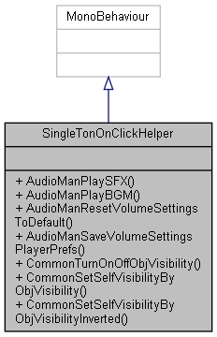

Collaboration diagram for SingleTonOnClickHelper:



### Public Member Functions

void **AudioManPlaySFX** (string name)

void **AudioManPlayBGM** (string name)

void **AudioManResetVolumeSettingsToDefault** ()

void **AudioManSaveVolumeSettingsPlayerPrefs** ()

void **CommonTurnOnOffObjVisibility** (GameObject obj)

void **CommonSetSelfVisibilityByObjVisibility** (GameObject obj)

void **CommonSetSelfVisibilityByObjVisibilityInverted** (GameObject obj)

### Member Function Documentation

#### void SingleTonOnClickHelper.AudioManPlayBGM (string *name*)

Here is the call graph for this function:

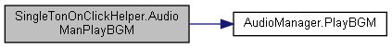

#### void SingleTonOnClickHelper.AudioManPlaySFX (string *name*)

Here is the call graph for this function:

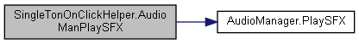

#### void SingleTonOnClickHelper.AudioManResetVolumeSettingsToDefault ()

Here is the call graph for this function:

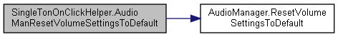

#### void SingleTonOnClickHelper.AudioManSaveVolumeSettingsPlayerPrefs ()

Here is the call graph for this function:



#### void SingleTonOnClickHelper.CommonSetSelfVisibilityByObjVisibility (GameObject *obj*)

#### void SingleTonOnClickHelper.CommonSetSelfVisibilityByObjVisibilityInverted (GameObject *obj*)

#### void SingleTonOnClickHelper.CommonTurnOnOffObjVisibility (GameObject *obj*)

#### The documentation for this class was generated from the following file:

C:/_SSDSPEEDUP/2021/clone/gps1_manadesigner/GPS1-Manadesigner/Assets/_UtilsV0.4/MyScripts/_Utils/_CommonV0.2/UICanvas/Helper/**SingleTonOnClickHelper.cs**

## Sound Class Reference

Collaboration diagram for Sound:

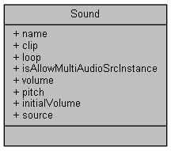

### Public Attributes

string **name**

AudioClip **clip**

bool **loop** = false

bool **isAllowMultiAudioSrcInstance** = false

float **volume** = 1f

float **pitch** = 1f

float **initialVolume**

AudioSource **source**

### Member Data Documentation

#### AudioClip Sound.clip

#### float Sound.initialVolume

#### bool Sound.isAllowMultiAudioSrcInstance = false

#### bool Sound.loop = false

#### string Sound.name

#### float Sound.pitch = 1f

#### AudioSource Sound.source

#### float Sound.volume = 1f

#### The documentation for this class was generated from the following file:

C:/_SSDSPEEDUP/2021/clone/gps1_manadesigner/GPS1-Manadesigner/Assets/_UtilsV0.4/MyScripts/_Utils/_CommonV0.2/Singletons/**Sound.cs**

## SpawnFlockManager Class Reference

Inheritance diagram for SpawnFlockManager:

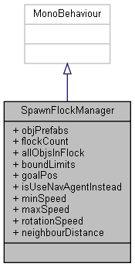

Collaboration diagram for SpawnFlockManager:



### Public Attributes

GameObject[] **objPrefabs**

int **flockCount**

List< GameObject > **allObjsInFlock**

Vector3 **boundLimits** = new Vector3(5, 5, 5)

Vector3 **goalPos**

bool **isUseNavAgentInstead**

float **minSpeed**

float **maxSpeed**

float **rotationSpeed** = 4.0f

float **neighbourDistance** = 3f

### Member Data Documentation

#### List<GameObject> SpawnFlockManager.allObjsInFlock

#### Vector3 SpawnFlockManager.boundLimits = new Vector3(5, 5, 5)

#### int SpawnFlockManager.flockCount

#### Vector3 SpawnFlockManager.goalPos

#### bool SpawnFlockManager.isUseNavAgentInstead

#### float SpawnFlockManager.maxSpeed

#### float SpawnFlockManager.minSpeed

#### float SpawnFlockManager.neighbourDistance = 3f

#### GameObject [] SpawnFlockManager.objPrefabs

#### float SpawnFlockManager.rotationSpeed = 4.0f

#### The documentation for this class was generated from the following file:

C:/_SSDSPEEDUP/2021/clone/gps1_manadesigner/GPS1-Manadesigner/Assets/_UtilsV0.4/MyScripts/_Utils/__Experimental/AIApproach/General/Unique/**SpawnFlockManager.cs**

## Stat Class Reference

Collaboration diagram for Stat:

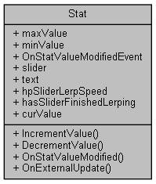

### Public Member Functions

int **IncrementValue** (int incrementVal)

int **DecrementValue** (int decrementVal)

void **OnStatValueModified** ()

void **OnExternalUpdate** ()

### Public Attributes

int **maxValue**

int **minValue** = 0

UnityEvent **OnStatValueModifiedEvent**

Slider **slider**

TextMeshProUGUI **text**

float **hpSliderLerpSpeed** = 0.95f

bool **hasSliderFinishedLerping**

### Properties

virtual int **curValue** [getset]

### Member Function Documentation

#### int Stat.DecrementValue (int *decrementVal*)

Here is the call graph for this function:



#### int Stat.IncrementValue (int *incrementVal*)

Here is the call graph for this function:



#### void Stat.OnExternalUpdate ()

#### void Stat.OnStatValueModified ()

Here is the caller graph for this function:

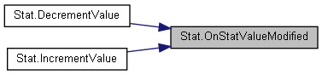

### Member Data Documentation

#### bool Stat.hasSliderFinishedLerping

#### float Stat.hpSliderLerpSpeed = 0.95f

#### int Stat.maxValue

#### int Stat.minValue = 0

#### UnityEvent Stat.OnStatValueModifiedEvent

#### Slider Stat.slider

#### TextMeshProUGUI Stat.text

### Property Documentation

#### virtual int Stat.curValue[get], [set]

#### The documentation for this class was generated from the following file:

C:/_SSDSPEEDUP/2021/clone/gps1_manadesigner/GPS1-Manadesigner/Assets/_UtilsV0.4/MyScripts/_Utils/__Experimental/**Stat.cs**

## StdioCommon Class Reference

Collaboration diagram for StdioCommon:

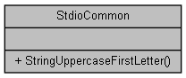

### Static Public Member Functions

static string **StringUppercaseFirstLetter** (string str)

### Member Function Documentation

#### static string StdioCommon.StringUppercaseFirstLetter (string *str*)[static]

#### The documentation for this class was generated from the following file:

C:/_SSDSPEEDUP/2021/clone/gps1_manadesigner/GPS1-Manadesigner/Assets/_UtilsV0.4/MyScripts/_Utils/_CommonV0.2/Calculation/**StdioCommon.cs**

## storage Class Reference

Inheritance diagram for storage:

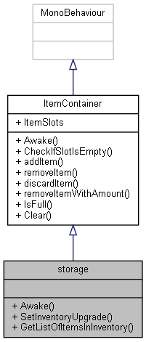

Collaboration diagram for storage:



### Public Member Functions

override void **Awake** ()

void **SetInventoryUpgrade** (**Inventory** inventoryUpgrade)

List< **itemSlots** > **GetListOfItemsInInventory** ()

### Additional Inherited Members

### Member Function Documentation

#### override void storage.Awake ()[virtual]

Reimplemented from **ItemContainer** (*p.426*).

Here is the call graph for this function:



#### List< itemSlots > storage.GetListOfItemsInInventory ()

Here is the caller graph for this function:

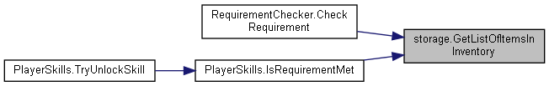

#### void storage.SetInventoryUpgrade (Inventory *inventoryUpgrade*)

Here is the call graph for this function:



Here is the caller graph for this function:

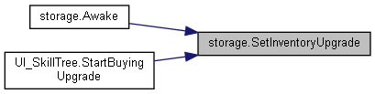

#### The documentation for this class was generated from the following file:

C:/_SSDSPEEDUP/2021/clone/gps1_manadesigner/GPS1-Manadesigner/Assets/Scripts/InventoryScripts/**storage.cs**

## SyncTextWithTextMeshPro Class Reference

Inheritance diagram for SyncTextWithTextMeshPro:

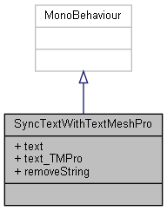

Collaboration diagram for SyncTextWithTextMeshPro:

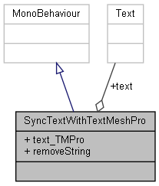

### Public Attributes

Text **text**

TextMeshProUGUI **text_TMPro**

string **removeString**

### Member Data Documentation

#### string SyncTextWithTextMeshPro.removeString

#### Text SyncTextWithTextMeshPro.text

#### TextMeshProUGUI SyncTextWithTextMeshPro.text_TMPro

#### The documentation for this class was generated from the following file:

C:/_SSDSPEEDUP/2021/clone/gps1_manadesigner/GPS1-Manadesigner/Assets/_UtilsV0.4/MyScripts/_Utils/_CommonV0.2/UICanvas/**SyncTextWithTextMeshPro.cs**

## UnityEngine.PostProcessing.TaaComponent Class Reference

Inheritance diagram for UnityEngine.PostProcessing.TaaComponent:

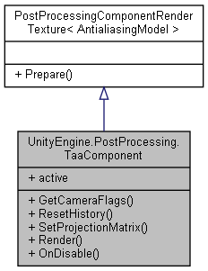

Collaboration diagram for UnityEngine.PostProcessing.TaaComponent:



### Public Member Functions

override DepthTextureMode **GetCameraFlags** ()

void **ResetHistory** ()

void **SetProjectionMatrix** (Func< Vector2, Matrix4x4 > jitteredFunc)

void **Render** (RenderTexture source, RenderTexture destination)

override void **OnDisable** ()

### Properties

override bool **active** [get]

### Member Function Documentation

#### override DepthTextureMode UnityEngine.PostProcessing.TaaComponent.GetCameraFlags ()

#### override void UnityEngine.PostProcessing.TaaComponent.OnDisable ()

Here is the call graph for this function:

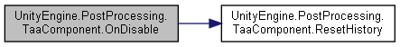

#### void UnityEngine.PostProcessing.TaaComponent.Render (RenderTexture *source*, RenderTexture *destination*)

Here is the call graph for this function:

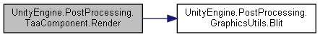

#### void UnityEngine.PostProcessing.TaaComponent.ResetHistory ()

Here is the caller graph for this function:

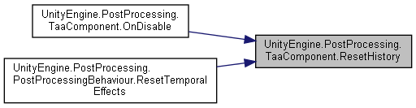

#### void UnityEngine.PostProcessing.TaaComponent.SetProjectionMatrix (Func< Vector2, Matrix4x4 > *jitteredFunc*)

### Property Documentation

#### override bool UnityEngine.PostProcessing.TaaComponent.active[get]

#### The documentation for this class was generated from the following file:

C:/_SSDSPEEDUP/2021/clone/gps1_manadesigner/GPS1-Manadesigner/Assets/Samples/Input System/1.0.2/Tanks Demo/TanksDemo/PostProcessing/Runtime/Components/**TaaComponent.cs**

## UnityEngine.PostProcessing.AntialiasingModel.TaaSettings Struct Reference

Collaboration diagram for UnityEngine.PostProcessing.AntialiasingModel.TaaSettings:

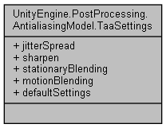

### Public Attributes

float **jitterSpread**

float **sharpen**

float **stationaryBlending**

float **motionBlending**

### Properties

static **TaaSettings** **defaultSettings** [get]

### Member Data Documentation

#### float UnityEngine.PostProcessing.AntialiasingModel.TaaSettings.jitterSpread

#### float UnityEngine.PostProcessing.AntialiasingModel.TaaSettings.motionBlending

#### float UnityEngine.PostProcessing.AntialiasingModel.TaaSettings.sharpen

#### float UnityEngine.PostProcessing.AntialiasingModel.TaaSettings.stationaryBlending

### Property Documentation

#### TaaSettings UnityEngine.PostProcessing.AntialiasingModel.TaaSettings.defaultSettings[static], [get]

#### The documentation for this struct was generated from the following file:

C:/_SSDSPEEDUP/2021/clone/gps1_manadesigner/GPS1-Manadesigner/Assets/Samples/Input System/1.0.2/Tanks Demo/TanksDemo/PostProcessing/Runtime/Models/**AntialiasingModel.cs**

## TankHealth Class Reference

Inheritance diagram for TankHealth:

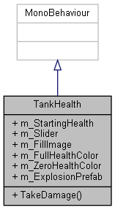

Collaboration diagram for TankHealth:



### Public Member Functions

void **TakeDamage** (float amount)

### Public Attributes

float **m_StartingHealth** = 100f

Slider **m_Slider**

Image **m_FillImage**

Color **m_FullHealthColor** = Color.green

Color **m_ZeroHealthColor** = Color.red

GameObject **m_ExplosionPrefab**

### Member Function Documentation

#### void TankHealth.TakeDamage (float *amount*)

### Member Data Documentation

#### GameObject TankHealth.m_ExplosionPrefab

#### Image TankHealth.m_FillImage

#### Color TankHealth.m_FullHealthColor = Color.green

#### Slider TankHealth.m_Slider

#### float TankHealth.m_StartingHealth = 100f

#### Color TankHealth.m_ZeroHealthColor = Color.red

#### The documentation for this class was generated from the following file:

C:/_SSDSPEEDUP/2021/clone/gps1_manadesigner/GPS1-Manadesigner/Assets/Samples/Input System/1.0.2/Tanks Demo/TanksDemo/Scripts/Tank/**TankHealth.cs**

## TankManager Class Reference

Collaboration diagram for TankManager:

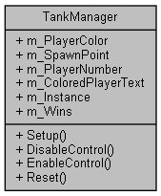

### Public Member Functions

void **Setup** ()

void **DisableControl** ()

void **EnableControl** ()

void **Reset** ()

### Public Attributes

Color **m_PlayerColor**

Transform **m_SpawnPoint**

int **m_PlayerNumber**

string **m_ColoredPlayerText**

GameObject **m_Instance**

int **m_Wins**

### Member Function Documentation

#### void TankManager.DisableControl ()

#### void TankManager.EnableControl ()

#### void TankManager.Reset ()

#### void TankManager.Setup ()

### Member Data Documentation

#### string TankManager.m_ColoredPlayerText

#### GameObject TankManager.m_Instance

#### Color TankManager.m_PlayerColor

#### int TankManager.m_PlayerNumber

#### Transform TankManager.m_SpawnPoint

#### int TankManager.m_Wins

#### The documentation for this class was generated from the following file:

C:/_SSDSPEEDUP/2021/clone/gps1_manadesigner/GPS1-Manadesigner/Assets/Samples/Input System/1.0.2/Tanks Demo/TanksDemo/Scripts/Managers/**TankManager.cs**

## TankMovement Class Reference

Inheritance diagram for TankMovement:

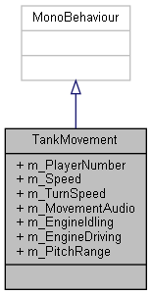

Collaboration diagram for TankMovement:



### Public Attributes

int **m_PlayerNumber** = 1

float **m_Speed** = 12f

float **m_TurnSpeed** = 180f

AudioSource **m_MovementAudio**

AudioClip **m_EngineIdling**

AudioClip **m_EngineDriving**

float **m_PitchRange** = 0.2f

### Member Data Documentation

#### AudioClip TankMovement.m_EngineDriving

#### AudioClip TankMovement.m_EngineIdling

#### AudioSource TankMovement.m_MovementAudio

#### float TankMovement.m_PitchRange = 0.2f

#### int TankMovement.m_PlayerNumber = 1

#### float TankMovement.m_Speed = 12f

#### float TankMovement.m_TurnSpeed = 180f

#### The documentation for this class was generated from the following file:

C:/_SSDSPEEDUP/2021/clone/gps1_manadesigner/GPS1-Manadesigner/Assets/Samples/Input System/1.0.2/Tanks Demo/TanksDemo/Scripts/Tank/**TankMovement.cs**

## TankShooting Class Reference

Inheritance diagram for TankShooting:

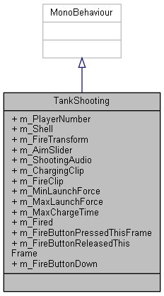

Collaboration diagram for TankShooting:



### Public Attributes

int **m_PlayerNumber** = 1

Rigidbody **m_Shell**

Transform **m_FireTransform**

Slider **m_AimSlider**

AudioSource **m_ShootingAudio**

AudioClip **m_ChargingClip**

AudioClip **m_FireClip**

float **m_MinLaunchForce** = 15f

float **m_MaxLaunchForce** = 30f

float **m_MaxChargeTime** = 0.75f

bool **m_Fired**

bool **m_FireButtonPressedThisFrame**

bool **m_FireButtonReleasedThisFrame**

bool **m_FireButtonDown**

### Member Data Documentation

#### Slider TankShooting.m_AimSlider

#### AudioClip TankShooting.m_ChargingClip

#### bool TankShooting.m_FireButtonDown

#### bool TankShooting.m_FireButtonPressedThisFrame

#### bool TankShooting.m_FireButtonReleasedThisFrame

#### AudioClip TankShooting.m_FireClip

#### bool TankShooting.m_Fired

#### Transform TankShooting.m_FireTransform

#### float TankShooting.m_MaxChargeTime = 0.75f

#### float TankShooting.m_MaxLaunchForce = 30f

#### float TankShooting.m_MinLaunchForce = 15f

#### int TankShooting.m_PlayerNumber = 1

#### Rigidbody TankShooting.m_Shell

#### AudioSource TankShooting.m_ShootingAudio

#### The documentation for this class was generated from the following file:

C:/_SSDSPEEDUP/2021/clone/gps1_manadesigner/GPS1-Manadesigner/Assets/Samples/Input System/1.0.2/Tanks Demo/TanksDemo/Scripts/Tank/**TankShooting.cs**

## TanksInputActions Class Reference

Inheritance diagram for TanksInputActions:

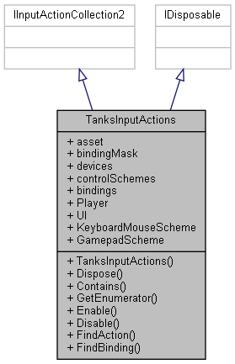

Collaboration diagram for TanksInputActions:



### Classes

interface **IPlayerActions**

interface **IUIActions**

struct **PlayerActions**

struct **UIActions**

### Public Member Functions

**TanksInputActions** ()

void **Dispose** ()

bool **Contains** (InputAction action)

IEnumerator< InputAction > **GetEnumerator** ()

void **Enable** ()

void **Disable** ()

InputAction **FindAction** (string actionNameOrId, bool throwIfNotFound=false)

int **FindBinding** (InputBinding **bindingMask**, out InputAction action)

### Properties

InputActionAsset **asset** [get]

InputBinding? **bindingMask** [getset]

ReadOnlyArray< InputDevice >? **devices** [getset]

ReadOnlyArray< InputControlScheme > **controlSchemes** [get]

IEnumerable< InputBinding > **bindings** [get]

**PlayerActions** **Player** [get]

**UIActions** **UI** [get]

InputControlScheme **KeyboardMouseScheme** [get]

InputControlScheme **GamepadScheme** [get]

### Constructor & Destructor Documentation

#### TanksInputActions.TanksInputActions ()

### Member Function Documentation

#### bool TanksInputActions.Contains (InputAction *action*)

#### void TanksInputActions.Disable ()

#### void TanksInputActions.Dispose ()

#### void TanksInputActions.Enable ()

#### InputAction TanksInputActions.FindAction (string *actionNameOrId*, bool *throwIfNotFound* = false)

#### int TanksInputActions.FindBinding (InputBinding *bindingMask*, out InputAction *action*)

#### IEnumerator< InputAction > TanksInputActions.GetEnumerator ()

### Property Documentation

#### InputActionAsset TanksInputActions.asset[get]

#### InputBinding? TanksInputActions.bindingMask[get], [set]

#### IEnumerable<InputBinding> TanksInputActions.bindings[get]

#### ReadOnlyArray<InputControlScheme> TanksInputActions.controlSchemes[get]

#### ReadOnlyArray<InputDevice>? TanksInputActions.devices[get], [set]

#### InputControlScheme TanksInputActions.GamepadScheme[get]

#### InputControlScheme TanksInputActions.KeyboardMouseScheme[get]

#### PlayerActions TanksInputActions.Player[get]

#### UIActions TanksInputActions.UI[get]

#### The documentation for this class was generated from the following file:

C:/_SSDSPEEDUP/2021/clone/gps1_manadesigner/GPS1-Manadesigner/Assets/Samples/Input System/1.0.2/Tanks Demo/TanksDemo/**TanksInputActions.cs**

## TestDialogue Class Reference

Inheritance diagram for TestDialogue:

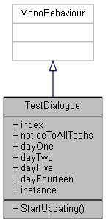

Collaboration diagram for TestDialogue:

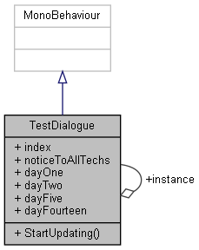

### Public Member Functions

void **StartUpdating** ()

### Public Attributes

int **index** = 0

string **noticeToAllTechs** = "Leave the last element in every dialogue boxes empty or there'll be an **index** boundary error."

string[] **dayOne**

string[] **dayTwo**

string[] **dayFive**

string[] **dayFourteen**

### Static Public Attributes

static **TestDialogue** **instance**

### Member Function Documentation

#### void TestDialogue.StartUpdating ()

Here is the call graph for this function:

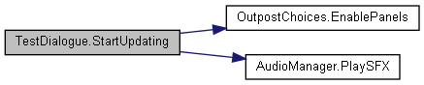

### Member Data Documentation

#### string [] TestDialogue.dayFive

**Initial value:**= new string[]

{

"Oh, hmm. Things have been… hectic around here. :Liam",

"Liam looks tired, as if he hasn’t had a good night’s sleep lately. :You",

"Research has been coming along well at least. Good progress. We’re catching up with them. :Liam",

"A long breath of relief escapes from him. :You",

"Liam takes out his clipboard and looks through a few papers.",

"They’re almost at the end of the Continental Region. :Liam",

" "

}

#### string [] TestDialogue.dayFourteen

**Initial value:**= new string[]

{

"Well, it’s the final day. :Liam McCoy",

"Liam’s voice is stoic despite the exhaustion weighing him down. :",

"He takes out his clipboard, but he doesn’t even look at it to know what to say next.",

"It’s approximately 20 hours before they reach the bottom. Maybe even less. :Liam McCoy",

"His eyes stare intensely into yours. : ",

"It’s now or never. This is your last shot. :Liam McCoy",

"Liam claps a hand on your shoulder, firmly. : ",

"Go out there and prove that you’re really the Navy’s finest. : Liam McCoy",

" "

}

#### string [] TestDialogue.dayOne

**Initial value:**= new string[]

{

"As you enter the room you were in the day before, you see Liam pacing around frantically. :You",

"There you are, finally! :Liam",

"He doesn’t seem to be very happy. :You",

"You’re not late, are you? You ask Liam.",

"No, no, it’s-- ugh. :Liam",

"It’s clear that he’s stressed out of his mind, restless feet walking back and forth, restless fingers clicking on his pen. :You",

"The USSR. We’ve just received intel they’re inbound to the bottom in 14 days. 14 days! That’s barely enough time to do anything. I was expecting soon, but- :Liam",

"The panic in his voice is thick, so unlike what you’ve seen of him yesterday. :You",

"You try reassuring him that you’ll do your best, and this calms him, somewhat.",

"Okay. Okay. :Liam",

"Liam takes a deep breath and gathers his composure. Then, he stares straight into your eyes, deathly serious. :You",

"If you’re really the Navy’s top diver, then you better start now if we’re going to stand a chance. :Liam",

"You tell him that you’ve got this and hurriedly get changed into your gear. :You",

"Liam clasps a firm grip onto your shoulder, and nudges you towards the submarine docking station.",

"We’re counting on you. :Liam",

" "

}

#### string [] TestDialogue.dayTwo

**Initial value:**= new string[]

{

"Well, not much to update, really. The USSR is making steady progress. :Liam",

"With the current projections and the speed they’re going, they’ll reach there in 2 weeks, as we’ve speculated.",

"Maybe even less.",

"Liam lets out an exhausted sigh. The news has taken a toll on him. :You",

"There’s no point worrying about this, in any case. We’ll do what we have to do. :Liam",

"He’s extremely bad at hiding his worry, even with his arms folded. A lone finger taps against his arm in apprehensive energy. :You",

"Just keep at it with what you’re doing, and we’ll be fine. :Liam",

"Liam looks at you, a subtle expression of concern mingled with a hint of hope. :You",

" "

}

#### int TestDialogue.index = 0

#### TestDialogue TestDialogue.instance[static]

#### string TestDialogue.noticeToAllTechs = "Leave the last element in every dialogue boxes empty or there'll be an index boundary error."

#### The documentation for this class was generated from the following file:

C:/_SSDSPEEDUP/2021/clone/gps1_manadesigner/GPS1-Manadesigner/Assets/Scripts/Stage Scripts/Outpost/Dialogues/**TestDialogue.cs**

## Testing Class Reference

Inheritance diagram for Testing:

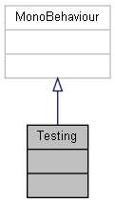

Collaboration diagram for Testing:



The documentation for this class was generated from the following file:

C:/_SSDSPEEDUP/2021/clone/gps1_manadesigner/GPS1-Manadesigner/Assets/Scripts/Arif's Test Scripts/Skill Tree/**Testing.cs**

## TextAnimation Class Reference

Inheritance diagram for TextAnimation:

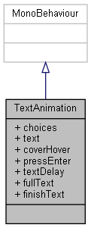

Collaboration diagram for TextAnimation:



### Public Attributes

GameObject **choices**

GameObject **text**

GameObject **coverHover**

GameObject **pressEnter**

float **textDelay** = 0.1f

string **fullText**

bool **finishText** = false

### Member Data Documentation

#### GameObject TextAnimation.choices

#### GameObject TextAnimation.coverHover

#### bool TextAnimation.finishText = false

#### string TextAnimation.fullText

#### GameObject TextAnimation.pressEnter

#### GameObject TextAnimation.text

#### float TextAnimation.textDelay = 0.1f

#### The documentation for this class was generated from the following file:

C:/_SSDSPEEDUP/2021/clone/gps1_manadesigner/GPS1-Manadesigner/Assets/Scripts/Stage Scripts/Outpost/Dialogues/**TextAnimation.cs**

## TimedParamStateBehavior Class Reference

Inheritance diagram for TimedParamStateBehavior:

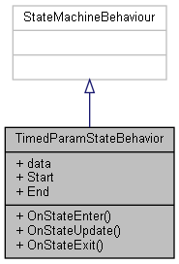

Collaboration diagram for TimedParamStateBehavior:

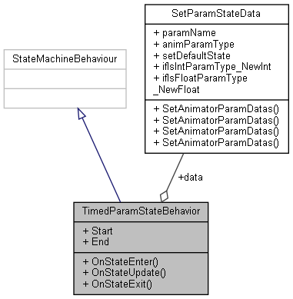

### Public Member Functions

override void **OnStateEnter** (Animator animator, AnimatorStateInfo stateInfo, int layerIndex)

override void **OnStateUpdate** (Animator animator, AnimatorStateInfo stateInfo, int layerIndex)

override void **OnStateExit** (Animator animator, AnimatorStateInfo stateInfo, int layerIndex)

### Public Attributes

**SetParamStateData** **data**

float **Start**

float **End**

### Member Function Documentation

#### override void TimedParamStateBehavior.OnStateEnter (Animator *animator*, AnimatorStateInfo *stateInfo*, int *layerIndex*)

Here is the call graph for this function:

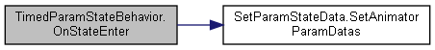

#### override void TimedParamStateBehavior.OnStateExit (Animator *animator*, AnimatorStateInfo *stateInfo*, int *layerIndex*)

Here is the call graph for this function:

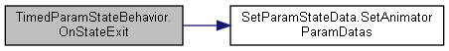

#### override void TimedParamStateBehavior.OnStateUpdate (Animator *animator*, AnimatorStateInfo *stateInfo*, int *layerIndex*)

Here is the call graph for this function:

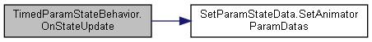

### Member Data Documentation

#### SetParamStateData TimedParamStateBehavior.data

#### float TimedParamStateBehavior.End

#### float TimedParamStateBehavior.Start

#### The documentation for this class was generated from the following file:

C:/_SSDSPEEDUP/2021/clone/gps1_manadesigner/GPS1-Manadesigner/Assets/_UtilsV0.4/MyScripts/_Utils/_CommonV0.2/Animator/**TimedParamStateBehavior.cs**

## UnityEngine.InputSystem.Samples.VisualizationHelpers.TimelineVisualizer Class Reference

Inheritance diagram for UnityEngine.InputSystem.Samples.VisualizationHelpers.TimelineVisualizer:

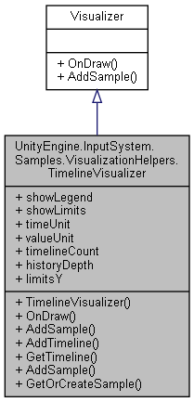

Collaboration diagram for UnityEngine.InputSystem.Samples.VisualizationHelpers.TimelineVisualizer:



### Public Types

enum **PlotType** { **LineGraph**, **BarChart** }

enum **TimeUnit** { **Seconds**, **Frames** }

### Public Member Functions

**TimelineVisualizer** (float totalTimeUnitsShown=4)

override void **OnDraw** (Rect rect)

override void **AddSample** (object value, double time)

int **AddTimeline** (string name, Color color, **PlotType** plotType=default)

int **GetTimeline** (string name)

void **AddSample** (int timelineIndex, PrimitiveValue value, float time)

ref PrimitiveValue **GetOrCreateSample** (int timelineIndex, int frame)

### Properties

bool **showLegend** [getset]

bool **showLimits** [getset]

**TimeUnit** **timeUnit** = **TimeUnit.Seconds** [getset]

GUIContent **valueUnit** [getset]

int **timelineCount** [get]

int **historyDepth** = 100 [getset]

Vector2 **limitsY** [getset]

### Member Enumeration Documentation

#### enum UnityEngine.InputSystem.Samples.VisualizationHelpers.TimelineVisualizer.PlotType

##### Enumerator:

|  |  |
| --- | --- |
| LineGraph |  |
| BarChart |  |

#### enum UnityEngine.InputSystem.Samples.VisualizationHelpers.TimelineVisualizer.TimeUnit

##### Enumerator:

|  |  |
| --- | --- |
| Seconds |  |
| Frames |  |

### Constructor & Destructor Documentation

#### UnityEngine.InputSystem.Samples.VisualizationHelpers.TimelineVisualizer.TimelineVisualizer (float *totalTimeUnitsShown* = 4)

### Member Function Documentation

#### void UnityEngine.InputSystem.Samples.VisualizationHelpers.TimelineVisualizer.AddSample (int *timelineIndex*, PrimitiveValue *value*, float *time*)

#### override void UnityEngine.InputSystem.Samples.VisualizationHelpers.TimelineVisualizer.AddSample (object *value*, double *time*)[virtual]

Implements **UnityEngine.InputSystem.Samples.VisualizationHelpers.Visualizer** (*p.847*).

Here is the call graph for this function:

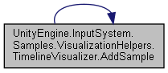

Here is the caller graph for this function:

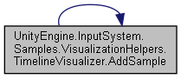

#### int UnityEngine.InputSystem.Samples.VisualizationHelpers.TimelineVisualizer.AddTimeline (string *name*, Color *color*, PlotType *plotType* = default)

#### ref PrimitiveValue UnityEngine.InputSystem.Samples.VisualizationHelpers.TimelineVisualizer.GetOrCreateSample (int *timelineIndex*, int *frame*)

#### int UnityEngine.InputSystem.Samples.VisualizationHelpers.TimelineVisualizer.GetTimeline (string *name*)

#### override void UnityEngine.InputSystem.Samples.VisualizationHelpers.TimelineVisualizer.OnDraw (Rect *rect*)[virtual]

Implements **UnityEngine.InputSystem.Samples.VisualizationHelpers.Visualizer** (*p.847*).

### Property Documentation

#### int UnityEngine.InputSystem.Samples.VisualizationHelpers.TimelineVisualizer.historyDepth = 100[get], [set]

#### Vector2 UnityEngine.InputSystem.Samples.VisualizationHelpers.TimelineVisualizer.limitsY[get], [set]

#### bool UnityEngine.InputSystem.Samples.VisualizationHelpers.TimelineVisualizer.showLegend[get], [set]

#### bool UnityEngine.InputSystem.Samples.VisualizationHelpers.TimelineVisualizer.showLimits[get], [set]

#### int UnityEngine.InputSystem.Samples.VisualizationHelpers.TimelineVisualizer.timelineCount[get]

#### TimeUnit UnityEngine.InputSystem.Samples.VisualizationHelpers.TimelineVisualizer.timeUnit = TimeUnit.Seconds[get], [set]

#### GUIContent UnityEngine.InputSystem.Samples.VisualizationHelpers.TimelineVisualizer.valueUnit[get], [set]

#### The documentation for this class was generated from the following file:

C:/_SSDSPEEDUP/2021/clone/gps1_manadesigner/GPS1-Manadesigner/Assets/Samples/Input System/1.0.2/Visualizers/**VisualizationHelpers.cs**

## UnityEngine.PostProcessing.ColorGradingModel.TonemappingSettings Struct Reference

Collaboration diagram for UnityEngine.PostProcessing.ColorGradingModel.TonemappingSettings:

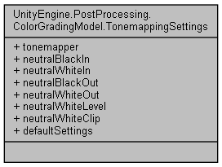

### Public Attributes

**Tonemapper** **tonemapper**

float **neutralBlackIn**

float **neutralWhiteIn**

float **neutralBlackOut**

float **neutralWhiteOut**

float **neutralWhiteLevel**

float **neutralWhiteClip**

### Properties

static **TonemappingSettings** **defaultSettings** [get]

### Member Data Documentation

#### float UnityEngine.PostProcessing.ColorGradingModel.TonemappingSettings.neutralBlackIn

#### float UnityEngine.PostProcessing.ColorGradingModel.TonemappingSettings.neutralBlackOut

#### float UnityEngine.PostProcessing.ColorGradingModel.TonemappingSettings.neutralWhiteClip

#### float UnityEngine.PostProcessing.ColorGradingModel.TonemappingSettings.neutralWhiteIn

#### float UnityEngine.PostProcessing.ColorGradingModel.TonemappingSettings.neutralWhiteLevel

#### float UnityEngine.PostProcessing.ColorGradingModel.TonemappingSettings.neutralWhiteOut

#### Tonemapper UnityEngine.PostProcessing.ColorGradingModel.TonemappingSettings.tonemapper

### Property Documentation

#### TonemappingSettings UnityEngine.PostProcessing.ColorGradingModel.TonemappingSettings.defaultSettings[static], [get]

#### The documentation for this struct was generated from the following file:

C:/_SSDSPEEDUP/2021/clone/gps1_manadesigner/GPS1-Manadesigner/Assets/Samples/Input System/1.0.2/Tanks Demo/TanksDemo/PostProcessing/Runtime/Models/**ColorGradingModel.cs**

## UnityEngine.PostProcessing.TrackballAttribute Class Reference

Inheritance diagram for UnityEngine.PostProcessing.TrackballAttribute:

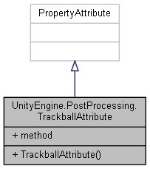

Collaboration diagram for UnityEngine.PostProcessing.TrackballAttribute:



### Public Member Functions

**TrackballAttribute** (string **method**)

### Public Attributes

readonly string **method**

### Constructor & Destructor Documentation

#### UnityEngine.PostProcessing.TrackballAttribute.TrackballAttribute (string *method*)

### Member Data Documentation

#### readonly string UnityEngine.PostProcessing.TrackballAttribute.method

#### The documentation for this class was generated from the following file:

C:/_SSDSPEEDUP/2021/clone/gps1_manadesigner/GPS1-Manadesigner/Assets/Samples/Input System/1.0.2/Tanks Demo/TanksDemo/PostProcessing/Runtime/Attributes/**TrackballAttribute.cs**

## UnityEngine.PostProcessing.TrackballGroupAttribute Class Reference

Inheritance diagram for UnityEngine.PostProcessing.TrackballGroupAttribute:

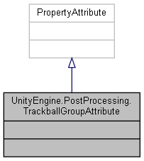

Collaboration diagram for UnityEngine.PostProcessing.TrackballGroupAttribute:



The documentation for this class was generated from the following file:

C:/_SSDSPEEDUP/2021/clone/gps1_manadesigner/GPS1-Manadesigner/Assets/Samples/Input System/1.0.2/Tanks Demo/TanksDemo/PostProcessing/Runtime/Attributes/**TrackballGroupAttribute.cs**

## Transform2DAutoLookAtObj2D Class Reference

Inheritance diagram for Transform2DAutoLookAtObj2D:

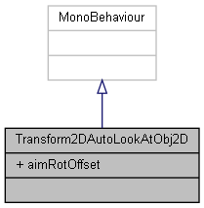

Collaboration diagram for Transform2DAutoLookAtObj2D:



### Public Attributes

float **aimRotOffset** = -90

### Member Data Documentation

#### float Transform2DAutoLookAtObj2D.aimRotOffset = -90

#### The documentation for this class was generated from the following file:

C:/_SSDSPEEDUP/2021/clone/gps1_manadesigner/GPS1-Manadesigner/Assets/_UtilsV0.4/MyScripts/_Utils/_CommonV0.2/CommonExtend/2D/**Transform2DAutoLookAtObj2D.cs**

## TransformAutoFakeParent Class Reference

Inheritance diagram for TransformAutoFakeParent:

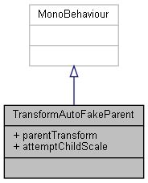

Collaboration diagram for TransformAutoFakeParent:



### Public Attributes

Transform **parentTransform**

bool **attemptChildScale** = false

### Member Data Documentation

#### bool TransformAutoFakeParent.attemptChildScale = false

#### Transform TransformAutoFakeParent.parentTransform

#### The documentation for this class was generated from the following file:

C:/_SSDSPEEDUP/2021/clone/gps1_manadesigner/GPS1-Manadesigner/Assets/_UtilsV0.4/MyScripts/_Utils/_CommonV0.2/Redundant/**TransformAutoFakeParent.cs**

## TransformAutoRelative Class Reference

Inheritance diagram for TransformAutoRelative:

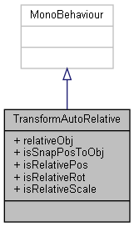

Collaboration diagram for TransformAutoRelative:



### Public Attributes

Transform **relativeObj**

bool **isSnapPosToObj**

bool **isRelativePos**

bool **isRelativeRot**

bool **isRelativeScale**

### Member Data Documentation

#### bool TransformAutoRelative.isRelativePos

#### bool TransformAutoRelative.isRelativeRot

#### bool TransformAutoRelative.isRelativeScale

#### bool TransformAutoRelative.isSnapPosToObj

#### Transform TransformAutoRelative.relativeObj

#### The documentation for this class was generated from the following file:

C:/_SSDSPEEDUP/2021/clone/gps1_manadesigner/GPS1-Manadesigner/Assets/_UtilsV0.4/MyScripts/_Utils/_CommonV0.2/Redundant/**TransformAutoRelative.cs**

## TransformAutoRotate Class Reference

Inheritance diagram for TransformAutoRotate:

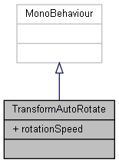

Collaboration diagram for TransformAutoRotate:



### Public Attributes

Vector3 **rotationSpeed** = Vector3.zero

### Member Data Documentation

#### Vector3 TransformAutoRotate.rotationSpeed = Vector3.zero

#### The documentation for this class was generated from the following file:

C:/_SSDSPEEDUP/2021/clone/gps1_manadesigner/GPS1-Manadesigner/Assets/_UtilsV0.4/MyScripts/_Utils/_CommonV0.2/TransformOffsetORCustomTwine/**TransformAutoRotate.cs**

## TransformCommon Class Reference

Collaboration diagram for TransformCommon:

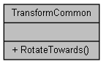

### Static Public Member Functions

static Quaternion **RotateTowards** (Transform selfTransform, Transform targetTransform, float rotSpeed=1f)

### Member Function Documentation

#### static Quaternion TransformCommon.RotateTowards (Transform *selfTransform*, Transform *targetTransform*, float *rotSpeed* = 1f)[static]

#### The documentation for this class was generated from the following file:

C:/_SSDSPEEDUP/2021/clone/gps1_manadesigner/GPS1-Manadesigner/Assets/_UtilsV0.4/MyScripts/_Utils/_CommonV0.2/Calculation/**TransformCommon.cs**

## TransformPosShake Class Reference

Inheritance diagram for TransformPosShake:

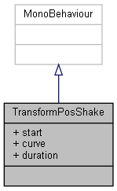

Collaboration diagram for TransformPosShake:



### Public Attributes

bool **start** = false

AnimationCurve **curve**

float **duration** = 1f

### Member Data Documentation

#### AnimationCurve TransformPosShake.curve

#### float TransformPosShake.duration = 1f

#### bool TransformPosShake.start = false

#### The documentation for this class was generated from the following file:

C:/_SSDSPEEDUP/2021/clone/gps1_manadesigner/GPS1-Manadesigner/Assets/_UtilsV0.4/MyScripts/_Utils/_CommonV0.2/CommonExtend/**TransformPosShake.cs**

## TriggerTransitionTuto Class Reference

Inheritance diagram for TriggerTransitionTuto:

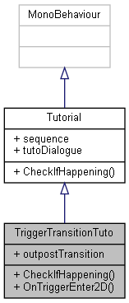

Collaboration diagram for TriggerTransitionTuto:



### Public Member Functions

override void **CheckIfHappening** ()

void **OnTriggerEnter2D** (Collider2D collision)

### Public Attributes

Transform **outpostTransition**

### Member Function Documentation

#### override void TriggerTransitionTuto.CheckIfHappening ()[virtual]

Reimplemented from **Tutorial** (*p.787*).

#### void TriggerTransitionTuto.OnTriggerEnter2D (Collider2D *collision*)

Here is the call graph for this function:

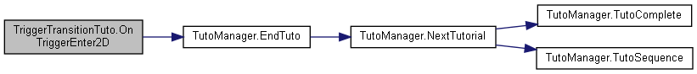

### Member Data Documentation

#### Transform TriggerTransitionTuto.outpostTransition

#### The documentation for this class was generated from the following file:

C:/_SSDSPEEDUP/2021/clone/gps1_manadesigner/GPS1-Manadesigner/Assets/Scripts/Tutorial Scripts/**TriggerTransitionTuto.cs**

## Turbine Class Reference

Inheritance diagram for Turbine:

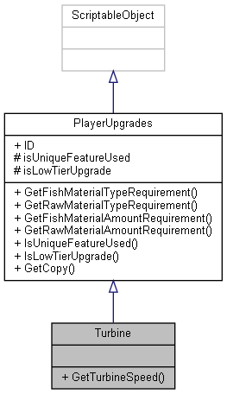

Collaboration diagram for Turbine:



### Public Member Functions

float **GetTurbineSpeed** ()

### Additional Inherited Members

### Member Function Documentation

#### float Turbine.GetTurbineSpeed ()

#### The documentation for this class was generated from the following file:

C:/_SSDSPEEDUP/2021/clone/gps1_manadesigner/GPS1-Manadesigner/Assets/Scripts/Arif's Test Scripts/Upgrades/Turbine/**Turbine.cs**

## turbineUnique Class Reference

Inheritance diagram for turbineUnique:

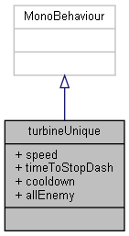

Collaboration diagram for turbineUnique:



### Public Attributes

float **speed** = 4f

float **timeToStopDash** = 1f

float **cooldown** = 5f

GameObject[] **allEnemy**

### Member Data Documentation

#### GameObject [] turbineUnique.allEnemy

#### float turbineUnique.cooldown = 5f

#### float turbineUnique.speed = 4f

#### float turbineUnique.timeToStopDash = 1f

#### The documentation for this class was generated from the following file:

C:/_SSDSPEEDUP/2021/clone/gps1_manadesigner/GPS1-Manadesigner/Assets/Scripts/Thrish/**turbineUnique.cs**

## TutoManager Class Reference

Inheritance diagram for TutoManager:

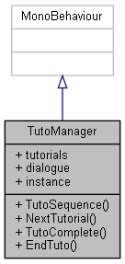

Collaboration diagram for TutoManager:

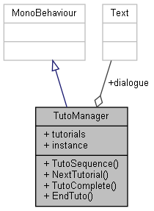

### Public Member Functions

**Tutorial** **TutoSequence** (int order)

void **NextTutorial** (int onSequence)

void **TutoComplete** ()

void **EndTuto** ()

### Public Attributes

List< **Tutorial** > **tutorials** = new List<**Tutorial**>()

Text **dialogue**

### Properties

static **TutoManager** **instance** [get]

### Member Function Documentation

#### void TutoManager.EndTuto ()

Here is the call graph for this function:

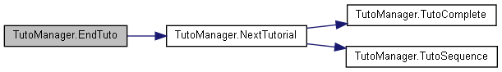

Here is the caller graph for this function:

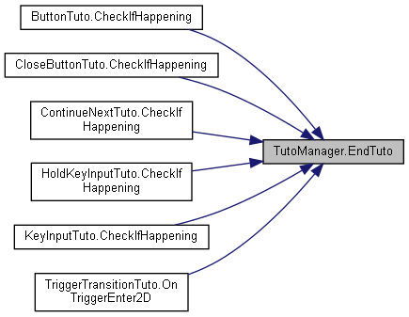

#### void TutoManager.NextTutorial (int *onSequence*)

Here is the call graph for this function:

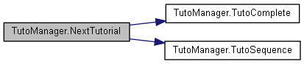

Here is the caller graph for this function:

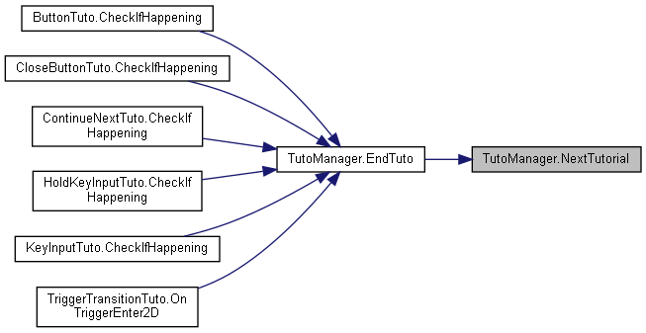

#### void TutoManager.TutoComplete ()

Here is the caller graph for this function:

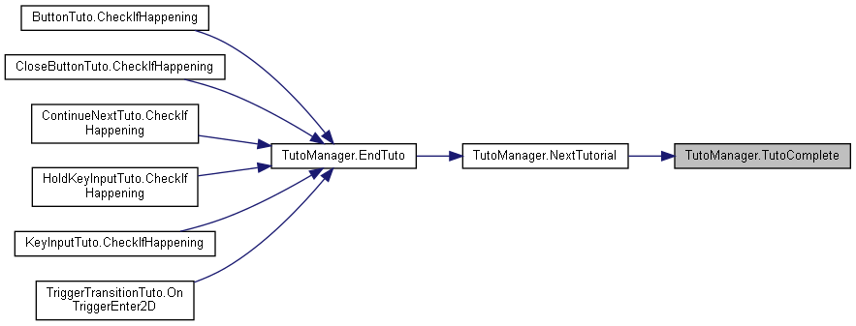

#### Tutorial TutoManager.TutoSequence (int *order*)

Here is the caller graph for this function:

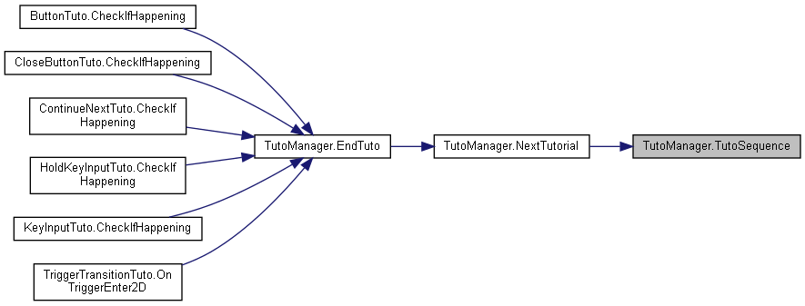

### Member Data Documentation

#### Text TutoManager.dialogue

#### List<Tutorial> TutoManager.tutorials = new List<Tutorial>()

### Property Documentation

#### TutoManager TutoManager.instance[static], [get]

#### The documentation for this class was generated from the following file:

C:/_SSDSPEEDUP/2021/clone/gps1_manadesigner/GPS1-Manadesigner/Assets/Scripts/Tutorial Scripts/**TutoManager.cs**

## TutoOutpostDialogue Class Reference

Inheritance diagram for TutoOutpostDialogue:

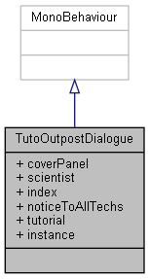

Collaboration diagram for TutoOutpostDialogue:

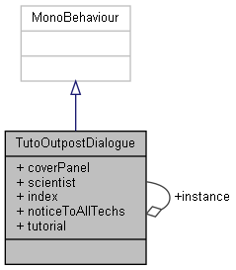

### Public Attributes

GameObject **coverPanel**

GameObject **scientist**

int **index** = 0

string **noticeToAllTechs** = "Leave the last element in every dialogue boxes empty or there'll be an **index** boundary error."

string[] **tutorial**

### Static Public Attributes

static **TutoOutpostDialogue** **instance**

### Member Data Documentation

#### GameObject TutoOutpostDialogue.coverPanel

#### int TutoOutpostDialogue.index = 0

#### TutoOutpostDialogue TutoOutpostDialogue.instance[static]

#### string TutoOutpostDialogue.noticeToAllTechs = "Leave the last element in every dialogue boxes empty or there'll be an index boundary error."

#### GameObject TutoOutpostDialogue.scientist

#### string [] TutoOutpostDialogue.tutorial

**Initial value:**= new string[]

{

"A quiet, content hum from Liam. :You",

"Pointing at the shelf and wooden counter that was definitely not here from before, he gives you a serious look.",

"This is where you’ll be handing in your ‘haul of the day’. :Liam",

"You see him do air quotes when he says that. :You",

"We need a certain amount of specimens to be able to complete research on a specific submarine component. :Liam",

"Once you turn them in, we’ll be able to hand you the research results, which, in your case, is an upgraded component to help you navigate the ocean better.",

"I’ve set up something to help you get into the routine. ",

"Liam jabs a finger at the only component on the shelf-- the Oxygen Tank. :You",

"Click on it to see what upgrades are available for it. :Liam",

"If you hover over it, you’ll see the details of what and how many of each resource you’ll need to exchange to obtain the upgrade.",

"Since you have enough resources for this, click on exchange.",

"After that, you’re done. We’ll handle the rest for you.",

"The upgrade will be available during your next dive, so basically the next day.",

"Liam tilts his head questioningly at you. :You",

"Got it? :Liam",

"You nod. :You",

"The tension from his shoulders seems to disappear when you did that.",

"Good. If you’ll excuse me, I’ll be going back to work. :Liam",

"He doesn’t spare another moment before taking his leave. :You",

"See you tomorrow. :Liam",

"You are left to your own devices, unsupervised. :You",

"You spend the remaining time of your day checking if your submarine is in good order and touring around the outpost.",

"So far, it’s off to a great start, you think. ",

" "

}

#### The documentation for this class was generated from the following file:

C:/_SSDSPEEDUP/2021/clone/gps1_manadesigner/GPS1-Manadesigner/Assets/Scripts/Tutorial Scripts/**TutoOutpostDialogue.cs**

## Tutorial Class Reference

Inheritance diagram for Tutorial:

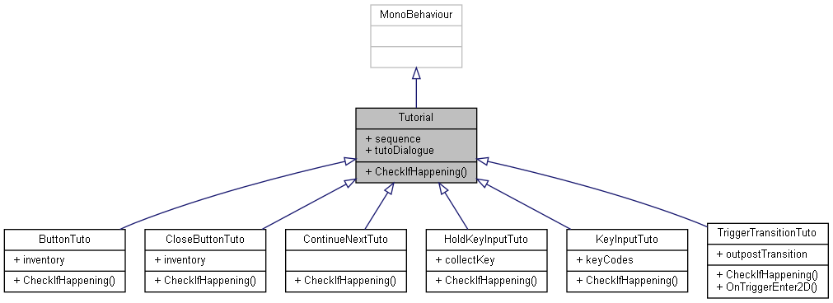

Collaboration diagram for Tutorial:

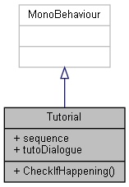

### Public Member Functions

virtual void **CheckIfHappening** ()

### Public Attributes

int **sequence**

string **tutoDialogue**

### Member Function Documentation

#### virtual void Tutorial.CheckIfHappening ()[virtual]

Reimplemented in **ButtonTuto** (*p.108*), **CloseButtonTuto** (*p.141*), **ContinueNextTuto** (*p.198*), **HoldKeyInputTuto** (*p.341*), **KeyInputTuto** (*p.451*), and **TriggerTransitionTuto** (*p.776*).

### Member Data Documentation

#### int Tutorial.sequence

#### string Tutorial.tutoDialogue

#### The documentation for this class was generated from the following file:

C:/_SSDSPEEDUP/2021/clone/gps1_manadesigner/GPS1-Manadesigner/Assets/Scripts/Tutorial Scripts/**Tutorial.cs**

## UI_SkillTree Class Reference

Inheritance diagram for UI_SkillTree:

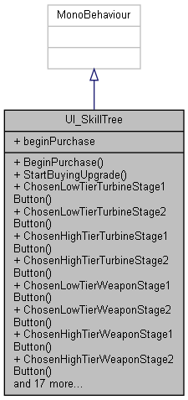

Collaboration diagram for UI_SkillTree:



### Public Member Functions

delegate void **BeginPurchase** ()

void **StartBuyingUpgrade** ()

void **ChosenLowTierTurbineStage1Button** ()

void **ChosenLowTierTurbineStage2Button** ()

void **ChosenHighTierTurbineStage1Button** ()

void **ChosenHighTierTurbineStage2Button** ()

void **ChosenLowTierWeaponStage1Button** ()

void **ChosenLowTierWeaponStage2Button** ()

void **ChosenHighTierWeaponStage1Button** ()

void **ChosenHighTierWeaponStage2Button** ()

void **ChosenLowTierHullStage1Button** ()

void **ChosenLowTierHullStage2Button** ()

void **ChosenHighTierHullStage1Button** ()

void **ChosenHighTierHullStage2Button** ()

void **ChosenLowTierSelfRepairStage1Button** ()

void **ChosenLowTierSelfRepairStage2Button** ()

void **ChosenHighTierSelfRepairStage1Button** ()

void **ChosenHighTierSelfRepairStage2Button** ()

void **ChosenLowTierOxygenTankStage1Button** ()

void **ChosenLowTierOxygenTankStage2Button** ()

void **ChosenHighTierOxygenTankStage1Button** ()

void **ChosenHighTierOxygenTankStage2Button** ()

void **ChosenLowTierInventoryStage1Button** ()

void **ChosenLowTierInventoryStage2Button** ()

void **ChosenHighTierInventoryStage1Button** ()

void **ChosenHighTierInventoryStage2Button** ()

void **SetPlayerSkills** (**PlayerSkills** playerSkills)

### Public Attributes

**BeginPurchase** **beginPurchase**

### Member Function Documentation

#### delegate void UI_SkillTree.BeginPurchase ()

#### void UI_SkillTree.ChosenHighTierHullStage1Button ()

#### void UI_SkillTree.ChosenHighTierHullStage2Button ()

#### void UI_SkillTree.ChosenHighTierInventoryStage1Button ()

#### void UI_SkillTree.ChosenHighTierInventoryStage2Button ()

#### void UI_SkillTree.ChosenHighTierOxygenTankStage1Button ()

#### void UI_SkillTree.ChosenHighTierOxygenTankStage2Button ()

#### void UI_SkillTree.ChosenHighTierSelfRepairStage1Button ()

#### void UI_SkillTree.ChosenHighTierSelfRepairStage2Button ()

#### void UI_SkillTree.ChosenHighTierTurbineStage1Button ()

#### void UI_SkillTree.ChosenHighTierTurbineStage2Button ()

#### void UI_SkillTree.ChosenHighTierWeaponStage1Button ()

#### void UI_SkillTree.ChosenHighTierWeaponStage2Button ()

#### void UI_SkillTree.ChosenLowTierHullStage1Button ()

#### void UI_SkillTree.ChosenLowTierHullStage2Button ()

#### void UI_SkillTree.ChosenLowTierInventoryStage1Button ()

#### void UI_SkillTree.ChosenLowTierInventoryStage2Button ()

#### void UI_SkillTree.ChosenLowTierOxygenTankStage1Button ()

#### void UI_SkillTree.ChosenLowTierOxygenTankStage2Button ()

#### void UI_SkillTree.ChosenLowTierSelfRepairStage1Button ()

#### void UI_SkillTree.ChosenLowTierSelfRepairStage2Button ()

#### void UI_SkillTree.ChosenLowTierTurbineStage1Button ()

#### void UI_SkillTree.ChosenLowTierTurbineStage2Button ()

#### void UI_SkillTree.ChosenLowTierWeaponStage1Button ()

#### void UI_SkillTree.ChosenLowTierWeaponStage2Button ()

#### void UI_SkillTree.SetPlayerSkills (PlayerSkills *playerSkills*)

#### void UI_SkillTree.StartBuyingUpgrade ()

Here is the call graph for this function:

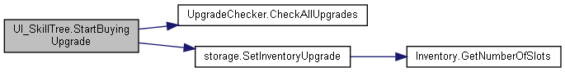

### Member Data Documentation

#### BeginPurchase UI_SkillTree.beginPurchase

#### The documentation for this class was generated from the following file:

C:/_SSDSPEEDUP/2021/clone/gps1_manadesigner/GPS1-Manadesigner/Assets/Scripts/Arif's Test Scripts/Skill Tree/**UI_SkillTree.cs**

## TanksInputActions.UIActions Struct Reference

Collaboration diagram for TanksInputActions.UIActions:

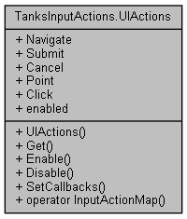

### Public Member Functions

**UIActions** (@**TanksInputActions** wrapper)

InputActionMap **Get** ()

void **Enable** ()

void **Disable** ()

void **SetCallbacks** (**IUIActions** instance)

### Static Public Member Functions

static implicit **operator InputActionMap** (**UIActions** set)

### Properties

InputAction **Navigate** [get]

InputAction **Submit** [get]

InputAction **Cancel** [get]

InputAction **Point** [get]

InputAction **Click** [get]

bool **enabled** [get]

### Constructor & Destructor Documentation

#### TanksInputActions.UIActions.UIActions (@TanksInputActions *wrapper*)

### Member Function Documentation

#### void TanksInputActions.UIActions.Disable ()

Here is the call graph for this function:

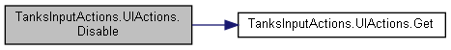

#### void TanksInputActions.UIActions.Enable ()

Here is the call graph for this function:

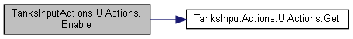

#### InputActionMap TanksInputActions.UIActions.Get ()

Here is the caller graph for this function:

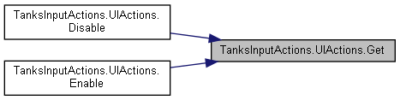

#### static implicit TanksInputActions.UIActions.operator InputActionMap (UIActions *set*)[static]

#### void TanksInputActions.UIActions.SetCallbacks (IUIActions *instance*)

Here is the call graph for this function:

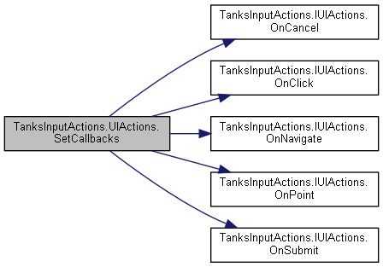

### Property Documentation

#### InputAction TanksInputActions.UIActions.Cancel[get]

#### InputAction TanksInputActions.UIActions.Click[get]

#### bool TanksInputActions.UIActions.enabled[get]

#### InputAction TanksInputActions.UIActions.Navigate[get]

#### InputAction TanksInputActions.UIActions.Point[get]

#### InputAction TanksInputActions.UIActions.Submit[get]

#### The documentation for this struct was generated from the following file:

C:/_SSDSPEEDUP/2021/clone/gps1_manadesigner/GPS1-Manadesigner/Assets/Samples/Input System/1.0.2/Tanks Demo/TanksDemo/**TanksInputActions.cs**

## UICommandList Class Reference

Inheritance diagram for UICommandList:

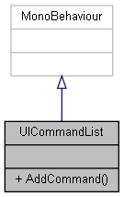

Collaboration diagram for UICommandList:



### Public Member Functions

void **AddCommand** (**ICommandOWS** command)

### Member Function Documentation

#### void UICommandList.AddCommand (ICommandOWS *command*)

#### The documentation for this class was generated from the following file:

C:/_SSDSPEEDUP/2021/clone/gps1_manadesigner/GPS1-Manadesigner/Assets/_UtilsV0.4/MyScripts/_Utils/CommandPattern/_Bin/OWS/_Samples/Script/**UICommandList.cs**

## Complete.UIDirectionControl Class Reference

Inheritance diagram for Complete.UIDirectionControl:

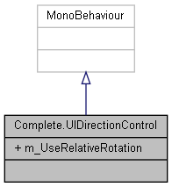

Collaboration diagram for Complete.UIDirectionControl:



### Public Attributes

bool **m_UseRelativeRotation** = true

### Member Data Documentation

#### bool Complete.UIDirectionControl.m_UseRelativeRotation = true

#### The documentation for this class was generated from the following file:

C:/_SSDSPEEDUP/2021/clone/gps1_manadesigner/GPS1-Manadesigner/Assets/Samples/Input System/1.0.2/Tanks Demo/TanksDemo/Scripts/UI/**UIDirectionControl.cs**

## UIHPSliderColor Class Reference

Inheritance diagram for UIHPSliderColor:

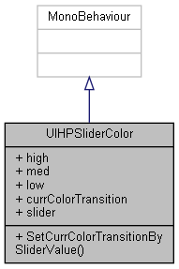

Collaboration diagram for UIHPSliderColor:



### Public Types

enum **UIColorTransition** { **High**, **Med**, **Low** }

### Public Member Functions

void **SetCurrColorTransitionBySliderValue** ()

### Public Attributes

Color **high** = Color.green

Color **med** = Color.yellow

Color **low** = new Color(1.0f, 0.64f, 0.0f)

**UIColorTransition** **currColorTransition**

Slider **slider**

### Member Enumeration Documentation

#### enum UIHPSliderColor.UIColorTransition

##### Enumerator:

|  |  |
| --- | --- |
| High |  |
| Med |  |
| Low |  |

### Member Function Documentation

#### void UIHPSliderColor.SetCurrColorTransitionBySliderValue ()

### Member Data Documentation

#### UIColorTransition UIHPSliderColor.currColorTransition

#### Color UIHPSliderColor.high = Color.green

#### Color UIHPSliderColor.low = new Color(1.0f, 0.64f, 0.0f)

#### Color UIHPSliderColor.med = Color.yellow

#### Slider UIHPSliderColor.slider

#### The documentation for this class was generated from the following file:

C:/_SSDSPEEDUP/2021/clone/gps1_manadesigner/GPS1-Manadesigner/Assets/_UtilsV0.4/MyScripts/_Utils/_CommonV0.2/UICanvas/**UIHPSliderColor.cs**

## RebindUISampleActionsModified.UIMainActions Struct Reference

Collaboration diagram for RebindUISampleActionsModified.UIMainActions:

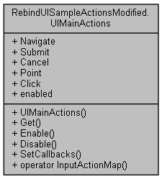

### Public Member Functions

**UIMainActions** (@**RebindUISampleActionsModified** wrapper)

InputActionMap **Get** ()

void **Enable** ()

void **Disable** ()

void **SetCallbacks** (**IUIMainActions** instance)

### Static Public Member Functions

static implicit **operator InputActionMap** (**UIMainActions** set)

### Properties

InputAction **Navigate** [get]

InputAction **Submit** [get]

InputAction **Cancel** [get]

InputAction **Point** [get]

InputAction **Click** [get]

bool **enabled** [get]

### Constructor & Destructor Documentation

#### RebindUISampleActionsModified.UIMainActions.UIMainActions (@RebindUISampleActionsModified *wrapper*)

### Member Function Documentation

#### void RebindUISampleActionsModified.UIMainActions.Disable ()

Here is the call graph for this function:

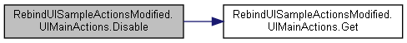

#### void RebindUISampleActionsModified.UIMainActions.Enable ()

Here is the call graph for this function:

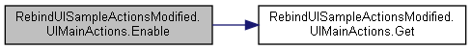

#### InputActionMap RebindUISampleActionsModified.UIMainActions.Get ()

Here is the caller graph for this function:

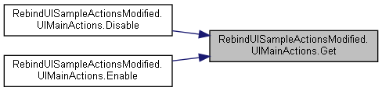

#### static implicit RebindUISampleActionsModified.UIMainActions.operator InputActionMap (UIMainActions *set*)[static]

#### void RebindUISampleActionsModified.UIMainActions.SetCallbacks (IUIMainActions *instance*)

Here is the call graph for this function:

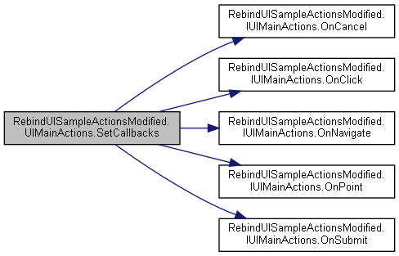

### Property Documentation

#### InputAction RebindUISampleActionsModified.UIMainActions.Cancel[get]

#### InputAction RebindUISampleActionsModified.UIMainActions.Click[get]

#### bool RebindUISampleActionsModified.UIMainActions.enabled[get]

#### InputAction RebindUISampleActionsModified.UIMainActions.Navigate[get]

#### InputAction RebindUISampleActionsModified.UIMainActions.Point[get]

#### InputAction RebindUISampleActionsModified.UIMainActions.Submit[get]

#### The documentation for this struct was generated from the following file:

C:/_SSDSPEEDUP/2021/clone/gps1_manadesigner/GPS1-Manadesigner/Assets/_UtilsV0.4/MyScripts/_Utils/CommandPattern/Command/SOAssets/InputSystemPackage/**RebindUISampleActionsModified.cs**

## UIShowHideToggle Class Reference

Inheritance diagram for UIShowHideToggle:

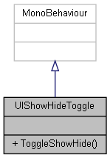

Collaboration diagram for UIShowHideToggle:



### Public Member Functions

void **ToggleShowHide** ()

### Member Function Documentation

#### void UIShowHideToggle.ToggleShowHide ()

#### The documentation for this class was generated from the following file:

C:/_SSDSPEEDUP/2021/clone/gps1_manadesigner/GPS1-Manadesigner/Assets/_UtilsV0.4/MyScripts/_Utils/_CommonV0.2/UICanvas/**UIShowHideToggle.cs**

## UIToggleSaveToPlayerPrefs Class Reference

Inheritance diagram for UIToggleSaveToPlayerPrefs:

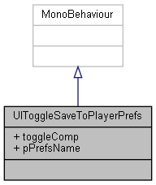

Collaboration diagram for UIToggleSaveToPlayerPrefs:



### Public Attributes

Toggle **toggleComp**

string **pPrefsName**

### Member Data Documentation

#### string UIToggleSaveToPlayerPrefs.pPrefsName

#### Toggle UIToggleSaveToPlayerPrefs.toggleComp

#### The documentation for this class was generated from the following file:

C:/_SSDSPEEDUP/2021/clone/gps1_manadesigner/GPS1-Manadesigner/Assets/**UIToggleSaveToPlayerPrefs.cs**

## UIVolumeSlider Class Reference

Inheritance diagram for UIVolumeSlider:

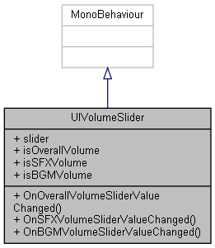

Collaboration diagram for UIVolumeSlider:



### Public Member Functions

void **OnOverallVolumeSliderValueChanged** ()

void **OnSFXVolumeSliderValueChanged** ()

void **OnBGMVolumeSliderValueChanged** ()

### Public Attributes

Slider **slider**

bool **isOverallVolume**

bool **isSFXVolume**

bool **isBGMVolume**

### Member Function Documentation

#### void UIVolumeSlider.OnBGMVolumeSliderValueChanged ()

Here is the call graph for this function:

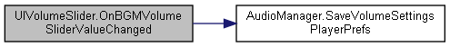

#### void UIVolumeSlider.OnOverallVolumeSliderValueChanged ()

Here is the call graph for this function:

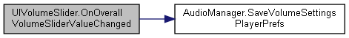

#### void UIVolumeSlider.OnSFXVolumeSliderValueChanged ()

Here is the call graph for this function:

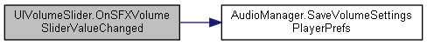

### Member Data Documentation

#### bool UIVolumeSlider.isBGMVolume

#### bool UIVolumeSlider.isOverallVolume

#### bool UIVolumeSlider.isSFXVolume

#### Slider UIVolumeSlider.slider

#### The documentation for this class was generated from the following file:

C:/_SSDSPEEDUP/2021/clone/gps1_manadesigner/GPS1-Manadesigner/Assets/_UtilsV0.4/MyScripts/_Utils/_CommonV0.2/UICanvas/**UIVolumeSlider.cs**

## UnityEngine.InputSystem.Samples.RebindUI.RebindActionUI.UpdateBindingUIEvent Class Reference

Inheritance diagram for UnityEngine.InputSystem.Samples.RebindUI.RebindActionUI.UpdateBindingUIEvent:

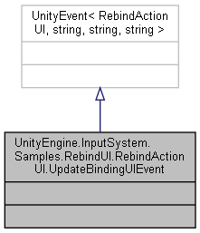

Collaboration diagram for UnityEngine.InputSystem.Samples.RebindUI.RebindActionUI.UpdateBindingUIEvent:



The documentation for this class was generated from the following file:

C:/_SSDSPEEDUP/2021/clone/gps1_manadesigner/GPS1-Manadesigner/Assets/_UtilsV0.4/MyScripts/_Utils/UnityRegistryIntegration/InputSystem/Rebinding UI/_Modified/**RebindActionUI.cs**

## UpgradeChecker Class Reference

Inheritance diagram for UpgradeChecker:

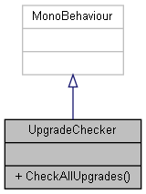

Collaboration diagram for UpgradeChecker:



### Public Member Functions

void **CheckAllUpgrades** ()

### Member Function Documentation

#### void UpgradeChecker.CheckAllUpgrades ()

Here is the caller graph for this function:

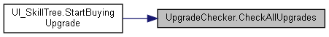

#### The documentation for this class was generated from the following file:

C:/_SSDSPEEDUP/2021/clone/gps1_manadesigner/GPS1-Manadesigner/Assets/**UpgradeChecker.cs**

## UpgradeDatabase Class Reference

Inheritance diagram for UpgradeDatabase:

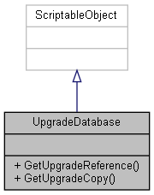

Collaboration diagram for UpgradeDatabase:



### Public Member Functions

**PlayerUpgrades** **GetUpgradeReference** (string upgradeID)

**PlayerUpgrades** **GetUpgradeCopy** (string upgradeID)

### Member Function Documentation

#### PlayerUpgrades UpgradeDatabase.GetUpgradeCopy (string *upgradeID*)

Here is the call graph for this function:

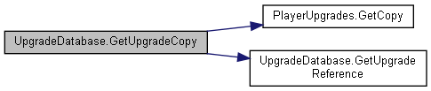

Here is the caller graph for this function:



#### PlayerUpgrades UpgradeDatabase.GetUpgradeReference (string *upgradeID*)

Here is the caller graph for this function:



#### The documentation for this class was generated from the following file:

C:/_SSDSPEEDUP/2021/clone/gps1_manadesigner/GPS1-Manadesigner/Assets/Scripts/Arif's Test Scripts/Save State/**UpgradeDatabase.cs**

## UpgradeHolder Class Reference

Inheritance diagram for UpgradeHolder:

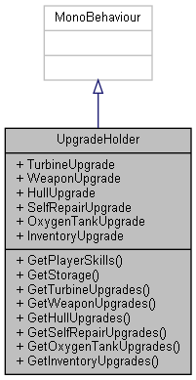

Collaboration diagram for UpgradeHolder:



### Public Member Functions

**PlayerSkills** **GetPlayerSkills** ()

**storage** **GetStorage** ()

**Turbine**[] **GetTurbineUpgrades** ()

**Weapon**[] **GetWeaponUpgrades** ()

**Hull**[] **GetHullUpgrades** ()

**SelfRepair**[] **GetSelfRepairUpgrades** ()

**OxygenTank**[] **GetOxygenTankUpgrades** ()

**Inventory**[] **GetInventoryUpgrades** ()

### Properties

**Turbine** **TurbineUpgrade** [getset]

**Weapon** **WeaponUpgrade** [getset]

**Hull** **HullUpgrade** [getset]

**SelfRepair** **SelfRepairUpgrade** [getset]

**OxygenTank** **OxygenTankUpgrade** [getset]

**Inventory** **InventoryUpgrade** [getset]

### Member Function Documentation

#### Hull[] UpgradeHolder.GetHullUpgrades ()

Here is the caller graph for this function:



#### Inventory[] UpgradeHolder.GetInventoryUpgrades ()

Here is the caller graph for this function:

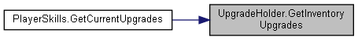

#### OxygenTank[] UpgradeHolder.GetOxygenTankUpgrades ()

Here is the caller graph for this function:

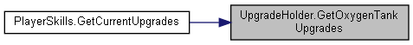

#### PlayerSkills UpgradeHolder.GetPlayerSkills ()

#### SelfRepair[] UpgradeHolder.GetSelfRepairUpgrades ()

Here is the caller graph for this function:

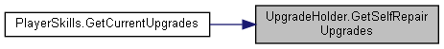

#### storage UpgradeHolder.GetStorage ()

#### Turbine[] UpgradeHolder.GetTurbineUpgrades ()

Here is the caller graph for this function:

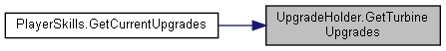

#### Weapon[] UpgradeHolder.GetWeaponUpgrades ()

Here is the caller graph for this function:



### Property Documentation

#### Hull UpgradeHolder.HullUpgrade[get], [set]

#### Inventory UpgradeHolder.InventoryUpgrade[get], [set]

#### OxygenTank UpgradeHolder.OxygenTankUpgrade[get], [set]

#### SelfRepair UpgradeHolder.SelfRepairUpgrade[get], [set]

#### Turbine UpgradeHolder.TurbineUpgrade[get], [set]

#### Weapon UpgradeHolder.WeaponUpgrade[get], [set]

#### The documentation for this class was generated from the following file:

C:/_SSDSPEEDUP/2021/clone/gps1_manadesigner/GPS1-Manadesigner/Assets/Scripts/**UpgradeHolder.cs**

## UpgradeSaveData Class Reference

Collaboration diagram for UpgradeSaveData:

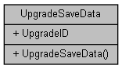

### Public Member Functions

**UpgradeSaveData** (string id)

### Public Attributes

string **UpgradeID**

### Constructor & Destructor Documentation

#### UpgradeSaveData.UpgradeSaveData (string *id*)

### Member Data Documentation

#### string UpgradeSaveData.UpgradeID

#### The documentation for this class was generated from the following file:

C:/_SSDSPEEDUP/2021/clone/gps1_manadesigner/GPS1-Manadesigner/Assets/Scripts/Arif's Test Scripts/Save State/**UpgradeSaveData.cs**

## UpgradeSaveIO Class Reference

Collaboration diagram for UpgradeSaveIO:

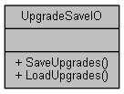

### Static Public Member Functions

static void **SaveUpgrades** (**InstalledUpgradeSaveData** upgrade, string filename)

static **InstalledUpgradeSaveData** **LoadUpgrades** (string filename)

### Member Function Documentation

#### static InstalledUpgradeSaveData UpgradeSaveIO.LoadUpgrades (string *filename*)[static]

Here is the caller graph for this function:



#### static void UpgradeSaveIO.SaveUpgrades (InstalledUpgradeSaveData *upgrade*, string *filename*)[static]

#### The documentation for this class was generated from the following file:

C:/_SSDSPEEDUP/2021/clone/gps1_manadesigner/GPS1-Manadesigner/Assets/Scripts/Arif's Test Scripts/Save State/**UpgradeSaveIO.cs**

## UpgradeSaveManager Class Reference

Inheritance diagram for UpgradeSaveManager:

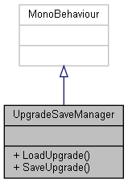

Collaboration diagram for UpgradeSaveManager:



### Public Member Functions

void **LoadUpgrade** (**UpgradeHolder** upgradeHolder)

void **SaveUpgrade** (**UpgradeHolder** upgradeHolder)

### Member Function Documentation

#### void UpgradeSaveManager.LoadUpgrade (UpgradeHolder *upgradeHolder*)

Here is the call graph for this function:

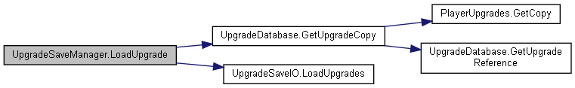

#### void UpgradeSaveManager.SaveUpgrade (UpgradeHolder *upgradeHolder*)

Here is the caller graph for this function:

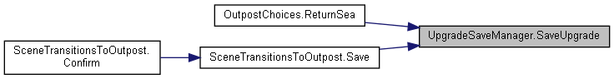

#### The documentation for this class was generated from the following file:

C:/_SSDSPEEDUP/2021/clone/gps1_manadesigner/GPS1-Manadesigner/Assets/Scripts/Arif's Test Scripts/Save State/**UpgradeSaveManager.cs**

## UnityEngine.PostProcessing.UserLutComponent Class Reference

Inheritance diagram for UnityEngine.PostProcessing.UserLutComponent:

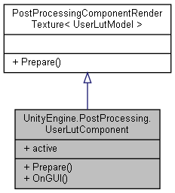

Collaboration diagram for UnityEngine.PostProcessing.UserLutComponent:



### Public Member Functions

override void **Prepare** (Material uberMaterial)

void **OnGUI** ()

### Properties

override bool **active** [get]

### Member Function Documentation

#### void UnityEngine.PostProcessing.UserLutComponent.OnGUI ()

#### override void UnityEngine.PostProcessing.UserLutComponent.Prepare (Material *uberMaterial*)[virtual]

Reimplemented from **UnityEngine.PostProcessing.PostProcessingComponentRenderTexture< UserLutModel >** (*p.594*).

### Property Documentation

#### override bool UnityEngine.PostProcessing.UserLutComponent.active[get]

#### The documentation for this class was generated from the following file:

C:/_SSDSPEEDUP/2021/clone/gps1_manadesigner/GPS1-Manadesigner/Assets/Samples/Input System/1.0.2/Tanks Demo/TanksDemo/PostProcessing/Runtime/Components/**UserLutComponent.cs**

## UnityEngine.PostProcessing.UserLutModel Class Reference

Inheritance diagram for UnityEngine.PostProcessing.UserLutModel:

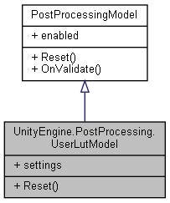

Collaboration diagram for UnityEngine.PostProcessing.UserLutModel:



### Classes

struct **Settings**

### Public Member Functions

override void **Reset** ()

### Properties

**Settings** **settings** [getset]

### Member Function Documentation

#### override void UnityEngine.PostProcessing.UserLutModel.Reset ()[virtual]

Implements **UnityEngine.PostProcessing.PostProcessingModel** (*p.597*).

### Property Documentation

#### Settings UnityEngine.PostProcessing.UserLutModel.settings[get], [set]

#### The documentation for this class was generated from the following file:

C:/_SSDSPEEDUP/2021/clone/gps1_manadesigner/GPS1-Manadesigner/Assets/Samples/Input System/1.0.2/Tanks Demo/TanksDemo/PostProcessing/Runtime/Models/**UserLutModel.cs**

## UnityEngine.InputSystem.Samples.VisualizationHelpers.ValueVisualizer< TValue > Class Template Reference

Inheritance diagram for UnityEngine.InputSystem.Samples.VisualizationHelpers.ValueVisualizer< TValue >:

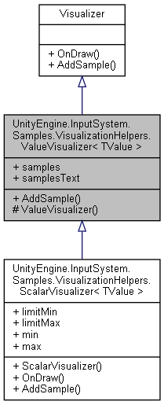

Collaboration diagram for UnityEngine.InputSystem.Samples.VisualizationHelpers.ValueVisualizer< TValue >:

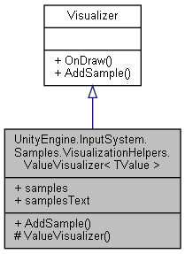

### Public Member Functions

override void **AddSample** (object value, double time)

### Public Attributes

**RingBuffer**< TValue > **samples**

**RingBuffer**< GUIContent > **samplesText**

### Protected Member Functions

**ValueVisualizer** (int numSamples=10)

### Constructor & Destructor Documentation

#### UnityEngine.InputSystem.Samples.VisualizationHelpers.ValueVisualizer< TValue >.ValueVisualizer (int *numSamples* = 10)[protected]

### Member Function Documentation

#### override void UnityEngine.InputSystem.Samples.VisualizationHelpers.ValueVisualizer< TValue >.AddSample (object *value*, double *time*)[virtual]

Implements **UnityEngine.InputSystem.Samples.VisualizationHelpers.Visualizer** (*p.847*).

Reimplemented in **UnityEngine.InputSystem.Samples.VisualizationHelpers.ScalarVisualizer< TValue >** (*p.652*).

### Member Data Documentation

#### RingBuffer<TValue> UnityEngine.InputSystem.Samples.VisualizationHelpers.ValueVisualizer< TValue >.samples

#### RingBuffer<GUIContent> UnityEngine.InputSystem.Samples.VisualizationHelpers.ValueVisualizer< TValue >.samplesText

#### The documentation for this class was generated from the following file:

C:/_SSDSPEEDUP/2021/clone/gps1_manadesigner/GPS1-Manadesigner/Assets/Samples/Input System/1.0.2/Visualizers/**VisualizationHelpers.cs**

## RebindUISampleActionsModified.Vector2AxisActions Struct Reference

Collaboration diagram for RebindUISampleActionsModified.Vector2AxisActions:

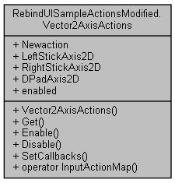

### Public Member Functions

**Vector2AxisActions** (@**RebindUISampleActionsModified** wrapper)

InputActionMap **Get** ()

void **Enable** ()

void **Disable** ()

void **SetCallbacks** (**IVector2AxisActions** instance)

### Static Public Member Functions

static implicit **operator InputActionMap** (**Vector2AxisActions** set)

### Properties

InputAction **Newaction** [get]

InputAction **LeftStickAxis2D** [get]

InputAction **RightStickAxis2D** [get]

InputAction **DPadAxis2D** [get]

bool **enabled** [get]

### Constructor & Destructor Documentation

#### RebindUISampleActionsModified.Vector2AxisActions.Vector2AxisActions (@RebindUISampleActionsModified *wrapper*)

### Member Function Documentation

#### void RebindUISampleActionsModified.Vector2AxisActions.Disable ()

Here is the call graph for this function:

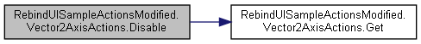

#### void RebindUISampleActionsModified.Vector2AxisActions.Enable ()

Here is the call graph for this function:

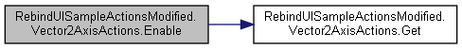

#### InputActionMap RebindUISampleActionsModified.Vector2AxisActions.Get ()

Here is the caller graph for this function:

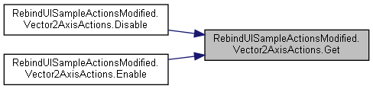

#### static implicit RebindUISampleActionsModified.Vector2AxisActions.operator InputActionMap (Vector2AxisActions *set*)[static]

#### void RebindUISampleActionsModified.Vector2AxisActions.SetCallbacks (IVector2AxisActions *instance*)

Here is the call graph for this function:

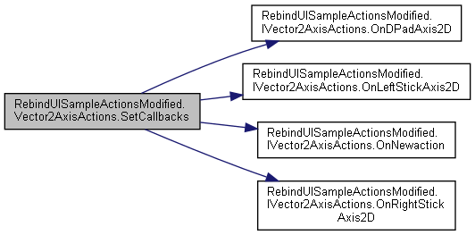

### Property Documentation

#### InputAction RebindUISampleActionsModified.Vector2AxisActions.DPadAxis2D[get]

#### bool RebindUISampleActionsModified.Vector2AxisActions.enabled[get]

#### InputAction RebindUISampleActionsModified.Vector2AxisActions.LeftStickAxis2D[get]

#### InputAction RebindUISampleActionsModified.Vector2AxisActions.Newaction[get]

#### InputAction RebindUISampleActionsModified.Vector2AxisActions.RightStickAxis2D[get]

#### The documentation for this struct was generated from the following file:

C:/_SSDSPEEDUP/2021/clone/gps1_manadesigner/GPS1-Manadesigner/Assets/_UtilsV0.4/MyScripts/_Utils/CommandPattern/Command/SOAssets/InputSystemPackage/**RebindUISampleActionsModified.cs**

## Vector2Common Class Reference

Collaboration diagram for Vector2Common:

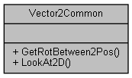

### Static Public Member Functions

static float **GetRotBetween2Pos** (Vector2 posA, Vector2 posB)

static void **LookAt2D** (Transform origin, Vector3 targetPos, float turnRate)

### Member Function Documentation

#### static float Vector2Common.GetRotBetween2Pos (Vector2 *posA*, Vector2 *posB*)[static]

#### static void Vector2Common.LookAt2D (Transform *origin*, Vector3 *targetPos*, float *turnRate*)[static]

#### The documentation for this class was generated from the following file:

C:/_SSDSPEEDUP/2021/clone/gps1_manadesigner/GPS1-Manadesigner/Assets/_UtilsV0.4/MyScripts/_Utils/_CommonV0.2/CommonExtend/2D/**Vector2Common.cs**

## UnityEngine.InputSystem.Samples.VisualizationHelpers.Vector2Visualizer Class Reference

Inheritance diagram for UnityEngine.InputSystem.Samples.VisualizationHelpers.Vector2Visualizer:

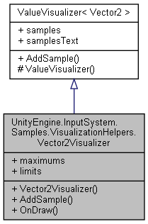

Collaboration diagram for UnityEngine.InputSystem.Samples.VisualizationHelpers.Vector2Visualizer:



### Public Member Functions

**Vector2Visualizer** (int numSamples=10)

override void **AddSample** (object value, double time)

override void **OnDraw** (Rect rect)

### Public Attributes

Vector2[] **maximums** = new Vector2[360 / 3]

Vector2 **limits** = new Vector2(1, 1)

### Additional Inherited Members

### Constructor & Destructor Documentation

#### UnityEngine.InputSystem.Samples.VisualizationHelpers.Vector2Visualizer.Vector2Visualizer (int *numSamples* = 10)

### Member Function Documentation

#### override void UnityEngine.InputSystem.Samples.VisualizationHelpers.Vector2Visualizer.AddSample (object *value*, double *time*)

#### override void UnityEngine.InputSystem.Samples.VisualizationHelpers.Vector2Visualizer.OnDraw (Rect *rect*)

### Member Data Documentation

#### Vector2 UnityEngine.InputSystem.Samples.VisualizationHelpers.Vector2Visualizer.limits = new Vector2(1, 1)

#### Vector2 [] UnityEngine.InputSystem.Samples.VisualizationHelpers.Vector2Visualizer.maximums = new Vector2[360 / 3]

#### The documentation for this class was generated from the following file:

C:/_SSDSPEEDUP/2021/clone/gps1_manadesigner/GPS1-Manadesigner/Assets/Samples/Input System/1.0.2/Visualizers/**VisualizationHelpers.cs**

## Vector3Common Class Reference

Collaboration diagram for Vector3Common:

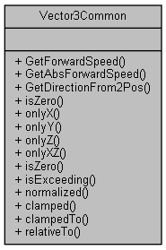

### Static Public Member Functions

static float **GetForwardSpeed** (Vector3 velocity)

static float **GetAbsForwardSpeed** (Vector3 velocity)

static Vector3 **GetDirectionFrom2Pos** (Vector3 origin, Vector3 target)

static bool **isZero** (this float value)

*Checks whether value is near to zero within a tolerance.*

static Vector3 **onlyX** (this Vector3 vector3)

*Returns a copy of given vector with only X component of the vector.*

static Vector3 **onlyY** (this Vector3 vector3)

*Returns a copy of given vector with only Y component of the vector.*

static Vector3 **onlyZ** (this Vector3 vector3)

*Returns a copy of given vector with only Z component of the vector.*

static Vector3 **onlyXZ** (this Vector3 vector3)

*Returns a copy of given vector with only X and Z components of the vector.*

static bool **isZero** (this Vector3 vector3)

*Checks whether vector is near to zero within a tolerance.*

static bool **isExceeding** (this Vector3 vector3, float magnitude)

*Checks whether vector is exceeding the magnitude within a small error tolerance.*

static Vector3 **normalized** (this Vector3 vector3, out float magnitude)

*Returns a copy of given vector with a magnitude of 1, and outs its magnitude before normalization.*

static Vector3 **clamped** (this Vector3 vector3, out float magnitude)

*Returns a copy of given vector with its magnitude clamped to 0 and 1, and outs its magnitude before clamp.*

static Vector3 **clampedTo** (this Vector3 vector3, float maxLength)

*Returns a copy of given vector with its magnitude clamped to maxLength.*

static Vector3 **relativeTo** (this Vector3 vector3, Transform target, bool onlyLateral=true)

*Transform a given vector to be relative to target transform.*

### Member Function Documentation

#### static Vector3 Vector3Common.clamped (this Vector3 *vector3*, out float *magnitude*)[static]

Returns a copy of given vector with its magnitude clamped to 0 and 1, and outs its magnitude before clamp.

#### static Vector3 Vector3Common.clampedTo (this Vector3 *vector3*, float *maxLength*)[static]

Returns a copy of given vector with its magnitude clamped to maxLength.

#### static float Vector3Common.GetAbsForwardSpeed (Vector3 *velocity*)[static]

#### static Vector3 Vector3Common.GetDirectionFrom2Pos (Vector3 *origin*, Vector3 *target*)[static]

#### static float Vector3Common.GetForwardSpeed (Vector3 *velocity*)[static]

#### static bool Vector3Common.isExceeding (this Vector3 *vector3*, float *magnitude*)[static]

Checks whether vector is exceeding the magnitude within a small error tolerance.

#### static bool Vector3Common.isZero (this float *value*)[static]

Checks whether value is near to zero within a tolerance.

#### static bool Vector3Common.isZero (this Vector3 *vector3*)[static]

Checks whether vector is near to zero within a tolerance.

#### static Vector3 Vector3Common.normalized (this Vector3 *vector3*, out float *magnitude*)[static]

Returns a copy of given vector with a magnitude of 1, and outs its magnitude before normalization.

If the vector is too small to be normalized a zero vector will be returned.

#### static Vector3 Vector3Common.onlyX (this Vector3 *vector3*)[static]

Returns a copy of given vector with only X component of the vector.

#### static Vector3 Vector3Common.onlyXZ (this Vector3 *vector3*)[static]

Returns a copy of given vector with only X and Z components of the vector.

#### static Vector3 Vector3Common.onlyY (this Vector3 *vector3*)[static]

Returns a copy of given vector with only Y component of the vector.

#### static Vector3 Vector3Common.onlyZ (this Vector3 *vector3*)[static]

Returns a copy of given vector with only Z component of the vector.

#### static Vector3 Vector3Common.relativeTo (this Vector3 *vector3*, Transform *target*, bool *onlyLateral* = true)[static]

Transform a given vector to be relative to target transform.

Eg: Use to perform movement relative to camera's view direction.

#### The documentation for this class was generated from the following file:

C:/_SSDSPEEDUP/2021/clone/gps1_manadesigner/GPS1-Manadesigner/Assets/_UtilsV0.4/MyScripts/_Utils/_CommonV0.2/Calculation/**Vector3Common.cs**

## UnityEngine.PostProcessing.VignetteComponent Class Reference

Inheritance diagram for UnityEngine.PostProcessing.VignetteComponent:

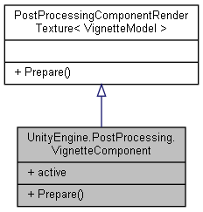

Collaboration diagram for UnityEngine.PostProcessing.VignetteComponent:



### Public Member Functions

override void **Prepare** (Material uberMaterial)

### Properties

override bool **active** [get]

### Member Function Documentation

#### override void UnityEngine.PostProcessing.VignetteComponent.Prepare (Material *uberMaterial*)[virtual]

Reimplemented from **UnityEngine.PostProcessing.PostProcessingComponentRenderTexture< VignetteModel >** (*p.594*).

### Property Documentation

#### override bool UnityEngine.PostProcessing.VignetteComponent.active[get]

#### The documentation for this class was generated from the following file:

C:/_SSDSPEEDUP/2021/clone/gps1_manadesigner/GPS1-Manadesigner/Assets/Samples/Input System/1.0.2/Tanks Demo/TanksDemo/PostProcessing/Runtime/Components/**VignetteComponent.cs**

## UnityEngine.PostProcessing.VignetteModel Class Reference

Inheritance diagram for UnityEngine.PostProcessing.VignetteModel:

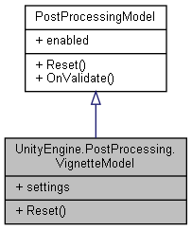

Collaboration diagram for UnityEngine.PostProcessing.VignetteModel:



### Classes

struct **Settings**

### Public Types

enum **Mode** { **Classic**, **Masked** }

### Public Member Functions

override void **Reset** ()

### Properties

**Settings** **settings** [getset]

### Member Enumeration Documentation

#### enum UnityEngine.PostProcessing.VignetteModel.Mode

##### Enumerator:

|  |  |
| --- | --- |
| Classic |  |
| Masked |  |

### Member Function Documentation

#### override void UnityEngine.PostProcessing.VignetteModel.Reset ()[virtual]

Implements **UnityEngine.PostProcessing.PostProcessingModel** (*p.597*).

### Property Documentation

#### Settings UnityEngine.PostProcessing.VignetteModel.settings[get], [set]

#### The documentation for this class was generated from the following file:

C:/_SSDSPEEDUP/2021/clone/gps1_manadesigner/GPS1-Manadesigner/Assets/Samples/Input System/1.0.2/Tanks Demo/TanksDemo/PostProcessing/Runtime/Models/**VignetteModel.cs**

## UnityEngine.InputSystem.UI.VirtualMouseInput Class Reference

A component that creates a virtual Mouse device and drives its input from gamepad-style inputs.

Inheritance diagram for UnityEngine.InputSystem.UI.VirtualMouseInput:

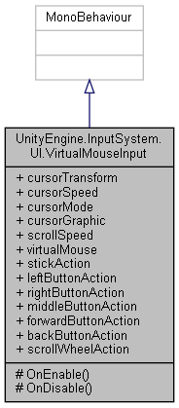

Collaboration diagram for UnityEngine.InputSystem.UI.VirtualMouseInput:



### Public Types

enum **CursorMode** { **SoftwareCursor**, **HardwareCursorIfAvailable** }

*Determines how the cursor for the virtual mouse is represented.*

### Protected Member Functions

void **OnEnable** ()

void **OnDisable** ()

### Properties

RectTransform **cursorTransform** [getset]

*Optional transform that will be updated to correspond to the current mouse position.*

float **cursorSpeed** [getset]

*How many pixels per second the cursor travels in one axis when the respective axis from* ***stickAction*** *is 1.*

**CursorMode** **cursorMode** [getset]

*Determines which cursor representation to use.*

Graphic **cursorGraphic** [getset]

*The* ***UI*** *graphic element that represents the mouse cursor.*

float **scrollSpeed** [getset]

*Multiplier for values received from* ***scrollWheelAction****.*

Mouse **virtualMouse** [get]

*The virtual mouse device that the component feeds with input.*

InputActionProperty **stickAction** [getset]

*The Vector2 stick input that drives the mouse cursor, i.e.*

InputActionProperty **leftButtonAction** [getset]

*Optional button input that determines when Mouse.leftButton is pressed on* ***virtualMouse****.*

InputActionProperty **rightButtonAction** [getset]

*Optional button input that determines when Mouse.rightButton is pressed on* ***virtualMouse****.*

InputActionProperty **middleButtonAction** [getset]

*Optional button input that determines when Mouse.middleButton is pressed on* ***virtualMouse****.*

InputActionProperty **forwardButtonAction** [getset]

*Optional button input that determines when Mouse.forwardButton is pressed on* ***virtualMouse****.*

InputActionProperty **backButtonAction** [getset]

*Optional button input that determines when Mouse.forwardButton is pressed on* ***virtualMouse****.*

InputActionProperty **scrollWheelAction** [getset]

*Optional Vector2 value input that determines the value of Mouse.scroll on* ***virtualMouse****.*

### Detailed Description

A component that creates a virtual Mouse device and drives its input from gamepad-style inputs.

This effectively adds a software mouse cursor.

This component can be used with UIs that are designed for mouse input, i.e. need to be operated with a cursor. By hooking up the InputActions of this component to gamepad input and directing **cursorTransform** to the **UI** transform of the cursor, you can use this component to drive an on-screen cursor.

Note that this component does not actually trigger **UI** input itself. Instead, it creates a virtual Mouse device which can then be picked up elsewhere (such as by InputSystemUIInputModule) where mouse/pointer input is expected.

Also note that if there is a Mouse added by the platform, it is not impacted by this component. More specifically, the system mouse cursor will not be moved or otherwise used by this component.

##### See also

Gamepad, Mouse

### Member Enumeration Documentation

#### enum UnityEngine.InputSystem.UI.VirtualMouseInput.CursorMode

Determines how the cursor for the virtual mouse is represented.

##### See also

**cursorMode**

##### Enumerator:

|  |  |
| --- | --- |
| SoftwareCursor | The cursor is represented as a **UI** element.  See **cursorGraphic**. |
| HardwareCursorIfAvailable | If a native Mouse device is present, its cursor will be used and driven by the virtual mouse using Mouse.WarpCursorPosition.  The software cursor referenced by **cursorGraphic** will be disabled.  Note that if no native Mouse is present, behavior will fall back to SoftwareCursor. |

### Member Function Documentation

#### void UnityEngine.InputSystem.UI.VirtualMouseInput.OnDisable ()[protected]

#### void UnityEngine.InputSystem.UI.VirtualMouseInput.OnEnable ()[protected]

### Property Documentation

#### InputActionProperty UnityEngine.InputSystem.UI.VirtualMouseInput.backButtonAction[get], [set]

Optional button input that determines when Mouse.forwardButton is pressed on **virtualMouse**.

Input for Mouse.forwardButton.

#### Graphic UnityEngine.InputSystem.UI.VirtualMouseInput.cursorGraphic[get], [set]

The **UI** graphic element that represents the mouse cursor.

Graphic element for the software mouse cursor.

If **cursorMode** is set to **CursorMode.HardwareCursorIfAvailable**, this graphic will be disabled.

Also, this **UI** component implicitly determines the Canvas that defines the screen area for the cursor. The canvas that this graphic is on will be looked up using GetComponentInParent and then the Canvas.pixelRect of the canvas is used as the bounds for the cursor motion range.

##### See also

**CursorMode.SoftwareCursor**

#### CursorMode UnityEngine.InputSystem.UI.VirtualMouseInput.cursorMode[get], [set]

Determines which cursor representation to use.

If this is set to **CursorMode.SoftwareCursor** (the default), then **cursorGraphic** and **cursorTransform** define a software cursor that is made to correspond to the position of **virtualMouse**. If this is set to **CursorMode.HardwareCursorIfAvailable** and there is a native Mouse device present, the component will take over that mouse device and disable it (so as for it to not also generate position updates). It will then use Mouse.WarpCursorPosition to move the system mouse cursor to correspond to the position of the **virtualMouse**. In this case, **cursorGraphic** will be disabled and **cursorTransform** will not be updated.

Whether the system mouse cursor (if present) should be made to correspond with the virtual mouse position.

Note that regardless of which mode is used for the cursor, mouse input is expected to be picked up from **virtualMouse**.

Note that if **CursorMode.HardwareCursorIfAvailable** is used, the software cursor is still used if no native Mouse device is present.

#### float UnityEngine.InputSystem.UI.VirtualMouseInput.cursorSpeed[get], [set]

How many pixels per second the cursor travels in one axis when the respective axis from **stickAction** is 1.

Mouse speed in pixels per second.

#### RectTransform UnityEngine.InputSystem.UI.VirtualMouseInput.cursorTransform[get], [set]

Optional transform that will be updated to correspond to the current mouse position.

Transform to update with mouse position.

This is useful for having a **UI** object that directly represents the mouse cursor. Simply add both the **VirtualMouseInput** component and an Image component and hook the RectTransform component for the **UI** object into here. The object as a whole will then follow the generated mouse cursor motion.

#### InputActionProperty UnityEngine.InputSystem.UI.VirtualMouseInput.forwardButtonAction[get], [set]

Optional button input that determines when Mouse.forwardButton is pressed on **virtualMouse**.

Input for Mouse.forwardButton.

#### InputActionProperty UnityEngine.InputSystem.UI.VirtualMouseInput.leftButtonAction[get], [set]

Optional button input that determines when Mouse.leftButton is pressed on **virtualMouse**.

Input for Mouse.leftButton.

#### InputActionProperty UnityEngine.InputSystem.UI.VirtualMouseInput.middleButtonAction[get], [set]

Optional button input that determines when Mouse.middleButton is pressed on **virtualMouse**.

Input for Mouse.middleButton.

#### InputActionProperty UnityEngine.InputSystem.UI.VirtualMouseInput.rightButtonAction[get], [set]

Optional button input that determines when Mouse.rightButton is pressed on **virtualMouse**.

Input for Mouse.rightButton.

#### float UnityEngine.InputSystem.UI.VirtualMouseInput.scrollSpeed[get], [set]

Multiplier for values received from **scrollWheelAction**.

Multiplier for scroll values.

#### InputActionProperty UnityEngine.InputSystem.UI.VirtualMouseInput.scrollWheelAction[get], [set]

Optional Vector2 value input that determines the value of Mouse.scroll on **virtualMouse**.

Input for Mouse.scroll.

In case you want to only bind vertical scrolling, simply have a Composites.Vector2Composite with only Up and Down bound and Left and Right deleted or bound to nothing.

#### InputActionProperty UnityEngine.InputSystem.UI.VirtualMouseInput.stickAction[get], [set]

The Vector2 stick input that drives the mouse cursor, i.e.

Mouse.position on **virtualMouse** and the anchoredPosition on **cursorTransform** (if set).

Stick input that drives cursor position.

This should normally be bound to controls such as Gamepad.leftStick and/or Gamepad.rightStick.

#### Mouse UnityEngine.InputSystem.UI.VirtualMouseInput.virtualMouse[get]

The virtual mouse device that the component feeds with input.

Instance of virtual mouse or null .

This is only initialized after the component has been enabled for the first time. Note that when subsequently disabling the component, the property will continue to return the mouse device but the device will not be added to the system while the component is not enabled.

#### The documentation for this class was generated from the following file:

C:/_SSDSPEEDUP/2021/clone/gps1_manadesigner/GPS1-Manadesigner/Assets/Samples/Input System/1.0.2/Gamepad Mouse Cursor/**VirtualMouseInput.cs**

## UnityEngine.InputSystem.Samples.VisualizationHelpers.Visualizer Class Reference

Inheritance diagram for UnityEngine.InputSystem.Samples.VisualizationHelpers.Visualizer:

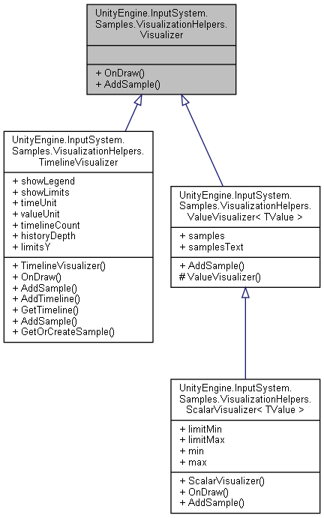

Collaboration diagram for UnityEngine.InputSystem.Samples.VisualizationHelpers.Visualizer:

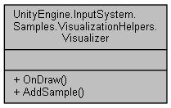

### Public Member Functions

abstract void **OnDraw** (Rect rect)

abstract void **AddSample** (object value, double time)

### Member Function Documentation

#### abstract void UnityEngine.InputSystem.Samples.VisualizationHelpers.Visualizer.AddSample (object *value*, double *time*)[pure virtual]

Implemented in **UnityEngine.InputSystem.Samples.VisualizationHelpers.ValueVisualizer< TValue >** (*p.824*), **UnityEngine.InputSystem.Samples.VisualizationHelpers.ScalarVisualizer< TValue >** (*p.652*), and **UnityEngine.InputSystem.Samples.VisualizationHelpers.TimelineVisualizer** (*p.759*).

#### abstract void UnityEngine.InputSystem.Samples.VisualizationHelpers.Visualizer.OnDraw (Rect *rect*)[pure virtual]

Implemented in **UnityEngine.InputSystem.Samples.VisualizationHelpers.ScalarVisualizer< TValue >** (*p.652*), and **UnityEngine.InputSystem.Samples.VisualizationHelpers.TimelineVisualizer** (*p.760*).

#### The documentation for this class was generated from the following file:

C:/_SSDSPEEDUP/2021/clone/gps1_manadesigner/GPS1-Manadesigner/Assets/Samples/Input System/1.0.2/Visualizers/**VisualizationHelpers.cs**

## WaypointPath Class Reference

Inheritance diagram for WaypointPath:

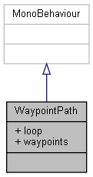

Collaboration diagram for WaypointPath:



### Public Attributes

bool **loop**

### Properties

Transform[] **waypoints** [get]

### Member Data Documentation

#### bool WaypointPath.loop

### Property Documentation

#### Transform [] WaypointPath.waypoints[get]

#### The documentation for this class was generated from the following file:

C:/_SSDSPEEDUP/2021/clone/gps1_manadesigner/GPS1-Manadesigner/Assets/_UtilsV0.4/MyScripts/_Utils/__Experimental/AIApproach/General/**WaypointPath.cs**

## WaypointPathMaker Class Reference

Inheritance diagram for WaypointPathMaker:

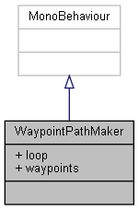

Collaboration diagram for WaypointPathMaker:



### Public Attributes

bool **loop**

### Properties

Transform[] **waypoints** [get]

### Member Data Documentation

#### bool WaypointPathMaker.loop

### Property Documentation

#### Transform [] WaypointPathMaker.waypoints[get]

#### The documentation for this class was generated from the following file:

C:/_SSDSPEEDUP/2021/clone/gps1_manadesigner/GPS1-Manadesigner/Assets/_UtilsV0.4/MyScripts/_Utils/_CommonV0.2/Redundant/**WaypointPathMaker.cs**

## Weapon Class Reference

Inheritance diagram for Weapon:

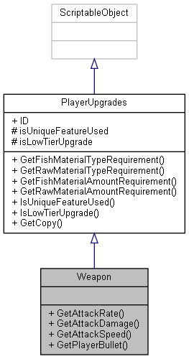

Collaboration diagram for Weapon:



### Public Member Functions

float **GetAttackRate** ()

float **GetAttackDamage** ()

float **GetAttackSpeed** ()

**PlayerBullet** **GetPlayerBullet** ()

### Additional Inherited Members

### Member Function Documentation

#### float Weapon.GetAttackDamage ()

Here is the caller graph for this function:



#### float Weapon.GetAttackRate ()

Here is the caller graph for this function:



#### float Weapon.GetAttackSpeed ()

Here is the caller graph for this function:



#### PlayerBullet Weapon.GetPlayerBullet ()

#### The documentation for this class was generated from the following file:

C:/_SSDSPEEDUP/2021/clone/gps1_manadesigner/GPS1-Manadesigner/Assets/Scripts/Arif's Test Scripts/Upgrades/Weapon/**Weapon.cs**

# File Documentation

## C:/_SSDSPEEDUP/2021/clone/gps1_manadesigner/GPS1-Manadesigner/Assets/_UtilsV0.4/_ProjectSpecific/Ocean/MyScripts/Passive Components/AutoFlipSpriteByDir.cs File Reference

### Classes

class **AutoFlipSpriteByDir**

## C:/_SSDSPEEDUP/2021/clone/gps1_manadesigner/GPS1-Manadesigner/Assets/_UtilsV0.4/Extend/BadScript.cs File Reference

### Classes

class **BadScript**

## C:/_SSDSPEEDUP/2021/clone/gps1_manadesigner/GPS1-Manadesigner/Assets/_UtilsV0.4/Extend/CollisionByTagEvent.cs File Reference

### Classes

class **CollisionByTagEvent**

## C:/_SSDSPEEDUP/2021/clone/gps1_manadesigner/GPS1-Manadesigner/Assets/_UtilsV0.4/MyScripts/_Utils/__Experimental/AIApproach/General/Unique/FlockAI.cs File Reference

### Classes

class **FlockAI**

## C:/_SSDSPEEDUP/2021/clone/gps1_manadesigner/GPS1-Manadesigner/Assets/_UtilsV0.4/MyScripts/_Utils/__Experimental/AIApproach/General/Unique/SpawnFlockManager.cs File Reference

### Classes

class **SpawnFlockManager**

## C:/_SSDSPEEDUP/2021/clone/gps1_manadesigner/GPS1-Manadesigner/Assets/_UtilsV0.4/MyScripts/_Utils/__Experimental/AIApproach/General/WaypointPath.cs File Reference

### Classes

class **WaypointPath**

## C:/_SSDSPEEDUP/2021/clone/gps1_manadesigner/GPS1-Manadesigner/Assets/_UtilsV0.4/MyScripts/_Utils/__Experimental/AIApproach/StatePattern/_bin/BinPatrol.cs File Reference

## C:/_SSDSPEEDUP/2021/clone/gps1_manadesigner/GPS1-Manadesigner/Assets/_UtilsV0.4/MyScripts/_Utils/__Experimental/AIApproach/StatePattern/CameraSightPerceptionSensor2D.cs File Reference

### Classes

class **CameraSightPerceptionSensor2D**

## C:/_SSDSPEEDUP/2021/clone/gps1_manadesigner/GPS1-Manadesigner/Assets/_UtilsV0.4/MyScripts/_Utils/__Experimental/AIApproach/StatePattern/FSMBaseState.cs File Reference

### Classes

class **FSMBaseState**

### Enumerations

enum **FSMExecutionState** { **NONE**, **ACTIVE**, **COMPLETED**, **TERMINATED** }

### Enumeration Type Documentation

#### enum FSMExecutionState

##### Enumerator:

|  |  |
| --- | --- |
| NONE |  |
| ACTIVE |  |
| COMPLETED |  |
| TERMINATED |  |

## C:/_SSDSPEEDUP/2021/clone/gps1_manadesigner/GPS1-Manadesigner/Assets/_UtilsV0.4/MyScripts/_Utils/__Experimental/AIApproach/StatePattern/FSMSystemBase.cs File Reference

### Classes

class **FSMSystemBase**

## C:/_SSDSPEEDUP/2021/clone/gps1_manadesigner/GPS1-Manadesigner/Assets/_UtilsV0.4/MyScripts/_Utils/__Experimental/AIApproach/StatePattern/Misc/TestState1.cs File Reference

## C:/_SSDSPEEDUP/2021/clone/gps1_manadesigner/GPS1-Manadesigner/Assets/_UtilsV0.4/MyScripts/_Utils/__Experimental/AIApproach/StatePattern/NPCAIStatesTypeA.cs File Reference

### Classes

class **DefaultState**

class **Alert**

class **Chase**

class **Flee**

class **PatrolByRandomPos**

class **PatrolByWaypoints**

## C:/_SSDSPEEDUP/2021/clone/gps1_manadesigner/GPS1-Manadesigner/Assets/_UtilsV0.4/MyScripts/_Utils/__Experimental/AIApproach/StatePattern/NPCAISystemTypeA.cs File Reference

### Classes

class **NPCAISystemTypeA**

### Enumerations

enum **NPCAITypeAReactinStyle** { **Chase**, **Flee**, **Flock**, **Patrol** }

### Enumeration Type Documentation

#### enum NPCAITypeAReactinStyle

##### Enumerator:

|  |  |
| --- | --- |
| Chase |  |
| Flee |  |
| Flock |  |
| Patrol |  |

## C:/_SSDSPEEDUP/2021/clone/gps1_manadesigner/GPS1-Manadesigner/Assets/_UtilsV0.4/MyScripts/_Utils/__Experimental/Stat.cs File Reference

### Classes

class **Stat**

## C:/_SSDSPEEDUP/2021/clone/gps1_manadesigner/GPS1-Manadesigner/Assets/_UtilsV0.4/MyScripts/_Utils/_CommonV0.2/Animator/_Bin/IStateBehavior.cs File Reference

### Classes

interface **IStateBehavior**

## C:/_SSDSPEEDUP/2021/clone/gps1_manadesigner/GPS1-Manadesigner/Assets/_UtilsV0.4/MyScripts/_Utils/_CommonV0.2/Animator/_Bin/MotionTypeStateBehavior.cs File Reference

## C:/_SSDSPEEDUP/2021/clone/gps1_manadesigner/GPS1-Manadesigner/Assets/_UtilsV0.4/MyScripts/_Utils/_CommonV0.2/Animator/ParamStateBehavior.cs File Reference

### Classes

class **ParamStateBehavior**

class **SetParamStateData**

### Enumerations

enum **EAnimParamType** { **BOOL_SetDefaultState**, **TRIGGER_Set**, **TRIGGER_Reset**, **INT**, **FLOAT** }

### Enumeration Type Documentation

#### enum EAnimParamType

##### Enumerator:

|  |  |
| --- | --- |
| BOOL_SetDefaultState |  |
| TRIGGER_Set |  |
| TRIGGER_Reset |  |
| INT |  |
| FLOAT |  |

## C:/_SSDSPEEDUP/2021/clone/gps1_manadesigner/GPS1-Manadesigner/Assets/_UtilsV0.4/MyScripts/_Utils/_CommonV0.2/Animator/TimedParamStateBehavior.cs File Reference

### Classes

class **TimedParamStateBehavior**

## C:/_SSDSPEEDUP/2021/clone/gps1_manadesigner/GPS1-Manadesigner/Assets/_UtilsV0.4/MyScripts/_Utils/_CommonV0.2/Calculation/Components/ConstraintCommon.cs File Reference

### Classes

class **ConstraintCommon**

## C:/_SSDSPEEDUP/2021/clone/gps1_manadesigner/GPS1-Manadesigner/Assets/_UtilsV0.4/MyScripts/_Utils/_CommonV0.2/Calculation/MathCommon.cs File Reference

### Classes

class **MathCommon**

## C:/_SSDSPEEDUP/2021/clone/gps1_manadesigner/GPS1-Manadesigner/Assets/_UtilsV0.4/MyScripts/_Utils/_CommonV0.2/Calculation/PhysicsCastCommon.cs File Reference

### Classes

class **Assets.MyScripts.SInt.Common.Calculation.PhysicsCastCommon**

### Namespaces

namespace **Assets**

namespace **Assets.MyScripts**

namespace **Assets.MyScripts.SInt**

namespace **Assets.MyScripts.SInt.Common**

namespace **Assets.MyScripts.SInt.Common.Calculation**

## C:/_SSDSPEEDUP/2021/clone/gps1_manadesigner/GPS1-Manadesigner/Assets/_UtilsV0.4/MyScripts/_Utils/_CommonV0.2/Calculation/StdioCommon.cs File Reference

### Classes

class **StdioCommon**

## C:/_SSDSPEEDUP/2021/clone/gps1_manadesigner/GPS1-Manadesigner/Assets/_UtilsV0.4/MyScripts/_Utils/_CommonV0.2/Calculation/TransformCommon.cs File Reference

### Classes

class **TransformCommon**

## C:/_SSDSPEEDUP/2021/clone/gps1_manadesigner/GPS1-Manadesigner/Assets/_UtilsV0.4/MyScripts/_Utils/_CommonV0.2/Calculation/Vector3Common.cs File Reference

### Classes

class **Vector3Common**

## C:/_SSDSPEEDUP/2021/clone/gps1_manadesigner/GPS1-Manadesigner/Assets/_UtilsV0.4/MyScripts/_Utils/_CommonV0.2/CommonExtend/2D/RigidBody2DAutoAddRelativeForceUp.cs File Reference

### Classes

class **RigidBody2DAutoAddRelativeForceUp**

## C:/_SSDSPEEDUP/2021/clone/gps1_manadesigner/GPS1-Manadesigner/Assets/_UtilsV0.4/MyScripts/_Utils/_CommonV0.2/CommonExtend/2D/Transform2DAutoLookAtObj2D.cs File Reference

### Classes

class **Transform2DAutoLookAtObj2D**

## C:/_SSDSPEEDUP/2021/clone/gps1_manadesigner/GPS1-Manadesigner/Assets/_UtilsV0.4/MyScripts/_Utils/_CommonV0.2/CommonExtend/2D/Vector2Common.cs File Reference

### Classes

class **Vector2Common**

## C:/_SSDSPEEDUP/2021/clone/gps1_manadesigner/GPS1-Manadesigner/Assets/_UtilsV0.4/MyScripts/_Utils/_CommonV0.2/CommonExtend/AINav/AINavAgentCommon.cs File Reference

### Classes

class **AINavAgentCommon**

## C:/_SSDSPEEDUP/2021/clone/gps1_manadesigner/GPS1-Manadesigner/Assets/_UtilsV0.4/MyScripts/_Utils/_CommonV0.2/CommonExtend/AINav/NavAgentTestAutoSetMouseDestination.cs File Reference

### Classes

class **NavAgentTestAutoSetMouseDestination**

## C:/_SSDSPEEDUP/2021/clone/gps1_manadesigner/GPS1-Manadesigner/Assets/_UtilsV0.4/MyScripts/_Utils/_CommonV0.2/CommonExtend/AINav/NavAgentTestAutoSetRandomDestination.cs File Reference

### Classes

class **NavAgentTestAutoSetRandomDestination**

## C:/_SSDSPEEDUP/2021/clone/gps1_manadesigner/GPS1-Manadesigner/Assets/_UtilsV0.4/MyScripts/_Utils/_CommonV0.2/CommonExtend/AINav/NavAgentTestAutoSetWASDMovement.cs File Reference

### Classes

class **NavAgentTestAutoSetWASDMovement**

## C:/_SSDSPEEDUP/2021/clone/gps1_manadesigner/GPS1-Manadesigner/Assets/_UtilsV0.4/MyScripts/_Utils/_CommonV0.2/CommonExtend/AINav/NavMeshCustomMove.cs File Reference

### Classes

class **NavMeshCustomMove**

## C:/_SSDSPEEDUP/2021/clone/gps1_manadesigner/GPS1-Manadesigner/Assets/_UtilsV0.4/MyScripts/_Utils/_CommonV0.2/CommonExtend/CommonEdit/GameObjSpawnHelper.cs File Reference

### Classes

class **GameObjSpawnHelper**

## C:/_SSDSPEEDUP/2021/clone/gps1_manadesigner/GPS1-Manadesigner/Assets/_UtilsV0.4/MyScripts/_Utils/_CommonV0.2/CommonExtend/TransformPosShake.cs File Reference

### Classes

class **TransformPosShake**

## C:/_SSDSPEEDUP/2021/clone/gps1_manadesigner/GPS1-Manadesigner/Assets/_UtilsV0.4/MyScripts/_Utils/_CommonV0.2/EngineOverride/Debug.cs File Reference

## C:/_SSDSPEEDUP/2021/clone/gps1_manadesigner/GPS1-Manadesigner/Assets/_UtilsV0.4/MyScripts/_Utils/_CommonV0.2/Event/AnimationEventHelper.cs File Reference

### Classes

class **AnimationEventHelper**

## C:/_SSDSPEEDUP/2021/clone/gps1_manadesigner/GPS1-Manadesigner/Assets/_UtilsV0.4/MyScripts/_Utils/_CommonV0.2/Event/OnAllUnityEventCall.cs File Reference

### Classes

class **OnAllUnityEventCall**

## C:/_SSDSPEEDUP/2021/clone/gps1_manadesigner/GPS1-Manadesigner/Assets/_UtilsV0.4/MyScripts/_Utils/_CommonV0.2/Event/OnEnableEventCallTimer.cs File Reference

### Classes

class **OnEnableEventCallTimer**

## C:/_SSDSPEEDUP/2021/clone/gps1_manadesigner/GPS1-Manadesigner/Assets/_UtilsV0.4/MyScripts/_Utils/_CommonV0.2/Event/OnEnablePlayBGM.cs File Reference

### Classes

class **OnEnablePlayBGM**

## C:/_SSDSPEEDUP/2021/clone/gps1_manadesigner/GPS1-Manadesigner/Assets/_UtilsV0.4/MyScripts/_Utils/_CommonV0.2/Event/OnEnablePlaySFX.cs File Reference

### Classes

class **OnEnablePlaySFX**

## C:/_SSDSPEEDUP/2021/clone/gps1_manadesigner/GPS1-Manadesigner/Assets/_UtilsV0.4/MyScripts/_Utils/_CommonV0.2/Helper/LineRendererDrawer.cs File Reference

### Classes

class **LineRendererDrawer**

*This class gets a line renderer in this object, and then set its end points based on its target.*

## C:/_SSDSPEEDUP/2021/clone/gps1_manadesigner/GPS1-Manadesigner/Assets/_UtilsV0.4/MyScripts/_Utils/_CommonV0.2/Helper/LookAtCameraMain.cs File Reference

### Classes

class **LookAtCameraMain**

## C:/_SSDSPEEDUP/2021/clone/gps1_manadesigner/GPS1-Manadesigner/Assets/_UtilsV0.4/MyScripts/_Utils/_CommonV0.2/Helper/PlayTestSpeedUp.cs File Reference

### Classes

class **PlayTestSpeedUp**

## C:/_SSDSPEEDUP/2021/clone/gps1_manadesigner/GPS1-Manadesigner/Assets/_UtilsV0.4/MyScripts/_Utils/_CommonV0.2/Monobehavior/BaseClass/Singleton.cs File Reference

### Classes

class **Singleton< T >**

## C:/_SSDSPEEDUP/2021/clone/gps1_manadesigner/GPS1-Manadesigner/Assets/_UtilsV0.4/MyScripts/_Utils/_CommonV0.2/Monobehavior/DestroyBySeconds.cs File Reference

### Classes

class **DestroyBySeconds**

## C:/_SSDSPEEDUP/2021/clone/gps1_manadesigner/GPS1-Manadesigner/Assets/_UtilsV0.4/MyScripts/_Utils/_CommonV0.2/Monobehavior/DontDestroyOnLoad.cs File Reference

### Classes

class **DontDestroyOnLoad**

## C:/_SSDSPEEDUP/2021/clone/gps1_manadesigner/GPS1-Manadesigner/Assets/_UtilsV0.4/MyScripts/_Utils/_CommonV0.2/Redundant/TransformAutoFakeParent.cs File Reference

### Classes

class **TransformAutoFakeParent**

## C:/_SSDSPEEDUP/2021/clone/gps1_manadesigner/GPS1-Manadesigner/Assets/_UtilsV0.4/MyScripts/_Utils/_CommonV0.2/Redundant/TransformAutoRelative.cs File Reference

### Classes

class **TransformAutoRelative**

## C:/_SSDSPEEDUP/2021/clone/gps1_manadesigner/GPS1-Manadesigner/Assets/_UtilsV0.4/MyScripts/_Utils/_CommonV0.2/Redundant/WaypointPathMaker.cs File Reference

### Classes

class **WaypointPathMaker**

## C:/_SSDSPEEDUP/2021/clone/gps1_manadesigner/GPS1-Manadesigner/Assets/_UtilsV0.4/MyScripts/_Utils/_CommonV0.2/Singletons/AudioManager.cs File Reference

### Classes

class **AudioManager**

class **AudioFade**

## C:/_SSDSPEEDUP/2021/clone/gps1_manadesigner/GPS1-Manadesigner/Assets/_UtilsV0.4/MyScripts/_Utils/_CommonV0.2/Singletons/GameplayManager.cs File Reference

### Classes

class **GameplayManager**

## C:/_SSDSPEEDUP/2021/clone/gps1_manadesigner/GPS1-Manadesigner/Assets/_UtilsV0.4/MyScripts/_Utils/_CommonV0.2/Singletons/SceneAsyncManager.cs File Reference

### Classes

class **SceneAsyncManager**

### Detailed Description

##### Author

John Doe jdoe@example.com

##### Version

1.0

## DESCRIPTION

The time class represents a moment of time.

## C:/_SSDSPEEDUP/2021/clone/gps1_manadesigner/GPS1-Manadesigner/Assets/_UtilsV0.4/MyScripts/_Utils/_CommonV0.2/Singletons/Sound.cs File Reference

### Classes

class **Sound**

## C:/_SSDSPEEDUP/2021/clone/gps1_manadesigner/GPS1-Manadesigner/Assets/_UtilsV0.4/MyScripts/_Utils/_CommonV0.2/TransformOffsetORCustomTwine/TransformAutoRotate.cs File Reference

### Classes

class **TransformAutoRotate**

## C:/_SSDSPEEDUP/2021/clone/gps1_manadesigner/GPS1-Manadesigner/Assets/_UtilsV0.4/MyScripts/_Utils/_CommonV0.2/UICanvas/GameObjActivePauseSync.cs File Reference

### Classes

class **GameObjActivePauseSync**

## C:/_SSDSPEEDUP/2021/clone/gps1_manadesigner/GPS1-Manadesigner/Assets/_UtilsV0.4/MyScripts/_Utils/_CommonV0.2/UICanvas/Helper/SingleTonOnClickHelper.cs File Reference

### Classes

class **SingleTonOnClickHelper**

## C:/_SSDSPEEDUP/2021/clone/gps1_manadesigner/GPS1-Manadesigner/Assets/_UtilsV0.4/MyScripts/_Utils/_CommonV0.2/UICanvas/PlayerPrefTextSync.cs File Reference

### Classes

class **PlayerPrefTextSync**

## C:/_SSDSPEEDUP/2021/clone/gps1_manadesigner/GPS1-Manadesigner/Assets/_UtilsV0.4/MyScripts/_Utils/_CommonV0.2/UICanvas/ScrollRectCommon.cs File Reference

### Classes

class **ScrollRectCommon**

## C:/_SSDSPEEDUP/2021/clone/gps1_manadesigner/GPS1-Manadesigner/Assets/_UtilsV0.4/MyScripts/_Utils/_CommonV0.2/UICanvas/SyncTextWithTextMeshPro.cs File Reference

### Classes

class **SyncTextWithTextMeshPro**

## C:/_SSDSPEEDUP/2021/clone/gps1_manadesigner/GPS1-Manadesigner/Assets/_UtilsV0.4/MyScripts/_Utils/_CommonV0.2/UICanvas/UIHPSliderColor.cs File Reference

### Classes

class **UIHPSliderColor**

## C:/_SSDSPEEDUP/2021/clone/gps1_manadesigner/GPS1-Manadesigner/Assets/_UtilsV0.4/MyScripts/_Utils/_CommonV0.2/UICanvas/UIShowHideToggle.cs File Reference

### Classes

class **UIShowHideToggle**

## C:/_SSDSPEEDUP/2021/clone/gps1_manadesigner/GPS1-Manadesigner/Assets/_UtilsV0.4/MyScripts/_Utils/_CommonV0.2/UICanvas/UIVolumeSlider.cs File Reference

### Classes

class **UIVolumeSlider**

## C:/_SSDSPEEDUP/2021/clone/gps1_manadesigner/GPS1-Manadesigner/Assets/_UtilsV0.4/MyScripts/_Utils/CommandPattern/_Bin/OWS/_Samples/Script/CharacterMove.cs File Reference

### Classes

class **CharacterMove**

## C:/_SSDSPEEDUP/2021/clone/gps1_manadesigner/GPS1-Manadesigner/Assets/_UtilsV0.4/MyScripts/_Utils/CommandPattern/_Bin/OWS/_Samples/Script/CharacterMoveClean.cs File Reference

### Classes

class **CharacterMoveClean**

## C:/_SSDSPEEDUP/2021/clone/gps1_manadesigner/GPS1-Manadesigner/Assets/_UtilsV0.4/MyScripts/_Utils/CommandPattern/_Bin/OWS/_Samples/Script/CharacterMoveTurnBased.cs File Reference

### Classes

class **CharacterMoveTurnBased**

## C:/_SSDSPEEDUP/2021/clone/gps1_manadesigner/GPS1-Manadesigner/Assets/_UtilsV0.4/MyScripts/_Utils/CommandPattern/_Bin/OWS/_Samples/Script/CharacterMoveUndo.cs File Reference

### Classes

class **CharacterMoveUndo**

## C:/_SSDSPEEDUP/2021/clone/gps1_manadesigner/GPS1-Manadesigner/Assets/_UtilsV0.4/MyScripts/_Utils/CommandPattern/_Bin/OWS/_Samples/Script/InputManager.cs File Reference

### Classes

class **InputManager**

## C:/_SSDSPEEDUP/2021/clone/gps1_manadesigner/GPS1-Manadesigner/Assets/_UtilsV0.4/MyScripts/_Utils/CommandPattern/_Bin/OWS/_Samples/Script/InputManagerTurnBased.cs File Reference

### Classes

class **InputManagerTurnBased**

## C:/_SSDSPEEDUP/2021/clone/gps1_manadesigner/GPS1-Manadesigner/Assets/_UtilsV0.4/MyScripts/_Utils/CommandPattern/_Bin/OWS/_Samples/Script/Move.cs File Reference

### Classes

class **Move**

## C:/_SSDSPEEDUP/2021/clone/gps1_manadesigner/GPS1-Manadesigner/Assets/_UtilsV0.4/MyScripts/_Utils/CommandPattern/_Bin/OWS/_Samples/Script/PathDraw.cs File Reference

### Classes

class **PathDraw**

## C:/_SSDSPEEDUP/2021/clone/gps1_manadesigner/GPS1-Manadesigner/Assets/_UtilsV0.4/MyScripts/_Utils/CommandPattern/_Bin/OWS/_Samples/Script/UICommandList.cs File Reference

### Classes

class **UICommandList**

## C:/_SSDSPEEDUP/2021/clone/gps1_manadesigner/GPS1-Manadesigner/Assets/_UtilsV0.4/MyScripts/_Utils/CommandPattern/_Bin/OWS/CommandHandler.cs File Reference

### Classes

class **CommandHandler**

## C:/_SSDSPEEDUP/2021/clone/gps1_manadesigner/GPS1-Manadesigner/Assets/_UtilsV0.4/MyScripts/_Utils/CommandPattern/_Bin/OWS/Interfaces/ICommandOWS.cs File Reference

### Classes

interface **ICommandOWS**

## C:/_SSDSPEEDUP/2021/clone/gps1_manadesigner/GPS1-Manadesigner/Assets/_UtilsV0.4/MyScripts/_Utils/CommandPattern/Command/_Bin/BinCommandHolder.cs File Reference

## C:/_SSDSPEEDUP/2021/clone/gps1_manadesigner/GPS1-Manadesigner/Assets/_UtilsV0.4/MyScripts/_Utils/CommandPattern/Command/_Bin/CommandHolder.cs File Reference

## C:/_SSDSPEEDUP/2021/clone/gps1_manadesigner/GPS1-Manadesigner/Assets/_UtilsV0.4/MyScripts/_Utils/CommandPattern/Command/_Bin/CommandManagerOld.cs File Reference

### Classes

class **CommandManagerOld**

## C:/_SSDSPEEDUP/2021/clone/gps1_manadesigner/GPS1-Manadesigner/Assets/_UtilsV0.4/MyScripts/_Utils/CommandPattern/Command/_Bin/Custom/BinCommandAccessorRefsBase.cs File Reference

### Classes

class **BinCommandAccessorRefsBase**

## C:/_SSDSPEEDUP/2021/clone/gps1_manadesigner/GPS1-Manadesigner/Assets/_UtilsV0.4/MyScripts/_Utils/CommandPattern/Command/_Bin/Custom/CommandCoolDownComp.cs File Reference

### Classes

class **CommandCoolDownComp**

## C:/_SSDSPEEDUP/2021/clone/gps1_manadesigner/GPS1-Manadesigner/Assets/_UtilsV0.4/MyScripts/_Utils/CommandPattern/Command/_Bin/CustomScriptableObjectBase/BinCommandWithCooldown.cs File Reference

### Classes

class **BinCommandWithCooldown**

## C:/_SSDSPEEDUP/2021/clone/gps1_manadesigner/GPS1-Manadesigner/Assets/_UtilsV0.4/MyScripts/_Utils/CommandPattern/Command/_Bin/ECommandEnums.cs File Reference

### Enumerations

enum **CommandCastStatus** { **Cooldown**, **Active**, **Ready** }

enum **ReadStyle** { **Tap**, **Hold**, **Release** }

### Enumeration Type Documentation

#### enum CommandCastStatus

##### Enumerator:

|  |  |
| --- | --- |
| Cooldown |  |
| Active |  |
| Ready |  |

#### enum ReadStyle

##### Enumerator:

|  |  |
| --- | --- |
| Tap |  |
| Hold |  |
| Release |  |

## C:/_SSDSPEEDUP/2021/clone/gps1_manadesigner/GPS1-Manadesigner/Assets/_UtilsV0.4/MyScripts/_Utils/CommandPattern/Command/_Bin/MyScene/Sample/Example/Scripts/ColorCreator.cs File Reference

### Classes

class **Examples.Command.ColorCreator**

### Namespaces

namespace **Examples**

namespace **Examples.Command**

*Utility script that creates a random color for us and returns it.*

## C:/_SSDSPEEDUP/2021/clone/gps1_manadesigner/GPS1-Manadesigner/Assets/_UtilsV0.4/MyScripts/_Utils/CommandPattern/Command/_Bin/MyScene/Sample/Example/Scripts/Commands/LightActiveToggle.cs File Reference

### Classes

class **Examples.Command.LightActiveToggle**

### Namespaces

namespace **Examples**

namespace **Examples.Command**

*Utility script that creates a random color for us and returns it.*

## C:/_SSDSPEEDUP/2021/clone/gps1_manadesigner/GPS1-Manadesigner/Assets/_UtilsV0.4/MyScripts/_Utils/CommandPattern/Command/_Bin/MyScene/Sample/Example/Scripts/Commands/LightColorChange.cs File Reference

### Classes

class **Examples.Command.LightColorChange**

### Namespaces

namespace **Examples**

namespace **Examples.Command**

*Utility script that creates a random color for us and returns it.*

## C:/_SSDSPEEDUP/2021/clone/gps1_manadesigner/GPS1-Manadesigner/Assets/_UtilsV0.4/MyScripts/_Utils/CommandPattern/Command/_Bin/MyScene/Sample/Example/Scripts/Commands/LightDecreaseIntensity.cs File Reference

### Classes

class **Examples.Command.LightDecreaseIntensity**

### Namespaces

namespace **Examples**

namespace **Examples.Command**

*Utility script that creates a random color for us and returns it.*

## C:/_SSDSPEEDUP/2021/clone/gps1_manadesigner/GPS1-Manadesigner/Assets/_UtilsV0.4/MyScripts/_Utils/CommandPattern/Command/_Bin/MyScene/Sample/Example/Scripts/Commands/LightIncreaseIntensity.cs File Reference

### Classes

class **Examples.Command.LightIncreaseIntensity**

### Namespaces

namespace **Examples**

namespace **Examples.Command**

*Utility script that creates a random color for us and returns it.*

## C:/_SSDSPEEDUP/2021/clone/gps1_manadesigner/GPS1-Manadesigner/Assets/_UtilsV0.4/MyScripts/_Utils/CommandPattern/Command/_Bin/MyScene/Sample/Example/Scripts/LightController.cs File Reference

### Classes

class **Examples.Command.LightController**

### Namespaces

namespace **Examples**

namespace **Examples.Command**

*Utility script that creates a random color for us and returns it.*

## C:/_SSDSPEEDUP/2021/clone/gps1_manadesigner/GPS1-Manadesigner/Assets/_UtilsV0.4/MyScripts/_Utils/CommandPattern/Command/MyScripts/ChainCommandData.cs File Reference

### Classes

class **ChainCommandData**

## C:/_SSDSPEEDUP/2021/clone/gps1_manadesigner/GPS1-Manadesigner/Assets/_UtilsV0.4/MyScripts/_Utils/CommandPattern/Command/MyScripts/ChainCommandInvoker.cs File Reference

### Classes

class **ChainCommandInvoker**

## C:/_SSDSPEEDUP/2021/clone/gps1_manadesigner/GPS1-Manadesigner/Assets/_UtilsV0.4/MyScripts/_Utils/CommandPattern/Command/MyScripts/CommandAccessorRefsBase.cs File Reference

### Classes

class **CommandAccessorRefsBase**

struct **CommandAccessorRefsBase.CommandSlotUnityEvents**

## C:/_SSDSPEEDUP/2021/clone/gps1_manadesigner/GPS1-Manadesigner/Assets/_UtilsV0.4/MyScripts/_Utils/CommandPattern/Command/MyScripts/CommandQueue.cs File Reference

### Classes

class **CommandQueue**

## C:/_SSDSPEEDUP/2021/clone/gps1_manadesigner/GPS1-Manadesigner/Assets/_UtilsV0.4/MyScripts/_Utils/CommandPattern/Command/MyScripts/CommandQueueHelper.cs File Reference

### Classes

class **CommandQueueHelper**

## C:/_SSDSPEEDUP/2021/clone/gps1_manadesigner/GPS1-Manadesigner/Assets/_UtilsV0.4/MyScripts/_Utils/CommandPattern/Command/MyScripts/Reusable/_Bin/CommandStack.cs File Reference

### Classes

class **CommandStack**

## C:/_SSDSPEEDUP/2021/clone/gps1_manadesigner/GPS1-Manadesigner/Assets/_UtilsV0.4/MyScripts/_Utils/CommandPattern/Command/MyScripts/Reusable/ICommand.cs File Reference

### Classes

interface **ICommand**

## C:/_SSDSPEEDUP/2021/clone/gps1_manadesigner/GPS1-Manadesigner/Assets/_UtilsV0.4/MyScripts/_Utils/CommandPattern/Command/MyScripts/TypeA_RefsToAllAvailableCommandInSingleScript/ChainCommandInvokerOldTypeA.cs File Reference

### Classes

class **ChainCommandInvokerOldTypeA**

class **ChainCommandDataOld**

## C:/_SSDSPEEDUP/2021/clone/gps1_manadesigner/GPS1-Manadesigner/Assets/_UtilsV0.4/MyScripts/_Utils/CommandPattern/Command/MyScripts/TypeA_RefsToAllAvailableCommandInSingleScript/InputHandlerOld_NewInputSystem.cs File Reference

### Classes

class **InputHandlerOld_NewInputSystem**

## C:/_SSDSPEEDUP/2021/clone/gps1_manadesigner/GPS1-Manadesigner/Assets/_UtilsV0.4/MyScripts/_Utils/CommandPattern/Command/MyScripts/TypeB_CommandHolder/CommandSlotHolder.cs File Reference

### Classes

class **CommandSlotHolder**

## C:/_SSDSPEEDUP/2021/clone/gps1_manadesigner/GPS1-Manadesigner/Assets/_UtilsV0.4/MyScripts/_Utils/CommandPattern/Command/MyScripts/TypeB_CommandHolder/CommandSlotsHolderManager.cs File Reference

### Classes

class **CommandSlotsHolderManager**

## C:/_SSDSPEEDUP/2021/clone/gps1_manadesigner/GPS1-Manadesigner/Assets/_UtilsV0.4/MyScripts/_Utils/CommandPattern/Command/SOAssets/InputSystemPackage/RebindUISampleActionsModified.cs File Reference

### Classes

class **RebindUISampleActionsModified**

struct **RebindUISampleActionsModified.PlayerMainActions**

struct **RebindUISampleActionsModified.UIMainActions**

struct **RebindUISampleActionsModified.GameplaySampleUnusedActions**

struct **RebindUISampleActionsModified.Vector2AxisActions**

interface **RebindUISampleActionsModified.IPlayerMainActions**

interface **RebindUISampleActionsModified.IUIMainActions**

interface **RebindUISampleActionsModified.IGameplaySampleUnusedActions**

interface **RebindUISampleActionsModified.IVector2AxisActions**

## C:/_SSDSPEEDUP/2021/clone/gps1_manadesigner/GPS1-Manadesigner/Assets/_UtilsV0.4/MyScripts/_Utils/CommandPattern/Command/SOScripts/_Bin/CommandTemplateCooldown.cs File Reference

## C:/_SSDSPEEDUP/2021/clone/gps1_manadesigner/GPS1-Manadesigner/Assets/_UtilsV0.4/MyScripts/_Utils/CommandPattern/Command/SOScripts/AbilityCommand.cs File Reference

### Classes

class **AbilityCommand**

## C:/_SSDSPEEDUP/2021/clone/gps1_manadesigner/GPS1-Manadesigner/Assets/_UtilsV0.4/MyScripts/_Utils/CommandPattern/Command/SOScripts/CommandBase.cs File Reference

### Classes

class **CommandBase**

struct **CommandBase.Info**

struct **CommandBase.InstanceInfoRuntime**

struct **CommandBase.CooldownInfo**

class **CommandBase.ExecutionInfo**

### Enumerations

enum **ExecStatus** { **None**, **ExecPress**, **ExecDown**, **ExecDownCharging**, **ExecRelease**, **Execd** }

### Enumeration Type Documentation

#### enum ExecStatus

##### Enumerator:

|  |  |
| --- | --- |
| None |  |
| ExecPress |  |
| ExecDown |  |
| ExecDownCharging |  |
| ExecRelease |  |
| Execd |  |

## C:/_SSDSPEEDUP/2021/clone/gps1_manadesigner/GPS1-Manadesigner/Assets/_UtilsV0.4/MyScripts/_Utils/CommandPattern/Command/SOScripts/InputCommand.cs File Reference

### Classes

class **InputCommand**

struct **InputCommand.ExecExtraInfo**

## C:/_SSDSPEEDUP/2021/clone/gps1_manadesigner/GPS1-Manadesigner/Assets/_UtilsV0.4/MyScripts/_Utils/CommandPattern/Command/SOScripts/Misc/EnableDisableGameObjectCommand.cs File Reference

### Classes

class **EnableDisableGameObjectCommand**

## C:/_SSDSPEEDUP/2021/clone/gps1_manadesigner/GPS1-Manadesigner/Assets/_UtilsV0.4/MyScripts/_Utils/CommandPattern/Command/SOScripts/Misc/SetMaterialColorCommand.cs File Reference

### Classes

class **SetMaterialColorCommand**

## C:/_SSDSPEEDUP/2021/clone/gps1_manadesigner/GPS1-Manadesigner/Assets/_UtilsV0.4/MyScripts/_Utils/CommandPattern/Events/CommandEvent.cs File Reference

### Classes

class **CommandEvent**

## C:/_SSDSPEEDUP/2021/clone/gps1_manadesigner/GPS1-Manadesigner/Assets/_UtilsV0.4/MyScripts/_Utils/CommandPattern/Events/CommandEventListener.cs File Reference

### Classes

class **CommandEventListener**

## C:/_SSDSPEEDUP/2021/clone/gps1_manadesigner/GPS1-Manadesigner/Assets/_UtilsV0.4/MyScripts/_Utils/CommandPattern/Events/Editor/EventEditor.cs File Reference

### Classes

class **EventEditor**

## C:/_SSDSPEEDUP/2021/clone/gps1_manadesigner/GPS1-Manadesigner/Assets/_UtilsV0.4/MyScripts/_Utils/CommandPattern/Events/GameEvent.cs File Reference

### Classes

class **GameEvent**

## C:/_SSDSPEEDUP/2021/clone/gps1_manadesigner/GPS1-Manadesigner/Assets/_UtilsV0.4/MyScripts/_Utils/CommandPattern/Events/GameEventListener.cs File Reference

### Classes

class **GameEventListener**

## C:/_SSDSPEEDUP/2021/clone/gps1_manadesigner/GPS1-Manadesigner/Assets/_UtilsV0.4/MyScripts/_Utils/SerializableDataStructures/GenericDictionary.cs File Reference

### Classes

class **GenericDictionary< TKey, TValue >**

*Generic Serializable Dictionary for Unity 2020.1.*

## C:/_SSDSPEEDUP/2021/clone/gps1_manadesigner/GPS1-Manadesigner/Assets/_UtilsV0.4/MyScripts/_Utils/SerializableDataStructures/SerializableQueueList.cs File Reference

### Classes

class **SerializableQueueList< T >**

## C:/_SSDSPEEDUP/2021/clone/gps1_manadesigner/GPS1-Manadesigner/Assets/_UtilsV0.4/MyScripts/_Utils/UnityRegistryIntegration/InputSystem/Rebinding UI/_Modified/RebindActionUI.cs File Reference

### Classes

class **UnityEngine.InputSystem.Samples.RebindUI.RebindActionUI**

*A reusable component with a self-contained* ***UI*** *for rebinding a single action.*

class **UnityEngine.InputSystem.Samples.RebindUI.RebindActionUI.UpdateBindingUIEvent**

class **UnityEngine.InputSystem.Samples.RebindUI.RebindActionUI.InteractiveRebindEvent**

### Namespaces

namespace **UnityEngine**

namespace **UnityEngine.InputSystem**

namespace **UnityEngine.InputSystem.Samples**

namespace **UnityEngine.InputSystem.Samples.RebindUI**

## C:/_SSDSPEEDUP/2021/clone/gps1_manadesigner/GPS1-Manadesigner/Assets/_UtilsV0.4/MyScripts/_Utils/UnityRegistryIntegration/InputSystem/Rebinding UI/_Modified/RebindIconsHelper.cs File Reference

### Classes

class **UnityEngine.InputSystem.Samples.RebindUI.RebindIconsHelper**

*This is an example for how to override the default display behavior of bindings.*

struct **UnityEngine.InputSystem.Samples.RebindUI.RebindIconsHelper.GamepadIcons**

struct **UnityEngine.InputSystem.Samples.RebindUI.RebindIconsHelper.KeyMouseIcons**

### Namespaces

namespace **UnityEngine**

namespace **UnityEngine.InputSystem**

namespace **UnityEngine.InputSystem.Samples**

namespace **UnityEngine.InputSystem.Samples.RebindUI**

## C:/_SSDSPEEDUP/2021/clone/gps1_manadesigner/GPS1-Manadesigner/Assets/_UtilsV0.4/MyScripts/_Utils/UnityRegistryIntegration/InputSystem/Rebinding UI/_Modified/RebindResetAllBindings.cs File Reference

### Classes

class **RebindResetAllBindings**

## C:/_SSDSPEEDUP/2021/clone/gps1_manadesigner/GPS1-Manadesigner/Assets/_UtilsV0.4/MyScripts/_Utils/UnityRegistryIntegration/InputSystem/Rebinding UI/_Modified/RebindSaveLoad.cs File Reference

### Classes

class **RebindSaveLoad**

## C:/_SSDSPEEDUP/2021/clone/gps1_manadesigner/GPS1-Manadesigner/Assets/_UtilsV0.4/MyScripts/_Utils/UnityRegistryIntegration/InputSystem/Rebinding UI/GamepadIconsExample.cs File Reference

### Classes

class **UnityEngine.InputSystem.Samples.RebindUI.GamepadIconsExample**

*This is an example for how to override the default display behavior of bindings.*

struct **UnityEngine.InputSystem.Samples.RebindUI.GamepadIconsExample.GamepadIcons**

### Namespaces

namespace **UnityEngine**

namespace **UnityEngine.InputSystem**

namespace **UnityEngine.InputSystem.Samples**

namespace **UnityEngine.InputSystem.Samples.RebindUI**

## C:/_SSDSPEEDUP/2021/clone/gps1_manadesigner/GPS1-Manadesigner/Assets/_UtilsV0.4/MyScripts/_Utils/UnityRegistryIntegration/InputSystem/Rebinding UI/RebindActionUIEditor.cs File Reference

## C:/_SSDSPEEDUP/2021/clone/gps1_manadesigner/GPS1-Manadesigner/Assets/AreaOfEffect.cs File Reference

### Classes

class **AreaOfEffect**

## C:/_SSDSPEEDUP/2021/clone/gps1_manadesigner/GPS1-Manadesigner/Assets/Character.cs File Reference

### Classes

class **Character**

## C:/_SSDSPEEDUP/2021/clone/gps1_manadesigner/GPS1-Manadesigner/Assets/Editor/Doxygen/DoxygenWindow.cs File Reference

### Classes

class **DoxygenConfig**

class **DoxygenWindow**

class **DoxyRunner**

*This class spawns and runs Doxygen in a separate thread, and could serve as an example of how to create plugins for unity that call a command line application and then get the data back into Unity safely.*

class **DoxyThreadSafeOutput**

*This class encapsulates the data output by Doxygen so it can be shared with Unity in a thread share way.*

## C:/_SSDSPEEDUP/2021/clone/gps1_manadesigner/GPS1-Manadesigner/Assets/EnemyAttack.cs File Reference

### Classes

class **EnemyAttack**

## C:/_SSDSPEEDUP/2021/clone/gps1_manadesigner/GPS1-Manadesigner/Assets/EnemyFinder.cs File Reference

### Classes

class **EnemyFinder**

## C:/_SSDSPEEDUP/2021/clone/gps1_manadesigner/GPS1-Manadesigner/Assets/EnemyHealth.cs File Reference

### Classes

class **EnemyHealth**

## C:/_SSDSPEEDUP/2021/clone/gps1_manadesigner/GPS1-Manadesigner/Assets/EnemyMovement.cs File Reference

### Classes

class **EnemyMovement**

## C:/_SSDSPEEDUP/2021/clone/gps1_manadesigner/GPS1-Manadesigner/Assets/IgnoreChildCollision.cs File Reference

### Classes

class **IgnoreChildCollision**

## C:/_SSDSPEEDUP/2021/clone/gps1_manadesigner/GPS1-Manadesigner/Assets/Movement.cs File Reference

### Classes

class **Movement**

## C:/_SSDSPEEDUP/2021/clone/gps1_manadesigner/GPS1-Manadesigner/Assets/NextStageBarrier.cs File Reference

### Classes

class **NextStageBarrier**

## C:/_SSDSPEEDUP/2021/clone/gps1_manadesigner/GPS1-Manadesigner/Assets/PlayerBullet/BreakableWallBullet.cs File Reference

### Classes

class **BreakableWallBullet**

## C:/_SSDSPEEDUP/2021/clone/gps1_manadesigner/GPS1-Manadesigner/Assets/PlayerBullet/HomingBullet.cs File Reference

### Classes

class **HomingBullet**

## C:/_SSDSPEEDUP/2021/clone/gps1_manadesigner/GPS1-Manadesigner/Assets/PlayerBullet/PlayerBullet.cs File Reference

### Classes

class **PlayerBulletProperties**

class **PlayerBullet**

## C:/_SSDSPEEDUP/2021/clone/gps1_manadesigner/GPS1-Manadesigner/Assets/PolyColToMesh.cs File Reference

### Classes

class **PolyColToMesh**

## C:/_SSDSPEEDUP/2021/clone/gps1_manadesigner/GPS1-Manadesigner/Assets/PressureStageChecker.cs File Reference

### Classes

class **PressureStageChecker**

## C:/_SSDSPEEDUP/2021/clone/gps1_manadesigner/GPS1-Manadesigner/Assets/QuickOpenInventory.cs File Reference

### Classes

class **QuickOpenInventory**

## C:/_SSDSPEEDUP/2021/clone/gps1_manadesigner/GPS1-Manadesigner/Assets/QuickPauseFix.cs File Reference

### Classes

class **QuickPauseFix**

## C:/_SSDSPEEDUP/2021/clone/gps1_manadesigner/GPS1-Manadesigner/Assets/RequirementChecker.cs File Reference

### Classes

class **RequirementChecker**

## C:/_SSDSPEEDUP/2021/clone/gps1_manadesigner/GPS1-Manadesigner/Assets/Samples/Input System/1.0.2/Custom Binding Composite/CustomComposite.cs File Reference

### Classes

class **CustomComposite**

## C:/_SSDSPEEDUP/2021/clone/gps1_manadesigner/GPS1-Manadesigner/Assets/Samples/Input System/1.0.2/Custom Device Usages/CustomDeviceUsages.cs File Reference

### Classes

class **InitCustomDeviceUsages**

class **CustomDeviceUsages**

## C:/_SSDSPEEDUP/2021/clone/gps1_manadesigner/GPS1-Manadesigner/Assets/Samples/Input System/1.0.2/Custom Device/CustomDevice.cs File Reference

### Classes

struct **CustomDeviceState**

class **CustomDevice**

## C:/_SSDSPEEDUP/2021/clone/gps1_manadesigner/GPS1-Manadesigner/Assets/Samples/Input System/1.0.2/Gamepad Mouse Cursor/VirtualMouseInput.cs File Reference

### Classes

class **UnityEngine.InputSystem.UI.VirtualMouseInput**

*A component that creates a virtual Mouse device and drives its input from gamepad-style inputs.*

### Namespaces

namespace **UnityEngine**

namespace **UnityEngine.InputSystem**

namespace **UnityEngine.InputSystem.UI**

## C:/_SSDSPEEDUP/2021/clone/gps1_manadesigner/GPS1-Manadesigner/Assets/Samples/Input System/1.0.2/In-Game Hints/InGameHintsActions.cs File Reference

### Classes

class **UnityEngine.InputSystem.Samples.InGameHints.InGameHintsActions**

struct **UnityEngine.InputSystem.Samples.InGameHints.InGameHintsActions.GameplayActions**

interface **UnityEngine.InputSystem.Samples.InGameHints.InGameHintsActions.IGameplayActions**

### Namespaces

namespace **UnityEngine**

namespace **UnityEngine.InputSystem**

namespace **UnityEngine.InputSystem.Samples**

namespace **UnityEngine.InputSystem.Samples.InGameHints**

## C:/_SSDSPEEDUP/2021/clone/gps1_manadesigner/GPS1-Manadesigner/Assets/Samples/Input System/1.0.2/In-Game Hints/InGameHintsExample.cs File Reference

### Classes

class **UnityEngine.InputSystem.Samples.InGameHints.InGameHintsExample**

### Namespaces

namespace **UnityEngine**

namespace **UnityEngine.InputSystem**

namespace **UnityEngine.InputSystem.Samples**

namespace **UnityEngine.InputSystem.Samples.InGameHints**

## C:/_SSDSPEEDUP/2021/clone/gps1_manadesigner/GPS1-Manadesigner/Assets/Samples/Input System/1.0.2/Input Recorder/InputRecorder.cs File Reference

### Classes

class **UnityEngine.InputSystem.InputRecorder**

*A wrapper component around InputEventTrace that provides an easy interface for recording input from a GameObject.*

class **UnityEngine.InputSystem.InputRecorder.ChangeEvent**

### Namespaces

namespace **UnityEngine**

namespace **UnityEngine.InputSystem**

## C:/_SSDSPEEDUP/2021/clone/gps1_manadesigner/GPS1-Manadesigner/Assets/Samples/Input System/1.0.2/Input Recorder/InputRecorderInspector.cs File Reference

## C:/_SSDSPEEDUP/2021/clone/gps1_manadesigner/GPS1-Manadesigner/Assets/Samples/Input System/1.0.2/Simple Demo/SimpleController_UsingActionAsset.cs File Reference

### Classes

class **SimpleController_UsingActionAsset**

## C:/_SSDSPEEDUP/2021/clone/gps1_manadesigner/GPS1-Manadesigner/Assets/Samples/Input System/1.0.2/Simple Demo/SimpleController_UsingActions.cs File Reference

### Classes

class **SimpleController_UsingActions**

## C:/_SSDSPEEDUP/2021/clone/gps1_manadesigner/GPS1-Manadesigner/Assets/Samples/Input System/1.0.2/Simple Demo/SimpleController_UsingPlayerInput.cs File Reference

### Classes

class **SimpleController_UsingPlayerInput**

## C:/_SSDSPEEDUP/2021/clone/gps1_manadesigner/GPS1-Manadesigner/Assets/Samples/Input System/1.0.2/Simple Demo/SimpleController_UsingState.cs File Reference

### Classes

class **SimpleController_UsingState**

## C:/_SSDSPEEDUP/2021/clone/gps1_manadesigner/GPS1-Manadesigner/Assets/Samples/Input System/1.0.2/Simple Demo/SimpleControls.cs File Reference

### Classes

class **SimpleControls**

struct **SimpleControls.GameplayActions**

interface **SimpleControls.IGameplayActions**

## C:/_SSDSPEEDUP/2021/clone/gps1_manadesigner/GPS1-Manadesigner/Assets/Samples/Input System/1.0.2/Simple Multiplayer/SimpleMultiplayerPlayer.cs File Reference

### Classes

class **SimpleMultiplayerPlayer**

## C:/_SSDSPEEDUP/2021/clone/gps1_manadesigner/GPS1-Manadesigner/Assets/Samples/Input System/1.0.2/Tanks Demo/TanksDemo/Editor/MoveSceneViewCamera.cs File Reference

## C:/_SSDSPEEDUP/2021/clone/gps1_manadesigner/GPS1-Manadesigner/Assets/Samples/Input System/1.0.2/Tanks Demo/TanksDemo/PostProcessing/Editor/Attributes/PostProcessingModelEditorAttribute.cs File Reference

### Classes

class **UnityEditor.PostProcessing.PostProcessingModelEditorAttribute**

### Namespaces

namespace **UnityEditor**

namespace **UnityEditor.PostProcessing**

## C:/_SSDSPEEDUP/2021/clone/gps1_manadesigner/GPS1-Manadesigner/Assets/Samples/Input System/1.0.2/Tanks Demo/TanksDemo/PostProcessing/Editor/Models/AmbientOcclusionModelEditor.cs File Reference

## C:/_SSDSPEEDUP/2021/clone/gps1_manadesigner/GPS1-Manadesigner/Assets/Samples/Input System/1.0.2/Tanks Demo/TanksDemo/PostProcessing/Editor/Models/AntialiasingModelEditor.cs File Reference

## C:/_SSDSPEEDUP/2021/clone/gps1_manadesigner/GPS1-Manadesigner/Assets/Samples/Input System/1.0.2/Tanks Demo/TanksDemo/PostProcessing/Editor/Models/BloomModelEditor.cs File Reference

## C:/_SSDSPEEDUP/2021/clone/gps1_manadesigner/GPS1-Manadesigner/Assets/Samples/Input System/1.0.2/Tanks Demo/TanksDemo/PostProcessing/Editor/Models/BuiltinDebugViewsEditor.cs File Reference

## C:/_SSDSPEEDUP/2021/clone/gps1_manadesigner/GPS1-Manadesigner/Assets/Samples/Input System/1.0.2/Tanks Demo/TanksDemo/PostProcessing/Editor/Models/ChromaticAberrationEditor.cs File Reference

## C:/_SSDSPEEDUP/2021/clone/gps1_manadesigner/GPS1-Manadesigner/Assets/Samples/Input System/1.0.2/Tanks Demo/TanksDemo/PostProcessing/Editor/Models/ColorGradingModelEditor.cs File Reference

## C:/_SSDSPEEDUP/2021/clone/gps1_manadesigner/GPS1-Manadesigner/Assets/Samples/Input System/1.0.2/Tanks Demo/TanksDemo/PostProcessing/Editor/Models/DefaultPostFxModelEditor.cs File Reference

## C:/_SSDSPEEDUP/2021/clone/gps1_manadesigner/GPS1-Manadesigner/Assets/Samples/Input System/1.0.2/Tanks Demo/TanksDemo/PostProcessing/Editor/Models/DepthOfFieldModelEditor.cs File Reference

## C:/_SSDSPEEDUP/2021/clone/gps1_manadesigner/GPS1-Manadesigner/Assets/Samples/Input System/1.0.2/Tanks Demo/TanksDemo/PostProcessing/Editor/Models/DitheringModelEditor.cs File Reference

## C:/_SSDSPEEDUP/2021/clone/gps1_manadesigner/GPS1-Manadesigner/Assets/Samples/Input System/1.0.2/Tanks Demo/TanksDemo/PostProcessing/Editor/Models/EyeAdaptationModelEditor.cs File Reference

## C:/_SSDSPEEDUP/2021/clone/gps1_manadesigner/GPS1-Manadesigner/Assets/Samples/Input System/1.0.2/Tanks Demo/TanksDemo/PostProcessing/Editor/Models/FogModelEditor.cs File Reference

## C:/_SSDSPEEDUP/2021/clone/gps1_manadesigner/GPS1-Manadesigner/Assets/Samples/Input System/1.0.2/Tanks Demo/TanksDemo/PostProcessing/Editor/Models/GrainModelEditor.cs File Reference

## C:/_SSDSPEEDUP/2021/clone/gps1_manadesigner/GPS1-Manadesigner/Assets/Samples/Input System/1.0.2/Tanks Demo/TanksDemo/PostProcessing/Editor/Models/MotionBlurModelEditor.cs File Reference

## C:/_SSDSPEEDUP/2021/clone/gps1_manadesigner/GPS1-Manadesigner/Assets/Samples/Input System/1.0.2/Tanks Demo/TanksDemo/PostProcessing/Editor/Models/ScreenSpaceReflectionModelEditor.cs File Reference

## C:/_SSDSPEEDUP/2021/clone/gps1_manadesigner/GPS1-Manadesigner/Assets/Samples/Input System/1.0.2/Tanks Demo/TanksDemo/PostProcessing/Editor/Models/UserLutModelEditor.cs File Reference

## C:/_SSDSPEEDUP/2021/clone/gps1_manadesigner/GPS1-Manadesigner/Assets/Samples/Input System/1.0.2/Tanks Demo/TanksDemo/PostProcessing/Editor/Models/VignetteModelEditor.cs File Reference

## C:/_SSDSPEEDUP/2021/clone/gps1_manadesigner/GPS1-Manadesigner/Assets/Samples/Input System/1.0.2/Tanks Demo/TanksDemo/PostProcessing/Editor/Monitors/HistogramMonitor.cs File Reference

## C:/_SSDSPEEDUP/2021/clone/gps1_manadesigner/GPS1-Manadesigner/Assets/Samples/Input System/1.0.2/Tanks Demo/TanksDemo/PostProcessing/Editor/Monitors/ParadeMonitor.cs File Reference

## C:/_SSDSPEEDUP/2021/clone/gps1_manadesigner/GPS1-Manadesigner/Assets/Samples/Input System/1.0.2/Tanks Demo/TanksDemo/PostProcessing/Editor/Monitors/VectorscopeMonitor.cs File Reference

## C:/_SSDSPEEDUP/2021/clone/gps1_manadesigner/GPS1-Manadesigner/Assets/Samples/Input System/1.0.2/Tanks Demo/TanksDemo/PostProcessing/Editor/Monitors/WaveformMonitor.cs File Reference

## C:/_SSDSPEEDUP/2021/clone/gps1_manadesigner/GPS1-Manadesigner/Assets/Samples/Input System/1.0.2/Tanks Demo/TanksDemo/PostProcessing/Editor/PostProcessingBehaviourEditor.cs File Reference

## C:/_SSDSPEEDUP/2021/clone/gps1_manadesigner/GPS1-Manadesigner/Assets/Samples/Input System/1.0.2/Tanks Demo/TanksDemo/PostProcessing/Editor/PostProcessingFactory.cs File Reference

## C:/_SSDSPEEDUP/2021/clone/gps1_manadesigner/GPS1-Manadesigner/Assets/Samples/Input System/1.0.2/Tanks Demo/TanksDemo/PostProcessing/Editor/PostProcessingInspector.cs File Reference

## C:/_SSDSPEEDUP/2021/clone/gps1_manadesigner/GPS1-Manadesigner/Assets/Samples/Input System/1.0.2/Tanks Demo/TanksDemo/PostProcessing/Editor/PostProcessingModelEditor.cs File Reference

## C:/_SSDSPEEDUP/2021/clone/gps1_manadesigner/GPS1-Manadesigner/Assets/Samples/Input System/1.0.2/Tanks Demo/TanksDemo/PostProcessing/Editor/PostProcessingMonitor.cs File Reference

## C:/_SSDSPEEDUP/2021/clone/gps1_manadesigner/GPS1-Manadesigner/Assets/Samples/Input System/1.0.2/Tanks Demo/TanksDemo/PostProcessing/Editor/PropertyDrawers/GetSetDrawer.cs File Reference

## C:/_SSDSPEEDUP/2021/clone/gps1_manadesigner/GPS1-Manadesigner/Assets/Samples/Input System/1.0.2/Tanks Demo/TanksDemo/PostProcessing/Editor/PropertyDrawers/MinDrawer.cs File Reference

## C:/_SSDSPEEDUP/2021/clone/gps1_manadesigner/GPS1-Manadesigner/Assets/Samples/Input System/1.0.2/Tanks Demo/TanksDemo/PostProcessing/Editor/PropertyDrawers/TrackballGroupDrawer.cs File Reference

## C:/_SSDSPEEDUP/2021/clone/gps1_manadesigner/GPS1-Manadesigner/Assets/Samples/Input System/1.0.2/Tanks Demo/TanksDemo/PostProcessing/Editor/Utils/CurveEditor.cs File Reference

## C:/_SSDSPEEDUP/2021/clone/gps1_manadesigner/GPS1-Manadesigner/Assets/Samples/Input System/1.0.2/Tanks Demo/TanksDemo/PostProcessing/Editor/Utils/EditorGUIHelper.cs File Reference

## C:/_SSDSPEEDUP/2021/clone/gps1_manadesigner/GPS1-Manadesigner/Assets/Samples/Input System/1.0.2/Tanks Demo/TanksDemo/PostProcessing/Editor/Utils/EditorResources.cs File Reference

## C:/_SSDSPEEDUP/2021/clone/gps1_manadesigner/GPS1-Manadesigner/Assets/Samples/Input System/1.0.2/Tanks Demo/TanksDemo/PostProcessing/Editor/Utils/FxStyles.cs File Reference

## C:/_SSDSPEEDUP/2021/clone/gps1_manadesigner/GPS1-Manadesigner/Assets/Samples/Input System/1.0.2/Tanks Demo/TanksDemo/PostProcessing/Editor/Utils/ReflectionUtils.cs File Reference

### Classes

class **UnityEditor.PostProcessing.ReflectionUtils**

### Namespaces

namespace **UnityEditor**

namespace **UnityEditor.PostProcessing**

## C:/_SSDSPEEDUP/2021/clone/gps1_manadesigner/GPS1-Manadesigner/Assets/Samples/Input System/1.0.2/Tanks Demo/TanksDemo/PostProcessing/Runtime/Attributes/GetSetAttribute.cs File Reference

### Classes

class **UnityEngine.PostProcessing.GetSetAttribute**

### Namespaces

namespace **UnityEngine**

namespace **UnityEngine.PostProcessing**

## C:/_SSDSPEEDUP/2021/clone/gps1_manadesigner/GPS1-Manadesigner/Assets/Samples/Input System/1.0.2/Tanks Demo/TanksDemo/PostProcessing/Runtime/Attributes/MinAttribute.cs File Reference

### Classes

class **UnityEngine.PostProcessing.MinAttribute**

### Namespaces

namespace **UnityEngine**

namespace **UnityEngine.PostProcessing**

## C:/_SSDSPEEDUP/2021/clone/gps1_manadesigner/GPS1-Manadesigner/Assets/Samples/Input System/1.0.2/Tanks Demo/TanksDemo/PostProcessing/Runtime/Attributes/TrackballAttribute.cs File Reference

### Classes

class **UnityEngine.PostProcessing.TrackballAttribute**

### Namespaces

namespace **UnityEngine**

namespace **UnityEngine.PostProcessing**

## C:/_SSDSPEEDUP/2021/clone/gps1_manadesigner/GPS1-Manadesigner/Assets/Samples/Input System/1.0.2/Tanks Demo/TanksDemo/PostProcessing/Runtime/Attributes/TrackballGroupAttribute.cs File Reference

### Classes

class **UnityEngine.PostProcessing.TrackballGroupAttribute**

### Namespaces

namespace **UnityEngine**

namespace **UnityEngine.PostProcessing**

## C:/_SSDSPEEDUP/2021/clone/gps1_manadesigner/GPS1-Manadesigner/Assets/Samples/Input System/1.0.2/Tanks Demo/TanksDemo/PostProcessing/Runtime/Components/AmbientOcclusionComponent.cs File Reference

### Classes

class **UnityEngine.PostProcessing.AmbientOcclusionComponent**

### Namespaces

namespace **UnityEngine**

namespace **UnityEngine.PostProcessing**

### Typedefs

using **UnityEngine.PostProcessing.DebugMode** = BuiltinDebugViewsModel.Mode

## C:/_SSDSPEEDUP/2021/clone/gps1_manadesigner/GPS1-Manadesigner/Assets/Samples/Input System/1.0.2/Tanks Demo/TanksDemo/PostProcessing/Runtime/Components/BloomComponent.cs File Reference

### Classes

class **UnityEngine.PostProcessing.BloomComponent**

### Namespaces

namespace **UnityEngine**

namespace **UnityEngine.PostProcessing**

## C:/_SSDSPEEDUP/2021/clone/gps1_manadesigner/GPS1-Manadesigner/Assets/Samples/Input System/1.0.2/Tanks Demo/TanksDemo/PostProcessing/Runtime/Components/BuiltinDebugViewsComponent.cs File Reference

### Classes

class **UnityEngine.PostProcessing.BuiltinDebugViewsComponent**

### Namespaces

namespace **UnityEngine**

namespace **UnityEngine.PostProcessing**

### Typedefs

using **UnityEngine.PostProcessing.Mode** = BuiltinDebugViewsModel.Mode

## C:/_SSDSPEEDUP/2021/clone/gps1_manadesigner/GPS1-Manadesigner/Assets/Samples/Input System/1.0.2/Tanks Demo/TanksDemo/PostProcessing/Runtime/Components/ChromaticAberrationComponent.cs File Reference

### Classes

class **UnityEngine.PostProcessing.ChromaticAberrationComponent**

### Namespaces

namespace **UnityEngine**

namespace **UnityEngine.PostProcessing**

## C:/_SSDSPEEDUP/2021/clone/gps1_manadesigner/GPS1-Manadesigner/Assets/Samples/Input System/1.0.2/Tanks Demo/TanksDemo/PostProcessing/Runtime/Components/ColorGradingComponent.cs File Reference

### Classes

class **UnityEngine.PostProcessing.ColorGradingComponent**

### Namespaces

namespace **UnityEngine**

namespace **UnityEngine.PostProcessing**

## C:/_SSDSPEEDUP/2021/clone/gps1_manadesigner/GPS1-Manadesigner/Assets/Samples/Input System/1.0.2/Tanks Demo/TanksDemo/PostProcessing/Runtime/Components/DepthOfFieldComponent.cs File Reference

### Classes

class **UnityEngine.PostProcessing.DepthOfFieldComponent**

### Namespaces

namespace **UnityEngine**

namespace **UnityEngine.PostProcessing**

## C:/_SSDSPEEDUP/2021/clone/gps1_manadesigner/GPS1-Manadesigner/Assets/Samples/Input System/1.0.2/Tanks Demo/TanksDemo/PostProcessing/Runtime/Components/DitheringComponent.cs File Reference

### Classes

class **UnityEngine.PostProcessing.DitheringComponent**

### Namespaces

namespace **UnityEngine**

namespace **UnityEngine.PostProcessing**

## C:/_SSDSPEEDUP/2021/clone/gps1_manadesigner/GPS1-Manadesigner/Assets/Samples/Input System/1.0.2/Tanks Demo/TanksDemo/PostProcessing/Runtime/Components/EyeAdaptationComponent.cs File Reference

### Classes

class **UnityEngine.PostProcessing.EyeAdaptationComponent**

### Namespaces

namespace **UnityEngine**

namespace **UnityEngine.PostProcessing**

## C:/_SSDSPEEDUP/2021/clone/gps1_manadesigner/GPS1-Manadesigner/Assets/Samples/Input System/1.0.2/Tanks Demo/TanksDemo/PostProcessing/Runtime/Components/FogComponent.cs File Reference

### Classes

class **UnityEngine.PostProcessing.FogComponent**

### Namespaces

namespace **UnityEngine**

namespace **UnityEngine.PostProcessing**

## C:/_SSDSPEEDUP/2021/clone/gps1_manadesigner/GPS1-Manadesigner/Assets/Samples/Input System/1.0.2/Tanks Demo/TanksDemo/PostProcessing/Runtime/Components/FxaaComponent.cs File Reference

### Classes

class **UnityEngine.PostProcessing.FxaaComponent**

### Namespaces

namespace **UnityEngine**

namespace **UnityEngine.PostProcessing**

## C:/_SSDSPEEDUP/2021/clone/gps1_manadesigner/GPS1-Manadesigner/Assets/Samples/Input System/1.0.2/Tanks Demo/TanksDemo/PostProcessing/Runtime/Components/GrainComponent.cs File Reference

### Classes

class **UnityEngine.PostProcessing.GrainComponent**

### Namespaces

namespace **UnityEngine**

namespace **UnityEngine.PostProcessing**

## C:/_SSDSPEEDUP/2021/clone/gps1_manadesigner/GPS1-Manadesigner/Assets/Samples/Input System/1.0.2/Tanks Demo/TanksDemo/PostProcessing/Runtime/Components/MotionBlurComponent.cs File Reference

### Classes

class **UnityEngine.PostProcessing.MotionBlurComponent**

class **UnityEngine.PostProcessing.MotionBlurComponent.ReconstructionFilter**

class **UnityEngine.PostProcessing.MotionBlurComponent.FrameBlendingFilter**

### Namespaces

namespace **UnityEngine**

namespace **UnityEngine.PostProcessing**

### Typedefs

using **UnityEngine.PostProcessing.Settings** = MotionBlurModel.Settings

## C:/_SSDSPEEDUP/2021/clone/gps1_manadesigner/GPS1-Manadesigner/Assets/Samples/Input System/1.0.2/Tanks Demo/TanksDemo/PostProcessing/Runtime/Components/ScreenSpaceReflectionComponent.cs File Reference

### Classes

class **UnityEngine.PostProcessing.ScreenSpaceReflectionComponent**

### Namespaces

namespace **UnityEngine**

namespace **UnityEngine.PostProcessing**

### Typedefs

using **UnityEngine.PostProcessing.SSRResolution** = ScreenSpaceReflectionModel.SSRResolution

using **UnityEngine.PostProcessing.SSRReflectionBlendType** = ScreenSpaceReflectionModel.SSRReflectionBlendType

## C:/_SSDSPEEDUP/2021/clone/gps1_manadesigner/GPS1-Manadesigner/Assets/Samples/Input System/1.0.2/Tanks Demo/TanksDemo/PostProcessing/Runtime/Components/TaaComponent.cs File Reference

### Classes

class **UnityEngine.PostProcessing.TaaComponent**

### Namespaces

namespace **UnityEngine**

namespace **UnityEngine.PostProcessing**

## C:/_SSDSPEEDUP/2021/clone/gps1_manadesigner/GPS1-Manadesigner/Assets/Samples/Input System/1.0.2/Tanks Demo/TanksDemo/PostProcessing/Runtime/Components/UserLutComponent.cs File Reference

### Classes

class **UnityEngine.PostProcessing.UserLutComponent**

### Namespaces

namespace **UnityEngine**

namespace **UnityEngine.PostProcessing**

## C:/_SSDSPEEDUP/2021/clone/gps1_manadesigner/GPS1-Manadesigner/Assets/Samples/Input System/1.0.2/Tanks Demo/TanksDemo/PostProcessing/Runtime/Components/VignetteComponent.cs File Reference

### Classes

class **UnityEngine.PostProcessing.VignetteComponent**

### Namespaces

namespace **UnityEngine**

namespace **UnityEngine.PostProcessing**

## C:/_SSDSPEEDUP/2021/clone/gps1_manadesigner/GPS1-Manadesigner/Assets/Samples/Input System/1.0.2/Tanks Demo/TanksDemo/PostProcessing/Runtime/Models/AmbientOcclusionModel.cs File Reference

### Classes

class **UnityEngine.PostProcessing.AmbientOcclusionModel**

struct **UnityEngine.PostProcessing.AmbientOcclusionModel.Settings**

### Namespaces

namespace **UnityEngine**

namespace **UnityEngine.PostProcessing**

## C:/_SSDSPEEDUP/2021/clone/gps1_manadesigner/GPS1-Manadesigner/Assets/Samples/Input System/1.0.2/Tanks Demo/TanksDemo/PostProcessing/Runtime/Models/AntialiasingModel.cs File Reference

### Classes

class **UnityEngine.PostProcessing.AntialiasingModel**

struct **UnityEngine.PostProcessing.AntialiasingModel.FxaaQualitySettings**

struct **UnityEngine.PostProcessing.AntialiasingModel.FxaaConsoleSettings**

struct **UnityEngine.PostProcessing.AntialiasingModel.FxaaSettings**

struct **UnityEngine.PostProcessing.AntialiasingModel.TaaSettings**

struct **UnityEngine.PostProcessing.AntialiasingModel.Settings**

### Namespaces

namespace **UnityEngine**

namespace **UnityEngine.PostProcessing**

## C:/_SSDSPEEDUP/2021/clone/gps1_manadesigner/GPS1-Manadesigner/Assets/Samples/Input System/1.0.2/Tanks Demo/TanksDemo/PostProcessing/Runtime/Models/BloomModel.cs File Reference

### Classes

class **UnityEngine.PostProcessing.BloomModel**

struct **UnityEngine.PostProcessing.BloomModel.BloomSettings**

struct **UnityEngine.PostProcessing.BloomModel.LensDirtSettings**

struct **UnityEngine.PostProcessing.BloomModel.Settings**

### Namespaces

namespace **UnityEngine**

namespace **UnityEngine.PostProcessing**

## C:/_SSDSPEEDUP/2021/clone/gps1_manadesigner/GPS1-Manadesigner/Assets/Samples/Input System/1.0.2/Tanks Demo/TanksDemo/PostProcessing/Runtime/Models/BuiltinDebugViewsModel.cs File Reference

### Classes

class **UnityEngine.PostProcessing.BuiltinDebugViewsModel**

struct **UnityEngine.PostProcessing.BuiltinDebugViewsModel.DepthSettings**

struct **UnityEngine.PostProcessing.BuiltinDebugViewsModel.MotionVectorsSettings**

struct **UnityEngine.PostProcessing.BuiltinDebugViewsModel.Settings**

### Namespaces

namespace **UnityEngine**

namespace **UnityEngine.PostProcessing**

## C:/_SSDSPEEDUP/2021/clone/gps1_manadesigner/GPS1-Manadesigner/Assets/Samples/Input System/1.0.2/Tanks Demo/TanksDemo/PostProcessing/Runtime/Models/ChromaticAberrationModel.cs File Reference

### Classes

class **UnityEngine.PostProcessing.ChromaticAberrationModel**

struct **UnityEngine.PostProcessing.ChromaticAberrationModel.Settings**

### Namespaces

namespace **UnityEngine**

namespace **UnityEngine.PostProcessing**

## C:/_SSDSPEEDUP/2021/clone/gps1_manadesigner/GPS1-Manadesigner/Assets/Samples/Input System/1.0.2/Tanks Demo/TanksDemo/PostProcessing/Runtime/Models/ColorGradingModel.cs File Reference

### Classes

class **UnityEngine.PostProcessing.ColorGradingModel**

struct **UnityEngine.PostProcessing.ColorGradingModel.TonemappingSettings**

struct **UnityEngine.PostProcessing.ColorGradingModel.BasicSettings**

struct **UnityEngine.PostProcessing.ColorGradingModel.ChannelMixerSettings**

struct **UnityEngine.PostProcessing.ColorGradingModel.LogWheelsSettings**

struct **UnityEngine.PostProcessing.ColorGradingModel.LinearWheelsSettings**

struct **UnityEngine.PostProcessing.ColorGradingModel.ColorWheelsSettings**

struct **UnityEngine.PostProcessing.ColorGradingModel.CurvesSettings**

struct **UnityEngine.PostProcessing.ColorGradingModel.Settings**

### Namespaces

namespace **UnityEngine**

namespace **UnityEngine.PostProcessing**

## C:/_SSDSPEEDUP/2021/clone/gps1_manadesigner/GPS1-Manadesigner/Assets/Samples/Input System/1.0.2/Tanks Demo/TanksDemo/PostProcessing/Runtime/Models/DepthOfFieldModel.cs File Reference

### Classes

class **UnityEngine.PostProcessing.DepthOfFieldModel**

struct **UnityEngine.PostProcessing.DepthOfFieldModel.Settings**

### Namespaces

namespace **UnityEngine**

namespace **UnityEngine.PostProcessing**

## C:/_SSDSPEEDUP/2021/clone/gps1_manadesigner/GPS1-Manadesigner/Assets/Samples/Input System/1.0.2/Tanks Demo/TanksDemo/PostProcessing/Runtime/Models/DitheringModel.cs File Reference

### Classes

class **UnityEngine.PostProcessing.DitheringModel**

struct **UnityEngine.PostProcessing.DitheringModel.Settings**

### Namespaces

namespace **UnityEngine**

namespace **UnityEngine.PostProcessing**

## C:/_SSDSPEEDUP/2021/clone/gps1_manadesigner/GPS1-Manadesigner/Assets/Samples/Input System/1.0.2/Tanks Demo/TanksDemo/PostProcessing/Runtime/Models/EyeAdaptationModel.cs File Reference

### Classes

class **UnityEngine.PostProcessing.EyeAdaptationModel**

struct **UnityEngine.PostProcessing.EyeAdaptationModel.Settings**

### Namespaces

namespace **UnityEngine**

namespace **UnityEngine.PostProcessing**

## C:/_SSDSPEEDUP/2021/clone/gps1_manadesigner/GPS1-Manadesigner/Assets/Samples/Input System/1.0.2/Tanks Demo/TanksDemo/PostProcessing/Runtime/Models/FogModel.cs File Reference

### Classes

class **UnityEngine.PostProcessing.FogModel**

struct **UnityEngine.PostProcessing.FogModel.Settings**

### Namespaces

namespace **UnityEngine**

namespace **UnityEngine.PostProcessing**

## C:/_SSDSPEEDUP/2021/clone/gps1_manadesigner/GPS1-Manadesigner/Assets/Samples/Input System/1.0.2/Tanks Demo/TanksDemo/PostProcessing/Runtime/Models/GrainModel.cs File Reference

### Classes

class **UnityEngine.PostProcessing.GrainModel**

struct **UnityEngine.PostProcessing.GrainModel.Settings**

### Namespaces

namespace **UnityEngine**

namespace **UnityEngine.PostProcessing**

## C:/_SSDSPEEDUP/2021/clone/gps1_manadesigner/GPS1-Manadesigner/Assets/Samples/Input System/1.0.2/Tanks Demo/TanksDemo/PostProcessing/Runtime/Models/MotionBlurModel.cs File Reference

### Classes

class **UnityEngine.PostProcessing.MotionBlurModel**

struct **UnityEngine.PostProcessing.MotionBlurModel.Settings**

### Namespaces

namespace **UnityEngine**

namespace **UnityEngine.PostProcessing**

## C:/_SSDSPEEDUP/2021/clone/gps1_manadesigner/GPS1-Manadesigner/Assets/Samples/Input System/1.0.2/Tanks Demo/TanksDemo/PostProcessing/Runtime/Models/ScreenSpaceReflectionModel.cs File Reference

### Classes

class **UnityEngine.PostProcessing.ScreenSpaceReflectionModel**

struct **UnityEngine.PostProcessing.ScreenSpaceReflectionModel.IntensitySettings**

struct **UnityEngine.PostProcessing.ScreenSpaceReflectionModel.ReflectionSettings**

struct **UnityEngine.PostProcessing.ScreenSpaceReflectionModel.ScreenEdgeMask**

struct **UnityEngine.PostProcessing.ScreenSpaceReflectionModel.Settings**

### Namespaces

namespace **UnityEngine**

namespace **UnityEngine.PostProcessing**

## C:/_SSDSPEEDUP/2021/clone/gps1_manadesigner/GPS1-Manadesigner/Assets/Samples/Input System/1.0.2/Tanks Demo/TanksDemo/PostProcessing/Runtime/Models/UserLutModel.cs File Reference

### Classes

class **UnityEngine.PostProcessing.UserLutModel**

struct **UnityEngine.PostProcessing.UserLutModel.Settings**

### Namespaces

namespace **UnityEngine**

namespace **UnityEngine.PostProcessing**

## C:/_SSDSPEEDUP/2021/clone/gps1_manadesigner/GPS1-Manadesigner/Assets/Samples/Input System/1.0.2/Tanks Demo/TanksDemo/PostProcessing/Runtime/Models/VignetteModel.cs File Reference

### Classes

class **UnityEngine.PostProcessing.VignetteModel**

struct **UnityEngine.PostProcessing.VignetteModel.Settings**

### Namespaces

namespace **UnityEngine**

namespace **UnityEngine.PostProcessing**

## C:/_SSDSPEEDUP/2021/clone/gps1_manadesigner/GPS1-Manadesigner/Assets/Samples/Input System/1.0.2/Tanks Demo/TanksDemo/PostProcessing/Runtime/PostProcessingBehaviour.cs File Reference

### Classes

class **UnityEngine.PostProcessing.PostProcessingBehaviour**

### Namespaces

namespace **UnityEngine**

namespace **UnityEngine.PostProcessing**

## C:/_SSDSPEEDUP/2021/clone/gps1_manadesigner/GPS1-Manadesigner/Assets/Samples/Input System/1.0.2/Tanks Demo/TanksDemo/PostProcessing/Runtime/PostProcessingComponent.cs File Reference

### Classes

class **UnityEngine.PostProcessing.PostProcessingComponentBase**

class **UnityEngine.PostProcessing.PostProcessingComponent< T >**

class **UnityEngine.PostProcessing.PostProcessingComponentCommandBuffer< T >**

class **UnityEngine.PostProcessing.PostProcessingComponentRenderTexture< T >**

### Namespaces

namespace **UnityEngine**

namespace **UnityEngine.PostProcessing**

## C:/_SSDSPEEDUP/2021/clone/gps1_manadesigner/GPS1-Manadesigner/Assets/Samples/Input System/1.0.2/Tanks Demo/TanksDemo/PostProcessing/Runtime/PostProcessingContext.cs File Reference

### Classes

class **UnityEngine.PostProcessing.PostProcessingContext**

### Namespaces

namespace **UnityEngine**

namespace **UnityEngine.PostProcessing**

## C:/_SSDSPEEDUP/2021/clone/gps1_manadesigner/GPS1-Manadesigner/Assets/Samples/Input System/1.0.2/Tanks Demo/TanksDemo/PostProcessing/Runtime/PostProcessingModel.cs File Reference

### Classes

class **UnityEngine.PostProcessing.PostProcessingModel**

### Namespaces

namespace **UnityEngine**

namespace **UnityEngine.PostProcessing**

## C:/_SSDSPEEDUP/2021/clone/gps1_manadesigner/GPS1-Manadesigner/Assets/Samples/Input System/1.0.2/Tanks Demo/TanksDemo/PostProcessing/Runtime/PostProcessingProfile.cs File Reference

### Classes

class **UnityEngine.PostProcessing.PostProcessingProfile**

### Namespaces

namespace **UnityEngine**

namespace **UnityEngine.PostProcessing**

## C:/_SSDSPEEDUP/2021/clone/gps1_manadesigner/GPS1-Manadesigner/Assets/Samples/Input System/1.0.2/Tanks Demo/TanksDemo/PostProcessing/Runtime/Utils/ColorGradingCurve.cs File Reference

### Classes

class **UnityEngine.PostProcessing.ColorGradingCurve**

### Namespaces

namespace **UnityEngine**

namespace **UnityEngine.PostProcessing**

## C:/_SSDSPEEDUP/2021/clone/gps1_manadesigner/GPS1-Manadesigner/Assets/Samples/Input System/1.0.2/Tanks Demo/TanksDemo/PostProcessing/Runtime/Utils/GraphicsUtils.cs File Reference

### Classes

class **UnityEngine.PostProcessing.GraphicsUtils**

### Namespaces

namespace **UnityEngine**

namespace **UnityEngine.PostProcessing**

### Typedefs

using **UnityEngine.PostProcessing.UnityObject** = **Object**

## C:/_SSDSPEEDUP/2021/clone/gps1_manadesigner/GPS1-Manadesigner/Assets/Samples/Input System/1.0.2/Tanks Demo/TanksDemo/PostProcessing/Runtime/Utils/MaterialFactory.cs File Reference

### Classes

class **UnityEngine.PostProcessing.MaterialFactory**

### Namespaces

namespace **UnityEngine**

namespace **UnityEngine.PostProcessing**

## C:/_SSDSPEEDUP/2021/clone/gps1_manadesigner/GPS1-Manadesigner/Assets/Samples/Input System/1.0.2/Tanks Demo/TanksDemo/PostProcessing/Runtime/Utils/RenderTextureFactory.cs File Reference

### Classes

class **UnityEngine.PostProcessing.RenderTextureFactory**

### Namespaces

namespace **UnityEngine**

namespace **UnityEngine.PostProcessing**

## C:/_SSDSPEEDUP/2021/clone/gps1_manadesigner/GPS1-Manadesigner/Assets/Samples/Input System/1.0.2/Tanks Demo/TanksDemo/Scripts/Camera/CameraControl.cs File Reference

### Classes

class **CameraControl**

## C:/_SSDSPEEDUP/2021/clone/gps1_manadesigner/GPS1-Manadesigner/Assets/Samples/Input System/1.0.2/Tanks Demo/TanksDemo/Scripts/Managers/GameManager.cs File Reference

### Classes

class **GameManager**

## C:/_SSDSPEEDUP/2021/clone/gps1_manadesigner/GPS1-Manadesigner/Assets/Samples/Input System/1.0.2/Tanks Demo/TanksDemo/Scripts/Managers/TankManager.cs File Reference

### Classes

class **TankManager**

## C:/_SSDSPEEDUP/2021/clone/gps1_manadesigner/GPS1-Manadesigner/Assets/Samples/Input System/1.0.2/Tanks Demo/TanksDemo/Scripts/Shell/ShellExplosion.cs File Reference

### Classes

class **ShellExplosion**

## C:/_SSDSPEEDUP/2021/clone/gps1_manadesigner/GPS1-Manadesigner/Assets/Samples/Input System/1.0.2/Tanks Demo/TanksDemo/Scripts/Tank/TankHealth.cs File Reference

### Classes

class **TankHealth**

## C:/_SSDSPEEDUP/2021/clone/gps1_manadesigner/GPS1-Manadesigner/Assets/Samples/Input System/1.0.2/Tanks Demo/TanksDemo/Scripts/Tank/TankMovement.cs File Reference

### Classes

class **TankMovement**

## C:/_SSDSPEEDUP/2021/clone/gps1_manadesigner/GPS1-Manadesigner/Assets/Samples/Input System/1.0.2/Tanks Demo/TanksDemo/Scripts/Tank/TankShooting.cs File Reference

### Classes

class **TankShooting**

## C:/_SSDSPEEDUP/2021/clone/gps1_manadesigner/GPS1-Manadesigner/Assets/Samples/Input System/1.0.2/Tanks Demo/TanksDemo/Scripts/UI/ButtonRemapScreenController.cs File Reference

### Classes

class **ButtonRemapScreenController**

## C:/_SSDSPEEDUP/2021/clone/gps1_manadesigner/GPS1-Manadesigner/Assets/Samples/Input System/1.0.2/Tanks Demo/TanksDemo/Scripts/UI/ControlRebindingUI.cs File Reference

### Classes

class **ControlRebindingUI**

## C:/_SSDSPEEDUP/2021/clone/gps1_manadesigner/GPS1-Manadesigner/Assets/Samples/Input System/1.0.2/Tanks Demo/TanksDemo/Scripts/UI/UIDirectionControl.cs File Reference

### Classes

class **Complete.UIDirectionControl**

### Namespaces

namespace **Complete**

## C:/_SSDSPEEDUP/2021/clone/gps1_manadesigner/GPS1-Manadesigner/Assets/Samples/Input System/1.0.2/Tanks Demo/TanksDemo/TanksInputActions.cs File Reference

### Classes

class **TanksInputActions**

struct **TanksInputActions.PlayerActions**

struct **TanksInputActions.UIActions**

interface **TanksInputActions.IPlayerActions**

interface **TanksInputActions.IUIActions**

## C:/_SSDSPEEDUP/2021/clone/gps1_manadesigner/GPS1-Manadesigner/Assets/Samples/Input System/1.0.2/Visualizers/InputActionVisualizer.cs File Reference

### Classes

class **UnityEngine.InputSystem.Samples.InputActionVisualizer**

*A component for debugging purposes that adds an on-screen display which shows activity on an input action over time (****InputActionVisualizer.Visualization.Interaction****) or an action's current value (****InputActionVisualizer.Visualization.Value****).*

### Namespaces

namespace **UnityEngine**

namespace **UnityEngine.InputSystem**

namespace **UnityEngine.InputSystem.Samples**

## C:/_SSDSPEEDUP/2021/clone/gps1_manadesigner/GPS1-Manadesigner/Assets/Samples/Input System/1.0.2/Visualizers/InputControlVisualizer.cs File Reference

### Classes

class **UnityEngine.InputSystem.Samples.InputControlVisualizer**

*A component for debugging purposes that adds an on-screen display which shows activity on an input control over time.*

### Namespaces

namespace **UnityEngine**

namespace **UnityEngine.InputSystem**

namespace **UnityEngine.InputSystem.Samples**

## C:/_SSDSPEEDUP/2021/clone/gps1_manadesigner/GPS1-Manadesigner/Assets/Samples/Input System/1.0.2/Visualizers/InputVisualizer.cs File Reference

### Classes

class **UnityEngine.InputSystem.Samples.InputVisualizer**

*Base class for* ***InputActionVisualizer*** *and* ***InputControlVisualizer****.*

### Namespaces

namespace **UnityEngine**

namespace **UnityEngine.InputSystem**

namespace **UnityEngine.InputSystem.Samples**

## C:/_SSDSPEEDUP/2021/clone/gps1_manadesigner/GPS1-Manadesigner/Assets/Samples/Input System/1.0.2/Visualizers/VisualizationHelpers.cs File Reference

### Classes

class **UnityEngine.InputSystem.Samples.VisualizationHelpers**

class **UnityEngine.InputSystem.Samples.VisualizationHelpers.Visualizer**

class **UnityEngine.InputSystem.Samples.VisualizationHelpers.ValueVisualizer< TValue >**

class **UnityEngine.InputSystem.Samples.VisualizationHelpers.ScalarVisualizer< TValue >**

class **UnityEngine.InputSystem.Samples.VisualizationHelpers.Vector2Visualizer**

class **UnityEngine.InputSystem.Samples.VisualizationHelpers.TimelineVisualizer**

struct **UnityEngine.InputSystem.Samples.VisualizationHelpers.RingBuffer< TValue >**

### Namespaces

namespace **UnityEngine**

namespace **UnityEngine.InputSystem**

namespace **UnityEngine.InputSystem.Samples**

## C:/_SSDSPEEDUP/2021/clone/gps1_manadesigner/GPS1-Manadesigner/Assets/ScenearioScreenHandler.cs File Reference

### Classes

class **ScenearioScreenHandler**

## C:/_SSDSPEEDUP/2021/clone/gps1_manadesigner/GPS1-Manadesigner/Assets/SceneHandler.cs File Reference

### Classes

class **SceneHandler**

## C:/_SSDSPEEDUP/2021/clone/gps1_manadesigner/GPS1-Manadesigner/Assets/Scripts/Arif's Test Scripts/AStarPathFinder.cs File Reference

### Classes

class **PathMarker**

class **AStarPathFinder**

## C:/_SSDSPEEDUP/2021/clone/gps1_manadesigner/GPS1-Manadesigner/Assets/Scripts/Arif's Test Scripts/Extensions.cs File Reference

### Classes

class **Extensions**

## C:/_SSDSPEEDUP/2021/clone/gps1_manadesigner/GPS1-Manadesigner/Assets/Scripts/Arif's Test Scripts/Inventory/InventoryTest.cs File Reference

## C:/_SSDSPEEDUP/2021/clone/gps1_manadesigner/GPS1-Manadesigner/Assets/Scripts/Arif's Test Scripts/ItemContainer.cs File Reference

### Classes

class **ItemContainer**

## C:/_SSDSPEEDUP/2021/clone/gps1_manadesigner/GPS1-Manadesigner/Assets/Scripts/Arif's Test Scripts/ItemToolTip.cs File Reference

### Classes

class **ItemToolTip**

## C:/_SSDSPEEDUP/2021/clone/gps1_manadesigner/GPS1-Manadesigner/Assets/Scripts/Arif's Test Scripts/Maze.cs File Reference

### Classes

class **MapLocation**

class **Maze**

## C:/_SSDSPEEDUP/2021/clone/gps1_manadesigner/GPS1-Manadesigner/Assets/Scripts/Arif's Test Scripts/PauseMenu.cs File Reference

### Classes

class **PauseMenu**

## C:/_SSDSPEEDUP/2021/clone/gps1_manadesigner/GPS1-Manadesigner/Assets/Scripts/Arif's Test Scripts/Resource/FishMaterial.cs File Reference

### Classes

class **FishMaterial**

## C:/_SSDSPEEDUP/2021/clone/gps1_manadesigner/GPS1-Manadesigner/Assets/Scripts/Arif's Test Scripts/Resource/RawMaterial.cs File Reference

### Classes

class **RawMaterial**

## C:/_SSDSPEEDUP/2021/clone/gps1_manadesigner/GPS1-Manadesigner/Assets/Scripts/Arif's Test Scripts/Resource/Resource.cs File Reference

### Classes

class **Resource**

## C:/_SSDSPEEDUP/2021/clone/gps1_manadesigner/GPS1-Manadesigner/Assets/Scripts/Arif's Test Scripts/Save State/FileReadWrite.cs File Reference

### Classes

class **FileReadWrite**

## C:/_SSDSPEEDUP/2021/clone/gps1_manadesigner/GPS1-Manadesigner/Assets/Scripts/Arif's Test Scripts/Save State/ItemDatabase.cs File Reference

### Classes

class **ItemDatabase**

## C:/_SSDSPEEDUP/2021/clone/gps1_manadesigner/GPS1-Manadesigner/Assets/Scripts/Arif's Test Scripts/Save State/ItemSaveData.cs File Reference

### Classes

class **ItemSlotSaveData**

class **ItemContainerSaveData**

## C:/_SSDSPEEDUP/2021/clone/gps1_manadesigner/GPS1-Manadesigner/Assets/Scripts/Arif's Test Scripts/Save State/ItemSaveIO.cs File Reference

### Classes

class **ItemSaveIO**

## C:/_SSDSPEEDUP/2021/clone/gps1_manadesigner/GPS1-Manadesigner/Assets/Scripts/Arif's Test Scripts/Save State/ItemSaveManager.cs File Reference

### Classes

class **ItemSaveManager**

## C:/_SSDSPEEDUP/2021/clone/gps1_manadesigner/GPS1-Manadesigner/Assets/Scripts/Arif's Test Scripts/Save State/Old/SaveHandler.cs File Reference

### Classes

class **SaveHandler**

## C:/_SSDSPEEDUP/2021/clone/gps1_manadesigner/GPS1-Manadesigner/Assets/Scripts/Arif's Test Scripts/Save State/Unused/PlayerData.cs File Reference

### Classes

class **PlayerData**

## C:/_SSDSPEEDUP/2021/clone/gps1_manadesigner/GPS1-Manadesigner/Assets/Scripts/Arif's Test Scripts/Save State/Unused/SaveSystem.cs File Reference

### Classes

class **SaveSystem**

## C:/_SSDSPEEDUP/2021/clone/gps1_manadesigner/GPS1-Manadesigner/Assets/Scripts/Arif's Test Scripts/Save State/UpgradeDatabase.cs File Reference

### Classes

class **UpgradeDatabase**

## C:/_SSDSPEEDUP/2021/clone/gps1_manadesigner/GPS1-Manadesigner/Assets/Scripts/Arif's Test Scripts/Save State/UpgradeSaveData.cs File Reference

### Classes

class **UpgradeSaveData**

class **InstalledUpgradeSaveData**

## C:/_SSDSPEEDUP/2021/clone/gps1_manadesigner/GPS1-Manadesigner/Assets/Scripts/Arif's Test Scripts/Save State/UpgradeSaveIO.cs File Reference

### Classes

class **UpgradeSaveIO**

## C:/_SSDSPEEDUP/2021/clone/gps1_manadesigner/GPS1-Manadesigner/Assets/Scripts/Arif's Test Scripts/Save State/UpgradeSaveManager.cs File Reference

### Classes

class **UpgradeSaveManager**

## C:/_SSDSPEEDUP/2021/clone/gps1_manadesigner/GPS1-Manadesigner/Assets/Scripts/Arif's Test Scripts/Skill Tree/PlayerSkills.cs File Reference

### Classes

class **PlayerSkills**

class **PlayerSkills.OnSkillUnlockedEventArgs**

## C:/_SSDSPEEDUP/2021/clone/gps1_manadesigner/GPS1-Manadesigner/Assets/Scripts/Arif's Test Scripts/Skill Tree/Testing.cs File Reference

### Classes

class **Testing**

## C:/_SSDSPEEDUP/2021/clone/gps1_manadesigner/GPS1-Manadesigner/Assets/Scripts/Arif's Test Scripts/Skill Tree/UI_SkillTree.cs File Reference

### Classes

class **UI_SkillTree**

## C:/_SSDSPEEDUP/2021/clone/gps1_manadesigner/GPS1-Manadesigner/Assets/Scripts/Arif's Test Scripts/Upgrades/Hull/Hull.cs File Reference

### Classes

class **Hull**

## C:/_SSDSPEEDUP/2021/clone/gps1_manadesigner/GPS1-Manadesigner/Assets/Scripts/Arif's Test Scripts/Upgrades/Inventory/Inventory.cs File Reference

### Classes

class **Inventory**

## C:/_SSDSPEEDUP/2021/clone/gps1_manadesigner/GPS1-Manadesigner/Assets/Scripts/Arif's Test Scripts/Upgrades/Oxygen Tank/OxygenTank.cs File Reference

### Classes

class **OxygenTank**

## C:/_SSDSPEEDUP/2021/clone/gps1_manadesigner/GPS1-Manadesigner/Assets/Scripts/Arif's Test Scripts/Upgrades/PlayerUpgrades.cs File Reference

### Classes

class **PlayerUpgrades**

## C:/_SSDSPEEDUP/2021/clone/gps1_manadesigner/GPS1-Manadesigner/Assets/Scripts/Arif's Test Scripts/Upgrades/Self Repair/SelfRepair.cs File Reference

### Classes

class **SelfRepair**

## C:/_SSDSPEEDUP/2021/clone/gps1_manadesigner/GPS1-Manadesigner/Assets/Scripts/Arif's Test Scripts/Upgrades/Turbine/Turbine.cs File Reference

### Classes

class **Turbine**

## C:/_SSDSPEEDUP/2021/clone/gps1_manadesigner/GPS1-Manadesigner/Assets/Scripts/Arif's Test Scripts/Upgrades/Weapon/Weapon.cs File Reference

### Classes

class **Weapon**

## C:/_SSDSPEEDUP/2021/clone/gps1_manadesigner/GPS1-Manadesigner/Assets/Scripts/Editor/_Utils/KeyShortcuts/Key_CtrlG_SnapToGround.cs File Reference

### Classes

class **Key_CtrlG_SnapToGround**

## C:/_SSDSPEEDUP/2021/clone/gps1_manadesigner/GPS1-Manadesigner/Assets/Scripts/Editor/_Utils/SerializableDataStructures/ExtendedScriptableObjectDrawer.cs File Reference

### Classes

class **ExtendedScriptableObjectDrawer**

*Extends how ScriptableObject object references are displayed in the inspector Shows you all values under the object reference Also provides a button to create a new ScriptableObject if property is null.*

### Typedefs

using **Object** = UnityEngine.Object

### Typedef Documentation

#### using Object = UnityEngine.Object

#### 

## C:/_SSDSPEEDUP/2021/clone/gps1_manadesigner/GPS1-Manadesigner/Assets/Scripts/Editor/_Utils/SerializableDataStructures/GenericDictionaryPropertyDrawer.cs File Reference

### Classes

class **GenericDictionaryPropertyDrawer**

*Draws the generic dictionary a bit nicer than Unity would natively (not as many expand-arrows and better spacing between KeyValue pairs).*

## C:/_SSDSPEEDUP/2021/clone/gps1_manadesigner/GPS1-Manadesigner/Assets/Scripts/InventoryScripts/item.cs File Reference

### Classes

class **item**

## C:/_SSDSPEEDUP/2021/clone/gps1_manadesigner/GPS1-Manadesigner/Assets/Scripts/InventoryScripts/itemSlots.cs File Reference

### Classes

class **itemSlots**

## C:/_SSDSPEEDUP/2021/clone/gps1_manadesigner/GPS1-Manadesigner/Assets/Scripts/InventoryScripts/storage.cs File Reference

### Classes

class **storage**

## C:/_SSDSPEEDUP/2021/clone/gps1_manadesigner/GPS1-Manadesigner/Assets/Scripts/Player Script/Player.cs File Reference

### Classes

class **Player**

## C:/_SSDSPEEDUP/2021/clone/gps1_manadesigner/GPS1-Manadesigner/Assets/Scripts/PlayerAttack.cs File Reference

### Classes

class **PlayerAttack**

## C:/_SSDSPEEDUP/2021/clone/gps1_manadesigner/GPS1-Manadesigner/Assets/Scripts/PlayerHealth.cs File Reference

### Classes

class **PlayerHealth**

## C:/_SSDSPEEDUP/2021/clone/gps1_manadesigner/GPS1-Manadesigner/Assets/Scripts/PlayerMovement.cs File Reference

### Classes

class **PlayerMovement**

## C:/_SSDSPEEDUP/2021/clone/gps1_manadesigner/GPS1-Manadesigner/Assets/Scripts/Stage Scripts/Game Over/LastInHeirarchy.cs File Reference

### Classes

class **LastInHeirarchy**

## C:/_SSDSPEEDUP/2021/clone/gps1_manadesigner/GPS1-Manadesigner/Assets/Scripts/Stage Scripts/Main Menu/ButtonTrigger.cs File Reference

### Classes

class **ButtonTrigger**

## C:/_SSDSPEEDUP/2021/clone/gps1_manadesigner/GPS1-Manadesigner/Assets/Scripts/Stage Scripts/Outpost/DayCounter.cs File Reference

### Classes

class **DayCounter**

## C:/_SSDSPEEDUP/2021/clone/gps1_manadesigner/GPS1-Manadesigner/Assets/Scripts/Stage Scripts/Outpost/Dialogues/DialogueSystem.cs File Reference

### Classes

class **DialogueSystem**

class **DialogueSystem.DIALOGUE_ELEMENTS**

## C:/_SSDSPEEDUP/2021/clone/gps1_manadesigner/GPS1-Manadesigner/Assets/Scripts/Stage Scripts/Outpost/Dialogues/OutpostChoices.cs File Reference

### Classes

class **OutpostChoices**

## C:/_SSDSPEEDUP/2021/clone/gps1_manadesigner/GPS1-Manadesigner/Assets/Scripts/Stage Scripts/Outpost/Dialogues/TestDialogue.cs File Reference

### Classes

class **TestDialogue**

## C:/_SSDSPEEDUP/2021/clone/gps1_manadesigner/GPS1-Manadesigner/Assets/Scripts/Stage Scripts/Outpost/Dialogues/TextAnimation.cs File Reference

### Classes

class **TextAnimation**

## C:/_SSDSPEEDUP/2021/clone/gps1_manadesigner/GPS1-Manadesigner/Assets/Scripts/Stage Scripts/Pause Menu/PauseMenuScripts.cs File Reference

### Classes

class **PauseMenuScripts**

## C:/_SSDSPEEDUP/2021/clone/gps1_manadesigner/GPS1-Manadesigner/Assets/Scripts/Stage Scripts/Resource Spawn/RandomEnemy.cs File Reference

### Classes

class **RandomEnemy**

## C:/_SSDSPEEDUP/2021/clone/gps1_manadesigner/GPS1-Manadesigner/Assets/Scripts/Stage Scripts/Resource Spawn/RandomSpawner.cs File Reference

### Classes

class **RandomSpawner**

## C:/_SSDSPEEDUP/2021/clone/gps1_manadesigner/GPS1-Manadesigner/Assets/Scripts/Stage Scripts/Scene Transitions/PreviousPosition.cs File Reference

### Classes

class **PreviousPosition**

## C:/_SSDSPEEDUP/2021/clone/gps1_manadesigner/GPS1-Manadesigner/Assets/Scripts/Stage Scripts/Scene Transitions/SceneBetweenStages.cs File Reference

### Classes

class **SceneBetweenStages**

## C:/_SSDSPEEDUP/2021/clone/gps1_manadesigner/GPS1-Manadesigner/Assets/Scripts/Stage Scripts/Scene Transitions/SceneTransitioning.cs File Reference

### Classes

class **SceneTransitioning**

## C:/_SSDSPEEDUP/2021/clone/gps1_manadesigner/GPS1-Manadesigner/Assets/Scripts/Stage Scripts/Scene Transitions/To Outpost/ConfirmPopup.cs File Reference

### Classes

class **ConfirmPopup**

## C:/_SSDSPEEDUP/2021/clone/gps1_manadesigner/GPS1-Manadesigner/Assets/Scripts/Stage Scripts/Scene Transitions/To Outpost/SceneTransitionsToOutpost.cs File Reference

### Classes

class **SceneTransitionsToOutpost**

## C:/_SSDSPEEDUP/2021/clone/gps1_manadesigner/GPS1-Manadesigner/Assets/Scripts/Thrish/breakableWall.cs File Reference

### Classes

class **breakableWall**

## C:/_SSDSPEEDUP/2021/clone/gps1_manadesigner/GPS1-Manadesigner/Assets/Scripts/Thrish/inventoryNew.cs File Reference

### Classes

class **inventoryNew**

## C:/_SSDSPEEDUP/2021/clone/gps1_manadesigner/GPS1-Manadesigner/Assets/Scripts/Thrish/itemSlotsNew.cs File Reference

### Classes

class **itemSlotsNew**

## C:/_SSDSPEEDUP/2021/clone/gps1_manadesigner/GPS1-Manadesigner/Assets/Scripts/Thrish/itemsNew.cs File Reference

### Classes

class **itemNew**

## C:/_SSDSPEEDUP/2021/clone/gps1_manadesigner/GPS1-Manadesigner/Assets/Scripts/Thrish/turbineUnique.cs File Reference

### Classes

class **turbineUnique**

## C:/_SSDSPEEDUP/2021/clone/gps1_manadesigner/GPS1-Manadesigner/Assets/Scripts/Tutorial Scripts/ButtonTuto.cs File Reference

### Classes

class **ButtonTuto**

## C:/_SSDSPEEDUP/2021/clone/gps1_manadesigner/GPS1-Manadesigner/Assets/Scripts/Tutorial Scripts/CloseButtonTuto.cs File Reference

### Classes

class **CloseButtonTuto**

## C:/_SSDSPEEDUP/2021/clone/gps1_manadesigner/GPS1-Manadesigner/Assets/Scripts/Tutorial Scripts/ContinueNextTuto.cs File Reference

### Classes

class **ContinueNextTuto**

## C:/_SSDSPEEDUP/2021/clone/gps1_manadesigner/GPS1-Manadesigner/Assets/Scripts/Tutorial Scripts/HoldKeyInputTuto.cs File Reference

### Classes

class **HoldKeyInputTuto**

## C:/_SSDSPEEDUP/2021/clone/gps1_manadesigner/GPS1-Manadesigner/Assets/Scripts/Tutorial Scripts/IntroChoice.cs File Reference

### Classes

class **IntroChoice**

## C:/_SSDSPEEDUP/2021/clone/gps1_manadesigner/GPS1-Manadesigner/Assets/Scripts/Tutorial Scripts/Introduction.cs File Reference

### Classes

class **Introduction**

## C:/_SSDSPEEDUP/2021/clone/gps1_manadesigner/GPS1-Manadesigner/Assets/Scripts/Tutorial Scripts/KeyInputTuto.cs File Reference

### Classes

class **KeyInputTuto**

## C:/_SSDSPEEDUP/2021/clone/gps1_manadesigner/GPS1-Manadesigner/Assets/Scripts/Tutorial Scripts/TriggerTransitionTuto.cs File Reference

### Classes

class **TriggerTransitionTuto**

## C:/_SSDSPEEDUP/2021/clone/gps1_manadesigner/GPS1-Manadesigner/Assets/Scripts/Tutorial Scripts/TutoManager.cs File Reference

### Classes

class **TutoManager**

## C:/_SSDSPEEDUP/2021/clone/gps1_manadesigner/GPS1-Manadesigner/Assets/Scripts/Tutorial Scripts/TutoOutpostDialogue.cs File Reference

### Classes

class **TutoOutpostDialogue**

## C:/_SSDSPEEDUP/2021/clone/gps1_manadesigner/GPS1-Manadesigner/Assets/Scripts/Tutorial Scripts/Tutorial.cs File Reference

### Classes

class **Tutorial**

## C:/_SSDSPEEDUP/2021/clone/gps1_manadesigner/GPS1-Manadesigner/Assets/Scripts/UI Test Scripts/HealthBar.cs File Reference

### Classes

class **HealthBar**

## C:/_SSDSPEEDUP/2021/clone/gps1_manadesigner/GPS1-Manadesigner/Assets/Scripts/UI Test Scripts/MeterTank.cs File Reference

### Classes

class **MeterTank**

## C:/_SSDSPEEDUP/2021/clone/gps1_manadesigner/GPS1-Manadesigner/Assets/Scripts/UpgradeHolder.cs File Reference

### Classes

class **UpgradeHolder**

## C:/_SSDSPEEDUP/2021/clone/gps1_manadesigner/GPS1-Manadesigner/Assets/UIToggleSaveToPlayerPrefs.cs File Reference

### Classes

class **UIToggleSaveToPlayerPrefs**

## C:/_SSDSPEEDUP/2021/clone/gps1_manadesigner/GPS1-Manadesigner/Assets/UpgradeChecker.cs File Reference

### Classes

class **UpgradeChecker**

# Index

INDEX